1. Following are the central abstractions of the NIO APIs .

1. Buffers, which are containers for data;
2. Charsets and their associated decoders and encoders. which translate bytes and Unicode characters;
3. Channels of various types, which represent connections of entities capable of performing I/O operations.
4. Selectors and selection keys, which together with selectable channels define a multiplexed, non blocking I/O facility

which of the following are options are correct about the NIO APIs

1. option A and B
2. option B and C
3. option C and D
4. option A and D
5. All of these

2. Which of the following cannot be considered as java.util.Collection interface's basic operation?

1. Can get its number of elements as size
2. Adds a new element to a collection
3. Check if the collection is vacant
4. Checks if an object exists in this collection
5. None of these

3. 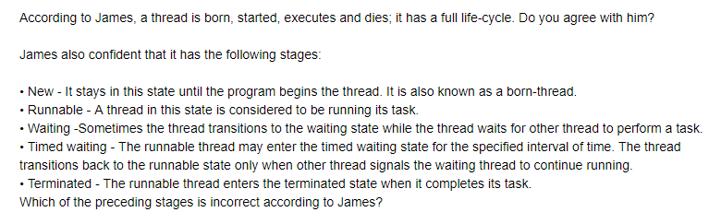

a. No, new

b. yes, waiting

c. yes, timed waiting

d. no, runnable

4.

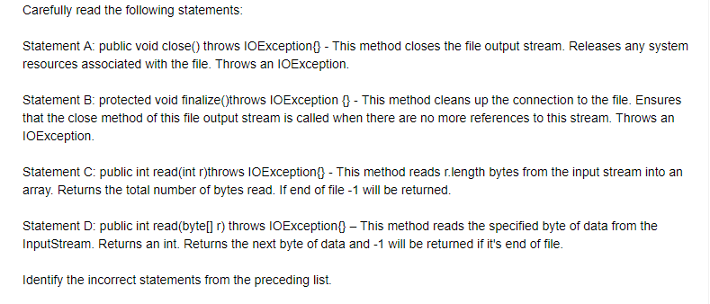

1. statement A and B
2. statement C
3. statement A only
4. statement B only
5. All statements are correct

5. Which of these methods of string class can be used to test to strings for equality?

1. isequal()
2. isequals()
3. equal()
4. equals()
5. None of these

6. A/an ________ is thrown when an attempt is created to change unmodifiable map.

1. UnsupportedOperationException
2. NullpointerException
3. ClassCastException
4. NoSuchElementException
5. None of these

7. ________ interface provides the remove operation to remove the last element returned by next from the collection

1. Iterator
2. List
3. Remove
4. Update
5. None of these

8. Which of the following extends AbstractList for use by a collection that uses sequential rather than random access of its elements.

1. AbstractCollection
2. AbstractListExtends
3. AbstractSequentialList
4. LinkedList
5. None of these

9. While developing java programs, which of the following type of application does Java supports?

1. Standalone Application
2. Web Application
3. Enterprise Application
4. Mobile Application
5. All of these

10. The angle brackets <> are informally called the ____ operator.

1. Diamond
2. Gold
3. instance Creation
4. Silver
5. None of these

11. Which of these methods return a smallest whole number greater than or equal to variable X?

1. double floor(double X)
2. double max(double X)
3. double min(double X)
4. double ciel(double X)
5. None of these

12. Which of the following can be defined as a grouping of related types(classes, interfaces, enumerations and annotations) providing access protection and namespace managemnt.

1. Polymorphism
2. Package
3. Objects
4. Classes
5. None of these

13. ________ are the methods which actually read the instance variables._______ are the methods which not only reads the instance variables but also change the data.

1. Accessor methods and mutator methods
2. Mutator method and Accessor
3. instance methods and static methods
4. static methods and instance
5. none of these

14. Which of the following is not a correct syntax for comment in java?

1. //
2. /* ...... */
3. /**
4. */ .... /*
5. none of these

15. Following are the list of few reserved words available with java. Identify the odd one out.

1. super
2. transient
3. instance
4. native
5. None of these

16. Which of the following method causes the currently running thread to yield to any other threads of the same priority that are waiting to be scheduled?

1. public static void sleep(long milisec)
2. public static boolean holdsLock(Object x)
3. public static Thread currentThread()
4. public static void dumpStack()
5. None of these

17. The ____ keyword in java makes a block of code referred to as the critical section.

1. synchronized
2. structured
3. critical
4. current method
5. none of these

18. The ______ package defines the buffer classes, which are used throughout the NIO APIs.

1. java.nio
2. java.nio.api
3. nio.java
4. java.nio.char
5. None of these

19. what is the purpose of limit method of stream in java 8?

1. Iterate each element of the stream
2. Map each element to its corresponding result
3. Eliminate elements based on a criteria
4. Reduce the size of the stream
5. none of these

20. Carefully examine the code below

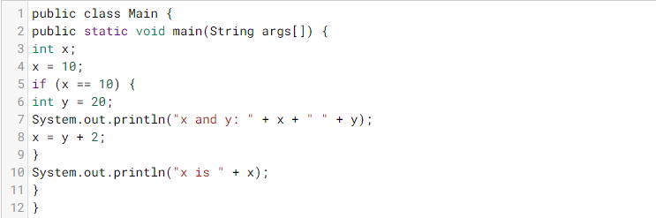

1. x and y: 10 20 x is 22
2. x and y: 20 10 x is 22
3. x and y: 22 22 x is 22
4. y=10;
5. None of these

21. carefully examine the code below

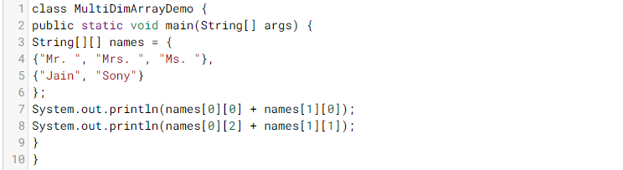

1. Ms.Sony Mr.Jain
2. Mr.Jain Ms.Sony
3. Mr.Jain Mrs.Sony
4. Mrs.Jain Mr.Sony
5. None of these

22. 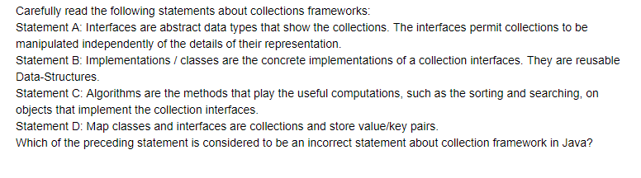

1. Statement A
2. Statement B
3. Statement C
4. Statement D
5. None of these

23. 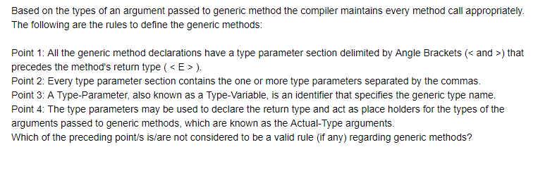

1. Point 1
2. Point 2
3. Point 3
4. Point 4
5. None of these