1. Following are the central abstractions of the NIO APIs .
- Buffers, which are containers for data;
- Charsets and their associated decoders and encoders. which translate bytes and Unicode characters;
- Channels of various types, which represent connections of entities capable of performing I/O operations.
- Selectors and selection keys, which together with selectable channels define a multiplexed, non blocking I/O facility
which of the following are options are correct about the NIO APIs
- option A and B
- option B and C
- option C and D
- option A and D
- All of these
2. Which of the following cannot be considered as java.util.Collection interface's basic operation?
- Can get its number of elements as size
- Adds a new element to a collection
- Check if the collection is vacant
- Checks if an object exists in this collection
- None of these
3. 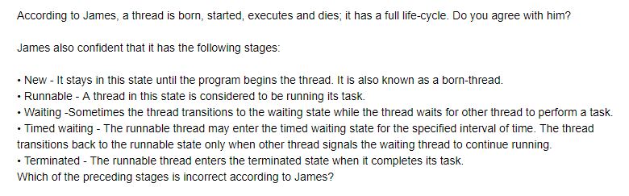

a. No, new
b. yes, waiting
c. yes, timed waiting
d. no, runnable

4.
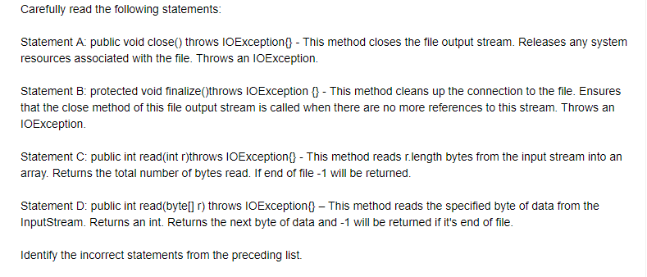

- statement A and B
- statement C
- statement A only
- statement B only
- All statements are correct
5. Which of these methods of string class can be used to test to strings for equality?
- isequal()
- isequals()
- equal()
- equals()
- None of these
6. A/an ________ is thrown when an attempt is created to change unmodifiable map.
- UnsupportedOperationException
- NullpointerException
- ClassCastException
- NoSuchElementException
- None of these
7. ________ interface provides the remove operation to remove the last element returned by next from the collection
- Iterator
- List
- Remove
- Update
- None of these
8. Which of the following extends AbstractList for use by a collection that uses sequential rather than random access of its elements.
- AbstractCollection
- AbstractListExtends
- AbstractSequentialList
- LinkedList
- None of these
9. While developing java programs, which of the following type of application does Java supports?
- Standalone Application
- Web Application
- Enterprise Application
- Mobile Application
- All of these
10. The angle brackets <> are informally called the ____ operator.
- Diamond
- Gold
- instance Creation
- Silver
- None of these
11. Which of these methods return a smallest whole number greater than or equal to variable X?
- double floor(double X)
- double max(double X)
- double min(double X)
- double ciel(double X)
- None of these
12. Which of the following can be defined as a grouping of related types(classes, interfaces, enumerations and annotations) providing access protection and namespace managemnt.
- Polymorphism
- Package
- Objects
- Classes
- None of these
13. ________ are the methods which actually read the instance variables._______ are the methods which not only reads the instance variables but also change the data.
- Accessor methods and mutator methods
- Mutator method and Accessor
- instance methods and static methods
- static methods and instance
- none of these
14. Which of the following is not a correct syntax for comment in java?
- //
- /* ...... */
- /**
- */ .... /*
- none of these
15. Following are the list of few reserved words available with java. Identify the odd one out.
- super
- transient
- instance
- native
- None of these
16. Which of the following method causes the currently running thread to yield to any other threads of the same priority that are waiting to be scheduled?
- public static void sleep(long milisec)
- public static boolean holdsLock(Object x)
- public static Thread currentThread()
- public static void dumpStack()
- None of these
17. The ____ keyword in java makes a block of code referred to as the critical section.
- synchronized
- structured
- critical
- current method
- none of these
18. The ______ package defines the buffer classes, which are used throughout the NIO APIs.
- java.nio
- java.nio.api
- nio.java
- java.nio.char
- None of these
19. what is the purpose of limit method of stream in java 8?
- Iterate each element of the stream
- Map each element to its corresponding result
- Eliminate elements based on a criteria
- Reduce the size of the stream
- none of these
20. Carefully examine the code below
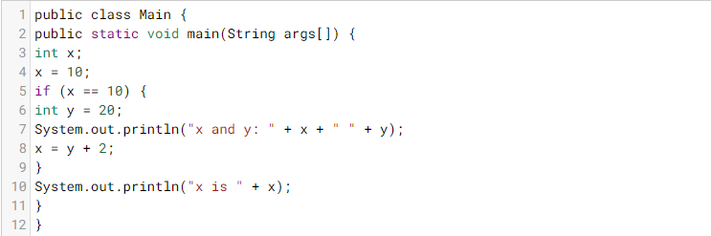
- x and y: 10 20 x is 22
- x and y: 20 10 x is 22
- x and y: 22 22 x is 22
- y=10;
- None of these

21. carefully examine the code below
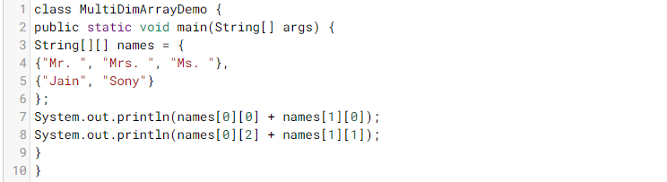

- Ms.Sony Mr.Jain
- Mr.Jain Ms.Sony
- Mr.Jain Mrs.Sony
- Mrs.Jain Mr.Sony
- None of these
22. 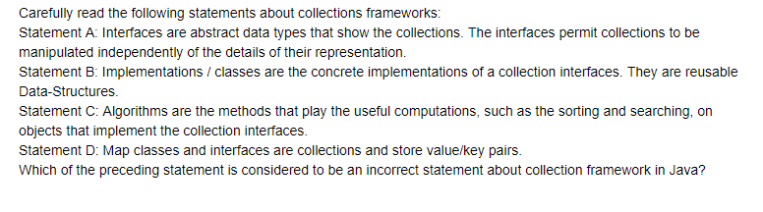
- Statement A
- Statement B
- Statement C
- Statement D
- None of these
23. 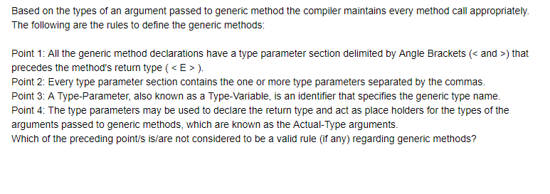
- Point 1
- Point 2
- Point 3
- Point 4
- None of these

