## Design of HDFS

HDFS is a filesystem designed for storing very large files with streaming data access patterns, running on clusters of commodity hardware.

* “Very large”

In this context means files that are hundreds of megabytes, gigabytes, or terabytes in size. There are Hadoop clusters running today that store petabytes of data. • Streaming data access

HDFS is built around the idea that the most efficient data processing pattern is a write-once, read-many-times pattern. A dataset is typically generated or copied from source, then various analyses are performed on that dataset over time. Each analysis will involve a large proportion, if not all, of the dataset, so the time to read the whole dataset is more important than the latency in reading the first record.

* Commodity hardware

Hadoop doesn’t require expensive, highly reliable hardware to run on. It’s designed to run on clusters of commodity hardware (commonly available hardware available from multiple vendors) for which the chance of node failure across the cluster is high, at least for large clusters. HDFS is designed to carry on working without a noticeable interruption to the user in the face of such failure. • Low-latency data access

Applications that require low-latency access to data, in the tens of milliseconds range, will not work well with HDFS. Remember, HDFS is optimized for delivering a high throughput of data, and this may be at the expense of latency

* Lots of small files

Since the namenode holds filesystem metadata in memory, the limit to the number of files in a filesystem is governed by the amount of memory on the namenode. As a rule of thumb, each file, directory, and block takes about 150 bytes. So, for example, if you had one million files, each taking one block, you would need at least 300 MB of memory. While storing millions of files is feasible, billions is beyond the capability of current hardware.

* Multiple writers, arbitrary file modifications

Files in HDFS may be written to by a single writer. Writes are always made at the end of the file. There is no support for multiple writers, or for modifications at arbitrary offsets in the file.

**MapReduce Data flow with single and multiple reduce tasks**

There are two types of nodes that control the job execution process: a jobtracker and a number of tasktrackers. The jobtracker coordinates all the jobs run on the system by scheduling tasks to run on tasktrackers. Tasktrackers run tasks and send progress reports to the jobtracker, which keeps a record of the overall progress of each job. If a task fails, the jobtracker can reschedule it on a different tasktracker.

Hadoop divides the input to a MapReduce job into fixed-size pieces called input splits, or just splits. Hadoop creates one map task for each split, which runs the userdefined map function for each record in the split.

Having many splits means the time taken to process each split is small compared to the time to process the whole input. So if we are processing the splits in parallel, the processing is better load-balanced if the splits are small, since a faster machine will be able to process proportionally more splits over the course of the job than a slower machine.

Even if the machines are identical, failed processes or other jobs running concurrently make load balancing desirable, and the quality of the load balancing increases as the splits become more fine-grained.

Hadoop does its best to run the map task on a node where the input data resides in HDFS. This is called the data locality optimization.

The whole data flow with a single reduce task is illustrated in Figure.

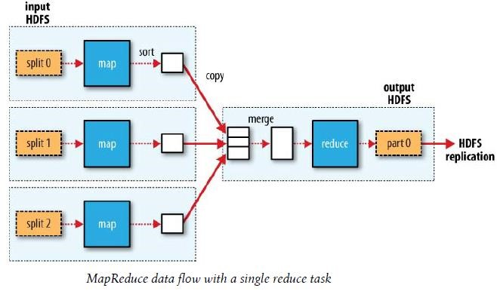

The number of reduce tasks is not governed by the size of the input, but is specified independently. When there are multiple reducers, the map tasks partition their output, each creating one partition for each reduce task. There can be many keys (and their associated values) in each partition, but the records for any given key are all in a single partition. The partitioning can be controlled by a user-defined partitioning function, but normally the default partitioner—which buckets keys using a hash function—works very well.

The data flow for the general case of multiple reduce tasks is illustrated in Figure.

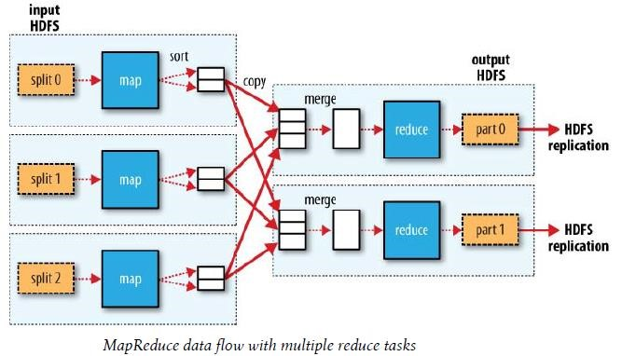

**Hadoop Architecture:**

HDFS has a master/slave architecture. An HDFS cluster consists of a single NameNode, a master server that manages the file system namespace and regulates access to files by clients. In addition, there are a number of DataNodes, usually one per node in the cluster, which manage storage attached to the nodes that they run on. HDFS exposes a file system namespace and allows user data to be stored in files. Internally, a file is split into one or more blocks and these blocks are stored in a set of DataNodes. The NameNode executes file system namespace operations like opening, closing, and renaming files and directories. It also determines the mapping of blocks to DataNodes. The DataNodes are responsible for serving read and write requests from the file system’s clients. The DataNodes also perform block creation, deletion, and replication upon instruction from the NameNode.

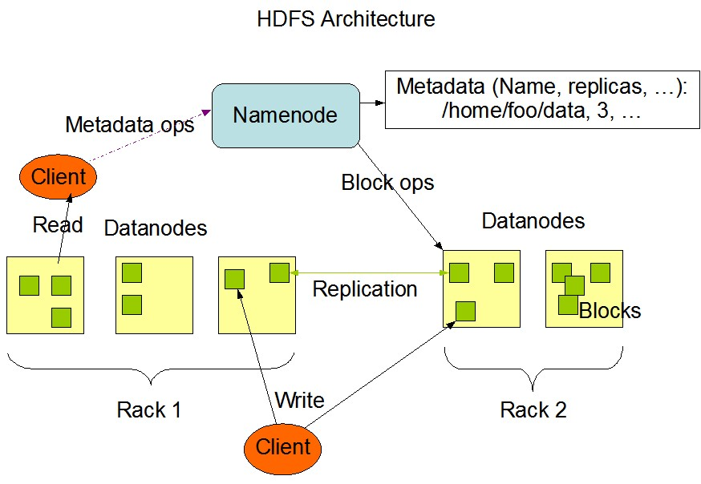

The NameNode and DataNode are pieces of software designed to run on commodity machines. These machines typically run a GNU/Linux operating system (OS). HDFS is built using the Java language; any machine that supports Java can run the NameNode or the DataNode software. Usage of the highly portable Java language means that HDFS can be deployed on a wide range of machines. A typical deployment has a dedicated machine that runs only the NameNode software. Each of the other machines in the cluster runs one instance of the DataNode software. The architecture does not preclude running multiple DataNodes on the same machine but in a real deployment that is rarely the case.

The existence of a single NameNode in a cluster greatly simplifies the architecture of the system. The NameNode is the arbitrator and repository for all HDFS metadata. The system is designed in such a way that user data never flows through the NameNode.