## Hive Data Types

Hive Support two types of data type formats

### 1. Primitive Data Types

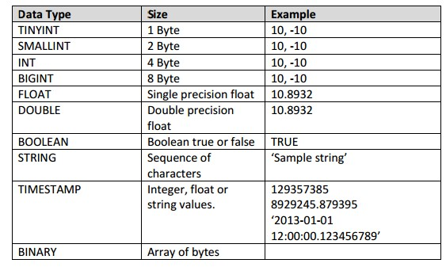

* TINYINT, SMALLINT, INT, BIGINT are four integer data types with only differences in their size.
* FLOAT and DOUBLE are two floating point data types. BOOLEAN is to store true or false.
* STRING is to store character strings. Note that, in hive, we do not specify length for STRING like in other databases. It’s more flexible and variable in length.
* TIMESTAMP can be an integer which is interpreted as seconds since UNIX epoch time. It may be a float where number after decimal is nanosecond. It may be string which is interpreted
* according to the JDBC date string format i.e. YYYY-MM-DD hh:mm:ss.fffffffff. Time component is interpreted as UTC time.
* BINARY is used to place raw bytes which will not be interpreted by hive. It is suitable for binary data.

### 2. Collection Data Types

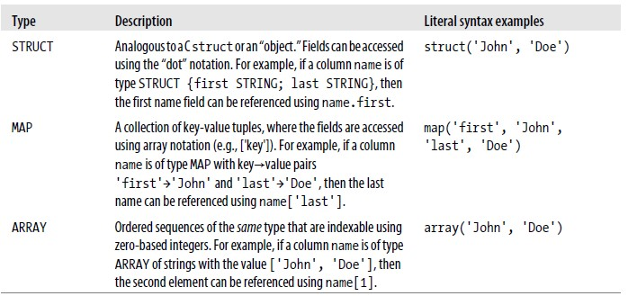

## Hive File formats

Hive supports all the Hadoop file formats, plus Thrift encoding, as well as supporting pluggable SerDe (serializer/deserializer) classes to support custom formats.

There are several file formats supported by Hive.

TEXTFILE is the easiest to use, but the least space efficient.

SEQUENCEFILE format is more space efficient.

MAPFILE which adds an index to a SEQUENCEFILE for faster retrieval of particular records.

Hive defaults to the following record and field delimiters, all of which are non-printable control characters and all of which can be customized.