physmerge: panel-free physical locus merging for GWAS summary statistics
Pin Yang1,2,3 Satoshi Koyama1,4,5,*
1 Cardiovascular Disease Initiative, Broad Institute of MIT and Harvard
2 Department of Epidemiology, Harvard T.H. Chan School of Public Health
3 Department of Medical Education, Far Eastern Memorial Hospital
4 Personalized Medicine, Mass General Brigham
5 Heart and Vascular Institute, Mass General Brigham
*To whom correspondence should be addressed.

Abstract
Summary: Linkage disequilibrium (LD) within a GWAS study can produce spurious hits; this is commonly addressed using an LD reference panel to perform clumping. In situations where only summary statistics are available, however, distance-based locus definition is the panel-free alternative but is typically applied as ad-hoc per-study code. We present physmerge, available as both a lightweight R package and an executable that collapses significant SNPs into non-overlapping locus blocks from summary statistics alone using a forward sliding-window rule. On simulated GWAS built from real 1000 Genomes genotypes, physmerge reproduces the established distance-chaining locus definition (as in gwasRtools/locus_breaker; Pilling, 2024; Ochoa, et al., 2024) and attains higher locus-level sensitivity and precision than panel-based LD clumping while needing no panel. Because it uses no reference panel, physmerge is immune to panel misspecification; in contrast, LD clumping loses precision steeply when the reference panel is contaminated across ancestries.
Availability: MIT-licensed at https://github.com/Droideight/physmerge; the R package installs with devtools::install_github("Droideight/physmerge") and the standalone executable is distributed from the same repository, where it builds with a single compiler invocation on macOS, Linux and Windows. A Base SAS implementation is distributed in the same repository.
Contact: skoyama2@mgh.harvard.edu Supplementary: figures appended.

1 Introduction
A GWAS yields many significant SNPs; these are often clustered into a few independent association signals, hence collapsing them into discrete loci and nominating a representative SNP is a prerequisite for downstream interpretation. The field standard, LD clumping with PLINK (Purcell, et al., 2007; Chang, et al., 2015), uses pairwise correlation and requires an LD reference panel. For the growing number of summary-statistic-only datasets, such a panel is often unavailable or population-mismatched.
While PLINK relies on r-square between two SNPs to nominate clusters, the panel-free alternative is distance-based locus definition, which first merges significant SNPs within a prespecified genomic window, then nominates the most significant SNP inside each window as representative. A handful of tools implement variants of this idea (Juliusdottir, 2023; He, et al., 2023; Pilling, 2024), but they are scattered across languages and output formats. We present physmerge that merges significant SNPs with a forward sliding window (an open block is extended whenever the next significant SNP lies within the window of the current one), yielding contiguous, strictly non-overlapping locus blocks directly from summary statistics. This program is available both as an R package and an executable.

2 Implementation
Algorithm. physical_merge() makes a single forward pass over position-sorted summary statistics. A block opens at the first significant SNP, with its start placed one window upstream (max(0, position − window)). The block carries a window-sized budget that is spent by the distance travelled and refilled to the full window at every significant SNP (reset_on = "any"); it stays open until the budget runs out (equivalently, until the next significant SNP lies one window or more beyond the previous one), at which point it closes one window downstream of the last significant SNP, mirroring its start. A new block opens upon the next significant SNP until the last position is visited.
The representative of each block is its most significant SNP. The representatives of successive blocks are at least one window apart, but because each block is padded by one window on both sides, adjacent blocks still overlap whenever that gap is less than two windows; a final trim step therefore shortens any block whose downstream-extended end runs past the next block's upstream-extended start, giving contiguous, strictly non-overlapping blocks. With a chromosome column the algorithm runs per chromosome (Figure 1).
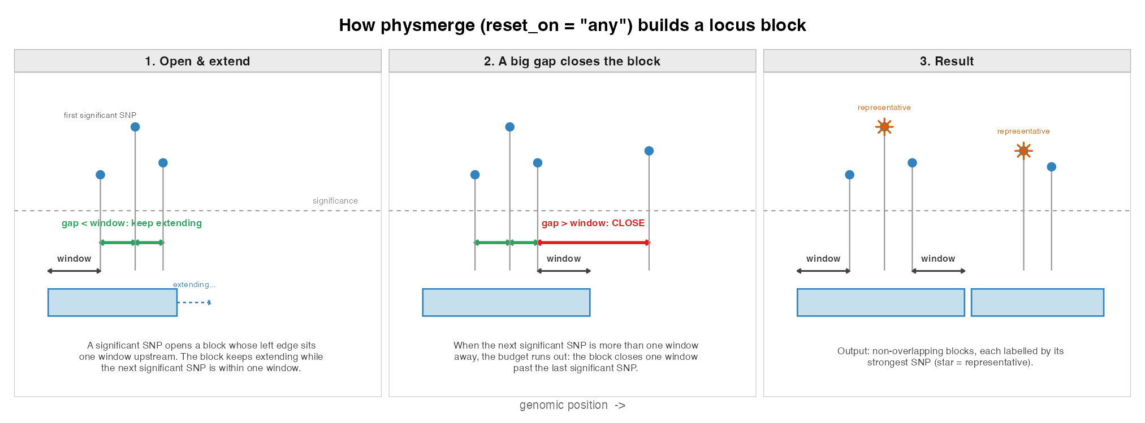
Figure 1. Algorithm of physmerge. A block opens one window upstream of the first significant SNP, is extended whenever the next significant SNP falls within one window, and closes at the first gap of one window or more.
Inputs and outputs. In the R package, read_sumstat() reads PLINK2 .glm.* output, per-SNP REML output (to complement GPC-M), or arbitrary tables via explicit column mapping, handling p-values or test statistics. physical_merge() returns one row per block (serial, chromosome, start, end, representative position and value); annotate_blocks() joins original fields back to each representative, and export_snp_list() writes representative SNP IDs as a flat file or per-chromosome ZIP. The R package depends only on base R and utils (data.table optional for fast reading).
As a standalone executable, physmerge performs the same merge from the command line without an R installation: it reads a summary-statistics file, applies the significance threshold, window and reset_on rule given as options, and writes the block table and, optionally, the representative SNP list. It is a dependency-free C99 program that streams the file in a single pass, so its memory footprint stays at 2.4 MB regardless of the file size.
SAS. The same merge is implemented for Base SAS as the macro %physmerge, for sites where SAS is the available language. It needs no SAS product beyond Base.

3 Results
We simulated GWAS summary statistics from real 1000 Genomes chromosome-1 genotypes (GRCh37, 50-60 Mb; European super-population, N = 503; 31,476 SNPs after filtering at MAF > 0.01). Each replicate drew 1-10 causal SNPs and gave every causal SNP the same variance explained (per-SNP h² = 0.075), so per-SNP power stays constant as the number of causal SNPs grows rather than being diluted; 84% of single causal SNPs reached p < 5e-8. We ran B = 200 replicates per condition.
We summarize each set of called blocks with three metrics: sensitivity, the fraction of causal SNPs that fall inside some block; precision, the fraction of blocks that contain at least one causal SNP; and merging rate, the fraction of blocks that contain two or more causal SNPs. Sensitivity and precision both improve as blocks get wider, so block count and merging rate are reported concurrently to provide fair assessment.
physmerge is compared against LD clumping and against two published distance-based families (Figure 3): greedy peak-pruning (topr/GWASLab; Juliusdottir, 2023; He, et al., 2023) and single-linkage chaining (gwasRtools; Pilling, 2024). LD clumping is implemented by R according to original methodology: a block is the span of genome-wide-significant SNPs in r^2 > 0.1 with the top SNP. In this implementation, r^2 is computed from the study genotypes themselves, so its LD reference is perfectly matched, and the absence of a distance cap makes it more permissive in range than PLINK's default, making LD based method deliberately favored.
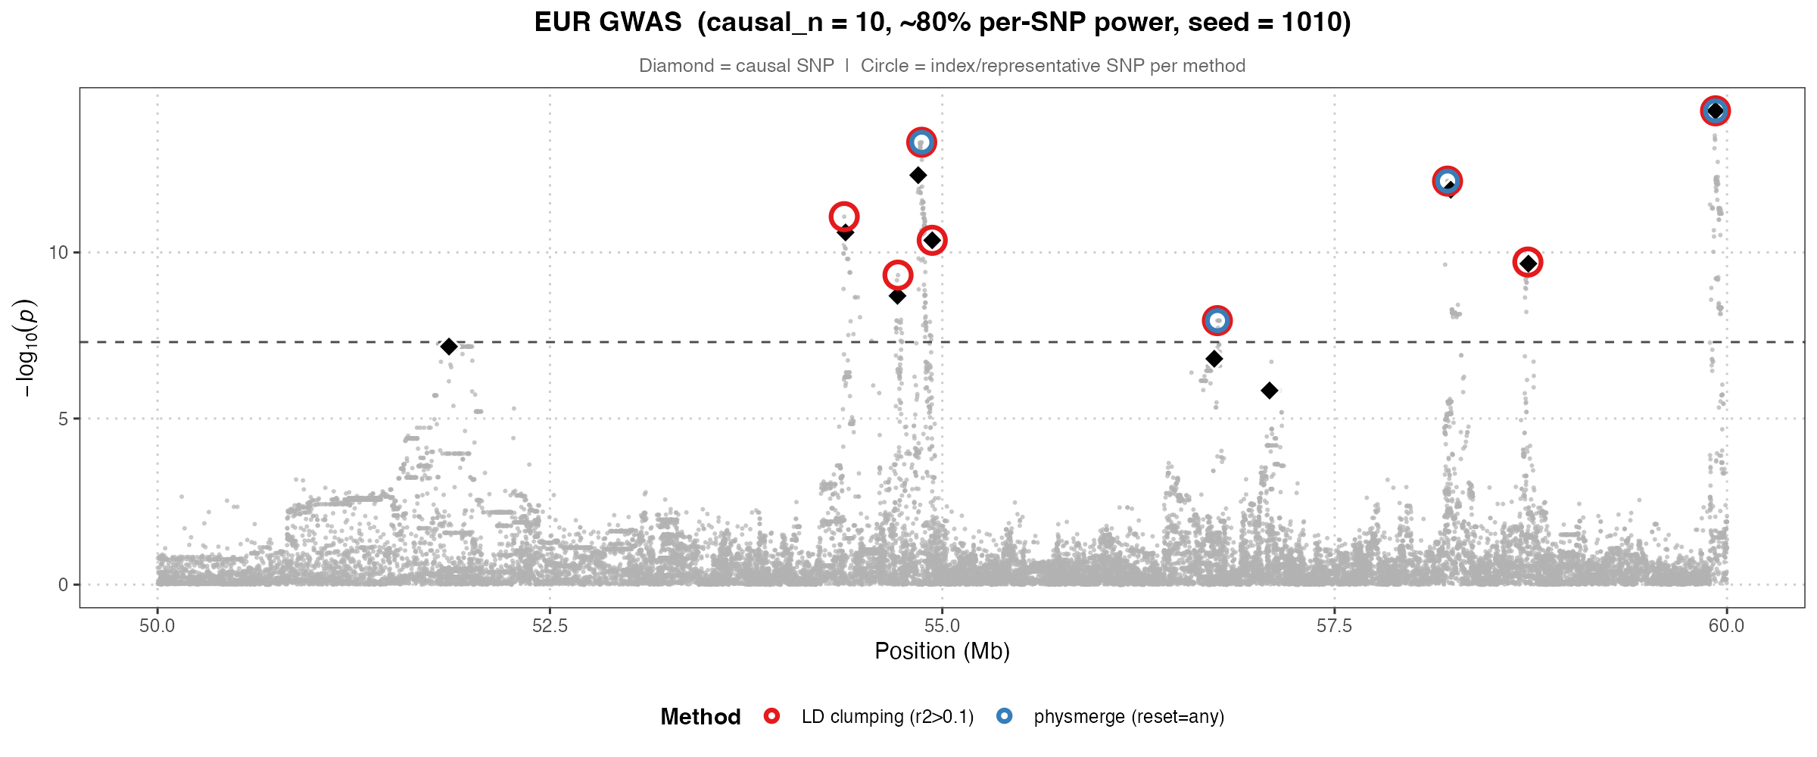
Figure 2. One simulated GWAS with 10 causal SNPs. LD clumping and physmerge pick similar lead SNPs.

3.1 Concordance with established tools
physmerge reset_on="any" was indistinguishable from single-linkage distance chaining (gwasRtools / locus_breaker). Across all causal-SNP counts the two gave identical sensitivity, precision, merging rate and block count in 98% of replicates, with mean differences below 0.004 in every metric (Figure 3); physmerge therefore provides a faithful R implementation of the standard distance-chaining locus definition, despite minor deviation in block range.

3.2 Versus LD clumping
Relative to panel-based LD clumping, physmerge achieved higher locus-level sensitivity (0.92 vs 0.79 at 10 causal SNPs) and precision (0.99 vs 0.95), using no LD reference at all (Figure 3). However, because it chains neighboring signals, it reports wider and fewer blocks (4.9 vs 8.0), and is more likely to group nearby causal SNPs into one block (merging rate 0.54 vs 0.10). physmerge therefore favors coverage and panel-free operation, whereas LD clumping yields tighter, more numerous loci at the cost of an LD panel and lower coverage; greedy peak-pruning (topr) sits between the two.
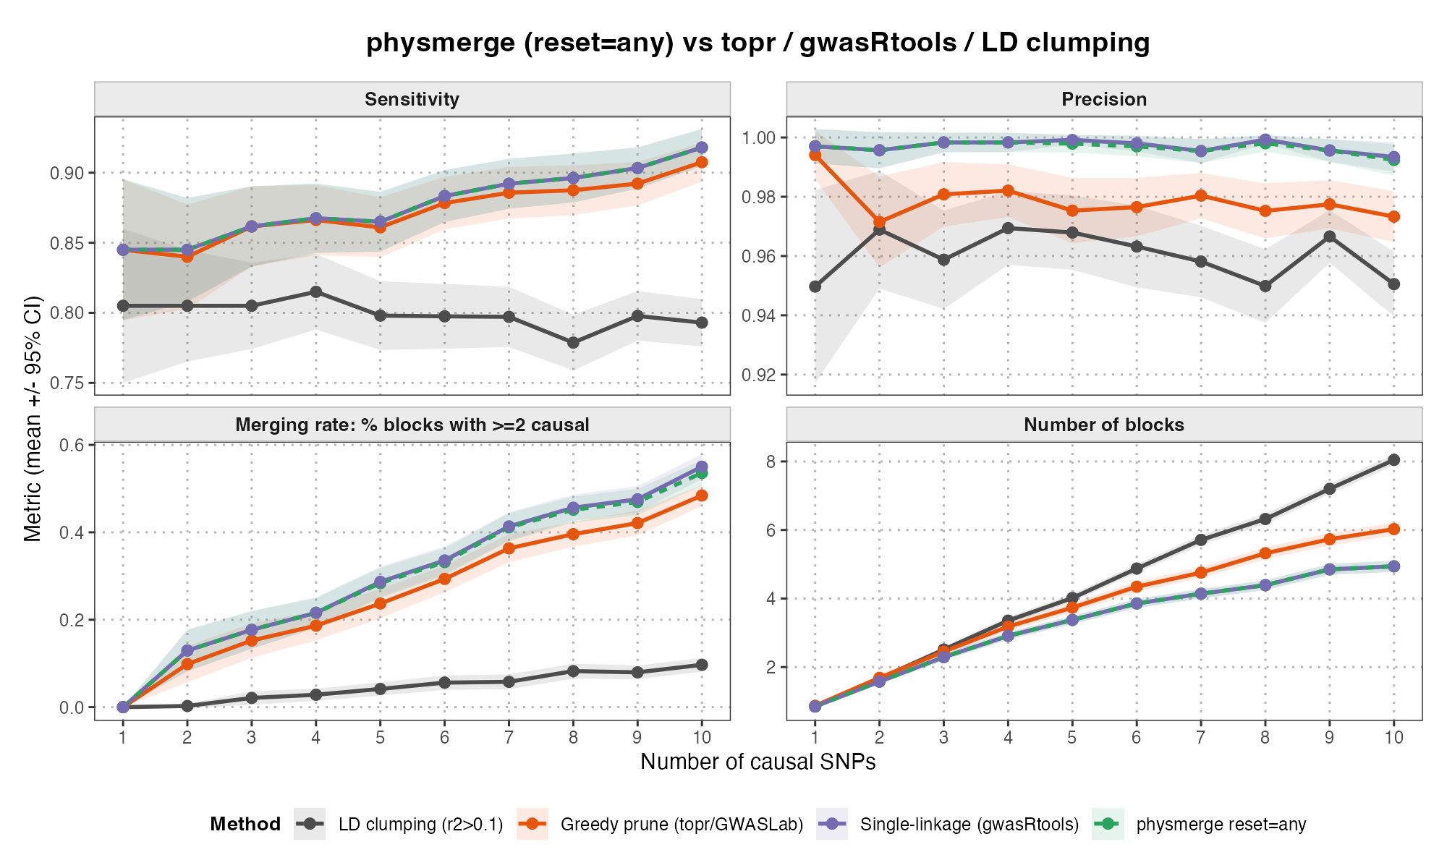
Figure 3. The four methods across 1-10 causal SNPs. physmerge and single-linkage chaining sit almost exactly on top of each other; LD clumping is lowest on sensitivity and precision while reporting the most blocks.

3.3 Reference-panel mismatch
Our simulation favors the LD-based method because panels are self-derived. Here, we simulate real-world scenarios by holding the GWAS fixed on European samples and progressively contaminating only the LD reference panel used by clumping, with three contaminants of increasing genetic distance: other mainland Europeans, a European genetic isolate (Finnish), and a different continental ancestry (African). A fresh panel was drawn for every replicate. Unlike other experiments using 1000 Genomes, this one is run on the gnomAD HGDP+1KG callset, which supplies the distinct European sub-populations needed for the same-ancestry contaminants.
As shown in Figure 4, there is an increase in degradation as genetic distance increases, particularly in the cross-continental case. Contaminating the panel with African samples reduced LD-clumping precision from 0.962 to 0.832 at 50% contamination (p ≈ 1 × 10⁻¹²⁷); in contrast, replacing up to half the panel with a completely different set of Europeans cost only 0.005 (HGDP European: 0.962 to 0.957, p = 0.02), and a European isolate only 0.007 (Finnish: 0.961 to 0.954, p = 4 × 10⁻⁴). In comparison, physmerge, which never consults a panel, is invariant across all of these conditions.
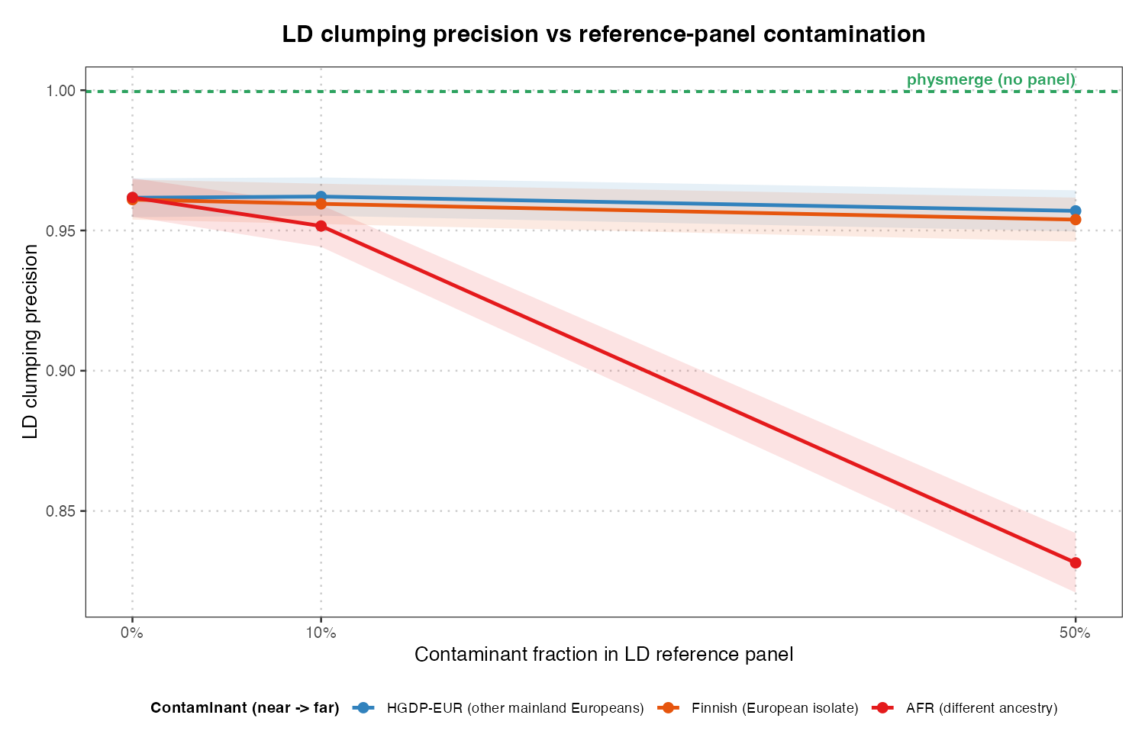
Figure 4. LD-clumping precision as the reference panel is contaminated. Only the cross-continental contaminant causes a substantial loss; physmerge uses no panel and is unaffected.

3.4 Window size and ancestry
Sensitivity and the merging rate both increase with the window: larger windows capture more of each signal but merge nearby loci more readily, so 250-500 kb offers a practical balance, consistent with common practice. To ask whether this behavior is ancestry-specific, we repeated the window sweep in five 1000 Genomes super-populations, subsampling each to a common N = 347 and holding the per-SNP heritability fixed so that sample size and per-SNP power were matched. Once N was controlled, the window-response curves of the four non-admixed groups (EUR, AFR, EAS, SAS) were grossly overlapping, indicating that differences in LD extent between continental populations have little effect on physmerge, whose block width is dominated by the ±window padding. The admixed American group (AMR) was the only departure: admixture LD widens the significant signal itself, giving higher sensitivity (0.83 vs 0.78 at a 1 Mb window) but lower precision (0.986 vs ≈1.000) and systematically wider blocks. A single default window is therefore reasonable across non-admixed ancestries. Admixed cohorts need the opposite adjustment: because admixture spreads the significant signal, a small window fragments it into blocks that contain no causal SNP, and AMR precision falls from 0.984 at 1 Mb to 0.803 at 100 kb. The cost is resolution, since AMR blocks stay proportionally wide at every window.

4 Conclusion
physmerge is a transparent and dependency-light implementation of panel-free physical locus merging. It reproduces the established distance-chaining locus definition, while providing higher coverage than panel-based LD clumping without any reference panel. Because it requires no panel, it avoids the precision loss that panel-based clumping suffers when the reference is ancestry-mismatched to the study sample, and its behavior is stable across non-admixed ancestries. Format readers, annotation and SNP-list export are provided alongside.

References
Chang, C.C., et al. Second-generation PLINK: rising to the challenge of larger and richer datasets. GigaScience 2015;4(1).
He, Y., et al. GWASLab: a Python package for processing and visualizing GWAS summary statistics. Jxiv 2023.
Juliusdottir, T. topr: an R package for viewing and annotating genetic association results. BMC Bioinformatics 2023;24(1):268.
Ochoa, D., et al. Open Targets Gentropy Python package. Version 1.0.0. Open Targets 2024. doi:10.5281/zenodo.10527086.
Pilling, L. gwasRtools: some useful R functions for processing GWAS output. R package version 0.1.7 2024. https://github.com/lcpilling/gwasRtools.
Purcell, S., et al. PLINK: a tool set for whole-genome association and population-based linkage analyzes. Am J Hum Genet 2007;81(3):559-575.

Supplementary Figures
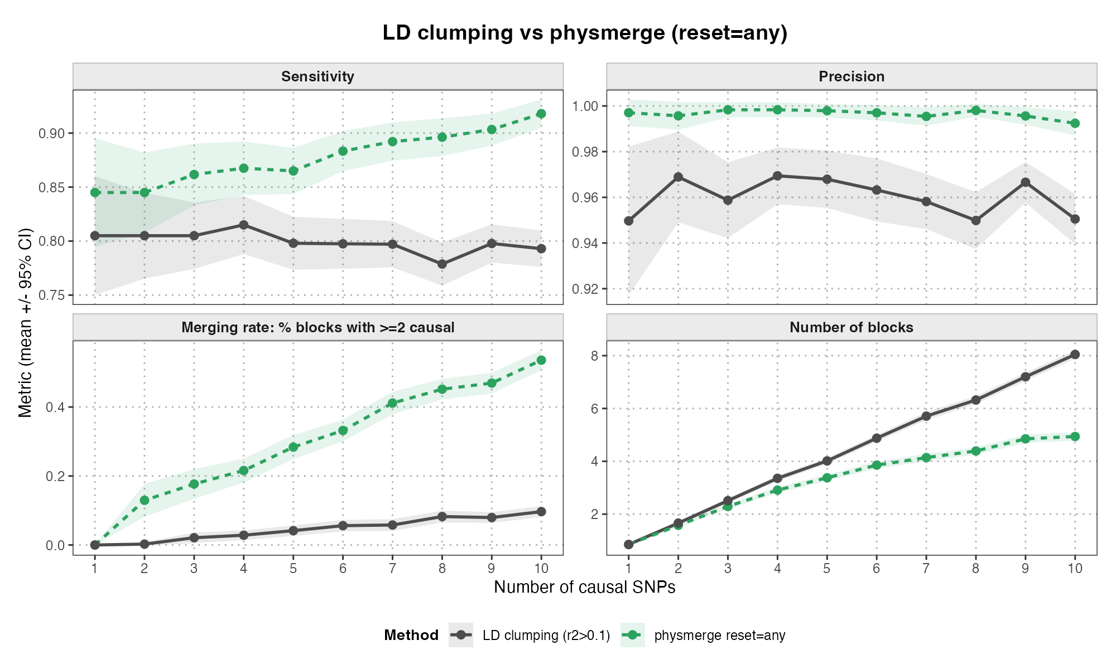
Figure S1. physmerge against LD clumping alone, across 1-10 causal SNPs.
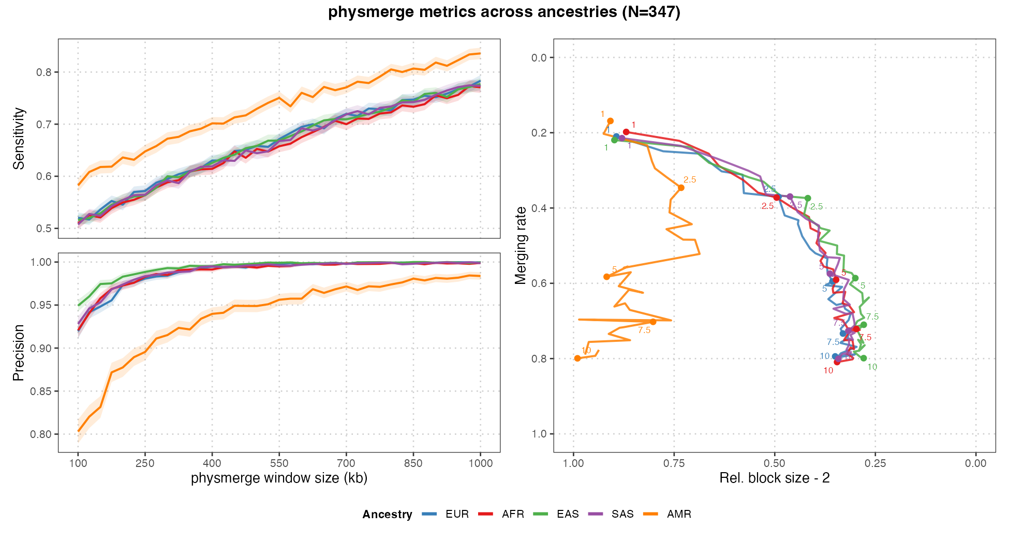
Figure S2. Sensitivity and precision against window size, with the block width and merging rate trade-off, for the five super-populations.
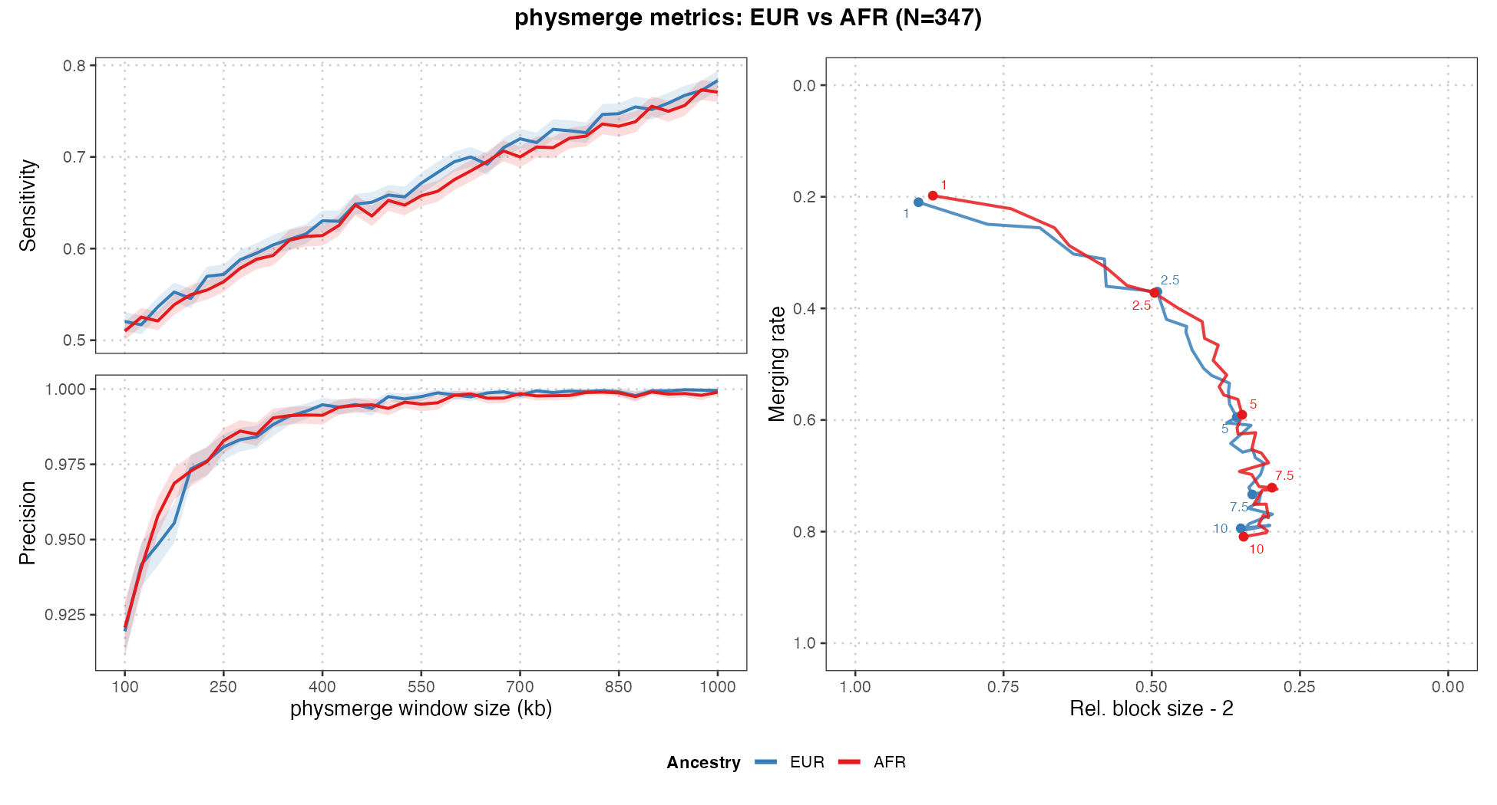
Figure S3. The same comparison restricted to Europeans and Africans, the two groups with the largest expected difference in LD extent.
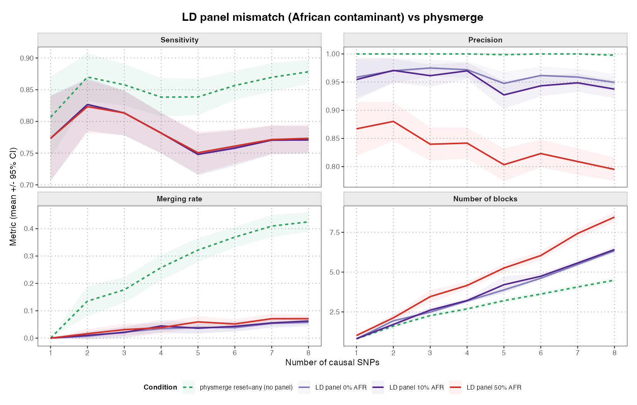
Figure S4. LD clumping with an African contaminant in the reference panel, against panel-free physmerge.
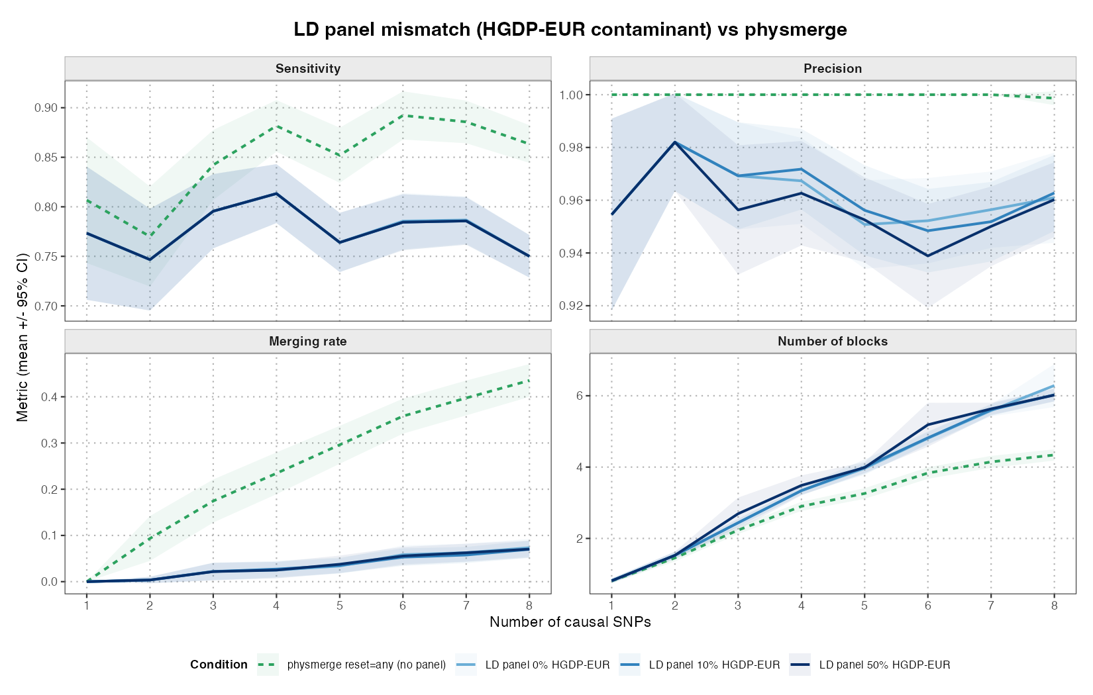
Figure S5. The same experiment with HGDP European samples as the contaminant.
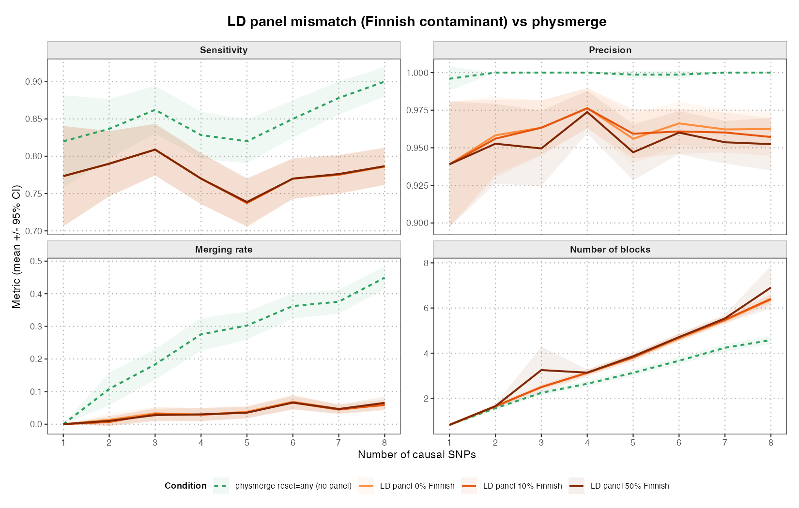
Figure S6. The same experiment with Finnish samples as the contaminant.

