Containerized CI Pipeline to Azure Container Registry
A REPORT

submitted by

Drona Srivastava ( 23BAI1314 )

in partial fulfilment for the award

of

B.Tech in Computer Science and Engineering with Specialization in Artificial Intelligence and Machine Learning

School of Computer Science and Engineering



September - 2026

School of Computer Science and Engineering

DECLARATION

I hereby declare that the project entitled “Containerized CI Pipeline to Azure Container Registry” submitted by me to the School of Computer Science and Engineering, Vellore Institute of Technology, Chennai Campus, Chennai 600127 in partial fulfilment of the requirements for the award of the degree of Bachelor of Technology in Computer Science and Engineering with Specialization in Artificial Intelligence and Machine Learning is a record of bonafide work carried out by me. I further declare that the work reported in this report has not been submitted and will not be submitted, either in part or in full, for the award of any other degree or diploma of this institute or of any other institute or university.

Signature

Drona Srivastava ( 23BAI1314 )

School of Computer Science and Engineering

CERTIFICATE

The project report entitled “Containerized CI Pipeline to Azure Container Registry” is prepared and submitted by Drona Srivastava (Register No: 23BAI1314 ). It has been found satisfactory in terms of scope, quality and presentation as partial fulfilment of the requirements for the award of the degree of Bachelor of Technology in Computer Science and Engineering with Specialization in Artificial Intelligence and Machine Learning in Vellore Institute of Technology, Chennai, India.

Examined by:

Examiner I Examiner II

INDUSTRY CERTIFICATE



ACKNOWLEDGEMENT

Give your acknowledgement here in the following format specification. Times new roman, 12 point scale, Normal, Justified with 1.5 line spacing. Do not sign in the acknowledgment page.
Follow the following hierarchy for acknowledging:

- Dr. TULASI PRASAD SARIKI, Head of the Department (HoD), B.Tech. Computer
Science and Engineering with Specialization in Artificial Intelligence and Machine Learning, Vellore Institute of Technology, Chennai

- Dr. Viswanathan V, DEAN, School of Computer Science & Engineering, Vellore Institute of Technology, Chennai

- Dr. NITHYANANDAM P, Associate Dean, School of Computer Science & Engineering, Vellore Institute of Technology, Chennai

- Dr. SUGANYA G, Associate Dean, School of Computer Science & Engineering, Vellore Institute of Technology, Chennai

- Dr. SWEETLIN HEMALATHA C, Associate Dean, School of Computer Science & Engineering, Vellore Institute of Technology, Chennai
- I also acknowledge the support of my Project Teammates, Kantammeni Pranith and
Ojaswi Gupta, whose contributions helped the project progress from application development to CI, security validation, and Azure Container Registry integration.

CONTENTS

 | Title Page | i
 | Declaration | ii
 | Certificate | iii
 | Industry certificate | iv
 | Acknowledgement | v
 | Table of contents | vi
 | List of Tables | vii
 | List of Figures | viii
 | List of Abbreviations | ix
 | Abstract | x
1 | Introduction | 01
2 | Project Overview and Requirement Mapping | 02
3 | System Design and Implementation | 03
3.1 | Application and Containerization | 04
3.2 | CI Pipeline Implementation | 05
3.3 | Security Investigation and Remediation | 08
3.4 | Azure Identity, Challenges and Cost Optimization | 10
3.5 | Workflow Validation and Results | 13
4 | Conclusion | 14
 | References | 15
 | Appendix I | 16

LIST OF TABLES

Title | Page
Table 1 : Requirement mapping | 02
Table 2 : Application endpoints | 04
Table 3 : Docker image tagging strategy | 07
Table 4 : Technical challenges and resolutions | 11

LIST OF FIGURES

Title | Page
Fig 1 : End-to-end CI architecture | 03
Fig 2 : Application and Dockerfile strategy | 04
Fig 3 : Trivy security gate failure | 08
Fig 4 : Azure identity and ACR configuration | 10
Fig 5 : Successful CI workflow | 13

LIST OF ABBREVIATIONS

Abbreviation | Expansion
ACR | Azure Container Registry
CI | Continuous Integration
CLI | Command-Line Interface
Entra ID | Microsoft Entra ID
RBAC | Role-Based Access Control
SHA | Secure Hash Algorithm
SBOM | Software Bill of Materials

ABSTRACT

Modern software delivery requires reproducible builds, automated validation, security controls, and reliable artifact management rather than manual deployment from a developer workstation. This project addressed these needs by transforming a standalone FastAPI URL shortener into a containerized application delivered through a gated Continuous Integration pipeline. The original setup had four principal limitations: environment inconsistency, manual deployment effort, security blindspots for dependencies and base images, and lack of traceability for application states. The implemented solution uses Docker with a multi-stage build based on python:3.12-alpine, GitHub Actions as the CI orchestrator, Pytest for eight automated tests, a runtime health check against the /health endpoint, AquaSecurity Trivy for vulnerability scanning, and Microsoft Azure Container Registry (ACR) for managed image storage. The workflow follows a fail-fast sequence of source checkout, testing, image build and tagging, runtime validation, security scanning, Azure authentication, and image delivery. A key engineering result occurred when the initial python:3.12-slim image passed all eight Pytests and the runtime health check but produced two CRITICAL Trivy findings originating from the Debian perl-base package. The security gate blocked the artifact as designed. The team migrated to python:3.12-alpine, after which Docker build, health validation, and Trivy scanning passed with zero CRITICAL findings. The final image size was approximately 25 MB. For traceability, the same image digest is associated with a CI run-based tag such as build-8 and a Git commit-based short-SHA tag such as sha-0c5b87b. Azure access uses a dedicated Microsoft Entra Service Principal, encrypted GitHub repository secrets, and resource-scoped RBAC. The completed workflow demonstrated 8/8 Pytests, an HTTP 200 health response, successful Azure login, and successful ACR delivery. The project therefore provides a reproducible path from source code to a tested, scanned, and traceable container artifact. It also demonstrates practical coordination between application development, container security, continuous integration, cloud identity, and registry-based artifact management within one workflow.

INTRODUCTION
The project titled “Containerized CI Pipeline to Azure Container Registry” was developed as the Ethnus Azure DevOps Project — P5. The work focused on creating a controlled path from source-code changes to a verified container artifact in Microsoft Azure. The central engineering goal was not simply to build a Docker image, but to ensure that an image reached the cloud registry only after passing functional tests, runtime validation, and security checks.
The application began as a standalone script running exclusively on a developer's local machine. This arrangement created environment inconsistency, manual deployment effort, security blindspots, and limited traceability. The project therefore combined application containerization, automated CI, vulnerability scanning, Azure authentication, and artifact tagging into one workflow.
The resulting pipeline follows a linear trust progression: source code is checked out, eight Pytest tests are executed, the container image is built and tagged, the container is started and checked through /health, Trivy scans the image for CRITICAL vulnerabilities, and only a clean artifact is authenticated and pushed to Azure Container Registry. The same image digest is retained while its identifiers are changed through retagging, preventing build drift between stages.
Drona Srivastava's primary contribution was the CI pipeline, container security, and ACR integration. The project presentation records the complementary responsibilities of Kantammeni Pranith for Azure infrastructure and container registry work, and Ojaswi Gupta for the FastAPI application and Dockerization.

PROJECT OVERVIEW AND REQUIREMENT MAPPING

Problem Statement
The original application workflow depended on local execution and manual handling. There was no guarantee that the local environment would behave identically elsewhere, updates required manual deployment effort, dependency and base-image vulnerabilities were not automatically detected, and application states did not have a consistent artifact-management mechanism. These issues motivated the design of a reproducible and security-gated CI pipeline.

Objectives
    - Containerize the application using a multi-stage Docker build with python:3.12-alpine.
    - Automate the build and validation process through GitHub Actions on repository push events.
    - Run eight automated tests and a runtime /health check before cloud delivery.
    - Scan container images with AquaSecurity Trivy and block CRITICAL vulnerabilities.
    - Authenticate to Azure through a Microsoft Entra Service Principal and deliver validated images to ACR.
    - Use immutable build and source identifiers to provide traceability and rollback capability.
    - Define a practical artifact-retention strategy for the educational deployment scope.

Requirement Mapping

Requirement | Technical implementation | Verification method
Containerization | Multi-stage Docker build using python:3.12-alpine | Successful docker build logs in CI runner
Automated CI Build | GitHub Actions triggered by repository  push events | Workflow execution history in GitHub
Immutable Tagging | Dual tagging with CI run number and short SHA | Repository tags inspected in Azure
Runtime Testing | Container instantiation and /health  polling | HTTP 200 response in pipeline logs
Vulnerability Scanning | AquaSecurity Trivy scan stage | 0 CRITICAL findings
Azure Integration | Azure CLI authentication through Entra Service Principal | Successful Azure Login step
Security Gate | Exit code 1 on CRITICAL vulnerabilities | Failure demonstrated with slim image
Retention Strategy | Defined lifecycle for build artifacts and releases | Documented registry maintenance proposal

SYSTEM DESIGN AND IMPLEMENTATION

End-to-End Architecture
The architecture is organized as a linear trust progression. A developer push initiates GitHub Actions. The workflow then executes Pytest, builds and tags the image, performs a container health check, and runs Trivy. If CRITICAL findings are detected, the workflow exits with code 1 and stops. If the scan is clean, Azure login is performed and the retagged image is pushed to ACR. This ordering deliberately keeps cloud operations after the functional and security gates.
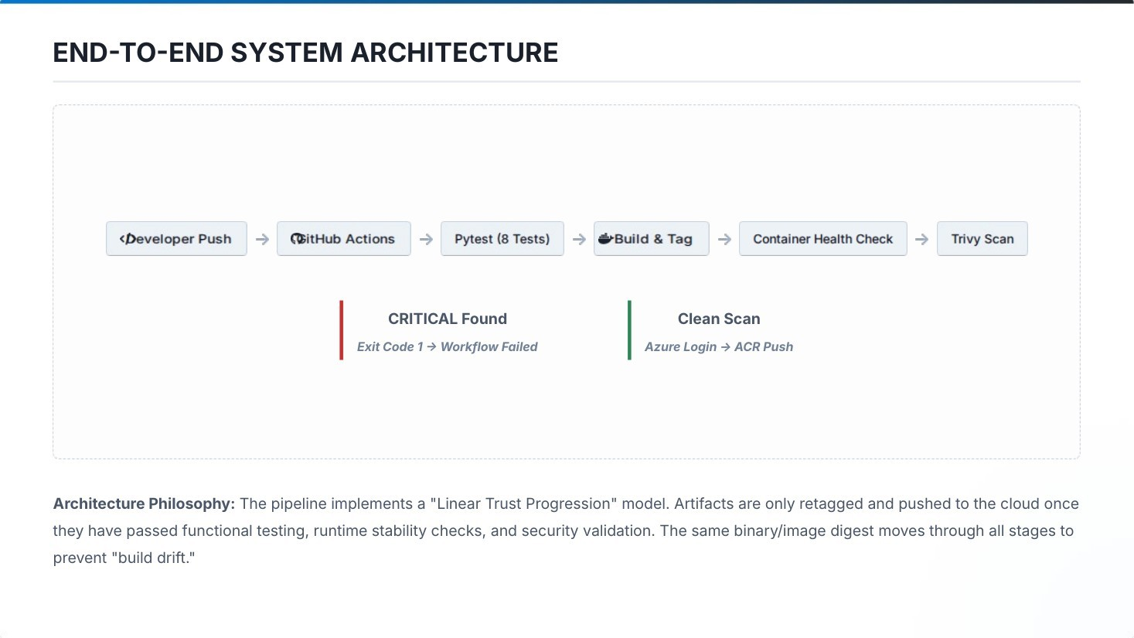
Fig. 1. End-to-end CI architecture showing the linear trust progression from developer push to Azure Container Registry.

Application and Containerization
The core application is a FastAPI URL shortener. The presentation identifies four endpoints used by the application and CI workflow. The /health endpoint is specifically used for runtime validation, while the remaining endpoints provide URL-shortening, redirection, and usage-metric functionality.

Endpoint | Method | Utility
/health | GET | CI runtime validation
/shorten | POST | Generate shortened URL
/{code} | GET | Redirection service
/stats | GET | Usage metrics

The Dockerfile was migrated from the python:3.12-slim base image to python:3.12-alpine to reduce the attack surface and bring the final image to approximately 25 MB. The container configuration exposes port 8000 and starts the FastAPI application through Uvicorn. A .dockerignore file was used so local virtual environments and Git metadata did not unnecessarily enter the build context.
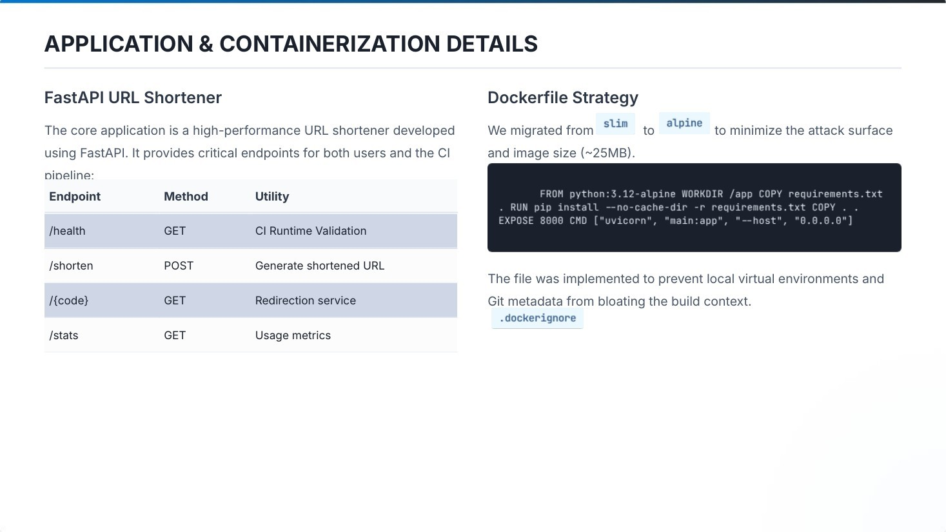
Fig. 2. FastAPI endpoints and Dockerfile strategy presented for the application container.

Team Responsibilities and Technology Stack
The project was completed by a three-member team. The work was divided so that application development, containerization, CI/security, and Azure infrastructure could be developed and verified as connected components.

Team member | Registration number | Primary contribution
Drona Srivastava | 23BAI1314 | CI Pipeline, Container Security & ACR Integration
Kantammeni Pranith | 23BAI1202 | Azure Infrastructure & Container  Registry
Ojaswi Gupta | 23BCE7914 | FastAPI Application & Dockerization

Technology selection

Technology | Role | Selection logic
FastAPI | Backend API framework | High performance, native async support, auto-generated OpenAPI docs.
Docker | Process isolation | Provides environment parity between local development and Azure production.
GitHub Actions | CI/CD orchestrator | Tight source-control integration and  flexible workflow syntax.
Trivy | Vulnerability scanner | Used for fast container security scanning and severity-based gating.
Azure ACR | Private registry | Managed artifact storage with integrated RBAC and authentication.
Microsoft Entra | Identity management | Provides Service Principal identities for  non-human CI workloads.

The interaction pattern places GitHub Actions at the center of the workflow. Repository secrets provide the values required to authenticate with Microsoft Entra ID, while Azure RBAC controls the scope of the CI identity's access to the container registry.

CI Pipeline Implementation
The pipeline uses a fail-fast approach. Early functional failures prevent later and more expensive cloud operations. The workflow stages are executed in the following order:
- Source Checkout: actions/checkout is used to pull the latest commit into the GitHub-hosted runner.
- Pytest Suite: eight automated tests are executed; a test failure stops the workflow.
- Image Synthesis: the Docker image is built and identified using a short Git SHA and CI run number.
- Runtime Probe: the container is launched on the runner and the /health endpoint is polled with five retries.
- Vulnerability Scan: Trivy scans the container and checks for CRITICAL findings.
- Azure Delivery: the workflow authenticates to Azure/ACR and pushes the retagged image.
The security stage is intentionally positioned before Azure delivery. This means the registry is not used as a staging area for known-blocked images; only an artifact that has passed the earlier gates is eligible for publication.

Docker Image Tagging and Traceability
Using only the latest tag was treated as a dangerous anti-pattern because it is mutable and does not uniquely identify an artifact. The project therefore uses two immutable identifiers for the same image digest: a CI run-based tag and a Git commit-based short-SHA tag.

Tag format | Type | Traceability | Best use case
latest | Mutable | Non-existent; points to newest | Local development testing only.
build-8 | Immutable | Maps to CI workflow run | Rollback to a specific CI execution.
sha-0c5b87b | Immutable | Maps to Git commit | Determining exactly which code is deployed.
The engineering advantage is that the image is built once and then tagged twice. Both identifiers refer to the same digest, creating independent search keys while preserving artifact integrity and making it possible to trace an image from the registry back to the CI execution and source commit.

Security Investigation and Remediation
During initial development, the python:3.12-slim image passed all eight Pytests and the runtime health check, but the Trivy security gate reported two CRITICAL findings. The findings originated from the Debian perl-base package. Because the workflow was configured to block CRITICAL vulnerabilities, the pipeline terminated before the vulnerable artifact could be delivered to Azure Container Registry.
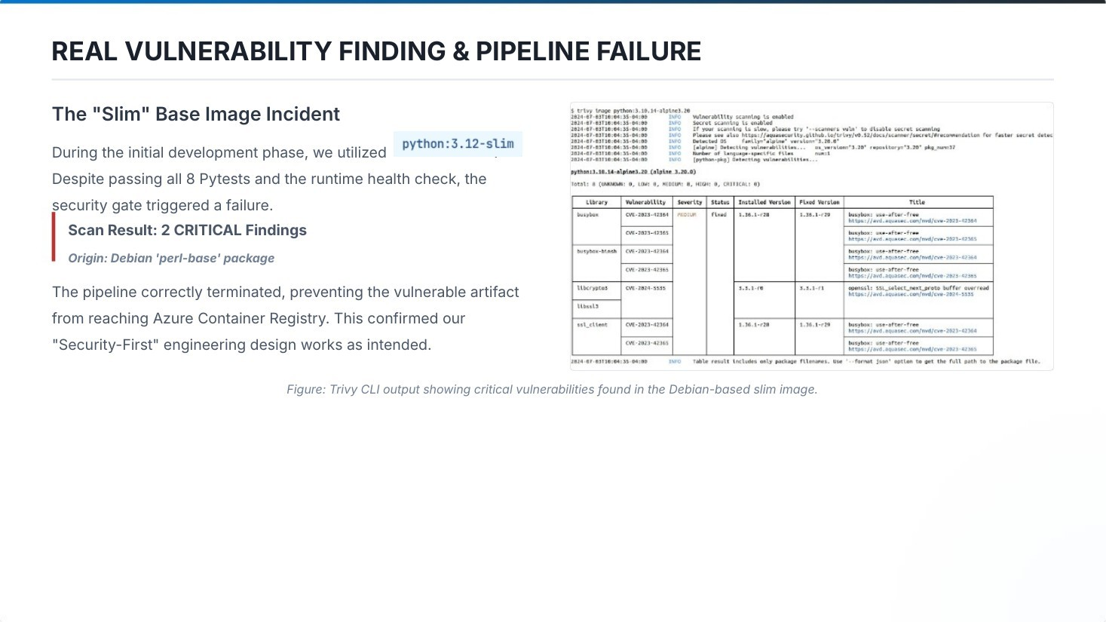
Fig. 3. Trivy output documenting the two CRITICAL findings in the Debian-based slim image.
The incident provided direct validation of the security-first design: functional correctness alone was not sufficient for registry publication. The team investigated the base-image dependency and found that no vendor patch was available for the slim image's current version. The selected remediation was to pivot to python:3.12-alpine, which uses musl libc and a smaller package set.

Security Gate Decision
The team selected automatic blocking rather than a warn-only policy. A warn-only model could allow vulnerable artifacts to enter the registry and would depend on a later manual decision. The selected blocking model enforces remediation before an image becomes a production-ready artifact.

Criteria | Warn-only approach | Blocking approach (selected)
Registry integrity | May contain vulnerable artifacts | Only validated artifacts allowed
Risk management | High; relies on manual review | Low; automated enforcement
Developer action | Often ignored for speed | Mandatory remediation required
Deployment safety | Runtime risk remains high | Minimizes supply-chain risk

The workflow uses exit-code: 1 for CRITICAL severity findings. Lower-risk findings may still be recorded for later review, while show-stopping vulnerabilities cause the workflow to fail and prevent registry publication.
After migration to Alpine, the recorded verification results were: Docker build — Pass; Health check — Pass; Trivy scan — 0 CRITICAL. This completed the remediation cycle without weakening the security gate.

Azure Identity and Container Registry Integration
Azure access was implemented using a dedicated Microsoft Entra Service Principal for automation. Authentication values were stored as encrypted GitHub repository secrets: AZURE_CLIENT_ID, AZURE_CLIENT_SECRET, and AZURE_TENANT_ID. The project
applied least-privilege principles by assigning the CI identity a resource-scoped registry role rather than subscription-wide access.
The ACR metadata recorded in the project is: registry pranithacr2026.azurecr.io, Basic SKU, Central India region, and resource group urlshortener-rg. The identity used for the registry integration is referred to as ArcPush in the project material and is scoped to the pranithacr2026 resource.
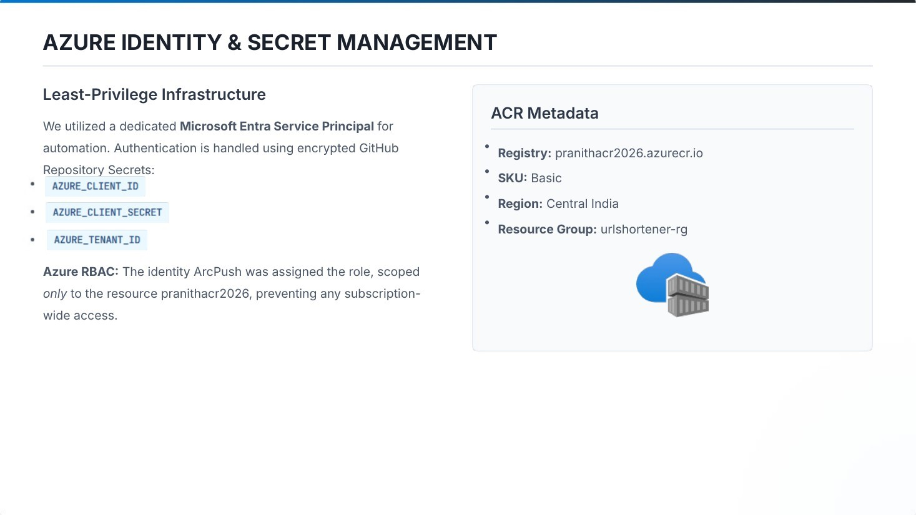
Fig. 4. Azure identity and secret-management configuration, including the resource-scoped Service Principal and ACR metadata.

Technical Challenges and Engineering Resolutions

Challenge | Root cause | Resolution | Engineering lesson
Runner availability | GitHub-hosted runner queues | Accepted minor delays for lower maintenance cost | Operational simplicity vs. latency trade-offs
Base-image vulnerabilities | Vulnerable slim dependencies | Migrated to Alpine-based Python 3.12 | OS choice is as important as application code for security
CLI versioning | Python 3.14 on Arch Linux development environment | Used official Azure CLI Docker image | Containerizing tools resolves dependency conflicts
Entra permission | Resource-group ownership vs. directory privileges | Assigned RBAC through the Object ID directly | IAM and RBAC are distinct planes in Azure

Cost Optimization and Retention Strategy
The project considered storage growth as a consequence of immutable tagging. The presentation notes that a lifecycle policy is necessary for long-term budget management. For the educational scope, the Basic ACR SKU was selected to minimize fixed daily costs.
    - The Alpine image is approximately 25 MB, reducing storage consumption and egress relative to a larger base image.
    - A .dockerignore file reduces unnecessary build-context transfer to the CI runner.
    - Release tags are retained indefinitely.
    - CI build tags are proposed to retain the last 20 successful builds for rollback.
    - Untagged manifests are proposed for deletion every 7 days to remove orphaned artifacts.
    - Development artifacts are proposed for purge after 30 days.
The retention policy is presented as a proposal because the project notes that the Basic SKU does not provide automated retention in the chosen scope. The policy therefore balances traceability and rollback requirements against long-term registry storage.

Workflow Validation and Results
The final workflow evidence shows a complete passing execution. The validation sequence recorded 8/8 Pytests passed, a successful Docker build with layer caching, an HTTP 200 response from the health check, successful Azure identity verification, and successful delivery of the artifacts to ACR.
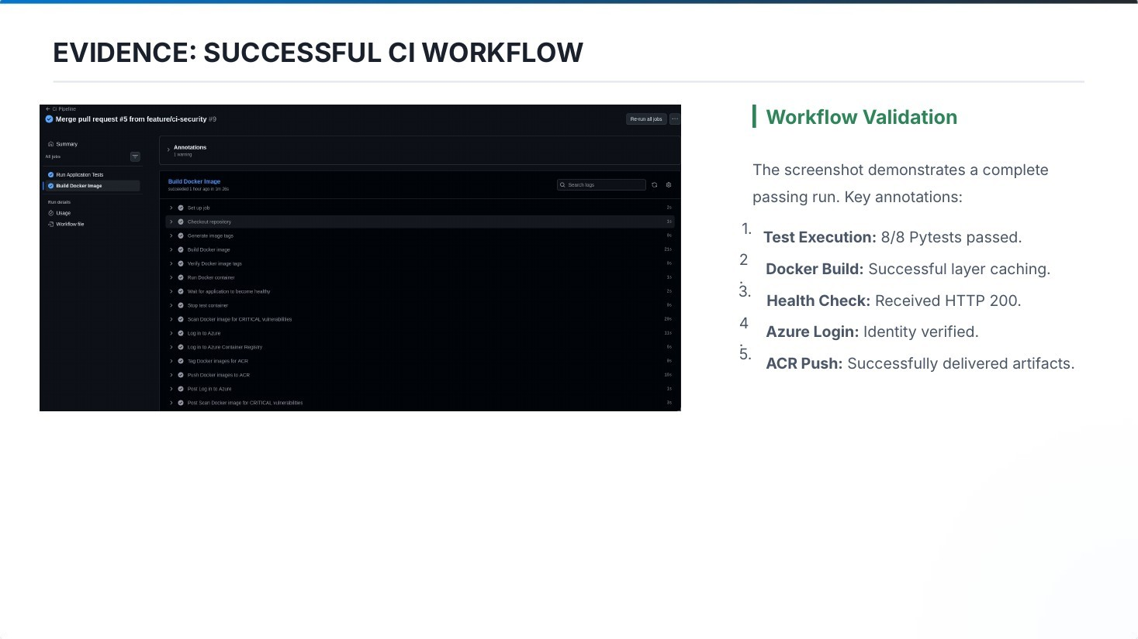
Fig. 5. Successful GitHub Actions workflow showing tests, Docker build, health check, Azure login, and ACR push.
The security evidence complements the successful run. The initial slim-image run was blocked because of two CRITICAL vulnerabilities, while the post-remediation Alpine run achieved a clean security result. This demonstrates that the security gate operated as an enforcement mechanism rather than as a passive reporting step.

CONCLUSION
The project successfully implemented a gated, containerized CI pipeline connecting local development with secure cloud artifact delivery. The workflow combines Docker, GitHub Actions, Pytest, Trivy, Microsoft Entra identity, and Azure Container Registry into a reproducible sequence in which each stage establishes additional trust in the artifact.
The most important engineering outcome was the successful enforcement of the security gate. The pipeline rejected the initial python:3.12-slim image after Trivy reported two CRITICAL findings, even though all eight functional tests and the runtime health check had passed. Migrating to python:3.12-alpine produced a smaller approximately 25 MB image and achieved a clean Trivy result with zero CRITICAL findings.
The project also established artifact traceability through dual immutable tagging, resource-scoped Azure access through a Microsoft Entra Service Principal, and a proposed retention policy for registry maintenance. The final workflow demonstrated 8/8 tests, HTTP 200 health validation, successful Azure login, and successful ACR delivery. The presentation identifies future improvements including automated deployment to Azure Container Apps or AKS, OIDC-based keyless authentication for GitHub Actions, SBOM generation, and image signing with Cosign.

REFERENCES
The following references correspond to the technologies and project material used in the implementation. They are listed alphabetically by organization/product name.
- Aqua Security, Trivy — Container Vulnerability Scanner. Project presentation references the Trivy CLI/action for CRITICAL vulnerability scanning.
- Docker, Docker Documentation. Project implementation uses Docker containerization and a multi-stage Docker build.
- FastAPI, FastAPI Documentation. Project application uses FastAPI for the URL-shortener backend.
- GitHub, GitHub Actions Documentation. Project workflow uses GitHub Actions for push-triggered CI execution.
- Microsoft, Azure Container Registry Documentation. Project uses Azure Container Registry as the managed private container registry.
- Microsoft, Microsoft Entra ID Documentation. Project uses a Service Principal for non-human CI authentication and RBAC-scoped access.
- Ethnus, Microsoft Certified: DevOps Engineer Expert (AZ-400) Course Certificate, May 2026–July 2026, certificate issued July 15, 2026.
- Ethnus Azure DevOps Project — P5, “Containerized CI Pipeline to Azure Container Registry”, project presentation, 2026.

APPENDIX I
Selected implementation evidence from the project presentation is reproduced below for reference. The figures document the architecture, application/containerization strategy, security failure, Azure identity configuration, and successful CI execution.
Appendix Fig. A1. End-to-end system architecture.

Appendix Fig. A2. Initial Trivy security failure for the slim base image.
Appendix Fig. A3. Successful CI workflow validation.

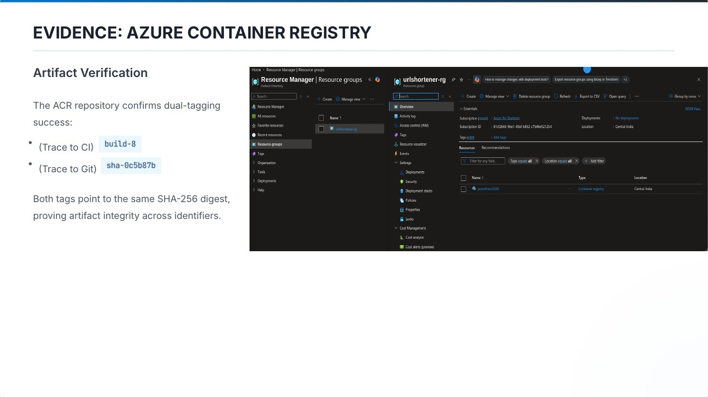
Appendix Fig. A4. Azure Container Registry project evidence and dual-tag traceability.

