**Assembly Process**

Straightforward for most part and can be clearly illustrated in an exploded view (Fig 1).

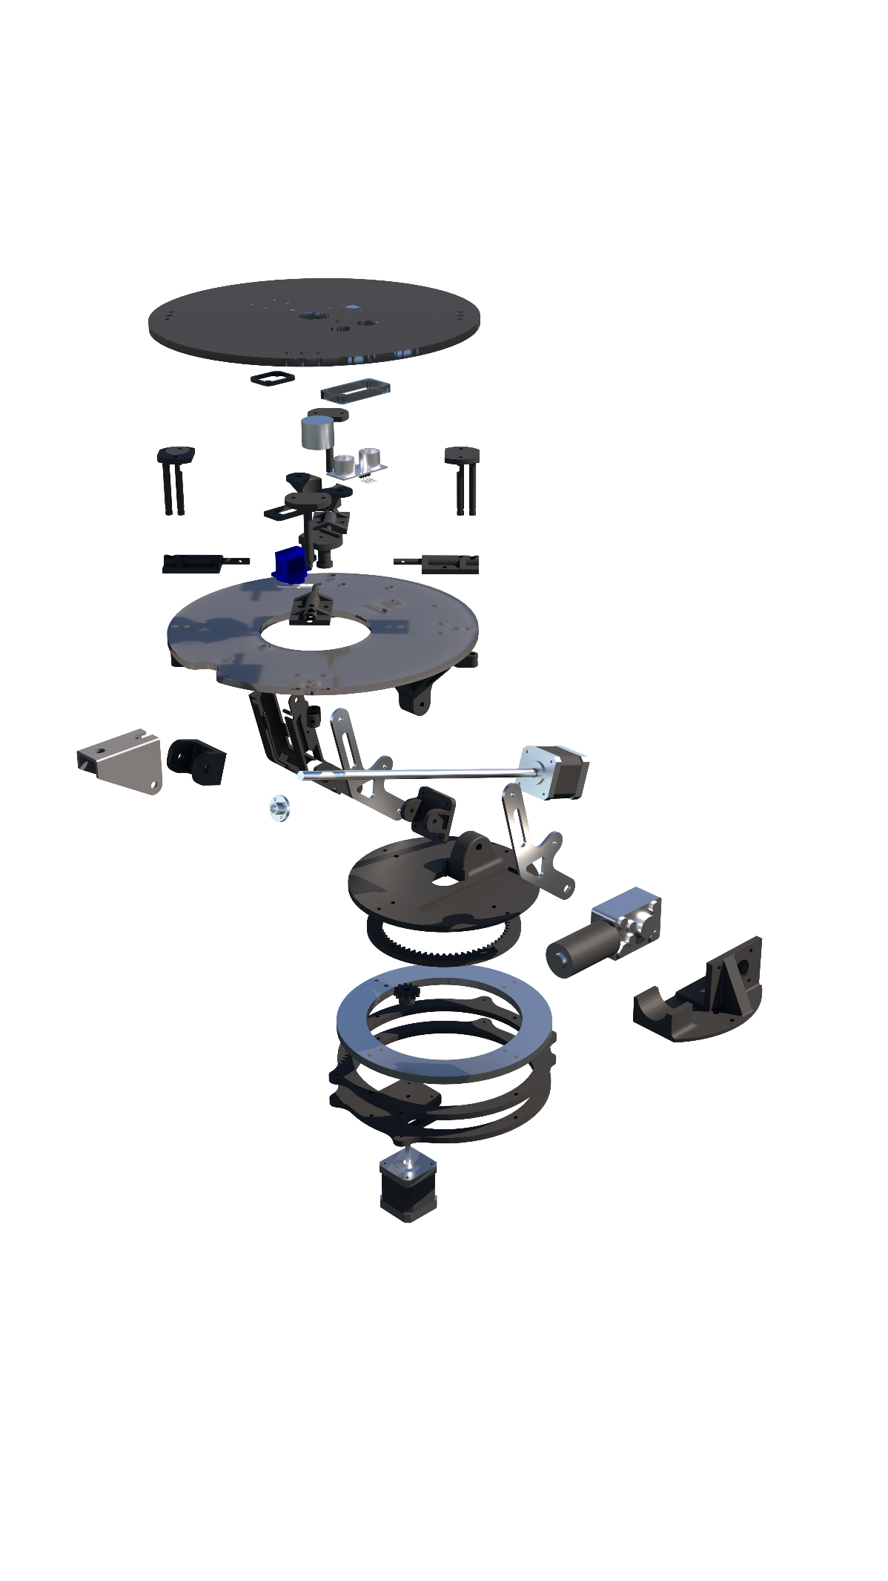

Fig 1: Exploded view.

Attention needs to be given to the assembly of arm where parts need to be assembled in a certain order.

1. Remove the leadscrew nut from the leadscrew threaded rod.
2. Fixing the leadscrew motor mount onto the leadscrew motor.
3. Install the arms onto the motor mount. *
4. Fix the leadscrew nut mount onto the leadscrew nut.
5. Attach the arm to the base with the non-keyhole arm first.
6. Insert and fix the non-keyhole arm with screw and nut through the base pivot. Note there is a different diameter along the length of the hole to accommodate the DC motor shaft (Fig 2). *
7. Fix the arm with keyhole by sliding the DC motor fixed to its mount into position.
8. Fix the leadscrew nut mount onto the bracket before screwing it onto the leadscrew threaded rod.
9. Fix the arm onto the top platform pivot. *

* There are metal spacers installed at each pivot to avoid the screw threads to dig into the parts and cause damage. These metal spacers can be obtained from electronics lab or design studio and is cut to certain length to fit.

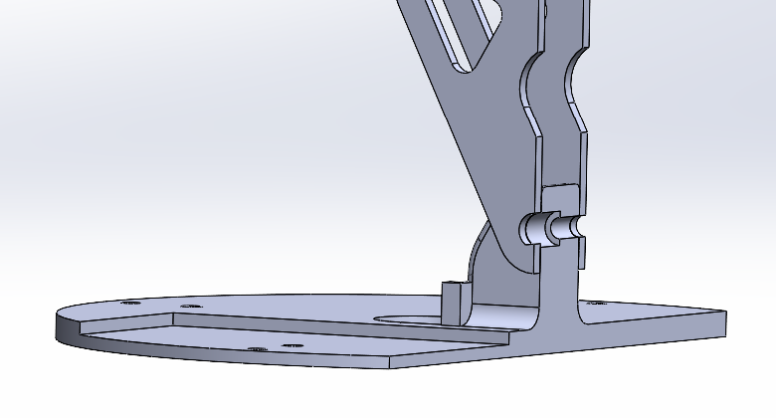

Fig 2: Installation of arm at the base. Red arrow indicating insertion of screw to fix the non-keyhole arm.

**Special attention:**

* Attention is required on the length of fasteners especially at the base where a long fastener/screw will hit the bottom stepper motor and hinder the base rotation.
* Hold and release mechanism is only activated on two of the four corners due to insufficient strength of the servo motor to pull all four at once.
* The orientation of the piston in the hold and release mechanism will affect its performance due to its geometry (Fig 3).
* The string attaching the piston to servo motor requires tuning to work smoothly.
* A smallest-sized allen key (≈ 0.7 mm) is required to install the spur gear on the bottom stepper motor.
* Waterjet cut component (i.e., arm) is fabricated via Waterjet ‘Drop-in’ Service from EDMC. Job request can be sent to [waterjet@soton.ac.uk](mailto:waterjet@soton.ac.uk) with an attached .sat and .dxf files, materials, thickness and quantities required, sub-project code and GDP group number.
* Extra care should be given to the camera cable which is fragile.
* The mounting points on the dock fixed base can be modified to fit different surfaces.

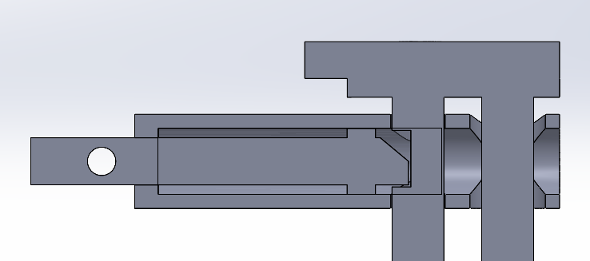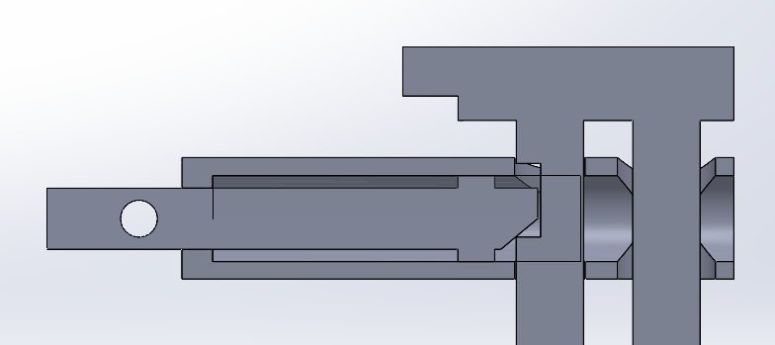

Fig 3: (Left) activated piston and can hold in the compressed position; (right) inactivated and is unable to hold in the compressed position.