**TX16S Remote Control Set Up (different models will have different steps)**

Select blank model, with only default 4 channels shown above.

Edit Channel 2 to invert the direction shown above.

To show all outputs as above, go to Main View – Layout – Full screen – Select Widget – Output.

**Connect receiver (X8R) to the remote control.**

Power the receiver by connecting it to the flight controller SBUS to RC in. (it should have a red blinking light)

If facing issues with initial connection, try changing input of receiver from SBUS to channel 3. Once connection is made, move input back to SBUS.

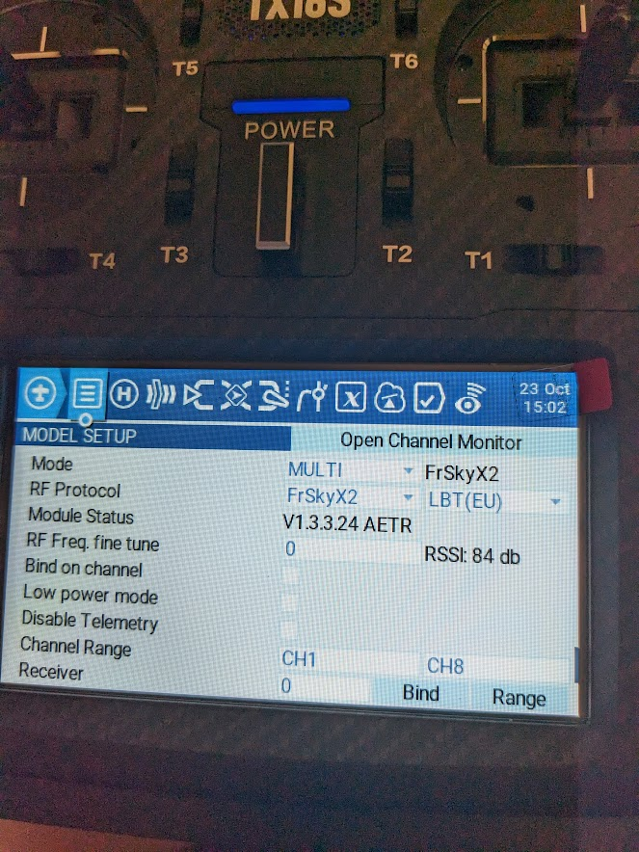

Check that throttle is down, and configuration on remote control is as above.

Unplug power, hold down the button on receiver with a pin, and plug the power back in. (Red and green solid light)

Press on the [BIND] button and beeping sound will begin while connecting. Once red-light flashes, connection is complete.

Reboot receiver (unplug and plug power), lights should be solid green indicating fully connected.

**Mission Planner Drone Configuration**

Download Mission Planner from Ardupilot website:

[https://ardupilot.org/planner/docs/mission-planner-installation.html](https://ardupilot.org/planner/docs/mission-planner-installation.html%20)

Connect Cube Pilot to computer with USB cable.

**Setup Parameters**

Install Firmware shown above, need to be connected into USB port but disconnected on the Mission Planner.

Once Firmware is finished uploading, connect to the Mission Planner on the top right by selecting the option with MAVLINK. Successful connection will look like the image above. Now we have to complete setups for all mandatory hardware steps.

1. **Frame Type**

Choose frame type, X quadcopter shown above or select frame of drone appropriately.

1. **Initial Tune Parameter**

Battery parameters, adjust based on battery used, for the 5000 mAh, 4s battery, set as values above.

**3. Accel Calibration**

Accelerometer can be calibrated by following each step as indicated by the instructions given in Mission Planner, once complete the above will be shown.

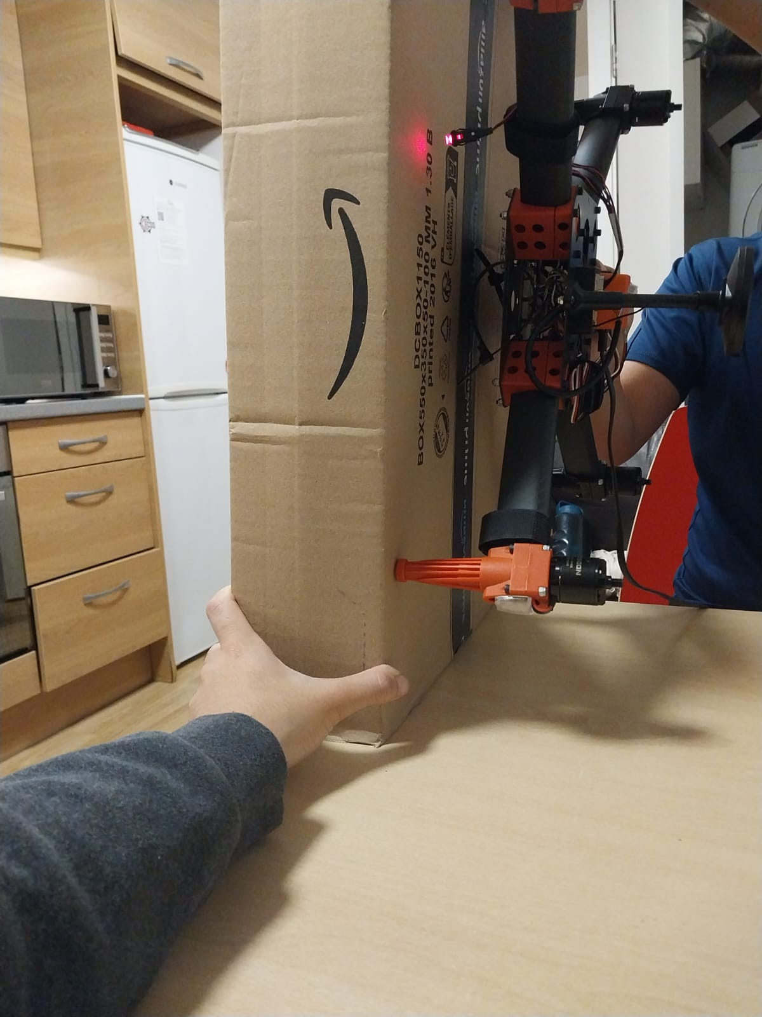

It is advised to use a box or rectangular object to ensure the drone is turned to the correct orientation with minimal errors as shown above.

Note: Error faced when running calibration, solved with multiple iteration with unclear solution. Other laptop was attempted with no success as well. Could attempt with a higher quality USB cable. Main suspect of error would be the software, Ardupilot, but no investigation was conducted.

**4. Compass**

Connect the 4 pin CAN cable connector to CAN1 or CAN2 port on the flight controller. Connection of both ports is still unsupported.

Power the flight controller and connect it to Mission Planner. Go to "Config/Tuning > Full Parameter List" and modify the following parameters:

**CAN_D1_PROTOCOL: 1** set virtual driver of CAN1 to DRONECAN

**CAN_D2_PROTOCOL: 1** set virtual driver of CAN 2 to DRONECAN

**CAN_P1_DRIVER: 1** set this parameter to enable CAN 1 bus

**CAN_P2_DRIVER: 1** set this parameter to enable CAN 2 bus

**GPS_TYPE: 9** set the communication protal type of GPS 1 to DRONECAN

**NTF_LED_TYPES: 231** Set to DRONECAN for LED type

There is no external safety switch. Set BRD_SAFETYENABLE as 0 to disable safety switch, or connect an physical external safety switch

Click "Write Params" when done. CAN functions will be available after rebooting the flight controller.

Move compass priority to the first option as shown above and ensure compass 1 is the only active option. Conduct GPS calibration by pressing start then move and turn the drone on all its axis until the green bar is filled. Reboot is required once completed.

**5. Radio Calibration**

Press button to begin calibration, move each stick to its maximum position until the above is achieved. If additional buttons are added, flip them all on and off for calibration as well.

**6. Servo Output**

Servo output calibration, check there is 4 and others are disabled, adjust min, trim and max accordingly.

**7. ESC Calibration**

**General calibration of ESC**

When doing esc calibration for all 4 motors, press the initiate button, unplug the battery and USB, put remote control in high throttle, then plug in battery of drone, press the safety button, hear 2 beeps, then push the throttle down, hear a long beep, it is done.

If general calibration is not successful, could attempt to calibrate each motor individually with method below:

**Individual Calibration of ESC**

Plug motor 1 into channel 3 of the X8R receiver.

Begin calibration on Mission Planner as the usual method.

Unplug power to drone, put the remote control to high throttle, plug power back into drone, press safety button, will hear 2 beeps, push throttle back down, then will hear long beep indicating that it is done.

Plug motor 1 back into the flight controller.

Repeat the above steps with each motor, until all 4 are completed.

**All calibration is completed and ready to fly.**

Connect battery to the drone to power up, drone will start beeping and safety will flash.

Push safety button until it stops flashing and is a solid red, beeping will stop.

Push throttle down and right to arm. Ready to fly.

Once flight is complete, disarm by pushing the throttle down and left to disarm.

Could connect to laptop with Ardupilot to check if drone can be armed, and if any error messages appear.