Apophenia Total Capture User Guide
What the app records, how authorization works, what stays local, and how to export for people and machines
Apophenia is a personal Android and Garmin black box for reconstructing the circumstances around a timestamped event. The operator logs the moment; the software freezes only the context that was deliberately authorized.
The privacy bargain. It can be maximum invasive when everything is authorized and armed. That is the capability ceiling, not the default. There is no account, analytics SDK, automatic cloud sync, or background uploader. Data stays local until an export is built, verified, previewed, and deliberately routed.
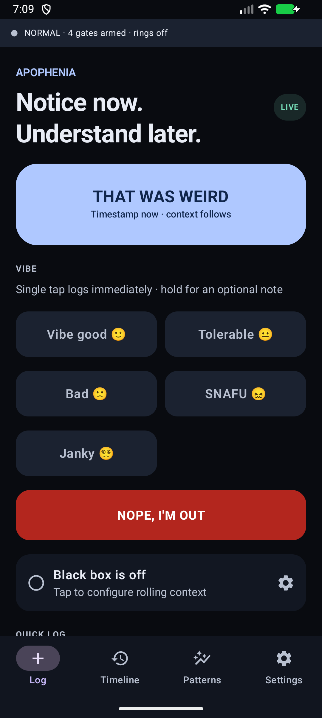
Current debug application on an Android emulator. The event timestamp is saved before context enrichment.

What the app is
The instrument is designed to answer a bounded question: what phone, environmental, radio, physiological, vehicle, aircraft, and audiovisual circumstances were present around the observation? It stores observations as descriptions and keeps hypotheses and evaluations separate.
Four controls must not be conflated:
- The named Apophenia gate authorizes a capability.
- Android permission or MediaProjection consent is granted separately where required.
- A drive, flight, control-link, RF, microphone, camera, or screen session is started explicitly where the channel has a live state.
- An export remains local through preparation and manifest preview; only an explicit route crosses the app boundary.
Evidence boundary. Gate presence or simulator success does not prove that hardware exists, that Android exposes the channel, that a recording is live, or that a physical result has been validated.

Capture a moment
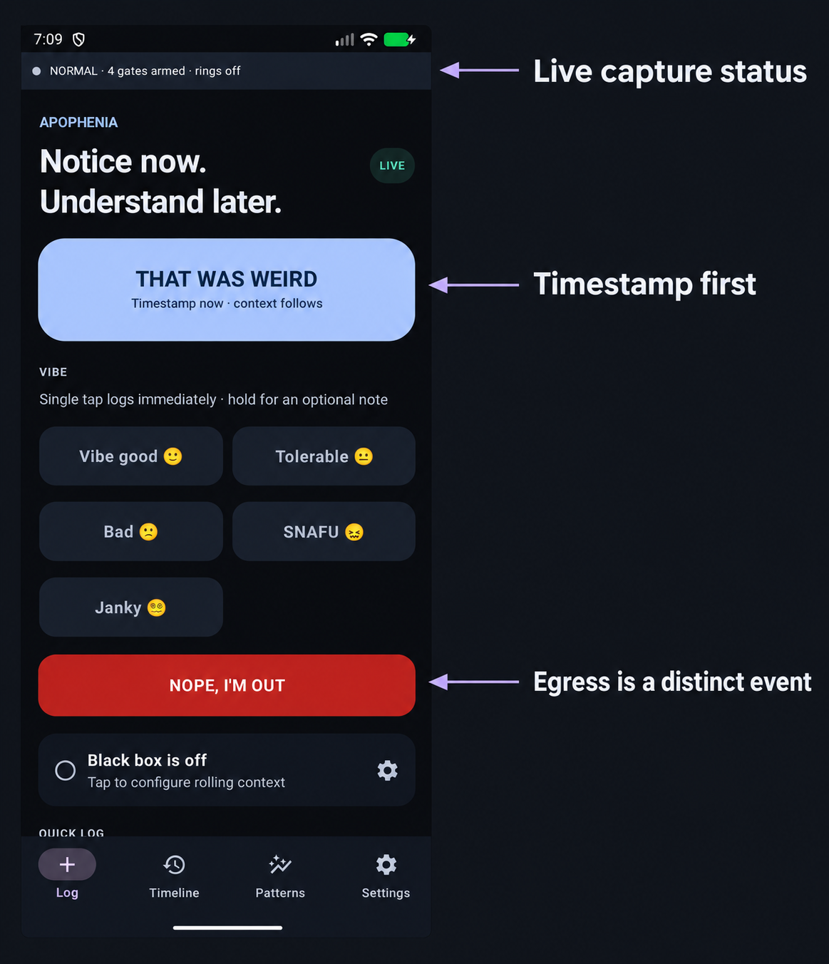
The source UI is an emulator capture; arrows and labels are documentation overlays.
- THAT WAS WEIRD saves the tap time first and enriches it with authorized context afterward.
- VIBE records a one-tap ordinal state from 1 through 5; holding opens an optional note without moving the event time.
- NOPE, I'M OUT records VIBE 5 with egress=true, preserving the difference between leaving and staying.
- The status strip distinguishes authorized gate count from AV rings that are actually live.

Choose how invasive the session should be
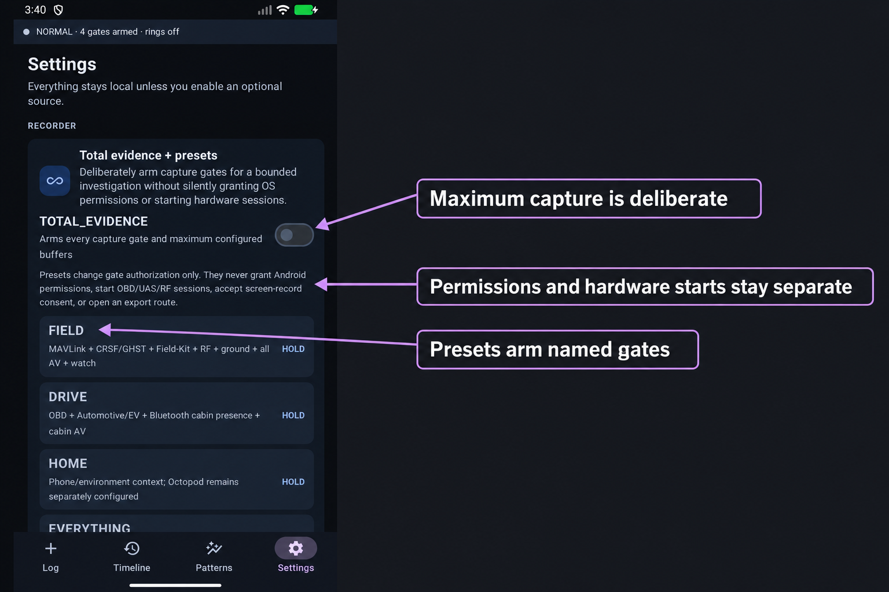
TOTAL_EVIDENCE and presets change named gate authorization. Permissions and hardware starts remain separate.
Control | Does | Does not
Named gate | Authorizes one channel | Bypass Android or invent hardware
TOTAL_EVIDENCE | Arms all capture gates and maximum configured buffers | Start OBD UAS RF or screen capture or enable LAN export
FIELD | Arms flight link detector RF ground AV and watch gates | Claim aircraft radio SDR camera or watch validation
DRIVE | Arms vehicle cabin presence and AV gates | Connect an adapter or start a drive session
EVERYTHING | Arms every capture gate | Send any data or silently grant permissions

What it can capture
Every channel is visible even when unavailable. Omniprobe records the stored value or a gap reason: gate off, permission denied, platform restricted, hardware absent, or statute.
Domain | Examples | Activation boundary
Phone and environment | Sensors battery thermal display network Wi-Fi Bluetooth time weather space weather | Named gates plus platform permissions where required
Protected contents | Notifications calendar contacts message metadata | Tier 2 exact-name authorization and Android access
Physiology | Health Connect and Garmin context | Read permission or paired-phone delivery
Vehicle | OBD-II Automotive EV and cabin Bluetooth | Gate paired adapter and operator-started DRIVE_SESSION
Aircraft and field | MAVLink CRSF GHST Field-Kit TAK ground context and SDR | Gate owned hardware or selected transport and bounded session/window
Audio and video | Microphone main front concurrent cameras and screen | Tier 2 gate permission or per-arm consent and persistent live indicator

Local retention
Ordinary records and derived metrics live in SQLite. Tier 2 contents and raw AV are encrypted with device-local keys. Raw AV expires after the configured deadline, 14 days by default, unless that event is marked keep forever.
- Scrub and expiry delete media ciphertext, its sidecar, and its event key.
- Non-reconstructive loudness, spectral, motion, brightness, flicker, and scene-change metrics survive.
- A purge ledger records what was deleted and why.
- Raw BSSIDs, MAC addresses, adapter addresses, and airframe IDs are not durable fields; locally keyed hashes are stored instead.

Export for people and machines
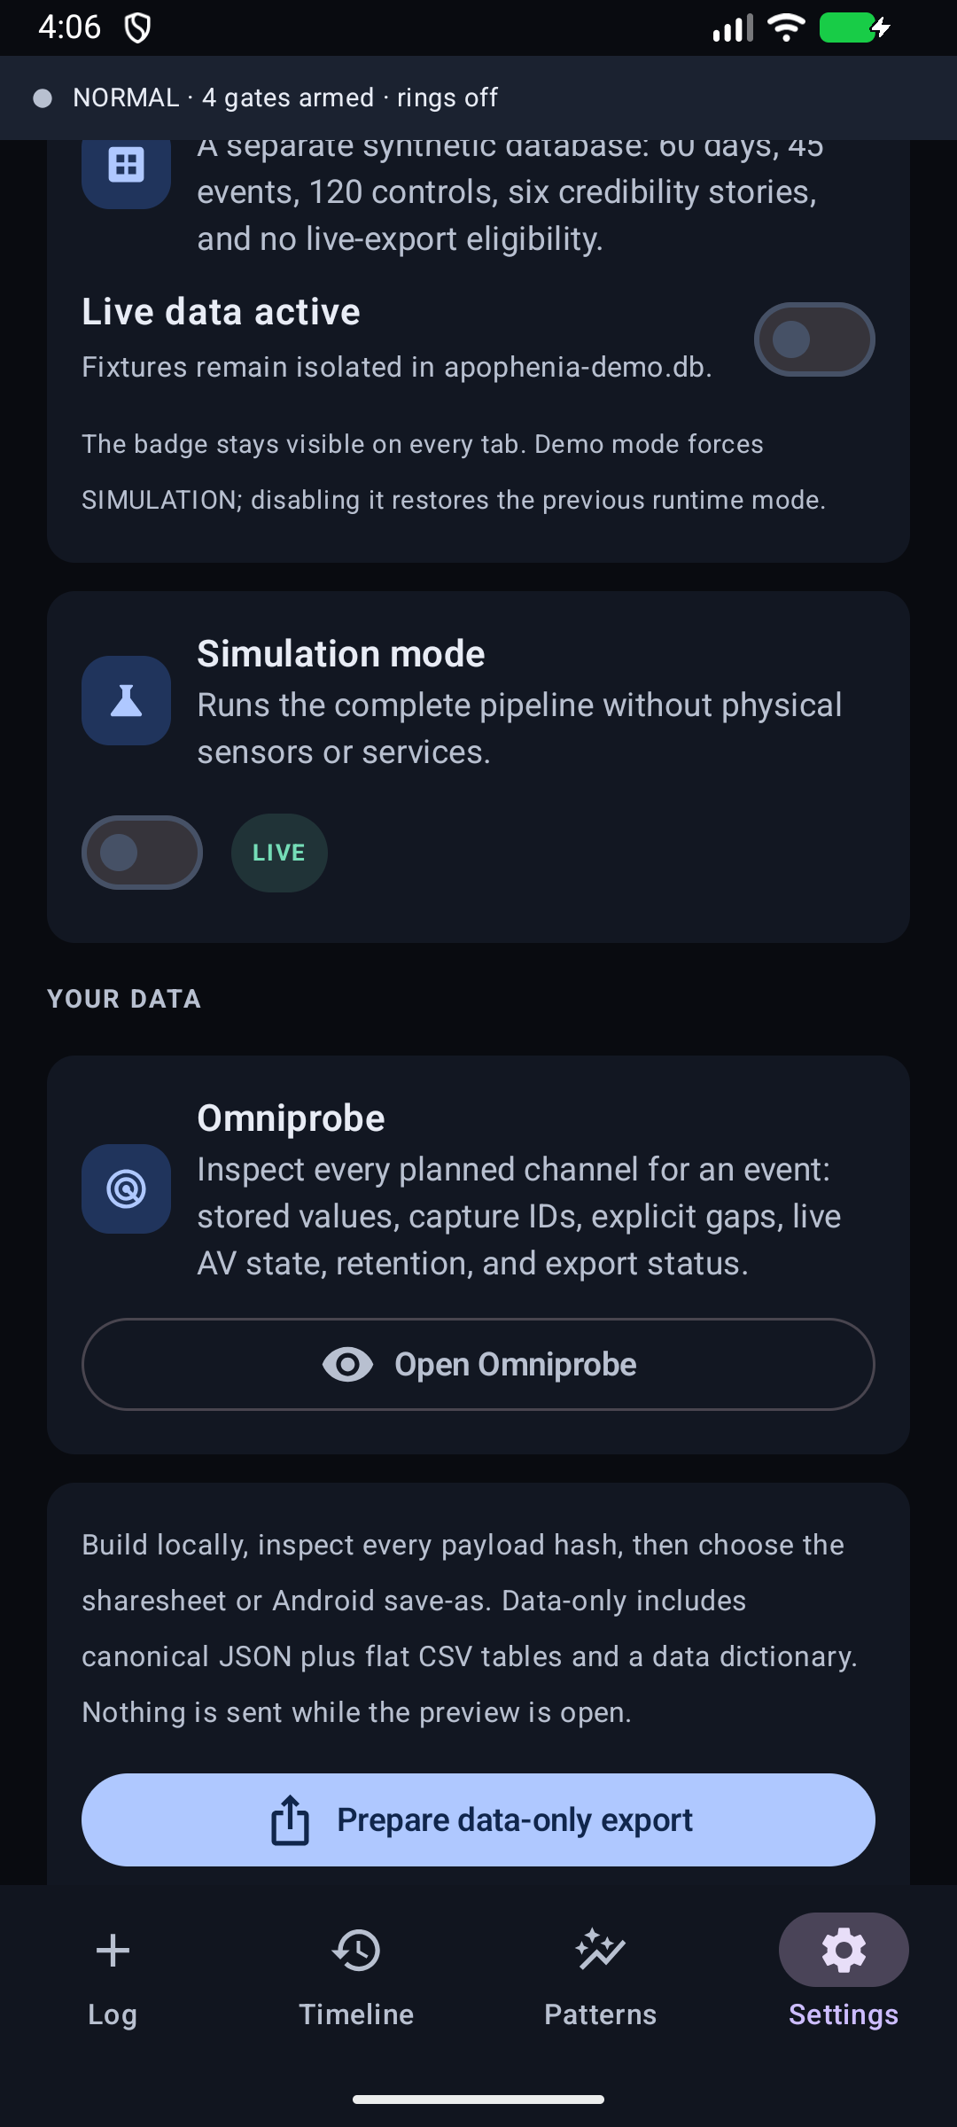
All export routes prepare locally and show a verified manifest before a destination can be selected.

Choose an export format
Export | Human-readable | Machine-readable
Data-only | Analysis README and CSV tables | Canonical JSON CSV and JSON data dictionary
Raw SQLite | Schema documentation | Checkpointed integrity-checked database
Event dossier | Plain summary and SVG chart | Event JSON context CSV inventories and retained evidence
Selected report | Self-contained HTML and PDF | Report JSON context CSV and SVG
Full evidence | Analysis README and inventories | JSON CSV AV Tier 2 attachments RF and hashes

Manifest preview and release
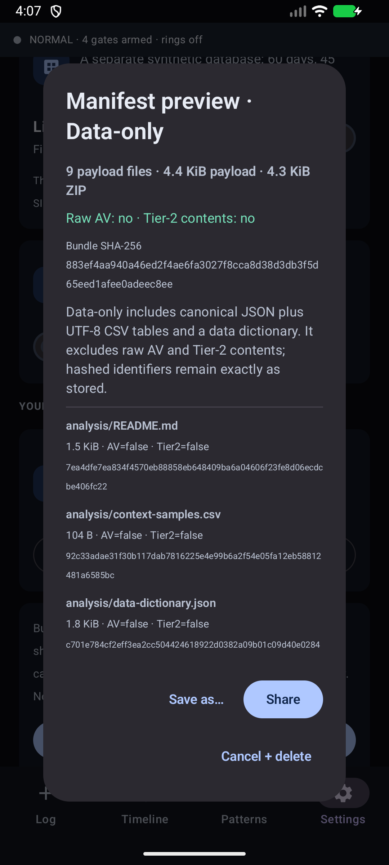
The preview lists payload count and bytes, AV and Tier 2 flags, the bundle digest, and every declared file digest.
The default data-only tier excludes raw AV, Tier 2 plaintext, RF IQ, and inbound attachment bytes. Full evidence materializes device-bound evidence into portable plaintext and requires two confirmations.
Honest route receipts. Sharesheet handoff, completed SAF writes, and LAN endpoint acknowledgement are different audit outcomes. None proves recipient reading, durable retention, or exactly-once delivery.

Analysis boundaries
- Group dense rows by capture_id before comparison; rows in one capture are not independent observations.
- Exclude phase POST from predictors while retaining it for reconstruction.
- Keep is_control and CONTROL phase rows identifiable.
- Preserve the tested-channel count and multiple-comparisons correction.
- Do not convert association into causation diagnosis or explanation.
- Treat a refuted preregistered pattern as the instrument working.
Validation boundary. Software tests and emulator screenshots do not establish phone hardware, multicamera, microphone, radio, adapter, vehicle, aircraft, SDR, watch, field, or flight performance. Use the dated physical-validation checklist in PROJECT_HANDOFF.md.

