

FINAL PROJECT FOR WEB TECHNOLOGIES:

The Weeknd

**Teacher:** Dana Yespenbetova

**Student:** Olzhas Toishybek

**Group:** SE-2014

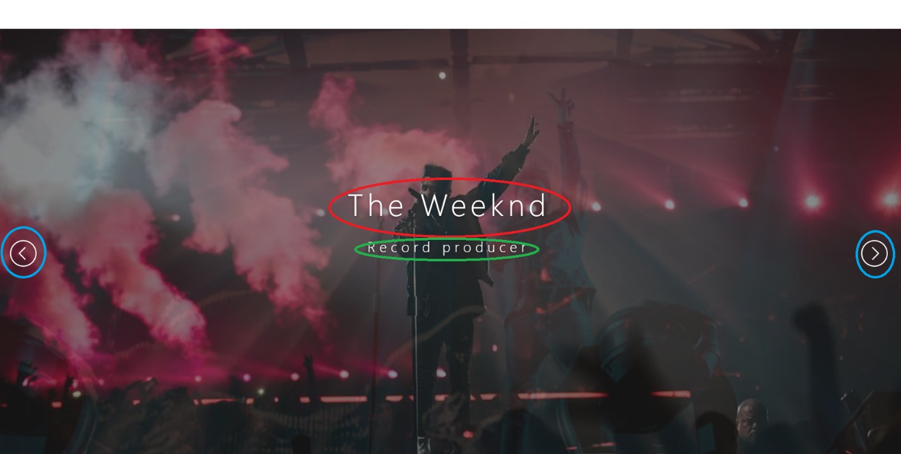

Name of the singer

Text that appears with the animation

Arrows that are responsible for the transition between the rear-view backgrounds



This is the navigation bar. It's pinned. This means that you can use it anywhere on the page. By clicking on these buttons you can go to different parts of the site

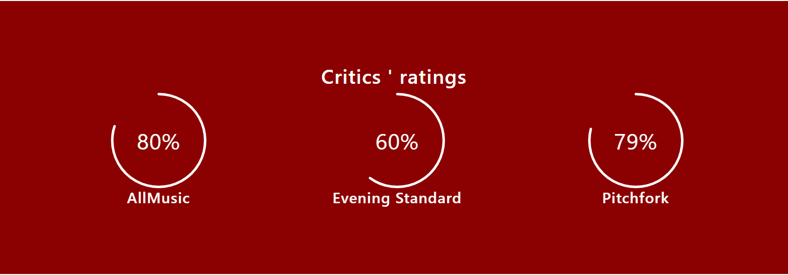

Some information about the singer. These circles with percentages come out with animation.



Clicking on the "Official website" button takes you to the original page.

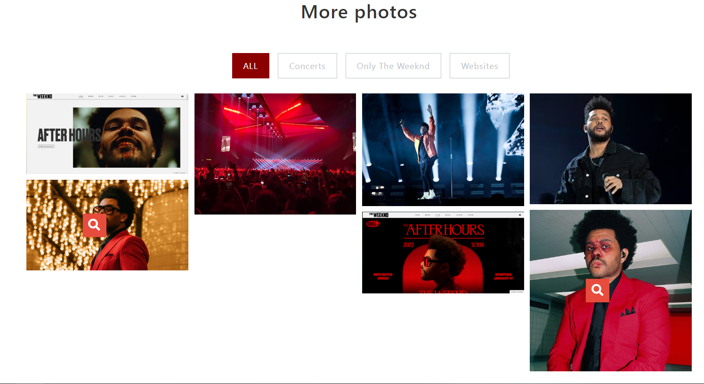

Here, each photo is divided into departments. By clicking on the magnifying glass, you can take a closer look at the photo. Each photo has an animation

Conclusion

This site is purely informational in nature. When creating the site, we used: html, css, javascript, jquery, bootstrap. For the average viewer, there is nothing special here, but for the programmer, this was a very labor-intensive job. I hope you enjoyed it.

References

https://en.wikipedia.org/wiki/The_Weeknd

<https://www.w3schools.com>

<https://moodle.astanait.edu.kz/course/view.php>

[www.youtube.com](http://www.youtube.com)