# Login

**Site:** https://skylinespark.sharepoint.com/sites/oneida-1

**Username:** oneida@skylinespark.onmicrosoft.com

**Password:** SpfxDev.123

# Agenda

## Day 1

* Introductions + Validate Installs
* Landscape
* Intro to SPFx React Developer
* Core Tools
* Talking to SharePoint
* Customization Scenarios

## Day 2

* Intro to SPFx
* Hello World!
* Deployment Options
* Workshop: Anniversaries
* (Optional) Solutioning
* Closeout

# Workshop: Anniversaries

## User Story

As a visitor to my intranet, I would like to see a list of current work Anniversaries for active associates at my company.

## Web Part Display

* Display employee name, number of years of service, anniversary date and department
* Display upcoming 2 weeks of anniversaries
* Sort by upcoming anniversaries first
* (Extra Credit) Employee name links to the Delve profile page

## Web Part Configuration

* (Nice to Have) Ability to configure the max items to display

## Data Management

* list driven employees
* Home page editors allowed to contribute, everyone else read

## Out of Scope

* Will not display the employee's profile photo

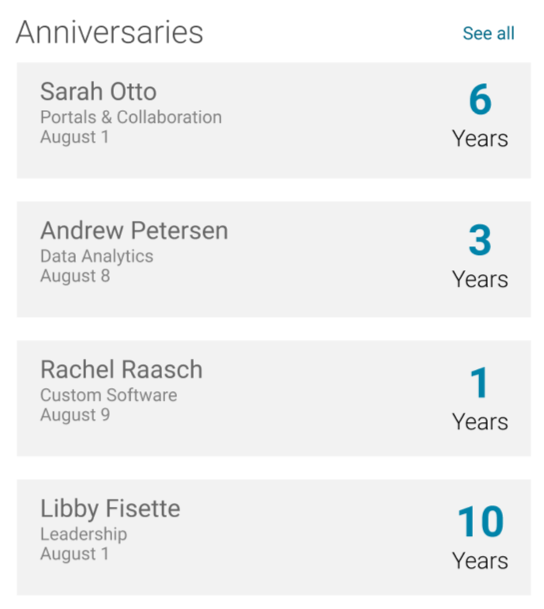

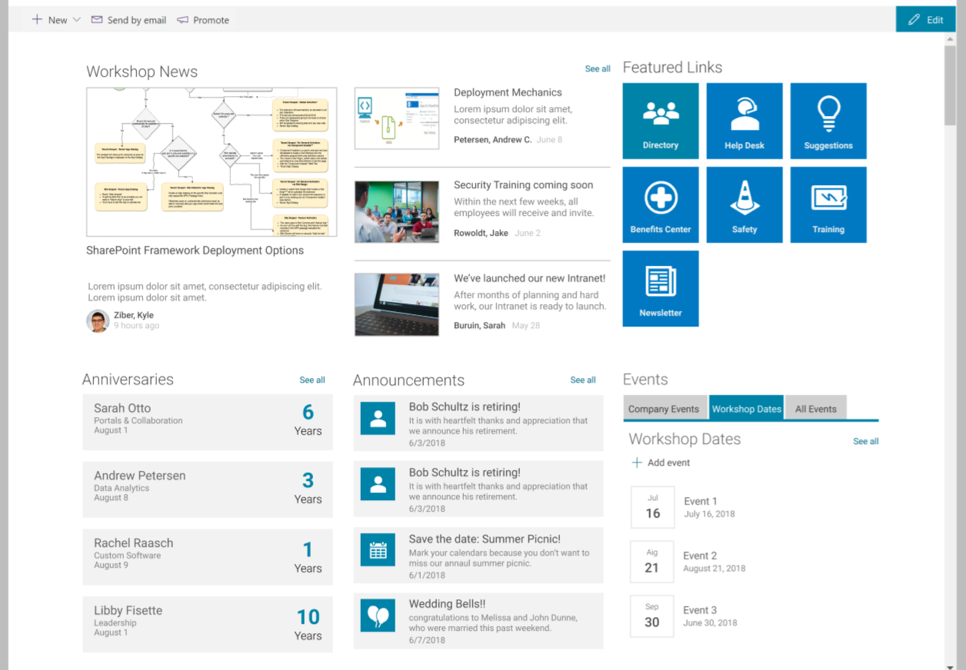

# Exercise: Component Design

