Hephaestus’s origin story has a few different versions depending on which source you choose, but most of them agree that he was the son of Hera and that his early life was not ideal. One of the most common accounts says that Hera gave birth to Hephaestus on her own without Zeus. According to Hesiod, Hera did this out of anger after Zeus had produced Athena without her “But Hera without union with Zeus - for she was very angry and quarrelled with her mate”, this quarrell betweem them caused Hera to have a child on her own as well, and that child was Hephaestus, who would eventually become the most skilled craftsman among the gods (Hesiod, Theogony 924). Some writers repeat this idea and say that Hephaestus was born from Hera solely without a father “From Juno without father, Vulcan.” (Hyginus, Fabulae p.19), although other traditions contest and claim that Zeus and Hera were both his parents ”but according to Homer he was one of her children by Zeus.” (Apollodorus, Library (Apollod.) 1.3.5).
The myths also describe Hephaestus as physically imperfect from birth. In Homer’s Odyssey, Hephaestus himself says “because he's handsome and sound-footed but I myself was born infirm.” (Homer, Odyssey 8.310), which helps explain why other gods often looked down on him despite his skill. In some versions of the story, Hera was ashamed of him, because of this she threw him down from Mount Olympus shortly after his birth (Homer, Iliad 18. 395). According to the Homeric Hymn 3, Hera cast him out of heaven because she considered him weak and embarrassing among the gods “my son Hephaestus whom I bare was weakly among all the blessed gods and shrivelled of foot, a shame and disgrace to me in heaven”(Homeric Hymn to Apollo 311). After he was thrown from Olympus, he fell into the sea where the sea goddesses Thetis and Eurynome rescued him and secretly raised him. While living with them, Hephaestus began learning metalworking and crafting skills “for nine years' space I forged much cunning handiwork”, creating many intricate objects and tools during the nine years he spent hidden away from the other gods (Homer, Iliad 18.400).

Another myth that reveals a different side of Hephaestus’s personality, beyond his craftmanship is his resentment and anger toward his mother(Hera) and the gods, after he had been rejected and thrown down from Olympus. Rather than fighting against the gods as whole, Hephaestus used the one thing he excelled at, his craftsmanship. According to Hyginus, Hephaestus created golden sandals for Zeus and the other gods and made a speacial pare for his mother, a pair made from admant. These adamant sandals were meant to trap his mother when she sat down. When Hera did take a seat, it immediately bound her and left her helpless “When Vulcan had made [golden sandals] for Jove and for the other gods, he made one of adamant[for Juno?] and as soon as she sat down she suddenly found herself hanging in the air” (Hyginus, Fabulae 166). This demonstrates how Hephaestus is consumed by his rage, anger and humiliation and he lets his feelings get the better of him, so much so that he even builds a dedicated machine for entraping his own mother.
The myth also shows how deeply the earlier rejection had affected him. When the other gods summoned him back to Olympus to free Hera, Hephaestus initially refused and even denied their relationship entirely “he denied that he had a mother.”, showing the bitterness he still carries. Eventually Dionysus (Father Liber) brought him back to the assembly of the gods while he was drunk, and he agreed to release her. In return, Zeus allowed him whatever he wished. After being encouraged by Poseidon, Hephaestus requested the hand of Athena(Minerva) in marriage. However, Athena rejected him and defended herself when he attempted to rape her. Hyginus describes that during the struggle “some of his seed fell to earth, and from it a boy was born” (Hyginus, Fabulae 166).
This story highlights several important aspects of Hephaestus’s character. His actions toward his mother(Hera) which reveal the depth of his resentment and his willingness to use his remarkable skills for evil and spite when he feels wronged. At the same time, the later incident when he is drunk when returning to the gods to free Hera and with Athena what he attacks her, these all seem to show him to act impulsively and aggressively. Unlike many of the Olympian gods who appear more secure in their origins, Hephaestus’s defining trait remains his creative ability aswell as the impact of his origin story. Even when acting out of anger or desire, he relies on craftsmanship and invention for his power, reinforcing his role as the divine builder whose creations can both help and hinder others.

K7.1 THE RETURN OF HEPHAESTUS, ca 430 - 420 B.C.
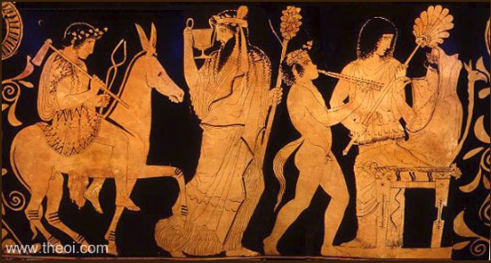
https://www.theoi.com/Gallery/K7.1.html

K7.2 THE RETURN OF HEPHAESTUS, ca 500 B.C.
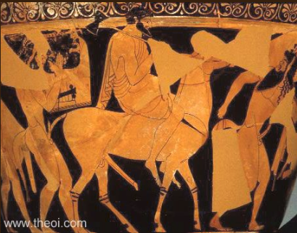

https://www.theoi.com/Gallery/K7.2.html

Image Analysis (K7.2 The Return of Hephaestus):
In the second image (ca. 500 B.C.), Hephaestus rides a donkey and holds a axe showing his multi dimensional capabilities, wielding a weapon equally capable of building as it is destroying. The image is heavily worn and less detailed, the other figures are harder to identify however they all seem to depict exagerated features.
In the first image (ca. 430-420 B.C.), more detail is visible. Hephaestus holds tongs and an axe and wears a detailed robe showing much the same as the first image but he does seems to have much nicer robes with some kind detailed pattern, he also has flowers or a wreath of some kind on his head showing his status and his great rise from being thrown from olympus (Homeric Hymn to Apollo 311, Hyginus, Fabulae 166). Dionysus is present and leading Hephaestus with a drinking cup and pincone staff, this could be the cup that Hephaestus becomes drunk off of (Hyginus, Fabulae 166). Hera appears seated or trapped almost certainly due too Hephaestus adamant sandals (Hyginus, Fabulae 166).
Both images show Hephaestus being brought back to Olympus to free Hera, providing a real image to the myth. His tools in both images emphasize that his power over the gods comes through his craftsmanship, not sheer strength, the tools also show his absolute dedication to his craft.

Ancient Sources
- Hesiod, Theogony 924
  - https://topostext.org/work/4
- Homer, Odyssey 8.310
  - https://topostext.org/work/3
- Homer, Iliad 18.395, 18.400
  - https://topostext.org/work/2
- Homeric Hymn to Apollo 311
  - https://topostext.org/work/356
- Apollodorus, Library (Apollod.) 1.3.5
  - https://topostext.org/work/150
- Hyginus, Fabulae p.19
  - https://topostext.org/work/206
- Hyginus, Fabulae 166
  - https://topostext.org/work/206

Modern Source
- Theoi Greek Mythology — “Hephaestus (Hephaistos)”
https://www.theoi.com/Olympios/Hephaistos.html
- Aikaterini Laskaridi Foundation
https://topostext.org/

