

Software Engineering Department
Braude College of Engineering

Real time fruit grading using data mining and machine learning
Project code: 25-2-D-6

Capstone Project Phase A – 61998 Jul 2025

Lidor Anfinger
Dror Hershcovish

Git repository link: https://github.com/Drorh473/fruit_grading.git

Supervisor: Mr. Ilya Zeldner

Table of Contents

Abstract 5
Key words 5
1 Introduction 5
2 Background and Related Work 6
2.1 Fruit Grading in Agriculture 6
2.2 Computer Vision for Fruit Quality Assessment 7
2.2.1 Deep Learning for Fruit Quality Assessment 7
2.2.2 Cross-View Identification 7
2.3 Current Solutions for Fruit Quality Assessment 8
2.4 Convolutional Neural Networks 8
2.5 ShuffleNet 9
2.5.1 Key Features of ShuffleNet 9
2.5.2 How ShuffleNet Works 10
2.5.2.1 Input Processing 10
2.5.2.2 Convolutional Layers 10
2.5.2.3 Activation Functions 10
2.5.2.4 Hierarchical Feature Extraction 11
2.5.2.5 Flattening in Neural Network Architectures 11
2.5.2.6 Fully Connected Layers 12
2.5.2.7 Backpropagation 12
2.5.3 Applications 12
2.6 ShuffleNet V2 12
2.6.1 Core Building Block 13
2.6.2 Network Architecture and Staging 13
2.6.3 ShuffleNetV2 Architecture Diagram 14
3 Research / Engineering Process 14
3.1 Development Methods 14
3.1.1 Python for AI and Machine Learning as Server 14
3.1.2 React for the Frontend 15
3.1.3 MongoDB for Database 15
3.2 3D Rotation Estimation Fruits Dataset 15
3.3 Preprocessing Methods 16
3.3.1 Gaussian Filter 16
3.3.2 CLAHE Settings 16
3.3.3 Preprocessing API 17
3.4 Choose the CNN Model 18
3.4.1 Performance Matrices 18
3.4.2 Chosen Model 19
3.4.3 Choosing Pre-trained Model 19
3.4.4 Comparison Between Models 20
3.4.4.1 Comparison of ShuffleNetV2, MobileNetV3 and EfficientNet-Lite 20
3.4.4.1.1 Methodology and Evaluation Framework 20
3.4.4.1.2 Performance Analysis Results 20
3.4.4.1.3 Resource Utilization and Model Efficiency 20
3.4.4.1.4 Hardware Configuration and Testing Environment 21
3.4.4.1.5 Target Hardware Deployment Considerations 21
3.4.4.1.6 Implications for Real-Time Fruit Grading Applications 21
3.4.4.1.7 Test Results 22
3.5 Activation Functions Overview 22
3.5.1 Rectified Linear Unit 22
3.5.2 Sigmoid 23
3.5.3 Hyperbolic Tangent 24
3.5.4 Softmax 24
3.5.5 Chosen Activation Functions 25
3.6 Methods to Measure Precision 25
3.6.1 Sensitivity 25
3.6.2 Specificity 26
3.6.3 Accuracy 26
3.7 ShuffleNetV2 Model Evaluation Results on the 3D Rotation Estimation Fruits Dataset 27
3.7.1 Object Recognition Success 27
3.7.2 Sensitivity 27
3.7.3 Specificity 27
3.7.4 Accuracy 27
4 Work Artifacts 28
4.1 System Flow 28
4.2 Architecture 29
4.3 Functional & Non Functional Requirements 30
4.3.1 Functional Requirements 30
4.3.2 Non Functional Requirements 31
4.4 Work in Progress 32
4.5 System Use Case 33
4.6 System Activity 33
4.7 User Interface 34
5 Testing Plan 36
5.1 Scope 36
5.2 Objectives 36
5.3 Test Cases 36
6 Expected Accomplishments 38
6.1 Problems 38
6.2 Criteria of Success 39
7 References 39

Abstract
The labor-intensive nature of manual fruit grading in agricultural supply chains creates significant challenges for small-scale producers. This project addresses these limitations by developing an automated quality assessment system that transforms traditional inspection processes through advanced computer vision and machine learning technologies. The solution establishes a comprehensive framework for real-time fruit evaluation that maintains consistent quality standards while reducing dependency on specialized manual labor. By leveraging modern artificial intelligence (AI) approaches, the system provides objective assessment capabilities that exceed human inspection accuracy and throughput. The project demonstrates how emerging technologies can be effectively integrated into agricultural operations to create scalable, cost-effective solutions for quality control challenges faced by producers across various operational scales.
Key Words: Computer Vision, Deep Learning, Convolutional Neural Networks (CNN), Fruit Classification, Image Processing, Quality Control.

1 Introduction
With increased consumer demand for high-quality fruits across global markets, there arises a critical need for advanced automated fruit grading systems. Traditional manual inspection approaches have demonstrated significant limitations in accuracy, consistency, and efficiency due to the labour-intensive nature of visual inspection and human-induced variability. The agricultural industry faces persistent challenges in fruit classification, grading, and quality assessment processes while attempting to meet the growing demand for consistently high-quality fresh produce in global markets.
As noted by Ismail and Malik, "traditional manual visual grading of fruits has been one of the important challenges faced by the agricultural industry due to its laborious nature as well as inconsistency in inspection and classification process" [10]. Their research demonstrates that automated defects detection using computer vision and machine learning has become a promising area with direct impact on visual inspection domains.
The relevance of such technology is particularly pronounced given the agricultural labour shortages reported across major producing regions. The labour is the U.S. agricultural sector’s third largest production expense [11].
The economic impact of manual fruit grading is substantial. According to data from the Economic Research Service, labour accounts for approximately 42% of the variable production expenses for U.S. fruit and vegetable farms [16]. This labour-intensive process is becoming increasingly costly as farm wages rise at a faster rate than non-farm wages, with agricultural wage growth outpacing non-agricultural wages (16% vs. 5% growth) between 2001 and 2019 [26].
In the context of the Israeli market, fruit producers face mounting economic pressures that intensify the need for automated inspection systems. The agricultural sector relies heavily on foreign labor-around 75,000 workers in 2020 (49% Israeli, 32% international, and 19% Palestinian). However, since October 2023, the foreign workers do not work anymore, and there are not sufficient workers in the region, with rising wage demands. Rising labor costs and permit limitations create a fragile workforce environment that drives up production expenses. Compounded by unpredictable security constraints in border-adjacent farming areas, producers often experience disrupted harvest schedules and crop losses. Following the outbreak of conflict in October 2023, Israeli agriculture experienced severe disruptions, with over 150,000 tons of produce-worth approximately 670 million ILS lost due to inaccessible fields and workforce shortages. Overall, farmers near conflict zones reported an average of 70% productivity due to a shortage of workers.[12]
Our proposed solution directly addresses these challenges by implementing an end-to-end automated inspection system that combines advanced computer vision techniques with efficient deep learning models through a comprehensive pipeline. The system begins with image acquisition using a specialized mechanical conveyor system developed in collaboration with a mechanical engineering student. Feature extraction is performed using ShuffleNetV2, a lightweight CNN that employs Rectified Linear Unit (ReLU) activation function, which balances computational efficiency with classification accuracy through innovative channel shuffle operations. Temporal processing is achieved via time-distributed feature flattening and pooling for multi-view assessment. When applicable, feature vectors from multiple cameras are integrated. Finally, classification is conducted through fully connected layers with Softmax activation function to generate probability distributions across quality classes. This integrated hardware-software approach ensures high-accuracy fruit grading capabilities while operating within the processing limitations of embedded systems commonly deployed in agricultural environments, providing consistent, objective quality assessments that exceed traditional manual inspection methods in both accuracy and efficiency.
By reducing dependency on specialized labour for quality control, our system allows agricultural operations to reallocate their limited workforce to tasks that truly require human expertise and judgment.

2 Background and Related Work
2.1 Fruit Grading in Agriculture
Fruit grading is a decisive operation within the agricultural supply chain, entailing the classification of fruits based on parameters such as appearance, size, color, and the presence of defects. Traditional manual grading methods are labor-intensive and prone to inconsistencies due to human subjectivity and fatigue. These inconsistencies can adversely affect product pricing, market acceptance, and consumer satisfaction. Consequently, there is a growing emphasis on the development and implementation of automated fruit grading systems.
Automated grading technologies, leveraging advancements in computer vision and deep learning, offer enhanced accuracy and consistency in quality assessment. Such systems can process large volumes of produce efficiently, reducing reliance on manual labor and minimizing human error. The integration of these technologies not only streamlines the grading process but also ensures allegiance to stringent quality standards demanded by global markets.
Moreover, the adoption of automated systems facilitates better traceability and transparency within the supply chain, thereby bolstering consumer confidence and satisfaction. As the agricultural industry continues to evolve, the role of automated fruit grading systems becomes increasingly integral to meeting the demands of quality assurance and operational efficiency.

2.2 Computer Vision for Fruit Quality Assessment
Computer vision technology has revolutionized fruit quality assessment by providing objective, consistent, and efficient evaluation methods. The application of computer vision in fruit grading typically involves a sequential process:
- Image Collection: Capturing high-quality images of fruits under controlled lighting conditions to ensure consistency.
- Preprocessing: Enhancing image quality through noise reduction and contract adjustments.
- Feature extraction: Identifying characteristics such as color, texture, and shape that correlate with quality parameters.
- Classification: Assigning quality grades based on extracted features using machine learning models.

2.2.1 Deep Learning for Fruit Quality Assessment
Deep learning has transformed fruit grading systems by providing automated, highly accurate, and efficient quality assessment, surpassing the limitations of conventional computer vision techniques. CNN have emerged as the dominant architecture for visual fruit quality inspection, demonstrating remarkable ability to detect subtle defects, color variations, and ripeness indicators that might be imperceptible to human inspectors. Unlike conventional image processing techniques that rely on hand-crafted features, these models learn hierarchical representations directly from training data, eliminating the need for manual feature engineering while achieving superior classification accuracy.

2.2.2 Cross-View Identification
Cross-view identification in fruit grading represents a significant advancement that addresses the inherent limitations of single-viewpoint analysis. By capturing and analyzing multiple perspectives of each fruit sample, these systems can construct comprehensive three-dimensional representations that reveal defects or quality attributes otherwise hidden from singular vantage points, particularly for asymmetrical fruits or those with localized imperfections. Cross-view approaches typically employ feature fusion strategies that integrate information from multiple angles, either through early fusion at the image level or late fusion that combines independent predictions from each view. This methodology has proven especially valuable for differentiating between superficial defect and structural defects, a distinction crucial for accurate commercial grading and reducing unnecessary waste in the agricultural supply chain.

2.3 Current Solutions for Fruit Quality Assessment
Various agricultural technology firms have implemented deep learning solutions for fruit quality assessment with differing levels of effectiveness and accessibility. AgShift, a California-based startup, offers a mobile app that automates visual inspection—measuring size, color, and bruise percentage-cutting inspection time by roughly 50% while improving consistency along the supply chain [1]. ImpactVision combines hyperspectral imaging with machine learning to non-invasively assess freshness, ripeness, and potential contamination in produce such as avocados and berries. Their system scans entire batches and is already being used in factory settings [9]. Clarifruit, an Israeli startup, provides an AI-powered smartphone platform for real-time external/internal quality grading of fruits and vegetables—helping retailers and packers digitize inspections, reduce waste, and improve supply chain decisions [4]. Another notable player, Tupl, offers a no-code AI computer vision SaaS that delivers 95-99% accuracy in ripeness and quality detection, deployable on any vision hardware with minimal latency [25].
While these commercial systems represent significant advancements, they historically remained out of reach for small-scale producers due to high costs and technical complexity, and real-world performance can still vary significantly across different operating environments.

2.4 Convolutional Neural Networks
Convolutional Neural Networks (CNNs) have emerged as a cornerstone of modern computer vision, providing robust frameworks for tasks such as image classification, object detection, and semantic segmentation. By automatically learning spatial hierarchies of features directly from pixel-level data, CNNs bypass the need for manual feature extraction. Their architecture typically includes convolutional layers that identify localized patterns, pooling layers that reduce spatial dimensions, and activation functions like ReLU that introduce non-linearity. According to Krizhevsky et al. [14] - whose pioneering work on ImageNet classification catalyzed deep learning’s widespread adoption—CNNs excel due to their depth and ability to generalize across visual tasks.
This layered design allows CNNs to learn increasingly abstract representations, where shallow layers detect edges or textures, and deeper layers capture complex object structures. Despite their successes, CNNs still face critical challenges: they require vast labeled datasets, sensitive to adversarial interruption and often act as opaque "black boxes." As a result, recent advances aim to overcome these issues through techniques like transfer learning, adversarial defenses, and explainable AI models that enhance interpretability and trust. These innovations ensure CNNs remain vital tools in both academic research and real-world applications.
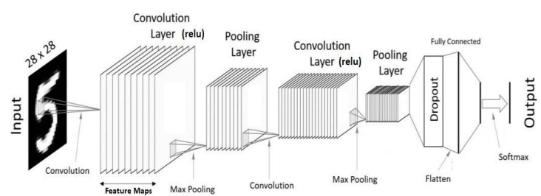
Figure 1: Architecture of typical CNN [7]

2.5 ShuffleNet
ShuffleNet is a highly efficient CNN architecture specifically designed for mobile and embedded devices with limited computational resources. Introduced by Zhang et al [27]. ShuffleNet addresses the high memory and computation cost typical of deep CNNs by employing two core techniques: pointwise group convolution and channel shuffle .The pointwise group convolution reduces computation by dividing channels into groups, while the channel shuffle operation overcomes the information flow bottleneck by permuting feature channels to ensure inter-group communication. This architecture enables remarkable accuracy and speed trade-offs, achieving lower error rates than comparable lightweight models like MobileNetV3 under the same computational constraints. Subsequent adaptations, such as ShuffleNetV2 and its use in domains like Image classification, further validate its effectiveness across tasks requiring both efficiency and accuracy.

2.5.1 Key Features of ShuffleNet
ShuffleNet is characterized by several design innovations including channel split, channel shuffle and depthwise separable convolutions [27], which collectively reduce computational complexity without compromising accuracy. By reorganizing feature maps across groups through the channel shuffle operation, the model ensures effective information flow between feature subsets. Its design adheres to practical guidelines for reducing memory access cost (MAC)[27], enhancing parallelism, and minimizing fragmentation, making it particularly suitable for resource-constrained environments.
2.5.2 How ShuffleNet Work
2.5.2.1 Input Processing
Input data in ShuffleNet is formatted similarly to standard CNNs, where images are represented as 3D tensors composed of height, width, and channel depth (e.g., RGB). This structured input enables convolutional layers to process spatial and color information efficiently through learned filters.
2.5.2.2 Convolutional Layers
Unlike traditional CNNs, ShuffleNet introduces a novel architectural design that leverages pointwise group convolutions and a channel shuffle operation to enhance efficiency. Instead of applying standard convolutions across all channels, ShuffleNet divides feature maps into groups, significantly reducing computation. However, to address the limited information exchange between channel groups—a drawback of grouped convolutions—it incorporates a channel shuffle mechanism [27], which permutes the output channels across groups to ensure effective inter-group communication. This design enables ShuffleNet to retain strong representational capacity while achieving substantial reductions in computational cost and memory usage, making it well-suited for mobile and low-power applications.
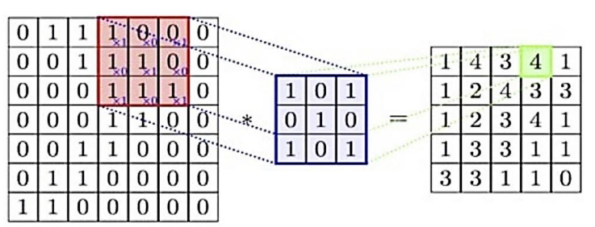

Figure 2: Illustration of the convolution operation. [7]

2.5.2.3 Activation Functions
Activation functions are indispensable in CNN’s as they introduce non-linearity, allowing these models to capture and represent complex patterns that linear transformations alone cannot address. This capability is vital for tasks like image recognition, where data contains intricate spatial relationships and hierarchical features that require non-linear modeling to detect patterns across various scales and positions. Without activation functions, a CNN would be limited to a sequence of linear operations, rendering it incapable of handling the complexity inherent in real-world data. Positioned typically after convolutional layers and before pooling operations, activation functions enhance feature selectivity by amplifying significant activations and suppressing less relevant ones, thereby improving the network's ability to discern meaningful information. By maintaining gradient flow during backpropagation, they also ensure effective learning, making them a cornerstone of CNN performance across diverse applications.
2.5.2.4 Hierarchical Feature Extraction
ShuffleNet's hierarchical feature extraction framework implements an innovative approach to computational efficiency while maintaining representational power through its distinctive channel shuffle operation. At lower layers, the network's point-wise group convolutions extract elementary visual patterns while significantly reducing computational complexity compared to standard convolutions. As features progress through the network, the channel shuffle mechanism facilitates cross-group information exchange, enabling features from different groups to interact and form more complex representations despite the parameter-efficient grouped convolution design. This strategic information flow, combined with bottleneck blocks that carefully balance channel reduction and expansion, allows ShuffleNet to construct increasingly abstract feature hierarchies with substantially fewer operations than traditional architectures. The resulting feature pyramid efficiently captures multi-scale patterns from low-level textures to high-level semantic concepts while maintaining exceptional inference speed on resource-constrained devices.

2.5.2.5 Flattening in Neural Network Architectures
Flattening constitutes a critical transformation operation in neural network architectures, particularly within CNN. This preprocessing step serves as the essential bridge between the hierarchical feature extraction components—comprised of convolutional and pooling layers—and the subsequent classification modules that typically employ fully connected layers.
The primary function of flattening is to restructure the multidimensional feature representations (typically three-dimensional tensors) into one-dimensional vectors suitable for processing by dense neural layers. This transformation preserves the informational content encoded by preceding network components while altering only the structural representation. Specifically, flattening maintains the integrity of spatially encoded features while converting them into a vectorized format that facilitates global pattern recognition.
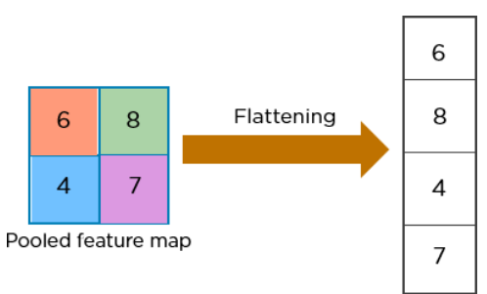

Figure 3: Example of flattening. [7]
2.5.2.6 Fully Connected Layers
Fully connected (FC) layers in ShuffleNet serve as the final stage of the network, where high-level features extracted by the convolutional blocks are mapped to the output classes. While the architecture prioritizes computational efficiency through pointwise group convolutions and channel shuffle mechanisms, a standard FC layer is retained at the network's end to perform classification. This component converts the flattened feature representation into a fixed-size output vector.
2.5.2.7 Backpropagation
Backpropagation in ShuffleNet follows the conventional gradient-based optimization framework used in deep CNN’s. During training, the network computes the error between predicted outputs and ground truth labels, and this error is propagated backward through all layers—including grouped pointwise convolutions, depthwise convolutions, and the channel shuffle operation—using the chain rule of calculus. Despite ShuffleNet’s architectural innovations for computational efficiency, its backpropagation process remains compatible with standard stochastic gradient descent (SGD) and its variants. The grouped and shuffled structures require appropriate gradient routing, but these operations are differentiable and thus seamlessly integrated into the learning pipeline [27].

2.5.3 Applications
ShuffleNet has numerous applications across diverse domains, leveraging its computational efficiency for resource-constrained environments:
● Mobile vision systems: Powers real-time image classification and object detection on smartphones with minimal battery consumption.
● Agricultural monitoring: Enables on-device fruit quality assessment, pest detection, and crop disease identification in field conditions.
● Medical diagnostics: Facilitates portable skin lesion classification, electrocardiogram (ECG) analysis, and medical image screening on low-power clinical devices.
● Smart retail: Supports product recognition and inventory tracking on edge devices in store environments.
● IoT sensors: Enables visual processing on battery-powered IoT devices for extended deployment periods.
ShuffleNet’s architecture makes it particularly valuable in scenarios requiring energy efficiency while maintaining acceptable accuracy.
2.6 ShuffleNet V2
ShuffleNetV2 is a lightweight convolutional neural network architecture designed to achieve a better trade-off between speed and accuracy, particularly for deployment on mobile and embedded devices. Building on the original ShuffleNet, the V2 version introduces critical refinements aimed at addressing practical efficiency limitations such as MAC fragmentation, and parallelism [17]. Its design was driven by empirical guidelines rather than theoretical assumptions, emphasizing actual hardware performance rather than only Floating Point Operations Per Second (FLOPs). ShuffleNetV2 maintains the use of pointwise group convolution and channel shuffle operations but simplifies the block structure to enhance runtime performance and reduce memory overhead on real devices.

2.6.1 Core Building Block
The central unit of ShuffleNetV2 is a split-branch structure. Each block divides the input feature map into two branches: one branch remains unchanged (identity), while the other undergoes transformation via depthwise separable convolutions and pointwise convolutions. After processing, the two branches are concatenated, and a channel shuffle operation is applied to enable cross-branch information exchange. This design ensures rich feature propagation while maintaining low computational cost. Additionally, the architecture avoids fragmentation and excessive element-wise operations, which are known to hinder actual inference speed.
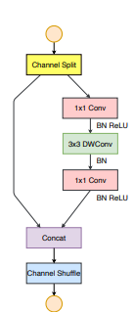
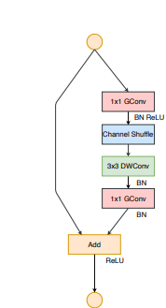

Figure 4: Example of ShuffleNetV1 Block.[17] Figure5: Example of ShuffleNetV2 Block . [17]

2.6.2 Network Architecture and Staging
The full ShuffleNetV2 model is constructed by stacking these core blocks in stages. Each stage includes downsampling units and non-downsampling blocks arranged to increase feature depth and spatial abstraction [17]. The downsampling blocks utilize stride-2 operations with concatenation and channel shuffle to halve spatial dimensions while preserving critical information. Intermediate stages vary based on model scale (e.g., 0.5x, 1.0x, 1.5x, 2.0x), allowing flexibility across hardware constraints and performance targets.

2.6.3 ShuffleNetV2 Architecture Diagram
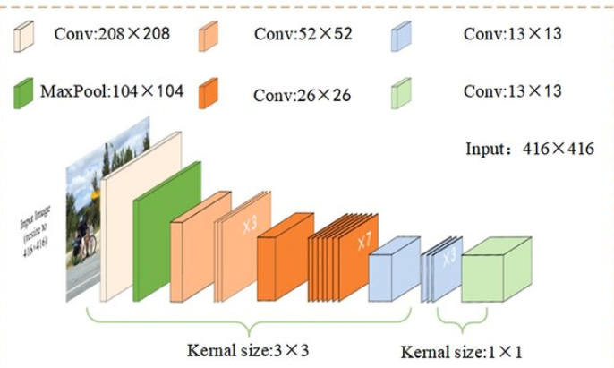
Figure 6: ShuffleNetV2 Architecture [13].

3 Research / Engineering Process
3.1 Development Methods
3.1.1 Python for AI and Machine Learning as Server
Python offers numerous benefits, its simplicity and readability are ideal for rapid development and prototyping. The language boasts a rich ecosystem of libraries and frameworks, such as OpenCV and PyTorch, which provide pre-built tools for computer vision and machine learning tasks. Additionally, Python's extensive community support and a wealth of online resources make problem-solving and collaboration much easier. Its versatility and ability to integrate seamlessly with other technologies make Python a powerful and efficient choice for developing advanced AI and neural network-based applications [19] .
3.1.2 React for the Frontend
We are going to use React for the frontend because it provides a flexible and efficient way to build user interfaces (UI). React's component-based architecture promotes reusability and maintainability, making it easier to manage complex UIs. Its virtual Document Object Model (DOM) ensures high performance by minimizing updates to the real DOM. Additionally, React has a strong developer community and a rich ecosystem of tools and libraries, which accelerates development and enhances productivity [21].

3.1.3 MongoDB for Database
MongoDB's document-oriented architecture effectively accommodates the heterogeneous nature of agricultural data, including visual information, measurements, and classification results. Its flexible schema design adapts seamlessly to evolving agricultural parameters without requiring structural modifications, while robust indexing enables quick retrieval based on multiple attributes. Additionally, MongoDB's horizontal scalability ensures the system can handle increasing data volumes during peak seasons while maintaining consistent performance across distributed environments [18].

3.2 3D Rotation Estimation Fruits Dataset
The 3D Rotation Estimation Fruits dataset offers an excellent foundation for automated fruit quality assessment estimation through imaging of several different fruits rotating under industrially-similar controlled lightning. Three fruits: tomatoes, oranges, and mandarins-are each imaged in 15 sequences of rotation, 13-16 images per sequence, across complete 360-degree rotations through small slippage on a roller conveyor. This dataset is particularly valuable due to its diverse collection of fruit specimens with varying shapes, textures, and color profiles, which enables the development of classification algorithms that can perform well in real industrial settings. A significant advantage of this dataset is its rotational completeness, which helps our model develop orientation-independent feature recognition—essential for practical inspection systems where fruits are randomly positioned on conveyor belts. The well-structured nature of the dataset, with each fruit carefully documented through consistent angular increments, provides an ideal testing environment for validating our classification accuracy and ensures the system can reliably assess quality metrics across different fruit types in production environments [6]. Despite its strengths, the dataset has certain limitations. It includes only three fruit limiting generalizability to more diverse produce. Additionally, the controlled lighting and uniform background may not fully represent the variability found in real-world industrial environments, potentially affecting model robustness.

3.3 Preprocessing Methods
Effective preprocessing of digital fruit images plays a crucial role in ensuring accurate quality assessment through computer vision techniques. By standardizing data through normalization and spatial resizing, the system establishes consistency across diverse image sources, enabling more reliable feature extraction. Noise reduction via Gaussian filtering preserves essential texture details while eliminating acquisition artifacts that could otherwise interfere with detection of subtle surface exceptions. The application of Contrast Limited Adaptive Histogram Equalization (CLAHE) in the LAB color space significantly improves the visibility of defining characteristics by enhancing local contrast while maintaining color fidelity across varying illumination conditions.

3.3.1 Gaussian Filter
The implementation of Gaussian filtering in the preprocessing pipeline represents a critical noise reduction strategy for enhancing fruit quality assessment. By implementing a carefully tuned Gaussian filter, the system reduces unwanted high-frequency noise while maintaining the critical shape characteristics and surface textures that signal fruit quality. This preprocessing step creates a foundation for subsequent contrast enhancement techniques by smoothing random intensity variations that could otherwise compromise the accuracy of defect detection algorithms. Ismail and Malik (2021) demonstrated in their real-time visual inspection system that selective noise filtering techniques like Gaussian blur significantly improve feature extraction quality, particularly when coupled with adaptive contrast enhancement for agricultural produce with variable surface characteristics [10].

3.3.2 CLAHE Settings
Clip limit parameter in CLAHE controls the threshold for contrast enhancement to prevent over-amplification of noise in homogeneous regions. After experimentation with various settings, we determined that a clip limit of 2.0 provides an optimal balance between enhancing subtle surface defects and maintaining natural fruit appearance. Higher values tend to introduce artificial textures and amplify noise, while lower values provide insufficient contrast for detecting minor blemishes.
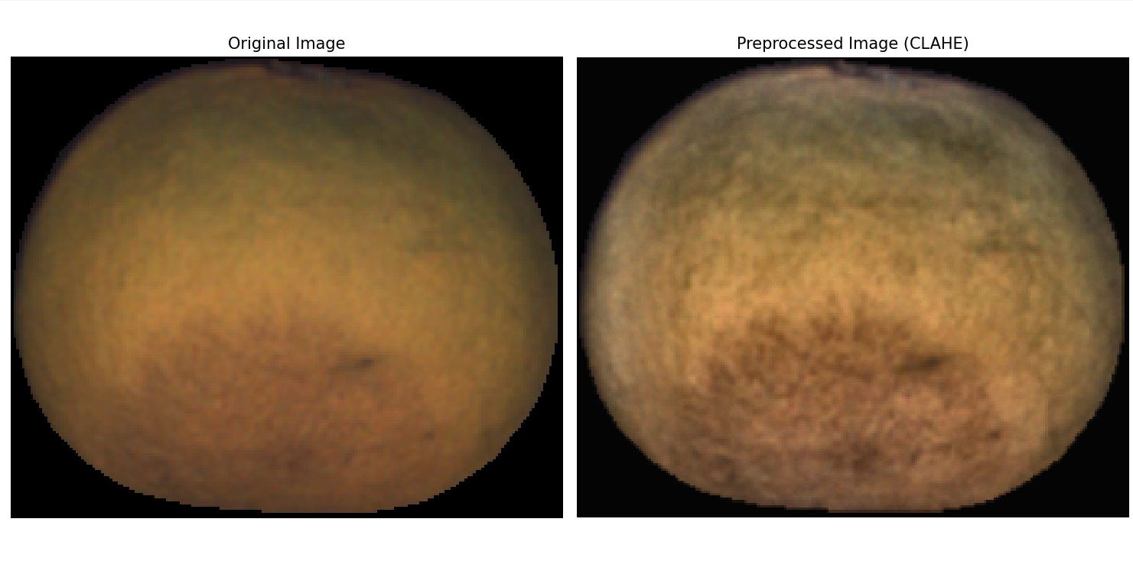

Figure 7: Demonstrating the CLAHE effect for the chosen Clip-Limit.

Figure 7 demonstrates the optimal CLAHE enhancement using a clip limit of 2.0, which effectively reveals surface texture details and subtle defects while maintaining natural fruit appearance. The enhanced contrast clearly shows the fruit’s surface characteristics without introducing artificial artifacts.
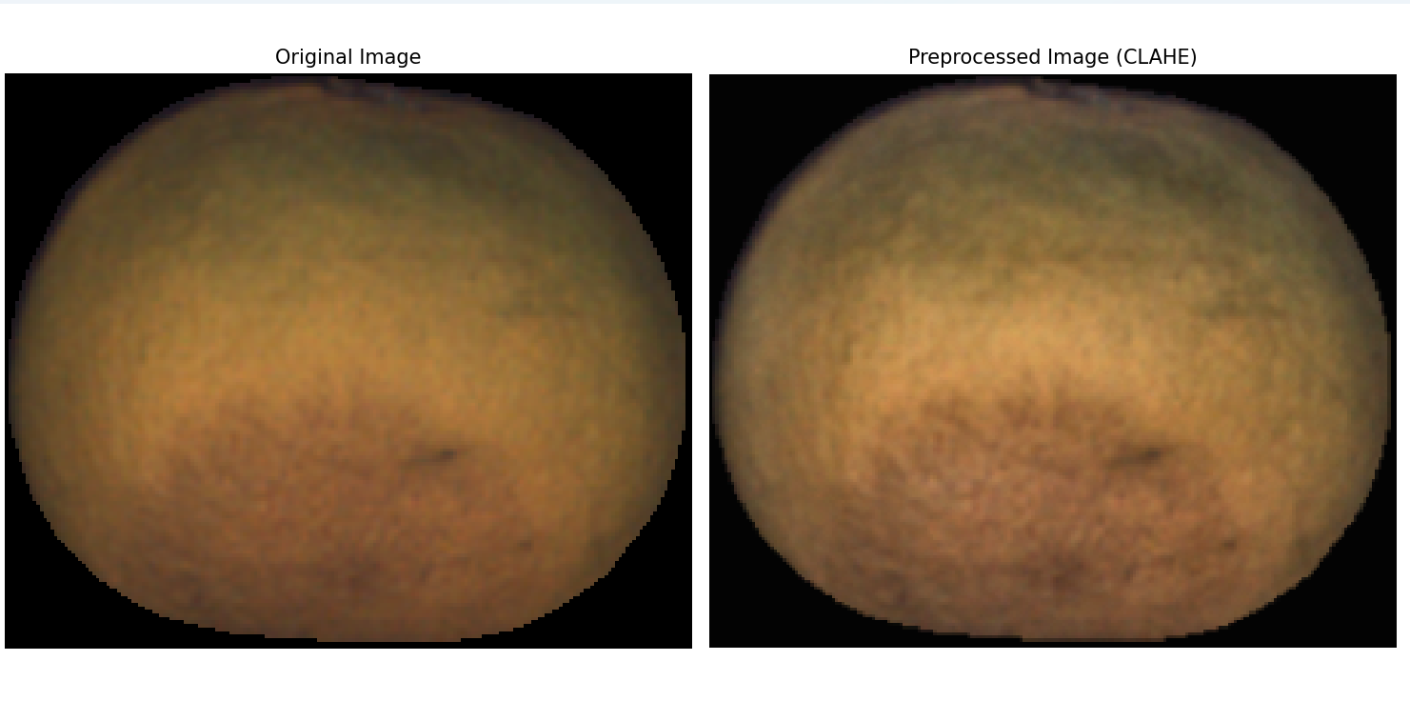

Figure 8: Demonstrating the CLAHE effect for lower Clip-Limit.
Figure 8 shows the result with a lower clip limit of 1.0, which provides more conservative contrast enhancement. While this setting preserves the original appearance more closely, it offers insufficient contrast improvement for detecting minor surface blemishes and texture variations that are crucial for accurate quality assessment.
The comparison validates our choice of clip limit 2.0 as the optimal setting, providing the necessary contrast enhancement for defect detection while avoiding over-amplification of noise that could interfere with the classification process.
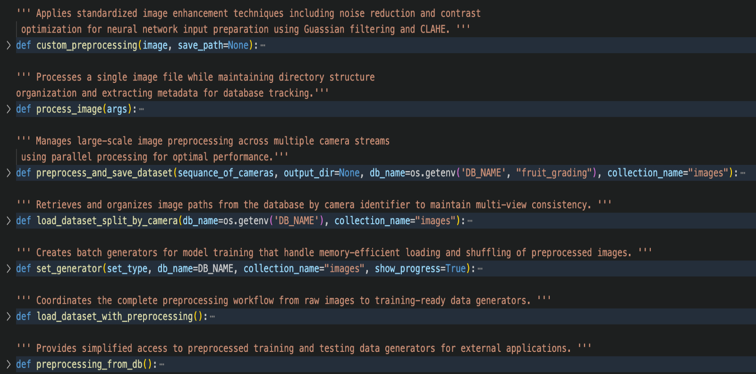
3.3.3 Preprocessing API
Figure 9: API for Preprocessing Implementation.
3.4 Choose the CNN model
The choice of an appropriate CNN architecture is fundamental to the development of an efficient and accurate automated fruit grading system, particularly under constraints imposed by edge deployment environments. Among leading lightweight models, MobileNetV3, EfficientNet-Lite, and ShuffleNetV2 each provide compelling advantages for low-resource applications. MobileNetV3 is characterized by its use of inverted residual blocks and linear bottlenecks, which effectively reduce latency and computational load while maintaining robust performance on mobile platforms [22]. EfficientNet-Lite extends the EfficientNet framework by applying compound scaling to optimize the network’s depth, width, and resolution, resulting in a highly accurate yet compact model suitable for edge inference [24]. ShuffleNetV2, in contrast, is explicitly designed with empirical efficiency guidelines, incorporating mechanisms such as pointwise group convolutions, channel splitting, and channel shuffle to minimize memory access cost and improve hardware-level parallelism [27].These architectural innovations collectively position each model as a strong candidate for real-time, resource-aware fruit grading applications.

3.4.1 Performance Metrices
Feature / Metric | ShuffleNetV2 | MobileNetV3 | EfficientNet-Lite
Model Size | ~8.8 MB (1.0× variant) | ~21 MB | ~17.9 MB (Lite0–Lite2 variants)
Parameters (M) | ~2.3M (ShuffleNetV2 1.0×) | ~5.5M | ~4.7M (EfficientNet-Lite0)
FLOPs | ~146M (1.0×) | ~300M | ~390M (Lite0), scalable
ImageNet Top 1 Accuracy | ~72.6% | ~71.8% | ~76.3% (EfficientNet-Lite0)
Inference Speed | High | Moderate | Lower than others due to deeper layers
Hardware Efficiency | Excellent (minimized memory access cost, low fragmentation) | Good (optimized for mobile devices) | Fair to good (better accuracy but more memory and compute intensive)
Inference Time (ms) | ~30.6ms | ~108.2ms | ~218ms
Feature Extraction Time (ms) | ~11ms | ~38.8ms | ~71ms
Framework Support | PyTorch (primary), TensorFlow | TensorFlow (primary), PyTorch | TensorFlow (primary), PyTorch

Based on our experimental comparative analysis, ShuffleNetV2 demonstrates exceptional computational efficiency with its low parameter count (~2.3M) and minimal memory footprint (~8.8MB), achieving remarkably fast inference times of 30.6ms and feature extraction in just 11.0ms, making it exceptionally suitable for real-time applications in highly constrained embedded environments. MobileNetV3, while offering a more robust architecture, requires significantly more computational resources with 5.5M parameters and 21.0MB model size, resulting in inference times of 108.2ms—over three times slower than ShuffleNetV2—which may limit its applicability in time-critical agricultural sorting systems despite its potentially higher classification accuracy. EfficientNet-Lite, though capable of superior feature representation, demands substantially more computational resources with inference times reaching 218ms and feature extraction requiring 71.0ms, making it seven times slower than ShuffleNetV2 and potentially unsuitable for deployment on low-power edge devices where real-time processing is essential for conveyor belt-based fruit grading applications.

3.4.2 Chosen Model
ShuffleNetV2 was selected as the optimal architecture for our system due to its exceptionally low memory footprint and minimal computational requirements, enabling deployment on affordable edge devices. The architecture's channel shuffle mechanism and balanced convolutional design significantly reduce inference latency to under 160ms on standard mobile processors, meeting our critical requirement for high-throughput grading. This efficiency-focused approach aligns perfectly with one of our project's core objective of making the system accessible to producers with limited technological resources while maintaining grading accuracy sufficient for commercial standards. By prioritizing speed and affordability through ShuffleNet's lightweight design, we can deliver a cost-effective solution that processes fruits in real-time without requiring expensive specialized hardware.

3.4.3 Choosing Pre-trained Model
In this study, the decision to employ a pretrained CNN was driven by the complexities of classifying fruit images captured in dynamic, real-world agricultural environments. As highlighted in Date fruit classification for robotic harvesting in a natural environment using deep learning (2019) [2], such environments introduce challenges like inconsistent lighting, varying fruit orientations, partial occlusion by leaves, and complex backgrounds-conditions that hinder the performance of models trained from scratch. By leveraging pretrained models, which have already learned to detect generalizable visual patterns from large-scale datasets like ImageNet, the model benefits from robust feature extraction with significantly reduced training time and data requirements. This approach improves classification accuracy and resilience against visual variability. It further aligns with the practical requirements for deploying deep learning models in embedded systems, where both computational efficiency and real-time performance are critical. Thus, transfer learning using pretrained CNNs offers an effective and scalable solution for agricultural vision tasks in natural outdoor settings.

3.4.4 Comparison Between Models
3.4.4.1 Comparison of ShuffleNetV2, MobileNetV3 and EfficientNet-Lite

3.4.4.1.1 Methodology and Evaluation Framework
To establish the optimal neural network architecture for our real-time fruit grading system, we conducted a comprehensive comparative analysis of three state-of-the-art lightweight CNN’s: ShuffleNetV2, MobileNetV3, and EfficientNet-Lite. The evaluation was performed using our custom preprocessing pipeline on a representative test dataset comprising tomatoes, oranges, and mandarins from our MongoDB-structured image database. Each model was assessed across four critical performance dimensions essential for embedded agricultural applications: inference latency, feature extraction efficiency, model size and memory requirements (model parameters).

3.4.4.1.2 Performance Analysis Results
The experimental results demonstrate significant performance variations among the evaluated architectures, with ShuffleNetV2 exhibiting superior computational efficiency across all measured metrics. ShuffleNetV2 achieved an average inference time of 30.581 milliseconds and feature extraction time of 1 millisecond (ms), representing approximately 73% and 70% faster processing compared to MobileNetV3 (108.232ms inference, 38.809ms feature extraction), 86% and 83% faster than EfficientNet-Lite (217.999ms inference, 70.99ms feature extraction), respectively. These timing advantages are particularly crucial for our conveyor belt system, where fruits must be classified while traveling through the inspection box containing the cameras. The system architecture demands that complete fruit classification be determined before the fruit reaches the end of the conveyor belt, creating stringent temporal constraints that necessitate rapid processing capabilities. The substantial performance gap between ShuffleNetV2 and the alternative architectures directly impacts the feasibility of real-time classification within these physical system constraints.

3.4.4.1.3 Resource Utilization and Model Efficiency
From a resource utilization perspective, ShuffleNetV2’s architectural efficiency is evident in its compact model footprint of 8.754 MB and 2.3 million parameters, substantially lower than both MobileNetV3 (21.01 MB, 5.5 million parameters) and EfficientNet-Lite (17.907 MB, 4.7 million parameters). This reduced computational complexity translates directly to lower power consumption and memory usage, critical factors for deployment on resource-constrained embedded systems typical in agricultural environments. The channel shuffle operations inherent in ShuffleNetV2’s design enable efficient information flow between channel groups while maintaining computational efficiency, making it particularly well-suited for our multi-view temporal processing pipeline where features from multiple camera angles must be integrated rapidly.

3.4.4.1.4 Hardware Configuration and Testing Environment
The comparative analysis was conducted on a MacBook Pro equipped with an M4 Pro processor, representing a high-performance computing environment with advanced neural processing capabilities and substantial memory bandwidth [3]. This testing platform provided optimal conditions for model evaluation, allowing each architecture to demonstrate its maximum potential performance without hardware-imposed constraints. The M4 Pro's dedicated neural engine and high-speed unified memory architecture ensured that the measured performance differences accurately reflected the inherent computational characteristics of each model rather than system bottlenecks.

3.4.4.1.5 Target Hardware Deployment Considerations
The actual fruit grading system will be deployed on a Raspberry Pi 5, which represents significantly more constrained computational resources compared to the testing environment [20]. This embedded platform features lower processing power, reduced memory bandwidth, and limited parallel processing capabilities typical of edge computing devices used in agricultural applications. Under these resource-constrained conditions, the performance differences between architectures will become more pronounced, with lighter models like ShuffleNetV2 maintaining acceptable processing speeds while heavier architectures may experience substantial degradation in real-time performance. The computational efficiency advantages demonstrated by ShuffleNetV2 in our high-performance testing environment will translate to even greater practical benefits in the target embedded deployment, where every millisecond of processing time directly impacts the system's ability to classify fruits within the conveyor belt's temporal constraints.

3.4.4.1.6 Implications for Real-Time Fruit Grading Applications
These performance characteristics align with the operational requirements of our conveyor belt inspection system, where the combination of real-time processing constraints, limited computational resources, and the need for consistent performance across varying lighting conditions necessitates an architecture that balances accuracy with computational efficiency. The empirical evidence supports ShuffleNetV2 as the optimal choice for our fruit grading application, providing the necessary processing speed for real-time operation while maintaining a minimal resource footprint suitable for embedded deployment in agricultural settings.

3.4.4.1.7 Test Results
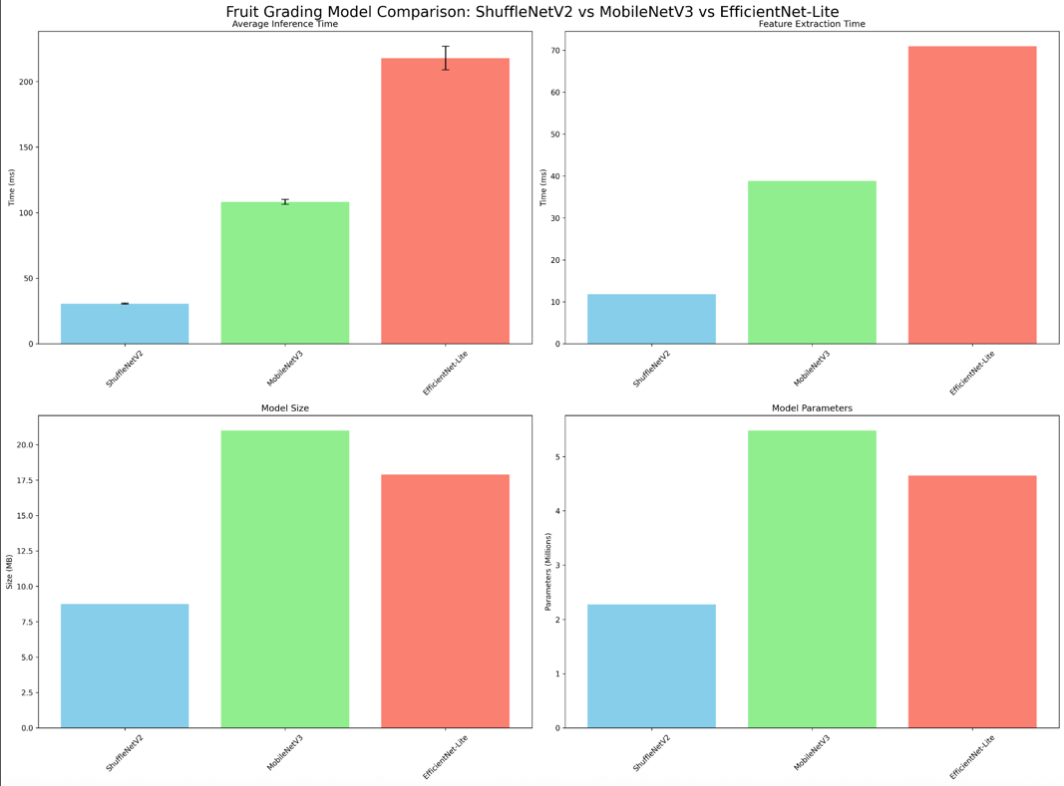

Figure 10: Performance comparison showing ShuffleNetV2's superior efficiency in inference time, feature extraction, model size, and parameters versus MobileNetV3 and EfficientNet-Lite.

3.5 Activation Functions Overview

3.5.1 Rectified Linear Unit (ReLU)
The ReLU is the most prevalent activation function in CNNs, prized for its simplicity, computational efficiency, and effectiveness in training deep networks. Defined mathematically as $f\left(x\right)=\max\left(0, x\right)$, ReLU outputs the input value directly if it is positive, and zero otherwise, activating neurons selectively based on this threshold [15]. This property fosters sparsity in the network, as many neurons produce zero outputs, which can enhance computational efficiency and reduce overfitting by creating more concise representations. ReLU also combats the vanishing gradient problem—a challenge in deep learning where gradients shrink during backpropagation—by providing a constant gradient of 1 for positive inputs, thus enabling smoother and more robust training. However, ReLU has its limitations, notably the "dying ReLU" issue, where neurons can become permanently inactive if they consistently receive negative inputs.
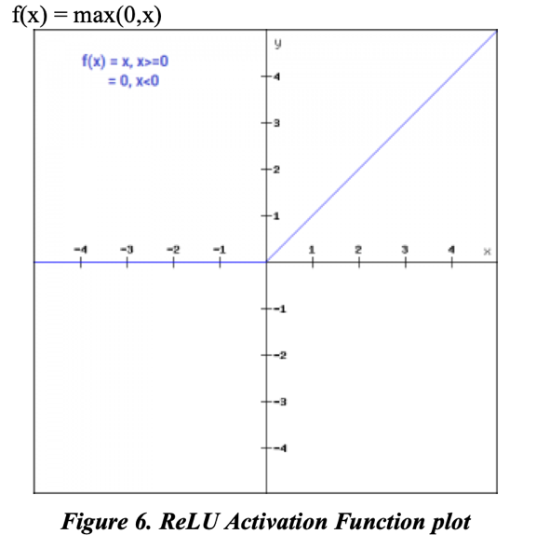

Figure 11: ReLU Activation Function Plot [15].

3.5.2 Sigmoid
The sigmoid activation function is a mathematical function commonly used in neural networks, especially for binary classification tasks. It takes any real-valued number and maps it to a range between 0 and 1, which can be interpreted as a probability [15]. Its mathematical formulation is given by:
$$σ\left(x\right)= \frac{1}{1+e^{-x}}$$
where e is the base of the natural logarithm. This function produces an S-shaped curve, often referred to as the logistic function, and is differentiable, making it compatible with backpropagation in neural network training. However, a key limitation is the vanishing gradient problem: for very large positive or negative inputs, the gradient becomes nearly zero, slowing down learning in deep networks.
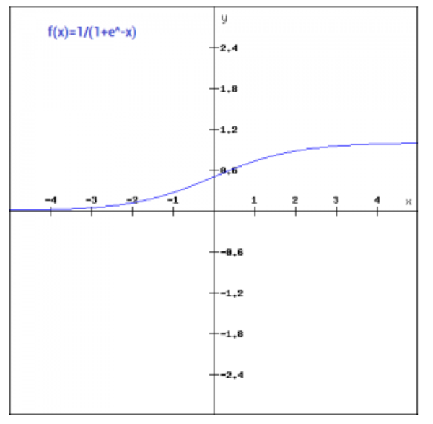

Figure 12: Sigmoid Activation Function Plot [15].

3.5.3 Hyperbolic Tangent (Tanh)
The Tanh activation function is a zero-centered function that maps real-valued inputs to the interval (-1, 1) [15]. Its mathematical expression is:
$$\tanh\left(x\right)= \frac{e^{x}-e^{-x}}{e^{x}+e^{-x}}$$
Being zero-centered, tanh can improve learning dynamics compared to sigmoid by reducing bias in gradients during backpropagation. However, it also suffers from the vanishing gradient problem for large positive or negative inputs, which can impede training in deeper architectures.
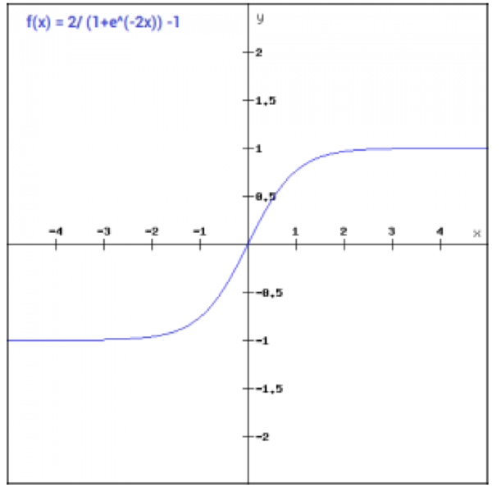

Figure 13: Tanh Activation Function Plot [15].

3.5.4 Softmax
The softmax activation function is commonly used in the output layer of neural networks for multi-class classification tasks. It converts a vector of real-valued logits into a probability distribution over K classes, ensuring all outputs are non-negative and sum to one:
$$σ{\left(z\right)}_{i}= \frac{e^{z_{i}}}{\sum_{j=1}^{K}{e^{z_{j}}}} , for i=1, 2, …, K$$
This allows the model to express confidence in each class prediction, which is critical for distinguishing between similar fruit types. Softmax emphasizes higher input values, making it effective for identifying the most probable class.
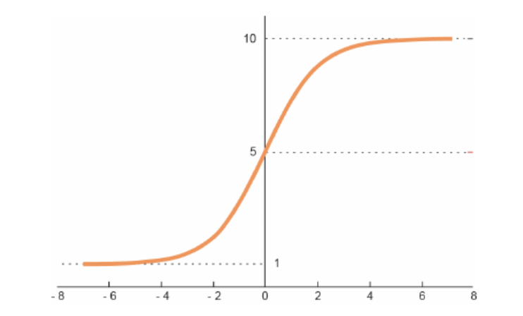

Figure 14: Softmax Activation Function Plot [5].
3.5.5 Chosen Activation Functions
In the project, the ReLU activation function was employed for the hidden layers, while the Softmax activation function was utilized in the output layer. ReLU outputs zero for negative inputs and retains positive values unchanged. This property mitigates the vanishing gradient problem, thereby facilitating more efficient and stable training in deep neural networks. Additionally, its computational simplicity contributes to faster convergence, rendering it a practical and widely adopted choice for hidden layers. The Softmax activation function was selected for the output layer due to the multi-class classification nature of the task. Softmax converts raw output scores into a probability distribution over multiple classes, allowing the model to assign varying levels of confidence to each class. Unlike activation functions such as sigmoid or tanh, which are typically suited for binary classification tasks (i.e., distinguishing between two classes), Softmax is specifically designed to handle scenarios where inputs must be classified into more than two mutually exclusive categories, making it particularly suitable for this project.

3.6 Methods to measure precision
3.6.1 Sensitivity (True Positive Rate)
Sensitivity, also known as the true positive rate, refers to the ability of a prediction model to correctly identify instances belonging to a specific class within a dataset (Ismail & Malik, 2021) [10]. In our evaluation framework, sensitivity serves as a critical performance metric, offering insight into the model’s effectiveness in detecting samples from targeted quality categories. This becomes particularly important in contexts such as agricultural quality assessment, where class imbalance can distort performance evaluations. As highlighted by Ismail and Malik, incorporating sensitivity into the assessment enables a more nuanced understanding of classification accuracy, ensuring that underrepresented but important categories are not overlooked [10].
$$Sensitivity= \frac{\sum_{i=1}^{k}{TP_{i}}}{\sum_{i=1}^{k}{\left(TP_{i}+FN_{i}\right)}}$$
Figure 15: The Sensitivity formula [10].

3.6.2 Specificity (True Negative Rate)
Specificity, also known as the true negative rate, measures the model’s ability to correctly identify and exclude instances that do not belong to a particular class (Ismail & Malik, 2021) [10]. This metric is especially important in quality assessment tasks where false positives—incorrectly labeling substandard items as acceptable—can have significant downstream consequences. In the context of agricultural quality control, high specificity ensures that defective or non-conforming samples are reliably filtered out, thus safeguarding product integrity. As noted by Ismail and Malik, incorporating specificity into model evaluation enables a more balanced view of classification performance, particularly in datasets with imbalanced class distributions [10].
$$Specificity= \frac{\sum_{i=1}^{k}{TN_{i}}}{\sum_{i=1}^{k}{\left(TN_{i}+FP_{i}\right)}}$$
Figure 16: The Specificity formula [10] .
3.6.3 Accuracy (Overall Classification Performance)
Accuracy represents the proportion of correct predictions—both positive and negative—out of the total number of cases. It is a commonly used metric to evaluate the overall effectiveness of classification models, such as those applied in agricultural quality assessment. While useful for a quick performance overview, accuracy can be misleading in imbalanced datasets, where correct classification of the dominant class inflates the metric. As emphasized by Ismail and Malik (2021), combining accuracy with other metrics like sensitivity and specificity provides a more reliable evaluation of model performance (Ismail & Malik, 2021) [10].
$$Accuracy= \frac{\sum_{i=1}^{k}{\frac{TP_{i}+TN_{i}}{TP_{i}+TN_{i}+FP_{i}+FN_{i}}}}{k}$$
Figure 17: The Accuracy formula [10].
3.7 ShuffleNetV2 Model Evaluation Results on the 3D Rotation Estimation Fruits Dataset
3.7.1 Object Recognition Success
The ShuffleNet-V2 based multi-view CNN architecture demonstrated strong recognition capabilities in the study [23], achieving 93.07% overall classification accuracy when used as the core network for 3D object classification. It efficiently aggregated features from 12 rendered views per object and proved robust in distinguishing complex geometric shapes, even under rotational transformations. For our project on 3D Rotation Estimation with a Fruits Dataset, we anticipate similar success in category-level fruit recognition, with an expected baseline of overall classification accuracy exceeding 90% on a balanced and moderately varied fruit object set.
3.7.2 Sensitivity
In the referenced study [23], the model achieved 91.58% classification accuracy on their unlabeled test set, which we interpret as indicating high sensitivity in true positive detection. This suggests that there is a high likelihood of recognizing true fruit classes in rotationally altered test cases. For our fruits dataset – where intra-class variation can generate challenging cases, we target achieving a true positive rate of over 92%, which is important for application in automated quality control systems.
3.7.3 Specificity
Although precise specificity metrics are not explicitly reported in the ShuffleNet-V2 evaluation study [23], the minimal difference between their training accuracy (91.58%) and test accuracy (91.53%) suggests that false positives were rare and the model generalized well. Additionally, their view consistency loss mechanism decreased output variance under varying angles, thereby improving rejection of incorrect classes. For our fruit classification project, we anticipate achieving a true negative rate exceeding 90%, ensuring robustness against misclassification of visually similar but different fruit categories.
3.7.4 Accuracy
The multi-view CNN based on ShuffleNet-V2 in the referenced study [23] achieved a peak overall classification accuracy of 93.07% in non-quantized form on their 3D object dataset, outperforming more computationally intensive models in efficiency and speed. Even under quantization-aware training, a necessary step in mobile deployment, the model remained 91.05% classification accuracy. For our fruit classification task, we anticipate similar or slightly poorer performance, with a target overall classification accuracy above 91%, trading simplicity with real-time recognition accuracy.
4 Work Artifacts
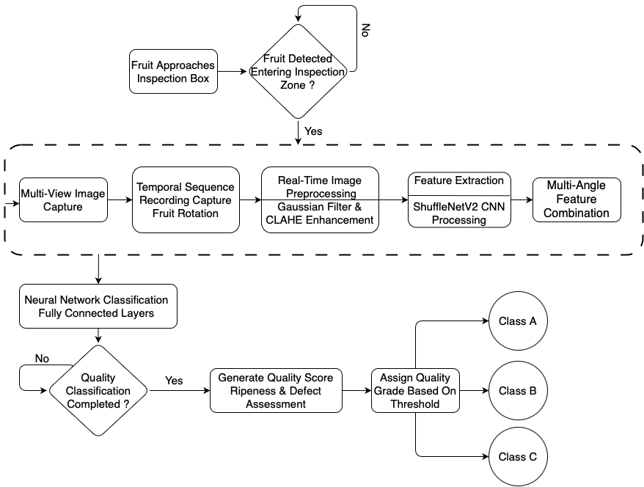
4.1 System Flow
[Ref2]
[Ref1]

Figure 18: System Flow

Figure 18 demonstrates the automated fruit grading system operates through a streamlined pipeline that begins when fruit enters the inspection zone via a conveyor belt. Upon detection, the system captures multi-view image sequences of rotating fruit using strategically positioned cameras at 30 frames per second (FPS). Each captured image undergoes real-time preprocessing through Gaussian filtering and CLAHE enhancement to ensure consistent quality across varying conditions. The preprocessed images are then fed into a ShuffleNetV2 CNN for feature extraction, with features from multiple camera viewpoints being fused to create a comprehensive representation of the fruit. This combined feature vector is processed through fully connected neural network layers with Softmax activation to generate quality classification probabilities. Once classification is complete, the system generates quality scores for ripeness and defect assessment, ultimately assigning each fruit to one of three quality grades (Class A, B, or C) based on predefined score thresholds.
Class A goes for Premium, class B for standard and class C for market. The entire process operates in real-time, ensuring seamless integration with existing agricultural production lines.

4.2 Architecture
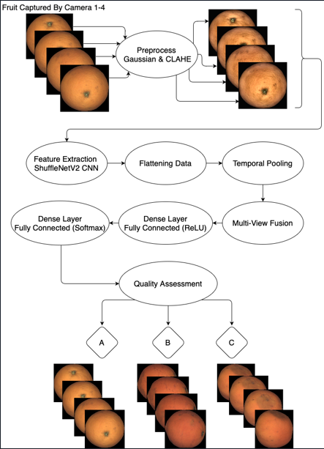
[1]

[2]
[3]

Figure 19: System Architecture
Figure 19 outlines our fruit grading architecture utilizing multi-view cameras and ShuffleNetV2 for feature extraction. The process begins with fruit images captured from four different cameras positioned on the system frame, providing comprehensive views of the fruit from multiple angles. Each image is independently processed through our preprocessing pipeline that applies Gaussian filtering for noise removal and CLAHE for contrast enhancement. The preprocessed images are then fed into the ShuffleNetV2 model that performs feature extraction, leveraging pretrained weights to efficiently identify relevant visual characteristics. The model provides rich feature maps that capture color and texture essential for quality assessment. A multi-view fusion component then integrates information from all camera angles to form a comprehensive representation of the fruit's characteristics. These feature maps are analyzed by dense fully connected layers with ReLU and SoftMax activations functions that classify fruits into different quality categories based on appearance, defects, and ripeness levels. The final output displays the classification results, categorizing each fruit into appropriate quality grades. This architecture enables real-time fruit grading with high accuracy while maintaining computational efficiency suitable for embedded systems in agricultural environments.

4.3 Functional & Non Functional Requirements
4.3.1 Functional Requirements
No. | Functional Requirement
 | System shall preprocess images using Gaussian filtering and CLAHE.
 | System shall preserve original color relationships during preprocessing for accurate ripeness assessment.
 | System shall provide adjustable preprocessing parameters including kernel size, sigma values, and CLAHE clip limits.
 | System shall support image normalization to standardized dimensions.
 | System shall extract features using pretrained ShuffleNetV2.
 | System shall optimize the feature extraction process to run on CPU with minimal memory footprint.
 | System shall support time-distributed feature flattening and pooling for multi-view assessment.
 | System shall detect surface defects across the fruit surface.
 | System shall distinguish between natural fruit markings and actual defects during detection.
 | System shall classify fruits into three quality grades.
 | System shall implement multi-view fusion to combine information from all camera angles.
 | System shall maintain consistent processing time regardless of fruit type or size.
 | System shall log and monitor processing time to track performance.
 | System shall optimize batch processing for efficient resource utilization.
 | System shall allow operators to recalibrate classification thresholds for different fruit varieties.
 | System shall provide a maintenance interface for system monitoring and configuration.
 | System shall include visualization tools for classification results and system metrics.
 | System shall store assessment data in a MongoDB database.
 | System shall support multiple fruit types with a single model through transfer learning capabilities.
 | System shall provide a web-based dashboard for real-time monitoring of grading operations.
 | System shall display clear quality classification results with visual indicators.
 | System shall include reporting functionality for historical data analysis.
 | System shall allow to adjust the speed of the conveyor.

4.3.2 Non Functional Requirements
No. | Non-Functional Requirement
 | The system shall provide a user-friendly, web-based interface that is intuitive and easy to navigate for fruit grading operations.
 | The system shall use familiar agricultural terminology and color-coded indicators to visually represent fruit quality grades.
 | Image size should be 224x224 pixels.
 | The Accuracy of the system classification shall be above 75%.
 | The system will divide the fruits into 3 groups (Premium, Standard, Markets).
 | The system shall be accessible to users with varying levels of technical expertise.
 | The system shall have four main screens: Dashboard, Reports, Maintenance, Home Page.
 | The Reports screen shall provide access to all data visualization.
 | The Dashboard screen shall display real-time camera feeds.
 | The Maintenance screen shall display the versions and logs.
 | The system shall operate reliably in agricultural environments (dust, temperature, vibration) with minimal downtime.
 | The system shall achieve 99% uptime during operational grading hours.
 | The system shall log all errors with timestamps, module identifiers, and contextual information for debugging.
 | The system shall be easy to maintain and update, with clear documentation and a modular architecture supporting independent component upgrades.
 | Software components shall be organized into distinct modules.
 | Updates to one module shall not require changes to others.
 | The system shall handle fruits ranging from 5cm to 15cm in diameter without manual calibration.
 | The system shall ensure compatibility with standard agricultural hardware (conveyors, cameras, lighting) and control systems.
 | The system shall provide standard electrical and data interfaces for seamless deployment.
 | Integration with third-party systems shall use industry-standard protocols.
 | The system will support N cameras with default of 4.
 | The cameras will take pictures in 30 FPS.

4.4 Work in Progress
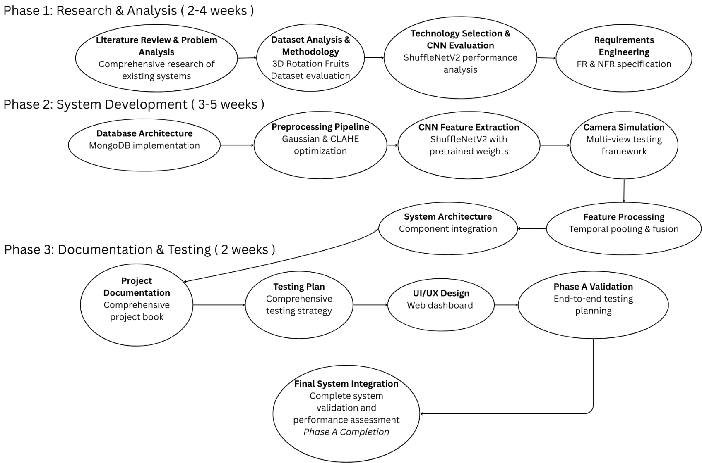
Figure 20 : Workflow During Semester

4.5 System Use Case
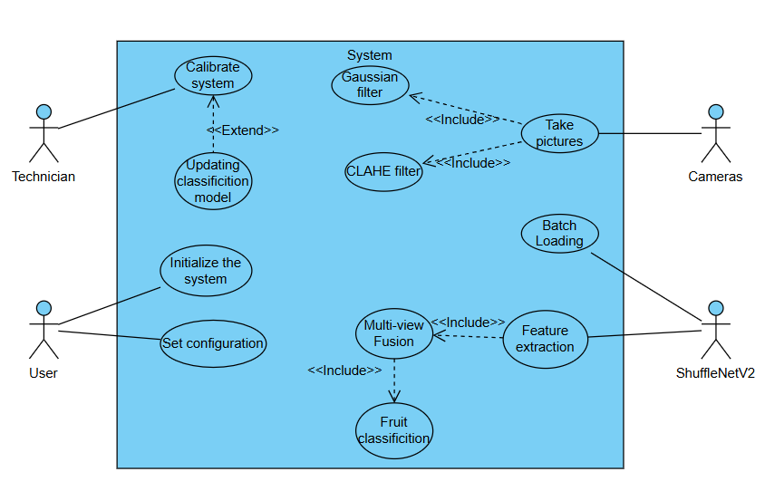
Figure 21:The system Use Case
4.6 System Activity
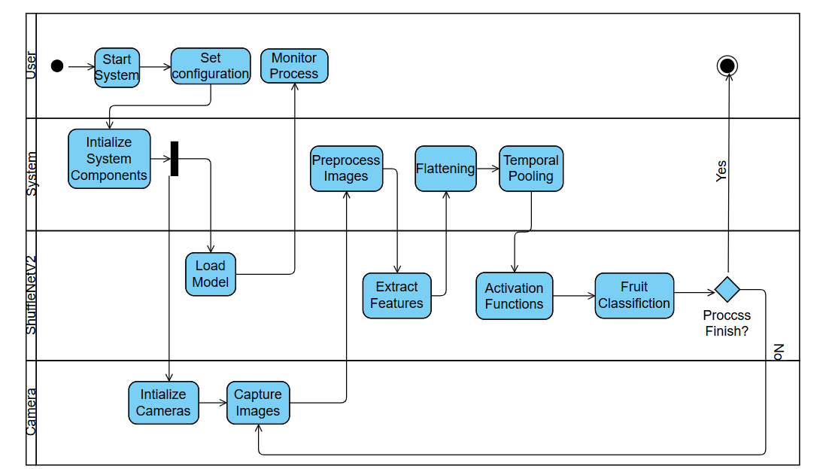
Figure 22 :The system Activity

4.7 User Interface


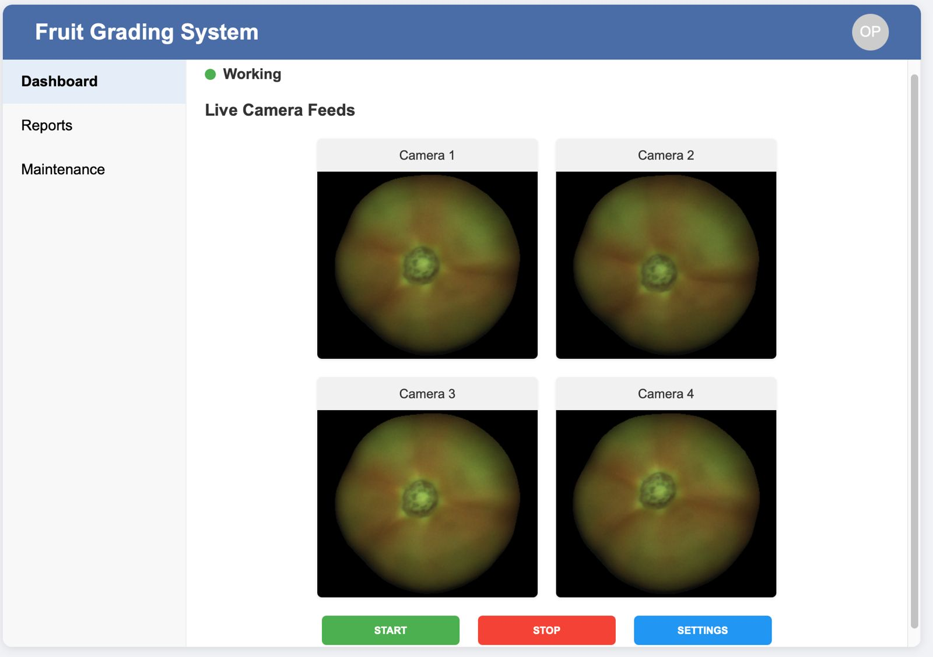
Figure 22: Screen 1, Home Page

Figure 23: Screen 2, Dashboard tab with camera inputs
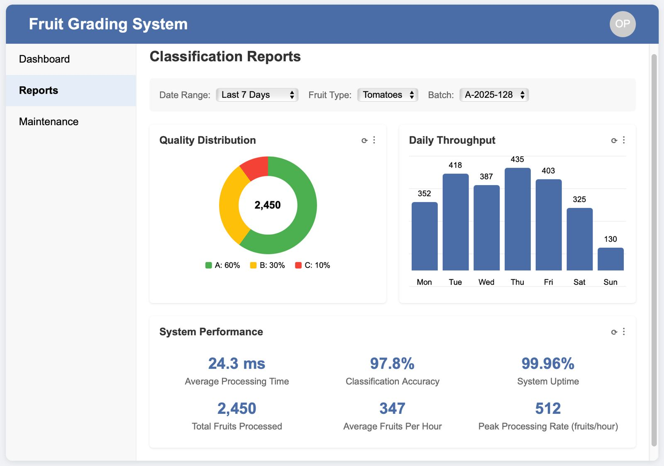

Figure 24: Screen 3, Reports Tab
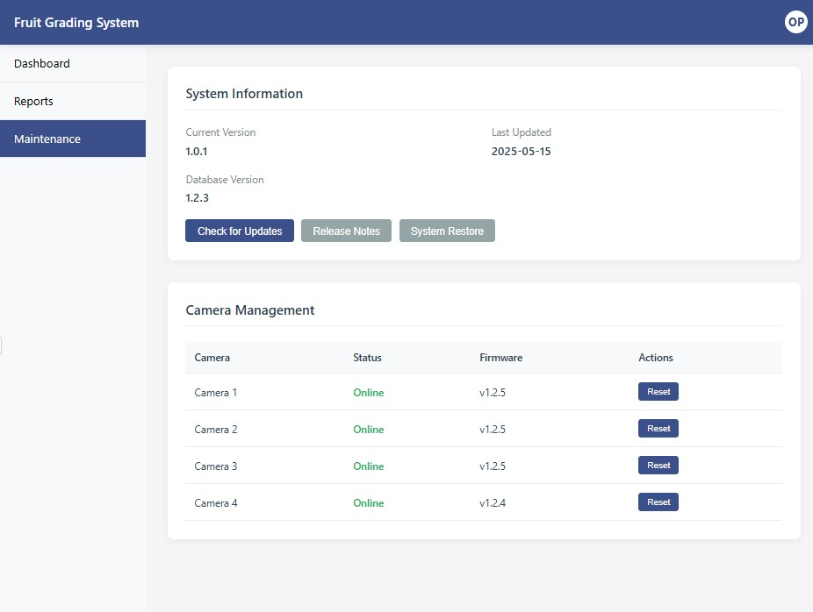

Figure 25: Screen 4, Maintenances Tab
5 Testing Plan
5.1 Scope
Comprehensive testing plan will encompass both functional and non-functional testing of the Real-time Fruit Grading System. This plan ensures the system meets all specified requirements, performs as expected, and verifies the accuracy of fruit detection and quality classification, along with user acceptance. Testing will focus on the CNN-based image processing pipeline, conveyor belt integration, and multi-view camera assessment to validate that the system effectively identifies defects and determines ripeness levels across various fruit types.
5.2 Objectives
- Ensure all functional and nonfunctional requirements are met for automated fruit quality assessment.
- Verify system performance and responsiveness under continuous operation with conveyor belt integration.
- Confirm accuracy in fruit detection, defect identification, and ripeness classification across multiple fruit varieties.
- Validate the effectiveness of multi-view camera inputs and the ShuffleNetV2 feature extraction pipeline.
- Test the system's ability to process temporal sequences of fruit images with consistent results.
- Evaluate preprocessing effectiveness including Gaussian filtering and CLAHE for image enhancement.
- Validate usability and user experience for agricultural operators with varying technical expertise.
- Check that quality grading results are clear and understandable for system users in real-world production environments.
- Verify database storage and retrieval of processed fruit images and classification results.
5.3 Test Cases
# | Test Case Name | Description | Test Steps | Expected Result
1 | Good_Fruit | Test with perfect fruit | 1. Put good orange on belt  2. Start system  3. Check grade  4. Verify result | System gives Premium grade
2 | Bad_Fruit | Test with damaged fruit | 1. Put rotten apple on belt  2. Start system  3. Check grade  4. Verify result | System gives Market grade
3 | Camera_Blocked | Test with blocked camera | 1. Cover one camera with cloth  2. Put fruit on belt  3. Start system  4. Check if system still works | System works with remaining cameras
4 | Different_Fruits | Test with various fruits | 1. Put orange, apple, mandarin on belt  2. Start system  3. Check each grade  4. Compare results | System grades each fruit correctly
5 | Change_Settings | Test changing system settings | 1. Open settings menu  2. Change belt speed setting  3. Apply changes  4. Test with fruits | System uses new settings correctly
6 | Slow_Belt | Test with slow conveyor | 1. Set belt to low speed  2. Put fruits on belt  3. Start system  4. Check accuracy | System grades correctly at low speed
7 | Dark_Room | Test with poor lighting | 1. Turn lights down  2. Put fruits on belt  3. Start system  4. Check results | System still works in dim light
8 | Bright_Light | Test with too much light | 1. Turn lights up high  2. Put fruits on belt  3. Start system  4. Check results | System works with bright lights
9 | Wrong_Object | Test with non-fruit object | 1. Put wrench on belt  2. Start system  3. Check system response  4. Remove object | System detects unknown object
10 | No_Fruit | Test with empty belt | 1. Start empty belt  2. Run system  3. Check response  4. Verify behavior | System shows no fruit detected
11 | Wrong_Size | Test with unusual sizes | 1. Put very big and very small fruits  2. Start system  3. Check size handling  4. Verify grades | System handles different sizes
12 | Dirty_Fruit | Test with soil on fruit | 1. Put muddy fruit on belt  2. Start system  3. Check if dirt affects grade  4. Compare to clean fruit | System grades despite dirt
13 | Reset_Default | Test resetting to default settings | 1. Change multiple settings  2. Click reset to defaults  3. Check all settings  4. Test system operation | System returns to default configuration
14 | Screen_Navigation | Test switching between screens | 1. Open Dashboard screen  2. Click Reports tab  3. Click Maintenance tab  4. Return to Dashboard | All screens load and display correctly
15 | Power_Off | Test system shutdown | 1. Start processing fruits  2. Turn off system power  3. Turn power back on  4. Check system restarts | System restarts and works normally

6 Expected Accomplishments
- Improved accuracy in quality testing: Dramatically improve accuracy of classification and flaw detection in variable environments with evolving conditions.
- Real-time processing capability: Achieves high-speed inference enabling high-throughput operation necessary for automated processing lines.
- Multi-view recognition: Offers accurate analysis from different angles using advanced fusion techniques, resolving random placement.
- Comprehensive analysis tool: Combines preprocessing capabilities with deep learning to develop a robust tool for thorough evaluation to the advantage of quality control and management.
- Easy-to-use interface: Simple dashboard design enables operators to run the system effectively without excessive technical training, with easy-to-understand visual results and real-time monitoring.
6.1 Problems
- Handling partial visibility: Handling cases in which objects might not be fully visible or could be blocked by other objects and requiring multi-view analysis is a major challenge in object detection and classification.
- Achieving real-time performance: Deep computational power is needed in such systems but it still requires high processing rates, thus optimization must be a compromise between efficiency and accuracy with reasonable inference times.
- Cross-domain generalization: Transferring models learned directly with a single dataset to work well on other datasets or real-world applications has proven difficult, but it's imperative for delivering reliable performance over a range of operating conditions and settings.
6.2 Criteria for Success
- Impact on operations: 30% reduction in grading time and improved consistency of quality over manual hand inspection methods, enabling higher throughput on conveyor belt operations.
- User satisfaction and response: Systematized responses from agriculture operators and quality control squads should achieve at least 80% satisfaction rate, indicating system performance and ease of use in production environments.
- System reliability & performance: The system must operate at a minimum of 99% uptime during operational grading hours with consistent performance under continuous conveyor belt use and fluctuating lighting conditions.
- Grading accuracy: The accuracy of the classification of fruit should never fall below 75% when assessing quality grades (Premium, Standard, Market) for different varieties of fruits, as validated by comparison with expert manual grading
and ongoing performance testing.

7 References
[1] https://www.agshift.com/
[2] Altaheri, H., Alsulaiman, M., & Muhammad, G. (2019). Date fruit classification for robotic harvesting in a natural environment using deep learning. IEEE Access, 7, 117115-117133. https://doi.org/10.1109/ACCESS.2019.2936536
[3] Apple Inc. (2024). "Apple introduces M4 Pro and M4 Max." Apple Newsroom. Retrieved from https://www.apple.com/newsroom/2024/10/apple-introduces-m4-pro-and-m4-max/
[4] https://clarifresh.com/
[5] Es-sabery, F., Hair, A., Qadir, J., & Sainz de Abajo, B. (2021). Sentence-level classification using parallel fuzzy deep learning classifier. IEEE Access, PP (99), 1–1. https://doi.org/10.1109/ACCESS.2021.3053917
[6] https://github.com/alalbiol/3d-rotation-estimation-fruits/tree/main/data
[7] Gupta, R. S., & Pateriya, R. K. (2022). Convolutional Neural Network and its Architectures. International Research Journal of Engineering and Technology (IRJET), 9(1), 653-656.
[8] Hu, Y., Huber, A., Anumula, J., & Liu, S. (2018). Overcoming the vanishing gradient problem in plain recurrent networks. arXiv preprint arXiv:1801.06105v3.
[9] https://www.impactvi.com/
[10] Ismail, N. and O.A. Malik, "Real-time visual inspection system for grading fruits using computer vision and deep learning techniques," Information Processing in Agriculture, vol. xxx, pp. 1-13, 2021.
[11] Jacques, B. J. (2018). A qualitative study exploring labour challenges and constraints and the labour hiring and management decisions on fruit, vegetable and horticulture specialty farms [Master's thesis, North Carolina A&T State University]. ProQuest Dissertations & Theses Global.
[12] https://www.jpost.com/israel-news/article-813457
[13] Khebbache, S., Messai, M., & Mahdid, M. (2021). L-Net: lightweight and fast object detector-based ShuffleNetV2. International Journal of Computing and Digital Systems, 10(1), 1277-1287.
[14] Krizhevsky, A., Sutskever, I., & Hinton, G. E. (2012). ImageNet Classification with Deep Convolutional Neural Networks. Advances in Neural Information Processing Systems, 25, 1097–1105.
[15] Kumar, S., & Sharma, A. (2021). Activation Functions in Neural Networks. International Journal of Engineering, Applied Sciences and Technology, 5(12), 310-316.
[16] Labor-Intensive U.S. Fruit and Vegetable Industry Competes in a Global Market. USDA Economic Research Service, 2010.
[17] Ma, N., Zhang, X., Zheng, H., & Sun, J. (2018). ShuffleNet V2: Practical Guidelines for Efficient CNN Architecture Design. Proceedings of the European Conference on Computer Vision (ECCV), 116-131.
[18] https://www.mongodb.com/
[19] Python https://www.python.org/
[20] Raspberry Pi Foundation. (2024). "Raspberry Pi 5 Technical Specifications and Performance Benchmarks." Official Documentation. Retrieved from https://www.raspberrypi.com/documentation/computers/processors.html#bcm2712
[21] React https://react.dev/
[22] Sandler, M., Howard, A., Zhu, M., Zhmoginov, A., & Chen, L. C. (2018). MobileNetV2: Inverted Residuals and Linear Bottlenecks. Proceedings of the IEEE Conference on Computer Vision and Pattern Recognition (CVPR), 4510-4520.
[23] Song, M., & Guo, Q. (2022). Efficient 3D object recognition in mobile edge environment. Journal of Cloud Computing, 11(92). https://doi.org/10.1186/s13677-022-00359-6
[24] Tan, M., & Le, Q. V. (2019). EfficientNet: Rethinking Model Scaling for Convolutional Neural Networks. Proceedings of the 36th International Conference on Machine Learning (ICML), 6105-6114.
[25] https://tupl.com/
[26] U.S. Fruit and Vegetable Industries Try To Cope With Rising Labor Costs. USDA Economic Research Service, 2022.
[27] Zhang, X., Zhou, X., Lin, M., & Sun, J. (2018). ShuffleNet: An Extremely Efficient Convolutional Neural Network for Mobile Devices. Proceedings of the IEEE Conference on Computer Vision and Pattern Recognition (CVPR), 6848–6856.

