**Barbara Joe Williams** is a bestselling author, publisher, speaker, editor, proofreader, and publishing consultant living in Tallahassee, Florida. She is a Navy veteran, a graduate of Tallahassee Community College, and Florida A & M University. She is the owner of Amani Publishing, LLC, and the co-founder of the Tallahassee Authors Network (TAN). Her Facebook group is titled: *Barbara Joe Reads & Writes!*

She has published over fifty authors and the following titles for herself:  *A Night to Remember (novelette)*, *Holiday Hotel 3*, *Love Never Felt So Good*, *A-Z Basic Editing Tips,* *A-Z Writing Tips, Holiday Hotel* 2, *A-Z Marketing Tips*, *A Cup of Barbara Joe*, *Holiday Hotel 1,*, *Forgive Us This Day (Anniversary Edition) featured in USA Today*, *First Class Love*, *You Don't Even Know My Name (novella), A Writer's Guide to Publishing & Marketing (Volume 2), Double Proposal, Losing My Soul, A Man of My Own, The 21 Lives of Lisette Donavan (Anthology),  Moving the Furniture: 52 Ways to Keep Your Marriage Fresh, How I Met My Sweetheart (Anthology),  Courtney's Collage, Falling for Lies, Dancing with Temptation,*and*Forgive Us This Day.*

Barbara has also published a four-book, Young Adult series titled, *Bell Bottom High*, under the pen name of B.J. Williams.

*Forgive Us This Day (Anniversary Edition)*is a rewritten version of the original title released in November 2004. She added more background on the main character and more drama for your reading pleasure in 2014.

Barbara was also featured in the January/February 2016 edition of *Tallahassee Magazine* as one of the Top 5 graduates of Tallahassee Community College.

All of her books are available on Amazon, BN, Kindle, and Nook.

**A Night to Remember**: <http://amzn.to/2qL3IUM>

**Amazon page:** <http://goo.gl/hCOkBb>

**Email:** [amanipublishing@aol.com](mailto:amanipublishing@aol.com)

**Facebook:** [www.facebook.com/barbara.williams.31105674](http://www.facebook.com/barbara.williams.31105674)

**Instagram:** Barbara.joe.williams

**Twitter:** @Barbarajoe22

**Website**: [www.Barbarajoe.webs.com](http://www.Barbarajoe.webs.com)

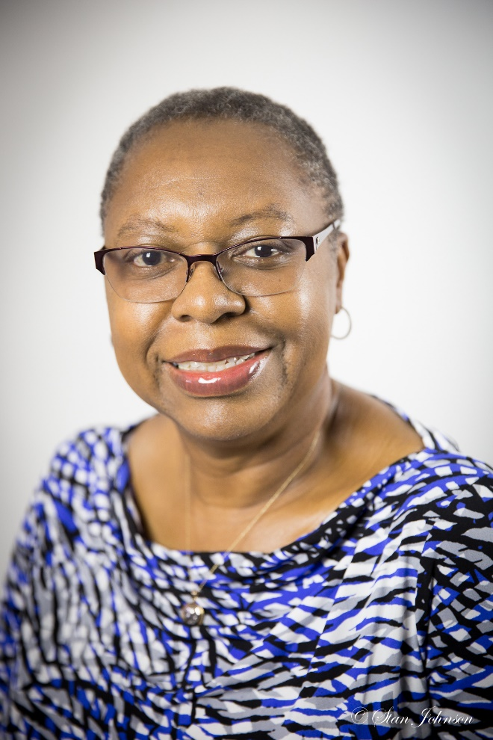

**Top 20 Book Marketing Tips**

This class will provide participants with the Top 20 marketing techniques needed for reaching their book selling goals. Using the principles from my bestselling book titled, *A Writer’s Guide to Publishing & Marketing: How to write, publish, and market books*, my sensible strategies will focus on “low cost” and “no cost” marketing.