Group: Azzzhole.

Project: Dating Application.

Introduction: These two are the use case diagrams.

Normal Use Case Diagram

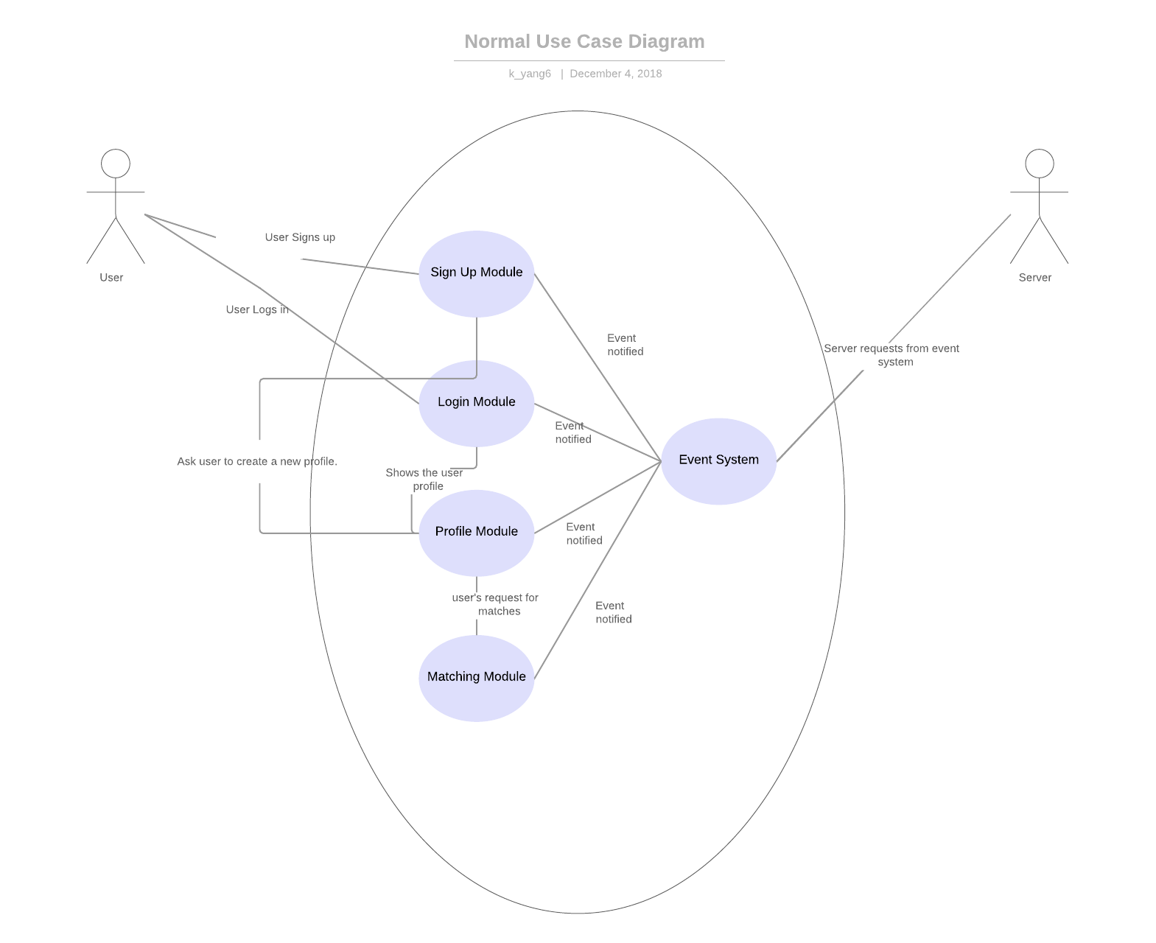

Actors: There are two actors with in the application, the client and the server.

Use Case: This is a dating application that requires the client interacting with the server. The interactions are divided into 3 major steps.

1. The client signs into the server, then client has the permission to create a new profile with in the dating app. Finally, the client has the ability to do step 3.
2. The client logs into the server, then the client has the permission to view, modify or delete the profile. The client also has the ability to do step 3.
3. Once, the client has the full access to the profile. The client has the abilities to view matches, or to create a match with other profiles.

Once the client is finished with all of the above steps, the clients can terminate the application. Then the application will terminate the connection with the server.

Error Use Case Diagram

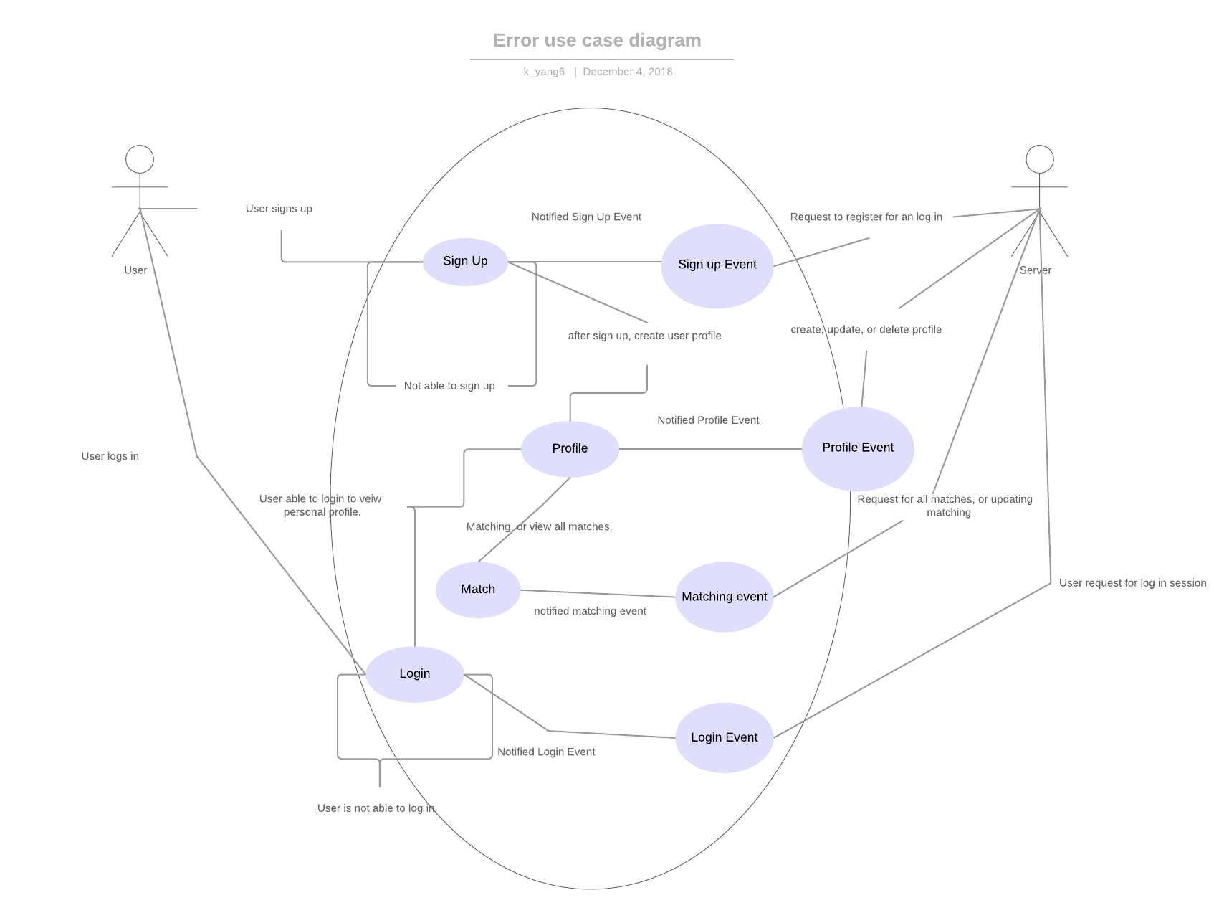

Actor: The clients and the server.

Use Case: In this diagram, it further illustrates the interaction between the client and the server within the dating application. In this use case description, it will be further illustrating the logic and error checking with the dating application.

1. The client signs up an account with the server, if the client is not able to sign up, the application will re-prompt the client to sign up for a different account. If the client is successfully signed in an account, the application will redirect the client to create the profile for this account. Once the client has finished creating the account, the client has the ability to do read, write, or delete the client’s personal profile, or the ability to perform step 3.
2. The client sends a log in request to the server, if the client can not log in, the application will re-prompt the client to log into an account with correct log in credentials. The client has the ability to read, write, or delete the client’s unique personal profile. The client has the ability to perform step 3.
3. Once the client has the full access to the client’s unique profile; the client has the ability to read all the matched or un-matched profiles, and the client also has the ability to make matches with un-matched profiles.

If the client has finished with the above procedures. The client can sign out and shutdown the application.