Manual de estilo aplicación Aulesco

2º DAW

Diego Villaverde PRado

2018

COLORES PRINCIPALES DE LA APLICACIÓN

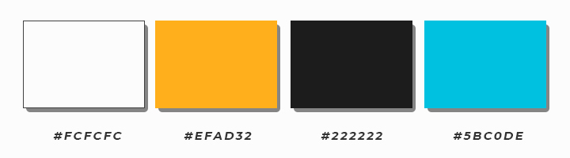

FUENTE DE LA APLICACIÓN

***16 PX***

“Helvetica Neue”

Bootstrap Default

ESTILOS GENERALES

BOTONES (Por defecto de Bootstrap)



|  |  |
| --- | --- |
| .btn {  display: inline-block  padding: 6px 12px;  margin-bottom: 0;  font-size: 14px;  font-weight: normal;  line-height: 1.42857143;  text-align: center;  white-space: nowrap;  vertical-align: middle;  -ms-touch-action: manipulation;  touch-action: manipulation; | cursor: pointer;  -webkit-user-select: none;  -moz-user-select: none;  -moz-user-select: none;  user-select: none;  background-image: none;  border: 1px solid transparent;  border-radius: 4px;  } |
|  |  |

FORMULARIOS (Por defecto de Bootstrap)

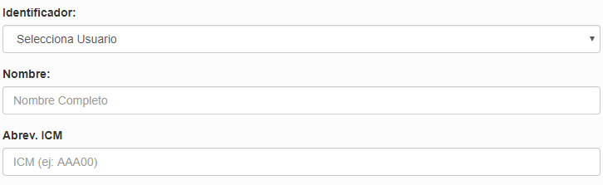

|  |  |
| --- | --- |
| .form-control {  display: block;  width: 100%;  height: 34px;  padding: 6px 12px;  font-size: 14px;  line-height: 1.42857143;  color: #555;  background-color: #fff;  background-image: none;  border: 1px solid #ccc;  border-radius: 4px; | -webkit-box-shadow: inset 0 1px 1px rgba(0, 0, 0, .075);  box-shadow: inset 0 1px 1px rgba(0, 0, 0, .075);  -webkit-transition: border-color ease-in-out .15s, -webkit-box-shadow ease-in-out .15s;  -o-transition: border-color ease-in-out .15s, box-shadow ease-in-out .15s;  transition: border-color ease-in-out .15s, box-shadow ease-in-out .15s;  } |

ESTILO CSS GENERAL DE LA APLICACIÓN

|  |  |
| --- | --- |
| body {  background-color: #fcfcfc;  min-width: 300px;  }  #logo {  width: 50%;  max-width:200px;  }  #header{  background-size: cover;  background-color: #3a3a3a;  background-image: url("./../img/header.jpg");  } | #logo{  padding-top: 3%;  padding-bottom: 3%;  }  /* Title */  .navbar-inverse .navbar-brand {  color: #efad32;  }  .navbar-inverse .navbar-brand:hover,  .navbar-inverse .navbar-brand:focus {  color: #fcfcfc;  } |

**NAVBAR DESKTOP**



**NAVBAR RESPONSIVE**

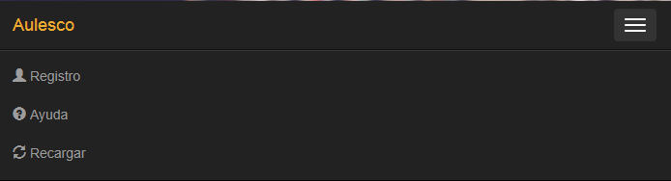

**Clases**: navbar navbar-inverse navbar-static-top

|  |
| --- |
| .navbar-inverse .navbar-brand {  color: #efad32;  }  .navbar-inverse .navbar-brand:hover,  .navbar-inverse .navbar-brand:focus {  color: #fcfcfc;  } |

LOGIN

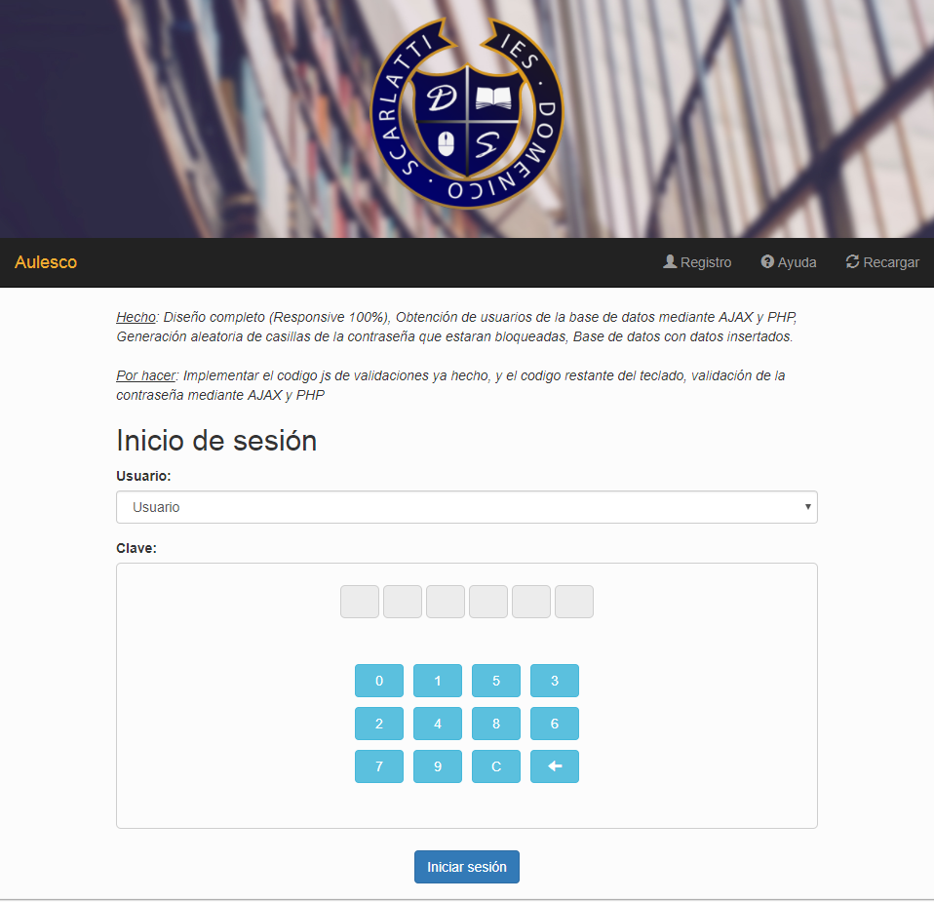



|  |  |
| --- | --- |
| **Clases** |  |
| Botones | btn btn-info |
|  | btn btn-primary |
| Input | text-center |
| Iconos | icon-bar  glyphicon glyphicon-user  glyphicon glyphicon-question-sign  glyphicon glyphicon-refresh |
| header | img-responsive center-block |
| Elementos de formulario | form-control |
|  |  |

**CODIGO CSS - Index.html**

|  |  |
| --- | --- |
| #div_pwd{  border: 1px solid #cecece;  border-radius: 5px;  padding-bottom: 3%;  padding-top: 3%;  margin-bottom:3%;  }  #div_pwd input{  width: 40px;  line-height: 2em;  border: 1px solid #cecece;  border-radius: 5px;  background-color: #ececec;  font-weight:bold;  font-size: 15px;  background-repeat: no-repeat;  background-position: center;  } | #div_teclado table{  position: relative;  top: 0px;  }  #div_teclado{  margin-top: 20px;  padding-top: 3%;  padding-bottom: 20px;  }  #div_teclado button{  width: 50px;  }  #login_div{  margin-bottom: 50px;  } |

REGISTRO

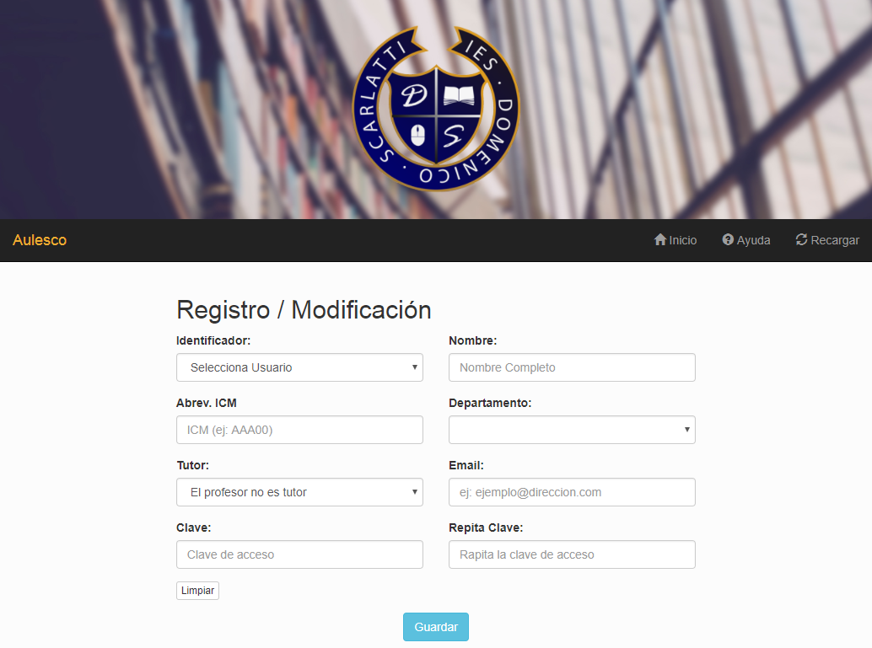

|  |  |
| --- | --- |
| **Clases** |  |
| Botones | btn btn-info |
|  | btn btn-danger  btn btn-success |
| Input | text-center |
| Iconos | icon-bar  glyphicon glyphicon-user  glyphicon glyphicon-question-sign  glyphicon glyphicon-refresh  glyphicon glyphicon-trash  glyphicon glyphicon-download-alt  glyphicon glyphicon-search |
| header | img-responsive center-block |
| Elementos de formulario | form-control  form-group |

**CODIGO CSS - registro.html**

|  |
| --- |
| #identificador_input {  background-color: #FCFCFC;  } |

RESERVA DE AULAS

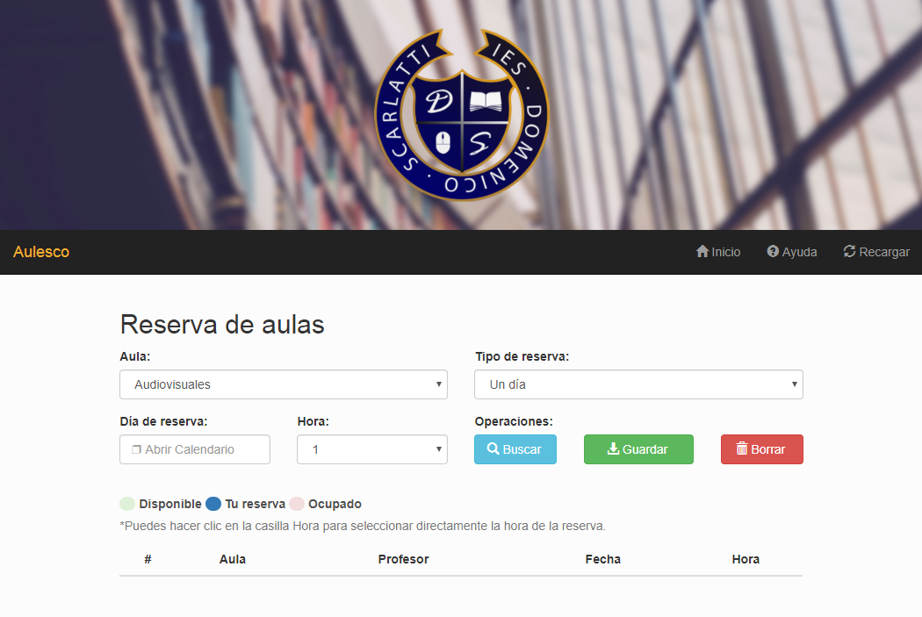

|  |  |
| --- | --- |
| **Clases** |  |
| Botones | btn btn-info |
|  | btn btn-danger  btn btn-success |
| Input | text-center |
| Iconos | icon-bar  glyphicon glyphicon-user  glyphicon glyphicon-question-sign  glyphicon glyphicon-refresh  glyphicon glyphicon-trash  glyphicon glyphicon-download-alt  glyphicon glyphicon-search |
| header | img-responsive center-block |
| Elementos de formulario | form-control  form-group |
| Span | bg-success  bg-primary  bg-danger |

**CODIGO CSS - reservas.html**

|  |  |
| --- | --- |
| .glyphicon.glyphicon-menu-hamburger{  font-size: 75px;  margin-top: 30px;  margin-bottom: 30px;  padding: 20px;  }  .glyphicon.glyphicon-edit, .glyphicon.glyphicon-share, .glyphicon.glyphicon-open-file, .glyphicon.glyphicon-copy {  font-size: 45px;  margin-bottom: 10px;  padding: 20px;  }  .glyphicon.glyphicon-remove-circle {  font-size: 30px;  }  .glyphicon.glyphicon-hand-up {  font-size: 20px;  }  #icono_menu {  border: 6px solid #333333;  border-radius: 100px;  }  h3 {  margin-bottom: 20px;  } | #leyenda span{  padding-left: 18px;  border-radius: 18px;  }  #leyenda {  margin-top: 20px;  color: #4f4f4f;  }  th, td{  text-align: center;  }  td:nth-child(3) {  text-align: left;  }  td:last-child{  font-weight: bold;  }  td select {  float: right;  width: 60px !important;  }  td select option {  padding-top: 40x;  padding-bottom: 4x;  } |

RESERVA DE AULAS

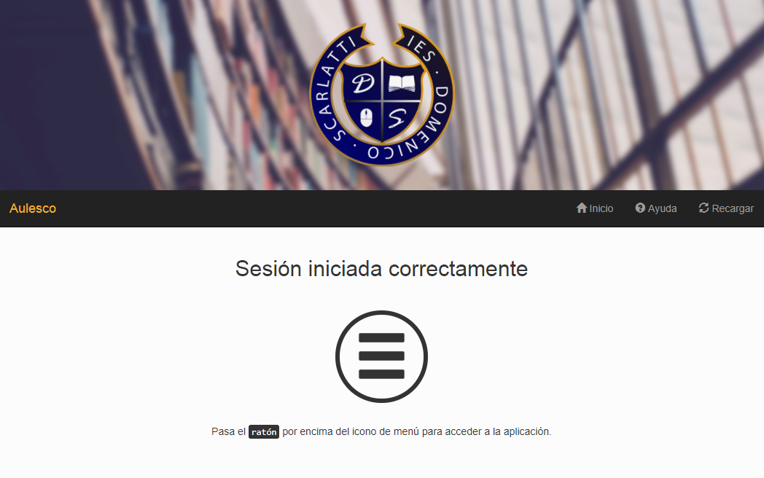

|  |  |
| --- | --- |
| **Clases** |  |
| Botones | btn btn-info |
|  | btn btn-danger  btn btn-success |
| Input | text-center |
| Iconos | icon-bar  glyphicon glyphicon-user  glyphicon glyphicon-question-sign  glyphicon glyphicon-refresh  glyphicon glyphicon-menu-hamburger  glyphicon glyphicon-remove-circle  glyphicon glyphicon-edit  glyphicon glyphicon-share  glyphicon glyphicon-open-file  glyphicon glyphicon-copy |
| header | img-responsive center-block |
| Elementos de formulario | form-control  form-group |
| Span | bg-success  bg-primary  bg-danger |

**CODIGO CSS - menu.html**

|  |  |
| --- | --- |
| .glyphicon.glyphicon-menu-hamburger{  font-size: 75px;  margin-top: 30px;  margin-bottom: 30px;  padding: 20px;  }  .glyphicon.glyphicon-edit, .glyphicon.glyphicon-share, .glyphicon.glyphicon-open-file, .glyphicon.glyphicon-copy {  font-size: 45px;  margin-bottom: 10px;  padding: 20px;  } | .glyphicon.glyphicon-remove-circle {  font-size: 30px;  }  #icono_menu {  border: 6px solid #333333;  border-radius: 100px;  }  h3 {  margin-bottom: 20px;  } |

MULTIMEDIA

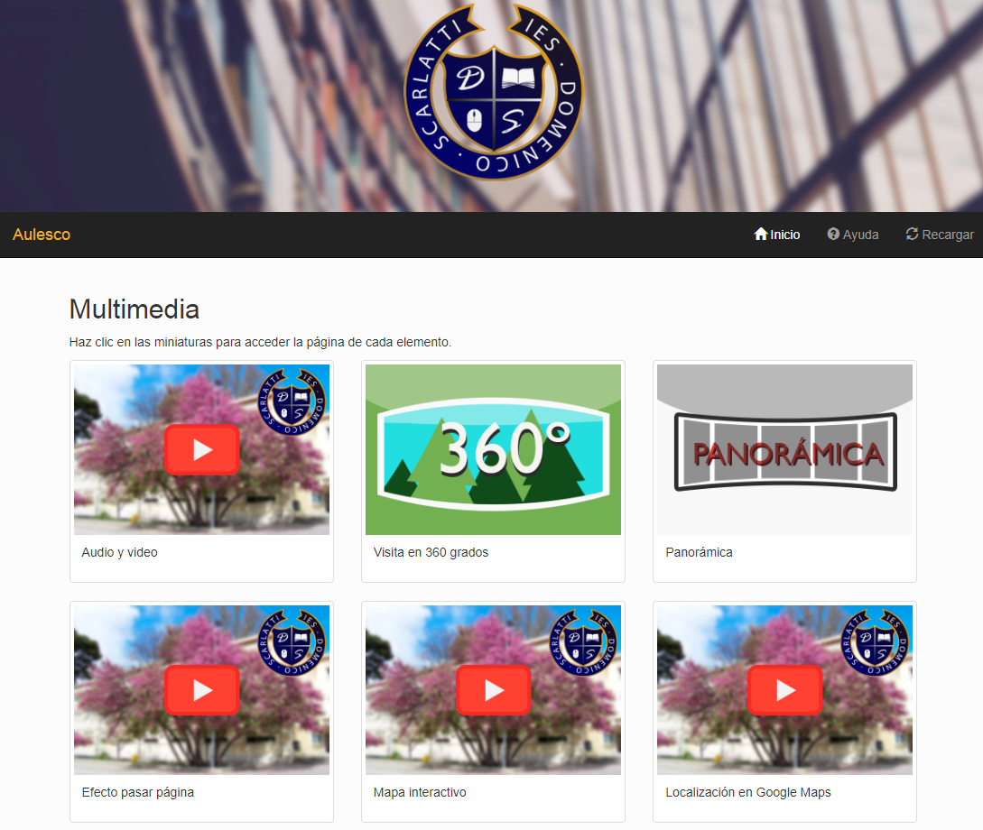

|  |  |
| --- | --- |
| **Clases** |  |
| Botones | btn btn-info |
|  | btn btn-danger  btn btn-success |
| Input | text-center |
| Iconos | icon-bar  glyphicon glyphicon-user  glyphicon glyphicon-question-sign  glyphicon glyphicon-refresh |
| header | img-responsive center-block |
| Span | bg-success  bg-primary  bg-danger |
| imagenes | thumbnail  caption |

IMÁGENES

Logotipo



Header



Icono de pestaña



Icono casilla bloqueada (Login)



Miniaturas página (multimedia)

