We have some questions about pass.

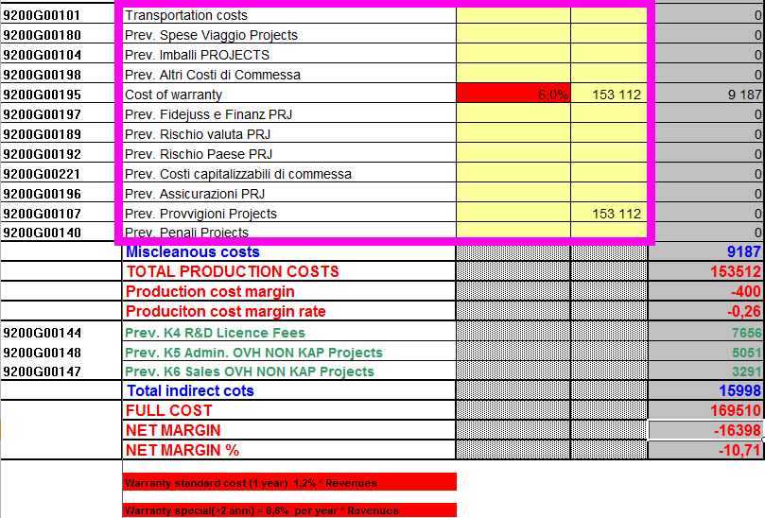

Screenshot 1

1.You have told us, that we should insert this fields into configurator, but they are empty, there only field “Cost of warranty” have calculations (screenshot 1), what about calculations in other fields?



Screenshot 2

2. Field “Cost of warranty”, there 6.0% * Transfer Price (that provided by user), how did you get value 6%? Is it 10 year of warranty * 0.6%(Screenshot 2)?

3.What about “Other contingency”, I didn’t find it in last excel document.



Screenshot 3

4.In previous documents like “2013 Calculation model“, cost Material of Packing calculated in second part of calculations with warranty, other contingency, should it calculate in cost of all materials now (Screenshot3)?

5.What about translation of fields (Screenshot 1), should we use google translate?

List of changes for PASS that we already discussed. Here only list:

**1. add note with product descripiton**

**2. add info about expeced number of compoonents (ex 3)**

**3. Either enable editing number when checkin is selected or automatically select checkin when user edit number**

**4. change currency to proper**

**5. remove category and clarificatoin form list of product view**

**6. Make 'warranty' field mandatory**

**7. disable '+" when there is one product already added**

**8. fix discount - as it doesn't work now**

**9. change tender ID to the same value that is prexented in CCP**

**10. change Selectica LTB to something specific to PASS configurator**

**11. use proper units (currency, time)**

**12. add extra input fields for every section**

**13. describe what '-'. Now there is description from "+"**