P3

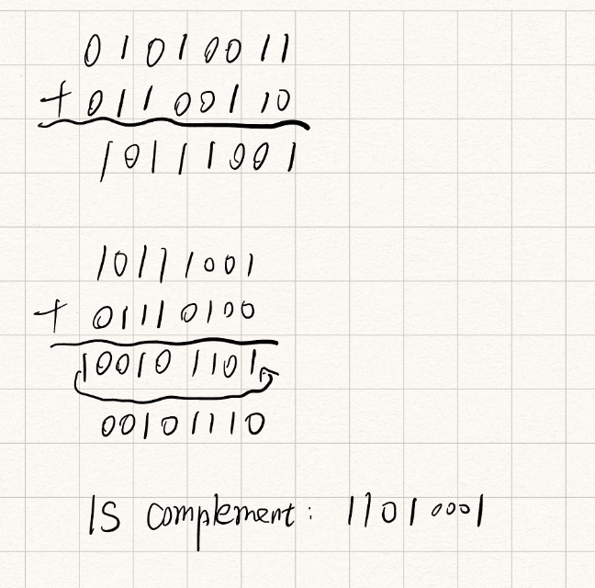

To detect errors , add the four words , if the sum contains a zero , then the receiver knows there is an error . All 1-bit errors will be detected , but two-bit errors can be undetected.

P8

I think the FSM for the receiver side of protocol rdt3.0 is the same as that of protocol rdt2.2

