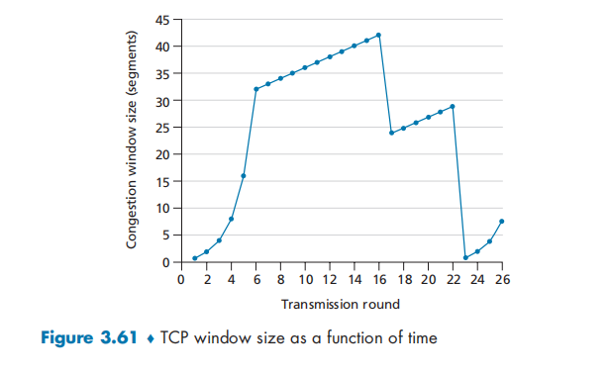

**P40. Consider Figure 3.61. Assuming TCP Reno is the protocol experiencing the behavior shown above, answer the following questions. In all cases, you should provide a short discussion justifying your answer.**

1. **Identify the intervals of time when TCP slow start is operating.**

The intervals of time when TCP slow start is operating is 1-6 and 23-26. At this time, the congestion window size is increasing by doubling.

1. **Identify the intervals of time when TCP congestion avoidance is operating.**

The intervals of time when TCP congestion avoidance is operating is from 6-16 and 17-23. At this time, the congestion window size is increasing by 1.

1. **After the 16th transmission round, is segment loss detected by a triple duplicate ACK or by a timeout?**

After the 16th transmission round, the segment loss is detected by a triple duplicate ACK. Because at 17th, the size of congestion window is decrease by half. If there is a timeout, the congestion window size will be 1.

1. **After the 22nd transmission round, is segment loss detected by a triple duplicate ACK or by a timeout?**

After the 22nd transmission round, the segment loss is detected by a timeout. Because at 23th, the congestion size decrease to 1. And after the segment loss, there is a slow start.

1. **What is the initial value of ssthresh at the first transmission round?**

The initial value of ssthresh is 32. After the 6th, the congestion window is increasing by 1 each transmission round, which means TCP congestion avoidance is operating. And before 6th, the window is increasing by doubling, which means the slow start is operating. So the 6th’s size, 32, is the initial value of ssthresh.

1. **What is the value of ssthresh at the 18th transmission round?**

The threshold is set to half the value of the congestion window when packet loss is detected. At the 16th, when packet loss is detected, the size of congestion window is 42. so the ssthresh is 21 during the 18th transmission round.

**g. What is the value of ssthresh at the 24th transmission round?**

At 22th, a packet loss is detected. And the size of congestion window is 26. so the value of ssthresh at 24th transmission round is 13.

**h. During what transmission round is the 70th segment sent?**

During 1th transmission round 1th packet is sent.

During 2th transmission round 2-3th packet is sent.

During 3th transmission round 4-7th packet is sent.

During 4th transmission round 8-15th packet is sent.

During 5th transmission round 16-31th packet is sent.

During 6th transmission round 32-63th packet is sent.

During 7th transmission round 64-96th packet is sent.

So the 70th segment is sent during 7th transmission round.

**i. Assuming a packet loss is detected after the 26th round by the receipt of a triple duplicate ACK, what will be the values of the congestion window size and of ssthresh?**

Because a triple duplicate ACK is receipted, the value of congestion will be set to 4, which is half of the 26th value of the congestion window.

The ssthresh will be set to 4, which is half of the 26th value of the congestion window too.

**j. Suppose TCP Tahoe is used (instead of TCP Reno), and assume that triple duplicate ACKs are received at the 16th round. What are the ssthresh and the congestion window size at the 19th round?**

Because triple duplicate ACKs are received at the 16th round, the ssthresh will be set to 21, which is half of the size of 16th window.

Because TCP Tahoe always sets cwnd to 1 (timeout or 3 duplicate acks), the congestion window size at the 17th is 1, and at 18th is 2, 19th is 4. In a word,congestion window size at the 19th round is 4.

**k. Again suppose TCP Tahoe is used, and there is a timeout event at 22nd round. How many packets have been sent out from 17th round till 22nd round, inclusive?**

During 17th transmission round 1 packet is sent.

During 18th transmission round 2 packets is sent.

During 19th transmission round 4 packets is sent.

During 20th transmission round 8 packets is sent.

During 21th transmission round 16 packets is sent.

During 22th transmission round 21 packets is sent.

So 52 packets have been sent out from 17th round till 22nd round.

**P44. Consider sending a large file from a host to another over a TCP connection that has no loss.**

1. **Suppose TCP uses AIMD for its congestion control without slow start. Assuming cwnd increases by 1 MSS every time a batch of ACKs is received and assuming approximately constant round-trip times, how long does it take for cwnd increase from 6 MSS to 12 MSS (assuming no loss events)?**

At 1th RTT, the cwnd increase from 6MSS to 7MSS.

At 2th RTT, the cwnd increase from 7MSS to 8MSS.

At 3th RTT, the cwnd increase from 8MSS to 9MSS.

At 4th RTT, the cwnd increase from 9MSS to 10MSS.

At 5th RTT, the cwnd increase from 10MSS to 11MSS.

At 6th RTT, the cwnd increase from 11MSS to 12MSS.

So it takes 6 RTT for cwnd increase from 6 MSS to 12 MSS.

**b. What is the average throughput (in terms of MSS and RTT) for this connection up through time = 6 RTT?**

Total segments sent over first 6 RTTs: 6+7+8+9+10+11 = 51. so the average throughput for this connection is 51/6 = 8.5MMS/RTT.