**P1.Consider the network below.**

**a. Show the forwarding table in router A, such that all traffic destined to host H3 is forwarded through interface 3.**

**b. Can you write down a forwarding table in router A, such that all traffic from H1 destined to host H3 is forwarded through interface 3, while all traffic from H2 destined to host H3 is forwarded through interface 4? (Hint: This is a trick question.)**

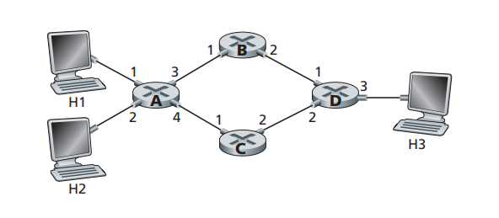

1. The forwarding table in router A is shown below.

Because all traffic destined to host H3 is forwarded through interface 3, destination address H3 is linked to interface 3.

|  |  |
| --- | --- |
| Destination address | interface |
| H3 | 3 |

1. No, it is not possible.

Because the forwarding rule is based on destination address only.

**P4. Consider the switch shown below. Suppose that all datagrams have the same fixed length, that the switch operates in a slotted, synchronous manner, and that in one time slot a datagram can be transferred from an input port to an output port. The switch fabric is a crossbar so that at most one datagram can be transferred to a given output port in a time slot, but different output ports can receive datagrams from different input ports in a single time slot. What is the minimal number of time slots needed to transfer the packets shown from input ports to their output ports, assuming any input queue scheduling order you want (i.e., it need not have HOL blocking)? What is the largest number of slots needed, assuming the worst-case scheduling order you can devise, assuming that a non-empty input queue is never idle?**

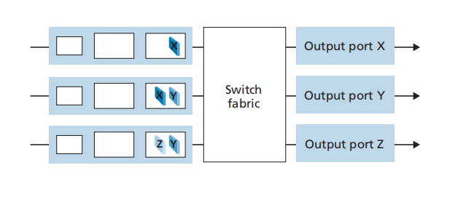

The minimal number of time slots needed to transfer the packets shown is 3 time slots.

The first slot: send X in the first input queue, and Y in the second input queue.

The second slot: send X in the second input queue, and Y in the third input queue.

The third slot: send Z in the last input queue.

The largest number of slots needed is 3.

Because in the first slot, X in the first input queue and Y in either the second input queue or third input queue will be sent. In the second slot, the first input queue is empty, and there is only one Y in the second or the third input queue. Two datagram will be sent. In the third slot, the last one datagram will be sent.

**P6. Consider the figure below. Answer the following questions:**

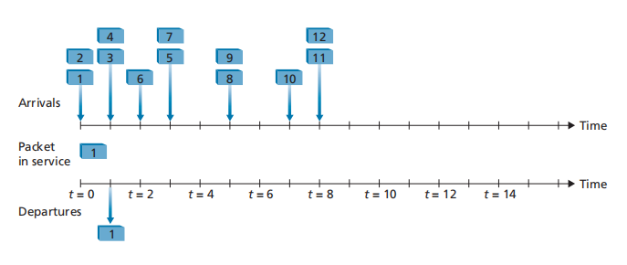

1. **Assuming FIFO service, indicate the time at which packets 2 through 12 each leave the queue. For each packet, what is the delay between its arrival and the beginning of the slot in which it is transmitted? What is the average of this delay over all 12 packets?**

|  |  |  |  |
| --- | --- | --- | --- |
| Packet | Arrival time | Departure time | Delay |
| 1 | 0 | 0 | 0 |
| 2 | 0 | 1 | 1 |
| 3 | 1 | 2 | 1 |
| 4 | 1 | 3 | 2 |
| 5 | 3 | 5 | 2 |
| 6 | 2 | 4 | 2 |
| 7 | 3 | 6 | 3 |
| 8 | 5 | 7 | 2 |
| 9 | 5 | 8 | 3 |
| 10 | 7 | 9 | 2 |
| 11 | 8 | 10 | 2 |
| 12 | 8 | 11 | 3 |

So the average of this delay over all 12 packets is (0+1+1+2+2+2+3+2+3+2+2+3)/12 = 1.92.

**b. Now assume a priority service, and assume that odd-numbered packets are high priority, and even-numbered packets are low priority. Indicate the time at which packets 2 through 12 each leave the queue. For each packet, what is the delay between its arrival and the beginning of the slot in which it is transmitted? What is the average of this delay over all 12 packets?**

|  |  |  |  |
| --- | --- | --- | --- |
| Packet | Arrival time | Departure time | Delay |
| 1 | 0 | 0 | 0 |
| 2 | 0 | 2 | 2 |
| 3 | 1 | 1 | 0 |
| 4 | 1 | 6 | 5 |
| 5 | 3 | 3 | 0 |
| 6 | 2 | 7 | 5 |
| 7 | 3 | 4 | 1 |
| 8 | 5 | 9 | 4 |
| 9 | 5 | 5 | 0 |
| 10 | 7 | 10 | 3 |
| 11 | 8 | 8 | 0 |
| 12 | 8 | 11 | 3 |

So the average of this delay over all 12 packets is (0+2+0+5+0+5+1+4+0+3+0+3)/12 = 1.92.

**c. Now assume round robin service. Assume that packets 1, 2, 3, 6, 11, and 12 are from class 1, and packets 4, 5, 7, 8, 9, and 10 are from class 2. Indicate the time at which packets 2 through 12 each leave the queue. For each packet, what is the delay between its arrival and its departure? What is the average delay over all 12 packets?**

|  |  |  |  |
| --- | --- | --- | --- |
| Packet | Arrival time | Departure time | Delay |
| 1 | 0 | 0 | 0 |
| 2 | 0 | 2 | 2 |
| 3 | 1 | 4 | 3 |
| 4 | 1 | 1 | 0 |
| 5 | 3 | 3 | 0 |
| 6 | 2 | 6 | 4 |
| 7 | 3 | 5 | 2 |
| 8 | 5 | 7 | 2 |
| 9 | 5 | 9 | 4 |
| 10 | 7 | 11 | 4 |
| 11 | 8 | 8 | 0 |
| 12 | 8 | 10 | 2 |

So the average of this delay over all 12 packets is (0+2+3+0+0+4+2+2+4+4+0+2)/12 = 1.92.

**d. Now assume weighted fair queueing (WFQ) service. Assume that odd numbered packets are from class 1, and even-numbered packets are from class 2. Class 1 has a WFQ weight of 2, while class 2 has a WFQ weight of 1. Note that it may not be possible to achieve an idealized WFQ schedule as described in the text, so indicate why you have chosen the particular packet to go into service at each time slot. For each packet what is the delay between its arrival and its departure? What is the average delay over all 12 packets?**

At the 0st time slot, there is 1 in class 1; 2 in class 2. The weight of class 1 is 2. The weight of class 2 is 1. So 1 is sent.

At the 1nd time slot, there is 3 in class 1;2,4 in class 2. The weight of class 1 is 2. The weight of class 2 is 2. So 3 is sent.

At the 2rd time slot, there is nothing in class 1; 2,4,6 in class 2. The weight of class 1 is 0. The weight of class 2 is 3. So 2 is sent.

At the 3th time slot, there is 5,7 in class 1; 4, 6 in class 2. The weight of class 1 is 4. The weight of class 2 is 2. So 5 is sent.

At the 4th time slot, there is 7 in class 1; 4,6 in class 2. The weight of class 1 is 2. The weight of class 2 is 2. So 7 is sent.

At the 5th time slot, there is 9 in class 1;4,6,8 in class 2. The weight of class 1 is 2. The weight of class 2 is 3. So 4 is sent.

At the 6th time slot, there is 9 in class 1; 6,8 in class 2. The weight of class 1 is 2. The weight of class 2 is 2. So 9 is sent.

At the 7th time slot, there is nothing in class 1; 6,8,10 in class 2. The weight of class 1 is 0. The weight of class 2 is 3. So 6 is sent.

At the 8th time slot, there is 11 in class 1; 8,10,12 in class 2. The weight of class 1 is 2. The weight of class 2 is 3. So 8 is sent.

At the 9th time slot, there is 11 in class 1; 10,12 in class 2. The weight of class 1 is 2. The weight of class 2 is 2. So 11 is sent.

At the 10th time slot, there is nothing in class 1; 10, 12 in class 2. The weight of class 1 is 2. The weight of class 2 is 2. So 10 is sent.

At the 11th time slot, there is nothing in class 1; 2 in class 2. The weight of class 1 is 2. The weight of class 2 is 1. So 12 is sent.

|  |  |
| --- | --- |
| Packet | Delay |
| 1 | 0 |
| 2 | 2 |
| 3 | 0 |
| 4 | 4 |
| 5 | 0 |
| 6 | 5 |
| 7 | 1 |
| 8 | 3 |
| 9 | 1 |
| 10 | 3 |
| 11 | 1 |
| 12 | 3 |

The average of this delay is (0+2+0+4+0+5+1+3+1+3+1+3)/12 = 1.92.

**e. What do you notice about the average delay in all four cases (FIFO, RR, priority, and WFQ)?**

If there is a packet sent at each time slot , the average delay will be the same.

But the delays of the packet values are different.

**P9. Consider a datagram network using 8-bit host addresses. Suppose a router uses longest prefix matching and has the following forwarding table:**

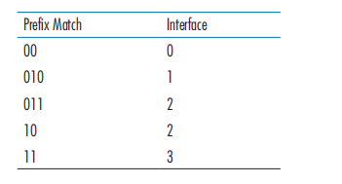

**For each of the four interfaces, give the associated range of destination host addresses and the number of addresses in the range.**

The associated range of interface 0 is 00000000 ~ 00111111. The number is 2^6 = 64.

The associated range of interface 1 is 01000000 ~ 01011111. The number is 2^5= 32.

The associated range of interface 0 is 01100000 ~ 01111111 and 10000000~10111111. The number is 2^6 + 2^5 = 96.

The associated range of interface 0 is 11000000 ~ 11111111. The number is 2^6 = 64.