**Data Mapping**

This section of the document will provide information about the relationship between the source data that we were given in the form of an Excel document, and the attributes of the final database in which the data was loaded. This document will specify which column of each sheet of the Excel document that was loaded into its database counterpart.

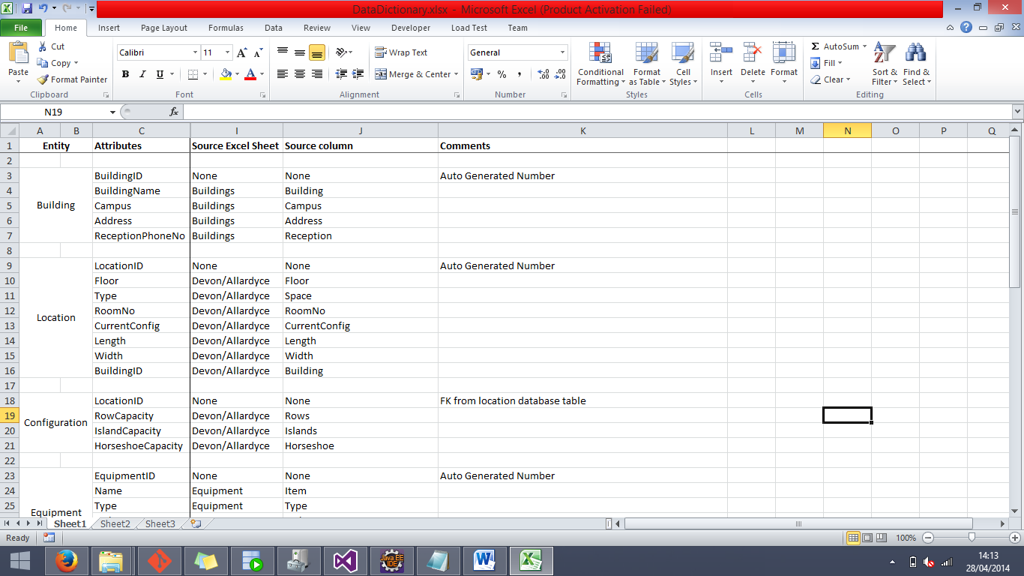**BUILDING**

The BUILDING entity is one of the simplest in the bunch; it was very clear cut as to which source column would be going into be going into which database column, as such, no clarification is needed on the above image.

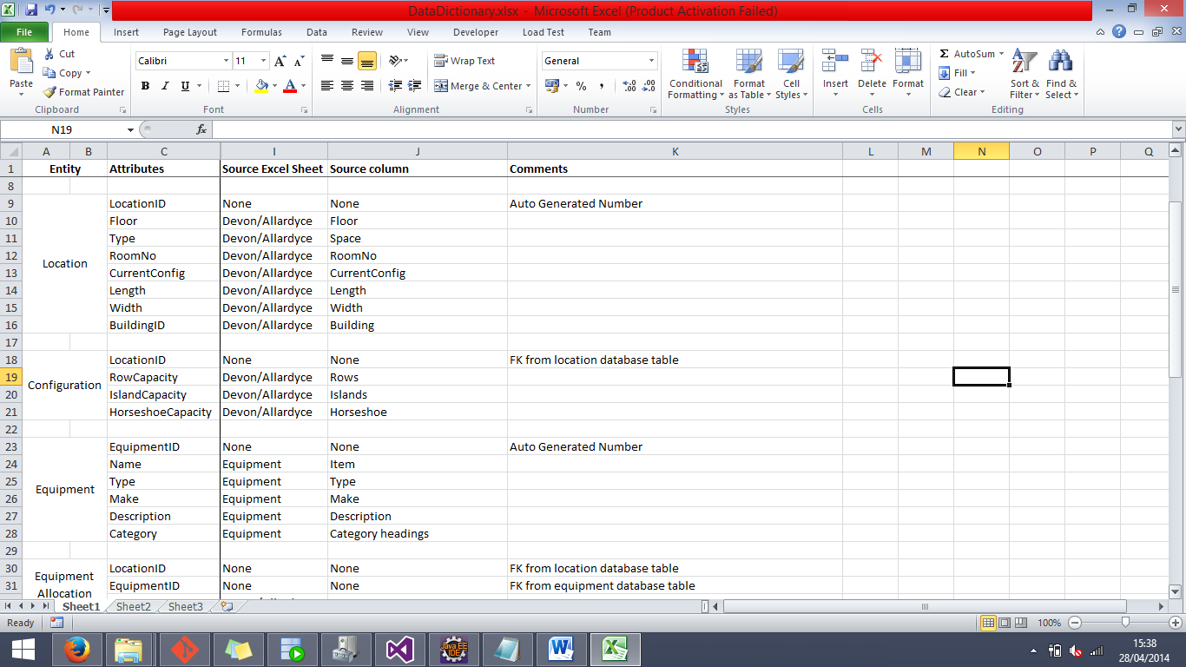**LOCATION**

The source data for the LOCATION entity came from multiple sheets (Devon & Allardyce) of the source document, as noted in the image above. The BuildingID attribute technically did have the source column of Building from the Buildings sheet, but this column was technically populated as a foreign key from the BUILDING entity.

**CONFIGURATION**

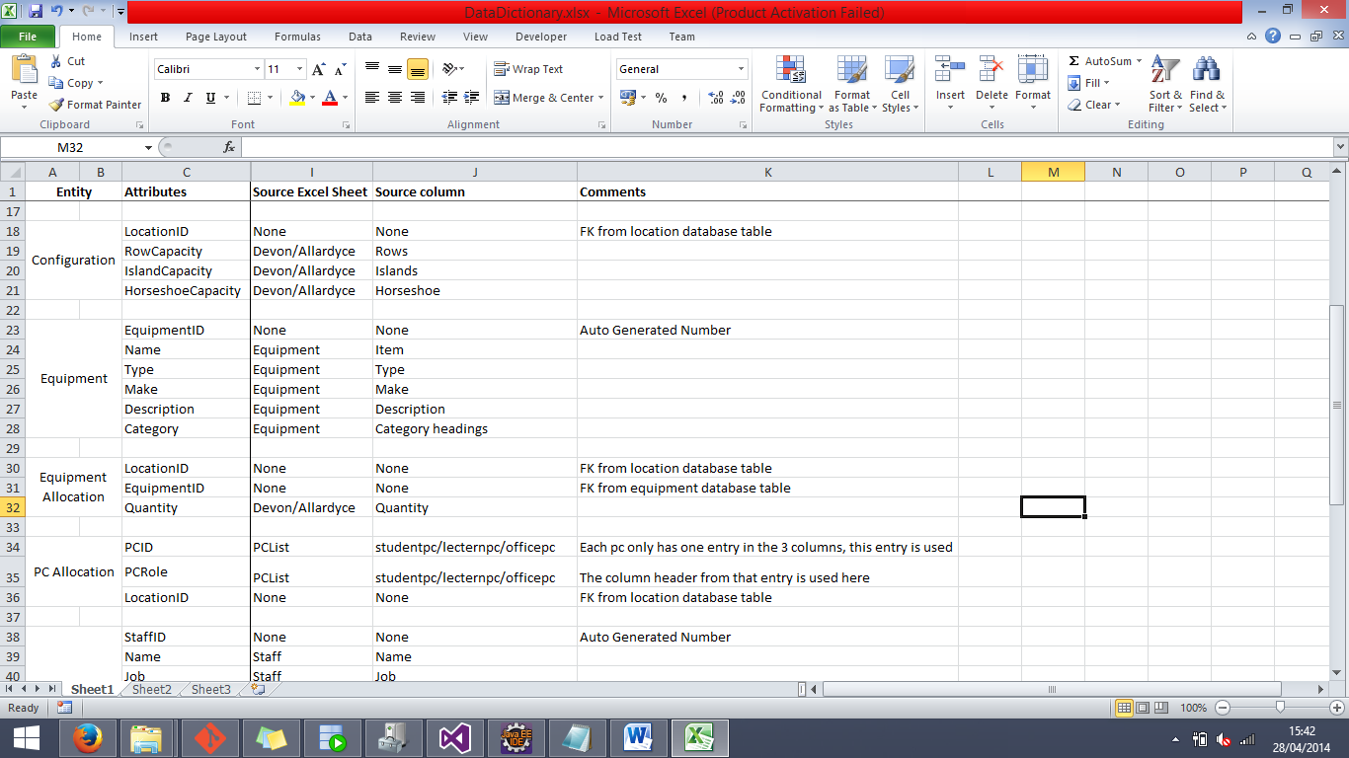

The LocationID from LOCATION serves as both the Primary Key of the table and a Foreign Key. It therefore does not have a source column from the Excel file.

**EQUIPMENT**

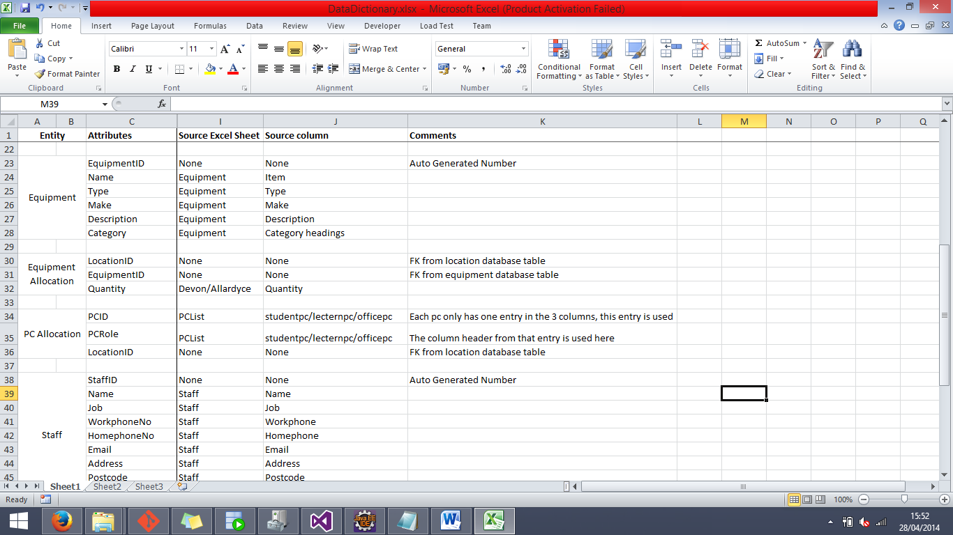The only unique circumstance that this in the EQUIPMENT table is that the Category attribute did not draw its data from a column per se. As described in the data loading explanation, they were simple headers at the top of each section, and had to be copied down in the Excel source file to match up the data.

**EQUIPMENT ALLOCATION**

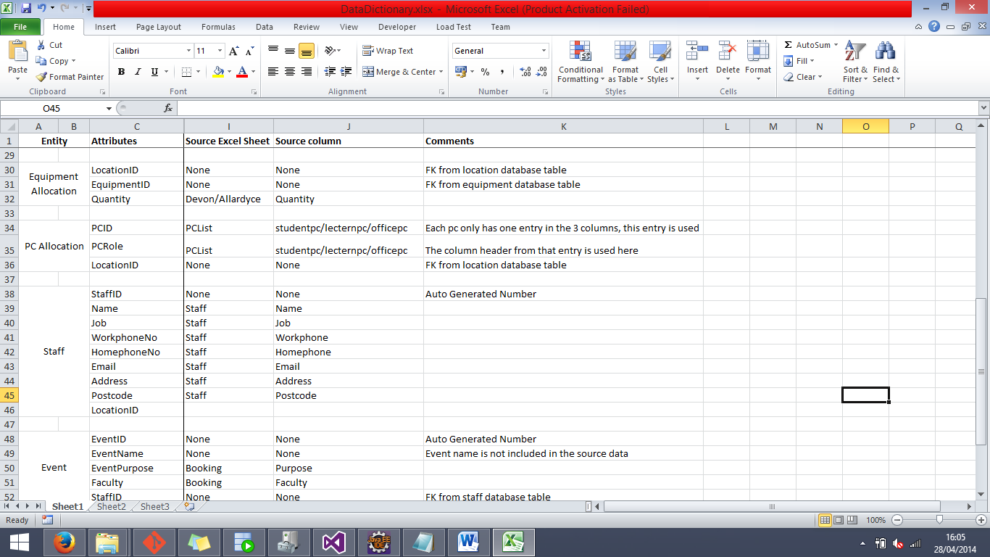This entity features two foreign keys from other tables, making it only one attribute from this table that has a source column directly loaded from the source Excel document.

**PC ALLOCATION**

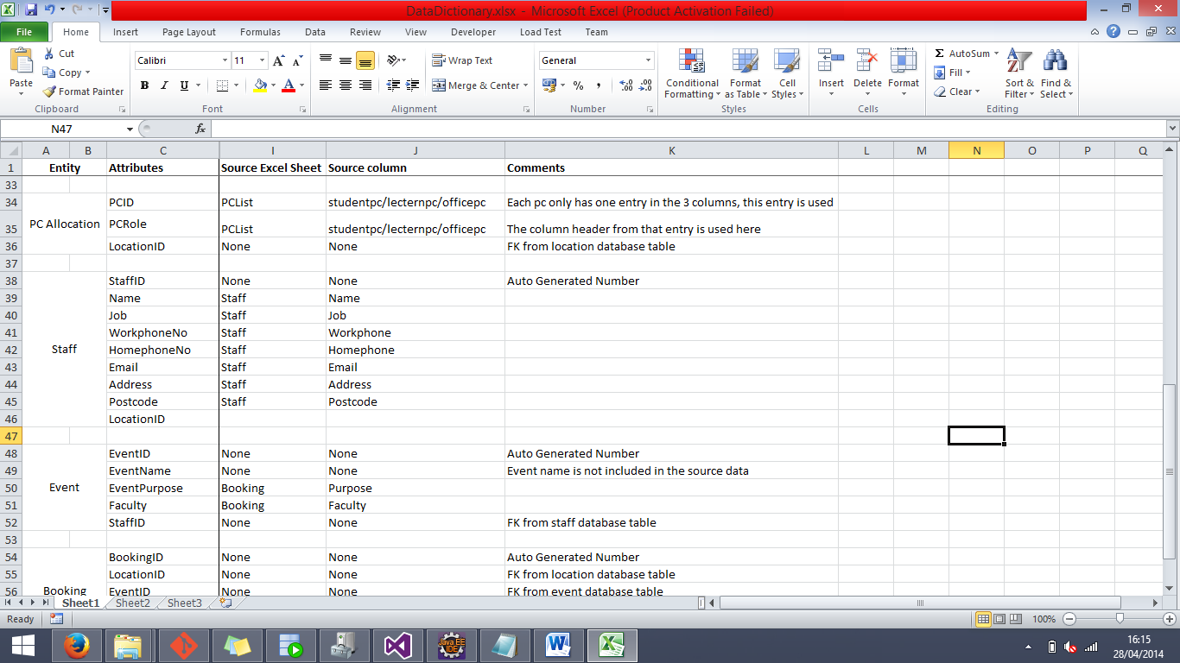As mentioned in the comments above, the PCID attribute actually has three different source columns, but all equating it essentially the same data. Another oddity from this entity would be that the PCRole attribute did not have its own column of data in the Excel file, but rather was populated using update statements based on which numbers were being inserted into the database at that time.

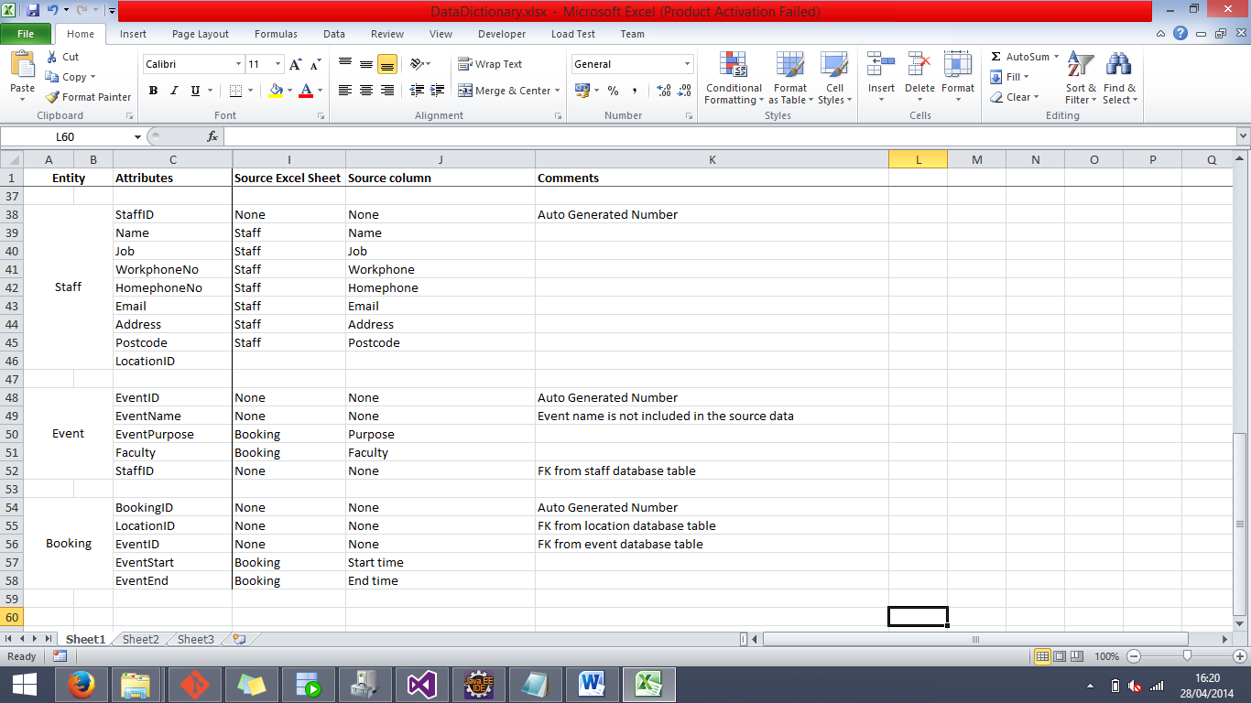**STAFF**

Staff was a very simple table with very little complicated about it with the exception that it would need LocationID as a foreign key to derive the office or room that they work in.

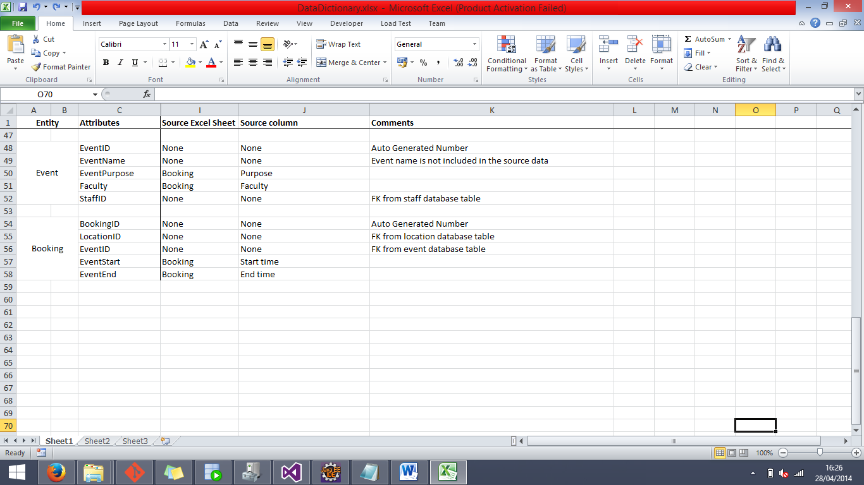**EVENT**

The only extraordinary thing about the EVENT entity was that, like mentioned just above, there is no EventName attribute listed in the data but it did not make sense to have Events without any names so it was decided to put that attribute in manually.

**BOOKING**

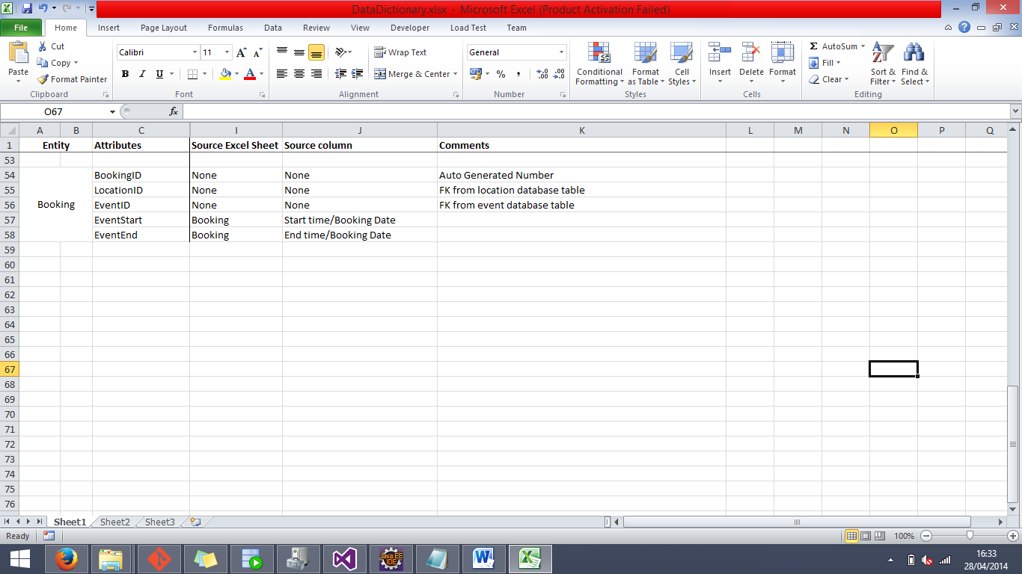Again, as mentioned in the data loading explanation, the EventStart and EventEnd attributes use both the time and date to complete their data, and such they have two source data columns.