**Database Specification Comments/Documentation**

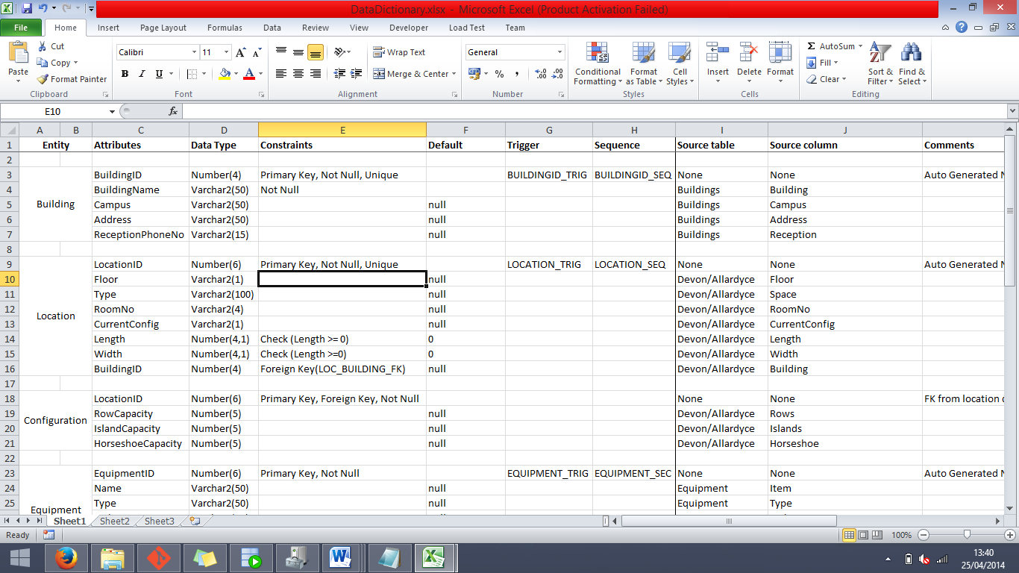This piece of documentation will go over every section of the database specification and provide comments on each column and significant constraint in the entity fields.

*(Note: The names of Primary Keys and Foreign Keys are listed next to the comments)*

**BUILDING**

***Attributes***

BuildingID (BUILDING_PK) – The purpose of this column is to provide a unique identifier generated from a sequence for the Building entity to serve as a primary key.

BuildingName – The purpose of this column is to store the name of the building.

Campus – The purpose of this column is to store the campus in which the associated building is located in.

Address – The purpose of this column is to store the address, most likely just the street name and number, of the associated building.

ReceptionPhoneNo – The purpose of this column is to hold the phone number that is linked to the reception in the building.

***Constraints***

*Sequences*

BUILDING_SEQ – The purpose of this sequence is to populate the BuildingID column whenever a new entry is inserted into the Building entity.

*Triggers*

BUILDING_TRIG – The purpose of this trigger is to act as an activator for the BUILDING_SEQ sequence, set to trigger after a row of data is inserted into the Building entity.

*Other Constraints*

BuildingID (Unique) – Due to the fact that this field is a Primary Key, it is by default unique.

BuildingName (Not Null) – We made this field Not Null because it would not make sense to add a building into the Building entity without even supplying it with a name, making it a redundant entry.

Campus, Address, ReceptionPhoneNo (Default Null) – These pieces of information about the building are less vital so we thought it would make sense to have the option to leave them as null to be added in later if desired.

**LOCATION**

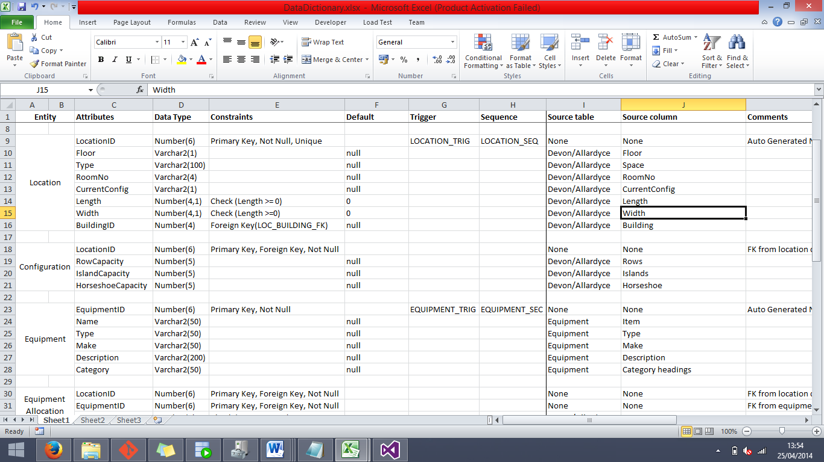

**Attributes**

LocationID (LOCATION_PK) – The purpose of this column is to provide a unique identifier generated from a sequence for the Location entity to serve as a primary key.

Floor – The purpose of this column is to specify the floor on which each location is on (G, 1, 2 etc).

Type – The purpose of this column is to specify the types of locations are stored in this entity. Examples of this are ones such as Classroom, Lecture Hall, Corridor etc.

RoomNo – The purpose of this column is to hold the room numbers of each location that it is applicable to, note that this only includes locations that class as teaching areas.

CurrentConfig – The purpose of this column is to specify the current configuration of that location, specified as a single letter (H, R, I).

Length – The purpose of this column is to specify the length (in meters) of the location, note that there is a CHECK constraint to ensure that this number cannot fall below 0.

Width – The purpose of this column is to specify the width (in meters) of the location, note that there is a CHECK constraint in place to ensure that this number cannot fall below 0.

BuildingID (LOC_BUILDING_FK) – The purpose of this column is to provide information about which building that the location is located in and to create a relationship between the two entities.

***Constraints***

*Sequences*

LOCATION_SEQ – The purpose of this sequence is to populate the LocationID column whenever a new entry is inserted into the Location entity.

*Triggers*

LOCATION_TRIG – The purpose of this trigger is to act as an activator for the LOCATION_SEQ sequence, set to trigger after a row of data is inserted into the Location entity.

*Other Constraints*

LocationID (Unique) – Due to the fact that this field is the primary key, it is automatically required to be unique.

Floor, Type, RoomNo, CurrentConfig, Length, Width, BuildingID (Default Null/0) – There is no absolute need for any single piece of data in this table, so everything has a default of null or 0 to let the user choose which information is included in the beginning.

Check (Length, Width) – These checks are in place to ensure that no value below 0 can be entered as location dimensions, as having a location with negative length and width would not make any sense.

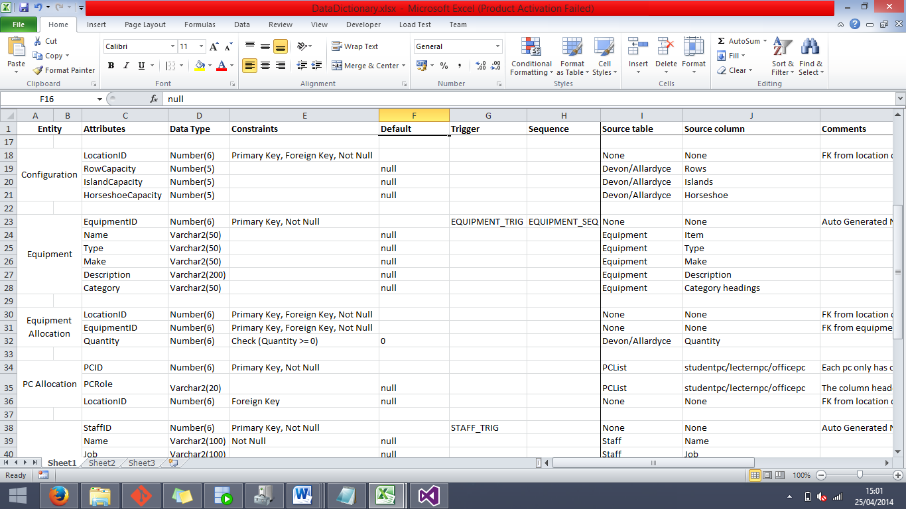**CONFIGURATION**

**Attributes**

LocationID (CONFIGURATION_PK, CONFIG_LOCATION_FK) – The purpose of this column is to both provide a unique identifier for the Configuration entity (as there will not be a single location that has two sets of configurations), and to provide a relationship link between the Location and Configuration entities.

RowCapacity – The purpose of this column is to store the capacity of the specified location as if it had the “Row” table layout in the room.

IslandCapacity – The purpose of this column is to store the capacity of the specified location as if it had the “Island” table layout in the room.

HorseshoeCapacity – The purpose of this column is to store the capacity of the specified location as if it had the “Horseshoe” table layout in the room.

**Constraints**

RowCapacity, IslandCapacity, HorseshoeCapacity (Default Null) – Due to the fact that not every location is going to have a capacity for each of these layouts (some locations will not have valid data for any of the layouts), the easiest solution was to include every location in the beginning and have Default Null for all three of these fields.

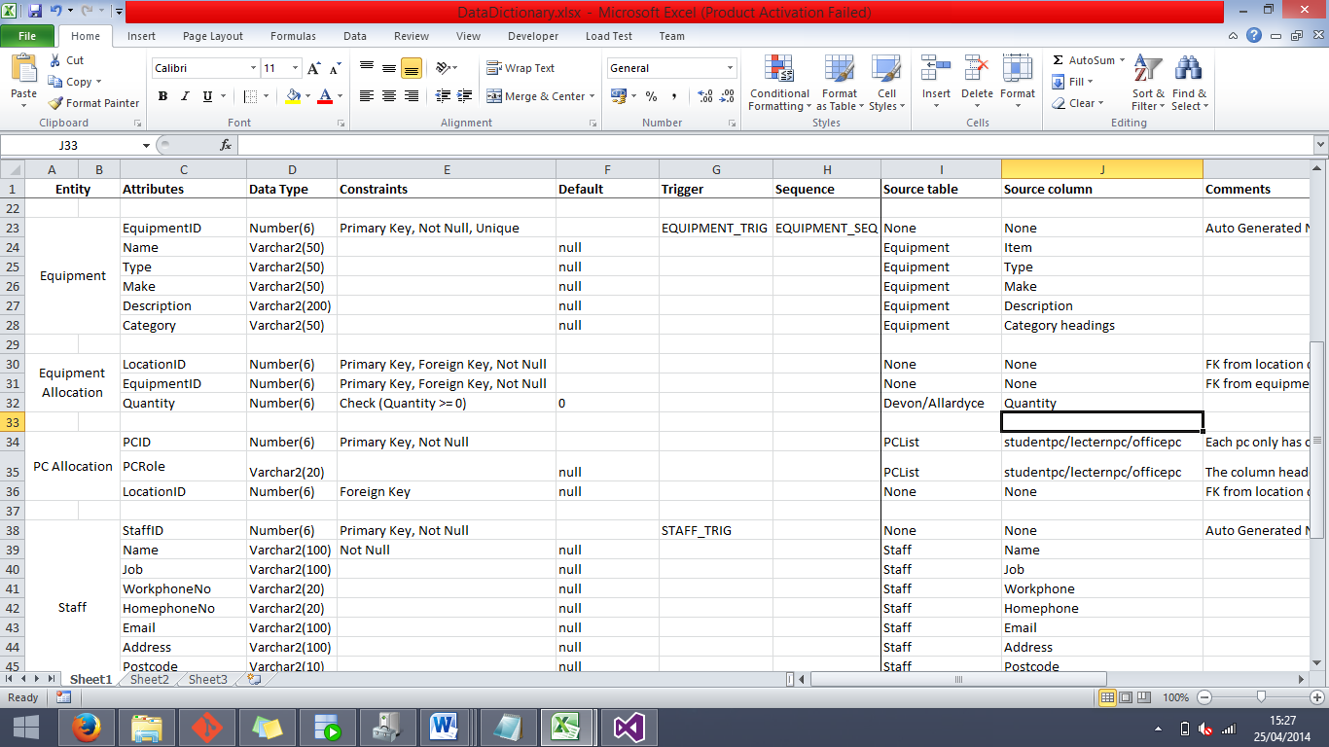**Equipment**

**Attributes**

EquipmentID (EQUIPMENT_PK) – The purpose of this column is to provide a unique index and serve as the Primary Key for the Equipment entity.

Name – The purpose of this column is to store the names of the pieces of equipment in the entity.

Type – The purpose of this column is to store the types of each piece of equipment, examples of this are table, chair, vacuum cleaner etc.

Make – The purpose of this column is to specify the manufacturer make and model number of the piece of equipment.

Description – The purpose of this column is to provide a short written description of the piece of equipment.

Category – The purpose of this column is to provide a rough category for each piece of equipment, examples of this are: cleaning equipment, furniture etc.

***Constraints***

*Sequences*

EQUIPMENT_SEQ – The purpose of this sequence is to populate the EquipmentID column whenever a new entry is inserted into the Equipment entity.

*Triggers*

EQUIPMENT_TRIG – The purpose of this trigger is to act as an activator for the EQUIPMENT_SEQ sequence, set to trigger after a row of data is inserted into the Equipment entity.

*Other Constraints*

EquipmentID (Unique, Not Null) – Due to the fact that this field is a Primary Key, it is automatically counted as Unique and Not Null.

Name, Type, Make, Description, Category (Default Null) – As none of these pieces of information are completely necessary at the creation of each row of data, we made the default for each field null.

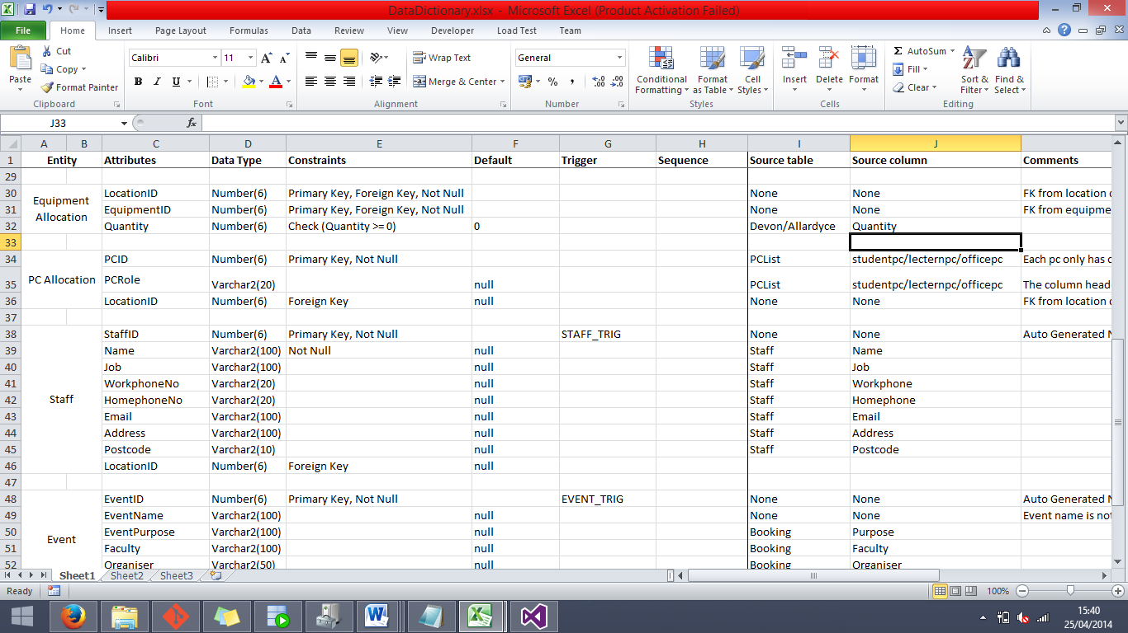**EQUIPMENT ALLOCATION**

**Attributes**

LocationID (EQUIPMENTALLOCATION_PK, EQUIPALLO_LOCATION_FK) – The purpose of this field is to work in conjunction with EquipmentID to provide a unique index for the Equipment Allocation entity to be used as a Primary Key, and to form a relationship with the Location entity to derive locations for each piece of equipment.

EquipmentID (EQUIPMENTALLOCATION_PK, EQUIPALLO_EQUIPMENT_FK) – The purpose of this field is to work in conjunction with LocationID to provide a unique index for the Equipment Allocation entity to be used as a Primary Key, and to form a relationship with the Equipment entity to derive pieces of equipment for each location.

Quantity – The purpose of this column is to represent the quantity of the item in every Location/Equipment pair.

***Constraints***

LocationID, EquipmentID (Not Null) – At the pair of these fields are what forms the Primary Key for this entity; it would not do very well to have either one of them as null at any time. Note that these fields are not required to be unique as most other Primary Keys are in other entities; this is due to the fact that there will be many pieces of the same equipment used in multiple locations and many locations will have multiple pieces of equipment.

Quantity (CHECK, Default 0) – This check is in place to make sure that the quantity entered cannot be below 0, as this would not make sense. The option is also there to leave the field blank for it to be set as 0, and fill it in later.

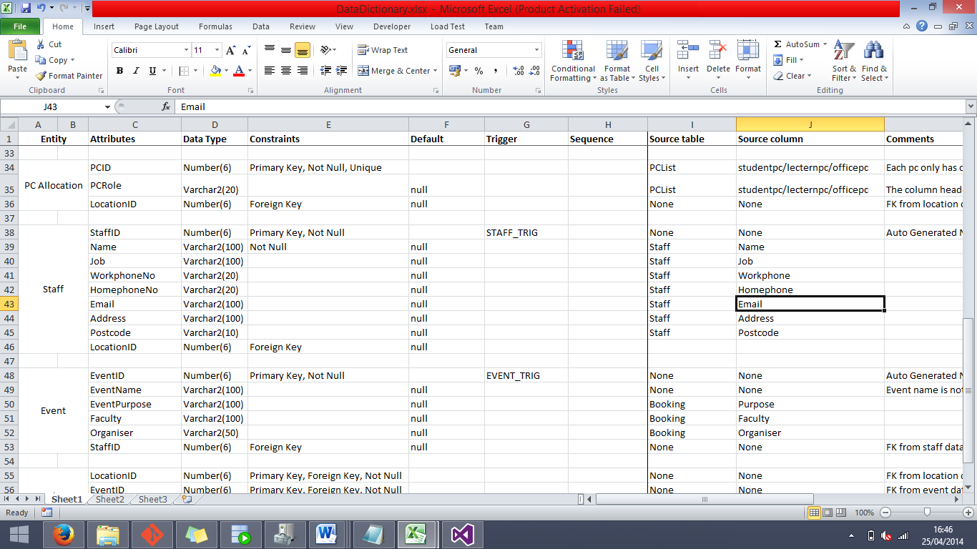**PC ALLOCATION**

**Attributes**

PCID (PCALLOCATION_PK) – The purpose of this field is to provide a unique index and to serve as the Primary Key for the PC Allocation entity.

PCRole – The purpose of this field is to specify the role of each PC that is listed within the PC Allocation table.

LocationID (PCALLO_LOCATION_FK) – The purpose of this field is to provide the location of each PC in the entity, and form a relationship between the PC Allocation and Location tables.

**Constraints**

PCID (Unique, Not Null) – Due to the fact that this field is the Primary Key for the PC Allocation entity, it is automatically set to Unique and Not Null.

PCRole, LocationID (Default Null) – As you don’t need both of these pieces of information to justify a row of data in this entity, these fields have a default of null so that you can come back later to fill it in.

**STAFF**

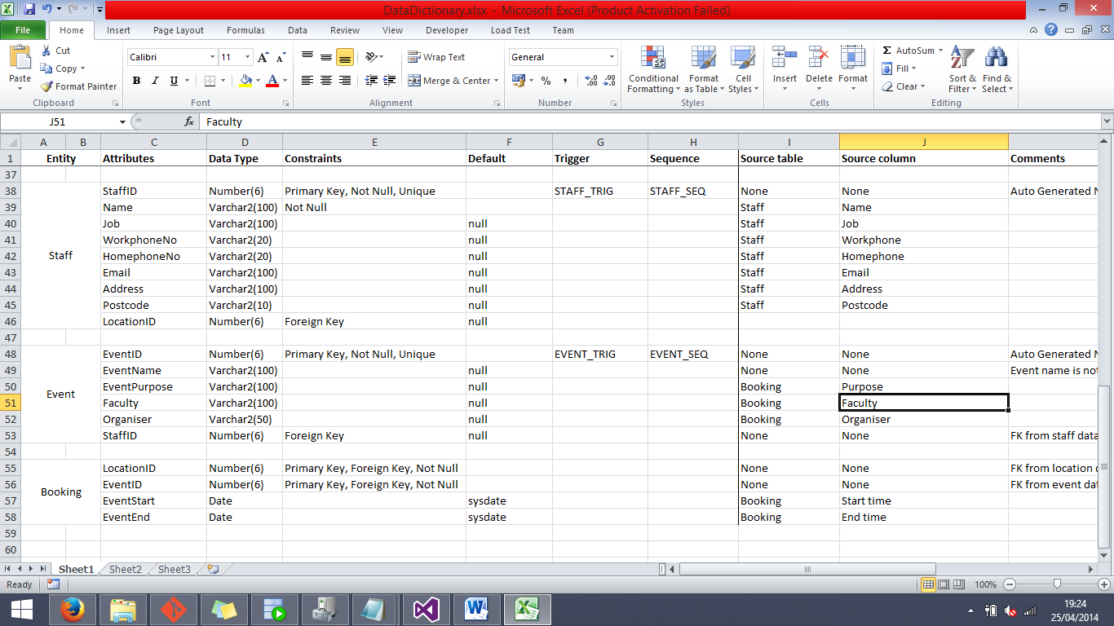

**Attributes**

StaffID (STAFF_PK) – The purpose of this column is to provide a unique index which is populated via a Sequence and Trigger, and to act as a Primary Key for the Staff entity.

Name – The purpose of this column is to store the names of each member of staff in this entity.

Job – The purpose of this column is to store the position that each member of staff hold at the university.

WorkphoneNo – The purpose of this column is to store the workplace phone numbers of each member of staff.

Homephoneno – The purpose of this column is to store the home phone numbers of each member of staff.

Email – The purpose of this column is to store the email addresses of each member of staff.

Address – The purpose of this column is to store the home address of each member of staff.

Postcode – The purpose of this column is to store the home postcode of each member of staff.

LocationID (STAFF_LOCATION_FK) – The purpose of this column is to provide a reference to the room that the member of staff is currently using as an office and to form a relationship between the Staff entity and the Location entity.

***Constraints***

*Sequences*

STAFF_SEQ – The purpose of this sequence is to populate the StaffID column whenever a new entry is inserted into the Staff entity.

*Triggers*

STAFF_TRIG – The purpose of this trigger is to act as an activator for the STAFF_SEQ sequence, set to trigger after a row of data is inserted into the Staff entity.

*Other Constraints*

StaffID (Unique, Not Null) – Due to the fact that this field is the Primary Key for the Staff table, it is automatically contributed the Unique and Not Null constraints.

Name (Not Null) – It would not make sense to create a new Staff entry without supplying at least a name, so we made the field with a Not Null constraint.

Job, WorkphoneNo, HomephoneNo, Email, Address, Postcode, LocationID (Default null) – None of this information is completely compulsory for an entry of a Staff immediately, so we gave them all a default value of null.

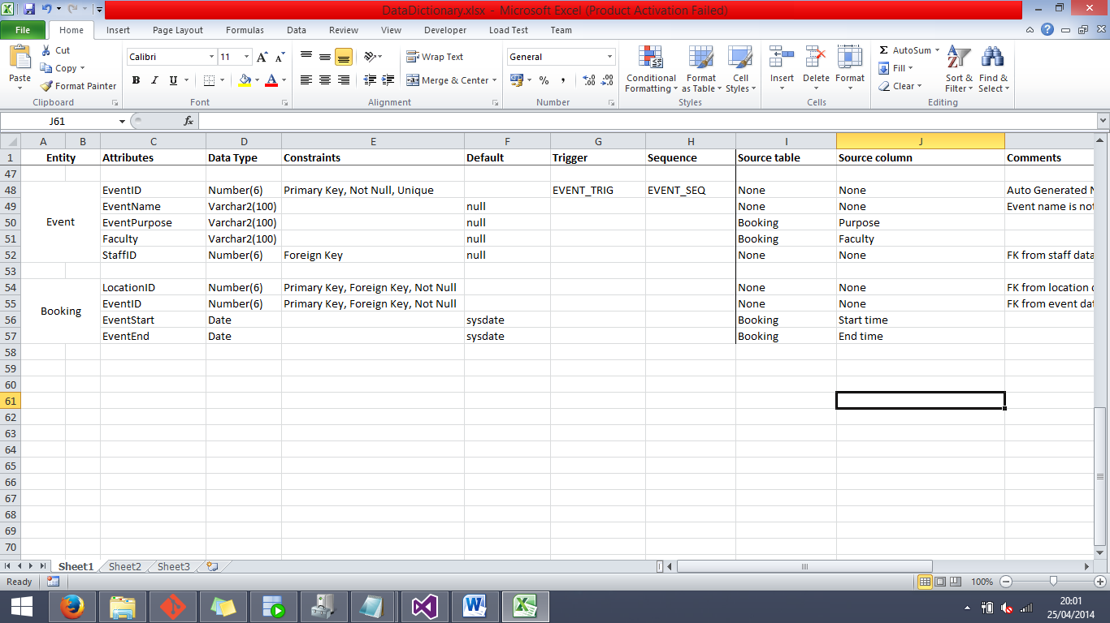**EVENT**

**Attributes**

EventID (EVENT_PK) – The purpose of this column is to provide a unique index for the Event entity by acting as a Primary and being populated by a Sequence.

EventName – The purpose of this column is to store information about the name of the event.

EventPurpose – The purpose of this column is to hold a short description of the event purpose.

Faculty – The purpose of this column is to specify which faculty of the university will be hosting the associated event.

StaffID (EVENT_STAFF_FK) – The purpose of this column is to provide a point of reference to see which member of staff is organising the event, and also to form a relationship between the Event and Staff entities.

***Constraints***

*Sequences*

EVENT_SEQ – The purpose of this sequence is to populate the EventID column whenever a new entry is inserted into the Event entity.

*Triggers*

EVENT_TRIG – The purpose of this trigger is to act as an activator for the EVENT_SEQ sequence, set to trigger after a row of data is inserted into the Event entity.

*Other Constraints*

EventID (Unique, Not Null) – Due to the fact that this column acts as a Primary Key, it automatically gains the Unique and Not Null constraints.

EventName, EventPurpose, Faculty, StaffID (Default Null) – As not all of these columns are necessary to create a sensible entry to this entity, they were all given a default value of null so that they can be filled in later.

**BOOKING**

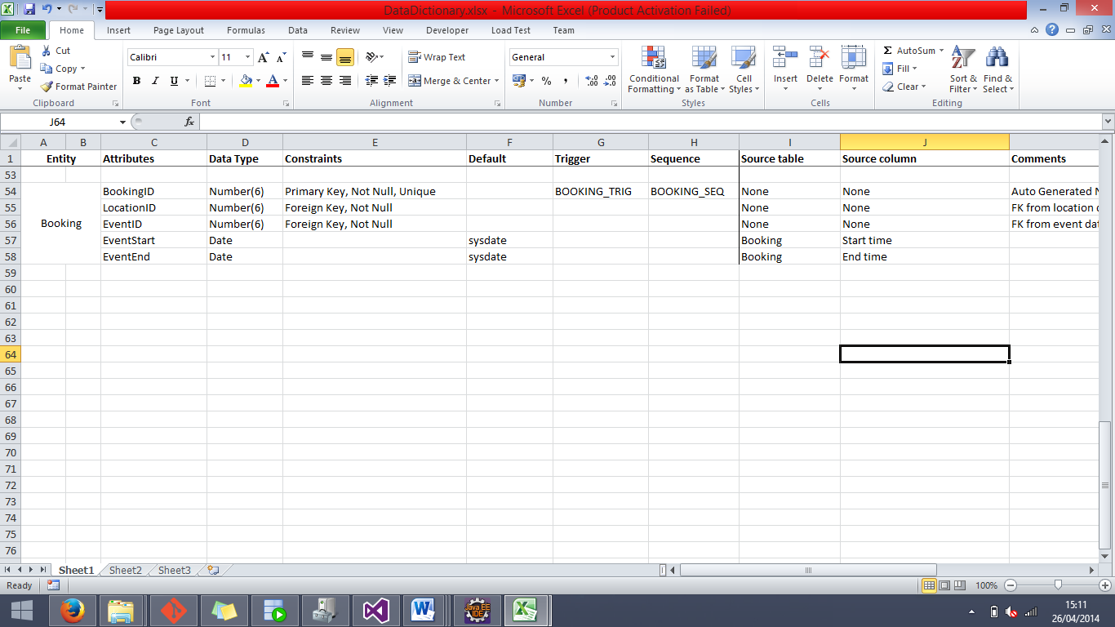**Attributes**

BookingID (BOOKING_PK) – The purpose of this column is to provide a unique index for the BOOKING entity to use as a Primary Key.

LocationID (BOOKING_LOCATION_FK) – The purpose of this column is to provide a reference with which to get the location that the corresponding booking is registered at, and to form a relationship between the BOOKING and LOCATION entities.

EventID (BOOKING_EVENT_FK) – The purpose of this column is to provide a reference with which to get the event that the corresponding booking is hosting, and to form a relationship between the BOOKING and EVENT entities.

EventStart – The purpose of this column is to store the date and time at which the event starts.

EventEnd – The purpose of this column is to store the date and time at which the event ends.

***Constraints***

*Sequences*

BOOKING_SEQ – The purpose of this sequence is to populate the BookingID column whenever a new entry is inserted into the Booking entity.

*Triggers*

BOOKING_TRIG – The purpose of this trigger is to act as an activator for the BOOKING_SEQ sequence, set to trigger after a row of data is inserted into the Booking entity.

*Other Constraints*

BookingID (Not Null, Unique) – This column serves as the Primary Key for the BOOKING entity, and as such it is automatically attributed the Not Null and Unique constraints.

LocationID, EventID (Not Null) – These columns were given the Not Null constraint due to the fact that it would not make sense to insert a new booking into the system without supplying both an event and a location.

EventStart, EventEnd (Default sysdate) – As a matter of just keeping dates in the date fields, it was decided to default these two fields to have the current system date and time if they are not specified at creation, and can just be changed later.