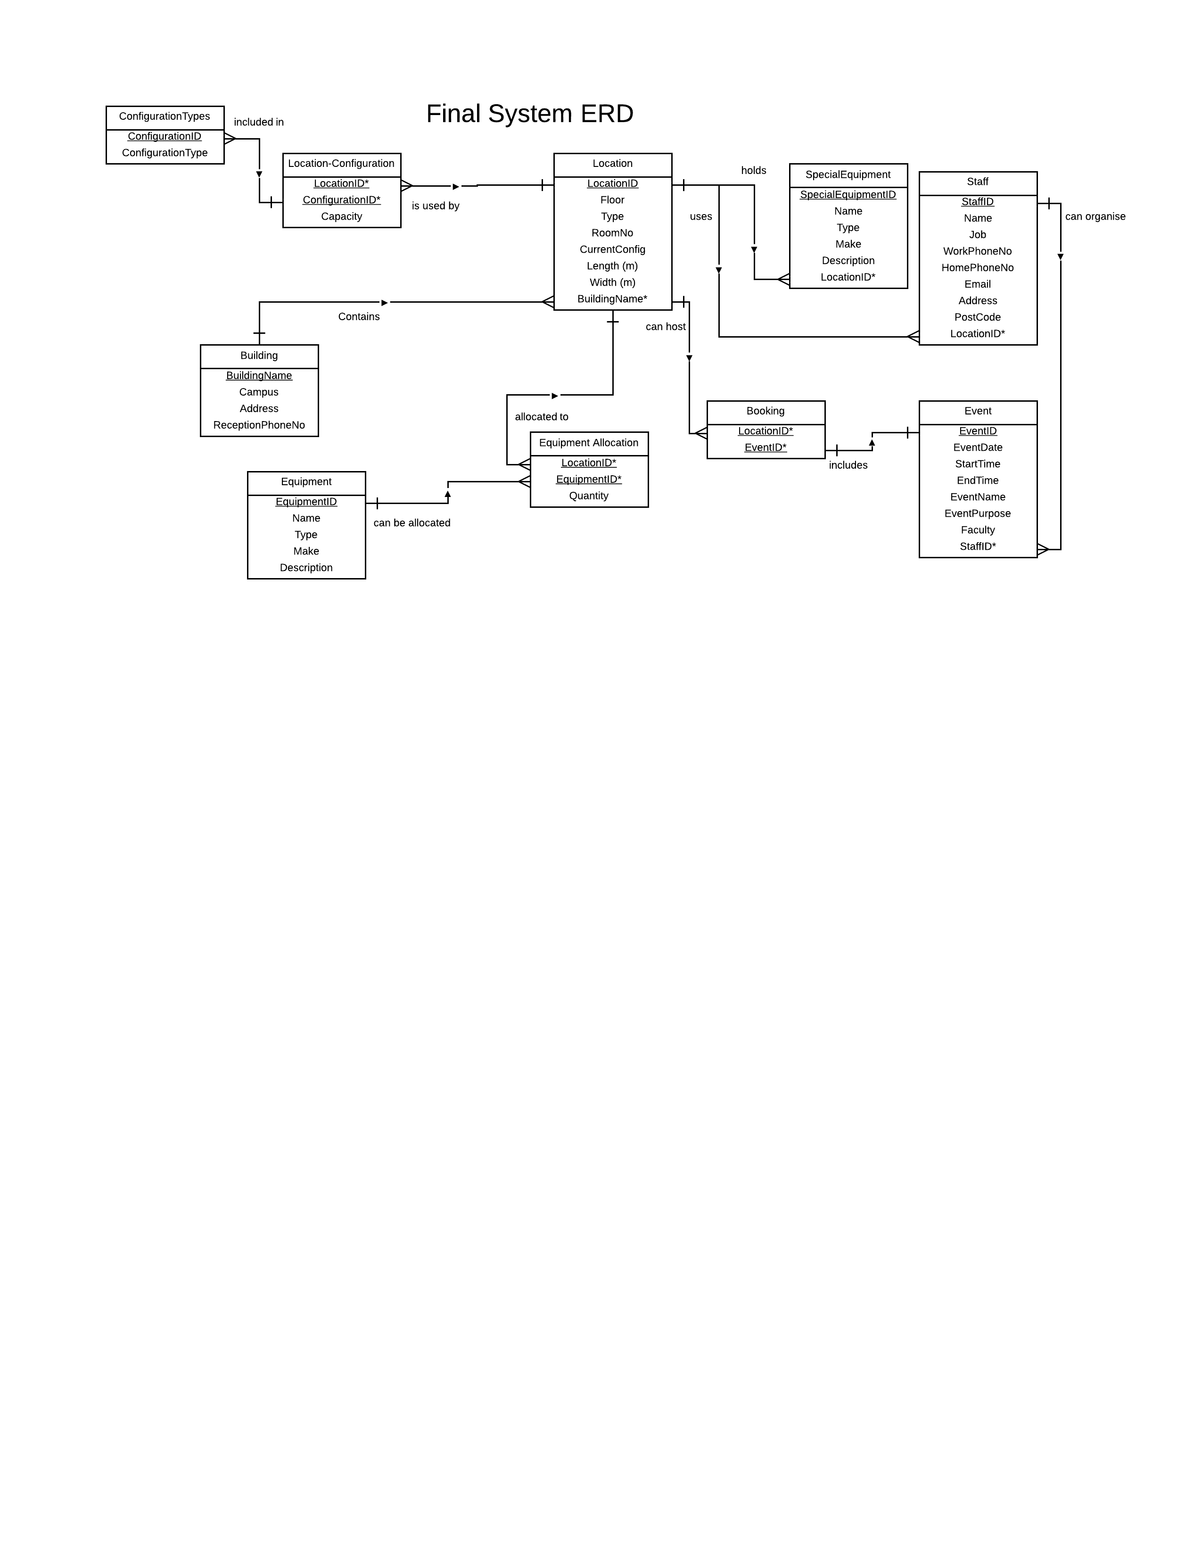

*Justification of consolidated changes*

The first change that we made when bringing the individual ERD’s together was to remove the OFFICE table that Luke had in his initial diagram. The entity was not necessary due to the fact that all of the data about the locations should just be held in the LOCATIONS table and would just be duplicated in the OFFICE table. Another change was to relate the STAFF and OFFICE relationship to a relationship between STAFF and LOCATION consistent with the rest of the group’s feedback. Initially we had it as a one-to-one relationship, but did not consider the possibility that there could be several staff in a single office, which led us to change the relationship to one-to-many.

The next major change that we decided to make was to the CONFIGURATION table, and that change involved stripping most of the attributes that were in there previously, and creating another table which would form a many-to-many relationship between CONFIGURATIONTYPES and LOCATION, thus making it necessary to have an intermediate table between the two. This table took form as CONFIGURATION, allowing each location to have many types of configuration, and each of these pairs have a capacity according to the location and the configuration type for that entry.

Changes were made to accommodate and relate both events themselves and a booking system for the events. In our individual ERD’s, we either accommodated for bookings alone or events alone, so we more or less took the events and bookings from all of our versions and integrated the best features. The booking table simply joins the ID’s from the LOCATION table and the EVENT table, creating a composite key.

Some of the slightly smaller changes to the final ERD that we made were to fill in gaps, missing attributes in the STAFF table, adding ones for things such as home and work phone number.

We also took a look at a few of the relationships throughout the ERD, revising some of them. The most notable change was to change the relationship between the configurations and location. Before it was many locations to one configuration, but after further thought it was decided to change to many configurations to one location, allowing each location to have its own unique set of configurations if necessary.