**QUERY TESTING**

Query 1 Testing

Code tested:

SELECT STAFF.NAME AS STAFF_NAME, STAFF.WORKPHONENO AS WORK_PHONE, STAFF.HOMEPHONENO AS HOME_PHONE, Building.buildingname AS BUILDING

FROM STAFF

INNER JOIN LOCATION

ON STAFF.LOCATIONID = LOCATION.LOCATIONID

INNER JOIN BUILDING

ON LOCATION.BUILDINGID = BUILDING.BUILDINGID

WHERE BUILDING.BUILDINGNAME = :User_Input_BuildingName;

:User_Input_BuildingName = ‘Devon’

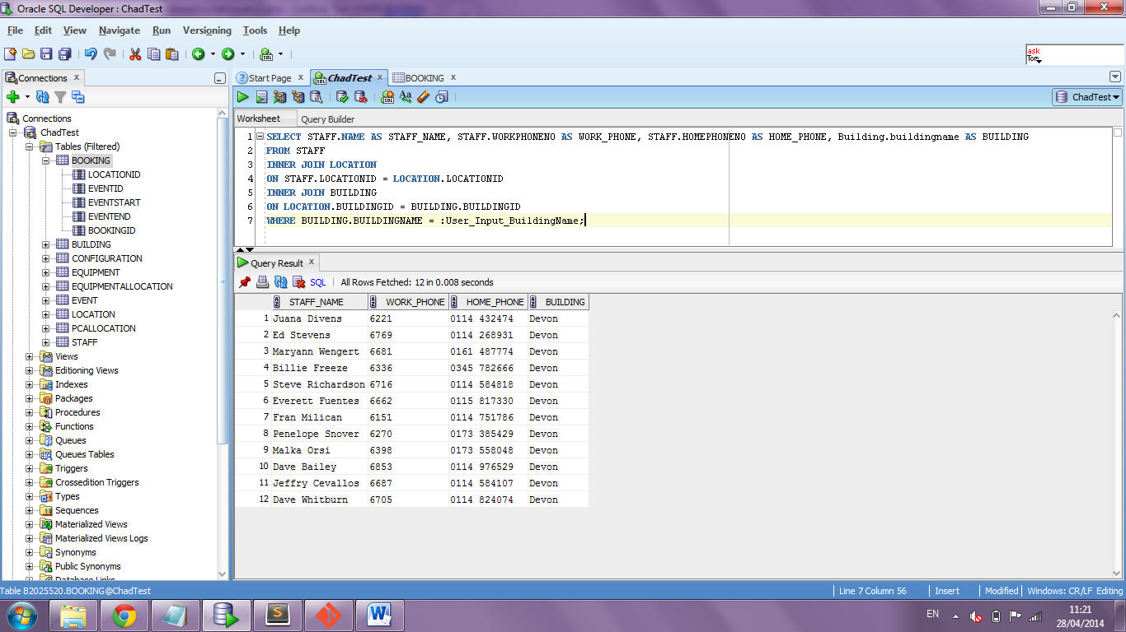Result:

When tested in SQL Developer the returned results are as expected meeting the critera of the query. For testing perposes the bulding name is returned, this allows incorrect data to be visible and ensure all the staff returned meet the building criteria

Code tested:

SELECT STAFF.NAME AS STAFF_NAME, STAFF.WORKPHONENO AS WORK_PHONE, STAFF.HOMEPHONENO AS HOME_PHONE, Building.buildingname AS BUILDING

FROM STAFF

INNER JOIN LOCATION

ON STAFF.LOCATIONID = LOCATION.LOCATIONID

INNER JOIN BUILDING

ON LOCATION.BUILDINGID = BUILDING.BUILDINGID

WHERE BUILDING.BUILDINGNAME = 12345;

Result:

An error is returned as expected; “Invalid number”.

Query 2 Testing:

Code tested:

SELECT EQUIPMENT.NAME AS EQUIPMENT_NAME, EQUIPMENTALLOCATION.QUANTITY, LOCATION.ROOMNO AS ROOM_NUMBER, LOCATION.FLOOR, LOCATION.TYPE AS ROOM_TYPE, BUILDING.BUILDINGNAME AS BUILDING

FROM EQUIPMENTALLOCATION

INNER JOIN EQUIPMENT

ON EQUIPMENTALLOCATION.EQUIPMENTID = EQUIPMENT.EQUIPMENTID

INNER JOIN LOCATION

ON EQUIPMENTALLOCATION.LOCATIONID = LOCATION.LOCATIONID

INNER JOIN BUILDING

ON LOCATION.BUILDINGID = BUILDING.BUILDINGID

WHERE BUILDING.BUILDINGNAME = :User_Input_BuildingName

AND

LOCATION.ROOMNO IS NOT NULL

AND

LOCATION.CURRENTCONFIG IS NOT NULL

AND

EQUIPMENTALLOCATION.LOCATIONID IS NOT NULL;

:User_Input_BuildingName = ‘Devon’

Result:

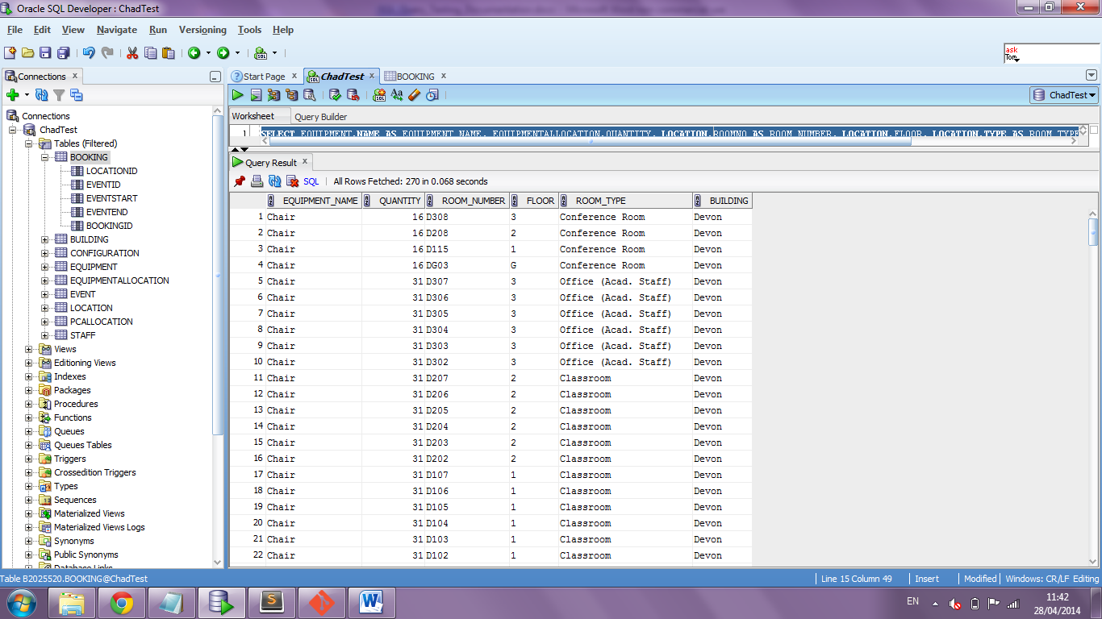The data returned is correct and as expected. The buildingname column shows that the data is related to the correct building.

Query 3 Testing:

Code tested:

SELECT LOCATION.LOCATIONID, LOCATION.ROOMNO, LOCATION.TYPE, LOCATION.FLOOR, BUILDING.BUILDINGNAME, LOCATION.CURRENTCONFIG,

CONFIGURATION.ISLANDCAPACITY, CONFIGURATION.HORSESHOECAPACITY, CONFIGURATION.ROWCAPACITY

FROM LOCATION

INNER JOIN CONFIGURATION

ON LOCATION.LOCATIONID = CONFIGURATION.LOCATIONID

INNER JOIN BUILDING

ON LOCATION.BUILDINGID = BUILDING.BUILDINGID

WHERE LOCATION.LOCATIONID NOT IN

(

SELECT DISTINCT LOCATIONID

FROM BOOKING

WHERE

(

(TO_DATE(:User_Input_Event_Start, 'dd-mm-rrrr hh24:mi') BETWEEN EVENTSTART AND EVENTEND)

OR

(TO_DATE(:User_Input_Event_End, 'dd-mm-rrrr hh24:mi') BETWEEN EVENTSTART AND EVENTEND)

OR

(TO_DATE(:User_Input_Event_Start, 'dd-mm-rrrr hh24:mi') <= EVENTSTART AND TO_DATE(:User_Input_Event_End, 'dd-mm-rrrr hh24:mi') >= EVENTEND)

)

)

AND

BUILDING.BUILDINGNAME = :User_Input_BuildingName

AND

(

CONFIGURATION.ROWCAPACITY >= :User_Input_Room_Capacity

OR

CONFIGURATION.ISLANDCAPACITY >= :User_Input_Room_Capacity

OR

CONFIGURATION.HORSESHOECAPACITY >= :User_Input_Room_Capacity

)

AND

LOCATION.ROOMNO IS NOT NULL

ORDER BY LOCATION.LOCATIONID

:User_Input_BuildingName = ‘Devon’

:User_Input_Room_Capacity = 30

:User_Input_Event_End = 04/10/2013 13:00

:User_Input_Event_Start = 04/10/2013 12:00

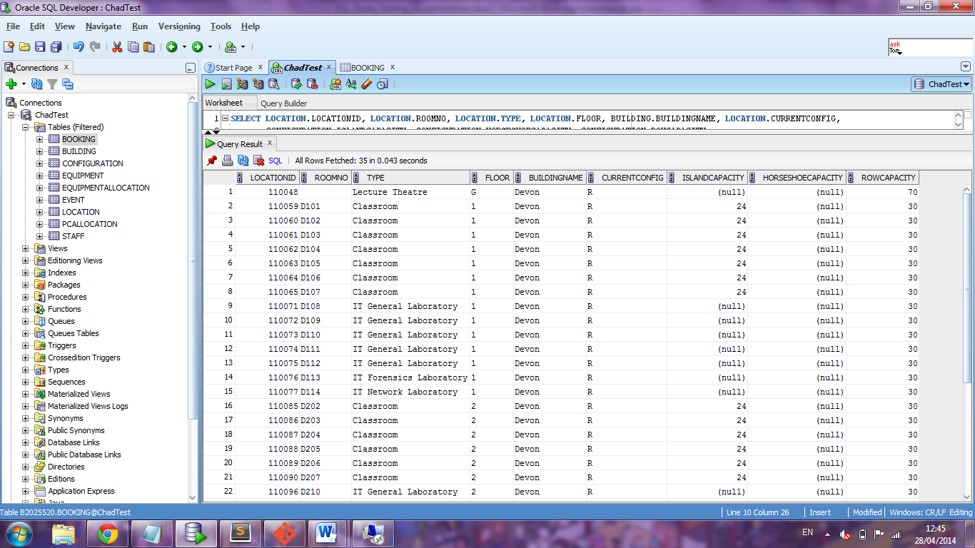Result:

The rows returned are correct fitting the critera of the requested query.

Query 4:

Code tested:

INSERT INTO EVENT (EVENTNAME, EVENTPURPOSE, STAFFID)

VALUES (:User_Input_EventName, :User_Input_EventPurpose, (SELECT STAFFID FROM STAFF WHERE STAFF.NAME = :User_Input_Organiser));

:User_Input_EventName = ‘Query4’

:User_Input_EventPurpose = ‘Query4’

:User_Input_Organiser = ‘Dave Whitburn’

Result:

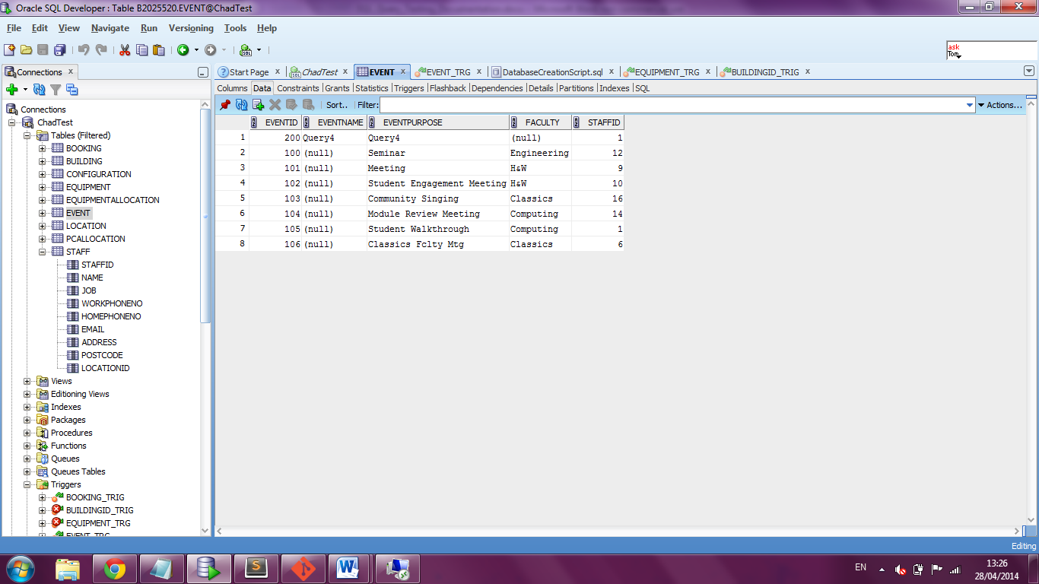

The row has been correctly inserted and the staff id is correctly selected from the staff table.

Query 5:

Code tested:

INSERT INTO BOOKING (LOCATIONID, EVENTID, EVENTSTART, EVENTEND)

VALUES ((SELECT LOCATIONID

FROM LOCATION

WHERE ROOMNO = :User_Input_RoomNo), (SELECT EVENTID

FROM EVENT

WHERE EVENTNAME = :User_Input_EventName), TO_DATE(:User_Input_EventStart, 'dd-mm-rrrr hh24:mi'), TO_DATE(:User_Input_EventEnd, 'dd-mm-rrrr hh24:mi'));

:User_Input_EventName = ‘Query4’

:User_Input_EventStart = ‘28/05/2014 12:00’

:User_Input_EventEnd = ‘28/05/2014 13:00’

Result:

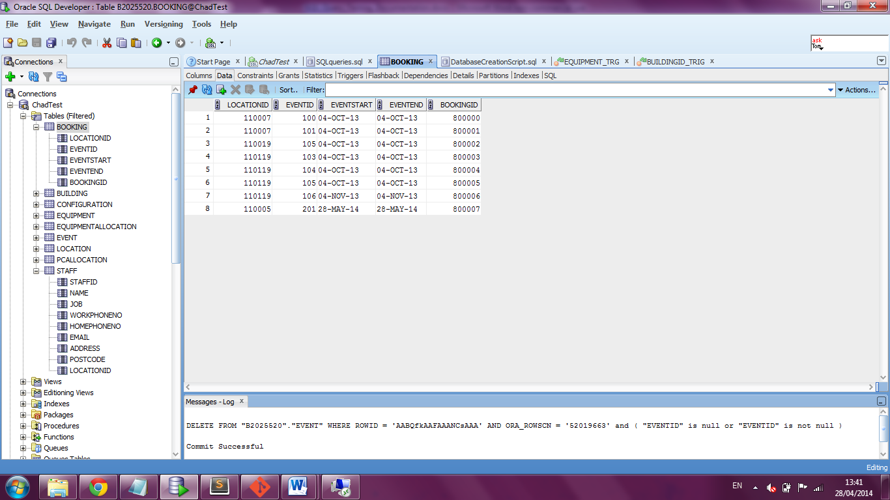

As seen on row 8 the data has been correctly inserted. The selected foreign keys from the Location and Event tables are correct.