**Web Queries**

In this section we will review the SQL queries that were converted into prepared statements using the PHP scripting language. Note that there is no user input for these web pages (as it was not required), so the data for the bind variables is hard coded.

**Query 1**

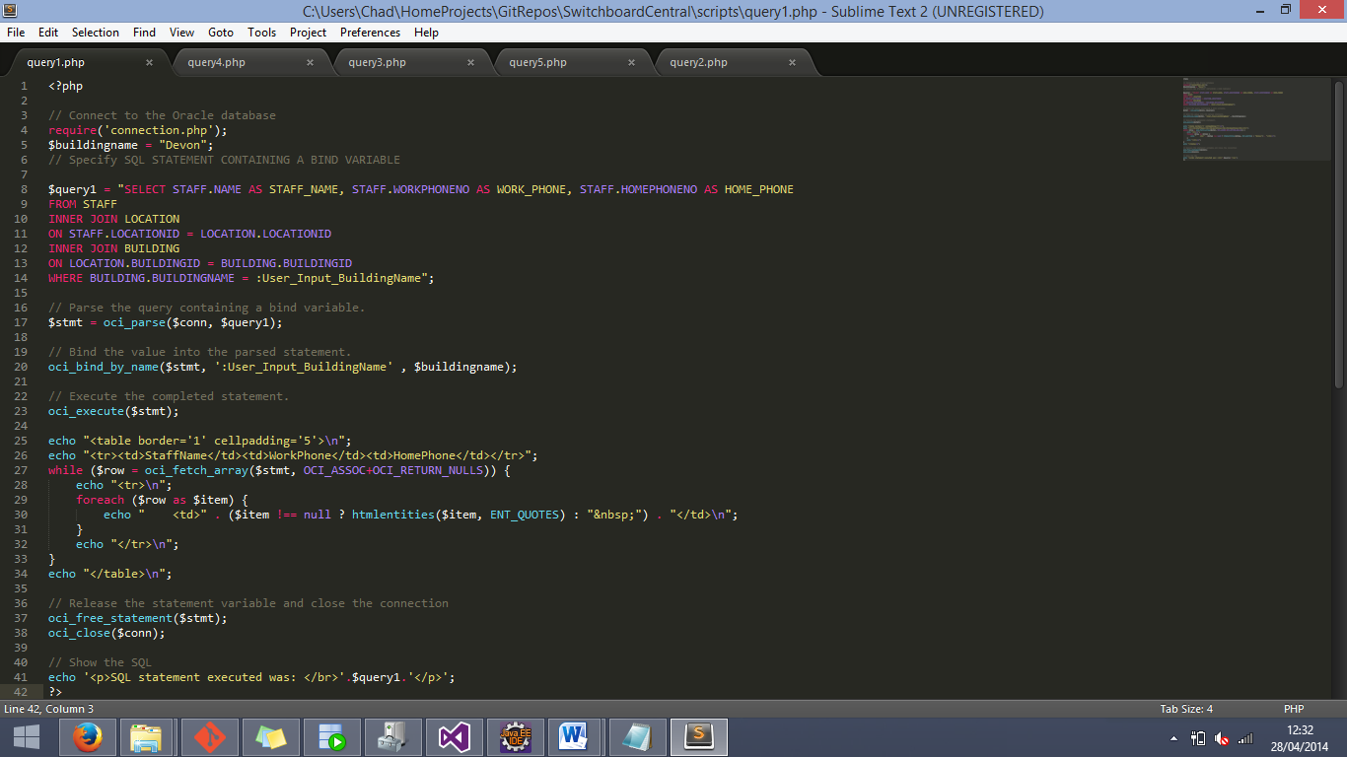

This query shows the first query, with the bind variable data being hard coded as “Devon”. The result of the above query is shown below.

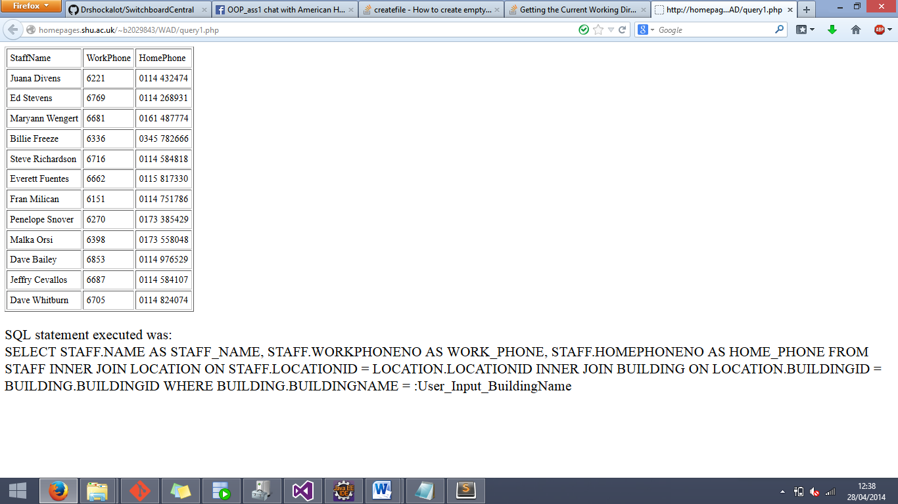

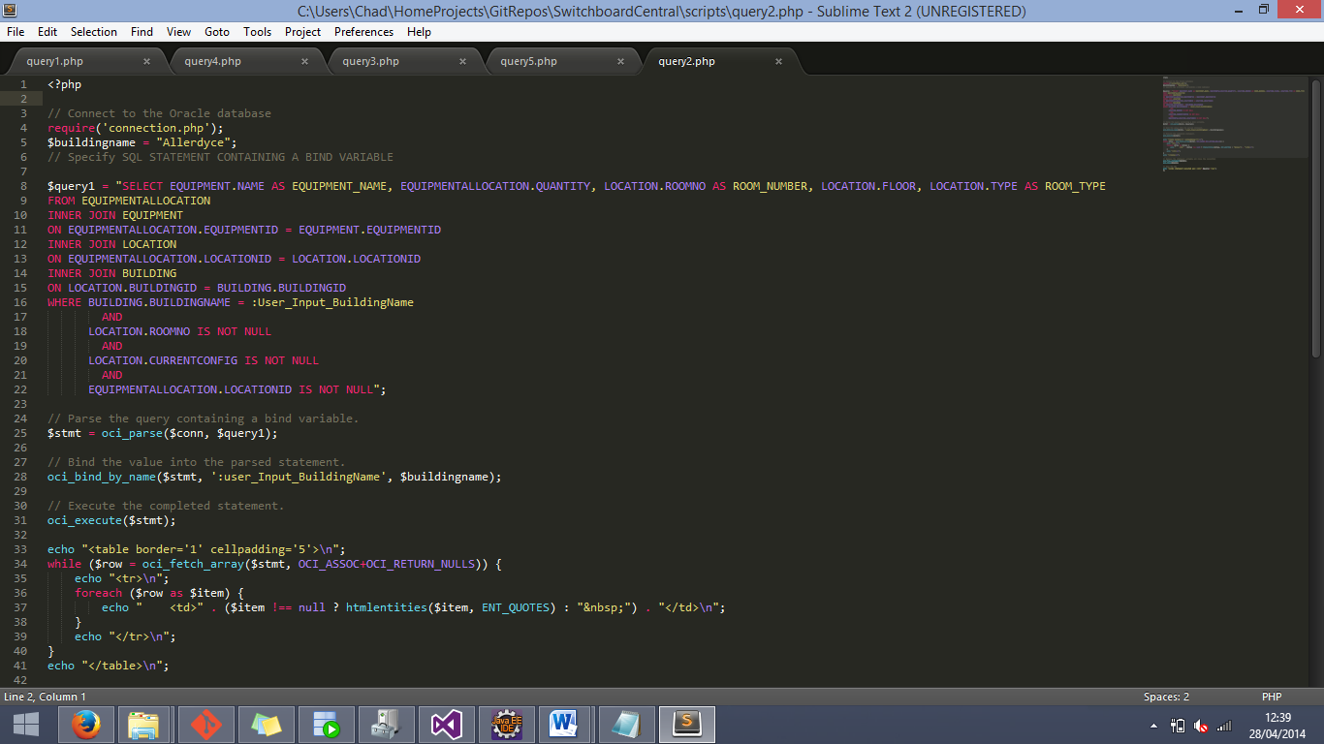**Query 2**

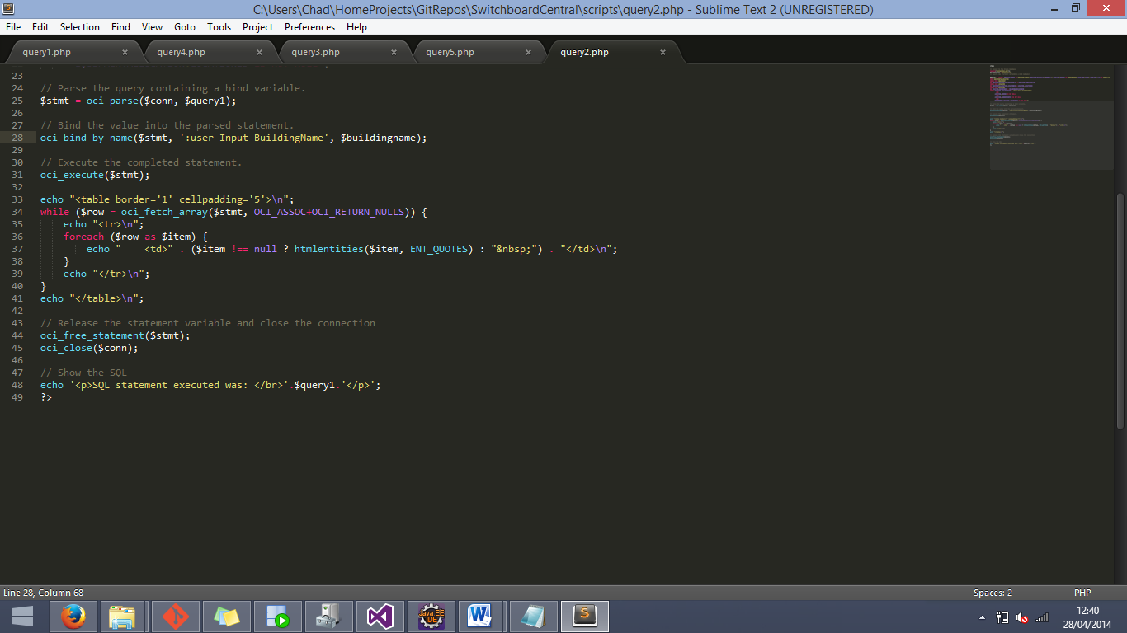

This image shows the second query, with the bind variable data being hard coded as “Allardyce”. The result of the above query is shown below.

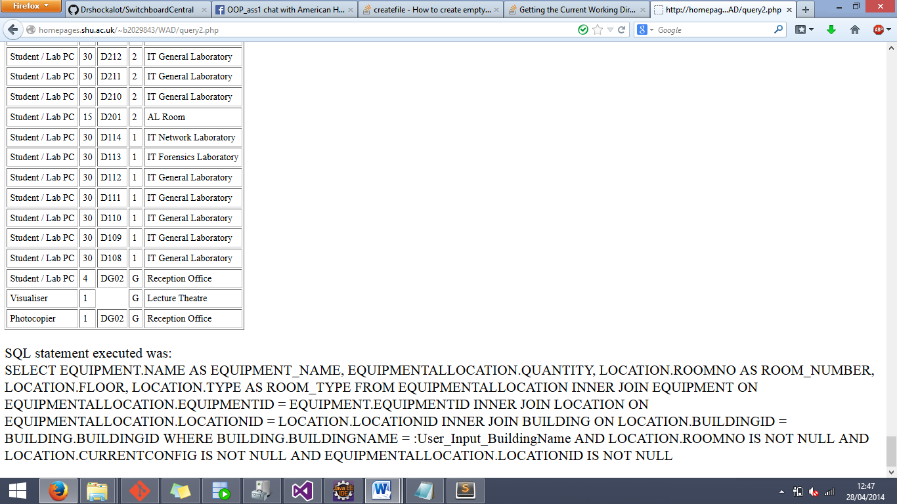The entire result obviously cannot be shown on a single screen, so this shown only a portion of the result.

**Query 3**

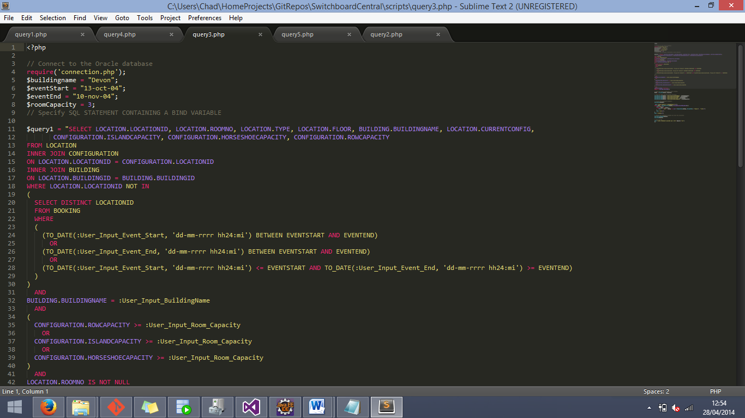

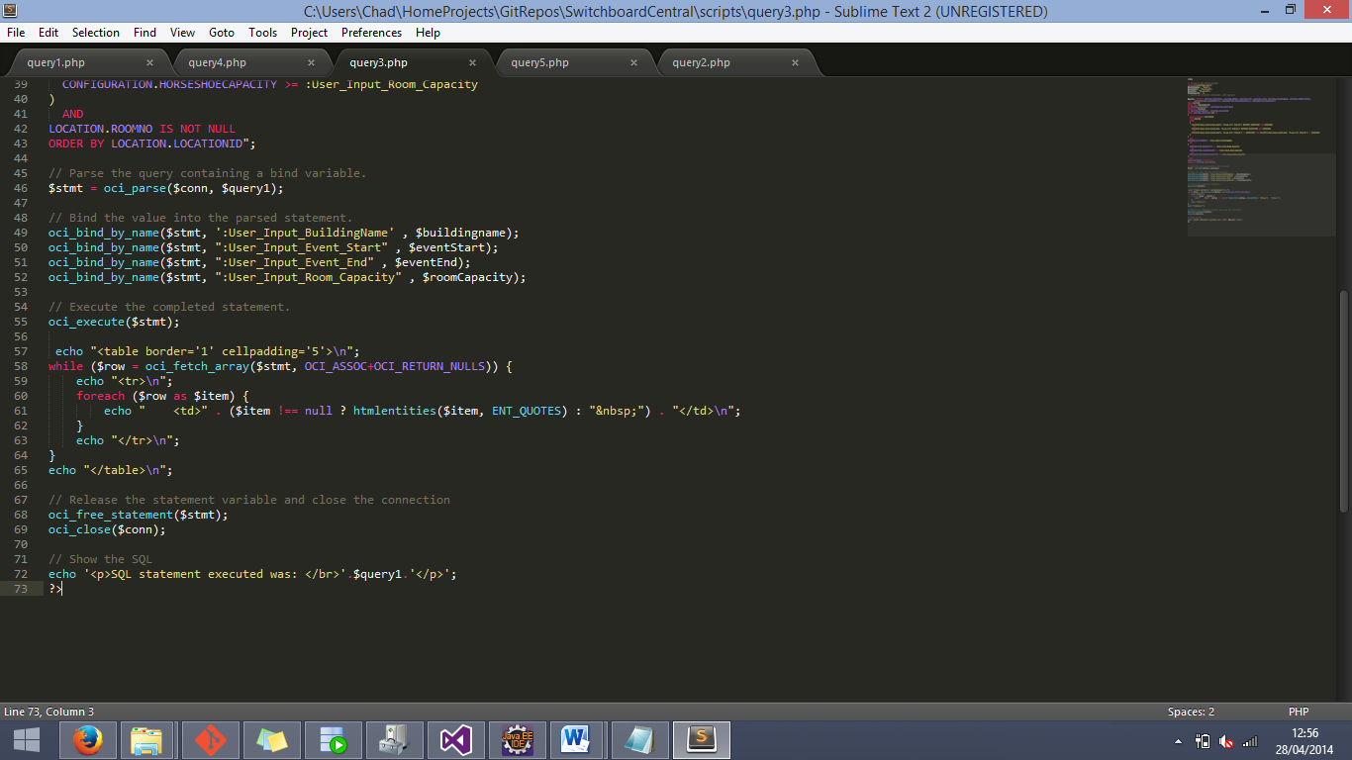**Query 3 cont.**

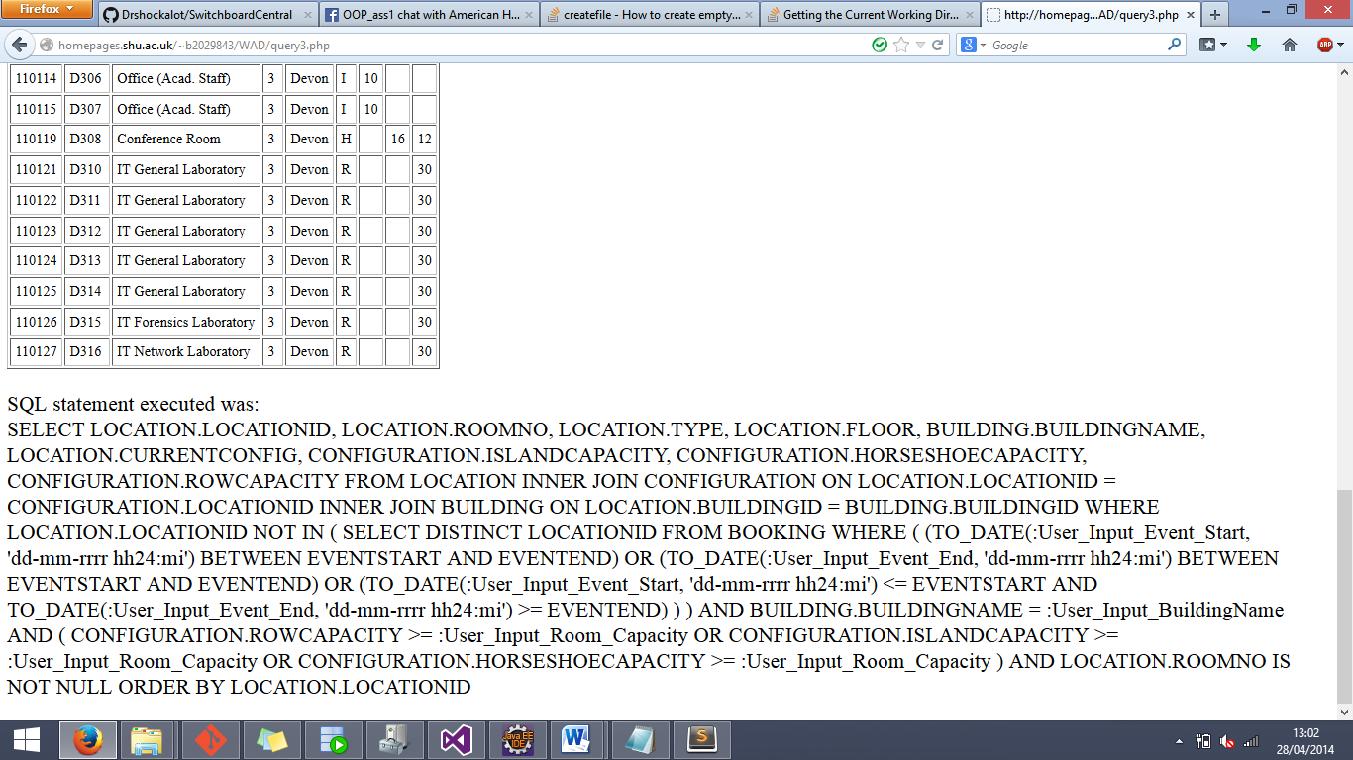The above image is of the third query, with the hardcoded data of “Devon”, “13-oct-04”, “10-nov-04”, and the number 3. The result of the query is as follows:

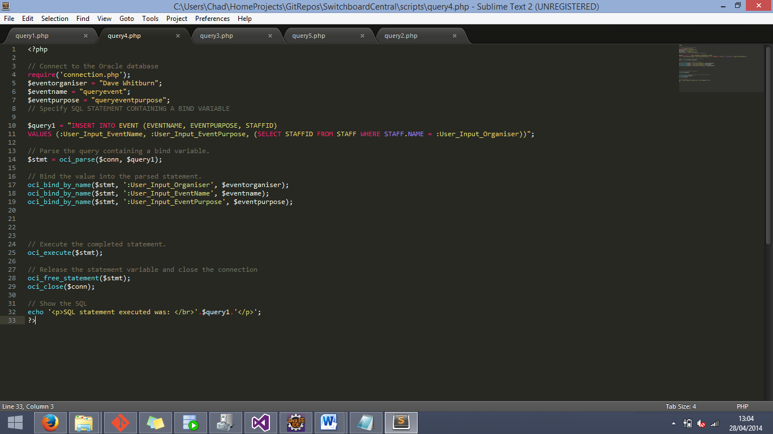**Query 4**

The above image is of the fourth query, with the hardcoded data of “Dave Whitburn”, “queryevent”, and “queryeventpurpose”. As this is an insert statement there is no easy way to prove that it works as a web query (it does) via images.

**Query 5**

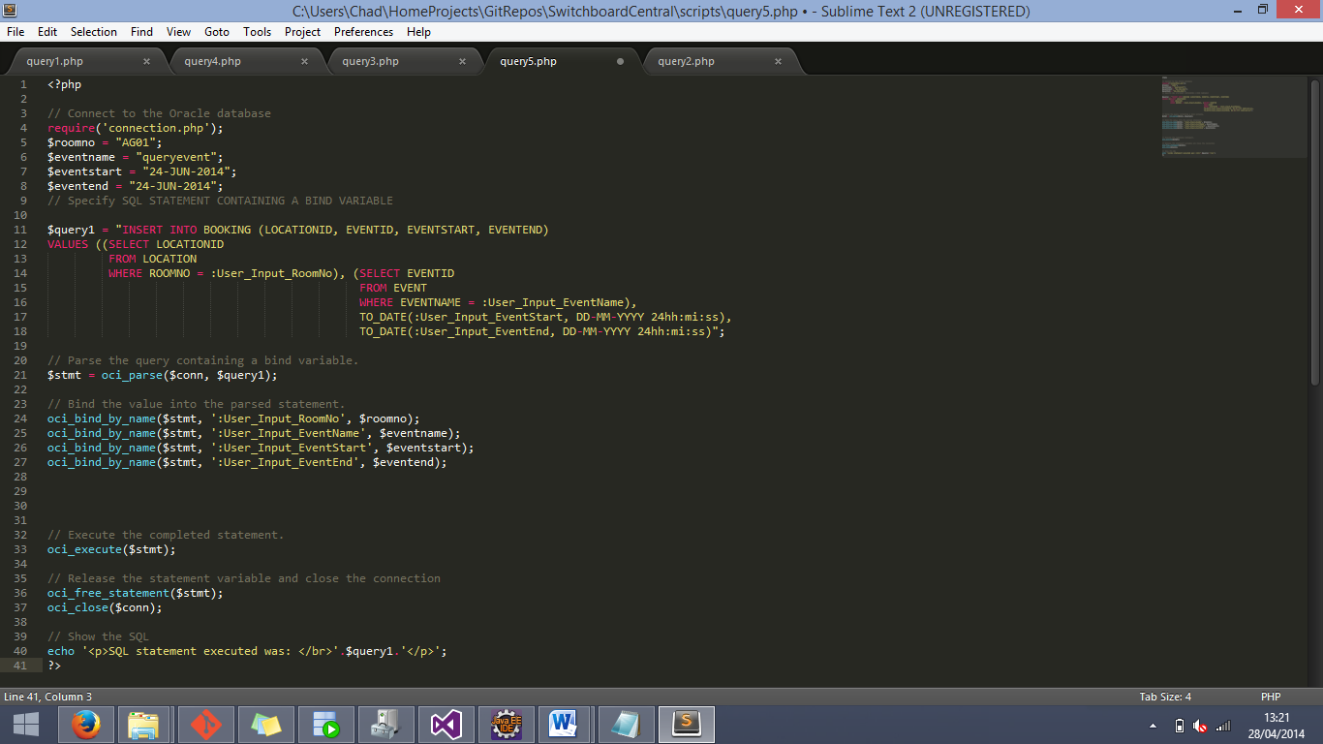

The above image shows the fifth and final SQL query, with the hardcoded data “AG01”, “queryevent”, “24-JUN-2014”, “24-JUN-2014”. Again, the results of this SQL statement cannot easily be shown via images so, we can only assure all those whom it concerns that it does indeed work.