Book One
of the
KISS Grammar Books

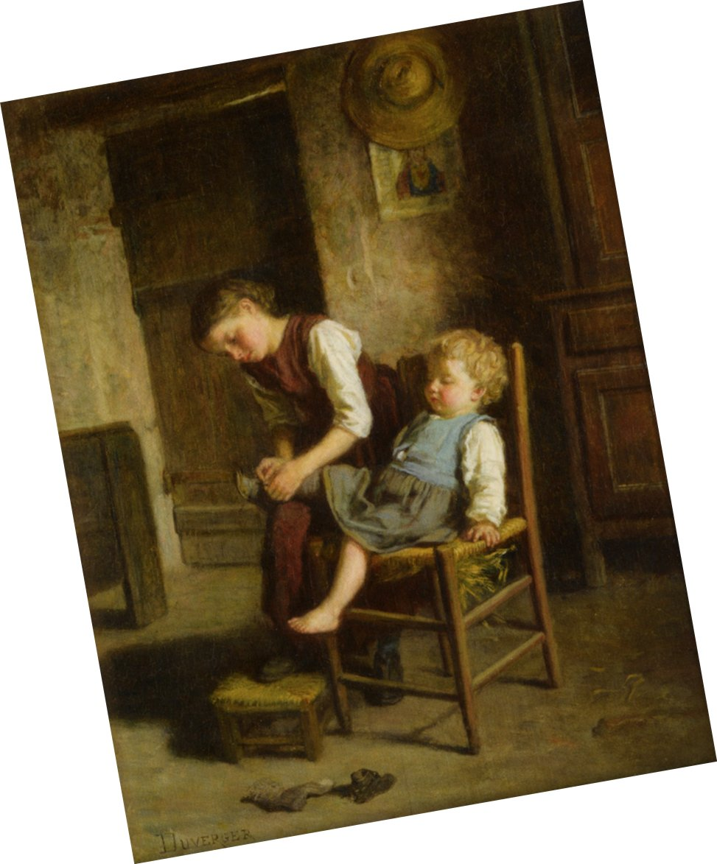 | 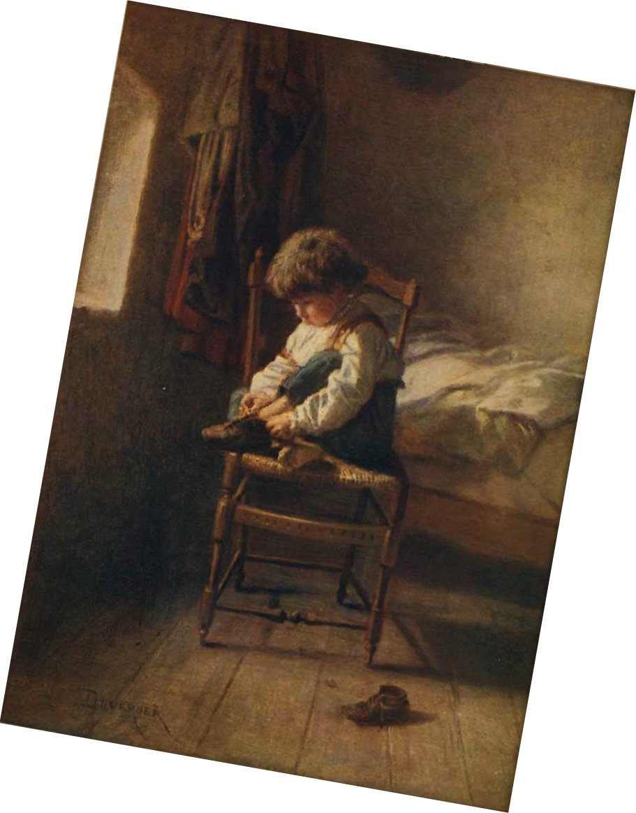
Soeurs | Alone

Both by
Theophile-Emmanuel Duverger
(1821-1901)

© Dr. Ed Vavra
Revised June, 2015

KISS Instructional Materials are available for free at KISSGrammar.org.

Welcome and Introduction 5
Unit 1—Identifying Sentences 6
Ex. 1: Statements — Capitals — Period [Ants, 1] 6
Ex. 2: Statements — Capitals — Period [Ants, 2] 7
Ex. 3: Statements — Capitals — Period [Ants, 3] 8
Ex. 4: Questions —Question Marks — Capitals [Spiders, 1] 9
Ex. 5: Questions and Statements [Spiders, 2] 10
Ex. 6: Question Mark—Period—Capitals [Spiders, 3] 11
Ex. 7: Joining Sentences [Spiders, 4] 12
Ex. 8: Exclamation Mark [Summer Shower, 1] 13
Ex. 9: Commands [Summer Shower, 2] 14
Ex. 10: Different Kinds of Sentences [Summer Shower, 3] 15
Ex. 11 [W]: Putting Sentences Together [Summer Shower, 4] 16
Ex. 12 [W]: Original Work 16
Ex. 13 Spelling 17
Unit 2—Identifying Subjects and Verbs 18
What Makes a Sentence? 18
Ex. 1 - Sentence or Phrase? 19
Understood “You” 20
Ex. 2 - “You” as the Understood Subject From Bunny Rabbit's Diary (# 1) 21
Ex. 3 - “You” as the Understood Subject From Bunny Rabbit's Diary (# 2) 22
“There” as a Subject 23
Ex. 4 - from The Haliburton First Reader 23
Ex. 5 - Based on The Tale of Tom Kitten, by Beatrix Potter 24
A Focus on Single-Word Verbs 25
A Christmas Tree 27
Ex. 6 – From “A Christmas Tree” by Mary Frances Blaisdell (# 1) 32
Ex. 7 – From “A Christmas Tree” by Mary Frances Blaisdell (# 2) 33
Ex. 8 – From “A Christmas Tree” by Mary Frances Blaisdell (# 3) 34
Ex. 9– From “A Christmas Tree” by Mary Frances Blaisdell (# 4) 35
Ex. 10 - Just for Fun: Riddles 36
Ex. 11–Spelling 37
Unit 3—Verb Phrases 38
“Helping” Verbs (Tense) 38
The Swimming Lesson 39
Ex. 1 - Helping Verbs From “The Swimming Lesson” 43
Ex. 2 - Helping Verbs From “The Swimming Lesson” 44
Ex. 3 - Helping Verbs From “The Swimming Lesson” 45
Other Helping Verbs 46
Ex. 4 - Other Helping Verbs From Bunny Rabbit’s Diary (#1) 47
Ex. 5 - Other Helping Verbs From Bunny Rabbit’s Diary (#2) 48
Ex. 6 - [V] An Exercise on Verbs from The Haliburton First Reader 49
Ex. 7 - Spelling 50
Ex. 8 - Just for Fun 51
Unit 4—Apostrophes in Contractions 52
Apostrophes in Contractions 52
Ex. 1 – Contractions and Apostrophes 52
Ex. 2 –Based on Bunny Rabbit’s Diary 53
Ex. 3 - More Practice with Helping Verbs From Old-time Stories 54
Ex. 4 – Spelling 55
Ex. 5 - Just for Fun 56
Unit 5—Adding Simple Complements 57
Identifying Complements: The S / V / C Pattern 57
Ex. 1 - Adding Complements Based on “April Fool’s Day” (#1) 63
Ex. 2 - Adding Complements Based on “April Fool’s Day” (# 2) 64
Ex. 3 - Adding Complements Based on “April Fool’s Day” (# 4) 65
Ex. 4 - Punctuating a Sentence From “Billy’s Slide” (# 1) 66
Ex. 5 – Spelling 67
Ex. 6 - Just for Fun 68
Unit 6—A Focus on Compounds 69
Coordinating Conjunctions and Compounding 69
Ex. 1 A Focus on Compounding From Ben and Alice (#1) 70
Ex. 2 - A Focus on Compounding From Ben and Alice (# 2) 71
Ex. 3 “The Robin”—A Poem for Analysis 72
Ex. 4 - Contractions From Bunny Rabbit’s Diary (#2) 73
Ex. 5 – Spelling 74
Ex. 6 - Riddles 75
Unit 7—Adding More Helping Verbs 76
Adding More “Helping” Verbs 76
Ex. 1 - More Helping Verbs From “Mrs. Duck’s Secret” (#1) 77
Ex. 2 – More Helping Verbs From “Mrs. Duck’s Secret” (#2) 78
Ex. 3 - Adding More Helping Verbs From Bunny Rabbit’s Diary (# 1) 79
Ex. 4 - Adding More Helping Verbs From Bunny Rabbit’s Diary (# 2) 80
Ex. 5 – Spelling 81
Ex. 6 - Just for Fun: Q and A (Puns) 82
Unit 8—Adding Adjectives and Adverbs 83
Adjectives and Adverbs 83
“The Clover Patch” 84
Ex. 1 - Adding Adjectives and Adverbs From “The Clover Patch” (# 1) 88
Ex. 2 - Adding Adjectives and Adverbs From “The Clover Patch” (# 2) 89
Ex. 3 - Adding Adjectives and Adverbs From “The Clover Patch” (# 3) 90
Ex. 4 - Adding Adjectives and Adverbs From “The Clover Patch” (# 4) 91
Ex. 5 – [V] Fill in the Blanks with Adjectives and Adverbs “How Nice!” 92
Ex. 6 – Spelling 93
Ex. 7 - Just for Fun 94
Unit 9—Adding Simple Prepositional Phrases 95
What Is a Prepositional Phrase? 95
Words That Can Function as Prepositions 96
The Cabbage Patch 97
Ex. 1 - A Matching Game with Prepositional Phrases 102
Ex. 2 - From “The Cabbage Patch” (# 1) 103
Ex. 3 - From “The Cabbage Patch” (# 2) 104
Ex. 4 - “Rain” 105
Ex. 5 - Spelling 106
Ex. 6 - Punctuating Sentences From “Billy’s Slide” (# 2) 107
Ex. 7 - Just for Fun 108
Unit 10—Adding Apostrophes to Show Possession 109
Apostrophes to Show Possession 109
Ex. 1 - Apostrophes to Show Possession From Bunny Rabbit’s Diary (#2) 110
Ex. 2 – Apostrophes in Contractions From Bunny Rabbit's Diary (#3) 111
Ex. 3 – Fix the Capitalization and Punctuation 112
Unit 11—Performing and Analyzing a Little Play 113
THE TWO HOLES 113
Ex. 1 -A Passage for Analysis THE TWO HOLES 115
Ex. 2 - A Writing Assignment on “THE TWO HOLES” 116

Welcome and Introduction
Welcome to KISS Grammar. Your teacher and I are going to help you understand how sentences work. That way, you’ll know and be able to discuss what’s good and what’s bad about different sentences—those you read and those you write. I think you’ll both learn and enjoy it.
—Dr. V.

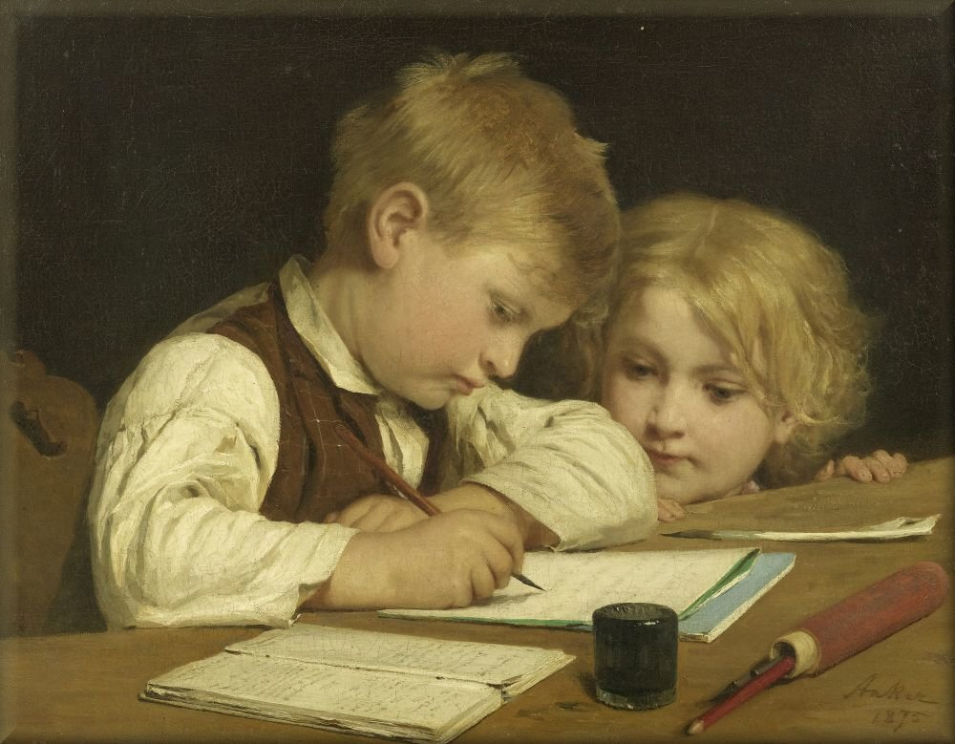

Writing Lessons
1875, by Albert Anker

Unit 1—Identifying Sentences

Ex. 1: Statements — Capitals — Period [Ants, 1]
Copy the following very carefully:—

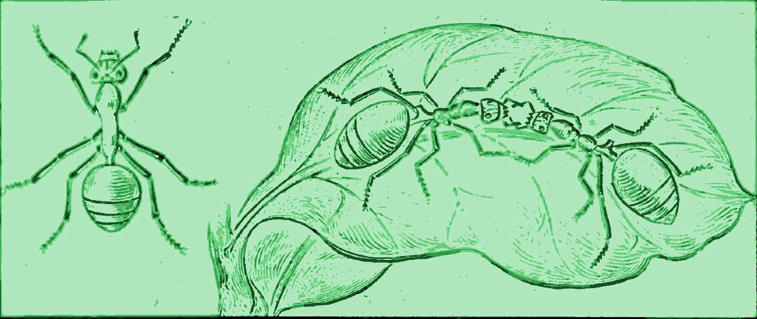
Ants build neat homes.
Some ants are farmers.
Baby ants have nurses.
Some ants keep slaves.
These insects are very wise.

What to See.—The first group of words above begins with what kind of letter?
Describe the mark after the last word of this group.
You may call this mark a Period.
Tell how each of the other groups begins and ends.
Does each group make sense by itself?
Leave out “build” from the first sentence, and then see whether it will make sense.
Will it make sense if you leave out “ants”?
Will it make sense if you leave out the last two words?

Ex. 2: Statements — Capitals — Period [Ants, 2]
Copy these lines very neatly :—

This little body has three parts. All insects have three parts. Ants are busy creatures. They run about on six legs.
What to See.—How many periods have you just copied?
How many groups of words make complete sense?
With what kind of letter does each group begin?
What do you find at the end of each group?
A group of words making complete sense is a Sentence.
In writing several sentences together we must show where one ends and another begins.
Exercise
This little body has three parts all insects have three parts ants are busy creatures they run about on six legs.
What to See.—Can you read the sentences in these lines as easily as you can the same sentences at the beginning of this lesson?
Find all the differences.
How may the different sentences be kept apart?
Of what use is the period?
How do capitals help?
How do we show where one sentence ends and another begins?

Ex. 3: Statements — Capitals — Period [Ants, 3]
Copy the sentences below and notice all about them :—

The ant’s legs are joined to the middle part. On its head are two feelers. Hundreds of ants live in one house. In these houses are many rooms and halls.
What to See.—How many sentences have you copied? How do you find out?

Ex. 4: Questions —Question Marks — Capitals [Spiders, 1]
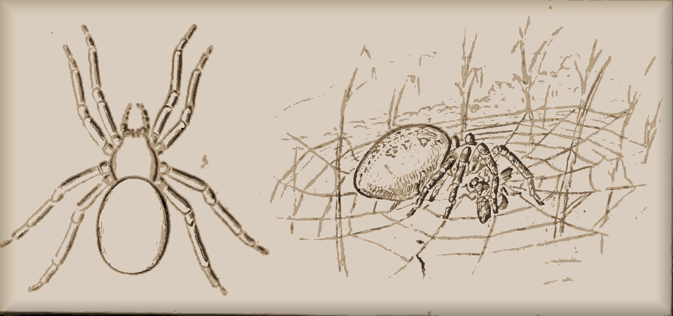
Copy the five lines below :—

Do spiders work?
What can they do?
What do spiders eat?
How many legs has a spider?
An ant has how many legs?
What to See,—Does the first group of words above make sense?
What do we call a group of words that makes sense?
Does the first sentence tell us something about spiders?
What does it do?
What does the second sentence do?
Tell what each of the others does.
Then each of these sentences is a question.
The little crooked Question Mark at the end helps to show this.
In the sentences before this lesson we tell, or state, something—make Statements.
In these sentences we ask about something—make Questions.
With what kind of letter does each question above begin?
What mark is put at the end of each question?

Ex. 5: Questions and Statements [Spiders, 2]

Copy the sentences below :—

Do spiders have wings?
Some ants have wings.
Is the spider’s body soft?
It is in two parts.
Do you see the spider’s eight legs?
What to See.—Which of the groups above are sentences?
Which may be called statements because they state, or tell, something?
Which are questions?
With what kind of letter does each of these sentences begin?
Notice the end of each sentence.
What do the statements end with?
What do the questions end with?
Make the question mark neatly.

Ex. 6: Question Mark—Period—Capitals [Spiders, 3]
Copy the sentences below :—

Are the spider’s legs all on the front part? The hind part is large and round. It carries the glue for making silken thread.
Is the spider pretty? Some spiders have rich colors.
What to See.—How many sentences do you find in the first three lines?
How do you find out?
Will the first make sense if we leave out “are”?
How is the first separated from the second?
What is the use of the period?
Can the question mark, as well as the period, help to show where one sentence ends and another begins?
How many sentences are in the last two lines?
Tell how each of the five sentences begins and ends.
All the five sentences are about the spider. In the first three we talk about the spider’s two parts, so we may begin one sentence right after another and make of the three one group.
In the last two sentences we talk about the spider’s looks, so we may make one group of these.
How are these groups of sentences separated?
What two lines begin farther to the right than the others?

Ex. 7: Joining Sentences [Spiders, 4]
Copy the following:—
The spider’s legs are all on the front part of the body. The hind part is large and round, and it carries the glue for making silken thread.
The spider is not pretty in shape, but it often has very rich colors.
What to See.—The sentences in Lesson 6 have here been changed a little, and some of them have been linked together. Tell all you can about what has happened in making the new groups.

Ex. 8: Exclamation Mark [Summer Shower, 1]
Copy the lines below :—
How the wind blows!
What clouds of dust sweep along!
How dark it grows!
How the woods roar!
What strange sounds I hear!
What to See,—Do you ever make such sentences as these when you are excited?
When you are surprised or afraid, do you ever exclaim?
What you say when you exclaim is called an Exclamation.
What are these five exclamations all about?
Does each exclamation here make sense?
Then what shall we call each?
With what kind of letter does each sentence begin?
Learn to make the Exclamation Mark at the end very neatly.
What does “I” mean in the last sentence?
Notice that this word “I” is a capital letter.

Ex. 9: Commands [Summer Shower, 2]
Copy the lines below:—

Listen to the large raindrops.
Now run into the house.
Shut the door.
Put the windows down.
See the people with their umbrellas.
What to See,—Does each group of words here make sense?
Then what may each group be called?
Are they exclamations?
Do they ask about anything?
Do they simply tell, or state, what something does?
They tell some one to do something.
They are Commands.
How does each command begin and end?
Read the last sentence as if you greatly enjoyed seeing the people with their umbrellas.
Now write it with an exclamation mark at the end.
This shows that the sentence is no longer intended as a command, but merely as an exclamation.
What are all these sentences about?

Ex. 10: Different Kinds of Sentences [Summer Shower, 3]
Copy the sentences below:—
The clouds are breaking.
Come out on the piazza.
Children are wading in the pools.
Do the ducks enjoy the rain?
How the shadows skim over the meadows!
Where shall I look for a rainbow?
What to See,—What is the first sentence called?
Does the second tell some one to do something?
Then what kind of sentence is it?
Remember that a command is not always stern. It may be a gentle request or an invitation.
What mark goes at the end of a statement?
What mark goes at the end of a command?
Read the exclamation.
What mark goes at the end of the exclamation?
Read the two questions.
What mark goes at the end of each question?
What does “I” in the last sentence mean?
This word is always written as a capital letter.

Ex. 11 [W]: Putting Sentences Together [Summer Shower, 4]
The Story of a Summer Shower
What to Do.—
If you will read over the sentences copied in the three preceding lessons, you will find that they make a short story about A Summer Shower.
The sentences are quite short, and so the story seems rather broken.
Perhaps you can change some of these sentences and link some together so as to make the story read more smoothly.
Notice how the sentences of Lesson 6 were put together in Lesson 7.
In writing two sentences that you have linked together, you will need but one capital; as.
The wind blows, and the woods roar.
Notice the comma between the two statements.
As you have seen many showers, and have noticed things not mentioned here, try to fill in and finish the story with more details.

Ex. 12 [W]: Original Work
What to Do.—Think of some hard shower that you have seen, and be prepared to tell your teacher and your class about it.
We will give you here some—
HINTS.
Where were you when the storm came up? What did you do? How did the sky, clouds, trees, grass, grain, leaves, papers, hats, birds, chickens, geese, horses, cattle, people, etc., look or act before and during the storm? What happened after the storm? What damage was done? What good was done?

Ex. 13 Spelling
beet boot those under visit
sweet root sugar train snow
street shoot target worth winter
With —“eet” put f, m, fl, gr, sh, sl; with —“oot” put h, t, sc.
Put another “o” in drop, stop, hot, shot, hop; as in, drop, droop.

Directions for Analysis. Underline verbs twice and their subjects once.
1. Some beets have a lot of sugar in them.
2. We sleep under a cool sheet.
3. Four horses have how many feet?
4. Snow and sleet come in winter.
5. Owls hoot at night.
6. John toots on his new horn.
7. The boys scoot down the street.
8. The young boys shoot at the target.
9. The fleet meets next week.
10. Some roots are sweet.

Unit 2—Identifying Subjects and Verbs
What Makes a Sentence? | 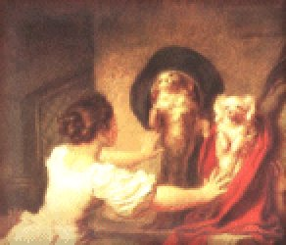 | Education is  Everything  (Detail)  1780  Jean-Honore  Fragonard  (1732-1806)
A simple sentence is a group of words that names something and then says something about what it has named. Because the thing that is named is what the sentence is about, grammarians call it the “subject.” The most important words that say something about the subject are called “verbs.” In the following sentence, the subject is in green and is underlined once. The verb is in blue and is underlined twice.
Birds fly.
Note that some sentences say something by asking a question about the subject.
Do birds fly?
In longer sentences, we speak of subject and verb phrases. In
The little words are the most difficult.
“words” is the subject, but because the words “The” and “little” go with “words,” we can call “The little words” the subject phrase. Similarly, “the most difficult” go with “are,” so we can call “are the most difficult” a verb phrase. A phrase, in other words, is a group of words that does not contain both a subject and a verb.
The following are examples of sentences:
April is the cruelest month.  Is April the cruelest month?  Bert likes baseball.  Does Bert like baseball? | Sarah was going to the museum.  Swimming can be good exercise.  Jane will have to work on Friday  The book was written by a child.

Ex. 1 - Sentence or Phrase?  Based on  Introductory Lessons in English Grammar  For Use in Intermediate Grades  By Wm. H. Maxwell, M.A. | 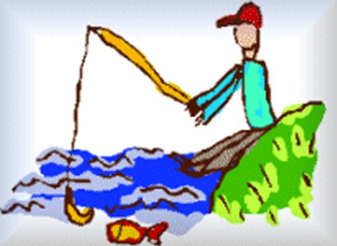
Directions: Which of the following are sentences? Draw a line through each of the following that is just a phrase. In the sentences:
1. complete the punctuation with a period for a statement or a question mark for a question;
2. underline the subject once, and the verb twice.

1. Fire burns  2. Full of apples  3. On the floor  4. Wasting his time  5. Is he well  6. Bitten by a dog  7. Eating a red apple  8. In the rain  9. The earth is round  10. May I go with you | 11. On a square piece of velvet  12. Why did you fall  13. In the running water  14. The rose is red  15. Helping his mother  16. Sugar is sweet  17. Life is short  18. At my home by the sea  19. During the storm  20. When did you come

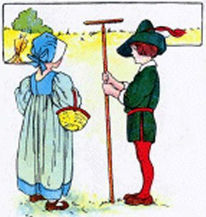 | Understood “You”
In some sentences the subject “you” is simply understood:
Close the door. = You close the door.
Be quiet! = You be quiet!
Take out the garbage. = You take out the garbage.
To show that you understand this, your teacher may want you to always write in, and underline once, the understood “you.”
Note that “I” or “We” is also sometimes understood:
Thank you! = I thank you! or We thank you!

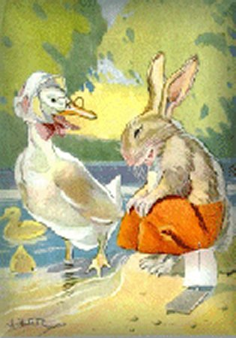 | Ex. 2 - “You” as the Understood Subject  From Bunny Rabbit's Diary (# 1)  by Mary Frances Blaisdell
Directions:
1. Write in the understood “you” in each sentence.
2. Underline verbs twice, their subjects once.
1. Follow us and you will see.
2. Come down here.
3. Wait for me.
4. See this big oak leaf?
5. Look, look!
6. Come, little leaves.
7. Put on your dresses of red and gold.
8. Wake up, Billy!
9. Don’t make a noise.
10. Come down and play with us.

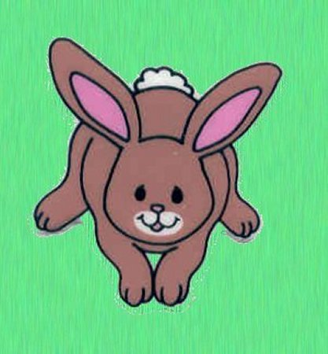 | Ex. 3 - “You” as the Understood Subject  From Bunny Rabbit's Diary (# 2)  by Mary Frances Blaisdell
Directions:
1. Write in the understood “you” in each sentence.
2. Underline verbs twice, their subjects once.
1. Look at that!
2. See my ducks.
3. Come back!
4. See Mrs. Duck and all the little ducks.
5. Paddle your feet, paddle your feet!
6. Show it to us.
7. See the fishes in the water.
8. Don’t go into that house.
9. Just see the flowers after the rain.
10. Flap your wings!

“There” as a Subject
In some sentences, you will find “there” as the subject. For example,
There are five trees there.
There are five trees there.
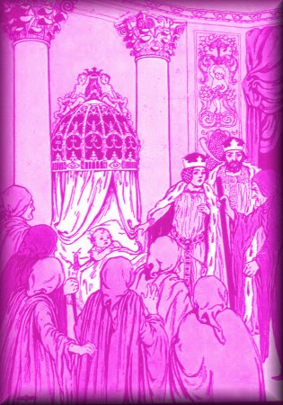 | Ex. 4 - from The Haliburton First Reader  Boston: D.. C. Heath and Co., 1912  Directions: Underline verbs twice, their subjects once..
1. There are three little eggs.
2. There are three baby birds in that little nest.
3. There is a song about the summer night.
4. There were sweet cakes and buns.
5. There were oranges and apples.
6. There was pudding, and some meat.
7. Now there was no spring near the castle.
8. Soon there was a deep hole in the ground.
9. There was once a good king and queen.
10 Once there was a little old woman and a little old man.

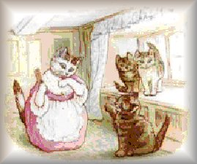 | Ex. 5 - Based on  The Tale of Tom Kitten, by Beatrix Potter
Directions: Underline verbs twice, their subjects once.
1. Once upon a time there were three little kittens.
2. There were several green smears!
3. There was a pit pat, paddle pat!
4. Somehow there were very extra--ordinary noises overhead.
5. There were no buttons.

Fillette au  Grand Chapeau  1908  by  Mary Cassatt  (1844-1926) | 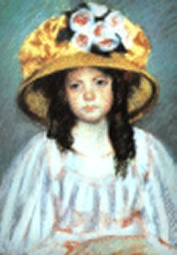 | A Focus on Single-Word Verbs

Many verbs express action that is performed by the subject. There are thousands of such verbs in English. The following are examples.
Ginger wrote a story.  Bill argued with his friend.  They went on a trip.  Paula kept a diary. | Lance flew an airplane.  Anthony rode in one.  We built a snowman.  My father paints houses.
Some common words do not express action, but they always function as verbs and therefore should always be underlined twice. The most common of these describe a “state of being.” Most of these verbs are forms of the verb “to be”—“am,” “is,” “are,” “was,” and “were.” When used alone, these verbs state what the subject is, what kind of thing it is, or where it is:
Mysha was our cat.
Their neighbor is nice.
I am in the garden.
Other words that are always verbs and that express “state of being” are “seem,” “resemble,” and “become.”
The baby seems hungry.
That store resembles a barn.
The weather became nasty.
If you remember not just these words, but what the words mean, you should be able to recognize many other verbs. For example, “The weather turned nasty” means that the weather became nasty. Because “turned” means “became,” it functions as a verb and should be underlined twice.
The words “has” and “had” are always verbs, as is “have” (unless it follows the word “to”—you’ll learn more about that later).
Margaret has Ted’s book.
The walls have pictures on them.
There are more words that function only as verbs. You'll learn about many of them in later lessons. For now, you need to remember that:
“Am,” “is,” “are,” “was,” “were,” and “has,” “had,” and “have” (unless it follows “to”) are always verbs that you should underline twice.

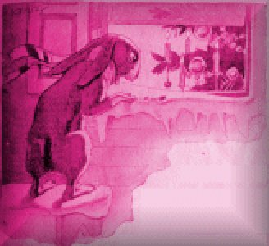 | A Christmas Tree  from  Bunny Rabbit’s Diary  by Mary Frances Blaisdell  Illustrated by George F. Kerr  Boston: Little, Brown, and Company, 1915 | 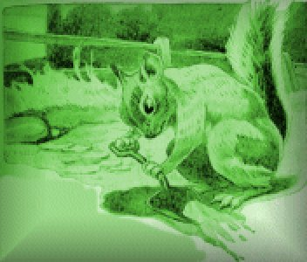
I
The little pine tree stood near the path that led through the woods.
In summer the rabbits often sat under this tree to rest.
The tree listened to the stories they told of the good times they had together.
The birds flew to its branches and talked to each other about the things they had seen in the woods.
Bobby Gray Squirrel and his brothers often ran up into the pine tree to play tag.
But Sammy Red Squirrel knew something about this tree that no one else knew.
He knew where there was a small hole in one of the branches.
He found it one day when he ran up into the tree to eat a nut.
And when he saw the hole he said to himself, “That is a good place to hide some nuts for the winter.”
The hole was not very large, but Sammy hid ten acorns in it. He packed them in one by one.
Last of all he put a piece of bark in the hole.
“This is a good door for my store-house,” he said, “I am sure no one will find these acorns.”
And no one did find them.
Sammy ran to the hole very often and lifted the door just a crack.
The ten little acorns were just where he had put them.
“I will eat these nuts last of all,” he said to himself.
All through the fall the little red squirrel hunted for nuts under the trees.
Sometimes he could not find any on the ground.
Then he would run round and round hunting for holes where he had hidden acorns away.
If the holes were empty Sammy knew some other little squirrel had been there before him.
And sometimes Sammy found nuts that other squirrels had stored away.
The hunting was always good, and no squirrel ever went to bed hungry.
But at last Jack Frost came and covered everything with snow.
All the nuts and acorns were frozen into the ground so the squirrels could not dig them out.
Then Sammy went to his store-house in the stone wall or in some old stump.
At last it became very cold.
North Wind blew through the woods.
The water in the little brook was covered with ice.
The birds tried to keep warm among the branches of the evergreen trees.
The rabbits slept in their warm home and did not come out very often.
The squirrels slept in their nests, and did not come out for days and days.
Blacky Crow stayed in the deep woods where the largest trees helped to keep him warm.
The ground had been covered with snow for two or three weeks.
And the squirrels and rabbits had taken long, long naps.
II
A few days before Christmas, Mr. Sun came up from behind the hills and shone brightly all day long.
He melted the snow in the warm hollows, and softened the ice on the brooks.
Bunny Rabbit and his brothers came out and hopped around to find roots to eat.
The squirrels ran up and down the trees, and all around everywhere to find hidden nuts.
All at once Bunny Rabbit heard a noise.
He sat up on his hind legs and held up his long ears.
The other rabbits listened, too.
Sammy and Bobby heard the noise and scampered up into the little pine tree.
“Bow-wow-wow!” barked Jip, as he ran through the woods.
“It’s the dog!” cried Bunny. “Let’s run and hide.”
The little rabbits whirled around and hopped back to their house.
Sammy and Bobby were safe in the tree, so they did not try to run away.
They heard some one talking and they looked to see who it was.
They saw two children and a man.
The man had an axe in his hand.
The two children ran along the path, talking and laughing.
They were looking at all the evergreen trees.
“This is a good one,” said the little boy.
“This is a better one,” said the girl, and she pointed right at the little pine tree where Sammy and Bobby were hiding.
“They are going to cut down this tree,” whispered Sammy. “What shall we do? What shall we do?”
But the man did not cut down the tree.
He looked at it and said, “That is too large for our Christmas tree.
“We must find one that is much smaller.”
So the man and the two children went along the path into the woods.
And before long the sound of the axe rang out through the stillness.
“I never was so frightened in my life,” said Sammy. “I thought they were going to cut down this tree.”
“I thought so, too,” said Bobby. “But I was not frightened. I could jump to that next tree. It is not very far.”
“I know that,” said Sammy. “But I have a store-house in this tree.”
“Where is it?” asked Bobby. “I wish you would show it to me. I am as hungry as a bear.”
“So am I,” said Sammy. “Let’s have dinner now.”
“We will call it a Christmas dinner. The children said this would make a good Christmas tree,” said Bobby.
“I wonder what a Christmas tree is like,” said Sammy, as he ran along the branch to find the store-house.
Bobby followed Sammy and peeped into the hole where the ten acorns were hidden.
Sammy took out a nut, and Bobby took out a nut.
They sat up on their hind legs and nibbled away happily.
And as they nibbled, the man and the two children and the dog came back through the woods.
They were dragging a little tree over the snow.
The dog ran along beside them barking loudly.
“That must be a Christmas tree,” said Bobby. “I wonder what they are going to do with it.”
“Tweet, tweet!” sang a little sparrow. “I can tell you. I saw one last year.
“I peeped in at the window after the tree had been set up in the warm room.
“I saw many pretty things hanging on the branches.
“I saw the candles lighted, and Santa Claus came in to give away the toys to the happy children.
“Oh, it was pretty! But I like to see the tree in the woods better.”
Then the little sparrow flew away, and the two squirrels ate another nut.
“I think this is a good Christmas tree,” said Bobby.
“Yes,” said Sammy. “A tree with a hole full of nuts is better than one covered with candles and toys.”
“It is better for squirrels,” said Bobby. And then he took another nut.

Ex. 6 – From “A Christmas Tree”
by Mary Frances Blaisdell (# 1)
Recognizing Subjects and Verbs

Remember: Find the verb first, then ask a question
with “Who” or “What” to find the subject of the verb.
Directions: In the following sentences underline the verb twice and its subject once.
1. The little pine tree stood near the path.
2. The path led through the woods.
3. The rabbits often sat under this tree.
4. The tree listened to the stories.
5. The birds flew to its branches.
6. Sammy Red Squirrel knew something about this tree.
7. The hole was not very large.
8. He put a piece of bark in the hole.
9. This is a good door for my store-house.
10. I am sure.

Ex. 7 – From “A Christmas Tree”  by Mary Frances Blaisdell (# 2)  Recognizing Subjects and Verbs | 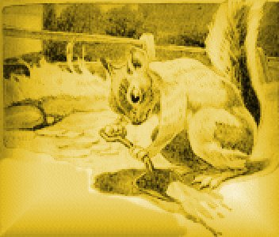

Directions: In the following sentences underline the verb twice and its subject once.
1. Sammy ran to the hole very often.
2. The little red squirrel hunted for nuts under the trees.
3. The holes were empty.
4. The hunting was always good.
5. Then Sammy went to his store-house in the stone wall.
6. At last it became very cold.
7. North Wind blew through the woods.
8. The squirrels slept in their nests.
9. Blacky Crow stayed in the deep woods.
10. He melted the snow in the warm hollows.

Ex. 8 – From “A Christmas Tree”
by Mary Frances Blaisdell (# 3)
Recognizing Subjects and Verbs
Directions: In the following sentences underline the verb twice and its subject once.
1. The squirrels ran up and down the trees.
2. All at once Bunny Rabbit heard a noise.
3. The other rabbits listened, too.
4. It is the dog!
5. Sammy and Bobby were safe in the tree.
6. The man had an axe in his hand.
7. The two children ran along the path.
8. This is a good one.
9. She pointed right at the little pine tree.
10. That is too large for our Christmas tree.

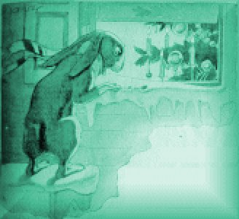 | Ex. 9– From “A Christmas Tree”  by Mary Frances Blaisdell (# 4)  Recognizing Subjects and Verbs
Directions: In the following sentences underline the verb twice and its subject once.
1. And before long the sound of the axe rang out through the stillness.
2. I thought so, too.
3. But I have a store-house in this tree.
4. Where is it?
5. I am as hungry as a bear.
6. So am I.
7. Sammy took out a nut.
8. I saw many pretty things.
9. Oh, it was pretty!
10. Then the little sparrow flew away.

Ex. 10 - Just for Fun: Riddles
Directions: In each sentence, underline verbs twice and their subjects once. If you can think of the answer, write it out as a sentence. If you can’t think of one, your teacher will give it to you, either as or after you do the exercise.
Example:
Q: What is the longest word in the world?
Response:
Q: What is the longest word in the world?
A: “Smiles” is the longest word in the world. There is a mile between two S’s.

1. Q: What has four wheels and flies?
2. Q: What kind of driver has no license?
3. Q: What kind of building has the most stories?
4. Q: What animal always breaks the law?
5. Q: What dog keeps the best time?
6. Q: Four cats were in a boat. One jumped out. How many were left?

Ex. 11–Spelling
died hoe chirp spill move
lied foe churn whey David
cried toe chunk first choose
To “ch”— add in, ill, aff, ew, ain, est, oose, eese, eck, ick, ore, air, arm, urch. With —“ied” put t, sh, sp, tr, fr, dr, pr.
Directions for Analysis. Underline verbs twice and their subjects once.
1. She tied her apron strings.
2. The flowers soon died.
3. A chunk of beech wood burns well.
4. You choose the cheese?
5. I spied you first.
6. She fried two lamb chops.
7. We tied the chest.
8. The sun dried my hair.
9. Robins chirp.
10. They checked the boxes.

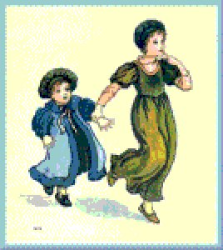  Illustration by Kate Greenaway | “Helping” Verbs (Tense)
Some verbs “help” other verbs express differences in time or emphasis. The results are “verb phrases.” For examples:
Past | Present | Future
They were playing.  Bobby was playing.  Bobby had been playing.  Bobby did play.  Bobby has played.  Bobby was going to play. | I am playing.  We are playing.  You are playing.  Bobby is playing.  Bobby does play. | I will have to play.  You will play.  Bobby will play.  Bobby will be playing.  Bobby will have been playing.
These helpers are usually forms of the verbs:
be: | is, are, was, were, am, be, being, been
have: | have, has, had
do: | do, does, did, done
Note that “will,” “going to,” and “used to” are also used as parts of a verb phrase:
Sam will play tomorrow.
They were going to play baseball.
Toni also used to play baseball.
When you underline verbs, be sure to underline all the helping verbs in the verb phrase.

The Swimming Lesson  from  Bunny Rabbit’s Diary  by Mary Frances Blaisdell  Illustrated by George F. Kerr  Boston: Little, Brown, and Company, 1915 | 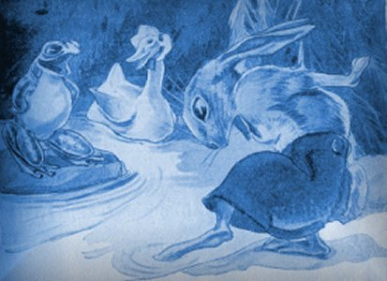
I
“Quack, quack, quack!” said Mrs. Duck, as she walked along the little path through the meadow.
“Quack, quack, quack! Follow me, little ducks.”
One, two, three, four, five, six little yellow ducks waddled after their mother along the little path through the meadow.
Bunny Rabbit was sitting under a tree, fast asleep, and he did not hear them coming.
He was dreaming of flying away with the little birds.
He could fly high up over the trees and over the houses.
Oh, it was great fun! All the other rabbits were sitting on the ground watching him.
“Good-by,” he called to Billy.
Then he waked up, and he was not under the oak tree.
“Quack, quack, quack!” said Mrs. Duck. “What are you talking about, Bunny? I cannot see Billy anywhere.”
“I was dreaming of flying,” said Bunny. “I said good-by to Billy because I was going far away.”
“Quack, quack!” said Mrs. Duck. “I should like to see you fly. You can’t even swim.”
“Perhaps I could,” said Bunny, “if you would teach me.”
“Come with me,” said Mrs. Duck “I am going to teach my little ones to swim, and I will teach you, too.”
“Quack, quack!” said all the little ducks, as they waddled after their mother.
“Come and see how soon we will learn to swim.”
Bunny did not like to think that these little ducks could do something that he could not do.
“I have four feet,” he said to himself, “and they have only two. I am sure I can do what they can do.”
So Bunny jumped up and followed the ducks along the path through the meadow.
In a few minutes they came to the brook. The water looked cool to the little ducks. But the water looked very wet to Bunny.
Mrs. Duck stood on the bank for one minute to talk to her ducklings.
“Follow me,” she said, “and do what I do. Swimming is the easiest thing in the world.
“When I count three we will all go into the water together.”
“I think I will wait and see how you do it,” said Bunny. “That will be the best way for me to learn.”
So Bunny sat down on the bank, and the little ducks stood in a row behind their mother.
“Now,” said Mrs. Duck, “one, two, three,—go!”
At the word “go” they all waddled into the water.
Paddle, paddle, paddle! Mrs. Duck made her feet go so fast that she was soon in the middle of the brook.
Paddle, paddle, paddle, went all the little ducks, and they were swimming after their mother.
“Oh, what fun this is!” said the littlest duck.
“How cool the water is,” said the biggest duck.
“Come in, Bunny,” called all the ducks. “Swimming is the easiest thing in the world.”
“Why don’t you try it, Bunny?” asked Mr. Green Frog, who was sitting on a rock close by.
“The water is cool, and swimming is the easiest thing in the world.”
II
Bunny sat still on the bank, but he did not say a word.
He watched the ducks swimming round and round in the water.
“All they have to do is to paddle their feet,” he said to himself. “I am sure I can do that. But I do wish the water was not so wet.”
“Are you afraid to come in?” asked Mrs. Duck.
“Are you afraid to come in?” asked Mr. Green Frog.
Of course Bunny was afraid, but he did not like to say so.
At last he stood up and went down to the edge of the brook. He put one foot in the water, but he pulled it out again very quickly.
“Oh, dear!” he said, “the water is so wet.”
“You can’t swim on dry land,” said Mrs. Duck. “Jump in, and you will like it, I know.”
“Jump in!” said Mr. Green Frog.
Bunny went a step nearer and put two feet in the water.
“Oh, dear!” he thought to himself. “I never can learn to swim. I wish I were back under the tree, fast asleep.”
Splash, splash! Mr. Green Frog jumped into the water close to Bunny’s feet.
It frightened the poor little rabbit and he slipped into the water, too.
“Paddle your feet, paddle your feet!” Mrs. Duck called to him.
But, of course, Bunny did not know how to paddle his feet.
He kicked and kicked and scrambled and splashed around in the brook.
The water ran into his eyes and he could not see.
The water ran into his ears and he could not hear.
The water ran into his mouth and he could not speak.
He kicked and splashed and scrambled until at last he felt his feet touch the ground.
Then he scrambled up on the bank and threw himself on the soft grass.
“You did not paddle your feet,” said Mrs. Duck.
“Watch us,” said all the little ducks. “Do it the way we do.”
“Oh, oh!” laughed Mr. Green Frog. “Do try it again. It was the funniest sight I ever saw.”
“It may have been funny for you,” said Bunny. “But it was not funny for me. I am so wet, that I shall never be dry again. And I am afraid I have spoiled my fur coat.”
But Mr. Sun shone down brightly and Bunny was soon dry and warm.
Then he hopped along home by the little path through the woods.
“Swimming may be easy for ducks,” he said to himself.
“And flying may be easy for birds.
“Rabbits and squirrels can run and hop and jump. And that is easy for them.”

Ex. 1 - Helping Verbs  From “The Swimming Lesson”  by Mary Frances Blaisdell (Ex. 1) | 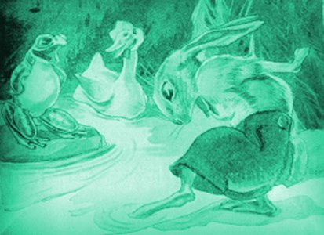
Directions: Underline the verbs twice, their subjects once.
1. Mrs. Duck was walking along the little path through the meadow.
2. Bunny Rabbit was sitting under a tree.
3. He did not hear them.
4. He was dreaming about the little birds.
5. All the other rabbits were sitting on the ground.
6. What are you saying, Bunny?
7. I was going far away.
8. I am going to teach my little ones.
9. I will teach you, too.
10. Mrs. Duck was talking to her ducklings.

Ex. 2 - Helping Verbs  From “The Swimming Lesson”  by Mary Frances Blaisdell (Ex. 2) | 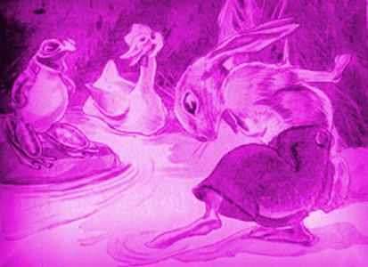
Directions: Underline the verbs twice, their subjects once.
1. We will all go into the water together.
2. That will be the best way for me.
3. The little ducks had been standing in a row behind their mother.
4. Mrs. Duck was soon swimming in the middle of the brook.
5. All the little ducks were swimming after their mother.
6. Why don’t you try it, Bunny?
7. Mr. Green Frog was sitting on a rock close by.
8. Bunny had been sitting still on the bank.
9. But he had not said a word.
10. The ducks had to paddle their feet.

Ex. 3 - Helping Verbs
From “The Swimming Lesson”
by Mary Frances Blaisdell (Ex. 3)
Directions: Underline the verbs twice, their subjects once.
1. He did put one foot in the water.
2. You will like it.
3. Bunny had gone a step nearer.
4. Bunny did not know how.
5. He was splashing around in the brook.
6. The water was running into his eyes.
7. At last his feet had touched the ground.
8. You did not paddle your feet.
9. But Mr. Sun had been shining down brightly.
10. Bunny will soon be dry.

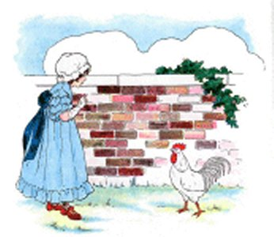  Illustration by Blanche Fisher Wright | Other Helping Verbs
Some helping verbs show the beginning, continuation, or ending of an action. For example:
begin | He will begin to swim in the morning.  They began playing the game.
start | Bobby is starting to draw a picture.  Sandi started reading a story.
continue | The rabbit continued to run away.  Blackie Crow will continue to fly high in the sky.
keep (on) | Bobtail kept on eating nuts.  Bobby will keep climbing into the trees.
stop | Mrs. Duck stopped swimming in the pond.  They will stop playing soon.
Other helping verbs show an attitude toward an action. For example:
like | Sammy Squirrel likes eating nuts.  Would you like to go to the park?
love | The ducks love to swim.  Bobtail does not love flying.
hate | Children hate to go to bed early.  Bobtail hates flying.
want | Blackie Crow will want to fly to the party.
try | Bobby will try to fly too.

Ex. 4 - Other Helping Verbs  From Bunny Rabbit’s Diary (#1)  by Mary Frances Blaisdell | 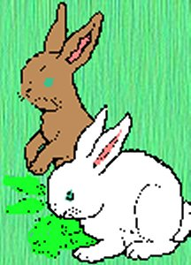
Directions: Underline the verbs twice, their subjects once.

1. But Jip wanted to play.
2. Bobtail stopped eating.
3. I like to see the water.
4. Bobtail began to hop around.
5. Bobtail liked to play with Bunny.
6. I never can learn to swim.
7. The birds tried to keep warm.
8. I love to eat the seeds.
9. Bobby began to scold Jip.
10. Do you like to live in a little house?

Ex. 5 - Other Helping Verbs  From Bunny Rabbit’s Diary (#2)  by Mary Frances Blaisdell | 
Directions: Underline the verbs twice, their subjects once.
1. The wind stopped blowing.
2. He did not like to work.
3. I am trying to find someone.
4. Bobtail began to nibble the greenest leaves.
5. He did not ask to play.
6. And the rabbits did not like to wet their feet.
7. I did not want to leave my home in the field this week.
8. He loved to curl up in the tall grass.
9. A gentle wind began to blow over the tall grass in the field.
10. Billy always liked to have a game of tag with Bobtail.

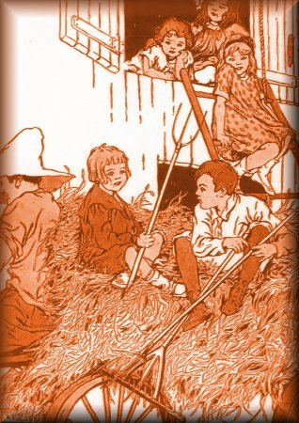 | Ex. 6 - [V] An Exercise on Verbs  from The Haliburton First Reader  Boston: D.. C. Heath and Co., 1912
Directions:
1. Fill in the blanks with verbs.
2. Underline the verbs twice, their subjects once.
3. Label complements “C.”
1. It ______________ the spring time.
2. The bright stars ______________ in the sky.
3. The birds ______________ through the sweet air.
4. The bees ______________ through the orchard.
5. We ______________ a nest in the tall tree.
6. Betty and Alice ______________ pet lambs.
7. The lambs ______________ and ______________ in the clover.
8. The children ______________ and ______________ with the lambs.
9. Mary and her sister ______________ ______________ the rain.
10. ______________ you ______________ the flowers on Alice’s lamb?

Ex. 7 - Spelling
ash dish water more finger
cash fish snap like knife
crash wish have pony words
Put l, s, h, m, r, cl, tr, thr, spl, with —“ash.”
Directions for Analysis. Underline verbs twice and their subjects once.
1. The fish are splashing in the water.
2. The dish had fallen with a crash.
3. How much cash do you have?
4. Do you wish to have a little more hash?
5. Will you snap the new lash?
6. My horse had been running like a flash.
7. Don’t thrash your pony so.
8. The sharp knife had cut a gash in my finger.
9. Billy has to write two more words.
10. Where has your new knife been?

Ex. 8 - Just for Fun
Directions: In each sentence, underline verbs twice and their subjects once.
1. Q. Why do cows have bells?
A. Their horns do not work!

2. Q. What did the spider do on the computer?
A. It made a website!

3. Q. Why was the dog sweating so much?
A. He was a hotdog!

4. Q. Why did Santa have three gardens?
A. So he could hoe-hoe-hoe.

5. Q. Why did fruit punch and cereal box?
A. They were having a food fight.

Unit 4—Apostrophes in Contractions

Apostrophes in Contractions

Ex. 1 – Contractions and Apostrophes
Copy the following very carefully:—
isn’t, wasn’t, hasn’t, doesn’t
aren’t, weren’t, haven’t, don’t
What to See and Do.—The first word of these lines is made up of “is” and “not.”
Notice that a little mark is placed between “n” and “t” to show where the “o” is left out.
This mark is like a comma, but it is higher up. It is called an apostrophe.

Describe each of the other words.

Make four sentences, using the words of the first line in telling about one thing ; as,
The game doesn’t work.

Make four sentences, using the words of the second line in telling about more than one thing; as.
The games don’t work.
“Do work” is the chief part that tells. The word “not” denies what the other words tell.

These forms are called “contractions.”

Use each of these words five times.

Ex. 2 –Based on Bunny Rabbit’s Diary  by Mary Frances Blaisdell (# 1) | 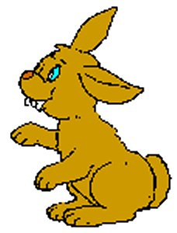
Directions:
1. Underline the verbs twice and their subjects once.
2. After each sentence, write the full form of the contraction. (For example, if the contraction is “I’m,” write “I am.”)
1. I don’t like to fly kites.
2. I’ve never seen you before.
3. But Teddy didn’t speak.
4. You can’t swim on dry land.
5. It’s the dog!
Directions:
1. Underline the verbs twice and their subjects once.
2. After each sentence, write a contraction that would combine two words in the sentence. (For example, if the sentence includes “I will,” write “I’ll.”)
1. It is going to rain.
2. I do not like the wind.
3. Teddy did not say a word.
4. But you will never be hungry here.
5. But he could not find Bobtail.

Ex. 3 - More Practice with Helping Verbs  From Old-time Stories  Fairy Tales and Myths Retold by Children  By E. Louise Smythe | 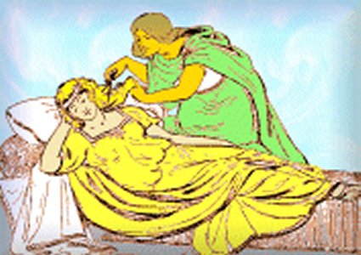
Directions: Underline verbs twice, their subjects once.
1. You have almost spoiled it.
2. One day they were playing in the garden.
3. So no one could get the golden fleece.
4. The Frost Giants did not like the sunshine.
5. You may have the falcon suit.
6. These rocks had been put in the sea.
7. I am going to see those birds.
8. Then you must pay for cutting off my wife's hair.
9. Did you cut off Sif's hair?
10. They had to put rags in the windows.
11. Can you lay eggs?

Ex. 4 – Spelling
lass less hiss loss fuss
mass mess miss moss muss
bass Bess kiss boss buss
glass bless bliss gloss truss
Put p, gr, br, cl, with —“ass”; and t, fl, cr, acr, with —“oss.”
Directions for Analysis. Underline verbs twice and their subjects once.
1. Sam hadn’t given the horse less grass.
2. Isn’t there is a brass clock?
3. Jack didn’t catch six black bass.
4. Don’t they pack the moss in a glass box?
5. Don’t muss your new dress.
6. Mabel hasn’t tossed her baby doll across the room!
7. Aren’t you happy with the flossy gloss?
8. Miss Bess isn’t very cross.
9. Haven’t you tossed the sack across your back?
10. Don’t make a fuss in class!

Ex. 5 - Just for Fun
Directions: In each sentence, underline verbs twice and their subjects once. Note that the answer in number three has two subject/verb patterns.
1. Q: Did you hear about the pregnant bed-bug?
A. She’s having her babies in the spring.
2. Q: Why don’t dogs make good dancers?
A. They have two left feet!
3. Q: What is the difference between a bird and fly?
A: A bird can fly, but a fly can’t bird!
4. Q: Why doesn’t the elephant use a computer?
A. It’s afraid of the mouse!
5. Q: Why don’t mountains get cold in the winter?
A. They wear snow caps.

Unit 5—Adding Simple Complements
Identifying Complements:  The S / V / C Pattern  (Subject / Verb / Complement) | 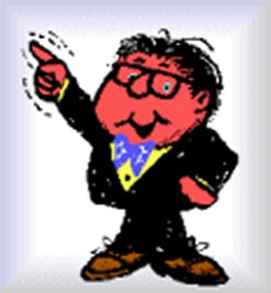
Once you can find most subjects and verbs, you should start to look at the full S/V/C pattern. The “C” stands for “complement.” To find the subject of a verb, you can ask a question with “Who” or “What” before the verb. For example, in the sentence
Arthur likes sandwiches.
we can ask “Who or what likes?” The word in the sentence that answers that question is “Arthur,” so “Arthur” is the subject of “likes.”
To find the complement of a verb, simply create a question with “whom” or “what” after the verb. “Arthur likes whom or what?” The answer to that question in this sentence is “sandwiches,” so “sandwiches” is the complement of “likes.”
Note that the question has to be based on the verb plus “whom” or “what.” Words that answer the questions “When?” “Why?” “How?” etc. do not identify complements. (They identify adverbs—which you will learn about later.

Note: For now, you are expected to be able to identify single words that function as complements, but some complements consist of several words and may confuse you. You are not expected to identify these complements. Simply concentrate on the complements that you can identify. (Remember, there are mistakes that you are expected to make.)

April Fool’s Day
from
Bunny Rabbit’s Diary
by Mary Frances Blaisdell
Illustrated by George F. Kerr
Boston: Little, Brown, and Company, 1915
“Wake up, Billy!” called Bunny. “Wake up and see how hard it is snowing.”
Billy opened his sleepy eyes and rolled out of bed.
Then he went to the door and peeped out.
“April fool, April fool!” shouted Bunny.
Billy laughed. Then he hopped out of doors.
It was a warm sunny day,—just the day to run around and play jokes.
But first the little rabbits had to find their breakfast.
Now that the warm days were coming they could find plenty to eat.
And Bunny and Billy and Bobtail were growing very fat.
Bobby Gray Squirrel and Sammy Red Squirrel could find plenty to eat, too.
In the fall they had stored away nuts and acorns in little holes in the ground.
When Jack Frost covered the ground with snow the squirrels could not dig up these nuts.
But now the ground was soft again, and Bobby and Sammy had plenty to eat.
Bunny and Billy and Bobtail saw the squirrels hide the nuts.
They did not like acorns so they never opened the store-house doors.
They just hopped around under the trees looking for green leaves and tender roots.
But on this first day of April Bunny found the biggest acorn he had ever seen.
It was hidden in a little hole, and he saw it when he sat down to eat his breakfast.
“Oh, oh!” he said to himself. “Now I can play a joke on Bobby Gray Squirrel.
“I am going to tie a string to this acorn, and when Bobby tries to pick it up I shall pull it away from him.”
He told Bobtail and Billy about the joke he was going to play on the gray squirrel.
“Ho, ho!” laughed Billy.
“Ha, ha!” laughed Bobtail.
“We must hurry and finish our breakfast,” said Bunny.
“Bobby will be out hunting for nuts very soon.”
In a few minutes the three rabbits had finished their breakfast.
Then Bunny hopped away to find a string he had seen under the oak tree.
It was the same string they had used to fly their kite.
The string had held the kite to the branch for a long time.
Then one day North Wind came again and tried to carry it away.
He puffed and puffed, and at last the branch let go of the string.
The kite flew up in the air and far away, but the string dropped to the ground under the oak tree.
There Bunny found it, and he tied the string around the acorn.
Then he scampered back to his brothers.
They were waiting for him near the old stone wall.
“Let’s fool Sammy Red Squirrel first,” said Billy.
“I saw him run out of his hole just a minute ago.”
Bunny put the acorn in front of Sammy’s door.
Then he held on to the other end of the string and hid behind a big rock.
Bobtail and Billy hid behind the pine tree.
They all kept as still as mice. They did not even shake one of their long ears.
“There is Sammy now,” whispered Billy. “I can see him running along the path.”
“Don’t make a noise,” said Bobtail.
Bunny saw the little red squirrel coming down the path.
He kept very still and held on to the string.
II
Sammy came skipping down the path.
He was singing a gay little tune:
“One, two, three, four, five, six,
“I’ll watch out for April tricks.”
Just then he saw the acorn lying on the ground near his door.
“Look at that!” he said. “Bobby Gray Squirrel must have been here.
“Something frightened him, and made him drop that nut near my door.”
Now Sammy was very fond of big acorns and he had not had one for a long time.
So he pounced on the acorn.
But it was not there! Bunny had given the string a quick pull.
Sammy put his hand down on a rock. There was no acorn to be seen.
“April fool!” shouted Bunny.
“April fool!” shouted Billy and Bobtail.
The three rabbits hopped out from their hiding places.
They laughed and laughed, and Sammy laughed, too.
“That was a good trick,” he said.
“We are going to play it on Bobby Gray Squirrel, now,” said Bunny.
“May I go with you?” asked Sammy.
“Oh, yes!” said the three rabbits.
So off through the woods they all went.
“Bobby often comes to the big oak tree,” said Billy. “I think that will be a good place to play the trick.”
Bunny put the acorn on the ground, and then they all hid behind the tree.
They did not wait very long before they saw Bobby coming.
And in another minute Bobby saw the acorn.
“Ho, ho!” he said. “Sammy Red Squirrel must have dropped that big acorn. I will pick it up.”
He ran along the ground toward the oak tree.
Bunny held on to the string.
He was going to wait until Bobby took hold of the acorn and then pull it away.
It was so still that the rabbits could hear Bobby’s feet as they pattered on the ground.
Then all at once it was not still in the woods.
Jip, the dog, came bounding along the little path.
“Bow-wow, bow-wow!” he barked. “Look out for me. I am coming.”
What a scampering there was!
Bobby forgot all about the acorn and skipped up the oak tree.
Sammy skipped up the tree after him.
The three little rabbits put their ears down on their heads, and hopped away out of sight.
“Bow-wow, bow-wow!” said Jip. “Where has every one gone?
“I thought I saw some one under this tree as I came along the path.”
The acorn lay on the ground where Bunny had left it.
Four little bright eyes watched Jip from the oak tree.
Sammy wished he could call out “April fool,” to Jip.
But he was afraid of dogs, so he kept very still.
Bobby kept still, too, and the three little rabbits hopped along towards home.
After a while Jip went home.
Then there was a quick scampering down the tree.
One of the squirrels had that big acorn for his dinner.
Was it Sammy or Bobby?

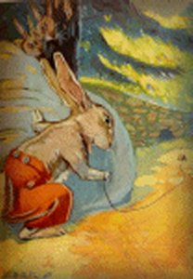 | Ex. 1 - Adding Complements  Based on “April Fool’s Day” (#1)  by Mary Frances Blaisdell
Directions: In the following sentences, underline the verbs twice, their subjects once, and write “C” above any complements.
1. Billy opened his sleepy eyes.
2. Then he went to the door.
3. Billy hopped out of doors.
4. It was a warm sunny day.
5. But first the little rabbits found their breakfast.
6. Bobtail grew very fat.
7. They stored away nuts.
8. Jack Frost covered the ground with snow.
9. The squirrels dug up these nuts.
10. But now the ground was soft again.

Ex. 2 - Adding Complements
Based on “April Fool’s Day” (# 2)
by Mary Frances Blaisdell
Directions: In the following sentences, underline the verbs twice, their subjects once, and write “C” above any complements.
1. They never opened the store-house doors.
2. They just hopped around under the trees.
3. But on this first day of April Bunny found the biggest acorn.
4. He told Bobtail about the joke.
5. In a few minutes the three rabbits finished their breakfast.
6. Bunny saw a string under the oak tree.
7. It was the same string.
8. The string held the kite to the branch for a long time.
9. Then one day North Wind came again.
10. The string dropped to the ground under the oak tree.

Ex. 3 - Adding Complements
Based on “April Fool’s Day” (# 4)
by Mary Frances Blaisdell
Directions: In the following sentences, underline the verbs twice, their subjects once, and write “C” above any complements.
1. That was a good trick.
2. Bobby often comes to the big oak tree.
3. Then they all hid behind the tree.
4. Sammy Red Squirrel dropped that big acorn.
5. Then all at once it was not still in the woods.
6. Bobby forgot all about the acorn.
7. Sammy skipped up the tree after him.
8. The three little rabbits put their ears down on their heads.
9. Four little bright eyes watched Jip from the oak tree.
10. One of the squirrels had that big acorn for his dinner.

Ex. 4 - Punctuating a Sentence  From “Billy’s Slide” (# 1)  by Mary Frances Blaisdell | 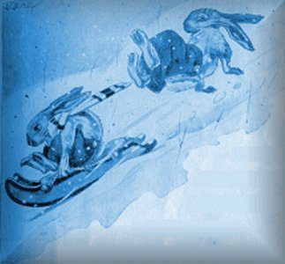
A sentence begins with a capital letter and ends with a period, question mark, or exclamation point.
Directions:
In the following ten items, one is not a sentence. Write “NS” after it (for “not a sentence”).
For those that are sentences,
1.) fix the capitalization and punctuation,
2.) underline the verb twice and its subject once, and
3.) label complements “C.”
1. one morning in winter bunny opened his eyes
2. then he pulled Bobtails long ears
3. oh, I am so sleepy
4. the sled going faster every minute
5. it is too cold
6. did the three little rabbits hop off through the woods
7. bunny jumped up and down in the snow
8. something hit bunny on the head
9. the three rabbits soon found some tender little roots
10. is this a good breakfast

Ex. 5 – Spelling
neck kick very peas yes
check chick two there play
wreck quick house where ship
With —“eck” put p, d, fl, sp; and with —“ick” put l, p, s, t, w, br, sl, st, th, tr.
Directions for Analysis:
- Underline verbs twice and their subjects once.
- Label complements “C.”

1. The brick is very thick.
2. Pick two pecks of peas.
3. Be quick.
4. Where is the brick house?
5. There is a speck of red on the chick.
6. Is Jack sick?
7. Play no bad tricks.
8. The ship was a wreck.
9. The hen has two chicks.
10. Can you see the house with the thick bricks?

Ex. 6 - Just for Fun
Directions: In each sentence, underline verbs twice, their subjects once, and write “C” over complements.

1. Q: Why didn’t the skeleton cross the road?
A: He didn’t have the guts!
2. Q. Why did the Easter egg hide?
A. He was a little chicken!
3. Why did the computer squeak?
A. Someone stepped on its mouse.
4. Q. Why did the elephant eat the candle?
A. He wanted a light snack!
5. Q: How does a dog stop a video?
A: He presses the paws button.

Unit 6—A Focus on Compounds  Coordinating Conjunctions and Compounding | 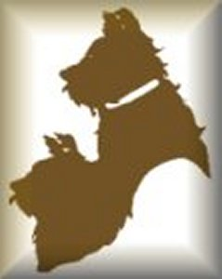
“Compound” refers to two or more words or phrases that serve the same function within a sentence. Usually, compounds are joined together by coordinating conjunctions—“and,” “or,” or “but.”
Subjects can be compounded:
Jan, Jill, Sally, and Sarah went to a party.
And so can verbs:
Joe did his English homework but forgot his math.
In other words, subjects, verbs, and complements can all be compounded:
“Mary and Bill ate dinner ^{(C)} and
then played tennis ^{(C)} and basketball ^{(C)}.”
Note that “either ... or...” and “neither ... nor....” are variations of “or,” and thus also function as coordinating conjunctions:
Neither Bill nor Tom likes either swimming ^{(C)} or fishing ^{(C)}.
Simply remember that any type of grammatical construction may be compounded.

Ex. 1 A Focus on Compounding  From Ben and Alice (#1) | 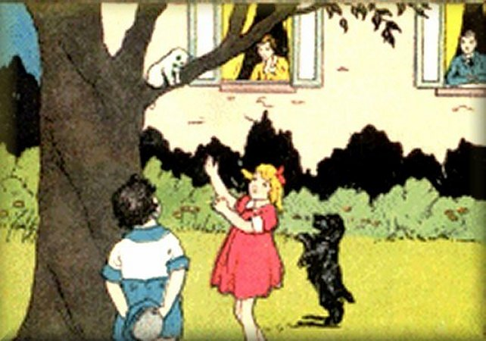

Directions:
1. Underline the verbs twice, their subjects once.
2. Write “C” above any complements.
1. They put bread and water in the bird house.
2. Ben and Alice ran and ran.
3. You are a bird and can fly.
4. I run and play in the garden.
5. Alice ran after Ben and Blackie.
6. Mother, Ben, and Alice went to Uncle Ben’s farm.
7. He had bread, milk, eggs, and apples with him.
8. The tree was black and white.
9. The children looked and looked at the baby bear.
10. I took Ben and Alice to my room.

Ex. 2 - A Focus on Compounding  From Ben and Alice (# 2) | 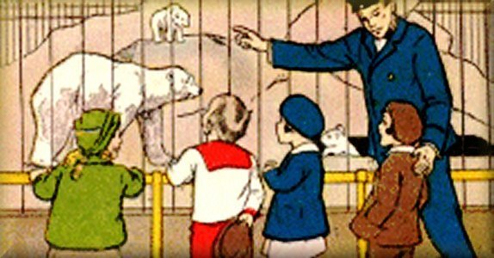
Directions:
1. Underline the verbs twice, their subjects once.
2. Write “C” above any complements.
1. It was little and brown.
2. Away ran Blackie and Whitie.
3. Then he went to the door and looked out.
4. We work and play here.
5. We saw the cow, the sheep, and the hen.
6. You and Alice and I will make the house.
7. I see a father monkey and a mother monkey.
8. We keep a big white bear and a little baby bear.
9. The mouse ran around a chair and then jumped into Ben’s cap.
10. Ben jumped out of his chair and ran to the telephone.

Ex. 3 “The Robin”—A Poem for Analysis
From The Real Mother Goose. Illustrated by Blanche Fisher Wright.
Chicago: Rand McNally & Co., 1916.

Directions:
1. Underline the verbs twice, their subjects once.
2. Write “C” above any complements.

The north wind doth blow,
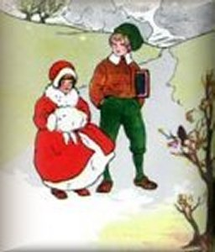
And we shall have snow,
And what will poor robin do then,
Poor thing?
He’ll sit in a barn,
And keep himself warm,
And hide his head under his wing,
Poor thing!

Ex. 4 - Contractions
From Bunny Rabbit’s Diary (#2)
by Mary Frances Blaisdell
Directions: In the following sentences, underline the verbs twice and their subjects once. Label complements “C.” After each sentence, write the full form of the contraction. (For example, if the contraction is “I’m,” write “I am.”)
1. I don’t want that now.
2. It’s too cold.
3. I’ll never go in there again.
4. I’m out.
5. I don’t like to stay in this yard all the time.

Directions: In the following sentences, underline the verbs twice and their subjects once. Label complements (C). After each sentence, write a contraction that would combine two words in the sentence. (For example, if the sentence includes “I will,” write “I’ll.”)
1. I am so hungry.
2. I am going home.
3. I will show you.
4. I have had enough to last me all day.
5. I can not swim.

Ex. 5 – Spelling
talk kept board floor aunt
walk wept knees next uncle
chalk slept Lucy hurt flower
Add —“es” to box, fox, watch, church, dish, wish, glass, brush, class, ditch, patch. Copy: Mr. John Smith; Mrs. Ellen Jones.
Directions for Analysis:
1. Underline verbs twice and their subjects once.
2. Label complements “C.”
1. Teachers talk and write on the board with chalk.
2. Baby and kitty crept on hands and knees.
3. Next year baby will walk and talk.
4. Aunt Lucy wept and couldn’t sleep.
5. My brothers and sisters like the flowers on that stalk.
6. I slept till half-past eight and then walked to class.
7. I kept the dishes and glasses from Uncle Alfred.
8. She moved the boxes and swept the floor.

Ex. 6 - Riddles
Directions: In each sentence, underline verbs twice, their subjects once, and write “C” over complements. If the answer is not stated as a sentence, write it out as one.
1. Q. What always falls but never gets hurt?
A: Rain!

2. Q. What is full of holes but can still hold water?
A: A sponge.

3. Q. What did one flea say to the other?
A. Should we walk or take a dog?
4. Q. What has a neck but no head?
A. A bottle.

5. Q. What three inventions help man up in the world?
A: The elevator, the ladder and the alarm clock

6. Q. What’s big and grey and has sixteen wheels?
A. An elephant on roller skates!

Unit 7—Adding More Helping Verbs
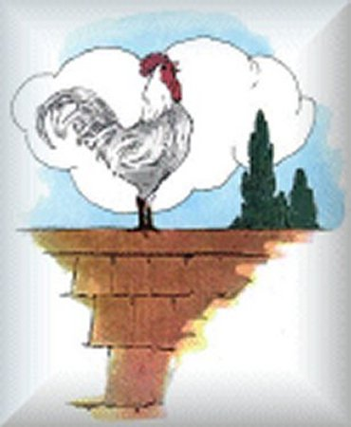 | Adding More “Helping” Verbs  Illustration by Blanche Fisher Wright
As you learn to identify verb phrases, remember that the following words often function as “helping” verbs and are thus part of the verb phrase.
Can and Could | They can see the parade from here.  But Samantha could see it from there.
Dare | Do they dare go to the cemetery?
May and Must | Charlie Brown may have seen the Great Pumpkin.  Charlie, you must not kick that football.
Might | You might see Venus on a clear night.
Need | They need only ask for help.
Ought | Bobby ought to practice more if he wants to be a better player.
Shall and  Should | Cinderella shall not go to the ball.  You should read more fairy tales.
Will and Would | Cinderella, you will go to the ball.  A fairy Godmother would be a big help.
Note that “had better” means the same as “should”:
They should weed the garden.
They had better weed the garden.
Thus “better” is considered part of the verb phrase.

Ex. 1 - More Helping Verbs  From “Mrs. Duck’s Secret” (#1)  by Mary Frances Blaisdell | 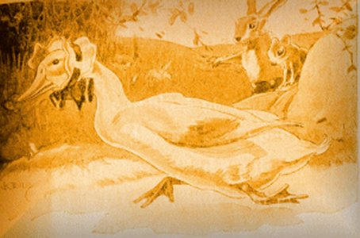
Directions:
1. Underline the verbs twice, their subjects once.
2. Label complements “C.”
3. After each sentence, write “past,” “present,” or “future.”
1. Mrs. Duck would not tell him.
2. Mrs. Duck must have gone long ago.
3. They ran back and forth along the little path.
4. In the sun we shall go to sleep.
5. After a while the three little rabbits became sleepy.
6. I can not tell you.
7. Where are you going, now?
8. But they did not tell the secret to any of their friends.
9. May we go with you?
10. Some little yellow heads were peeping out from under her wings.

Ex. 2 – More Helping Verbs  From “Mrs. Duck’s Secret” (#2)  by Mary Frances Blaisdell | 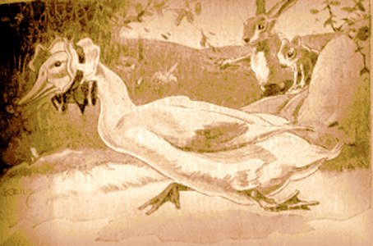
Directions:
1. Underline the verbs twice, their subjects once.
2. Label complements “C.”
3. After each sentence, write “past,” “present,” or “future.”
1. Now I must cover my eggs up.
2. Mrs. Duck would not get off the nest.
3. I will show you my secret.
4. Then we shall not see Mrs. Duck.
5. How pretty they are!
6. Where can the ducks be?
7. Perhaps he can keep awake.
8. Perhaps you have guessed Mrs. Duck’s secret by this time.
9. What can you see?
10. You must stay in the nest.

Ex. 3 - Adding More Helping Verbs
From Bunny Rabbit’s Diary (# 1)
by Mary Frances Blaisdell
Directions:
1. Underline the verbs twice, their subjects once.
2. Label complements “C.”
3. After each sentence, write “past,” “present,” or “future.”
1. Bunny could not find one picture.
2. You must write the stories in the book.
3. You can write about the good times.
4. I can not find one story.
5. What shall we do?
6. That must be a Christmas tree.
7. They could not find very much.
8. Bunny may have his turn first.
9. This would make a good Christmas tree.
10. I shall stay in the house today.

Ex. 4 - Adding More Helping Verbs  From Bunny Rabbit’s Diary (# 2)  by Mary Frances Blaisdell | 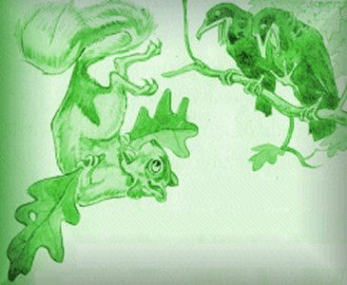
Directions:
1. Underline the verbs twice, their subjects once.
2. Label complements “C.”
3. After each sentence, write “past,” “present,” or “future.”
1. We must find one.
2. This would make a good kite.
3. Sammy dared to play a joke on Bobby Gray Squirrel.
4. I am going to teach my little ones.
5. Bobby Gray Squirrel must have been here.
6. The squirrels could not dig up these nuts.
7. The squirrels ought to dig them out.
8. Bobtail could not see it.
9. Sammy Red Squirrel must have dropped that big acorn.
10. Would you show it to me?

Ex. 5 – Spelling
and hang hear one drum
sand sang near none upon
grand sprang church done write
With —“and” put b, h, l, s, st; and with —“ang” put r, b, g, cl, sl.
Copy: I see her. She sees us. We see you.
Directions for Analysis.
Underline verbs twice and their subjects once.
Label complements “C.”
1. Did Dick dare spring upon that brown horse?
2. One man would loudly bang the drum.
3. The two boys might be in the grand stand.
4. Must you hang the key near the clock?
5. That girl ought to sing in church!
6. Could Jack even do one exercise?
7. No, he can’t do any of them.
8. Should the baby stand in the wet sand?
9. Does the bell need to clang so loudly?
10. Will Sally hang her hat and coat upon the rack in church?

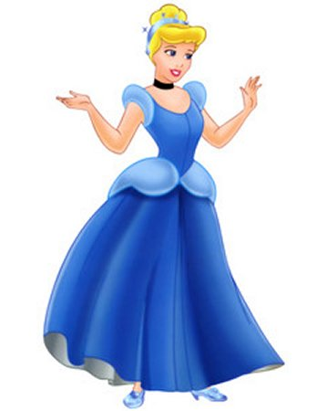 | Ex. 6 - Just for Fun:  Q and A (Puns)
Directions:
1. Place parentheses ( ) around each prepositional phrase.
2. Underline verbs twice, their subjects once, and label complements (“C”).
1. Q. Why did Cinderella get thrown out of the football team?
A. She kept running away from the ball!!
2. Q. Why can’t two elephants go swimming?
A. They only have one pair of trunks!!
3. Q. Why are clocks dirty?
A. They work 24 hours a day, and never wash their hands or face!!
4. Q. Why do golf players wear two pairs of trousers?
A. They might get a hole in one!!
5. Q. What do clouds wear under their clothes?
A. They wear thunderwear.

Unit 8—Adding Adjectives and Adverbs

Adjectives and Adverbs
Adjectives and adverbs describe (modify the meaning of) other words in a sentence. Adjectives modify nouns. Therefore:
A word that describes a noun functions as (and therefore is) an adjective.
Adverbs modify verbs, adjectives, or other adverbs. Therefore:
A word that describes a verb, an adjective, or another adverb functions as (and therefore is) an adverb.
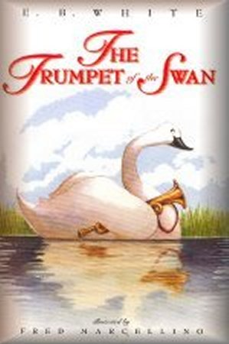
“A,” “an,” and “the” always function as adjectives. “A” and “an” indicate that the word modified refers to anything named by the noun or to something that is not specifically known to the person spoken to.
For example, “A man never cries,” means that any man never cries. In “A man was walking down the road,” the speaker or writer implies that the person hearing or reading does not know the identity of the man. On the other hand, “The man was walking down the road,” means that the people hearing or reading already know which man is being talked or written about.

In order to tell if a word is an adjective or an adverb, you must first look at the word in the context of a sentence. For example, in the sentence
The little swan proudly blew his trumpet.
“The” and “little” are adjectives because they describe the noun “swan.” “Proudly” describes how he “blew.” Since “blew” is a verb, “proudly” is an adverb. Similarly, “his” describes the noun “trumpet,” so “his” is an adjective.

“The Clover Patch”  from Bunny Rabbit’s Diary  by Mary Frances Blaisdell  Illustrated by George F. Kerr  Boston: Little, Brown, and Company, 1915 | 
I
It was a lovely day in June.
Bunny had been playing all the morning with Billy and Bobtail.
They had played tag, and hide-and-seek, and ever so many other games.
At last they were all tired and hungry.
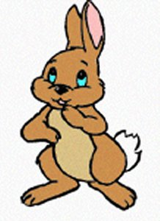
“I know where there is a great big patch of clover,” said Bunny.
“Oh, Bunny!” begged Bobtail, “show us where it is. I have not had a taste of clover for ever so long.”
“I like clover, too,” said Billy. “Is it very far from here?”
“Oh, no,” said Bunny. “It is down beside the brook.”
The three little rabbits hopped off to find the big patch of clover.
They hopped down to the brook, but they could not see any clover there.
“Perhaps it was in the meadow,” said Billy.
“The brook runs through the meadow.”
“Yes,” said Bobtail, “and then it runs through the woods.”
“Clover would not grow under the trees,” said Bunny. “It grows in the fields where the sun shines.”
“The sun shines in the meadow,” said Billy. “Let’s go down there and look for the clover patch.”
So the three little rabbits hopped off through the field.
They hopped along beside the brook all the way.
“Oh, look!” said Bunny. “See the fishes swimming in the water.”
Billy hopped very close to the brook.
Splash, splash! went something right under his feet.
Billy hopped back and looked all around to see what had happened.
“What was that?” he asked.
“That was old Mr. Green Frog,” said Bunny. “There he is now, sitting on a rock laughing at you.”
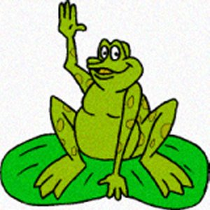
“Ho, ho!” laughed Mr. Green Frog. “I frightened you that time.”
“I frightened you, too,” said Billy. “That was why you jumped into the water.”
“Well,” said Mr. Green Frog, “you almost hopped on my back.
“Of course I was frightened. I jumped into the water without looking to see what was the matter.”
“Come, come,” said Bunny. “We must find that clover patch. I am as hungry as a bear.”
So the three little rabbits hopped off across the meadow.
They could not hop so near the brook now because the ground was soft and wet.
And the rabbits did not like to wet their feet.
They hopped along, and at last Bunny called out, “Here it is. Here it is.”
Billy and Bobtail hopped up close to Bunny.
Sure enough, there was the biggest patch of clover they had ever seen.
And how green every leaf was!
The clover was all in blossom, too.
The white blossoms held their heads up to the sun.
The sun smiled to see the pretty white flowers among the green leaves.
Many bees were flying over the clover patch.
They were asking the blossoms for nectar to make sweet honey.
“Buzz, buzz!” sang the bees, as they flew from flower to flower.
II
Bunny and Billy and Bobtail began to nibble the greenest leaves.
They nibbled and nibbled and nibbled.
The bees buzzed and buzzed and buzzed.
“What good honey we can make,” said the bees. “Clover honey is best of all.”
“Oh, how good this clover is,” said Billy. “I am glad I came so far.”
“Yes,” said Bunny. “It is the sweetest clover I ever tasted.”
“Yes, it is,” said Billy. “I –
“Oh, oh, oh!” he cried. “Oh, my nose!”
Billy jumped up and hopped round and round. He rubbed his nose and wiped the tears out of his eyes.
Bunny and Bobtail stopped eating, and went to see what had happened to Billy.
“What is the matter?” asked Bunny.
“Oh, my nose!” said Billy. “I took a bite of clover and something stung me on the nose.”
A bee flew up from the clover and sailed round and round in the air.
“Buzz, buzz, buzz!” said the bee. “I stung your nose, Billy. I thought you were going to eat me.”
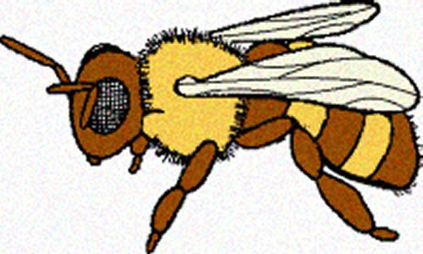
Bunny saw the bee flying round and round over their heads.
“It must have been a bee that stung you,” said Bunny.
Billy looked at the bee.
“I am going home,” he said. “I did not want to come so far anyway. There are plenty of good things eat in our own field.”
So Billy hopped along home very slowly.
He stopped every few steps to rub his poor little nose.
Mother Rabbit saw him coming and went to the door to meet him.
“What is the matter?” she asked.
“I went to the meadow to eat clover,” said Billy. “The bees were there and one stung me on the nose.”
“Rub your nose in the dirt and that will make it feel well again,” said Mother Rabbit.
Billy put some dirt on his nose, and the pain soon went away.
Then Mother Rabbit took him to a place where the grass was tender.
He ate all the dinner he wanted and then went home to take a nap.
Bunny and Bobtail ate their dinner in the meadow.
The clover was so sweet and tender that they wanted to eat it all.
They nibbled and nibbled and nibbled.
But they were both very careful not to nibble any of the blossoms where the bees were gathering honey.

Ex. 1 - Adding Adjectives and Adverbs
From “The Clover Patch” (# 1)
by Mary Frances Blaisdell
Directions:
1. Underline the verbs twice, their subjects once;
2. Write “C” above any complements.
3. Draw an arrow from every adjective and adverb to the word it modifies.
1. It was a lovely day in June.
2. I know a great big patch of clover.
3. I have not had a taste of clover.
4. I like clover, too.
5. Is it very far from here?
6. The three little rabbits hopped off to the patch of clover.
7. They hopped down to the brook.
8. But they could not see any clover there.
9. The brook runs quietly through the meadow.
10. Then it runs quickly through the woods.

Ex. 2 - Adding Adjectives and Adverbs
From “The Clover Patch” (# 2)
by Mary Frances Blaisdell
Directions:
1. Underline the verbs twice, their subjects once;
2. Write “C” above any complements.
3. Draw an arrow from every adjective and adverb to the word it modifies.
1. Clover would not grow under the trees.
2. The warm sun shines brightly in the meadow.
3. They were eagerly watching the small fishes in the water.
4. Billy hopped very close to the brook.
5. Then Billy hopped back from the water.
6. That was just old Mr. Green Frog.
7. There he is now.
8. I frightened you, too.
9. You almost hopped on my back.
10. I was very frightened.

Ex. 3 - Adding Adjectives and Adverbs
From “The Clover Patch” (# 3)
by Mary Frances Blaisdell
Directions:
1. Underline the verbs twice, their subjects once;
2. Write “C” above any complements.
3. Draw an arrow from every adjective and adverb to the word it modifies.
1. We must find that clover patch soon.
2. They could not hop so near the brook now.
3. The muddy ground was very soft and wet.
4. The white blossoms held their heads up to the sun.
5. The sun smiled sweetly at the pretty white flowers among the green leaves.
6. Many bees were flying over the clover patch.
7. They were politely asking the beautiful blossoms for nectar.
8. The busy bees flew swiftly from flower to flower.
9. Bobtail hungrily began to nibble the greenest leaves.
10. What good honey we can make!

Ex. 4 - Adding Adjectives and Adverbs
From “The Clover Patch” (# 4)
by Mary Frances Blaisdell
Directions:
1. Underline the verbs twice, their subjects once;
2. Write “C” above any complements.
3. Draw an arrow from every adjective and adverb to the word it modifies.
1. How good this clover is!
2. I never tasted such sweet clover before.
3. Billy hopped round and round.
4. He carefully rubbed his sore nose.
5. I just took a big bite of this clover.
6. A small bee flew up from the clover.
7. I did not want to come so far anyway.
8. Billy hopped along home very slowly.
9. He stopped every few steps and softly rubbed his poor little nose.
10. Because of the dirt on his nose, the pain soon went away.

Ex. 5 – [V]  Fill in the Blanks with Adjectives and Adverbs  “How Nice!”  Adapted from: Chit-chat stories for little folks.  New York: Thomas Nelson & Sons;  London: S. W. Partridge & Co. | 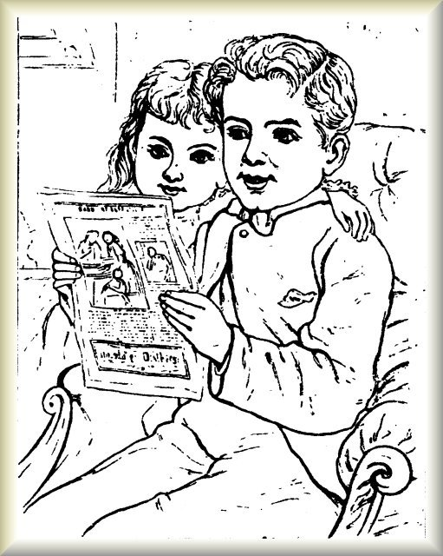
Directions:
1. Fill in the blanks with adjectives or adverbs.
Optional:
2. Underline the verbs twice, their subjects once;
3. Write “C” above any complements.
4. Draw an arrow from every adjective and adverb to the word it modifies.
(Note that some sentences have more than one S/V/C pattern.)
Hubert has _____Adv._____ been reading to _____Adj._____ _____Adj._____ sister _____Adj._____ _____Adj._____ story, and they are _____Adv._____ looking at _____Adj._____ picture. _____Adj._____ mama buys _____Adj.____ ______Adj._____ books for them, so they have _____Adj._____ lot on _____Adj._____ shelf in _____Adj._____ schoolroom. They _____Adv._____ take _____Adj._____ care of _____Adj._____ books, so that they last _____Adj.____ ______Adj._____ time.

Ex. 6 – Spelling
fast best blue said coat
last nest birds mice half
past chest year John great
With —“est” put r, l, j, p, t, v, w; and with —“rap” put t, st, w, sc.
Add —s to whip, duck, horse, boy, word
Directions for Analysis:
1. Underline the verbs twice, their subjects once;
2. Write “C” above any complements.
3. Draw an arrow from every adjective and adverb to the word it modifies.

1. Two big blue birds quickly built a beautiful nest there.
2. Were some birds in the new church?
3. You should carefully brush your best coat and brown vest.
4. John said that about the old chest in jest.
5. Did John run fast past the ducks?

Ex. 7 - Just for Fun
Directions:
1. Underline the verbs twice, their subjects once;
2. Write “C” above any complements.
3. Draw an arrow from every adjective and adverb to the word it modifies.

A poor duck, an unusual skunk and a female deer happily went out for dinner at a restaurant one night. They needed to pay. The skunk didn’t have a scent. The deer didn’t have a buck. So they put the meal on the duck’s bill.
~~~
Q. There are four apples, and you carefully take away three. How many do you now have?
A. You took three apples. So obviously you have three.
~~~
Q: What is the difference between a unicorn and a lettuce?
A: One is a funny beast. The other is a bunny feast.

Unit 9—Adding Simple Prepositional Phrases

What Is a Prepositional Phrase?
Prepositional phrases are simply prepositions (listed on the next page) plus the noun(s) or pronoun(s) that answer(s) the questions “Whom?” or “What?” after them:
“to Dave”  “about Mary”  “to the house”  “under the desk”  “from the street” | 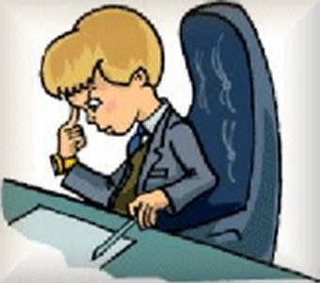
To identify prepositional phrases you need to recognize prepositions and then make a question with “whom?” or “what?” after them:
“about whom?”—“about Mary”
“under what?”—“under the desk”
If a verb answers the question “to what,” it is probably not a prepositional phrase. “To go” is not a prepositional phrase.

Words That Can Function as Prepositions
about  above  across  according to  after  against  along  among  around  as  aside from  as for  as to  at  because of  before  behind  beneath  beside  between  beyond  but *  by  despite  down  down to  due to  during  except  for  from | Note: Some prepositions consist  of more than one word.  The word that answers the questions “whom?” or “what?” after a preposition is called the “object of the preposition.” | in  inside  instead of  into  like  near  of  off  on  onto  opposite  out  out of  outside  over  per  regardless of  since  such as  than  through  to  toward  under  until  up  upon  via  with  within  without
  All the words  in brown  could be used  to tell a squirrel’s relationship  in space  to trees: | 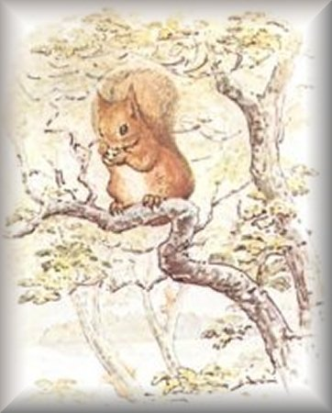
  The squirrel is ____ the trees.
  Other prepositions express
  relationships in time:
  They left after dinner.
  They arrived before dinner.
  We talked during dinner.
  We haven't eaten since dinner.
  We waited until dinner.
* when it means “except”

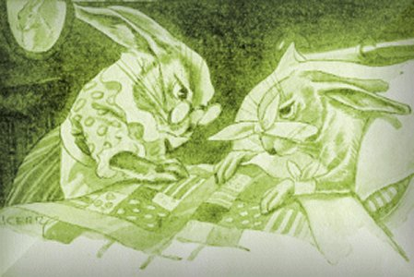 | The Cabbage Patch  from Bunny Rabbit’s Diary  by Mary Frances Blaisdell  Illustrated by George F. Kerr  Boston: Little, Brown, and Company, 1915

I
“Oh, dear me!” said Billy. “I am so hungry. I wish I could find something good to eat.”
“I know where there is a big cabbage patch,” said Bunny.
“Where, where?” asked Billy.
“Where, where?” asked Bobtail.
“Follow me,” said Bunny, “and I will show you.”
“Is it far?” asked Billy.
“No,” said Bunny. “It is not very far, — just down in Mr. Man’s garden.”
“I think I will stay here,” said Billy. “This clover is very good.”
So Billy stayed and ate the clover, but Bobtail and Bunny hopped off down the road.
They hopped along the road until they came to Mr. Man’s barn.
Then they stopped to listen.
Bunny sat up straight and held up his long ears.
Bobtail sat up straight and held up his long ears.
They listened and listened, but they did not hear a sound.
“I think Jip is asleep in the house,” said Bunny.
“I think Mr. Man is eating his dinner,” said Bobtail.
“Let’s hurry,” said Bunny. “We can reach the garden without any one seeing us, I am sure.”
So the two little rabbits laid their ears down on their heads and hopped away.
They hopped behind the barn.
Mr. Rooster saw them coming.
“Cock-a-doodle-doo!” he said. “Who are you? Where are you going in such a hurry?”
“We are going to the garden to get our dinner,” said Bunny.
“Mr. Man never lets me go to the garden,” said Mr. Rooster.
“Mr. Man never lets me go to the garden if he knows about it,” laughed Bunny.
“Cock-a-doodle-doo!” said the rooster, as he flapped his wings and flew up on the fence.
“Please do not make so much noise,” begged Bobtail. “Mr. Man will hear you and come out to see what is the matter.”
But the rooster just flapped his big wings and crowed again.
“Come,” said Bunny. “This is no place for us.
“Let’s hop into the garden and get some cabbage.”
II
The two rabbits hopped off across the yard and into the garden.
There they found the biggest cabbages they had ever seen.
There were rows and rows of them.
They were great big green cabbages. How good they did look to the hungry little rabbits!
“I aim going to eat this one,” said Bunny. And he stopped at a big, big cabbage at the end of one long row.
Bobtail picked out a big one for himself and began to nibble the sweet leaves.
Nibble, nibble, nibble! Not a word did the little rabbits speak.
They could not talk. They were so busy eating that they could not say a word.
Nibble, nibble, nibble! How still it was in the garden!
Bunny heard the bees humming as they flew among the flowers.
Once Blacky Crow flew over and called to the rabbits.
But he did not fly down to the garden. There was nothing there for him to eat, now.
He liked the corn when it had just peeped out of the ground.
Then it was tender and sweet, and he often pulled it up for his dinner.
Nibble, nibble, nibble! How still it was everywhere.
Then all at once there was a noise.
It was a noise the rabbits knew too well.
“Bow-wow-wow!” said Jip, as he bounded across the field.
“Bow-wow-wow! I think some one is in my master’s garden.”
Bunny and Bobtail knew who was coming. They did not have to wait and see.
Off through the garden they hopped.
They hopped so fast that they were soon out of sight.
But Jip knew where they had gone, and he ran after them, barking louder and louder at every step.
“Oh, dear me!” cried Bobtail. “What shall we do? Jip will catch us before we reach home.”
“Follow me,” said Bunny, “I know where there is a hole big enough for both of us to hide.”
So Bobtail followed Bunny.
They hopped across the field and into the woods.
“Bow-wow-wow!” said Jip. “I am going to catch you this time.”
And then, all at once, Jip could not see the rabbits anywhere.
They had hopped into a hole under the big rock at the foot of the oak tree.
They hopped into the hole and then they were safe.
Jip could not reach them.
He sat down beside the hole to wait until they came out, but they were too wise to come out.
III
Jip waited and waited, and the rabbits waited and waited, too.
At last Jip grew tired of watching the hole and ran off home.
Then the two rabbits knew it was safe for them to go home, too.
Bunny put his nose out and looked around.
There was no one in sight.
“I am going now,” he said to Bobtail. “Jip has gone away.”
And then Bunny started to get out of the hole.
He put out his head, but he could not get any farther.
“What is the matter? What are you waiting for? Is Jip coming back?” asked Bobtail.
But Bunny did not answer. He just kept on wiggling and twisting.
He twisted and wiggled, twisted and wiggled. But he could not get out of that hole.
At last he pulled his head back through the hole. Then he sat down and looked at Bobtail.
“What shall we do?” he said. “The hole has grown small since we came through it.”
“Perhaps I can get out,” said Bobtail. “Let me try.”
So Bobtail put his head out and then he hopped out the rest of the way.
“I’m out,” he called to Bunny. “You can get out, I am sure.”
Bobtail hopped off home leaving Bunny to get out the best way he could.
Of course Bunny got out; but he scratched his poor little nose and he scratched his back.
He hurt his long ears and he hurt his foot.
But he did get out at last.
And when he was safe on the outside of the hole he turned around and looked at it.
“I’ll never go in there again,” he said as he rubbed his nose.
“I thought it was a big hole, but I must be bigger than the hole.”
Then Bunny hopped off home.
Mother Rabbit was standing at the door watching for him.
Bobtail and Billy were watching, too.
“How did you get out of the hole?” they asked.
“This is the way I got out,” said Bunny, and he pointed to his poor little scratched nose.
When Mother Rabbit saw that Bunny had hurt himself she took him into the house.
She gave him some hot cabbage soup.
Then she wrapped his nose up in flannel and made him stay in bed a whole day until he was all well again.

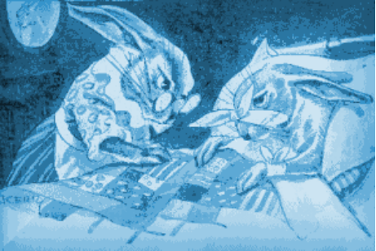 | Ex. 1 - A Matching Game with Prepositional Phrases  From “The Cabbage Patch”  by Mary Frances Blaisdell
Directions: The seven prepositional phrases below lost their places. Help the phrases find where they belong by writing the number of the phrase in the blank where it best belongs.
1. to the hungry little rabbits  2. of one long row  3. into the garden  4. at the end | 5. across the yard  6. at a big, big cabbage  7. of them
The two rabbits hopped off __________ and __________.
There they found the biggest cabbages they had ever seen.
There were rows and rows __________.
They were great big green cabbages. How good they did look __________!
“I am going to eat this one,” said Bunny. And he stopped ____________ ____________ ____________.

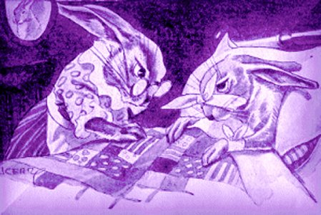 | Ex. 2 - From “The Cabbage Patch” (# 1)  by Mary Frances Blaisdell
Directions:
1. Place parentheses ( ) around each prepositional phrase.
2. Underline the verbs twice, their subjects once, and write “C” above any complements.
1. Bobtail and Bunny hopped off down the road.
2. They hopped along the road and came to Mr. Man’s barn.
3. So the two little rabbits laid their ears down on their heads and hopped away behind the barn.
4. Where are you going in such a hurry?
5. The rooster flapped his wings and flew up on the fence.
6. This is no place for us.
7. Not a word did the little rabbits speak.
8. How still it was in the garden!
9. The bees were humming among the flowers.
10. The tender and sweet corn had just peeped out of the ground.

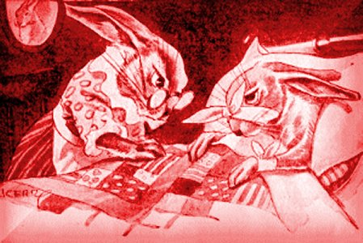 | Ex. 3 - From “The Cabbage Patch” (# 2)  by Mary Frances Blaisdell
Directions:
1. Place parentheses ( ) around each prepositional phrase.
2. Underline the verbs twice, their subjects once, and write “C” above any complements.
1. Jip bounded across the field.
2. Someone is in my master’s garden.
3. Off through the garden they hopped.
4. Jip ran after them and barked louder and louder at every step.
5. They hopped across the field and into the woods.
6. They had hopped into a hole under the big rock at the foot of the oak tree.
7. At last Bunny pulled his head back through the hole.
8. He was safe on the outside of the hole.
9. Mother Rabbit was standing at the door and watching for him.
10. Bunny pointed to his poor little scratched nose.

Ex. 4 - “Rain”  From A Child’s Garden of Verses.  by Robert Louis Stevenson  Illustration adapted from Jessie Wilcox Smith’s | 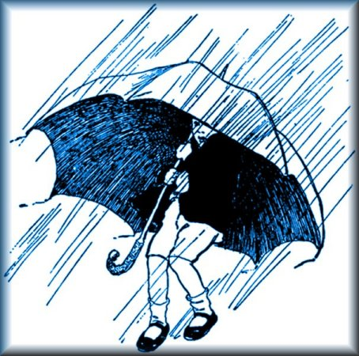
Directions:
1. Place parentheses ( ) around each prepositional phrase.
2. Underline the verbs twice, their subjects once, and write “C” above any complements.

The rain is raining all around,
It falls on field and tree,
It rains on the umbrellas here,
And on the ships at sea.

Ex. 5 - Spelling
bank bunk eye sailor iron
drank drunk again often coal
prank trunk sleep pear orange
Put dr, w, p, m, 1, bl, th, s, r, br, shr, with —“ink”; and t, bl, pl, sp, dr, cr, Fr, with —“ank.” Copy: Was it she?
Directions for Analysis:
1. Place parentheses ( ) around each prepositional phrase.
2. Underline the verbs twice, their subjects once.
3. Write “C” above any complements.
1. Frank writes in ink on a copy book.
2. Did you wink your eye again?
3. The iron trunk sank in the water.
4. People often see the sailors near the bay.
5. Sailors sleep in bunks on ships.
6. Frank drank much orange tea after supper.
7. Thank mamma again for the pear.
8. In the evening, Eddie sank into the muddy bank.
9. She is busy with her pink mink.
10. Dick found a chunk of coal in the sink.

Ex. 6 - Punctuating Sentences
From “Billy’s Slide” (# 2)
by Mary Frances Blaisdell
Remember: A sentence begins with a capital letter and ends with a period, question mark, or exclamation point.
Directions: In the following ten items, one is not a sentence. Write “NS” after it (for “not a sentence”). For those that are sentences:
1.) Fix the capitalization and punctuation.
2.) Place parentheses ( ) around each prepositional phrase.
3.) Underline the verb twice and its subject once.
4.) And label complements “C.”
1. soon they came to the long hill
2. is the ice thick on the pond
3. jack frost covered the pond with ice last night
4. the time to sleep
5. ice is very thick
6. the big round sun peeped up from behind the hills
7. i know that
8. was billy on the sled
9. it was not very deep
10. it came to the pond

Ex. 7 - Just for Fun
Directions: In each sentence:
1. Place parentheses around each prepositional phrase,
2. Underline verbs twice, their subjects once, and write “C” over complements.
3. If the answer is not stated as a sentence, write it out as one.
1. Q. Why did the witch travel on a broom?
A. She couldn’t afford a vacuum cleaner!
2. Doctor, I feel like a pack of cards.
I’ll deal with you later.
3. Q: What did the left ear say to the right ear?
A: Between us, we have brains.
4. Q: What is the same size and shape of an elephant and weighs nothing?
A: His shadow.
5. Q: A man arrived in a small town on Friday. He stayed for two days and left on Friday. How is this possible?
A: His horse’s name is Friday!

Unit 10—Adding Apostrophes to Show Possession
Chess-Players  c. 1863-1867  Honoré  Daumier  (1808-1879)  Oil on panel  Musée du Petit Palais  Paris, France | 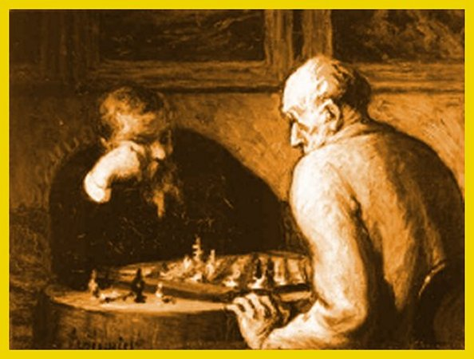 | Apostrophes  to Show  Possession
An apostrophe is used to show that something in some way belongs to someone:
Anthony’s house
Sharon’s idea
the town’s streets.
Usually, the noun with the apostrophe can be replaced by an “of” phrase:
the house of Anthony
the idea of Sharon
the streets of the town
To use an apostrophe, first, make the noun either singular or plural. Then add the apostrophe:
the player’s pieces = the pieces of one player
the players’ pieces = the pieces of all the players

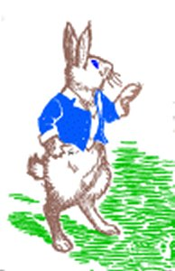 | Ex. 1 - Apostrophes to Show Possession  From Bunny Rabbit’s Diary (#2)  by Mary Frances Blaisdell
Directions:
1. Fix the apostrophe problem in each sentence.
2. Put parentheses ( ) around each prepositional phrase.
3. Underline the verbs twice, subjects once, and label (“C”) any complements.
1. One great big drop fell on Bunnys nose.
2. You would have to go to Mr. Mans garden.
3. Did he know Mrs. Ducks secret?
4. Jack dropped Whities supper on the ground.
5. The oak leaf fell to the ground at Billys feet.
6. And the little duck wriggled back again under her mothers wing.
7. Jip is Jacks dog.
8. They could not find the bunnies home.
9. The kite was stuck in the trees branches.
10. The childrens Christmas tree was very big.

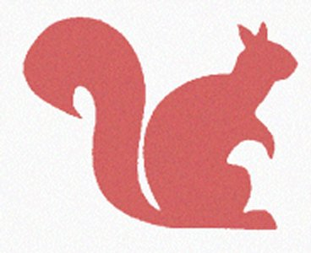 | Ex. 2 – Apostrophes in Contractions  From Bunny Rabbit's Diary (#3)  by Mary Frances Blaisdell
An apostrophe is used to indicate that letters have been left out. This usually happens when two words are combined into one. The resulting word is called a “contraction.” For example, “it’s” is a contraction of “it is.”
Directions: In the following sentences, underline the verbs twice and their subjects once. After each sentence, write the full form of the contraction. (For example, if the contraction is “I’m,” write “I am.”)
1. I don’t believe him.
2. I’m going to eat this one.
3. I’ll write a story every day.
4. I don’t want to learn to swim.
5. They’re going to the pond.
Directions: In the following sentences, underline the verbs twice and their subjects once. After each sentence, write a contraction that would combine two words in the sentence. (For example, if the sentence includes “I will,” write “I’ll.”)
1. She will go to the pond.
2. Bobby Gray Squirrel did not like the noise.
3. We are going to the garden.
4. But Blacky Crow did not fly down to the garden.
5. They will look just like wings.

Ex. 3 – Fix the Capitalization and Punctuation  from New National First Reader (20)  by CHARLES J. BARNES, et al. | 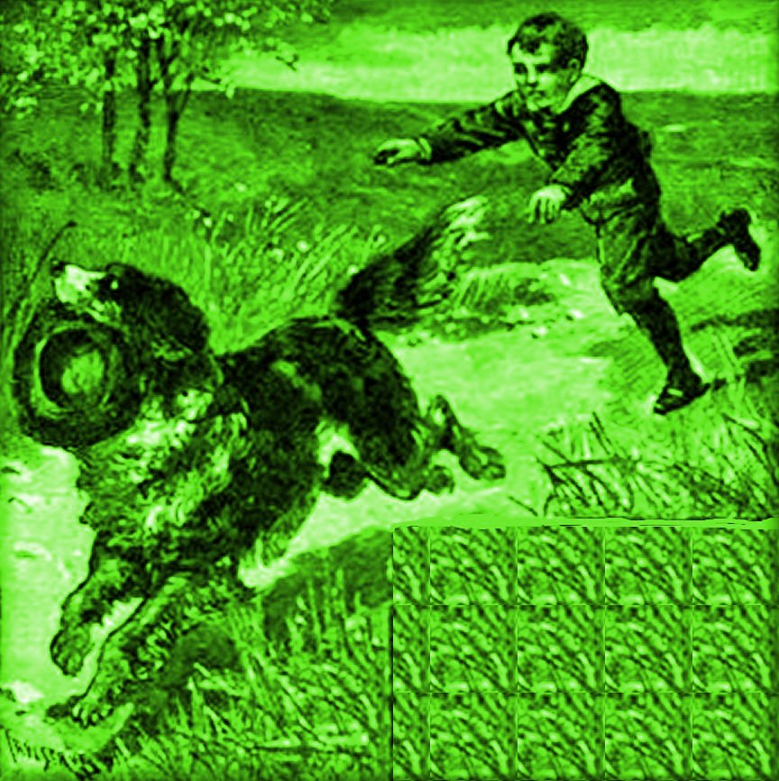
Directions: The capital letters and the punctuation in the following have been lost. Please fix it, right on this page.
Then:
1. Place parentheses ( ) around each prepositional phrase.
2. Underline verbs twice, their subjects once, and label complements “C.”

here rover here that is my hat do not run off with it
you are a bad dog to run off with my hat i will not have you with me you are not a good dog
you bad dog why did you go off with my hat

Unit 11—Performing and Analyzing a Little Play

THE TWO HOLES
Based on a German story.
From Children’s Classics in Dramatic Form, Book One, by Augusta Stevenson
Illustrated by Clara E. Atwood. Boston: Houghton Mifflin, 1911.
Time: one afternoon.
Place: the Old Lady's house.
The Old Lady. Her Friend.
[The Old Lady and her Friend are having a cup of tea.] *
* The explanations in brackets may be read aloud by the teacher.
Friend. I see two holes in that door.
Old Lady. Yes, yes, two holes.
Friend. Why are there two holes?
Old Lady. I have two cats.
Friend. Are the holes for your cats?
Old Lady. Yes. The cats come and go through the holes.
Friend. Why is one hole so large? Why is the other so small?
Old Lady. One cat is large. The other is a kitten.
Friend. Is not one hole enough?
Old Lady. Oh no! The large cat cannot get through the small hole.
Friend. No, but the small cat can get through the large hole.
Old Lady. Why, I had not thought of that! It is true! It is quite true! Ha, ha, ha!
Friend. Ha, ha, ha!
Old Lady and Friend. Ha, ha, ha, ha

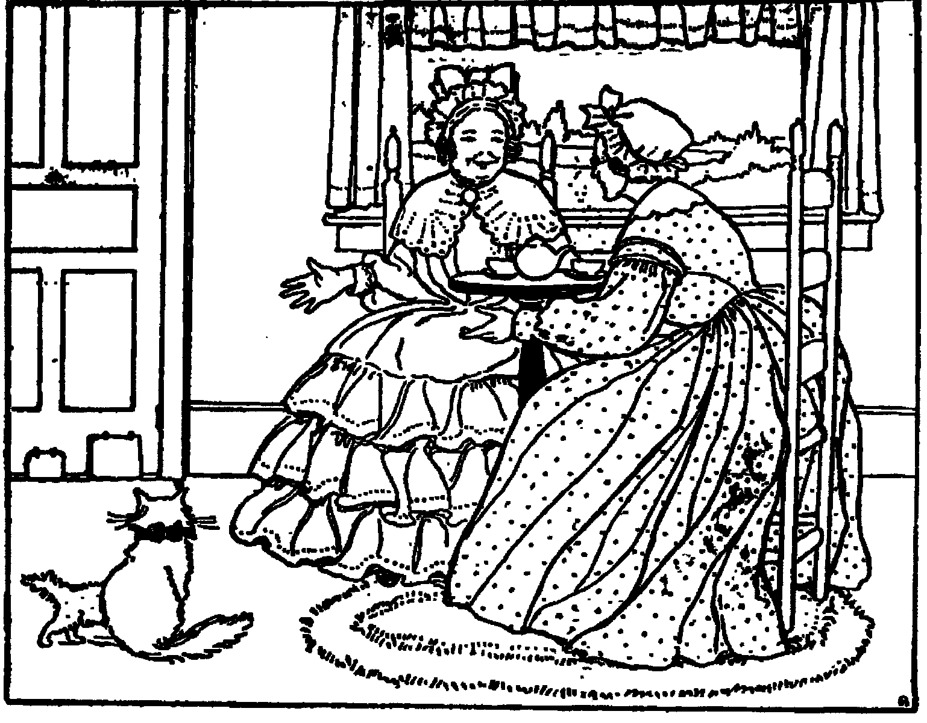

Ex. 1 -A Passage for Analysis
THE TWO HOLES
Directions:
1. Ignore the words in small print and the words that tell who is speaking.
2. Work sentence by sentence. Don’t jump around.
3. Put parentheses ( ) around prepositional phrases.
4. Underline subjects once, verbs twice, and label complements “C”.

The Old Lady and her Friend are having a cup of tea.
The explanations in brackets may be read aloud by the teacher.
Friend. I see two holes in that door.
Old Lady. Yes, yes, two holes.
Friend. Why are there two holes?
Old Lady. I have two cats.
Friend. Are the holes for your cats?
Old Lady. Yes. The cats come and go through the holes.
Friend. Why is one hole so large? Why is the other so small?
Old Lady. One cat is large. The other is a kitten.
Friend. Is not one hole enough?
Old Lady. Oh no! The large cat cannot get through the small hole.
Friend. No, but the small cat can get through the large hole.
Old Lady. Why, I had not thought of that! It is true! It is quite true! Ha, ha, ha!

Ex. 2 - A Writing Assignment on
“THE TWO HOLES”
While looking at your copy of the play, write a story version of it. If you quote the speakers exactly, put their words in quotation marks (“ . . . . . ”). After you tell the story, explain why you did or did not like it. Then explain which words gave you trouble when you analyzed it grammatically. Use the rest of this page to make notes on what you liked and didn’t, and what words confused you in analyzing the words in the play.

I hope you have enjoyed your work with KISS Grammar.
—Dr. V.

