The Ideal KISS Grammar Sequence
Book 1
Supplemental Exercises

© Dr. Ed Vavra
Revised June, 2015

KISS Instructional Materials are available for free at KISSGrammar.org.

For Unit 2--A Focus on Subjects and Verbs 2
Ex. 1 - From Ben and Alice 2
Ex. 2 - Verb Phrases (Tenses) From Ben and Alice 3
Ex. 3 - Verb Phrases - Tenses From Ben and Alice 4
For Unit 9—Prepositional Phrases 5
Ex. 1 - Adding Prepositional Phrases From Ben and Alice (#1) 5
Ex. 2 - Adding Prepositional Phrases From Ben and Alice (#2) 6
Passages for Analysis 7
Ex. 1 -Little Rabbit (Part 1) by Anne Schutze 7
Ex. 2 - Little Rabbit (Part 2) by Anne Schutze 8
Ex. 3 -Time to Rise 9
Ex. 4 - Lesson Twenty-Seven adapted from STANDARD FIRST READER 10
Ex. 5 - Lesson Twenty-Eight adapted from STANDARD FIRST READER 11
Ex. 6 – Singing From A Child's Garden of Verses, by Robert Louis Stevenson 12
Ex. 7 - An Exercise in Capitalization and Punctuation: The Heron 13
Ex. 8 - Lesson Sixty-Six adapted from the STANDARD FIRST READER 14
Ex. 9 - Lesson Seventy-Two adapted from the STANDARD FIRST READER 15
Ex. 10 - Lesson Seventy-Four adapted from STANDARD FIRST READER 16

For Unit 2--A Focus on Subjects and Verbs
Single Word Verbs  Ex. 1 - From Ben and Alice | 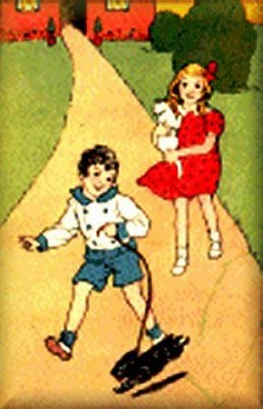
Directions: Underline verbs twice and their subjects once.
1. We have a little white cat.
2. We like a white cat.
3. Who is in the house?
4. Are you in the house?
5. Here I am.
6. Blackie ran away.
7. Jumpity-hoppity was a little rabbit.
8. You are one of our many friends on the farm.
9. Mother saw the dog house.
10. They put the bird in the house.

Ex. 2 - Verb Phrases (Tenses)  From Ben and Alice | 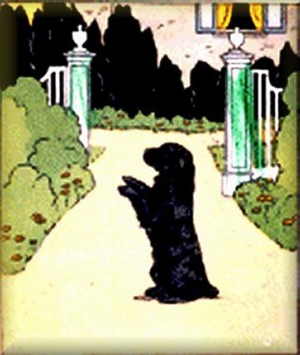
Directions: Underline verbs twice and their subjects once.
1. Blackie will not hurt you.
2. Your home is in town.
3. We will run to the garden.
4. I found the little bird here in the garden.
5. Who will play house?
6. I give many good eggs.
7. Father was in the house.
8. Do we have a bear picture in this room?
9. You will live in this house.
10. We have made a good picture.

Ex. 3 - Verb Phrases - Tenses  From Ben and Alice | 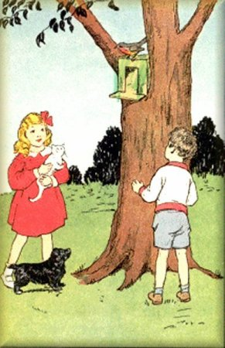
Directions: Underline verbs twice and their subjects once.
1. My bird can not fly.
2. I am in a tree.
3. I will get your bird for you.
4. I did not color my picture.
5. You will like this school.
6. Is the little bird hurt?
7. Jack had put a box under Ben’s cap.
8. Who is here in the house?
9. Will you come to the garden with me?
10. They made this house with my help.

For Unit 9—Prepositional Phrases
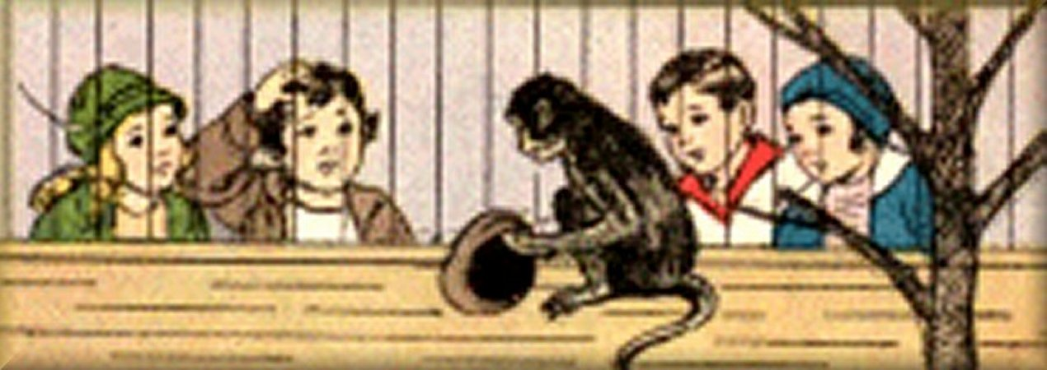

Ex. 1 - Adding Prepositional Phrases From Ben and Alice (#1)
Directions:
1. Place parentheses ( ) around each prepositional phrase.
2. Underline the verbs twice, their subjects once, and write “C” above any complements.
1. Ben ran to Alice.
2. The monkey ran up a tree.
3. I want to play with Ben.
4. The monkey put the cap on his head.
5. The monkey ran down the tree.
6. They found a man at the door of the zoo.
7. Will you find Ben for me?
8. Draw a tree by the house for us.
9. Will you draw the picture of a girl for us?
10. Alice ran to the big tree in the garden.

Ex. 2 - Adding Prepositional Phrases  From Ben and Alice (#2) | 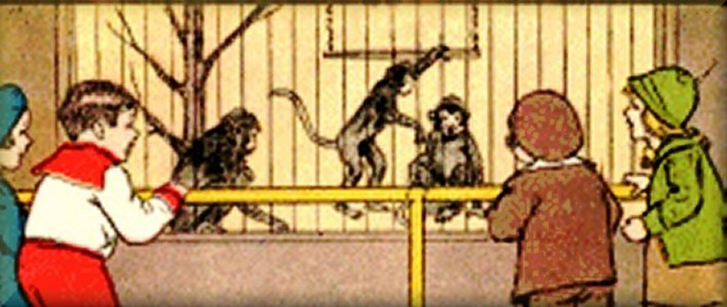
Directions:
1. Place parentheses ( ) around each prepositional phrase.
2. Underline the verbs twice, their subjects once, and write “C” above any complements.
1. Father monkey ran after baby monkey.
2. The box was under the table.
3. Mother sat down in a chair by the door.
4. Then you will like a book about the zoo, too.
5. They went at once to the store.
6. Will you draw a little cat for the girl?
7. You may keep my mouse for a pet at school.
8. Down the road went the pony with Ben on his back.
9. You will find the picture of a monkey on the blue book.
10. Out of the house he went and down the road to New Town.

Passages for Analysis

Ex. 1 -Little Rabbit (Part 1)
by Anne Schutze
from The Elson Readers Primer
This is Part 1 of 2 from a complete story from The Elson Readers Primer
Directions:
1. Place parentheses ( ) around each prepositional phrase.
2. Underline the verbs twice, their subjects once. (Write in any understood “you.”)
3. Write “C” above any complements. (For quotations with “said,” put a “C” above the opening quotation mark.)
4. Write “DirA” over each word that functions as Direct Address, “Inj” over Interjections, and “NuA” over Nouns Used as Adverbs.

Stop, Stop, Little Rabbit!
Where are you going?
Do not run away from me.
I can not see you, now.
Where are you, Little Rabbit?
Oh, now I see you!
You are behind the flowers.
You are in the pretty clovers.

Ex. 2 - Little Rabbit (Part 2)
by Anne Schutze
from The Elson Readers Primer
This is Part 2 of 2 from a complete story from The Elson Readers Primer
Directions:
1. Place parentheses ( ) around each prepositional phrase.
2. Underline the verbs twice, their subjects once. (Write in any understood “you.”)
3. Write “C” above any complements. (For quotations with “said,” put a “C” above the opening quotation mark.)
4. Write “DirA” over each word that functions as Direct Address, “Inj” over Interjections, and “NuA” over Nouns Used as Adverbs.
Stop, stop, Little Rabbit!
Do not eat the clovers.
They are so pretty.
They are so white.
They are white like your ears.
The clovers are so little, now.
Soon they will be big.
Then you may eat them.
Good-bye, Little Rabbit, good-bye.
--L. E. Orth.

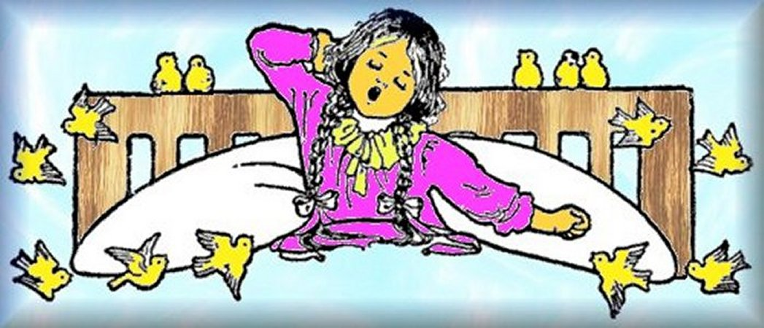

Ex. 3 -Time to Rise
by Robert Louis Stevenson
From A Child's Garden of Verses
Illustration adapted from Millicent Sowerby's
Directions:
1. Place parentheses ( ) around each prepositional phrase.
2. Underline every verb twice, every subject once, and label complements (“C”).
3. Label each interjection (“Inj”), each example of Direct Address (“DirA”), and every noun used as an adverb (“NuA”).
Note: The complement of “said” is the words in quotation marks. Analyze them as if they were a separate sentence.
A birdie with a yellow bill
Hopped upon my window sill,
Cocked his shining eye and said:
“Ain’t you ‘shamed, you sleepy-head!”

Ex. 4 -  Lesson Twenty-Seven  adapted from  STANDARD FIRST READER  NEW YORK AND LONDON:  FUNK & WAGNALLS COMPANY, 1902 | Directions:  1. Place parentheses ( ) around each prepositional phrase.  2. Underline verbs twice, their subjects once.  3. Label complements (“C”).
Note that some sentences have more than one S/V pattern. In doing the analysis, ignore the words that are in small letters. (You'll learn how to analyze them later.)
 | Fish swim in the water.  They can not live long out of the water.  They have many small gills,  through which they breathe.  Fish lay many eggs.  Have you seen a fish swim?  It moves its tail when it swims.  Fish are of many colors.  Some fish have colors like the rainbow.


Ex. 5 - Lesson Twenty-Eight  adapted from  STANDARD FIRST READER  NEW YORK AND LONDON:  FUNK & WAGNALLS COMPANY, 1902 | Directions:  1. Place parentheses ( ) around each prepositional phrase.  2. Underline verbs twice, their subjects once.  3. Label complements (“C”).
Note that some sentences have more than one S/V pattern. In doing the analysis, ignore the words that are in small letters. (You'll learn how to analyze them later.)
The peach-tree is in the garden.
There are leaves on the tree. They are green.
The tree has pink flowers on it.
These flowers are called blossoms.
The peach-blossoms fall to the ground
when the peaches begin to grow.
A peach is at first green.
Then it turns ripe, and we may eat it.
A peach-stone is inside of the peach.


Ex. 6 – Singing  From A Child's Garden of Verses,  by Robert Louis Stevenson | Illustration adapted from  Myrtle Sheldon’s for a 1916 edition.
Directions:
1. Place parentheses ( ) around each prepositional phrase.
2. Underline verbs twice, their subjects once.
3. Label complements (“C”).
Of speckled eggs the birdie sings
And nests among the trees;
The sailor sings of ropes and things
In ships upon the seas.
The children sing in far Japan,
The children sing in Spain;
The organ with the organ man
Is singing in the rain.

Ex. 7 -  An Exercise in Capitalization and Punctuation:  The Heron  Adapted from: Chit-chat stories for little folks.  New York: Thomas Nelson & Sons; London: S. W. Partridge & Co. | 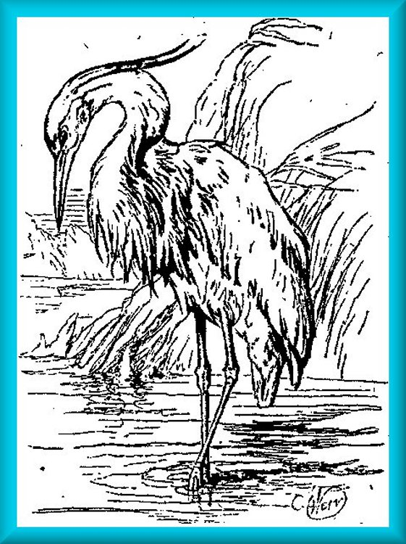
Directions:
1. The capital letters and punctuation in this passage has been lost. Please fix it, right on this page.
Optional:
2. Put parentheses ( ) around each prepositional phrase.
3. Underline the verbs twice, subjects once, and label (“C”) any complements. (Note that some sentences have more than one S/V/C pattern.)
the heron is a large strange-looking bird he has very long thin legs and his bill also is very long he likes to live apart from other birds herons make nests of sticks and wool they often stand quite still in shallow water and watch for fish

 | Ex. 8 - Lesson Sixty-Six  adapted from the  STANDARD FIRST READER  NEW YORK AND LONDON:  FUNK & WAGNALLS COMPANY, 1902
Directions:
1. Place parentheses ( ) around each prepositional phrase.
2. Underline verbs twice, their subjects once.
3. Label complements (“C”).
In doing the analysis, ignore the words that are in small letters. (You’ll learn how to analyze them later.)
Alfred Tennyson was a poet. He wrote about a king named Arthur. King Arthur had brave men around him, called knights. The knights were always kind, and took care of the sick and of the poor. They wore coats of steel, and carried swords and shields and spears. They wore steel caps, called helmets. King Arthur was brave, and loved truth and honor.

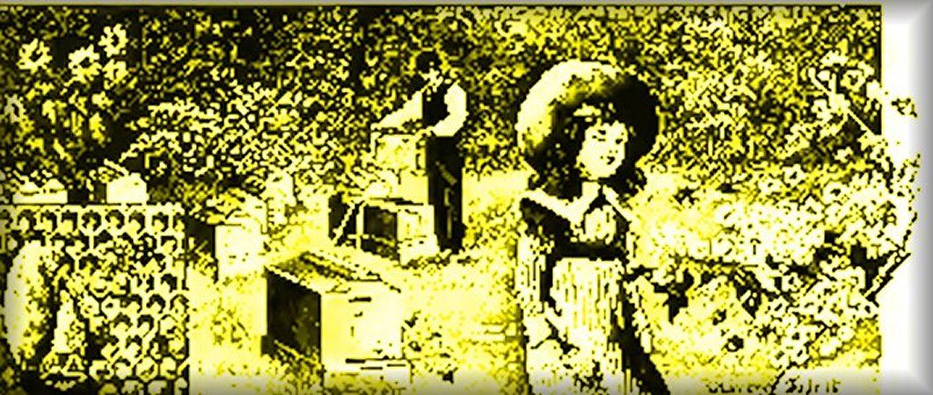 | Ex. 9 - Lesson Seventy-Two  adapted from the  STANDARD FIRST READER  NEW YORK AND LONDON:  FUNK & WAGNALLS COMPANY, 1902
Directions:
1. Place parentheses ( ) around each prepositional phrase.
2. Underline verbs twice, their subjects once.
3. Label complements (“C”).
Note that some sentences have more than one S/V/C pattern. In doing the analysis, ignore the words that are in small letters. (You’ll learn how to analyze them later.)
Bees make honey. They find the honey in the flowers. Have you ever seen a beehive? The beehive is a nice home for the bee when it is not flying among the flowers. Honey is made in combs. The combs are wax, and are full of little pockets, called cells. The honey is put in the cells. Each cell has six sides. The comb is called a honeycomb. The worker bee is always busy.

Ex. 10 - Lesson Seventy-Four  adapted from  STANDARD FIRST READER  NEW YORK AND LONDON:  FUNK & WAGNALLS COMPANY, 1902 | 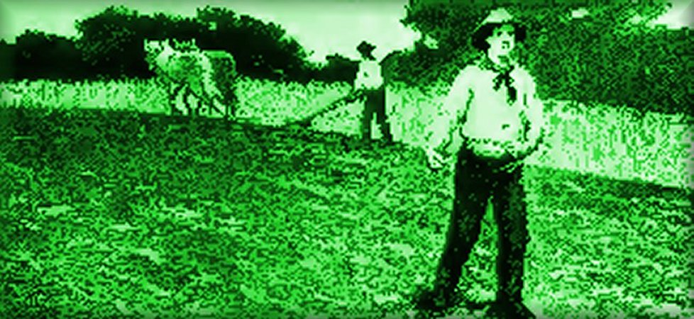
Directions:
1. Place parentheses ( ) around each prepositional phrase.
2. Underline verbs twice, their subjects once.
3. Label complements (“C”).
Note that some sentences have more than one S/V/C pattern. In doing the analysis, ignore the words that are in small letters. (You’ll learn how to analyze them later.)

The man planted some seeds in the ground. Then he covered them up so that they would be warm. In the Spring the warm sun found them. Then the seeds sent little white roots into the ground. They were fed in the soft, warm earth. Then little green leaves and

