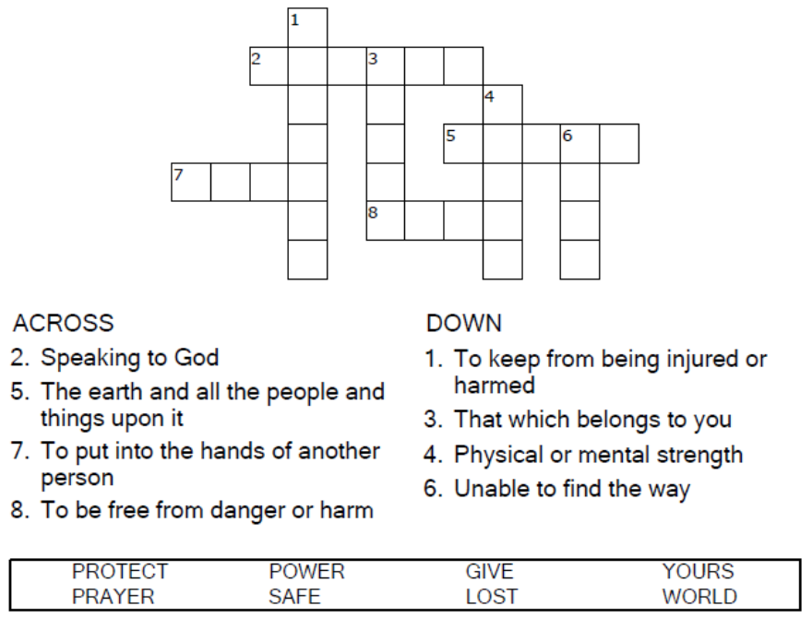

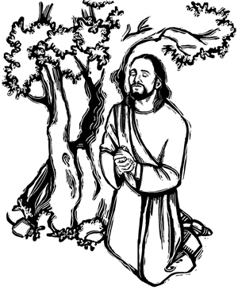

Copyright © Sermons4Kids, Inc.
May be reproduced for Ministry Use
Children’s Worship Bulletin

Through Life's Maze

Jesus Prays for His Disciples
John 17:6-19

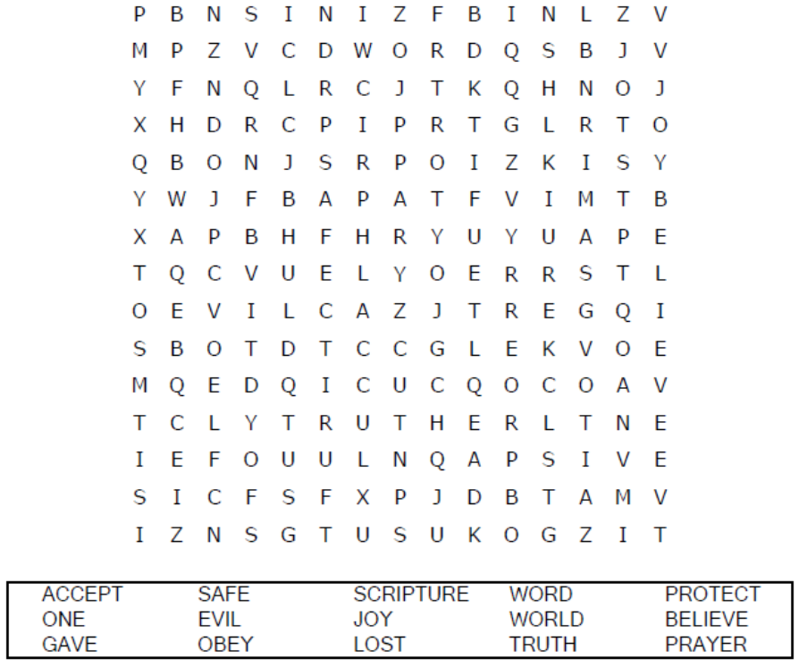

Your Church Name Here
Anytown, Anywhere

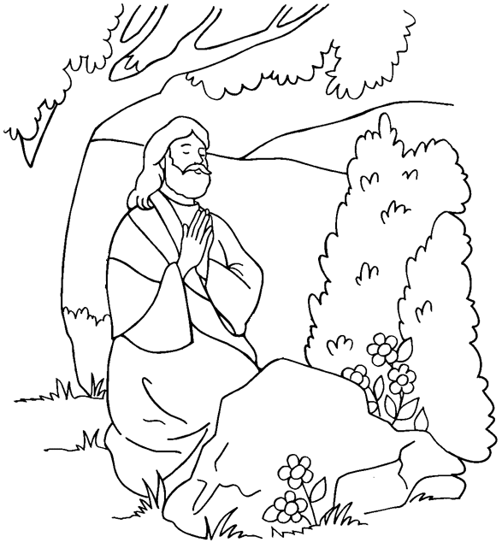
Jesus Prays for His Disciples

From Thru-the-Bible Coloring Pages for Ages 4-8. © 1986,1988
Standard Publishing. Used by permission. Reproducible Coloring Books may be
purchased from Standard Publishing, www.standardpub.com, 1-800-543-1301.

Can you find your way home?





