IMSOP - API Flows & Sequences

Authentication Flow
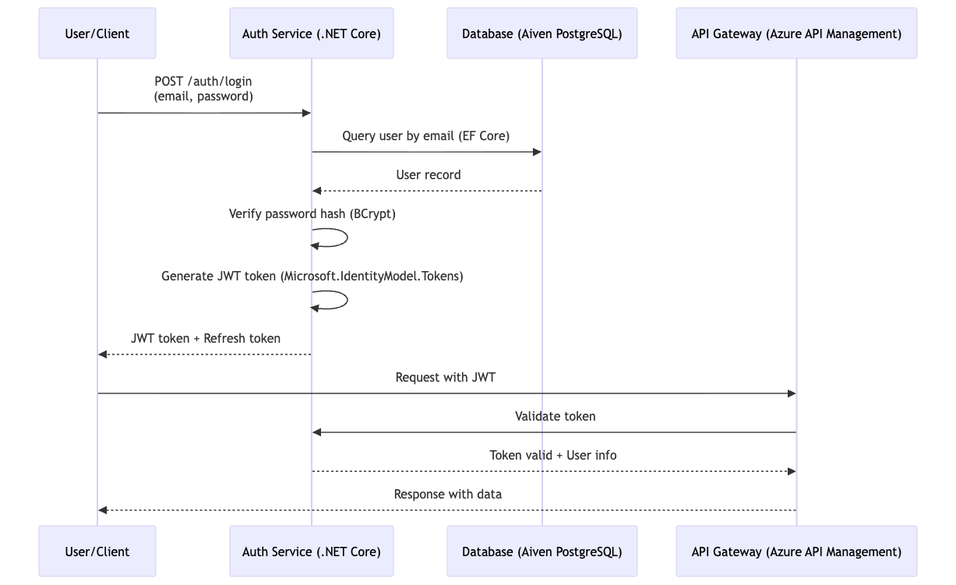
Supply Chain Order Flow
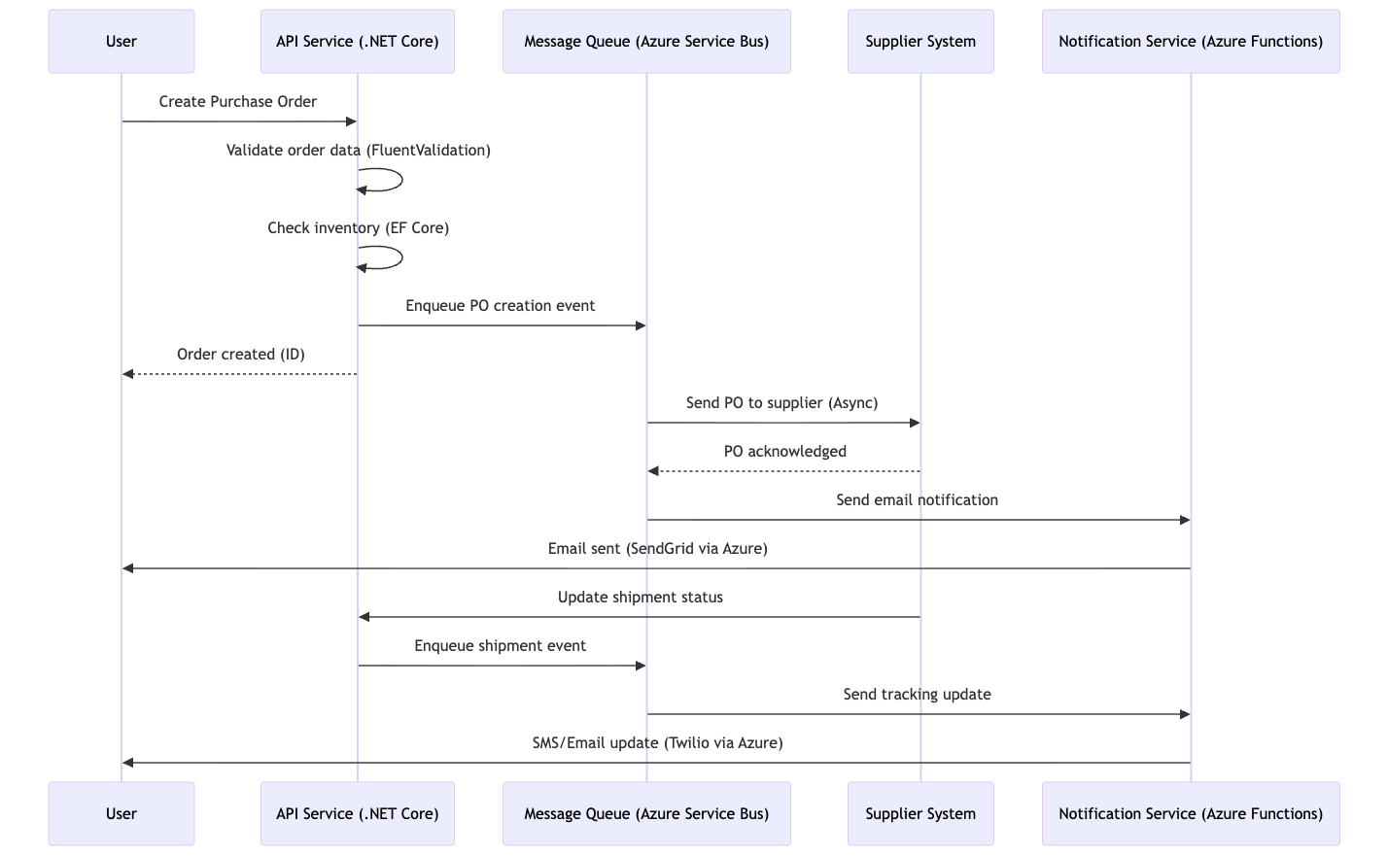
Real-time Analytics Flow
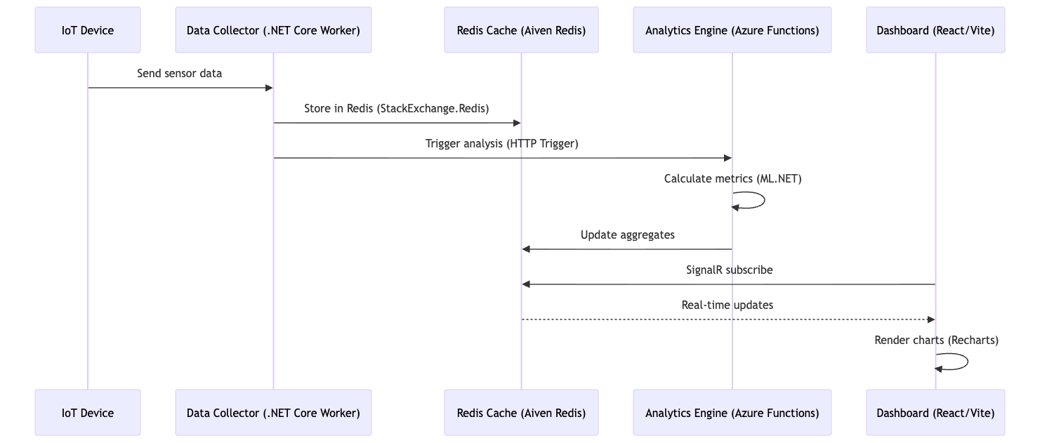

Multi-Cloud Integration Flow
Note: Shifted to Azure-centric with optional multi-cloud via Azure Arc.
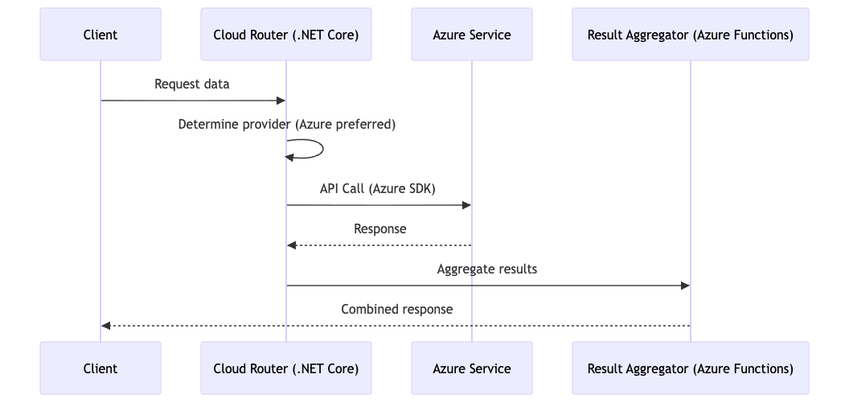
Inventory Management Flow
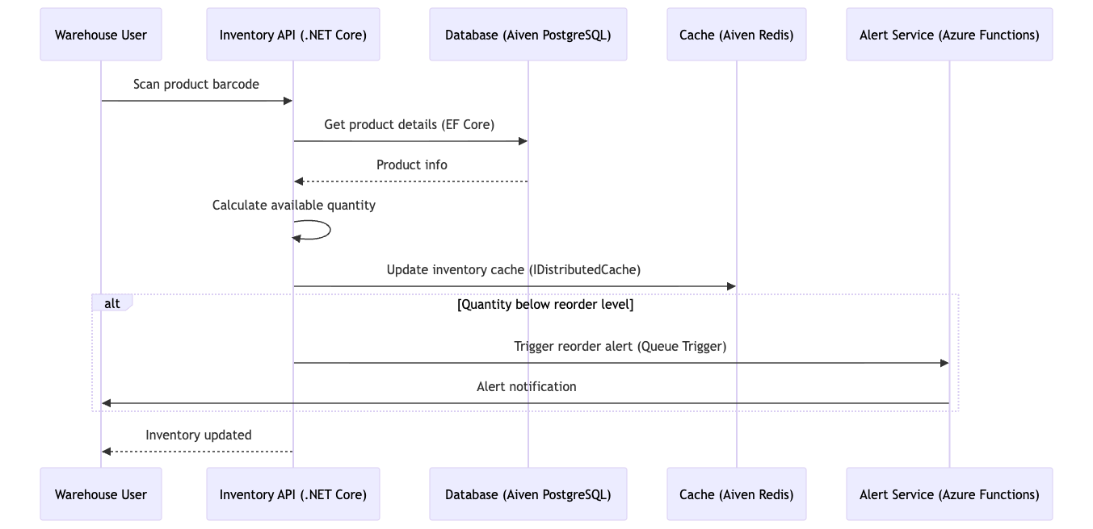
Shipment Tracking Flow
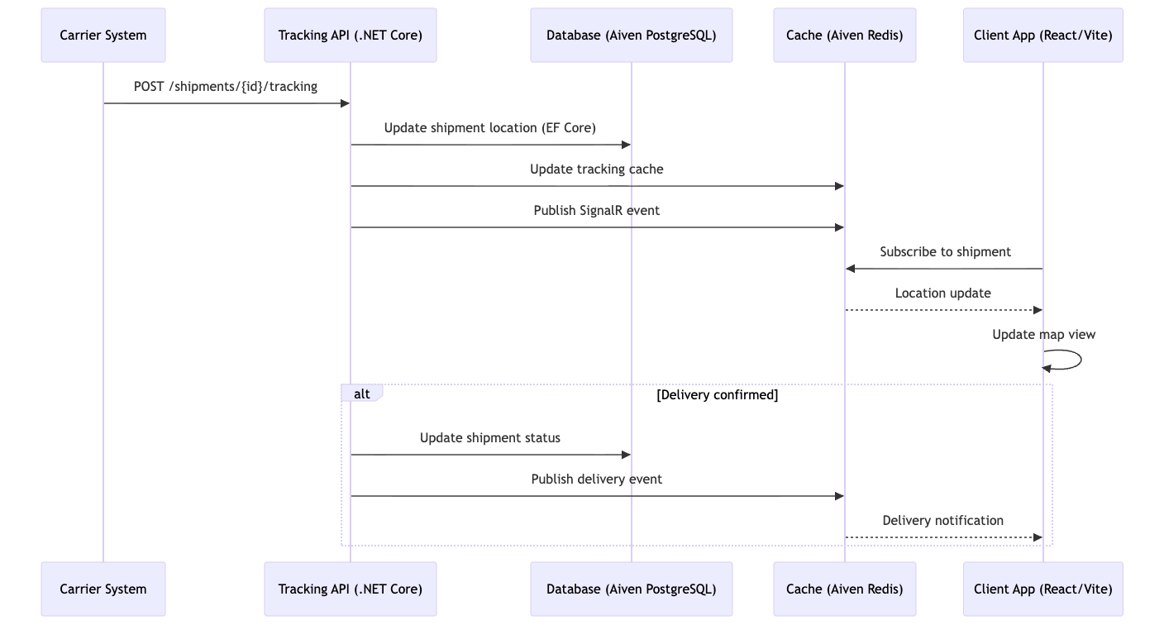

User Permission Flow

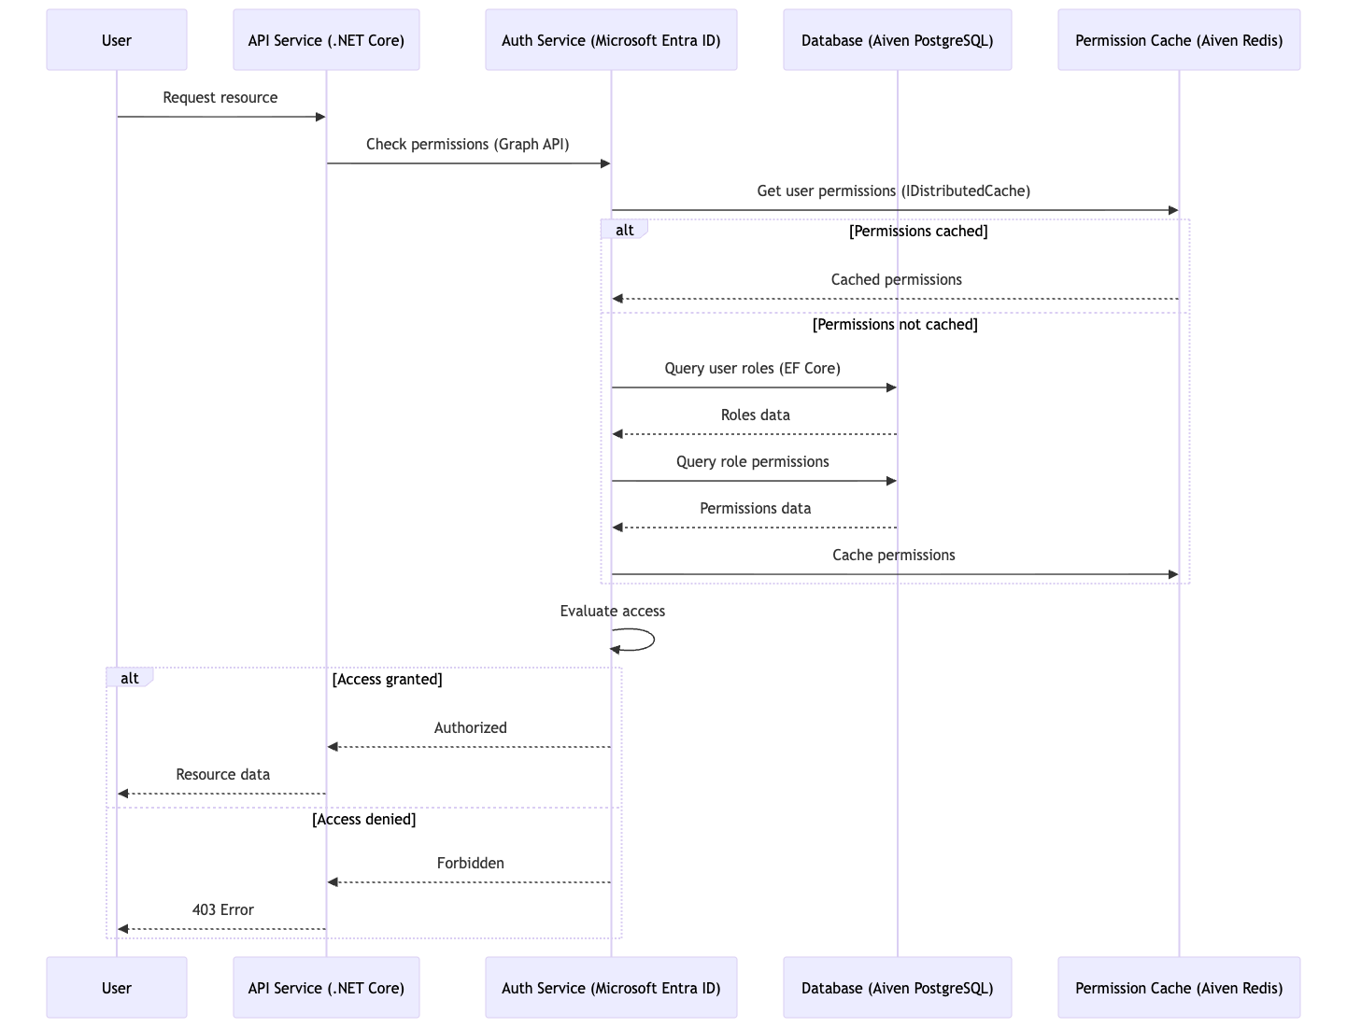
Report Generation Flow
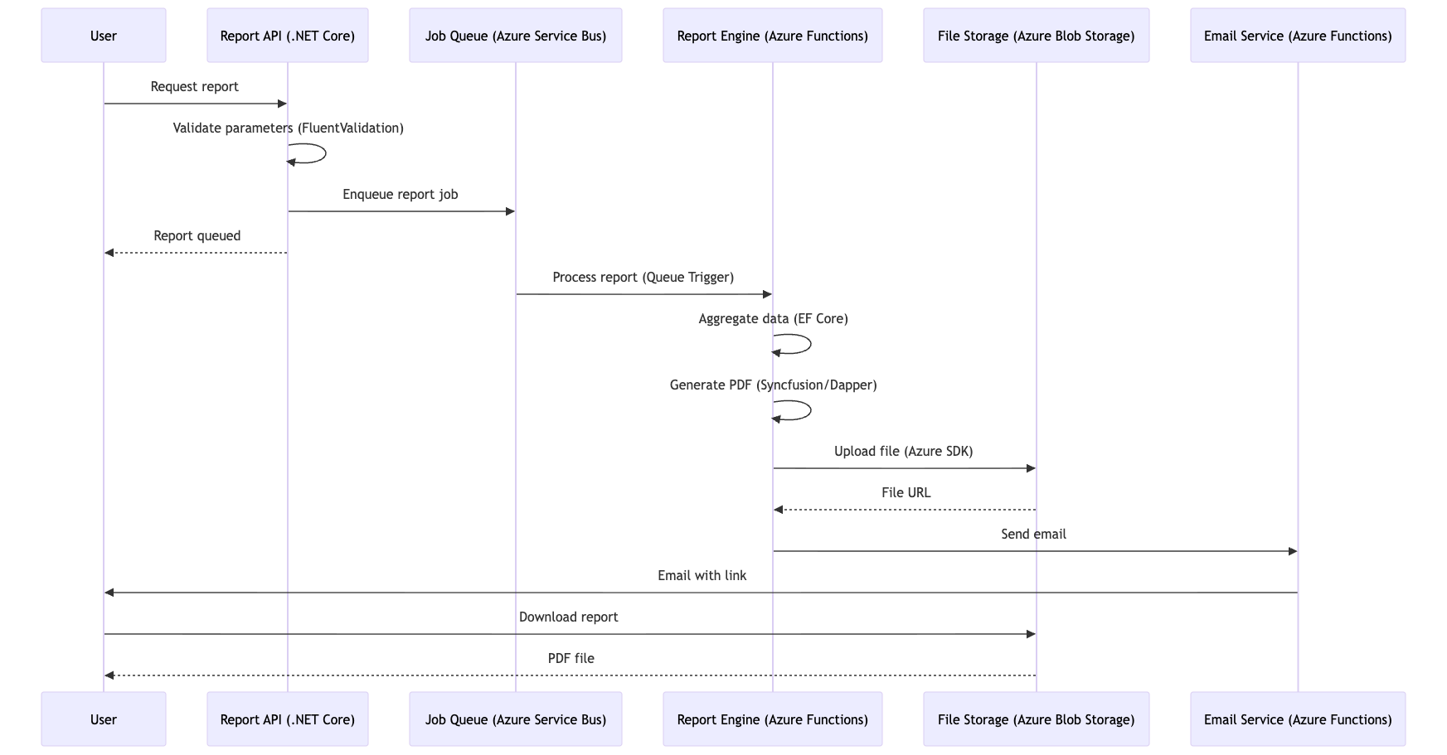

API Response Formats

Success Response
JSON
{
"success": true,
"data": {
"id": "uuid",
"name": "Example",
"createdAt": "2024-01-10T10:00:00Z"
},
"meta": {
"timestamp": "2024-01-10T10:00:00Z",
"version": "1.0"
}
}

Error Response
JSON
{
"success": false,
"error": {
"code": "VALIDATION_ERROR",
"message": "Invalid input parameters",
"details": [
{
"field": "email",
"message": "Invalid email format"
}
]
},
"meta": {
"timestamp": "2024-01-10T10:00:00Z",
"requestId": "req-12345"
}
}

Paginated Response
JSON
{
"success": true,
"data": [
{ "id": "1", "name": "Item 1" },
{ "id": "2", "name": "Item 2" }
],
"pagination": {
"page": 1,
"pageSize": 20,
"total": 100,
"totalPages": 5,
"hasNextPage": true,
"hasPreviousPage": false
}
}

Rate Limiting Configuration

Implementation Strategy
To enforce these limits within your .NET 8 and Azure ecosystem, you can utilize the following components:
- ASP.NET Core Rate Limiting Middleware: Introduced in .NET 7/8, this allows you to define policies (Fixed Window, Sliding Window, or Token Bucket) directly in your Program.cs.
- Redis-based Rate Limiting: Since you are using Aiven Redis, you can implement a distributed rate limiter. This ensures that if you have multiple instances of your microservices running in AKS (Azure Kubernetes Service), the request count is synchronized across all nodes.
- Azure API Management (APIM): If you scale further, placing APIM in front of your services allows you to handle "Throttling" at the gateway level before the request even reaches your compute layer.
Endpoint Type | Requests/Minute | Burst
Authentication | 5 | 10
Read Operations | 60 | 100
Write Operations | 30 | 50
Bulk Operations | 10 | 20
Search | 30 | 50

Implementation Guide
To enforce these timeouts across your enterprise stack, you should apply settings at multiple layers:
- EF Core (Database): Set the command timeout in your DbContext configuration:
  - options.UseNpgsql(connectionString, o => o.CommandTimeout(10));
- HttpClient: For external API calls, ensure the client is configured to cancel after 30 seconds to avoid thread pool starvation.
- SignalR (WebSockets): Configure the ClientTimeoutInterval and KeepAliveInterval in your Hub options to match the 30s idle requirement.
- Azure Functions: For reports, use the function.json or host.json to extend the functionTimeout attribute to 10 minutes.
Operation | Timeout
API Request | 30s
Database Query | 10s
File Upload | 5m
Report Generation | 10m
WebSocket Connection | 30s (idle)

API Versioning Strategy

URL-based Versioning
/api/v1/orders
/api/v2/orders

Header-based Versioning
text
Accept: application/vnd.imsop.v1+json

Deprecation Policy
- Announce deprecation 6 months in advance
- Maintain deprecated version for 12 months
- Provide migration guide
- Support both versions during transition

Error Handling Flow

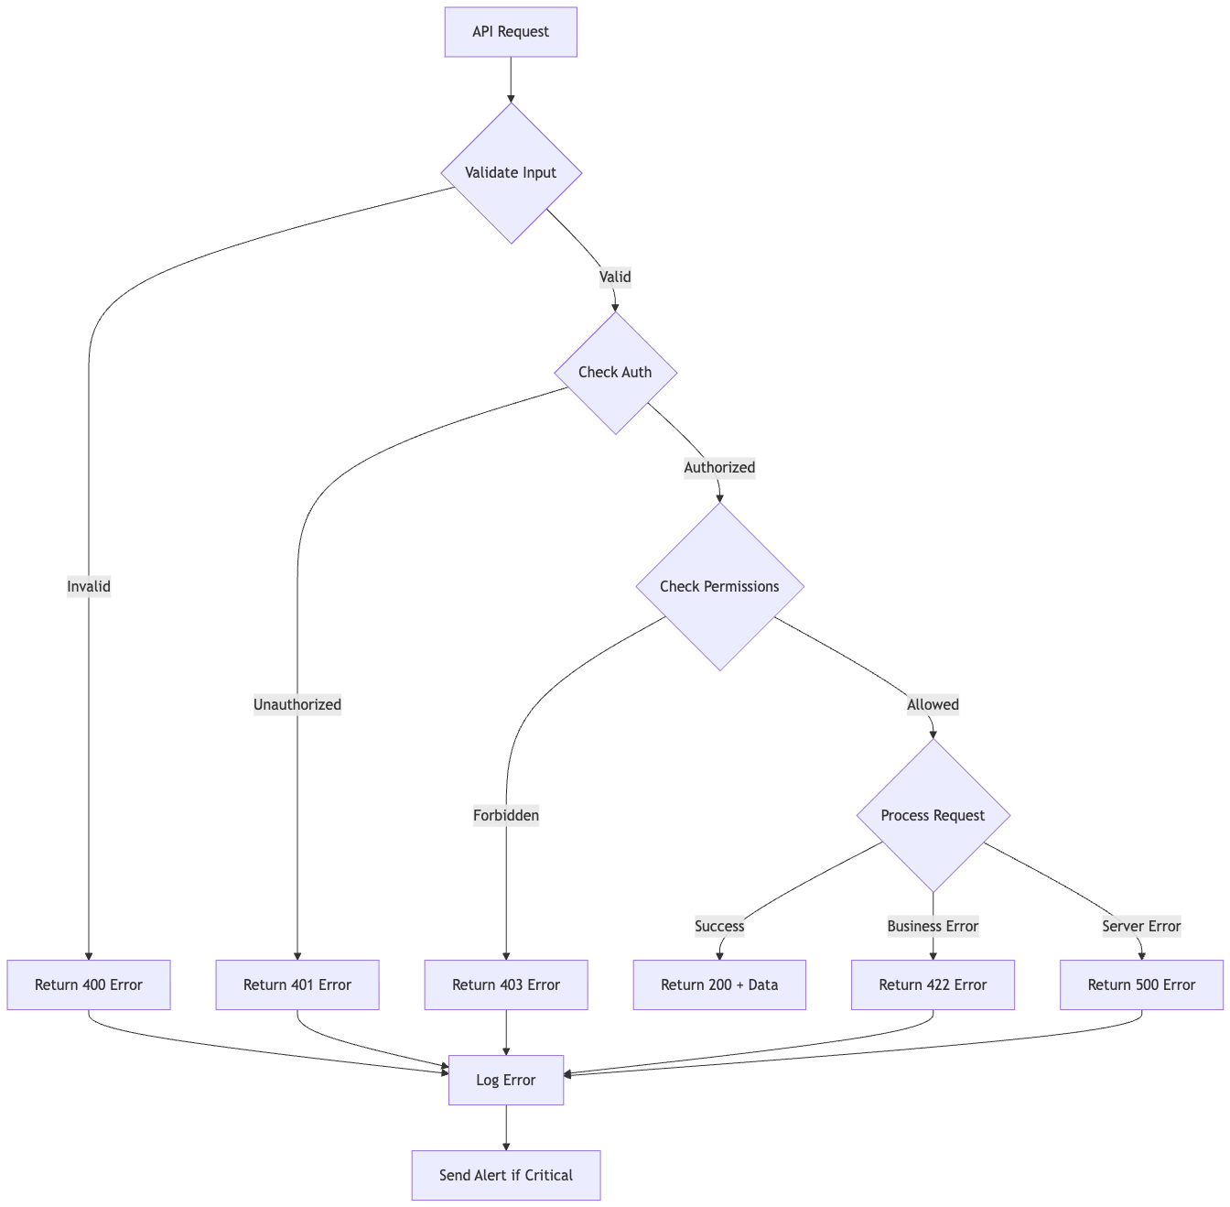
WebSocket Connection Management

Connection Flow

1. Client initiates SignalR connection

2. Server validates JWT token (Microsoft Entra ID)

3. Server subscribes client to channels
4. Server sends initial state
5. Client receives real-time updates
6. Connection maintained with heartbeat
7. Client disconnects or timeout

Message Format
JSON
{
"type": "update",
"channel": "shipments:123",
"event": "status_changed",
"data": {
"shipmentId": "123",
"status": "in_transit",
"location": "New York, NY"
},
"timestamp": "2024-01-10T10:00:00Z"
}

Data Aggregation Flow

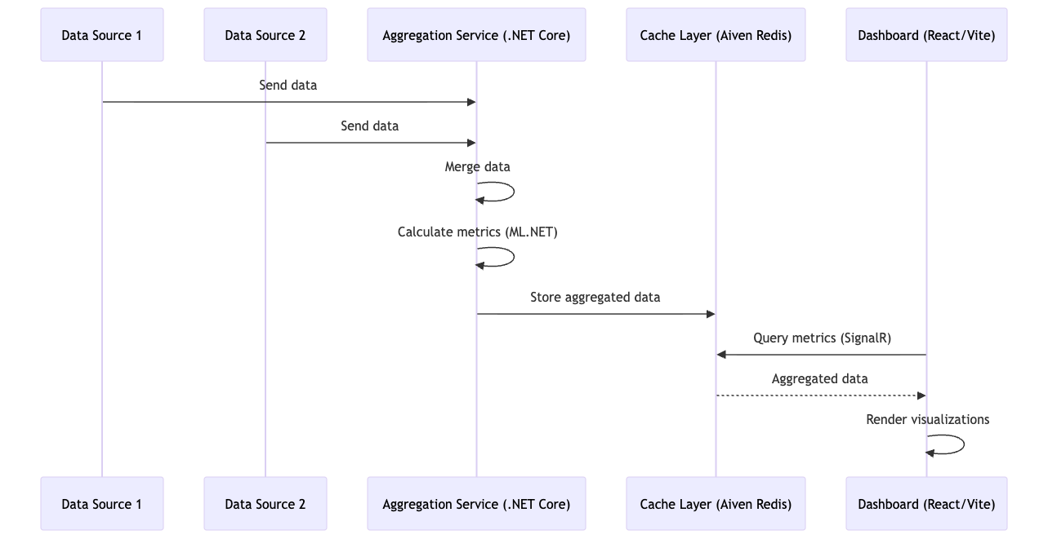
Multi-Device Grouping Flow

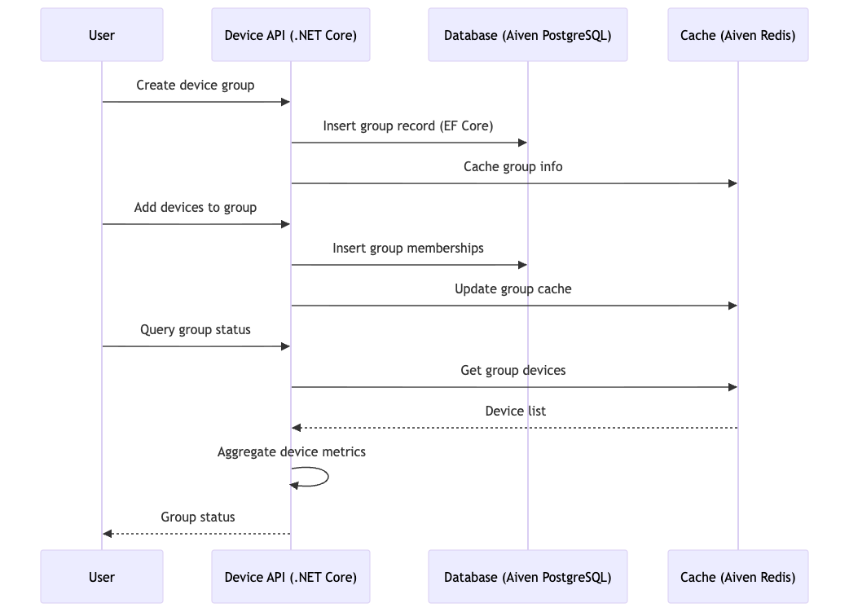

Performance Optimization Strategies

Caching Strategy
- Cache frequently accessed data (5 min TTL) using Aiven Redis
- Cache user permissions (10 min TTL)
- Cache product catalog (1 hour TTL)
- Cache organization settings (1 day TTL)

Query Optimization
- Use database indexes for common queries (EF Core LINQ)
- Implement query result pagination
- Use projection to select only needed fields
- Batch related queries together (EF Core)

Async Processing
- Queue long-running operations (Azure Service Bus)
- Process reports asynchronously (Azure Functions)
- Send notifications asynchronously
- Archive data asynchronously

Load Distribution
- Distribute requests across multiple servers (Azure App Service)
- Use message queues for async tasks
- Cache responses at CDN level (Azure CDN)
- Implement request batching

