IMSOP - Database Schema

Entity Relationship Diagram

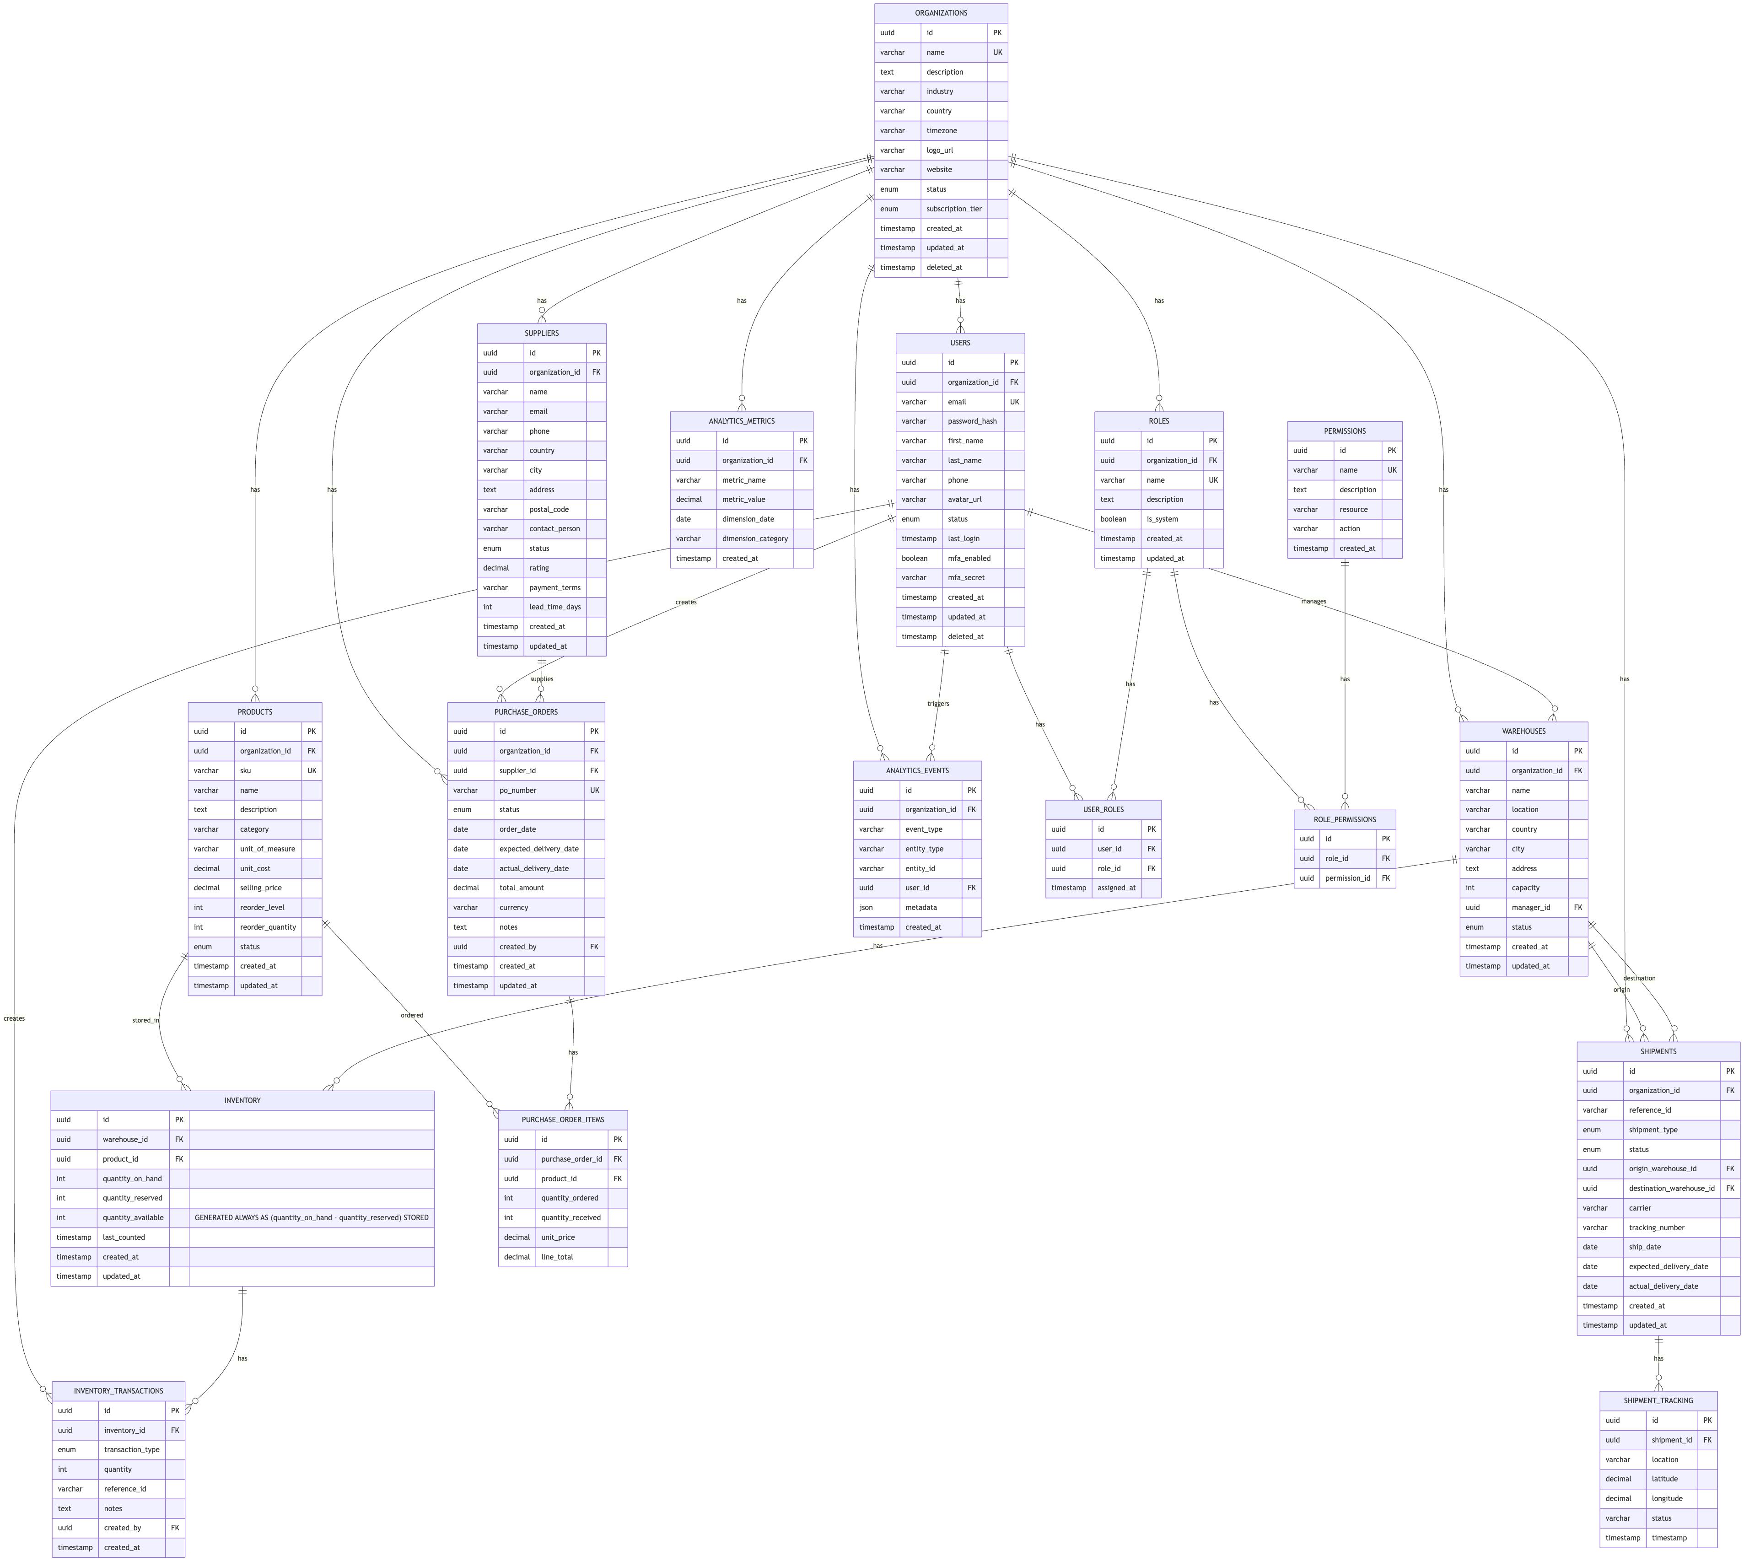

Core Tables

Organizations - Central organization management and multi-tenancy support.
CREATE TABLE organizations (
id UUID PRIMARY KEY DEFAULT gen_random_uuid(),
name VARCHAR(255) NOT NULL UNIQUE,
description TEXT,
industry VARCHAR(100),
country VARCHAR(100),
timezone VARCHAR(50) DEFAULT 'UTC',
logo_url VARCHAR(500),
website VARCHAR(255),
status ENUM('active', 'inactive', 'suspended') DEFAULT 'active',
subscription_tier ENUM('starter', 'professional', 'enterprise') DEFAULT 'starter',
created_at TIMESTAMP DEFAULT CURRENT_TIMESTAMP,
updated_at TIMESTAMP DEFAULT CURRENT_TIMESTAMP ON UPDATE CURRENT_TIMESTAMP,
deleted_at TIMESTAMP NULL,
INDEX idx_status (status),
INDEX idx_subscription_tier (subscription_tier),
UNIQUE KEY unique_active_org (name, deleted_at)
);

Users - User accounts and authentication.
CREATE TABLE users (
id UUID PRIMARY KEY DEFAULT gen_random_uuid(),
organization_id UUID NOT NULL,
email VARCHAR(255) NOT NULL,
password_hash VARCHAR(255) NOT NULL,
first_name VARCHAR(100),
last_name VARCHAR(100),
phone VARCHAR(20),
avatar_url VARCHAR(500),
status ENUM('active', 'inactive', 'suspended') DEFAULT 'active',
last_login TIMESTAMP NULL,
mfa_enabled BOOLEAN DEFAULT FALSE,
mfa_secret VARCHAR(255),
created_at TIMESTAMP DEFAULT CURRENT_TIMESTAMP,
updated_at TIMESTAMP DEFAULT CURRENT_TIMESTAMP ON UPDATE CURRENT_TIMESTAMP,
deleted_at TIMESTAMP NULL,
FOREIGN KEY (organization_id) REFERENCES organizations(id),
UNIQUE KEY unique_email_per_org (organization_id, email),
INDEX idx_organization_id (organization_id),
INDEX idx_status (status),
UNIQUE KEY unique_active_user (email, deleted_at)
);

Roles & Permissions - Role-based access control.
CREATE TABLE roles (
id UUID PRIMARY KEY DEFAULT gen_random_uuid(),
organization_id UUID NOT NULL,
name VARCHAR(100) NOT NULL,
description TEXT,
is_system BOOLEAN DEFAULT FALSE,
created_at TIMESTAMP DEFAULT CURRENT_TIMESTAMP,
updated_at TIMESTAMP DEFAULT CURRENT_TIMESTAMP ON UPDATE CURRENT_TIMESTAMP,
FOREIGN KEY (organization_id) REFERENCES organizations(id),
UNIQUE KEY unique_role_per_org (organization_id, name),
INDEX idx_organization_id (organization_id)
);
CREATE TABLE permissions (
id UUID PRIMARY KEY DEFAULT gen_random_uuid(),
name VARCHAR(100) NOT NULL UNIQUE,
description TEXT,
resource VARCHAR(100) NOT NULL,
action VARCHAR(50) NOT NULL,
created_at TIMESTAMP DEFAULT CURRENT_TIMESTAMP,
UNIQUE KEY unique_resource_action (resource, action)
);
CREATE TABLE role_permissions (
id UUID PRIMARY KEY DEFAULT gen_random_uuid(),
role_id UUID NOT NULL,
permission_id UUID NOT NULL,
FOREIGN KEY (role_id) REFERENCES roles(id) ON DELETE CASCADE,
FOREIGN KEY (permission_id) REFERENCES permissions(id),
UNIQUE KEY unique_role_permission (role_id, permission_id)
);
CREATE TABLE user_roles (
id UUID PRIMARY KEY DEFAULT gen_random_uuid(),
user_id UUID NOT NULL,
role_id UUID NOT NULL,
assigned_at TIMESTAMP DEFAULT CURRENT_TIMESTAMP,
FOREIGN KEY (user_id) REFERENCES users(id) ON DELETE CASCADE,
FOREIGN KEY (role_id) REFERENCES roles(id),
UNIQUE KEY unique_user_role (user_id, role_id)
);

Suppliers - Supplier management and tracking.
CREATE TABLE suppliers (
id UUID PRIMARY KEY DEFAULT gen_random_uuid(),
organization_id UUID NOT NULL,
name VARCHAR(255) NOT NULL,
email VARCHAR(255),
phone VARCHAR(20),
country VARCHAR(100),
city VARCHAR(100),
address TEXT,
postal_code VARCHAR(20),
contact_person VARCHAR(100),
status ENUM('active', 'inactive', 'blocked') DEFAULT 'active',
rating DECIMAL(3,2) DEFAULT 0,
payment_terms VARCHAR(50),
lead_time_days INT DEFAULT 0,
created_at TIMESTAMP DEFAULT CURRENT_TIMESTAMP,
updated_at TIMESTAMP DEFAULT CURRENT_TIMESTAMP ON UPDATE CURRENT_TIMESTAMP,
FOREIGN KEY (organization_id) REFERENCES organizations(id),
INDEX idx_organization_id (organization_id),
INDEX idx_status (status),
INDEX idx_rating (rating)
);

Products - Product catalog and specifications.
CREATE TABLE products (
id UUID PRIMARY KEY DEFAULT gen_random_uuid(),
organization_id UUID NOT NULL,
sku VARCHAR(100) NOT NULL,
name VARCHAR(255) NOT NULL,
description TEXT,
category VARCHAR(100),
unit_of_measure VARCHAR(20),
unit_cost DECIMAL(12,4),
selling_price DECIMAL(12,4),
reorder_level INT DEFAULT 0,
reorder_quantity INT DEFAULT 0,
status ENUM('active', 'discontinued', 'archived') DEFAULT 'active',
created_at TIMESTAMP DEFAULT CURRENT_TIMESTAMP,
updated_at TIMESTAMP DEFAULT CURRENT_TIMESTAMP ON UPDATE CURRENT_TIMESTAMP,
FOREIGN KEY (organization_id) REFERENCES organizations(id),
UNIQUE KEY unique_sku_per_org (organization_id, sku),
INDEX idx_organization_id (organization_id),
INDEX idx_category (category),
INDEX idx_status (status)
);

Warehouses & Inventory - Warehouse locations and inventory tracking.
CREATE TABLE warehouses (
id UUID PRIMARY KEY DEFAULT gen_random_uuid(),
organization_id UUID NOT NULL,
name VARCHAR(255) NOT NULL,
location VARCHAR(255),
country VARCHAR(100),
city VARCHAR(100),
address TEXT,
capacity INT,
manager_id UUID,
status ENUM('active', 'inactive', 'maintenance') DEFAULT 'active',
created_at TIMESTAMP DEFAULT CURRENT_TIMESTAMP,
updated_at TIMESTAMP DEFAULT CURRENT_TIMESTAMP ON UPDATE CURRENT_TIMESTAMP,
FOREIGN KEY (organization_id) REFERENCES organizations(id),
FOREIGN KEY (manager_id) REFERENCES users(id),
INDEX idx_organization_id (organization_id),
INDEX idx_status (status)
);
CREATE TABLE inventory (
id UUID PRIMARY KEY DEFAULT gen_random_uuid(),
warehouse_id UUID NOT NULL,
product_id UUID NOT NULL,
quantity_on_hand INT DEFAULT 0,
quantity_reserved INT DEFAULT 0,
quantity_available INT GENERATED ALWAYS AS (quantity_on_hand - quantity_reserved) STORED,
last_counted TIMESTAMP,
created_at TIMESTAMP DEFAULT CURRENT_TIMESTAMP,
updated_at TIMESTAMP DEFAULT CURRENT_TIMESTAMP ON UPDATE CURRENT_TIMESTAMP,
FOREIGN KEY (warehouse_id) REFERENCES warehouses(id),
FOREIGN KEY (product_id) REFERENCES products(id),
UNIQUE KEY unique_warehouse_product (warehouse_id, product_id),
INDEX idx_warehouse_id (warehouse_id),
INDEX idx_product_id (product_id)
);
CREATE TABLE inventory_transactions (
id UUID PRIMARY KEY DEFAULT gen_random_uuid(),
inventory_id UUID NOT NULL,
transaction_type ENUM('receipt', 'shipment', 'adjustment', 'return') NOT NULL,
quantity INT NOT NULL,
reference_id VARCHAR(100),
notes TEXT,
created_by UUID,
created_at TIMESTAMP DEFAULT CURRENT_TIMESTAMP,
FOREIGN KEY (inventory_id) REFERENCES inventory(id),
FOREIGN KEY (created_by) REFERENCES users(id),
INDEX idx_inventory_id (inventory_id),
INDEX idx_created_at (created_at)
);

Purchase Orders - Purchase order management and tracking.
CREATE TABLE purchase_orders (
id UUID PRIMARY KEY DEFAULT gen_random_uuid(),
organization_id UUID NOT NULL,
supplier_id UUID NOT NULL,
po_number VARCHAR(100) NOT NULL,
status ENUM('draft', 'submitted', 'confirmed', 'shipped', 'received', 'cancelled') DEFAULT 'draft',
order_date DATE NOT NULL,
expected_delivery_date DATE,
actual_delivery_date DATE,
total_amount DECIMAL(14,2),
currency VARCHAR(3) DEFAULT 'USD',
notes TEXT,
created_by UUID,
created_at TIMESTAMP DEFAULT CURRENT_TIMESTAMP,
updated_at TIMESTAMP DEFAULT CURRENT_TIMESTAMP ON UPDATE CURRENT_TIMESTAMP,
FOREIGN KEY (organization_id) REFERENCES organizations(id),
FOREIGN KEY (supplier_id) REFERENCES suppliers(id),
FOREIGN KEY (created_by) REFERENCES users(id),
UNIQUE KEY unique_po_per_org (organization_id, po_number),
INDEX idx_organization_id (organization_id),
INDEX idx_supplier_id (supplier_id),
INDEX idx_status (status),
INDEX idx_order_date (order_date)
);
CREATE TABLE purchase_order_items (
id UUID PRIMARY KEY DEFAULT gen_random_uuid(),
purchase_order_id UUID NOT NULL,
product_id UUID NOT NULL,
quantity_ordered INT NOT NULL,
quantity_received INT DEFAULT 0,
unit_price DECIMAL(12,4),
line_total DECIMAL(14,2),
FOREIGN KEY (purchase_order_id) REFERENCES purchase_orders(id) ON DELETE CASCADE,
FOREIGN KEY (product_id) REFERENCES products(id),
INDEX idx_purchase_order_id (purchase_order_id)
);

Shipments & Tracking - Shipment management and real-time tracking.
CREATE TABLE shipments (
id UUID PRIMARY KEY DEFAULT gen_random_uuid(),
organization_id UUID NOT NULL,
reference_id VARCHAR(100),
shipment_type ENUM('inbound', 'outbound', 'transfer') NOT NULL,
status ENUM('pending', 'in_transit', 'delivered', 'cancelled') DEFAULT 'pending',
origin_warehouse_id UUID,
destination_warehouse_id UUID,
carrier VARCHAR(100),
tracking_number VARCHAR(100),
ship_date DATE,
expected_delivery_date DATE,
actual_delivery_date DATE,
created_at TIMESTAMP DEFAULT CURRENT_TIMESTAMP,
updated_at TIMESTAMP DEFAULT CURRENT_TIMESTAMP ON UPDATE CURRENT_TIMESTAMP,
FOREIGN KEY (organization_id) REFERENCES organizations(id),
FOREIGN KEY (origin_warehouse_id) REFERENCES warehouses(id),
FOREIGN KEY (destination_warehouse_id) REFERENCES warehouses(id),
INDEX idx_organization_id (organization_id),
INDEX idx_status (status),
INDEX idx_tracking_number (tracking_number)
);
CREATE TABLE shipment_tracking (
id UUID PRIMARY KEY DEFAULT gen_random_uuid(),
shipment_id UUID NOT NULL,
location VARCHAR(255),
latitude DECIMAL(10,8),
longitude DECIMAL(11,8),
status VARCHAR(50),
timestamp TIMESTAMP,
FOREIGN KEY (shipment_id) REFERENCES shipments(id) ON DELETE CASCADE,
INDEX idx_shipment_id (shipment_id),
INDEX idx_timestamp (timestamp)
);

Analytics & Metrics - Analytics and performance metrics.
CREATE TABLE analytics_events (
id UUID PRIMARY KEY DEFAULT gen_random_uuid(),
organization_id UUID NOT NULL,
event_type VARCHAR(100) NOT NULL,
entity_type VARCHAR(100),
entity_id VARCHAR(100),
user_id UUID,
metadata JSON,
created_at TIMESTAMP DEFAULT CURRENT_TIMESTAMP,
FOREIGN KEY (organization_id) REFERENCES organizations(id),
FOREIGN KEY (user_id) REFERENCES users(id),
INDEX idx_organization_id (organization_id),
INDEX idx_event_type (event_type),
INDEX idx_created_at (created_at)
);
CREATE TABLE analytics_metrics (
id UUID PRIMARY KEY DEFAULT gen_random_uuid(),
organization_id UUID NOT NULL,
metric_name VARCHAR(100) NOT NULL,
metric_value DECIMAL(14,4),
dimension_date DATE,
dimension_category VARCHAR(100),
created_at TIMESTAMP DEFAULT CURRENT_TIMESTAMP,
FOREIGN KEY (organization_id) REFERENCES organizations(id),
INDEX idx_organization_id (organization_id),
INDEX idx_metric_name (metric_name),
INDEX idx_dimension_date (dimension_date)
);

Indexing Strategy

Primary Indexes
- All primary keys indexed automatically
- Foreign keys indexed for join performance
- Organization ID indexed for multi-tenancy filtering

Performance Indexes
- Status fields indexed for filtering
- Date fields indexed for range queries
- Frequently searched fields indexed

Composite Indexes
- (organization_id, status) for filtered queries
- (warehouse_id, product_id) for inventory lookups
- (created_at, organization_id) for time-series queries

Query Patterns

Get Inventory by Product
SELECT i.*, p.name, w.name as warehouse_name
FROM inventory i
JOIN products p ON i.product_id = p.id
JOIN warehouses w ON i.warehouse_id = w.id
WHERE p.organization_id = ? AND p.sku = ?
ORDER BY w.name;

Get Purchase Order Status
SELECT po.*, GROUP_CONCAT(p.name) as products
FROM purchase_orders po
LEFT JOIN purchase_order_items poi ON po.id = poi.purchase_order_id
LEFT JOIN products p ON poi.product_id = p.id
WHERE po.organization_id = ? AND po.po_number = ?
GROUP BY po.id;

Real-time Shipment Tracking
SELECT s.*, st.location, st.latitude, st.longitude, st.timestamp
FROM shipments s
LEFT JOIN shipment_tracking st ON s.id = st.shipment_id
WHERE s.organization_id = ? AND s.tracking_number = ?
ORDER BY st.timestamp DESC
LIMIT 1;

Performance Optimization

Query Optimization
- Use EXPLAIN ANALYZE for query planning
- Avoid SELECT * queries
- Use appropriate JOIN types
- Implement pagination for large result sets

Caching Strategy
- Cache frequently accessed products
- Cache organization settings
- Cache user permissions
- Cache warehouse locations

Data Retention
- Archive old purchase orders (>2 years)
- Archive old shipment tracking (>1 year)
- Archive old analytics events (>6 months)
- Keep current inventory indefinitely

Backup & Recovery

Backup Strategy
- Daily full backups (Aiven automated)
- Hourly incremental backups
- Point-in-time recovery enabled
- Backup retention: 30 days

Recovery Procedures
- Test recovery procedures monthly
- Document recovery time objectives (RTO)
- Document recovery point objectives (RPO)
- Maintain backup verification logs

Security Considerations

Data Protection
- Encrypt sensitive data at rest (Aiven PostgreSQL encryption)
- Use TLS for data in transit
- Hash passwords with bcrypt
- Mask PII in logs

Access Control
- Row-level security for multi-tenancy
- Column-level encryption for sensitive data
- Audit trail for all modifications
- Regular security audits

