Smart Factory IoT - API Flows & Sequences

Authentication Flow
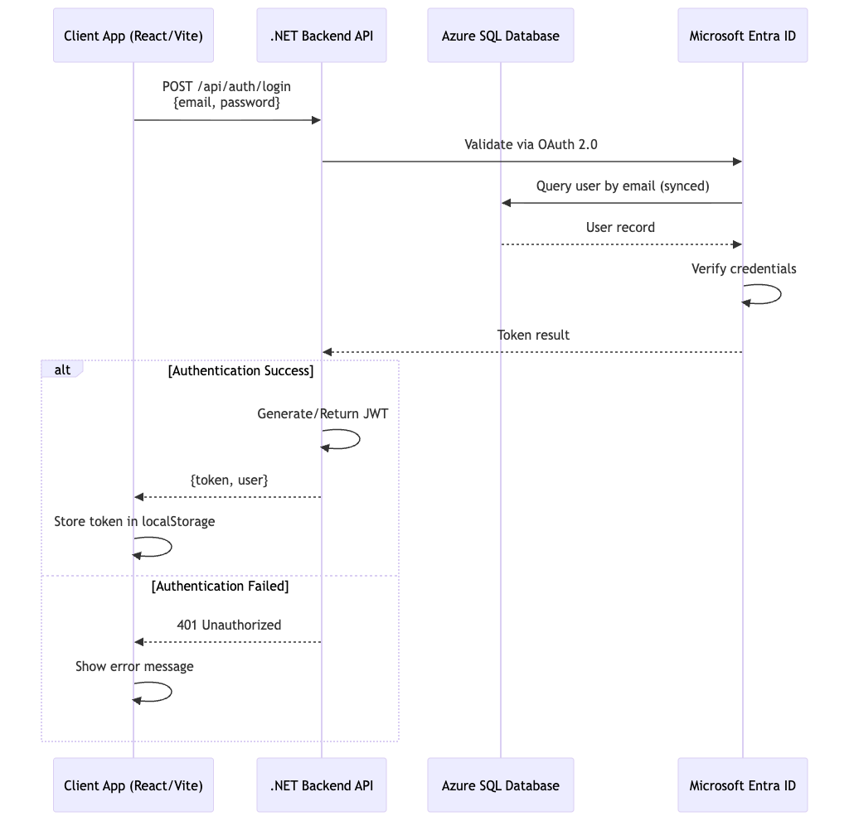

Real-time Device Monitoring Flow
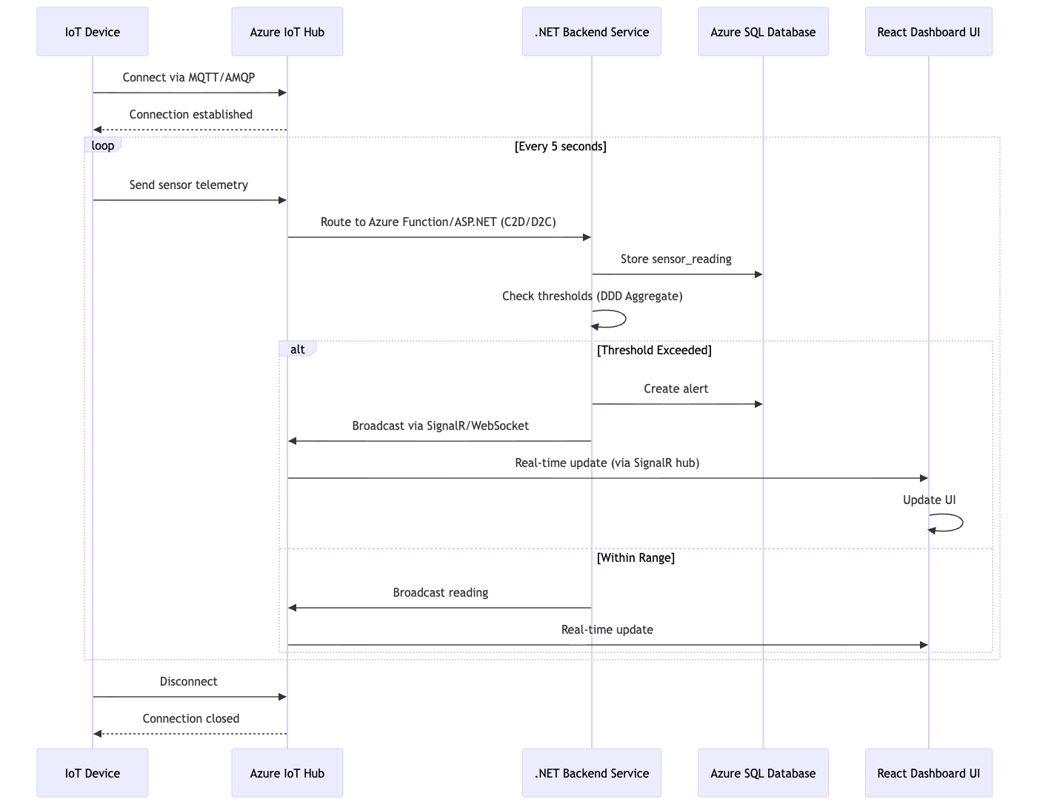
Alert Management Flow
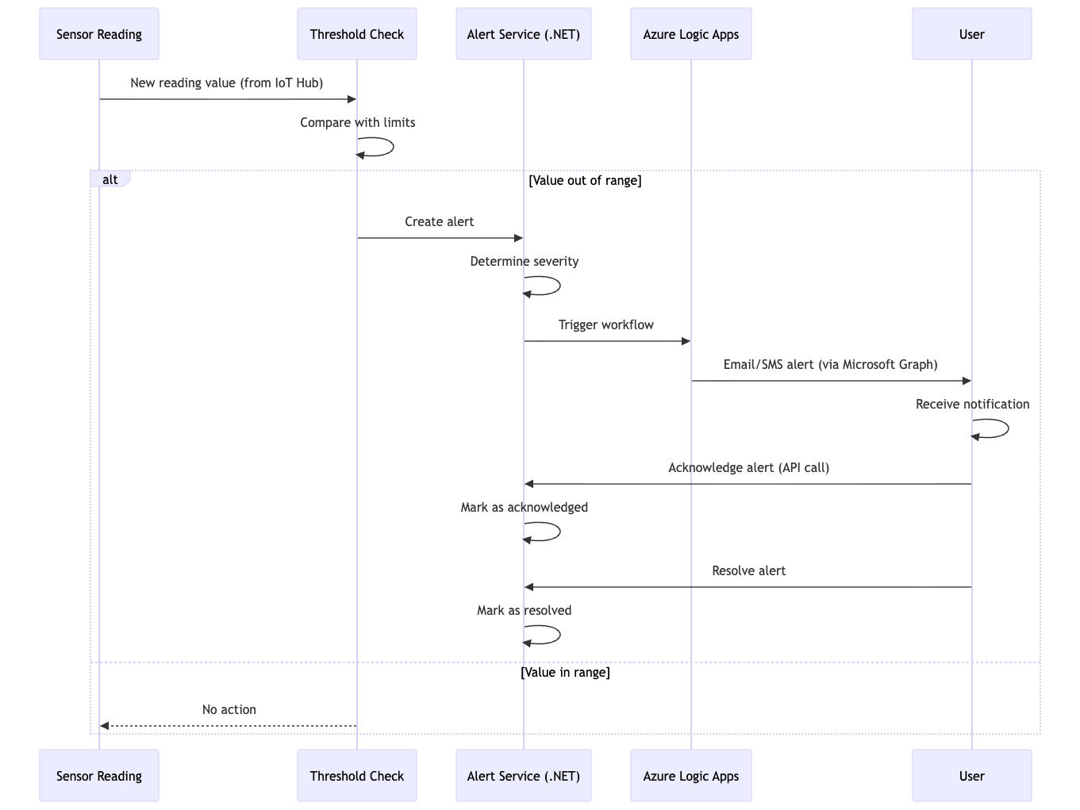
Device Management Flow
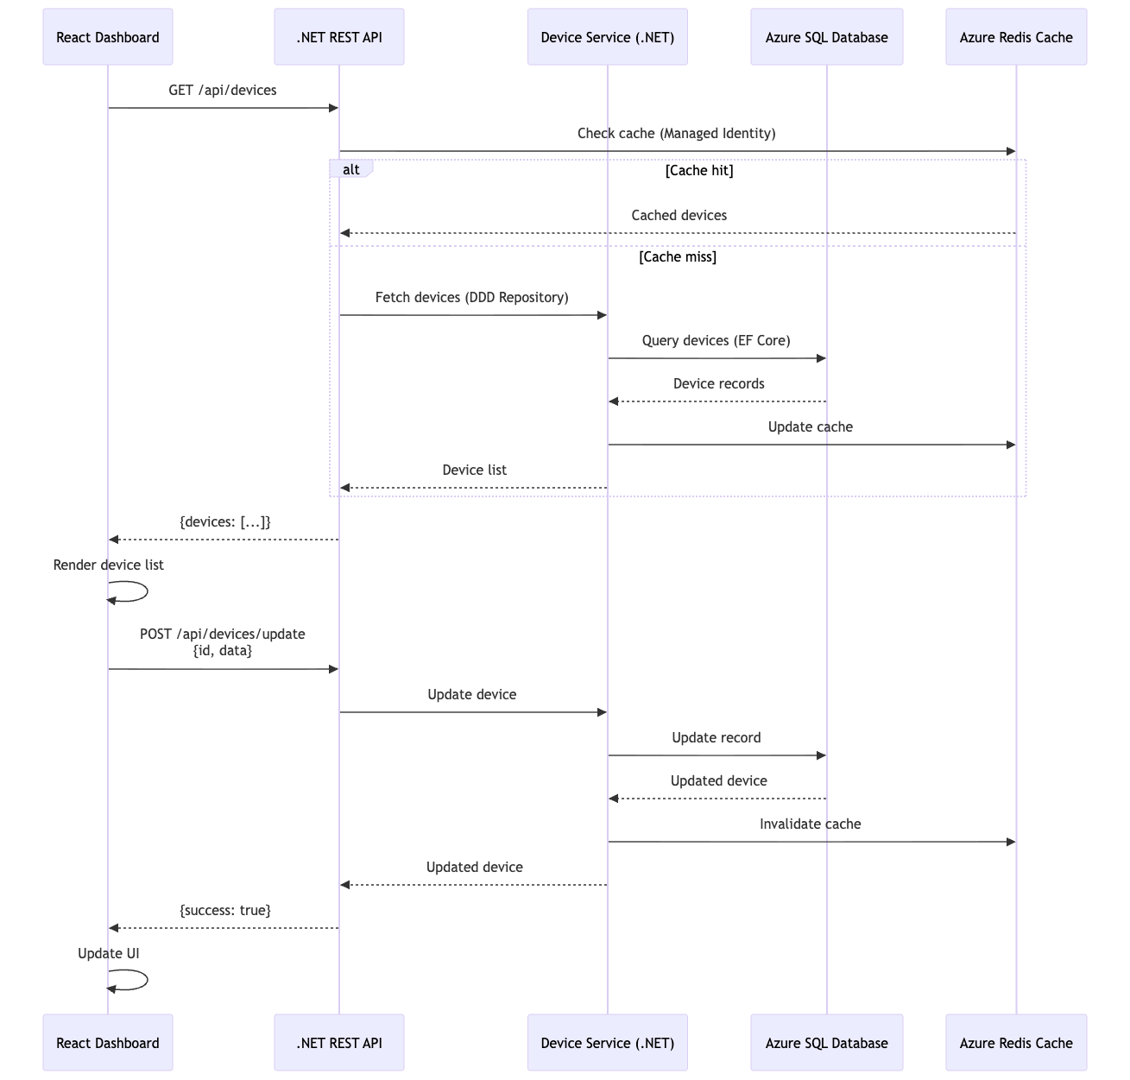
OTA Update Flow
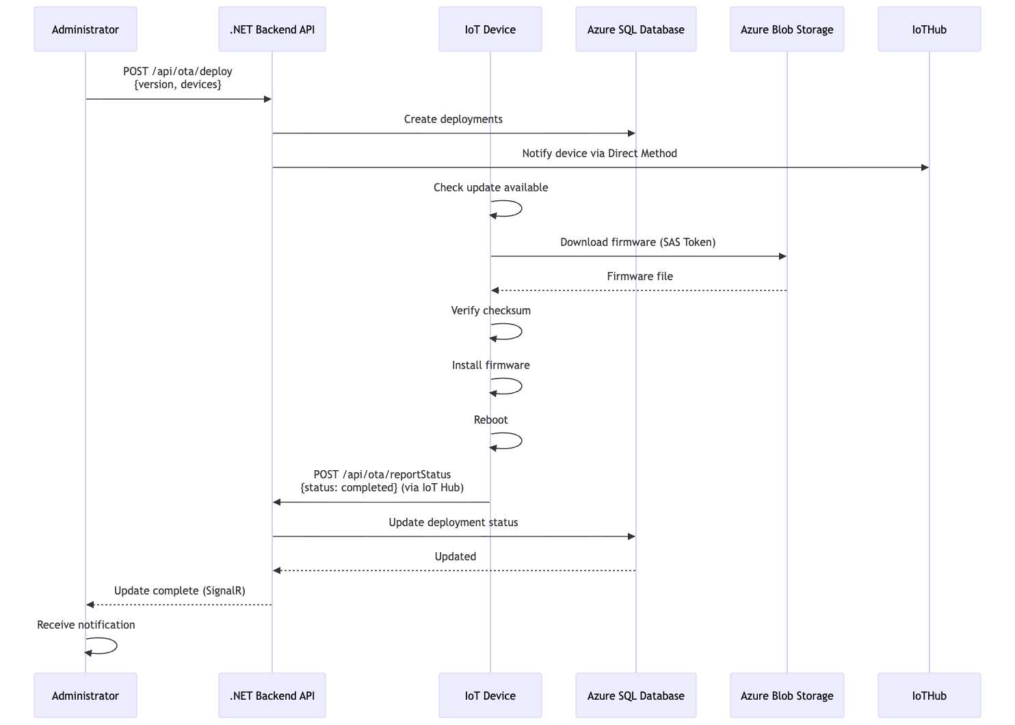
Analytics & Reporting Flow
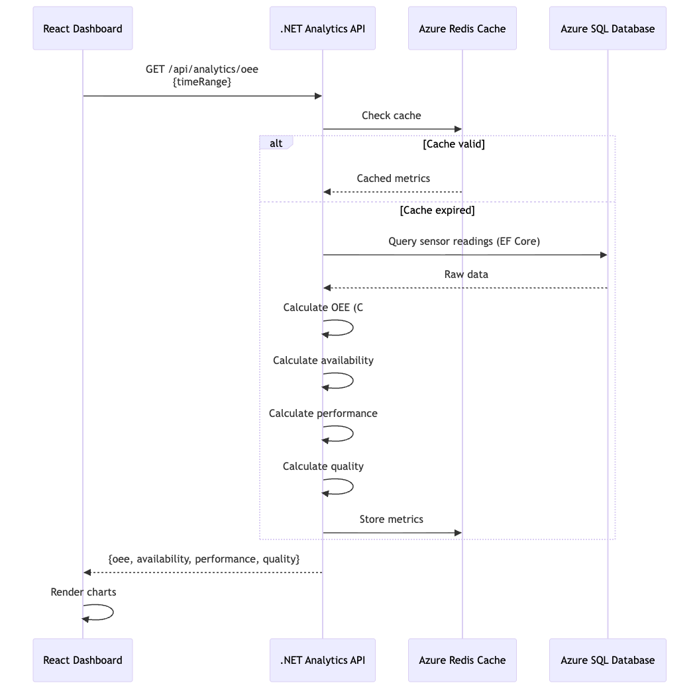
Error Handling Flow
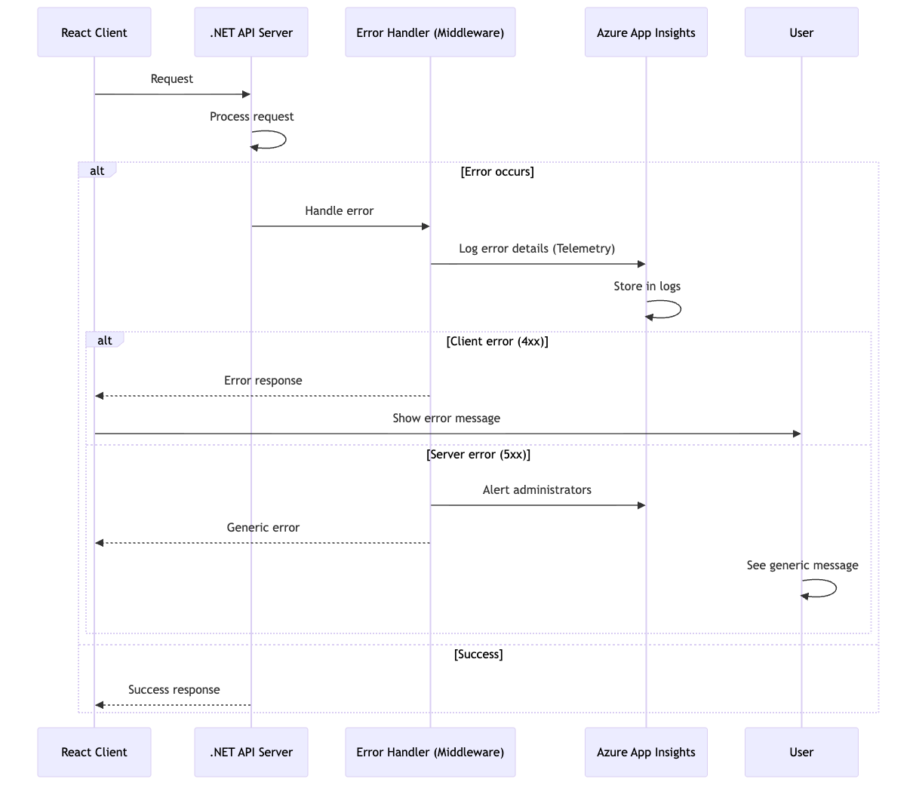
WebSocket Connection Management
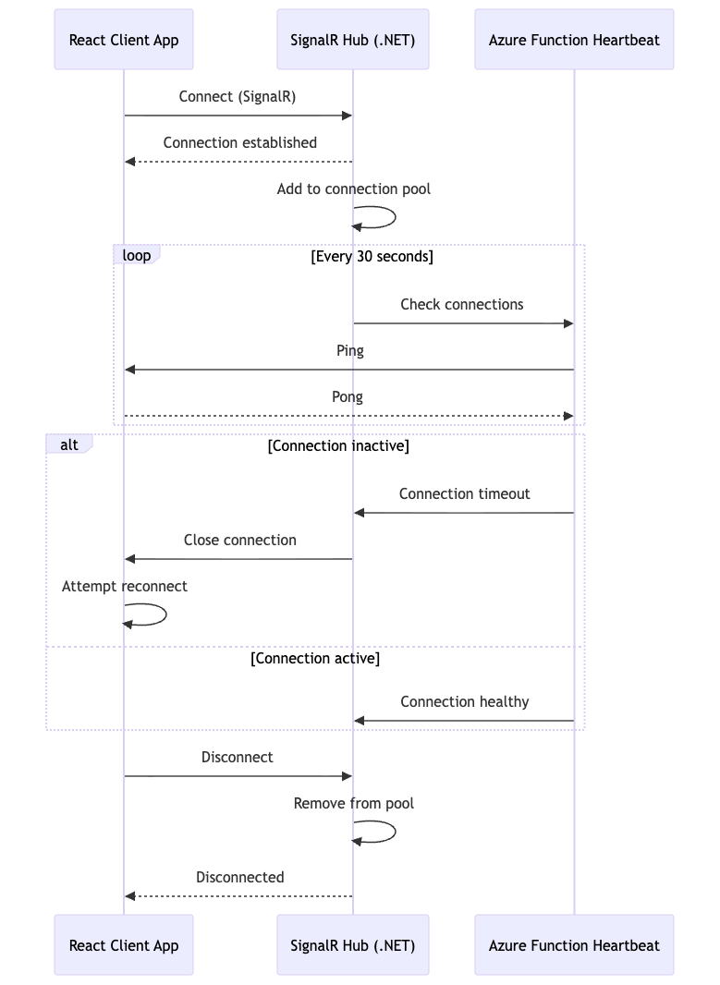

Data Aggregation Flow
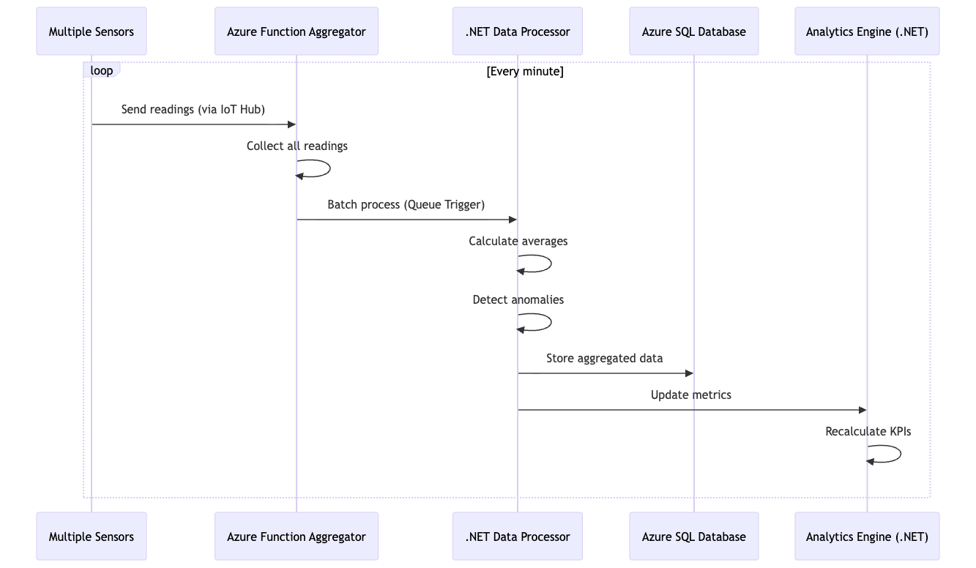
Multi-Device Grouping Flow
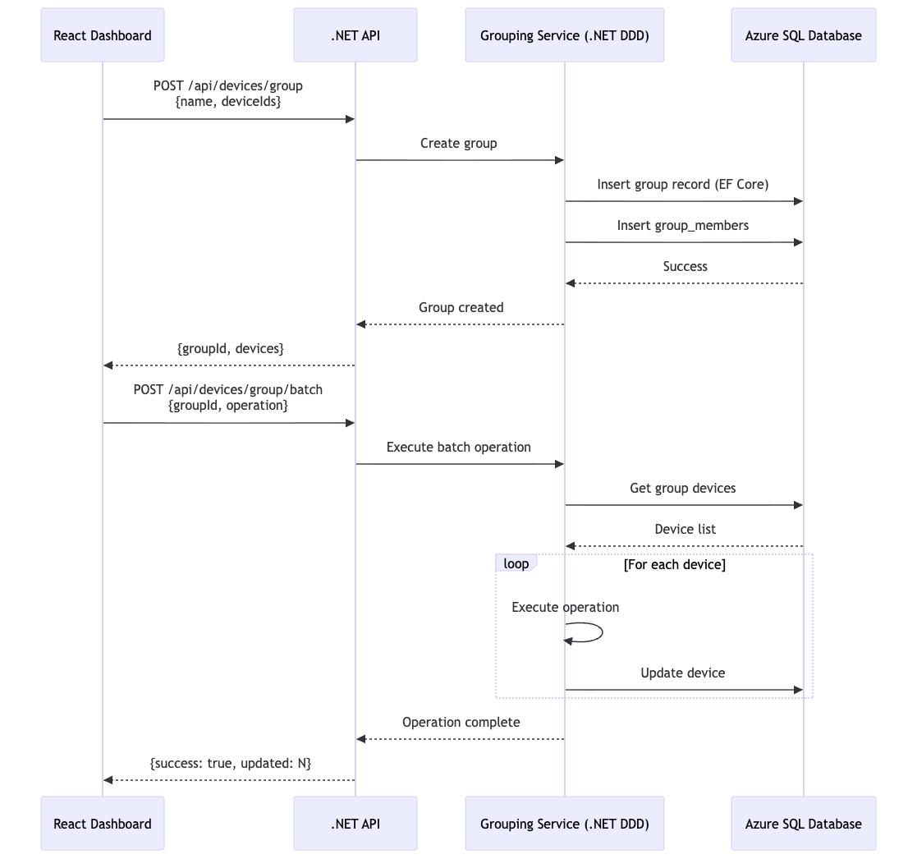

API Response Format

Success Response
JSON
{
"data": {
"id": 1,
"name": "Device 1",
"status": "online"
}
}

Error Response
JSON
{
"error": {
"code": "UNAUTHORIZED",
"message": "Invalid credentials"
}
}

Rate Limiting
- API Endpoints: 100 requests per minute per user (via Azure API Management)
- SignalR/WebSocket: 1000 messages per minute per connection
- File Upload: 10 MB per file, 100 MB per day

Timeout Configuration
Operation | Timeout
REST API Call | 30 seconds
SignalR Connection | 60 seconds
Database Query | 10 seconds
File Upload | 5 minutes
Device Firmware Download | 30 minutes

API Versioning
• Current Version: v1
• Endpoint Pattern: /api/v1/[controller]
• Backward Compatibility: Maintained for 2 major versions
• Deprecation Notice: 6 months before removal

