Smart Factory IoT - System Architecture

Overview
The Smart Factory IoT platform is a comprehensive real-time industrial monitoring and control system. It features a React (Vite) frontend for interactive dashboards, a .NET backend for robust API and business logic, and integration with Azure IoT Hub for device connectivity. The architecture emphasizes robustness through microservices and containerization, security via Microsoft Entra ID and RBAC, extensibility using DDD and SOLID principles, and high performance with caching, asynchronous processing, and optimized queries.

System Architecture Diagram
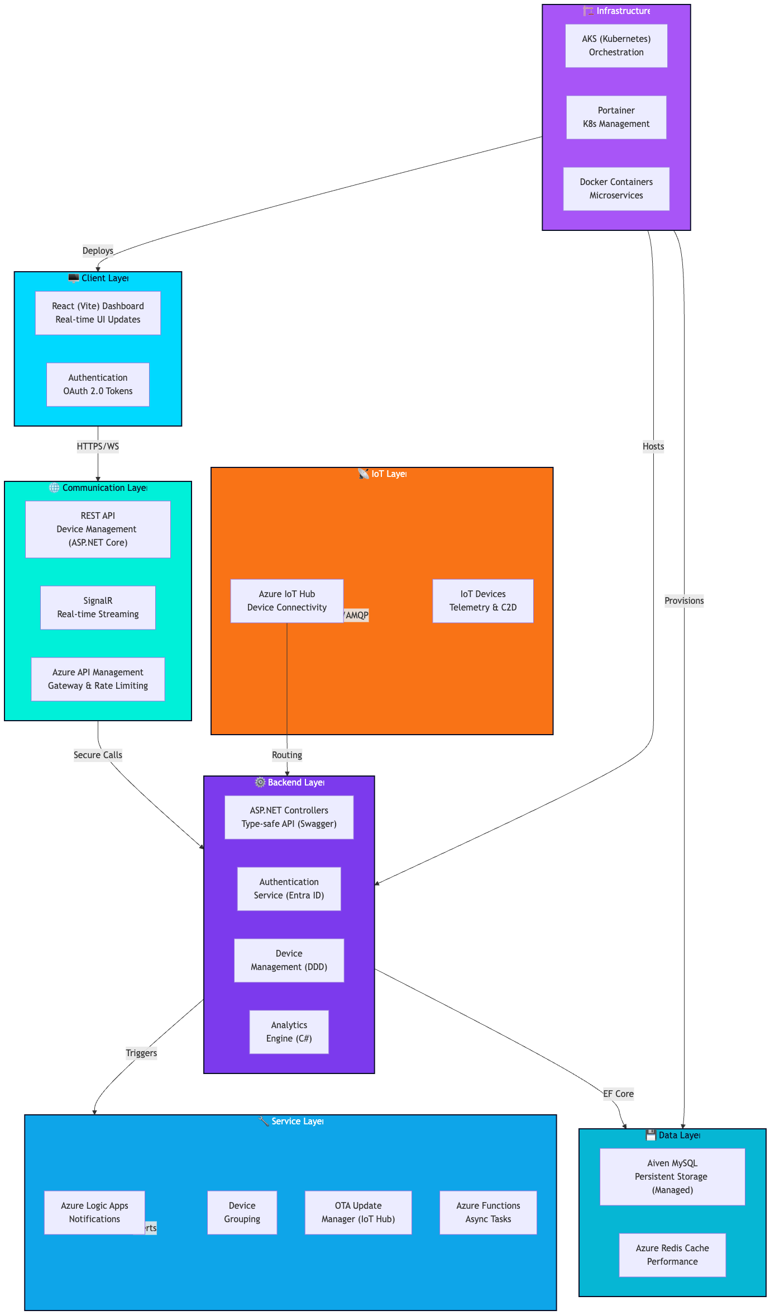

Component Details

Client Layer
- React (Vite) Dashboard: Interactive UI for real-time monitoring, built with Vite for fast development and bundling. Deployed to Vercel for serverless hosting and automatic scaling.
- Authentication: OAuth 2.0 with Microsoft Entra ID for secure token-based auth.
- State Management: React Context + TanStack Query for data fetching.

Communication Layer
- REST API: Device CRUD operations, configuration via ASP.NET Core Web API.
- SignalR: Real-time sensor data streaming integrated with Azure SignalR Service for scalability.
- Azure API Management: Gateway for API versioning, rate limiting, and security policies.

Backend Layer
- ASP.NET Controllers: Centralized API endpoint management with OpenAPI/Swagger for documentation.
- Authentication Service: Entra ID integration with JWT validation.
- Device Management: CRUD operations and device grouping using Domain-Driven Design (DDD) aggregates and repositories.
- Analytics Engine: OEE calculations and reporting in C#.

Data Layer
- Aiven MySQL: Managed MySQL database for persistent storage, provisioned via Terraform for cross-cloud compatibility.
- Azure Redis Cache: In-memory caching for high-performance reads.

Service Layer
- Azure Logic Apps: Workflow automation for notifications (Email/SMS via Microsoft Graph API).
- Device Grouping: Batch operations and analytics aggregation.
- OTA Update Manager: Firmware updates via Azure IoT Hub direct methods.
- Azure Functions: Serverless async tasks for data processing, triggered by IoT Hub or queues.

IoT Layer
- Azure IoT Hub: Central hub for device registration, telemetry ingestion (D2C), commands (C2D), and twins for metadata sync.
- IoT Devices: Connect via MQTT/AMQP, with SDKs for secure communication.

Infrastructure Layer
- Docker: Containerization of .NET backend microservices for portability.
- Kubernetes (AKS): Orchestration for backend services, ensuring high availability and auto-scaling.
- Portainer: Web-based management for Kubernetes clusters, simplifying operations.

Data Flow

Real-time Monitoring Flow
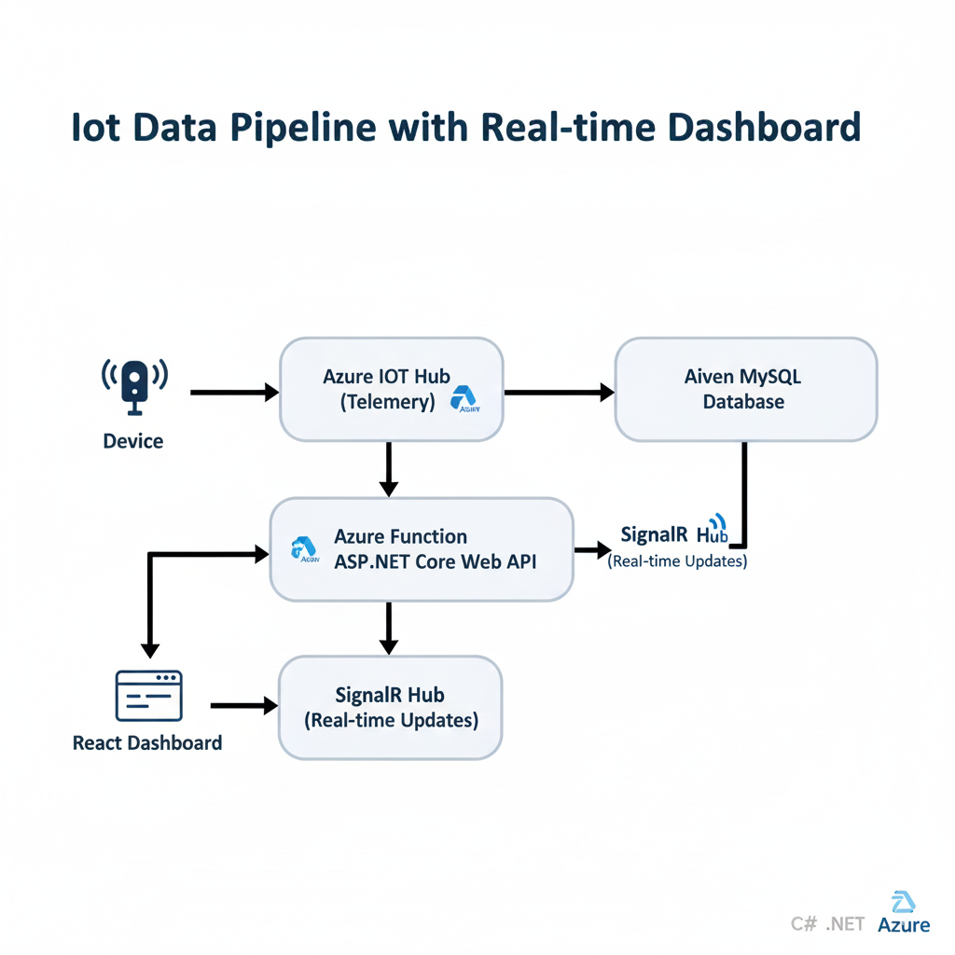

1. Ingestion Layer (The Entry Point)
- Device: A physical sensor or simulated device (e.g., Raspberry Pi, ESP32) that collects data like temperature or pressure.
- Azure IoT Hub: The central cloud gateway. It manages secure, bi-directional communication and ingests the raw telemetry data stream via protocols like MQTT, AMQP, or HTTPS.

2. Processing & Storage Layer (The Brain)
- Azure Function / ASP.NET: A "hot-path" processor. As telemetry arrives at the IoT Hub, it triggers a serverless Azure Function or a .NET worker.
- Aiven MySQL: The processed data is persisted here. This managed database serves as the "Source of Truth" for historical reporting and data integrity.

3. Presentation Layer (The User Experience)
- SignalR: This is the "Live" connector. Instead of the browser asking for new data, SignalR pushes the latest telemetry values from the backend to the user instantly.
- React Dashboard: The front-end UI. It receives SignalR updates to refresh charts and gauges in real-time, providing an interactive, low-latency monitoring experience.

Alert Flow
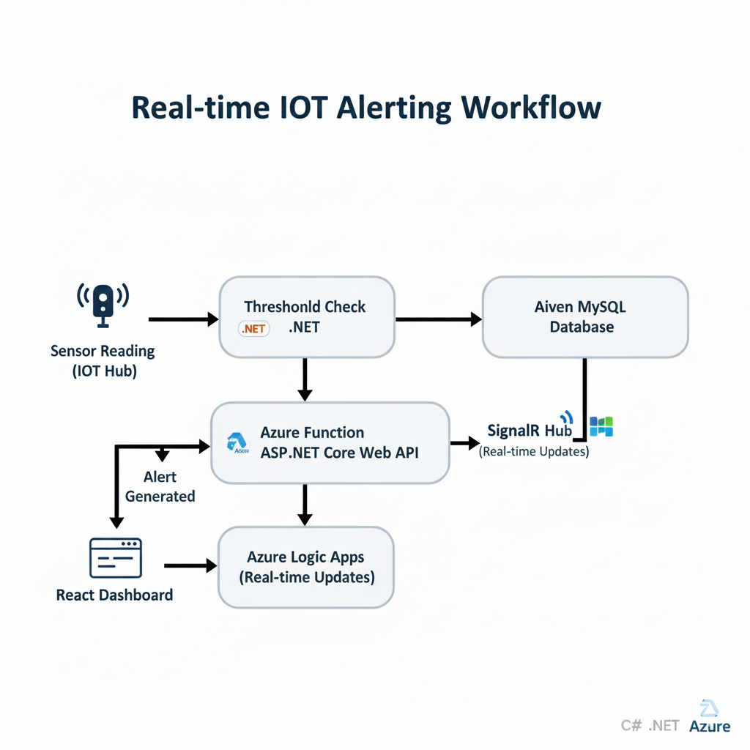

1. Detection & Evaluation
- Sensor Reading (IoT Hub): Telemetry data (like temperature, vibration, or pressure) is ingested from the edge into Azure IoT Hub.
- Threshold Check (.NET): A .NET background worker or Azure Function processes the stream in real-time. It compares the incoming values against predefined business rules (e.g., Is the temperature $> 100°C$?).

2. Orchestration & Logic
- Alert Generated: If the threshold is breached, the .NET service generates an alert payload.
- Azure Logic Apps: This acts as the workflow engine. Instead of hard-coding notification logic, Logic Apps receives the alert and manages the "if-this-then-that" flow. It can handle retries, branching logic (e.g., if critical, page the manager; if warning, send an email), and connections to hundreds of services.

3. Communication & Delivery
- User Notification (Graph API): The final step uses the Microsoft Graph API to deliver the message directly into the user’s ecosystem. This typically manifests as:
  - A Microsoft Teams channel message.
  - An Outlook email.
  - A calendar event or a task created in Microsoft To Do.

Technology Stack
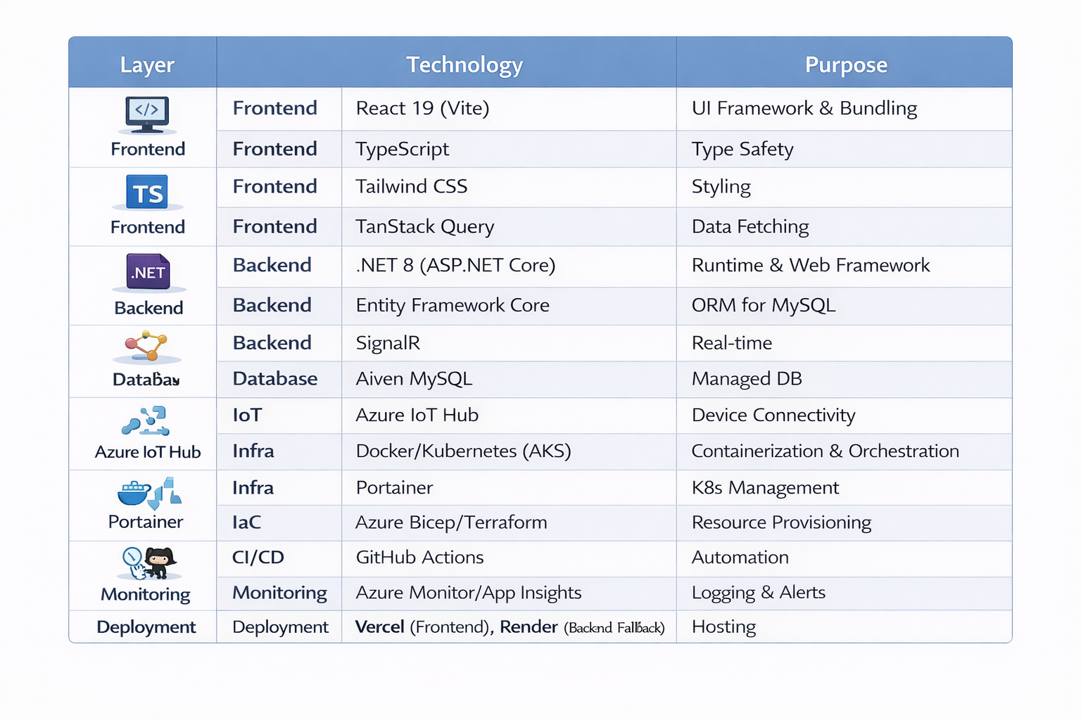

Key Features

1. Real-time Monitoring
- Live device status via SignalR and IoT Hub.
- Telemetry streaming with low latency.
- Automatic reconnection.

2. Alert Management
- Threshold-based alerts processed in .NET.
- Severity levels with Logic Apps notifications.

3. Device Management
- CRUD with grouping, using DDD.
- Health monitoring via IoT Hub.

4. Analytics
- OEE calculation in C#.
- Historical analysis with cached queries.

5. Firmware Management
- OTA via IoT Hub and Blob Storage.
- Status tracking.

Security Architecture

Authentication
- OAuth 2.0 with Entra ID.
- Secure hashing (bcrypt) as fallback.
- Token refresh.

Authorization
- RBAC integrated with Entra ID.
- Managed Identities for services.
- Policy-driven access.

Data Protection
- TLS encryption.
- Key Vault for secrets.
- Input validation.

Scalability Considerations

Horizontal Scaling
- Stateless .NET services in K8s.
- IoT Hub scaling units.
- Redis for distributed caching.

Performance Optimization
- EF Core query optimization.
- AsyncAPI for events.
- Load balancing in AKS.

Monitoring & Observability
- App Insights for telemetry.
- Log Analytics for queries.
- Alerts via Azure Monitor.

Deployment Architecture
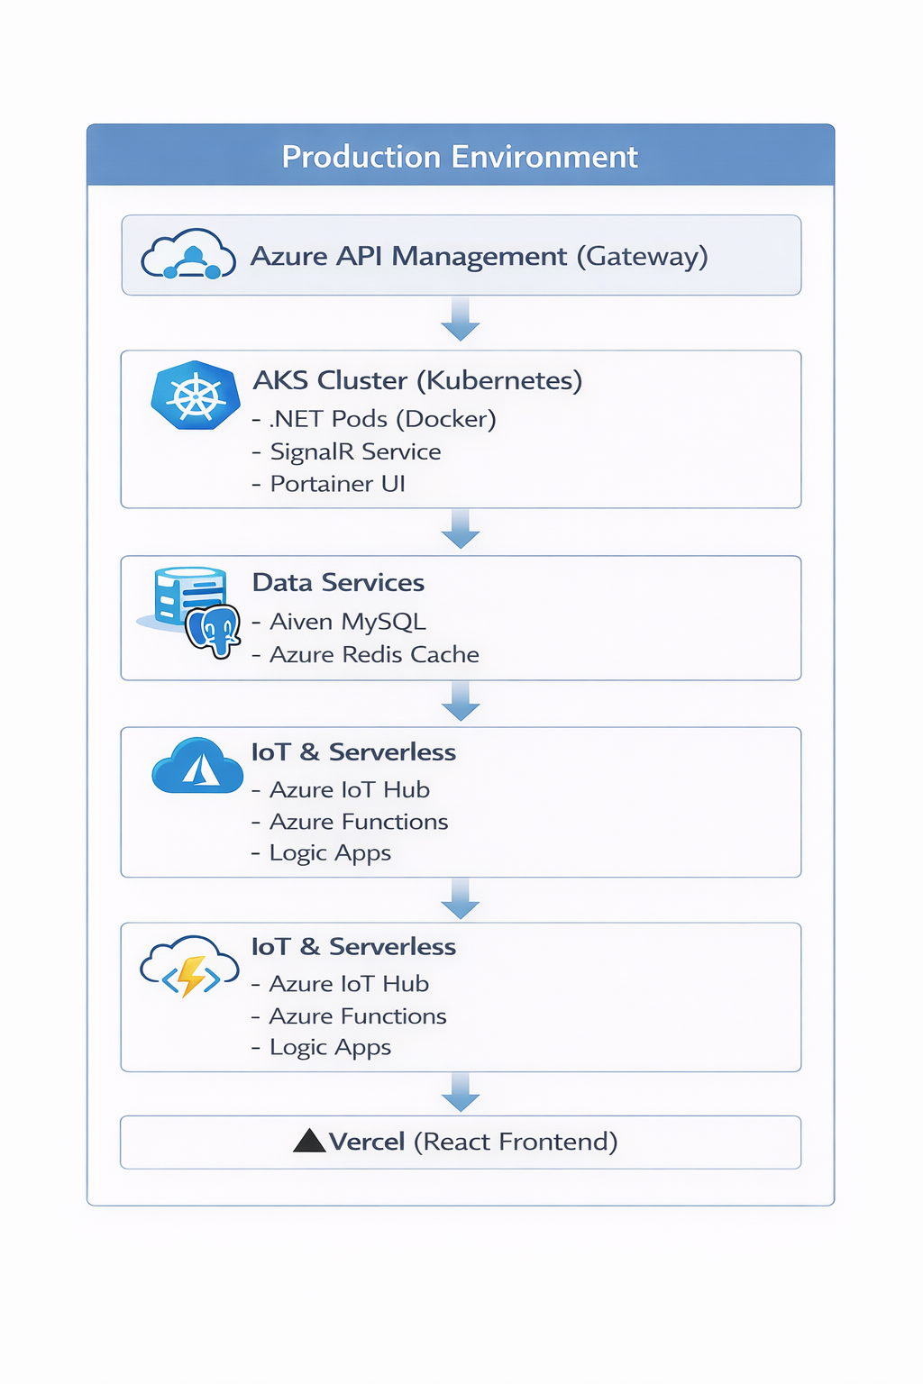
IaC: Provisioned with Bicep for Azure resources, Terraform for Aiven DB.
CI/CD: GitHub Actions for build/deploy, with TDD via xUnit.

Development Workflow
- Local Development
  - Docker Compose for local stack.
  - Vite dev server.
  - EF Core migrations.
- Testing
  - Unit/Integration tests (xUnit).
  - TDD practices.
  - Swagger for API testing.
- Deployment
  - GitHub Actions pipeline.
  - Bicep/Terraform apply.
  - Kubernetes manifests via Helm.

SOLID Principles Implementation

Single Responsibility
- Each microservice/Domain has one purpose.

Open/Closed
- Extensible via interfaces.

Liskov Substitution
- Consistent behaviors.

Interface Segregation
- Focused interfaces.

Dependency Inversion
- DI in .NET.

Performance Metrics
- API Response Time: < 200ms (p95)
- SignalR Latency: < 100ms
- Dashboard Load Time: < 2s
- DB Query Time: < 50ms (p95)
- Memory Usage: < 512MB/pod
- CPU Usage: < 50% under load

Future Enhancements
- Machine Learning
  - Azure ML for predictive maintenance.
- Advanced Analytics
  - Power BI integration.
- Integration
  - Kafka for event streaming.
- Scalability
  - Multi-region AKS.

