Title
Spatiotemporally Adaptive Gaussian Mixture Modelling (ST-GMM) Framework for SAR-based Long-term Surface Water Monitoring

Authors
Milon Bokshi ^{1, 2,} *
Drubo Paul ¹
Md. Munir Mahmud ²
Md. Nurul Islam ³

Affiliations
¹ ICT, GIS & Remote Sensing Division, Institute of Water Modelling (IWM), Dhaka, Bangladesh
² Institute of Remote Sensing and GIS, Jahangirnagar University, Dhaka, Bangladesh
³ Department of Geography & Environment, Jahangirnagar University, Dhaka, Bangladesh

* Corresponding author
Email: mbokshi45@gmail.com

Spatiotemporally Adaptive Gaussian Mixture Modelling (ST-GMM) Framework for SAR-based Long-term Surface Water Monitoring

Highlights
- Developed a spatiotemporally adaptive ST-GMM framework for SAR water mapping.
- Processed 7,891 scenes using district-month probabilistic threshold.
- Achieved 92.55% classification accuracy across diverse hydrological settings.
- Surface water expanded ~2.4-fold from the dry to monsoon season.
- Quantified stable long-term national water dynamics during 2015–2025.

ABSTRACT
Study region: Bangladesh, located within the Ganges–Brahmaputra–Meghna (GBM) delta, is one of the world’s largest and most hydrologically dynamic monsoonal floodplain systems.
Study focus: This study develops a Spatiotemporally Adaptive Gaussian Mixture Model (ST-GMM) framework for monthly surface water monitoring using Sentinel-1 Synthetic Aperture Radar (SAR) imagery. The framework dynamically models land–water backscatter distributions to derive spatially and temporally adaptive classification thresholds under varying hydro-climatic conditions.
New hydrological insights for the region: The proposed ST-GMM framework provides an adaptive, training-independent approach for nationwide surface water monitoring by combining Sentinel-1 SAR observations with district-specific probabilistic threshold estimation, enabling reliable mapping under persistent monsoon cloud cover. The framework achieved an overall classification accuracy of 92.55% (κ = 0.85) and demonstrated strong cross-sensor agreement with Sentinel-2 observations, confirming its applicability across diverse hydrological settings. Application of the framework revealed a pronounced seasonal hydrological cycle, with surface water extent expanding approximately from ~15,900 km² during the dry season to ~37,500 km² during the monsoon. Despite substantial inter-annual fluctuations associated with major flood events, no significant long-term trend in national surface water extent was detected during 2015–2025, indicating that the overall hydrological regime remained stable while experiencing considerable seasonal and spatial redistribution of surface water. The framework provides a scalable and transferable methodology for long-term hydrological monitoring in cloud-prone monsoonal and deltaic environments.

Keywords: SAR, Surface Water, Adaptive Thresholding, Spatiotemporal Modelling, Remote Sensing

Introduction
Surface water dynamics are a critical component of the global hydrological cycle, strongly influencing flood regulation, ecosystem stability, agricultural productivity, and climate adaptation across floodplains, wetlands, and deltaic environments worldwide. Accurate monitoring of surface water variability is therefore essential for sustainable water resource management and disaster-risk reduction. However, optical remote sensing in humid tropical and monsoonal regions is frequently constrained by persistent cloud cover during peak hydrological periods, limiting the reliability of long-term surface water observations (Uday et al., 2025; Li et al., 2021). Bangladesh, situated within the Ganges–Brahmaputra–Meghna (GBM) delta system, represents one of the world’s most hydrologically dynamic monsoonal landscapes and provides an ideal testbed for evaluating robust all-weather monitoring frameworks (Brammer, 2014; Gain et al., 2016; Masood et al., 2015).
Remote sensing remains the only feasible approach for systematic large-scale surface water monitoring. Optical sensors such as Landsat and Sentinel-2 have been widely applied for water mapping (Pekel et al., 2016; Pickens et al., 2020); however, their utility in cloud-prone environments is severely restricted during monsoon periods when atmospheric obstruction frequently exceeds 80% coverage (Singha et al., 2019; Uddin et al., 2019). Synthetic Aperture Radar (SAR), operating in the microwave spectrum, overcomes these limitations through all-weather, day–night imaging capability. Sentinel-1 C-band SAR, in particular, has emerged as a major global resource for operational hydrological monitoring due to its free accessibility, systematic acquisition strategy, and well-characterized backscatter response over water surfaces (Chini et al., 2019; Torres et al., 2012; Twele et al., 2016).

SAR-based water detection exploits the specular reflection properties of smooth water surfaces, which produce characteristically low radar backscatter relative to surrounding land. Numerous studies have demonstrated the effectiveness of VV-polarized thresholding for flood and water delineation (Bioresita et al., 2018; Martinis et al., 2009; Twele et al., 2016). However, most existing SAR applications remain event-specific, focusing primarily on short-term flood mapping rather than long-term hydrological variability, seasonal persistence, and inter-annual dynamics (DeVries et al., 2020). Recent advancements, including the NASA JPL Dynamic Surface Water Extent product (Huang et al., 2018) and automated recursive classification frameworks (Schlaffer et al., 2017; Schumann et al., 2010), further highlight the growing importance of operational SAR-based hydrological monitoring. Nevertheless, many existing approaches rely on static backscatter thresholds that inadequately capture seasonal variability caused by changes in vegetation phenology, soil moisture, wind conditions, and hydrological forcing. These limitations are particularly pronounced in monsoonal delta systems characterized by strong temporal variability in inundation patterns. Tran et al. (2022) recently demonstrated the utility of Sentinel-1 time-series for monitoring dynamic deltaic environments, further emphasizing the need for adaptive and transferable SAR monitoring frameworks.

This study addresses these methodological gaps by presenting a decadal Sentinel-1 SAR framework for adaptive surface water monitoring using a Spatiotemporally Adaptive Gaussian Mixture Model (ST-GMM). The proposed framework dynamically models land–water backscatter distributions to derive spatially and temporally adaptive thresholds under varying hydro-climatic conditions. Using Bangladesh as a challenging monsoonal deltaic testbed, this study aims to: (1) develop and evaluate a transferable probabilistic SAR-based water detection framework; (2) quantify seasonal and inter-annual surface water dynamics during 2015–2025. The study contributes an adaptive probabilistic framework for robust SAR water detection, the first decadal Sentinel-1 SAR surface water archive for Bangladesh, explicit cross-sensor benchmarking against optical baselines, and a fully reproducible cloud-based computational workflow.

Materials and methods

Study area
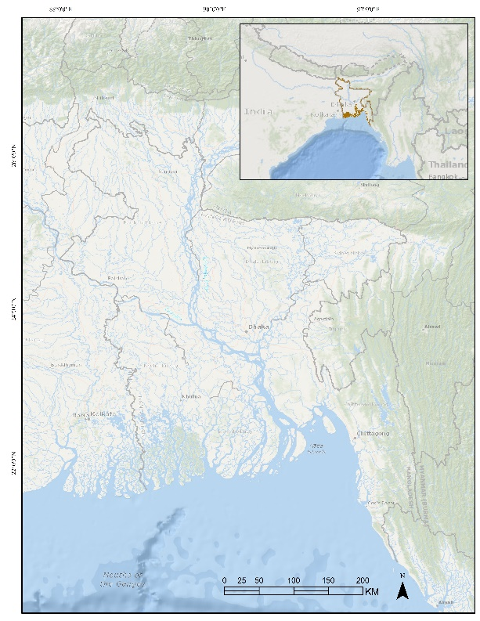
Bangladesh was selected as a representative monsoonal deltaic testbed for evaluating adaptive SAR-based surface water monitoring in cloud-prone hydrological environments. Located in South Asia between latitudes 20°34′ and 26°38′ N and longitudes 88°01′ and 92°41′ E, the country covers approximately 147,570 km² (Fig. 1). The landscape is characterized by low-relief topography, dense river networks, and extensive floodplains associated with the Ganges–Brahmaputra–Meghna (GBM) river system, the world’s largest delta complex. Elevation ranges from near sea level in the southern coastal region to approximately 1,000 m in the Chittagong Hill Tracts.
The hydro-climatic regime of Bangladesh provides an ideal environment for testing dynamic surface water monitoring frameworks due to strong seasonal variability in inundation patterns. The country experiences a tropical monsoon climate with four distinct hydrological seasons. The Dry Winter period (December–February) is characterized by limited rainfall and reduced river discharge, resulting in minimum surface water extent. The Pre-Monsoon season (March–May) involves increasing temperatures, convective storms, and gradual hydrological expansion. The Monsoon period (June–September) contributes approximately 70–80% of annual precipitation, generating peak river discharge and extensive floodplain inundation, while the Post-Monsoon season (October–November) is associated with progressive floodwater recession and contraction of seasonal water bodies. Persistent monsoon cloud cover and rapidly fluctuating hydrological conditions make the region particularly challenging for optical remote sensing–based monitoring (Azad et al., 2022; Khan et al., 2019).
Fig. 1. Study domain used for evaluating the ST-GMM adaptive SAR framework, showing the Ganges–Brahmaputra–Meghna (GBM) delta system, principal river networks, and regional hydrological context of Bangladesh.
Administratively, Bangladesh comprises 8 divisions and 64 districts. This administrative hierarchy was utilized to support multi-scale spatial analysis of surface water dynamics and to evaluate the adaptability of the proposed ST-GMM framework across diverse hydrological settings.

Data and processing
Sentinel-1 C-band SAR Ground Range Detected (GRD) imagery acquired in Interferometric Wide (IW) swath mode was used as the primary data source to support scalable surface water monitoring in hydrologically dynamic and cloud-prone environments.
Although both VV and VH polarizations have been widely applied for surface water mapping (Schlaffer et al., 2022; Xing et al., 2018), VV generally provides stronger and more stable contrast between open water and surrounding land surfaces because smooth water bodies produce very low co-polarized backscatter under most acquisition conditions (Souza et al., 2022; Bioresita et al., 2018; Twele et al., 2016). Moreover, the proposed ST-GMM framework was designed to estimate adaptive thresholds directly from district-specific backscatter histograms, for which the unimodal land–water separability of VV data provides a more consistent statistical basis than VH across heterogeneous landscapes. The use of a single polarization also reduces computational complexity while ensuring methodological consistency for nationwide processing of the complete Sentinel-1 archive. The cloud-based workflow enables a transferable implementation across large floodplain and deltaic regions without requiring local high-performance computing infrastructure (Gorelick et al., 2017).
However, a small number of district-month observations were unavailable because of incomplete Sentinel-1 acquisitions during the early stage of the mission (December 2015–February 2016). Rather than estimating missing values, these observations were excluded from the corresponding monthly analyses. The proportion of missing data was negligible relative to the complete 2015–2025 archive and therefore did not affect the assessment of long-term surface water dynamics or trend analyses. To strictly quantify classification veracity independent of self-referential benchmarks, probability-based stratified random sampling was employed across diverse seasonal and hydrological conditions over the 11-year archive. A set of 500 geographically target hubs were evenly dispersed across historical permanence classes, yielding 4,310 spatially referenced field observations representing W ∈ {0,1}. These points were post-stratified using the long-term Water Occurrence Layer (F) to ensure representative coverage across hydrological extremes: 700 points (16.2%) represented permanent water bodies (F ≥ 10), 700 points (16.2%) represented semi-permanent water (5 ≤ F < 10), and 528 points (12.3%) represented ephemeral floods (F < 5), while 2,382 points (55.3%) represented diverse non-water land cover. Baseline fidelity was established via unambiguous on-site verification and multi-temporal cross sensor confirmation.

Framework and analysis
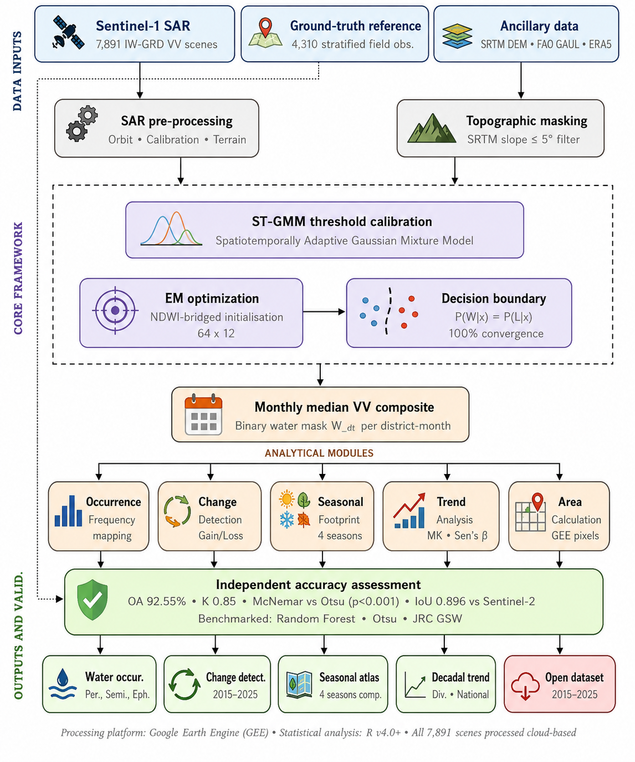
The proposed analytical framework (Fig. 2) was designed to support scalable long-term SAR-based surface water monitoring in hydrologically dynamic and cloud-prone environments. The framework consists of five main components: (1) SAR-based monthly surface water detection using seasonally adaptive thresholds; (2) annual water occurrence frequency mapping; (3) inter-annual change detection for gain, loss, and stable classifications; (4) seasonal water footprint analysis; and (5) decadal trend assessment across multiple spatial scales.
Fig. 2. The methodological framework for adaptive SAR-based surface water monitoring using the Spatiotemporally Adaptive Gaussian Mixture Model (ST-GMM). The workflow integrates Sentinel-1 SAR observations, topographic constraints, probabilistic threshold calibration, and multi-scale analytical modules to support long-term hydrological monitoring under highly dynamic and cloud-prone conditions.

2.3.1 ST-GMM formulation
To determine the optimal diagnostic threshold (τ) following the extraction of monthly regional backscatter histograms, we propose a Spatiotemporally Adaptive Gaussian Mixture Model (ST-GMM) framework. Unlike static or globally fixed thresholding approaches, the ST-GMM dynamically models land–water backscatter distributions (σ⁰) for each spatial unit (d) and temporal interval (t), enabling adaptive threshold estimation under highly variable hydro-climatic conditions commonly observed in monsoonal floodplains, wetlands, and deltaic systems. The bimodal distribution is modeled as a mixture of two Gaussian components, a choice specifically adopted to represent the fundamental land–water contrast while avoiding the over-parameterization associated with higher-order mixtures. The probabilistic state of the ST-GMM for each district and month is described by the parameter vector:
$θ_{dt}​=\{π_{W,dt}​, μ_{W,dt}​,{ σ}_{W,dt}^{2}​, { π}_{L,dt}​, μ_{L,dt}​,{ σ}_{L,dt}^{2}​ ​\}$ (1)
where π denotes the class mixing coefficient (prior probability), μ is the Gaussian mean, and σ² is the Gaussian variance. The subscripts W and L represent the water and land classes, respectively, while d and t denote the district and month. The corresponding probability density function of the two-component Gaussian mixture is defined as:

$p\left(x ∣ θ_{dt}​\right)=π_{W,dt}​N(x;μ_{W,dt}​,{ σ}_{W,dt}^{2}​)+{ π}_{L,dt}​N(x;μ_{L,dt}​,{ σ}_{L,dt}^{2}​)$ (2)

where N (x; μ, σ²) denotes a Gaussian probability density function with mean μ and variance σ².
The objective of the framework is binary surface water detection rather than detailed characterization of individual land-cover scattering mechanisms. Consequently, the mixture model is designed to identify the principal land-water decision boundary, which forms the basis for adaptive threshold estimation. Moreover, Gaussian Mixture Models were selected because they provide a probabilistic representation of the dominant bimodal backscatter distribution associated with water and non-water surfaces while allowing efficient parameter estimation through the Expectation-Maximization algorithm. Unlike non-parametric approaches such as Kernel Density Estimation (KDE), which require bandwidth selection and do not directly yield parametric decision boundaries (Amadori et al., 2021; Bhageerath et al., 2024), GMMs provide an explicit statistical framework for estimating adaptive classification thresholds from the intersection of component probability density functions. Alternative parametric distributions, such as Gamma mixtures, are better suited to modelling strictly positive and highly skewed variables, whereas terrain-corrected Sentinel-1 backscatter expressed in decibels generally exhibits approximately Gaussian behavior within the dominant water and non-water populations (Pappas et al., 2021; Tan, 2024).
Application of the ST-GMM framework to the complete Sentinel-1 archive produced adaptive threshold estimates for all 768 district-month combinations (64 districts × 12 months). The resulting thresholds exhibited clear seasonal variability, reflecting shifts in land–water backscatter separability under contrasting hydro-climatic conditions. Lower threshold values were generally observed during peak monsoon periods when extensive inundation enhanced the distinction between open water and surrounding land surfaces, whereas dry-season conditions produced comparatively higher thresholds due to reduced water extent and increased landscape heterogeneity.

2.3.2 Adaptive threshold estimation
Optimization of the bi-modal mixture is achieved over three logical steps; initially, we implement an initialization via the NDWI bridge. In hydrologically dynamic floodplain and deltaic environments where class priors (π_{dt}) vary substantially between dry and wet seasons —unsupervised EM often suffers from initialization bias. This is resolved by an auxiliary probabilistic bridge where independent NDWI-derived masks from cloud-free optical windows (Sentinel-2 MSI) are utilized exclusively to initialize the starting class means (µ_{k,dt}) and mixing coefficients (π_{k,dt}). The NDWI masks are used solely to provide initial parameter estimates and are not used for classification, threshold determination, model training, accuracy assessment, or validation. Consequently, they do not contribute directly to the final surface water map. During the iterative EM optimization, the initial NDWI-derived parameters are progressively updated until convergence; thus, the final Gaussian distributions and adaptive threshold are determined exclusively from the Sentinel-1 backscatter statistics. The adaptive initialization strategy improves framework stability and transferability across heterogeneous hydrological landscapes exhibiting strong seasonal variability. Subsequently, the EM algorithm refines the Gaussian parameters using SAR backscatter alone, ensuring the study remains operationally robust during the monsoon season when cloud cover consistently exceeds 80%, rendering optical masking ineffective (Martinis et al., 2009). The iterative process alternates between the Expectation (E) step—computing posterior probabilities for each pixel—and the Maximization (M) step—updating the distribution parameters based on the high-resolution radar return. Finally, for optimal threshold determination, the diagnostic threshold (τ_{dt}) is mathematically defined as the precise intersection point of the fitted land and water Gaussian density curves. This decision boundary is physically justified by the fundamental contrast between the specular reflection of smooth water surfaces (low backscatter) and the diffuse scattering of land surfaces (high backscatter), representing the point of minimum total classification error. This intersection approach is consistent with established operational standards and earlier automated SAR thresholding frameworks (Bioresita et al., 2018; Martinis et al., 2009). The EM optimization procedure successfully converged for all district-month combinations, yielding a complete monthly threshold archive for the 2015–2025 period.
Binary surface water masks (W_{dt}) were derived by integrating the probabilistic ST-GMM threshold (τ_{dt}) with a deterministic physical constraint to eliminate systemic geographic artifacts. Specifically, topographical slope (ξ) derived from the SRTM 30m DEM was utilized to neutralize radar-shadowing effects— common in high-relief terrains where radar shadowing may mimic low-backscatter water signatures (Bioresita et al., 2018).

$W_{dt}=\{_{0 otherwise}^{1 if σ_{dt}^{0} ≤ τ_{dt} and ξ ≤ 5^{o} }$ (3)

where W_{dt} is the binary water classification (1 = water, 0 = non-water), $σ_{dt}^{0}$ is the backscatter coefficient (dB), $τ_{dt}$is the adaptive district-month threshold estimated from the ST-GMM. A pixel is classified as water only when $σ_{dt}^{0} ≤ τ_{dt} and ξ ≤ 5^{o}$, thereby minimizing false detections over steep terrain. σ⁰ denotes the Sentinel-1 radar backscatter coefficient and should not be confused with the Gaussian variance σ² used in Equation (1).
Application of the classification rule produced monthly binary surface water masks for all 64 districts throughout the 2015–2025 observation period. The integration of adaptive SAR thresholds with the terrain constraint effectively reduced false water detections associated with radar shadow and steep topography, particularly within the Chittagong Hill Tracts. Visual inspection and validation analyses confirmed that the slope filter preserved major river channels, floodplains, wetlands, and coastal water bodies while minimizing topographically induced commission errors.
By strictly clamping inundation to pixels where the local slope does not exceed 5◦, the framework filters out topographical commission errors while preserving true estuarine and floodplain features. This logical integration ensures that only geographically plausible depressions are mapped as water bodies, combining backscatter-based evidence with terrain-based constraints for maximum classification reliability.

2.3.3 Surface water characterization
Following the generation of the primary binary mask time-series, three higher-order analytical products were derived to characterize the hydrological regime. Initially, annual water occurrence frequency (F) was computed as the cumulative count of months in which a pixel was classified as surface water:

$F=\sum_{m=1}^{12}{W_{m}}$ (4)

where F ranges from 0 (never water) to 12 (water in all months). Based on this metric, surface water bodies are analytically partitioned into three hydrologically meaningful persistence classes. Permanent water (F ≥ 10) corresponds primarily to major river channels, large lakes, and deep reservoirs that maintain open water in nearly every month of the year; the threshold is set slightly below 12 to explicitly account for occasional missing satellite acquisitions or wind-induced surface roughening that may momentarily disrupt an otherwise perennial water signature. Semi-permanent water (5 ≤ F < 10) captures dynamic floodplains, seasonal wetlands, and shallow water bodies that are inundated for a significant portion of the year but recede during the dry season. Ephemeral water (F < 5) delineates zones of temporary inundation driven primarily by intense monsoon precipitation and transboundary discharge pulses, including shallow agricultural flooding and short-duration ponding.

2.3.4 Change detection and seasonal analysis
Change maps were generated for two key temporal windows; the full decadal comparison (2015 vs. 2025) and a more recent five-year comparison (2019 vs. 2024). To quantify surface water flux across the decadal observation period, inter-annual change mapping between two years was implemented for four distinct categories: Gained, Lost, Stable, and No Water. Pixels are classified as Gained, representing water expansion due to geomorphological shifting or land subsidence, or Lost, indicating contraction attributable to embanking or siltation. Stable pixels confirm the persistence of water bodies across the interval. Furthermore, the maximum seasonal footprint (W_{S}) was computed as the pixel-wise union of detections across the four hydrological seasons relevant to Bangladesh: Dry Winter (December– February), Pre-Monsoon (March–May), Monsoon (June–September), and Post-Monsoon (October– November).

Finally, the cumulative surface water area was quantified using pixel-based areal computation:

$A=\sum_{i=1}^{n}{W_{i . }a_{i}}$ (5)

where W_{i} is the binary water classification of pixel i and a_{i} is the geodetically corrected pixel area (m²) derived from the native GEE ee.Image.pixelArea() function. This approach accounts for latitude-dependent pixel size distortions and ensures that the final areal estimates, converted to km², remain geodetically consistent over the full 2015–2025 time-series. To bridge potential scale discrepancies between the pixel exports and histogram-derived estimates, a multiplicative calibration scalar was derived via regression against representative monthly outputs and applied uniformly to the decadal archive.

2.3.5 Trend analysis
Decadal-scale trends in surface water extent were assessed at national and divisional scales. For each administrative unit, annual peak water area (July) was computed for 2015–2025 using Linear Regression. The Modified Mann-Kendall test (Hamed and Rao, 1998), which accounts for temporal autocorrelation, was additionally applied to assess trend significance without distributional assumptions, a widely applied approach for hydrological time-series analysis in dynamic floodplain systems (Shen et al., 2019; Wilson and Atkinson, 2007). Sen’s slope estimator (Sen, 1968) was used to derive robust trend magnitudes with 95% confidence intervals. The Kruskal Wallis test was employed to evaluate statistical significance of seasonal differences in water extent. Inter-annual variability was quantified using the coefficient of variation (CV%) for each month. To account for potential scale discrepancies between the GEE pixel based exports (250m) and histogram-derived areas (100m), a multiplicative calibration ratio was computed by regressing five representative months (January, February, May, July, September 2015) against direct GEE reduction outputs; this single scalar correction was then uniformly applied to all computed areas. All statistical analyses were performed in R v4.5.2 using the trend package (R Core Team, 2024). Statistical significances was assessed at α = 0.05.

Validation and benchmarking strategy
The performance of the proposed ST-GMM framework was evaluated using three complementary strategies designed to assess classification accuracy, cross-sensor consistency, and methodological suitability. First, a probability-based stratified random sampling scheme was employed to generate an independent validation dataset representing diverse hydrological conditions across Bangladesh. A total of 4,310 spatially referenced observations were distributed among permanent water, semi-permanent water, ephemeral water, and non-water classes to ensure balanced representation of varying inundation regimes. Reference locations were verified through field observations conducted between 2023 and 2025, supplemented by contemporaneous high-resolution imagery and cloud-free Sentinel-2 observations where field access was not feasible. Classification performance was evaluated using a confusion matrix from which Overall Accuracy (OA), Producer's Accuracy (PA), User's Accuracy (UA), and Cohen's kappa coefficient (κ) were computed. While OA and κ provide overall measures of classification performance, PA and UA were additionally calculated to quantify omission and commission errors for each surface water class.
Second, to evaluate spatial consistency between radar- and optical-derived water products, monthly ST-GMM surface water masks were compared with Sentinel-2 NDWI composites generated from cloud-free observations during corresponding periods. Cross-sensor agreement was quantified using pixel agreement and the Intersection over Union (IoU) metric, providing an independent assessment of the spatial correspondence between the SAR-derived classifications and optical reference datasets.
Finally, the proposed framework was benchmarked against two widely adopted surface water mapping approaches representing unsupervised and supervised classification paradigms. Automatic Otsu thresholding was applied to Sentinel-1 VV backscatter histograms using identical spatial domains and temporal periods, while a Random Forest classifier was implemented using the same Sentinel-1 observations to provide a supervised reference. Comparative evaluation was performed over representative hydrological settings, including floodplain, wetland, and urban environments, using identical validation datasets and performance metrics to ensure a consistent assessment of methodological performance and transferability.

Results

Classification accuracy and benchmarking
The proposed ST-GMM framework demonstrated high classification accuracy across diverse hydrological environments in Bangladesh (Table 1). Validation against 4,310 field-verified observations yielded an Overall Accuracy (OA) of 92.55% with a Cohen's kappa coefficient (κ) of 0.85, indicating strong agreement between the classified surface water maps and reference observations.

Table 1
Stratified validation design, binary confusion matrix, and classification accuracy of the ST-GMM framework. Validation samples were selected using four persistence strata to ensure representative sampling across diverse hydrological conditions.
Validation component | Category / Metric | Value
Stratified validation sample (n = 4,310) | Permanent water (F ≥ 10) | 700 (16.2%)
 | Semi-permanent water (5 ≤ F < 10) | 700 (16.2%)
 | Ephemeral water (F < 5) | 528 (12.3%)
 | Non-water | 2,382 (55.3%)
Binary confusion matrix | True Positive (Water → Water) | 1,866
 | False Negative (Water → Land) | 62
 | False Positive (Land → Water) | 259
 | True Negative (Land → Land) | 2,123
Class-specific accuracy | Producer's Accuracy – Water | 96.78%
 | User's Accuracy – Water | 87.81%
 | Producer's Accuracy – Non-water | 89.13%
 | User's Accuracy – Non-water | 97.16%
Overall performance | Overall Accuracy (OA) | 92.55%
 | Cohen's Kappa (κ) | 0.85

To further evaluate spatial consistency, monthly ST-GMM classifications were compared with Sentinel-2 NDWI-derived surface water maps generated from corresponding cloud-free periods. The comparison achieved a pixel-level agreement of 97.9% with an Intersection over Union (IoU) of 0.896, demonstrating strong correspondence between SAR-derived and optical water products despite differences in sensor characteristics and acquisition conditions. These results indicate that the adaptive thresholding framework reliably captures the spatial distribution of surface water while overcoming the limitations of optical observations during cloud-prone monsoon periods.
The performance of ST-GMM was further benchmarked against conventional Otsu thresholding and a supervised Random Forest (RF) classifier using representative floodplain, wetland, and urban environments (Fig. 3). ST-GMM consistently outperformed Otsu thresholding by adapting classification thresholds to local and seasonal backscatter distributions, thereby reducing omission and commission errors associated with fixed histogram-based thresholding.
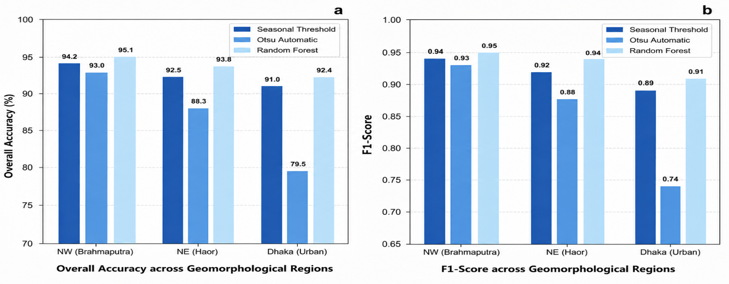
Fig. 3. Comparative performance evaluation of the ST-GMM framework across representative geomorphological regions. (a) Overall classification accuracy (%) and (b) F1-score comparison between the proposed seasonal adaptive thresholding framework, Otsu automatic thresholding, and Random Forest classification across the Brahmaputra floodplain, Haor wetlands, and urban environments.

Spatiotemporal variability and persistence patterns
The study domain exhibits a pronounced and consistent seasonal hydrological cycle characteristic of monsoonal deltaic environments. Mean monthly surface water area expands from a dry-season minimum of ∼15,900 km² (December– February) to a monsoon peak of ∼37,500 km² (July– August), representing a ∼2.4-fold seasonal amplitude. Transition months, particularly May and June (CV = 21.5% and 16.6%), display the highest inter-annual variability, reflecting the unpredictable timing of monsoon onset and the sensitivity of the early-season landscape to pre-monsoon precipitation spikes (Fig. 4).
Fig. 4. Monthly surface water cycle over the past decade in Bangladesh shows a temporal variability. This temporal characteristic is influenced by the surface water dynamics that includes precipitation and upstream flow.

Annual water occurrence frequency mapping further reveals the spatial logic of this variability. Permanent water bodies (F ≥ 10), which maintain open water for at least 10 months of the year, cover 3.4% of the national area and are primarily localized along the major Ganges– Brahmaputra–Meghna river corridors and deep-water Haor depressions. In contrast, ephemeral water bodies (F < 5) characterize 29.2% of the country, illustrating the extensive spatial footprint of temporary seasonal inundation typical of large floodplain systems (Fig. 5).
Fig. 5. Inter-annual variability of surface water extent during 2015–2025 derived from the ST-GMM Sentinel-1 SAR framework. Results demonstrate pronounced seasonal hydrological variability (Linear trend: -300.9 km²/yr; R2= 0.028, p= 0.620). and flood-driven inter-annual fluctuations despite the absence of a statistically significant long-term national trend (Linear trend: -30.4 km²/yr; R2= 0.003, p= 0.871).

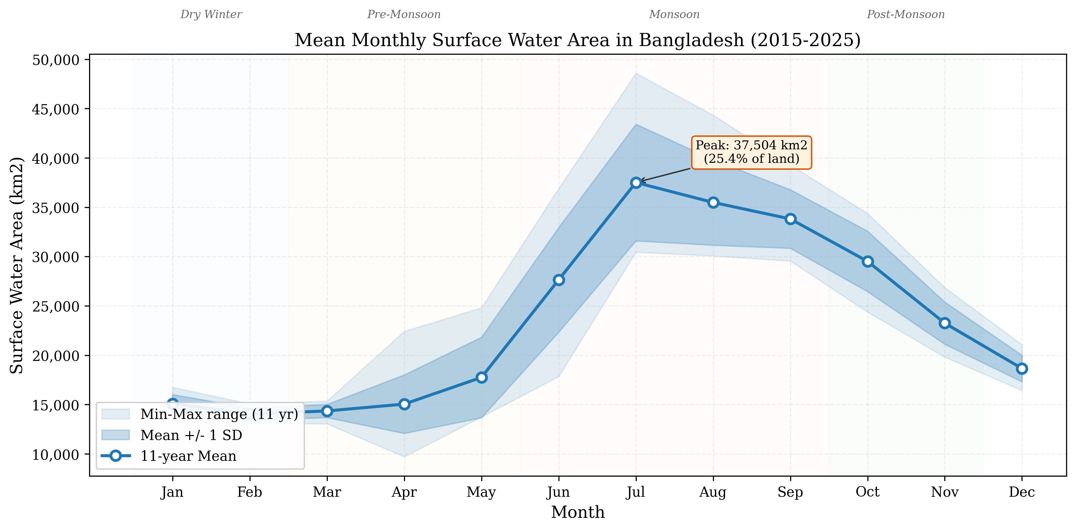
Long-term redistributive patterns and decadal trends
Analysis of surface water flux over the 2015–2025 period highlighting the capability of the framework to resolve subtle hydrological redistribution patterns over decadal timescales. Change detection analysis indicates that 21.5% of the 2025 monsoon water area represents newly gained inundation compared to 2015, while 26.5% of the original 2015 footprint was lost (Table 2). This spatially heterogeneous shifting is concentrated in active estuarine zones and reflects the geomorphological dynamism inherent in a mega-delta (Fig. 6).

Table 2
Decadal Surface Water Area Trends by Division (July, 2015–2025).
Division | Linear Trend (km²/yr) | Sen’s Slope (km²/yr) | Status
Barisal | -32.5 | -30.8 | Stable-Negative
Chittagong | -28.1 | -25.6 | Decreasing
Dhaka | -45.6 | -47.2 | Decreasing
Khulna | -30.4 | -32.1 | Decreasing
Mymensingh | +5.9 | +5.2 | Stable-Increase
Rajshahi | -145.2 | -151.4 | Largest Negative Trend
Rangpur | -15.8 | -14.3 | Stable
Sylhet | -9.2 | -7.8 | Stable
National Total | - 300.9 | -342.4 | Stable (p = 0.76)
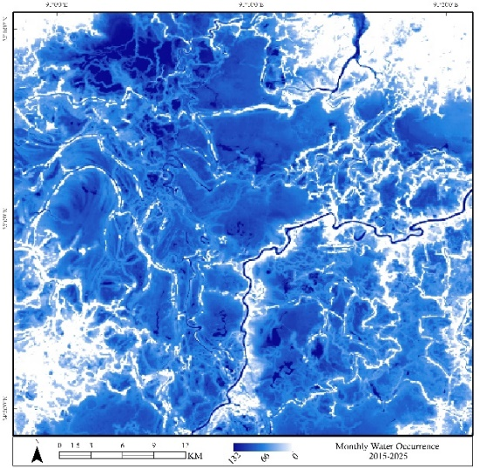
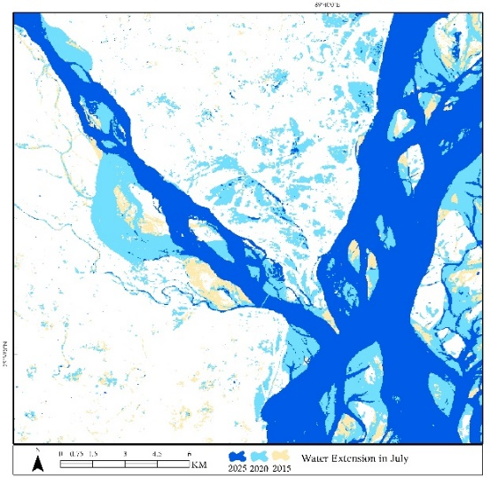
Fig. 6. (a) Monthly water occurrence in Haor wetland in northwestern basin and (b) lateral shifting of the Teesta river at the confluence.
a
b

At the national integration level, the Modified Mann-Kendall test detected no statistically significant monotonic trend in annual peak water extent (τ = −0.091, p = 0.76). Sen’s robust slope estimator indicates a non-significant negative tendency of −342.4 km²/yr, but with a 95% confidence interval ([−2,067, +1,087] km²/yr) that includes zero. This p-value (p = 0.76) reflects the Mann-Kendall rank-based assessment of monotonic trend strength, whereas a standard linear regression (which assumes a constant rate of change) yields a similar but distinct p-value (p = 0.62), both confirming the lack of statistical significance. Divisional analysis reveals that Rajshahi exhibited the largest negative trend, likely due to intensified groundwater-based irrigation and agricultural expansion in the Barind Tract, while other regions like Rangpur and Sylhet remained statistically stable. These findings indicate that while individual years exhibit substantial flood-driven variability (e.g., 2017, 2020), the broader decadal hydrological baseline remained statistically stable (Fig. 7)
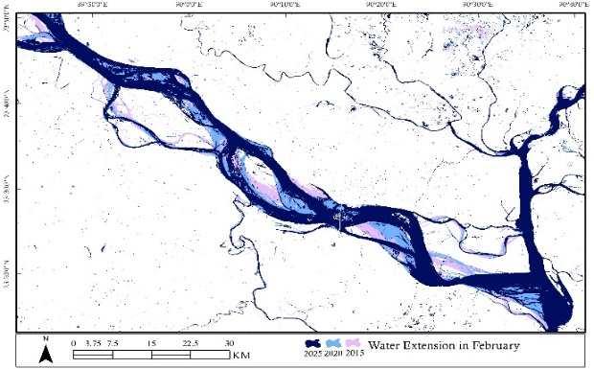
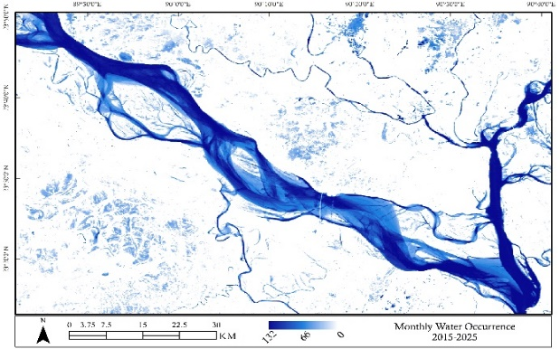
Fig. 7. February (a) water extents and Monthly (b) water occurrence of the Padma river
a
b

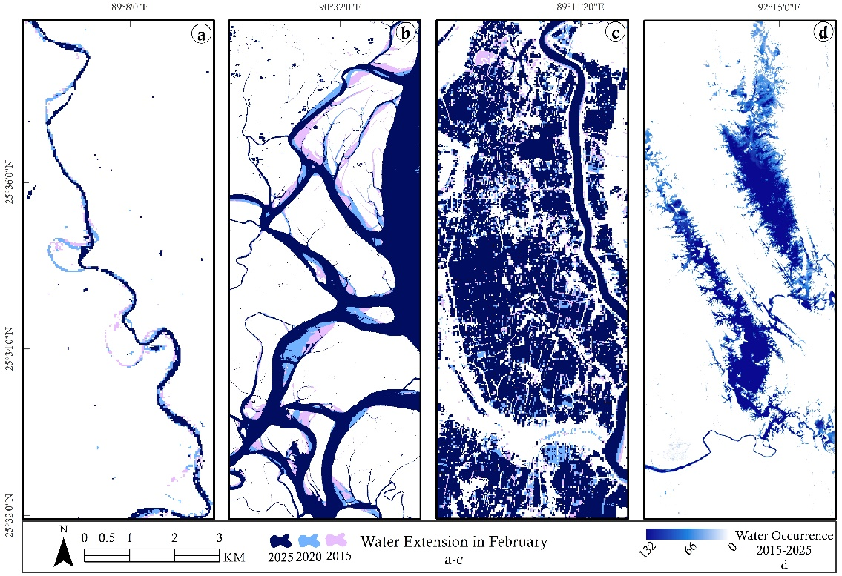
The reliability and operational applicability of the ST-GMM framework were quantified through multi-scale benchmarking against field-verified reference datasets (Supplementary Tables S8–S10). Statistical uncertainty of the mapped water extent was quantified using error propagation derived from the confusion matrix, yielding a highly restricted margin of ±0.65%, affirming the overall reliability of the multi-year spatial statistics.
Fig. 8. Different surface water dynamic scenarios; (a) Jamuneshwari river, (b) leftbank of the Lower Meghna, (c) salt field in Satkhira and (d) the Kaptai lake in Rangamati hill tract.

Discussion

Performance of the ST-GMM framework
The seasonally adaptive threshold approach offers several advantages, including computational efficiency, reproducibility, physical interpretability, and intrinsic calibration to varying hydrological conditions. In Bhola (coastal delta), Otsu-derived thresholds showed excellent agreement with the GMM-calibrated thresholds, with a mean absolute difference of only 0.49 dB, confirming that the probabilistic mixture framework effectively identifies the optimal land–water separation boundary. In Sunamganj (Haor wetlands), Otsu diverged substantially during dry-season months (January–March: +2.9–4.6 dB) when minimal water coverage produced unimodal histograms, causing threshold segmentation within the dominant land class rather than between water and non-water surfaces. Dhaka (urban environment) exhibited systematic positive deviations (+2–7 dB) because high-backscatter urban surfaces dominated the histogram distribution, a well-recognized limitation of histogram-based thresholding in heterogeneous urban landscapes (Ticehurst and Karim, 2023).
Furthermore, the ST-GMM framework was comparatively benchmarked against both Otsu automatic thresholding and a supervised Random Forest (RF) classifier to assess methodological competitiveness and operational reliability. The ST-GMM significantly outperformed the unsupervised Otsu approach (χ² = 142.8, p < 0.001; McNemar’s test), while achieving performance comparable to the data-intensive RF baseline within 1.3%, despite requiring no training labels. Spatially, commission errors (FP) remained consistently low across all validation scenarios (≤60 pixels), whereas omission errors (FN) were slightly elevated in fragmented Haor depressions during dry-season conditions due to water bodies falling below the conservative −17 dB detection threshold.
However, the Random Forest classifier achieved marginally higher classification accuracy in several benchmark environments (Fig. 3), its implementation requires representative training samples, careful parameter tuning, and periodic retraining to maintain performance under changing environmental conditions. Such supervised approaches also depend on the availability of reliable labelled datasets that may not be consistently available over long temporal periods or across large geographic extents. In contrast, ST-GMM is a fully unsupervised framework that derives adaptive thresholds directly from the statistical properties of Sentinel-1 backscatter distributions without requiring training data. This considerably reduces the effort associated with data preparation while ensuring consistent processing.
The proposed ST-GMM framework employs a two-component Gaussian mixture model to represent the dominant backscatter contrast between water and non-water surfaces. The objective of the framework is binary surface water detection rather than detailed characterization of individual land-cover scattering mechanisms. Consequently, the mixture model is designed to identify the principal land-water decision boundary, which forms the basis for adaptive threshold estimation. While adding 3 or 4 components can sometimes marginally reduce statistical error by fitting minor terrain noise or soil moisture variations, it mathematically leads to severe overfitting. To further examine model complexity, Akaike (AIC) and Bayesian (BIC) Information Criterion analyses were conducted for representative hydrological settings (Supplementary Figure S1). Although heterogeneous environments such as vegetated wetlands, urban areas, and tidal zones may exhibit more complex backscatter distributions, these primarily contribute to within-class variability rather than altering the dominant separation between water and non-water pixels at the district scale.

Hydrological perspectives: basin dynamics and regional impacts
This study demonstrates that highly dynamic monsoonal floodplain systems can exhibit strong seasonal hydrological variability while maintaining relative long-term baseline stability. The analyzed surface water regime exhibited a pronounced seasonal amplitude, with an approximately 2.4-fold expansion from dry-season minimum to monsoon peak conditions. A Modified Mann–Kendall test applied to the national integration detected no statistically significant monotonic trend in surface water extent during 2015–2025 (τ = −0.091, p = 0.76, VIF = 1.04). Furthermore, Sen’s slope estimator indicated a non-significant negative tendency of −342.4 km²/year (95% CI: [−2,067, +1,087] km²/year). These findings suggest that despite increasing concern regarding climate-driven hydrological instability in monsoonal delta systems, no statistically significant long-term monotonic trend was detected during the Sentinel-1 observation period.

Crucially, this baseline decadal stability is punctuated by extreme inter-annual spikes corresponding to historically documented flood events, demonstrating the sensitivity of the SAR framework to real hydrological extremes. For instance, the pronounced peak observed in 2017 corresponds to severe transboundary flooding across the Brahmaputra basin (Ali et al., 2019). Similarly, the unprecedented decadal maximum observed in 2020 (approaching 48,577 km² in July) captures the prolonged monsoon floods that inundated more than one-third of Bangladesh during that year (Aziz et al., 2022; Shen et al., 2019). Localized anomalies in recent years further reflect severe flash flood events, including the 2022 northeastern Sylhet floods and the 2024 eastern Bangladesh floods (Hossain et al., 2019). The strong agreement between SAR-derived temporal anomalies and independently documented flood events provides confidence that the observed fluctuations represent genuine hydrological variability rather than classification artifacts.
The coefficient of variation analysis further reveals strong seasonal asymmetry in hydrological stability. Dry-season conditions (February–March; CV ≈ 4.4–4.7%) remained comparatively stable relative to monsoon and transitional periods (April–May; CV ≈ 19.7–23.0%), reflecting the inherently variable nature of monsoonal inundation processes. Such seasonal asymmetry has important implications for long-term hydrological monitoring, suggesting that dry-season observations may provide reliable baselines for change detection while wet-season analyses require greater consideration of inter-annual variability. Similar dynamics are likely relevant across many floodplain and monsoonal environments worldwide. Notably, an exceptional localized increase in water extent (~179 km²) was detected in Bagerhat district during January 2021, coinciding with synchronized aquaculture flooding cycles. This observation highlights the sensitivity of the ST-GMM framework to anthropogenic water-management activities in addition to natural hydrological forcing.
Change detection analysis reveals that although the aggregate national trend remained statistically non-significant, approximately 21.5% of the 2025 monsoon water extent represented newly gained inundation relative to 2015. This redistribution indicates that water bodies are shifting spatially—particularly within active estuarine zones of the Lower Meghna and the southwestern coastal belt—rather than undergoing uniform expansion or contraction. Such localized geomorphological redistribution is consistent with intra-deltaic dynamics reported in previous multi-decadal surface water studies (Pekel et al., 2016).
A critical finding of this decadal analysis is the pronounced decoupling between national-scale surface water extent and localized precipitation variability. Correlation analysis between peak July surface water extent (2015–2024) and national July precipitation derived from ERA5 reanalysis revealed a negligible and statistically non-significant relationship (r = 0.073, p = 0.84). This finding (supplementary)reinforces the broader hydrological understanding that large monsoonal delta systems are frequently governed more strongly by upstream transboundary discharge than by localized rainfall alone. In the Bangladesh context, over 92% of the GBM catchment lies outside national boundaries, emphasizing the dominant influence of basin-scale hydrological connectivity on seasonal inundation dynamics.

Conclusion
This decadal Sentinel-1 SAR analysis demonstrates that highly dynamic monsoonal floodplain systems can exhibit pronounced seasonal hydrological variability while maintaining relative long-term baseline stability. Using Bangladesh as a representative monsoonal deltaic testbed, the proposed Spatiotemporally Adaptive Gaussian Mixture Model (ST-GMM) framework successfully characterized a ~2.4-fold seasonal expansion in surface water extent while detecting no statistically significant monotonic national trend during 2015–2025 (τ = −0.091, p = 0.76; Mann–Kendall test).
The framework remains subject to several known physical and analytical limitations. Wind-induced roughening of water surfaces and emergent wetland vegetation can produce varying degrees of double-bounce and diffuse scattering, occasionally generating omission errors in shallow or fragmented water bodies. Future developments should therefore focus on integrating adaptive SAR backscatter frameworks with optical deep-learning fusion networks (e.g., Sentinel-1/Sentinel-2 U-Net architectures) to support automated real-time flood monitoring and enhanced sub-pixel hydrological characterization.
Despite these constraints, the ST-GMM framework highlights its potential applicability for long-term hydrological monitoring across cloud-prone tropical, monsoonal, and deltaic environments worldwide. Beyond the Bangladesh case study, the methodological contribution offers broader relevance for flood-risk assessment, wetland monitoring, climate adaptation planning, and transboundary water-resource management across hydrologically dynamic regions globally.

Data availability
The complete monthly surface water dataset (2015–2025), GMM threshold lookup table, validation point datasets, and all analysis code (GEE JavaScript, Python, and R scripts) are publicly available at https://github.com/DruboPaul/HydroSAR-BD . All Sentinel-1 GRD data were accessed through GEE at https://developers.google.com/earth-engine/ datasets/catalog/COPERNICUS_S1_GRD. JRC Global Surface Water data are available at https://global-surface-water.appspot.com/. Administrative boundaries were obtained from the FAO GAUL dataset via GEE. Python dependencies are specified in requirements.txt; R dependencies include trend, ggplot2, dplyr, tidyr, and scales.

Acknowledgment
The authors would like to thank the Google Earth Engine team for providing the cloud-based computational infrastructure used in this study. We also acknowledge the use of European Space Agency (ESA) Sentinel-1 SAR data.

Funding
This research did not receive any specific grant from funding agencies in the public, commercial, or not-for-profit sectors.

Declaration of Competing Interest
The authors declare no competing interests.

References
Ali, M.H., et al., 2019. Challenges for flood risk management in flood-prone Sirajganj region of Bangladesh. J. Flood Risk Manag. 12, e12450. https://doi.org/10.1111/jfr3.12450.
Amadori, M., Zamparelli, V., De Carolis, G., Fornaro, G., Toffolon, M., Bresciani, M., et al., 2021. Monitoring lakes surface water velocity with SAR: A feasibility study on Lake Garda, Italy. Remote Sens. 13 (12), 2293. https://doi.org/10.3390/rs13122293
Azad, M.A.K., Islam, A.R.M.T., Ayen, K., et al., 2022. Changes in monsoon precipitation patterns over Bangladesh and its teleconnections with global climate. Theor. Appl. Climatol. 148, 1261–1278. https://doi.org/10.1007/s00704-022-03996-8
Aziz, M.A., et al., 2022. Delineating flood zones upon employing synthetic aperture radar data for the 2020 flood in Bangladesh. Earth Syst. Environ. 6, 733–743. https://doi.org/10.1007/s41748-022-00295-0.
Bhageerath, Y.V.S., Babu, A.V.S., Durga Rao, K.H.V., Sreenivas, K., Chauhan, P., 2024. Enhancing precision of flood estimation in EOS-04 SAR imagery: A statistical approach. Geomatics Nat. Hazards Risk 15 (1). https://doi.org/10.1080/19475705.2024.2413910
Bioresita, F., et al., 2018. A method for automatic and rapid mapping of water surfaces from Sentinel-1 imagery. Remote Sens. 10, 217. https://doi.org/10.3390/rs10020217.
Brammer, H., 2014. Bangladesh's dynamic coastal regions and sea-level rise. Clim. Risk Manag. 1, 51–62. https://doi.org/10.1016/j.crm.2013.10.001.
Chini, M., et al., 2019. Sentinel-1 InSAR coherence to detect floodwater in urban areas: Houston and Hurricane Harvey as a test case. Remote Sens. 11, 107. https://doi.org/10.3390/rs11020107.
DeVries, B., et al., 2020. Rapid and robust monitoring of flood events using Sentinel-1 and Landsat data on the Google Earth Engine. Remote Sens. Environ. 240, 111664. https://doi.org/10.1016/j.rse.2020.111664.
Gain, A.K., Giupponi, C., Wada, Y., 2016. Measuring global water security towards sustainable development goals. Environ. Res. Lett. 11, 124015. https://doi.org/10.1088/1748-9326/11/12/124015.
Gorelick, N., et al., 2017. Google Earth Engine: Planetary-scale geospatial analysis for everyone. Remote Sens. Environ. 202, 18–27. https://doi.org/10.1016/j.rse.2017.06.031.
Hamed, K.H., Rao, A.R., 1998. A modified Mann-Kendall trend test for autocorrelated data. J. Hydrol. 204, 182–196. https://doi.org/10.1016/S0022-1694(97)00125-X.
Hossain, M.S., Cloke, H.L., Ficchì, A., Turner, A.G., Stephens, E., 2019. Attributing the 2017 Bangladesh floods from meteorological and hydrological perspectives. Hydrol. Earth Syst. Sci. 23, 1409–1429. https://doi.org/10.5194/hess-23-1409-2019.
Huang, C., et al., 2018. Automated extraction of surface water extent from Sentinel-1 data. Remote Sens. 10, 797. https://doi.org/10.3390/rs10050797.
Khan, M.H.R., Rahman, A., Luo, C., Kumar, S., Islam, G.A., Hossain, M.A., 2019. Detection of changes and trends in climatic variables in Bangladesh during 1988–2017. Heliyon 5 (3), e01268. https://doi.org/10.1016/j.heliyon.2019.e01268
Li, X., Ling, F., Cai, X., Ge, Y., Li, X., Yin, Z., et al., 2021. Mapping water bodies under cloud cover using remotely sensed optical images and a spatiotemporal dependence model. Int. J. Appl. Earth Obs. Geoinf. 103, 102470. https://doi.org/10.1016/j.jag.2021.102470
Martinis, S., et al., 2009. Towards operational near real-time flood detection using a split-based automatic thresholding procedure. Nat. Hazards Earth Syst. Sci. 9, 303–314. https://doi.org/10.5194/nhess-9-303-2009.
Masood, M., et al., 2015. Model study of the impacts of future climate change on the hydrology of Ganges–Brahmaputra–Meghna basin. Hydrol. Earth Syst. Sci. 19, 747–770. https://doi.org/10.5194/hess-19-747-2015.
Pappas, O.A., Anantrasirichai, N., Achim, A.M., Adams, B.A., 2021. River planform extraction from high-resolution SAR images via generalized gamma distribution superpixel classification. IEEE Trans. Geosci. Remote Sens. 59 (5), 3942–3955. https://doi.org/10.1109/TGRS.2020.3011209
Pekel, J.-F., Cottam, A., Gorelick, N., Belward, A.S., 2016. High-resolution mapping of global surface water and its long-term changes. Nature 540, 418–422. https://doi.org/10.1038/nature20584.
Pickens, A.H., et al., 2020. Mapping and sampling to characterize global inland water dynamics from 1999 to 2018. Remote Sens. Environ. 243, 111792. https://doi.org/10.1016/j.rse.2020.111792.
R Core Team, 2024. R: A Language and Environment for Statistical Computing. R Foundation for Statistical Computing, Vienna, Austria. Available at: https://www.R-project.org/.
Schlaffer, S., Chini, M., Giustarini, L., Matgen, P., 2017. Probabilistic mapping of flood-induced backscatter changes in SAR time series. Int. J. Appl. Earth Obs. Geoinf. 56, 77–87. https://doi.org/10.1016/j.jag.2016.12.003.
Schlaffer, S., Chini, M., Dorigo, W., Plank, S., 2022. Monitoring surface water dynamics in the Prairie Pothole Region of North Dakota using dual-polarised Sentinel-1 synthetic aperture radar (SAR) time series. Hydrol. Earth Syst. Sci. 26 (3), 841–860. https://doi.org/10.5194/hess-26-841-2022
Schumann, G.J.-P., et al., 2010. Near real-time flood wave approximation on large rivers from space: Application to the River Po, Italy. Water Resour. Res. 46, W05601. https://doi.org/10.1029/2008WR007672.
Sen, P.K., 1968. Estimates of the regression coefficient based on Kendall's tau. J. Am. Stat. Assoc. 63, 1379–1389. https://doi.org/10.1080/01621459.1968.10480934.
Shen, X., et al., 2019. Inundation extent mapping by synthetic aperture radar: A review. Remote Sens. 11, 879. https://doi.org/10.3390/rs11070879.
Singha, M., et al., 2019. High-resolution paddy rice maps in cloud-prone Bangladesh and northeast India using Sentinel-1 data. Sci. Data 6, 26. https://doi.org/10.1038/s41597-019-0036-3.
Souza, W.d.O., Reis, L.G.d.M., Ruiz-Armenteros, A.M., Veleda, D., Ribeiro Neto, A., Fragoso Jr., C.R., Cabral, J.J.d.S.P., Montenegro, S.M.G.L., 2022. Analysis of environmental and atmospheric influences in the use of SAR and optical imagery from Sentinel-1, Landsat-8, and Sentinel-2 in the operational monitoring of reservoir water level. Remote Sens. 14 (9), 2218. https://doi.org/10.3390/rs14092218
Tan, S., 2024. A new ground open water detection scheme using Sentinel-1 SAR images. Eur. J. Remote Sens. 57 (1). https://doi.org/10.1080/22797254.2023.2278743
Ticehurst, C.J., Karim, F., 2023. Towards developing comparable optical and SAR remote sensing inundation mapping with hydrodynamic modelling. Int. J. Remote Sens. 44, 3443–3468. https://doi.org/10.1080/01431161.2023.2211714.
Torres, R., Snoeij, P., Geudtner, D., et al., 2012. GMES Sentinel-1 mission. Remote Sens. Environ. 120, 9–24. https://doi.org/10.1016/j.rse.2011.05.028.
Tran, K.H., Menenti, M., Jia, L., 2022. Surface water mapping and flood monitoring in the Mekong Delta using Sentinel-1 SAR time series and Otsu threshold. Remote Sens. 14, 5721. https://doi.org/10.3390/rs14225721.
Twele, A., Cao, W., Plank, S., Martinis, S., 2016. Sentinel-1-based flood mapping: A fully automated processing chain. Int. J. Remote Sens. 37, 2990–3004. https://doi.org/10.1080/01431161.2016.1192304.
Uday, G., Purse, B.V., Kelley, D.I., Vanak, A., Samrat, A., et al., 2025. Radar versus optical: The impact of cloud cover when mapping seasonal surface water for health applications in monsoon-affected India. PLoS One 20 (1), e0314033. https://doi.org/10.1371/journal.pone.0314033
Uddin, K., Matin, M.A., Meyer, F.J., 2019. Operational flood mapping using multi-temporal Sentinel-1 SAR images: A case study from Bangladesh. Remote Sens. 11, 1581. https://doi.org/10.3390/rs11131581.
Wilson, M.D., Atkinson, P.M., 2007. The use of remotely sensed land cover to derive floodplain friction coefficients for flood inundation modelling. Hydrol. Process. 21, 3576–3586. https://doi.org/10.1002/hyp.6584.
Xing, L., Tang, X., Wang, H., Fan, W., Wang, G., 2018. Monitoring monthly surface water dynamics of Dongting Lake using Sentinel-1 data at 10 m. PeerJ 6, e4992. https://doi.org/10.7717/peerj.4992

