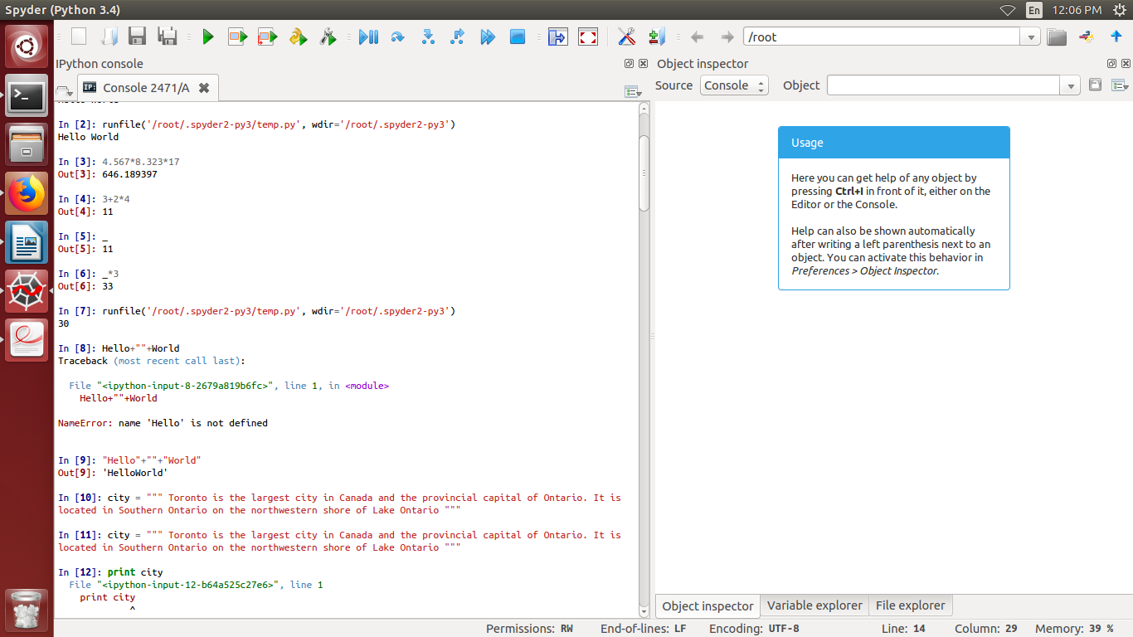
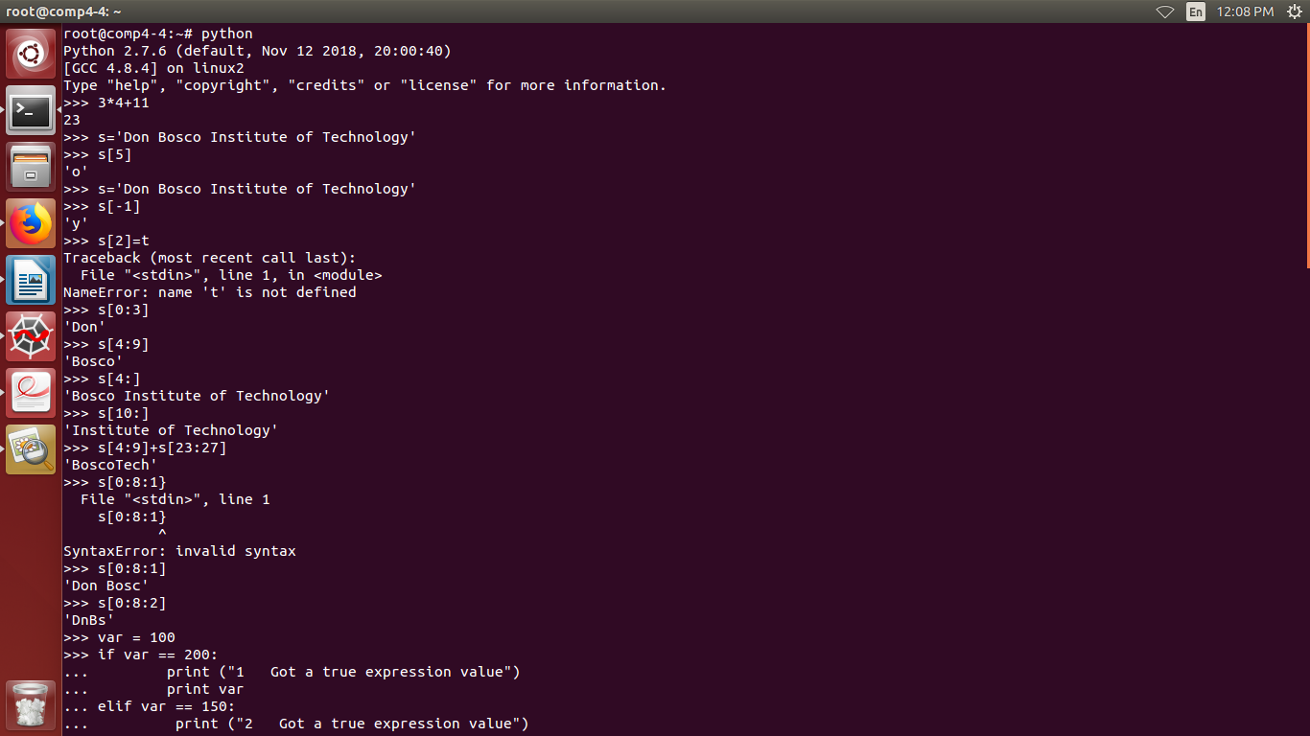

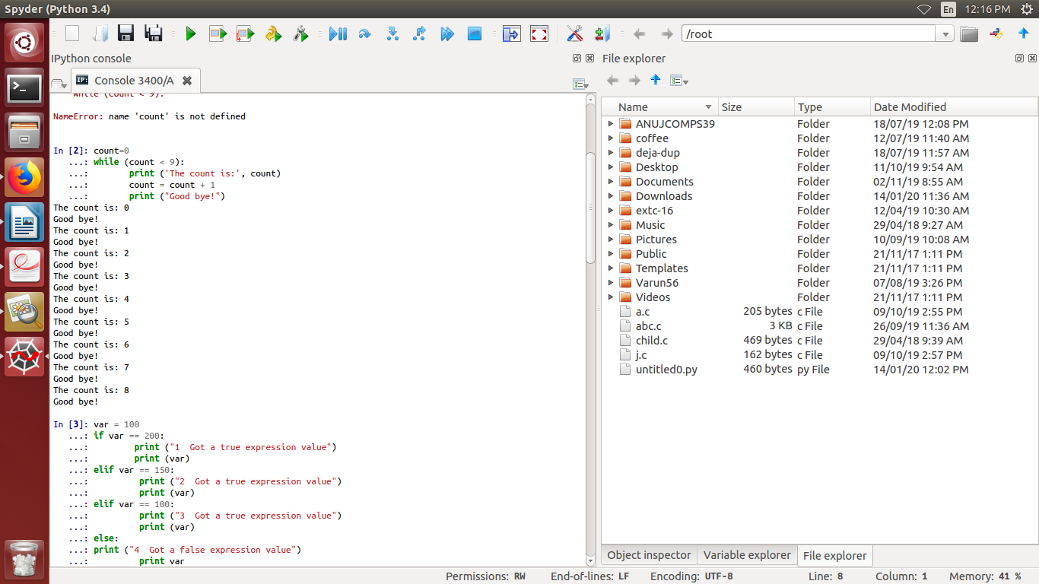
Exercise
2.
dist=input("Enter the distance in feet")
inches=dist*12
yards=dist/3.0
miles=dist/5280.0
print("The distance in inches is")
print(inches)
print("The distance in yards is")
print(yards)
print("The distance in miles is")
print(miles)
OUTPUT
Enter the distance in feet
12
The distance in inches is
144
The distance in yards is
4.0
The distance in miles is
0.00227272727273

3.kilo=input("Enter the weight in kilo")
pound= kilo*2.205
print("The weight in pound is")
print(pound)
pound1=input("Enter the weight in pound")
kilo1 = pound1*0.45351473
print("The weight in kilo is")
print(kilo1)

OUTPUT
root@comp4-4:~# python pound.py
Enter the weight in kilo 98
The weight in pound is
216.09
Enter the weight in pound 200
The weight in kilo is
90.702946
4.
length=input("Enter the length")
breadth=input("Enter the breadth")
height=input("Enter the height")
radius=input("Enter the radius")
base=input("Enter the base")
areac=3.14*radius*radius
arear=length*breadth
areat=0.5*base*height
print("Area of rectangle is")
print(arear)
print("Area of triangle is")
print(areat)
print("Area of circle is")
print(areac)
OUTPUT
root@comp4-4:~# python tri.py
Enter the length 12
Enter the breadth 12
Enter the height 12
Enter the radius 12
Enter the base 12
Area of rectangle is
144
Area of triangle is
72.0
Area of circle is
452.16
5.

hours=input("Enter the time in hours")
mins=input("Enter the time in mins")
days=input("Enter the time in days")
years=input("Enter the time in years")
secs=mins*60
secs1=hours*60*60
secs2=days*24*60*60
secs3=years*365*24*60*60
print("Time from mins to secs is")
print(secs)
print("Time from hours to secs is")
print(secs1)
print("Time from days to secs is")
print(secs2)
print("Time from years to secs is")
print(secs3)
OUTPUT
root@comp4-4:~# python time.py
Enter the time in hours 2
Enter the time in mins 24
Enter the time in days 200
Enter the time in years 2
Time from mins to secs is
1440
Time from hours to secs is
7200
Time from days to secs is
17280000
Time from years to secs is
63072000
6.
CORRECTED CODE
import random
health = 50
diff = input("Enter difficulty level:")
print("diff =",diff)
health_potion = random.randint(25,50)/diff
print("health_potion",health_potion)
health= health + health_potion
print("UR health potion=",health)
OUTPUT
Enter difficulty level: 12
Enter difficulty level: 12
('diff =', 12)
('health_potion', 3)
('UR health potion=', 53)
7.
pi=22/7
r =input ("Input the radius of the circle : ")
a=pi*r*r
print ("The area of the circle with radius ")
print (a)
OUTPUT
Input the radius of the circle : 15
The area of the circle with radius
675

