DUY TAN UNIVERSITY
INTERNATIONAL SCHOOL

SOFTWARE ARCHITECTURE DESIGN
DEEPFAKE FACE DETECTION SYSTEM

MENTOR :
FULL NAME | STUDENT ID
Nguyen Quang Bao | 29211158850
Nguyen Tan Duc | 29211156669
Nguyen Van Nguyen | 29211364802
Nguyen Ngoc Phuc | 29219051745
Dang Ngo Ngoc Viet | 29219064788

Da Nang, 7/2026

PROJECT INFORMATION

Project acronym | DFDS
Project Title | Deepfake Face Detection System
Start Date | 06 Jun 2026 | End Date | 15 July 2026
Lead Institution | International School, Duy Tan University
Project Mentor | MSc. Duc, Nguyen Manh.
Scrum master / Project Leader & contact details | Nguyen Van Nguyen
Partner Organization | Duy Tan University
Project Web URL
Team members | Name | Email | Contribution  %
1 | Nguyen Van Nguyen | nguyenvannguyen10@dtu.edu.vn | 100
2 | Nguyen Ngoc Phuc | nguyenngocphuc7@dtu.edu.vn | 100
3 | Thai Duc Thanh | thaiducthanh@dtu.edu.vn | 100

TABLE OF CONTENTS

1. Introduction 7
1.1. Purpose 7
1.2. Scope and Audience 7
1.3. Documents references 8
2. Project Statement 9
2.1. Project definition 9
2.2. Business needs/ User needs 10
2.3. Project Goal 11
3. Architectural Drivers 12
3.1. Functional Requirements 12
3.2. Quality Attributes 12
3.3. Constraints 16
4. System Context Diagram 20
5. Container Diagrams 22
6. Component Diagram 25
6.1. Frontend Web Application 25
6.2. Backend 1 (System Logic API) 30
6.3. Backend 2 (AI Model Service) 43
6.4. Database 1 54
6.5. Database 2 (Model Storage) 60
7. Code Diagrams 64
7.1. Backend 1 - Upload Management 64
7.2. Backend 1 - Detection Session 68
7.3. Backend 1 - Result & Moderator Review 73
7.4. Backend 2 - Input Processing 78
7.5. Backend 2 - Face Detection 82
7.6. Backend 2 - Deepfake Classification 86
7.7. Backend 2 - Model Management 91
8. Attribute-Driven Design 94
8.1. QA01 - Modifiability Design for Adding New Input Types without Changing the Core Classifier 94
8.2. QA02 - Modifiability Design for Updating the Deepfake Detection Model without Changing the Detection Flow 97
8.3. QA03 - Modifiability Design for Adding New Warning Levels to Detection results 101
8.4. QA04 - Performance Design for Short Video Deepfake Detection within 50 Seconds 104
8.5. QA05 - Performance Design for Handling Concurrent Detection Requests 107
8.6. QA06 - Security and Privacy Design for Real-time Screen Detection 111
9. Allocation – Deployment View 115

TABLE OF FIGURES

Figure 1: System Context Diagram 20
Figure 2. Module - Container Diagram 22
Figure 3. C&C - Container diagram 24
Figure 4. Module – Frontend Web Application 26
Figure 5. C&C - Frontend Web Application 29
Figure 6. Module - System Logic API 37
Figure 7. C&C - Backend 1 (System Logic API) 41
Figure 8. Module - Backend 2 (AI Model Service) 48
Figure 9. C&C - Backend 2 (AI Model Service) 52
Figure 10. Component level – Database 1 54
Figure 11. Component Level – Model Storage (Database 2) 60
Figure 12. Backend 1 – Upload Management 65
Figure 13. Sequence diagram - Backend 1 - Upload Management 68
Figure 14. Backend 1 - Detection Session 69
Figure 15. Sequence diagram - Backend 1 - Detection Session 73
Figure 16. Backend 1 - Result & Moderator Review 74
Figure 17. Sequence diagram - Backend 1 - Detection Session 78
Figure 18. Activity diagram - Backend 2 - Input Processing 82
Figure 19. Backend 2 – Face Detection 83
Figure 20. Sequence diagram - Backend 2 - Face Detection 86
Figure 21. Backend 2 - Deepfake Classification 86
Figure 22. Activity diagram - Backend 2 - Deepfake Classification 90
Figure 23. Backend 2 - Model Management 91
Figure 24. Sequence - Backend 2 - Model Management 94
TABLE OF TABLES

Table 1 Documents references 9
Table 2. Quality Attributes - Modifiability 12
Table 3. Quality Attributes – Modifiability 13
Table 4. Quality Attributes – Modifiability 13
Table 5. Quality Attributes – Performance 14
Table 6. Quality Attributes – Performance 14
Table 7. Quality Attributes – Security 15
Table 8. Business Constraints – Time Limitation 16
Table 9. Business Constraints – Resource Limitation 16
Table 10. Business Constraints – Feature Prioritization 16
Table 11. Business Constraints – Cost Minimization 16
Table 12. Business Constraints – Target Environment 16
Table 13. Business Constraints – Project Deliverables 16
Table 14. Business Constraints – Scope of Detection 17
Table 15. Business Constraints – Accuracy Expectation 17
Table 16. Technical Constraints – Application Type 18
Table 17. Technical Constraints – Backend APIs 18
Table 18.Technical Constraints – Core Technology 18
Table 19.Technical Constraints – Image Format Support 18
Table 20.Technical Constraints – Video Format Support 18
Table 21. Technical Constraints – Screen Capture Dependency 19
Table 22. Technical Constraints – Security Protocol 19
Table 23.Technical Constraints – Privacy Protection 19
Table 24. Technical Constraints – Computation 19
Table 25. Role & Responsibilities – Container level 23
Table 26. Role & Responsibilities – Component level – Backend1 - System Logic API 27
Table 27. Role & Responsibilities – Component level – API Application 39
Table 28. Role & Responsibilities – Component level – Backend2 - AI Model Service 50
Table 29. Users 54
Table 30. Roles 55
Table 31. Permissions 55
Table 32. User_roles 55
Table 33. Role_permissions 56
Table 34. Media_files 56
Table 35. Detection_sessions 56
Table 36. Detection_results 57
Table 37. Frame_results 57
Table 38. Review_labels 58
Table 39. Audit_logs 58
Table 40. System_errors 59
Table 41. Ai_models 60
Table 42. Model_versions 61
Table 43. Model_artifacts 61
Table 44. Model_metadata 62
Table 45. Active_model_versions 63
Table 46. Model_evaluation_reports 63
Table 47. Confusion_matrices 64
Table 48. Class/Interface & Responsibility – Upload Management 67
Table 49. Class/Interface & Responsibility – Detection Session 71
Table 50. Class/Interface & Responsibility – Result & Moderator Review 76
Table 51. Class/Interface & Responsibility – Input Processing 81
Table 52. Class/Interface & Responsibility – Face Detection 84
Table 53. Class/Interface & Responsibility – Deepfake Classification 88
Table 54. Class/Interface & Responsibility – Model Management 93

Introduction

Purpose
The purpose of this Architecture Design Document is to describe the software architecture of DrugTime, a medication reminder, drug-interaction safety, and AI-assisted care platform for Vietnamese patients. This document explains how the system is organized to support medication management, local reminder scheduling, drug-drug and drug-food interaction checking, family caregiver monitoring, and AI-based meal suggestions.
DrugTime is designed to help patients on multi-drug regimens avoid missed doses and unsafe drug or food combinations. To achieve this, the system separates the mobile application, the admin web dashboard, the backend API, the background job worker, and the shared database into independent architectural parts. This document records those parts, their responsibilities, and how they communicate with one another.
This document focuses on the architectural design needed to build and maintain the system. It describes the main actors, system boundary, containers, components, database structure, class design, and important processing flows such as medication entry, reminder scheduling, dose confirmation, interaction checking, family-alert delivery, and admin catalogue management.
The document also explains the architectural decisions that allow the system to evolve over time. Since Phase 2 features such as OCR prescription scanning, partner-pharmacy integration, Zalo reminders, and voice confirmation are planned after the MVP, the architecture is designed to support modifiability. The system should allow new reminder channels, new interaction data sources, and new Phase 2 features to be added with limited impact on existing components.

Scope and Audience

Documents references

Table 1 Documents references
No. | Reference
1 | Product Backlog Document
2 | Project Plan Document
3 | Database Design Document

Project Statement

Project definition
DrugTime is a mobile-first, AI-assisted software platform that helps patients on multi-drug regimens manage medications safely. It receives medication data through manual entry or on-device blister-pack scanning, schedules local dose reminders, checks entered medications against the Vietnamese drug catalogue for drug-drug and drug-food interactions, and generates AI-based meal suggestions.
The system includes three main types of users:
- Patient: adds medications, receives reminders, confirms doses, and looks up drug-drug and drug-food interaction warnings.
- Family member: links to a patient account, receives missed-dose alerts, and views the patient's adherence history.
- Admin: manages the medication and interaction catalogue, conducts DPIA, and processes data-deletion or consent-withdrawal requests.
The system is composed of several major architectural components. The Mobile App provides the user interface for medication entry, reminders, dose confirmation, adherence history, and interaction look-up for both Patients and Family members. The Admin Web Dashboard provides catalogue management and compliance oversight for Admins. The Backend API handles authentication, consent enforcement, medication management, interaction checking, family linking, and admin functions. The Background Job Worker handles scheduled reminders and catalogue synchronization, and triggers push notifications on a missed dose. The Database stores operational data such as patient profiles, medication schedules, adherence history, and catalogues.
For the blister-pack scan, the system does not send the packaging photo off the device. Instead, on-device text recognition reads the medication text locally and matches it against the licensed drug-name database, so no packaging image leaves the device.

Business needs/ User needs
The business need for this project comes from a documented gap in medication adherence in Vietnam. A survey of 60 respondents in Da Nang found that 75% had forgotten to take a medication in the past week, while only 5% used a dedicated medication-reminder app, and existing international apps do not reflect the Vietnamese drug formulary or interaction database.
- From a business perspective, the system needs to:
- Provide a practical solution for medication reminders and Vietnamese drug-interaction checking, reflecting the local formulary and guidance.
- Support reliable adherence tracking by storing medication schedules, dose confirmations, adherence history, and timestamps.
- Allow administrators to manage the medication and interaction catalogue and synchronize it from the Vietnamese Drug Regulatory Data Source.
- Allow administrators to conduct DPIA, process data-deletion and consent-withdrawal requests, and maintain a sensitive-data access log under Vietnam's 2025 Personal Data Protection Law.
- Support future changes such as adding Phase 2 features (OCR, partner-pharmacy integration, Zalo reminders, voice confirmation) with minimal impact on the overall system.
From the user perspective, the system needs to be simple, clear, and reliable. Patients need to add a medication and receive timely reminders with a clear confirmation action. When an interaction risk exists, patients need the system to show a clear, disclaimed warning at the point they need it. Patients also need access to their adherence history so they can review past doses when necessary.
Admins need tools to manage the medication and interaction catalogue and to oversee compliance. Family members need a way to monitor a linked patient's adherence and receive missed-dose alerts without having day-to-day access to unrelated health data. These needs ensure that the system is not only a reminder and interaction-checking tool but also a manageable and privacy-conscious care platform.

Project Goal
The goal of DrugTime is to design and develop a maintainable software system that helps Vietnamese patients on multi-drug regimens take their medications correctly and avoid unsafe drug or food interactions.
The system aims to achieve the following objectives:
- Allow patients to add medications via manual entry or on-device blister-pack scanning.
- Schedule and deliver local on-device reminders for medication doses.
- Return clear drug-drug and drug-food interaction warnings, including a mandatory medical disclaimer.
- Store medication schedules, dose confirmations, adherence history, and timestamps for history and audit purposes.
- Provide family caregiver alerts for missed doses.
- Provide admin functions for catalogue management, compliance oversight, and consent/deletion request handling.
- Separate the mobile app, admin dashboard, backend API, background worker, and database into independent components to reduce coupling and improve maintainability.
- Support future extension, including OCR prescription scanning, partner-pharmacy integration, Zalo reminders, and voice confirmation.
The expected outcome of the project is a flexible and extensible medication safety platform that can evolve as reminder channels, interaction data sources, and regulatory requirements change over time.

Architectural Drivers

Functional Requirements
ID | Functional Requirement
FR-01 | The system must allow users to register, log in, and complete purpose-separated consent for data processing.
FR-02 | The system must allow users to add medication via manual input or on-device blister-pack scanning, requiring manual confirmation.
FR-03 | The system must schedule and deliver local on-device notification reminders for medication doses.
FR-04 | The system must provide drug-drug and drug-food interaction warnings with mandatory medical disclaimers.
FR-05 | The system must generate suitable AI-based meal suggestions with explanations.
FR-06 | The system must provide a high-contrast, minimal-UI Simple Mode.
FR-07 | The system must allow family caregiver accounts to be linked via QR or referral codes to send real-time missed-dose alerts and basic adherence history.
FR-08 | The system must provide admin catalog management, including CRUD operations on the medication/interaction catalog and periodic synchronization from the Vietnamese Drug Regulatory Data Source.
FR-09 | The system must provide admin compliance operations, including conducting DPIA, processing data-deletion/consent-withdrawal requests, and maintaining a sensitive-data access log.
FR-10 | Family member extended access: multi-patient management and drug safety lookup for linked patients, scoped to explicit patient consent

Quality Attributes
Table 2. Quality Attributes - Modifiability
ID | QA01
Title | When users need to analyze a new media source, the system adds a new input type without changing the core classifier.
Quality Attribute | Modifiability
Source(s) of Stimulus | Developer
Stimulus | Add a new input type such as video URL or recorded call segment.
Environment | Design time
Artifacts | Upload Management, Detection Session, Media Preprocessing, Database
System Response | Add input handling, convert the input to standard frames, test the flow, and deploy.
Response Measure(s) | Completed within 2–3 working days; classifier unchanged; existing image/video/realtime detection still works.

Table 3. Quality Attributes – Modifiability
ID | QA02
Title | When the current deepfake detection model is no longer accurate or fast enough, the ML Engineer updates the system with a newer model without changing the user-facing detection flow.
Quality Attribute | Modifiability
Source(s) of Stimulus | Developer
Stimulus | Replace the current deepfake detection model with a newer model to improve accuracy or inference speed.
Environment | Initiation time
Artifacts | AI Model Service, Model Loader, Deepfake Classification
System Response | Upload the new model to Model Storage, update the active model version, test the new model, and restart the AI service with the new model.
Response Measure(s) | Completed within 1 working day; downtime ≤ 10 minutes; API contract unchanged; no new defects in upload or real-time detection.

Table 4. Quality Attributes – Modifiability
ID | QA03
Title | When the system needs clearer risk feedback, the Product Owner adds new warning levels for detection results.
Quality Attribute | Modifiability
Source(s) of Stimulus | Admin
Stimulus | Change result levels from Real / Suspicious / Deepfake to more detailed warning levels.
Environment | Design time
Artifacts | Result Management, Detection Result UI, Detection Result Schema
System Response | Update result mapping, update UI display, test old and new result categories, and deploy.
Response Measure(s) | Completed within 1–2 working days; no more than 3 components affected; old results remain readable.

Table 5. Quality Attributes – Performance
ID | QA04
Title | A user uploads a short video to detect whether the face content is Real or Deepfake, and the system returns the final detection result within 50 seconds.
Quality Attribute | Performance
Source(s) of Stimulus | User
Stimulus | The user uploads a short MP4 video and submits a DeepFake detection request.
Environment | Production environment
Artifacts | Media Upload Component, Preprocessing Component, Face Detection Component, Deepfake Classification Component, Result Management Component
System Response | The system samples frames from the video, preprocesses selected frames, detects face regions, classifies the faces as Real or DeepFake, aggregates the frame-level results, and displays the final result with a confidence score.
Response Measure(s) | The system returns the final result for a short video within 50 seconds.

Table 6. Quality Attributes – Performance
ID | QA05
Title | Multiple users submit image and video detection requests at the same time, and the system needs to process these requests without crashing or becoming unresponsive.
Quality Attribute | Performance
Source(s) of Stimulus | Multiple users
Stimulus | Many image and video detection requests arrive almost simultaneously.
Environment | Peak load
Artifacts | Backend API, Detection Session Component, ML Service, Database, History Management Component
System Response | The system accepts incoming requests, places heavy ML detection tasks into a processing queue, processes them based on available resources, returns results when completed, and notifies users if the system is temporarily busy.
Response Measure(s) | The system handles about 10 image checks per minute or 3–5 video checks per minute without crashing, hanging, or losing requests.

Table 7. Quality Attributes – Security
ID | QA06
Title | A user uploads media or starts a real-time detection session, and the system securely validates access before processing the request.
Quality Attribute | Security
Source(s) of Stimulus | User
Stimulus | The user uploads media or requests to start a real-time screen detection session.
Environment | Production environment
Artifacts | Frontend Web Application, Backend 1, Authentication Component, Authorization Component, Consent-Based Capture Component
System Response | The system authenticates the user, checks the user’s role, requests screen-capture permission when required, encrypts transmitted data, and rejects unauthorized requests.
Response Measure(s) | 100% of requests are authenticated, screen capture starts only after user consent, and unauthorized requests are rejected with HTTP 401 or 403.

Constraints

Business Constraints
Table 8. Business Constraints – Time Limitation
ID | BC-01
Title | Time Limitation
Description | The project must be completed within approximately 1.5 months. Team members need to manage their timeline strictly to ensure all core deliverables are met on schedule.
Table 9. Business Constraints – Resource Limitation
ID | BC-02
Title | Resource Limitation
Description | The development team consists of 3 members, so the project scope must be suitable for a small team. Tasks should be clearly distributed to optimize productivity without overloading the members.
Table 10. Business Constraints – Feature Prioritization
ID | BC-03
Title | Feature Prioritization
Description | The system must focus on core features first: image detection, video detection, screen-based real-time detection, and result display. Secondary features should only be considered after these core functionalities are stable.
Table 11. Business Constraints – Cost Minimization
ID | BC-04
Title | Cost Minimization
Description | The project must use low-cost or free tools, frameworks, datasets, and hosting options as much as possible. Any commercial software or paid services require alignment and justification.
Table 12. Business Constraints – Target Environment
ID | BC-05
Title | Target Environment
Description | The system must be suitable for academic demonstration, not full commercial deployment. The architecture and performance metrics should be optimized for presentation and validation purposes rather than large-scale enterprise production.
Table 13. Business Constraints – Project Deliverables
ID | BC-06
Title | Project Deliverables
Description | The final product must include a working web demo and basic technical documentation. The documentation should be clear enough for stakeholders to understand the implementation and system setup.
Table 14. Business Constraints – Scope of Detection
ID | BC-07
Title | Scope of Detection
Description | The real-time detection requirement is limited to scanning user-shared screen, window, or application content; it does not include full operating-system-level monitoring. Features out of this specific scope will not be handled.
Table 15. Business Constraints – Accuracy Expectation
ID | BC-08
Title | Accuracy Expectation
Description | The system does not guarantee 100% detection accuracy and must present results as prediction-based support information. Users should treat the output as recommendations rather than absolute absolute truths.

Technical Constraints
Table 16. Technical Constraints – Application Type
ID | TC-01
Title | Application Type
Description | The system must be implemented as a web application to ensure cross-platform availability and easy access for users without local installation.
Table 17. Technical Constraints – Backend APIs
Title | Backend APIs
Description | The backend must provide APIs for file upload, prediction processing, and result retrieval. These endpoints should be securely designed and well-documented.
Table 18.Technical Constraints – Core Technology
ID | TC-03
Title | Core Technology
Description | The system must use Machine Learning or Deep Learning for DeepFake detection. Algorithms should be tailored to identify manipulation patterns in media files.
Table 19.Technical Constraints – Image Format Support
ID | TC-04
Title | Image Format Support
Description | The system must support common image formats such as JPG, JPEG, and PNG. Proper validation must be implemented to handle file extensions and MIME types.
Table 20.Technical Constraints – Video Format Support
ID | TC-05
Title | Video Format Support
Description | The system must support short video files such as MP4. Suitable constraints on video duration or file size should be defined to avoid server timeout.
Table 21. Technical Constraints – Screen Capture Dependency
ID | TC-06
Title | Screen Capture Dependency
Description | The screen scanning function must depend on browser-supported screen capture capability and user permission. The interface should guide users on how to grant permissions correctly.
Table 22. Technical Constraints – Security Protocol
ID | TC-07
Title | Security Protocol
Description | The web application must use HTTPS in deployment to support secure browser media and capture features. This ensures that data streams between client and server are encrypted.
Table 23.Technical Constraints – Privacy Protection
ID | TC-08
Title | Privacy Protection
Description | The system cannot scan another application or screen content silently without user permission. Explicit user consent must be requested prior to initializing any scanning session.
Table 24. Technical Constraints – Computation
ID | TC-09
Title | Computation Reduction
Description | For video and screen scanning, the system must use frame sampling to reduce computation. Instead of processing every single frame, the system skips frames at a predefined rate.

System Context Diagram
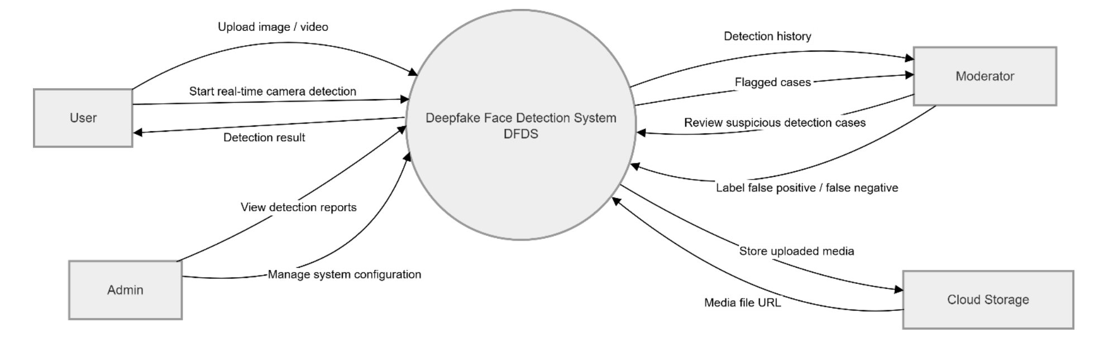
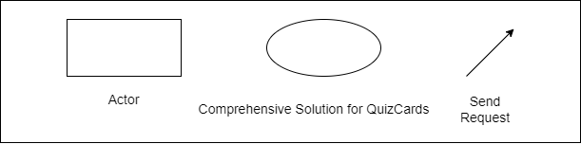
Figure 1: System Context Diagram
The System Context Diagram presents the Deepfake Face Detection System (DFDS) as a single software system and shows how it interacts with external actors and external services. At this level, the internal structure of the system is not shown. Instead, the diagram focuses on the system boundary, the main users of the system, and the information exchanged between the system and its surrounding environment.
The central element in the diagram is the Deepfake Face Detection System (DFDS). This system provides functions for detecting whether facial content in an uploaded image, uploaded video, or real-time camera/screen input is likely to be real or deepfake. The system receives media input, processes it, returns detection results, stores uploaded media, and supports administrative and moderation activities.
The first external actor is the User. The user interacts with DFDS to upload images or videos for deepfake detection. The user can also start real-time camera or screen-based detection. After the system completes the analysis, it returns a detection result to the user. The result helps the user understand whether the analyzed content is classified as real, suspicious, or deepfake.
The second external actor is the Admin. The admin uses the system to view detection reports and manage system configuration. This actor is responsible for administrative activities such as monitoring system usage, checking reports, and adjusting system settings when needed.
The third external actor is the Moderator. The moderator interacts with the system to review suspicious or flagged detection cases. The system provides detection history and flagged cases to the moderator. After reviewing a suspicious case, the moderator can label the result as false positive or false negative. This supports human validation and improves the reliability of the system’s detection results.
The diagram also includes Cloud Storage as an external service. DFDS sends uploaded media files to Cloud Storage for storage. After storing the files, Cloud Storage returns a media file URL to the system. This allows the system to keep media files externally while storing only references or metadata internally.
Overall, the System Context Diagram defines the DFDS boundary and shows the major interactions between the system and its environment. Users submit media and receive detection results, admins manage and monitor the system, moderators review suspicious cases, and Cloud Storage provides external storage for uploaded media. This view helps stakeholders understand the role of DFDS in the larger operational context before looking at lower-level container, component, or deployment view

Container Diagrams
  - Module
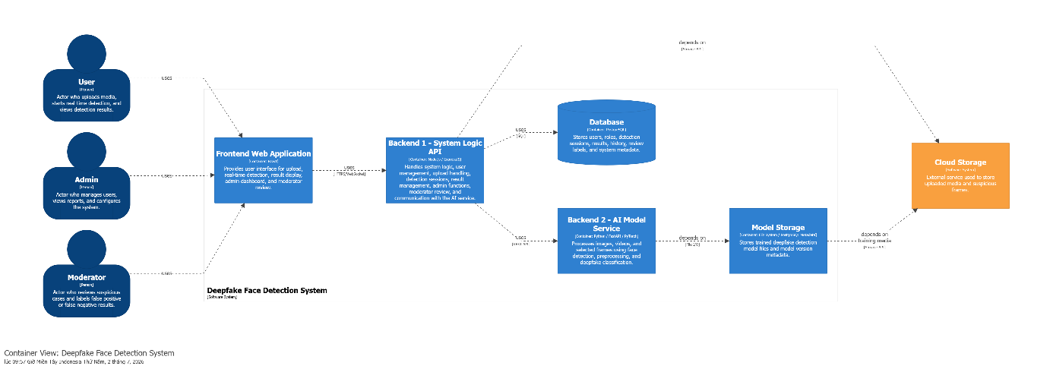

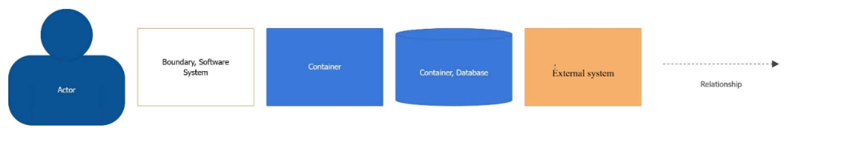

Figure 2. Module - Container Diagram
Prose:
Users access the Deepfake Face Detection System through a responsive React web application to upload images or videos, start real-time detection, view detection results, and review previous detection history. Admins also use the web application to manage users, view reports, and configure the system, while moderators use it to review suspicious cases and label false positive or false negative results.
The Frontend Web Application, built with React, provides the user interface for media upload, real-time detection, result display, detection history, admin dashboard, and moderator review. It communicates with the backend through API calls and sends upload, detection, history, admin, and moderator requests to the system logic API using HTTPS or WebSocket communication.
The Backend 1 – System Logic API, built with NodeJS and ExpressJS, acts as the central application backend. It handles authentication, upload management, detection session management, result management, admin functions, moderator review, and communication with the AI model service. It stores and retrieves uploaded media and suspicious frames through Cloud Storage, reads and writes operational data in the PostgreSQL database, and sends images, videos, or extracted frames to the AI model service for analysis.
The Backend 2 – AI Model Service, built with Python, FastAPI, and PyTorch, performs the AI-related processing. It receives images, videos, or extracted frames from Backend 1 through REST API calls, processes the input, detects faces, preprocesses frames, performs deepfake classification, and returns the prediction result, confidence score, and processing status to Backend 1.
The Database, implemented with PostgreSQL, stores system operational data such as users, roles, detection sessions, detection results, detection history, review labels, and system metadata. The Cloud Storage is used as an external storage service for uploaded media and suspicious frames, returning file URLs that can be used by the backend. The Model Storage, implemented using a file system, stores trained deepfake detection model files and model version metadata, allowing the AI model service to load the active detection model when needed.
Table 25. Role & Responsibilities – Container level
Role | Responsibility
Frontend Web Application | Provides the user interface for media upload, real-time detection, result display, detection history, admin dashboard, and moderator review; sends requests to the backend through HTTPS or WebSocket communication.
Backend 1 – System Logic API | Handles authentication, upload management, detection sessions, result management, admin functions, moderator review, and communication with the AI service; coordinates data flow between the frontend, database, cloud storage, and AI model service.
Backend 2 – AI Model Service | Receives images, videos, or extracted frames from Backend 1; performs frame processing, face detection, preprocessing, deepfake classification, and returns prediction results, confidence scores, and processing status..
Database 1 (PostgreSQL) | Stores users, roles, detection sessions, detection results, detection history, review labels, and system metadata; supports data retrieval and persistence for the system logic API.
Model Storage - Database 2 (PostgreSQL) | Stores trained deepfake detection model files and model version metadata; allows the AI model service to load the active model for inference.
Cloud Storage (Cloudinary) | Stores uploaded media and suspicious frames as an external storage service; returns file URLs for later access and review.

  - C&C
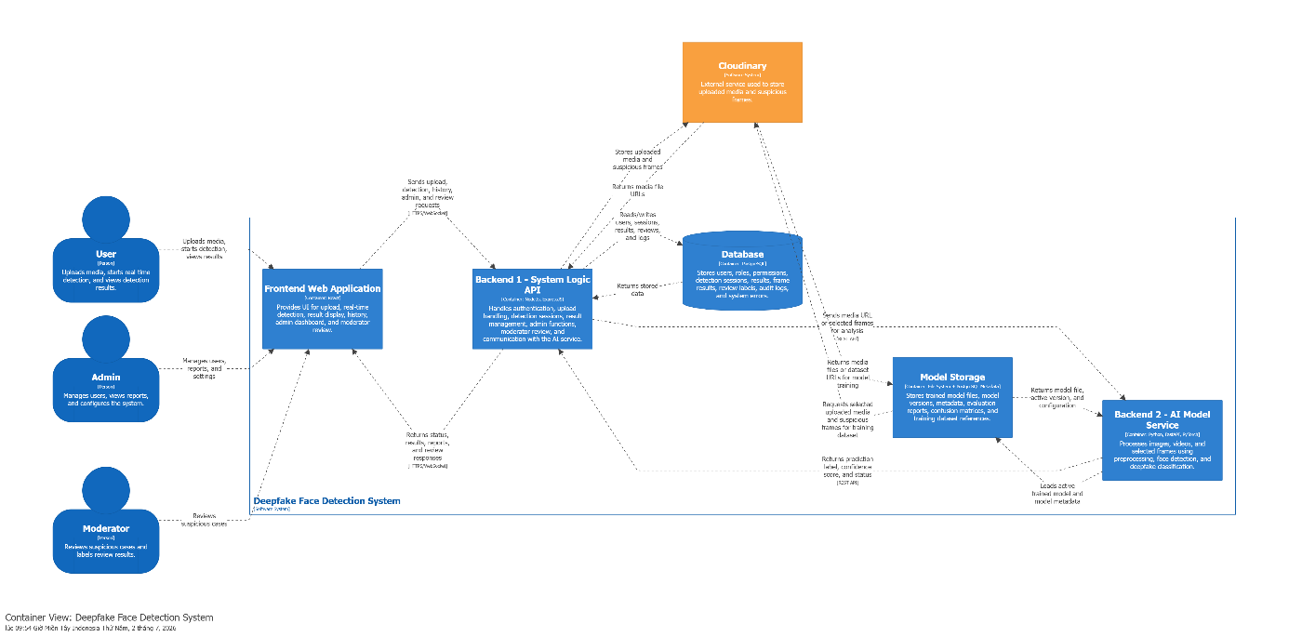

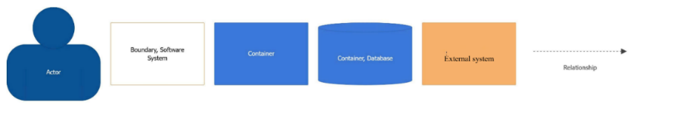
Figure 3. C&C - Container diagram
Prose:
The Deepfake Face Detection System is designed as a web-based system that allows users to upload images or videos, start real-time deepfake detection, view detection results, and check previous detection history. The system also supports admin and moderator roles. Admins manage users, view reports, and configure the system, while moderators review suspicious cases and label results such as false positive or false negative.
The User accesses the system through the Frontend Web Application. The user can upload image or video files, start real-time detection, and view the detection result. After the analysis is completed, the system shows whether the media is real, suspicious, or deepfake, together with the confidence score.
The Admin also uses the Frontend Web Application to manage the system. Admins can manage user accounts, view system reports, and configure system settings. These actions are sent from the frontend to the backend through secure API requests.
The Moderator uses the system to review suspicious detection cases. Moderators can inspect flagged results and label them as false positive or false negative. This helps improve the reliability and review quality of the deepfake detection system.
The Frontend Web Application, built with React, provides the user interface for media upload, real-time detection, detection result display, detection history, admin dashboard, and moderator review. It communicates with Backend 1 through HTTPS or WebSocket requests. The frontend does not directly access the database, cloud storage, or AI model service.
The Backend 1 – System Logic API, built with NodeJS and ExpressJS, acts as the central backend of the system. It handles authentication, upload management, detection session management, result management, admin functions, moderator review, and communication with the AI service. It receives requests from the frontend and coordinates the processing flow between storage, database, and the AI model service.
The Backend 2 – AI Model Service, built with Python, FastAPI, and PyTorch, is responsible for deepfake detection processing. It receives images, videos, or extracted frames from Backend 1, performs preprocessing, detects faces, classifies the media as real or deepfake, and returns the prediction result, confidence score, and processing status.
The Database, implemented with PostgreSQL, stores the main operational data of the system. This includes users, roles, detection sessions, detection results, detection history, review labels, and system metadata. Backend 1 reads and writes this data when managing users, sessions, results, and review information.
The Cloud Storage is an external storage service used to store uploaded media files and suspicious frames. Backend 1 uploads images, videos, and extracted suspicious frames to Cloud Storage. After storing the files, Cloud Storage returns media file URLs that can be used by the backend and frontend.
The Model Storage stores trained deepfake detection model files and model version metadata. The AI Model Service loads the active trained model from this storage when performing deepfake classification. This allows the system to manage and update AI models without changing the whole application structure.
Overall, the system separates responsibilities clearly. The frontend focuses on user interaction, Backend 1 manages business logic and system coordination, Backend 2 handles AI processing, the database stores structured system data, Cloud Storage stores uploaded media, and Model Storage manages trained AI model files.

Component Diagram

Frontend Web Application
    - Module

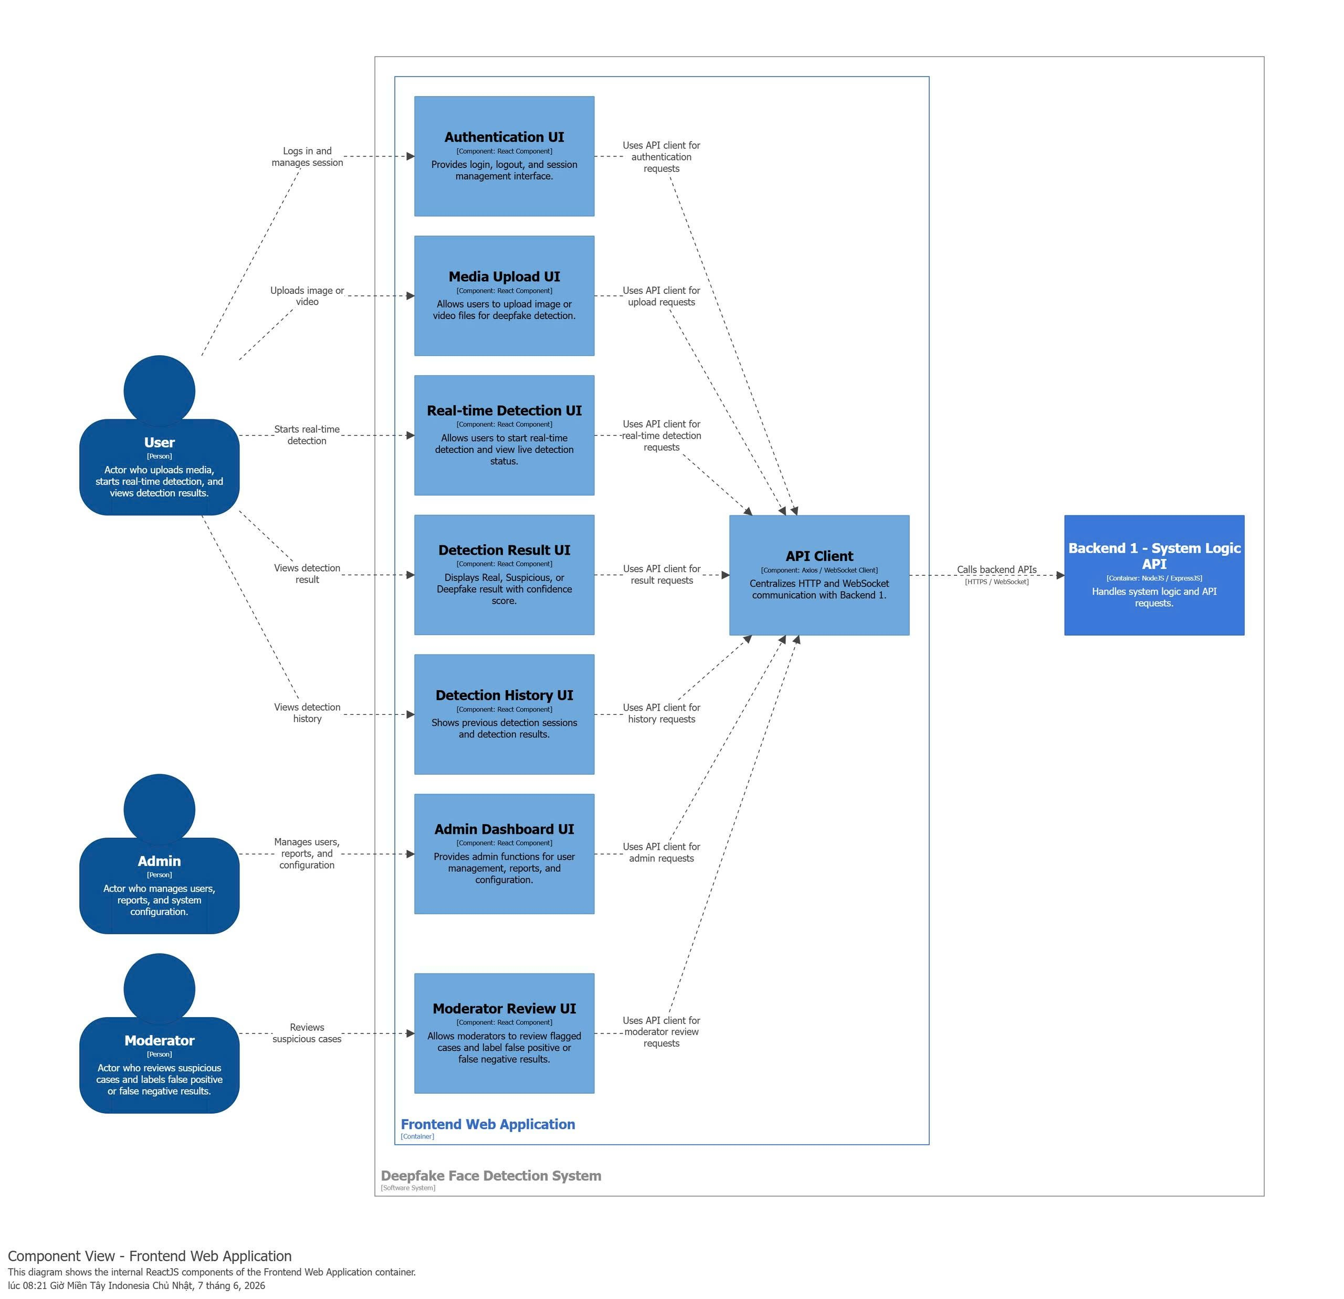

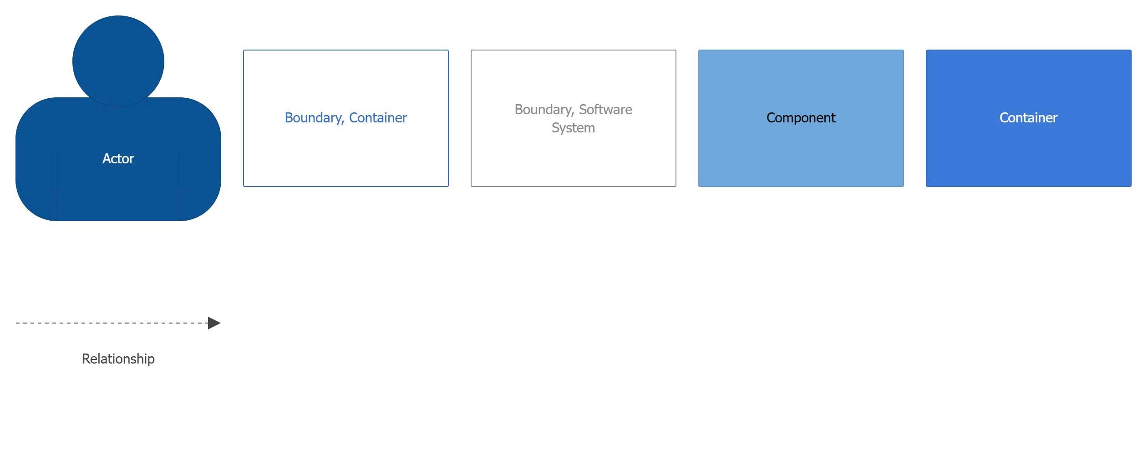
Figure 4. Module – Frontend Web Application
Prose:
The Frontend Web Application is structured as a React-based user interface that provides access to the main features of the Deepfake Face Detection System. It is divided into several UI components, each responsible for a specific user-facing function such as authentication, media upload, real-time detection, result display, detection history, admin management, and moderator review.
Each UI component does not communicate directly with the backend. Instead, all frontend components use a centralized API Client. The API Client manages HTTP and WebSocket communication with Backend 1 – System Logic API, ensuring that backend requests are handled consistently across the web application.
This structure improves maintainability because each UI component focuses only on its own presentation and interaction logic, while backend communication is centralized in the API Client. As a result, changes to backend endpoints, request formats, authentication headers, or WebSocket communication can be handled mainly inside the API Client without requiring major changes to every UI component.
Table 26. Role & Responsibilities – Component level – Backend1 - System Logic API
Role | Responsibilities
Authentication UI | Provides the login, logout, and session management interface; uses the API Client to send authentication requests to Backend 1.
Media Upload UI | Provides the interface for uploading image or video files for deepfake detection; uses the API Client to send upload requests to Backend 1.
Real-time Detection UI | Provides the interface for starting real-time detection and viewing live detection status; uses the API Client to send real-time detection requests to Backend 1.
Detection Result UI | Displays detection results such as Real, Suspicious, or Deepfake, together with the confidence score; uses the API Client to retrieve result information from Backend 1.
Detection History UI | Shows previous detection sessions and detection results; uses the API Client to request detection history from Backend 1.
Admin Dashboard UI | Provides admin functions for user management, report viewing, and system configuration; uses the API Client to send admin requests to Backend 1.
Moderator Review UI | Provides the review interface for flagged suspicious cases and allows moderators to label false positive or false negative results; uses the API Client to send moderator review requests to Backend 1.
API Client | Centralizes HTTP and WebSocket communication with Backend 1; handles API request creation, response processing, authentication/session headers, and communication errors for all frontend components.
Backend 1 – System Logic API | Provides backend API endpoints used by the API Client; receives authentication, upload, real-time detection, result, history, admin, and moderator review requests from the frontend.

    - C&C
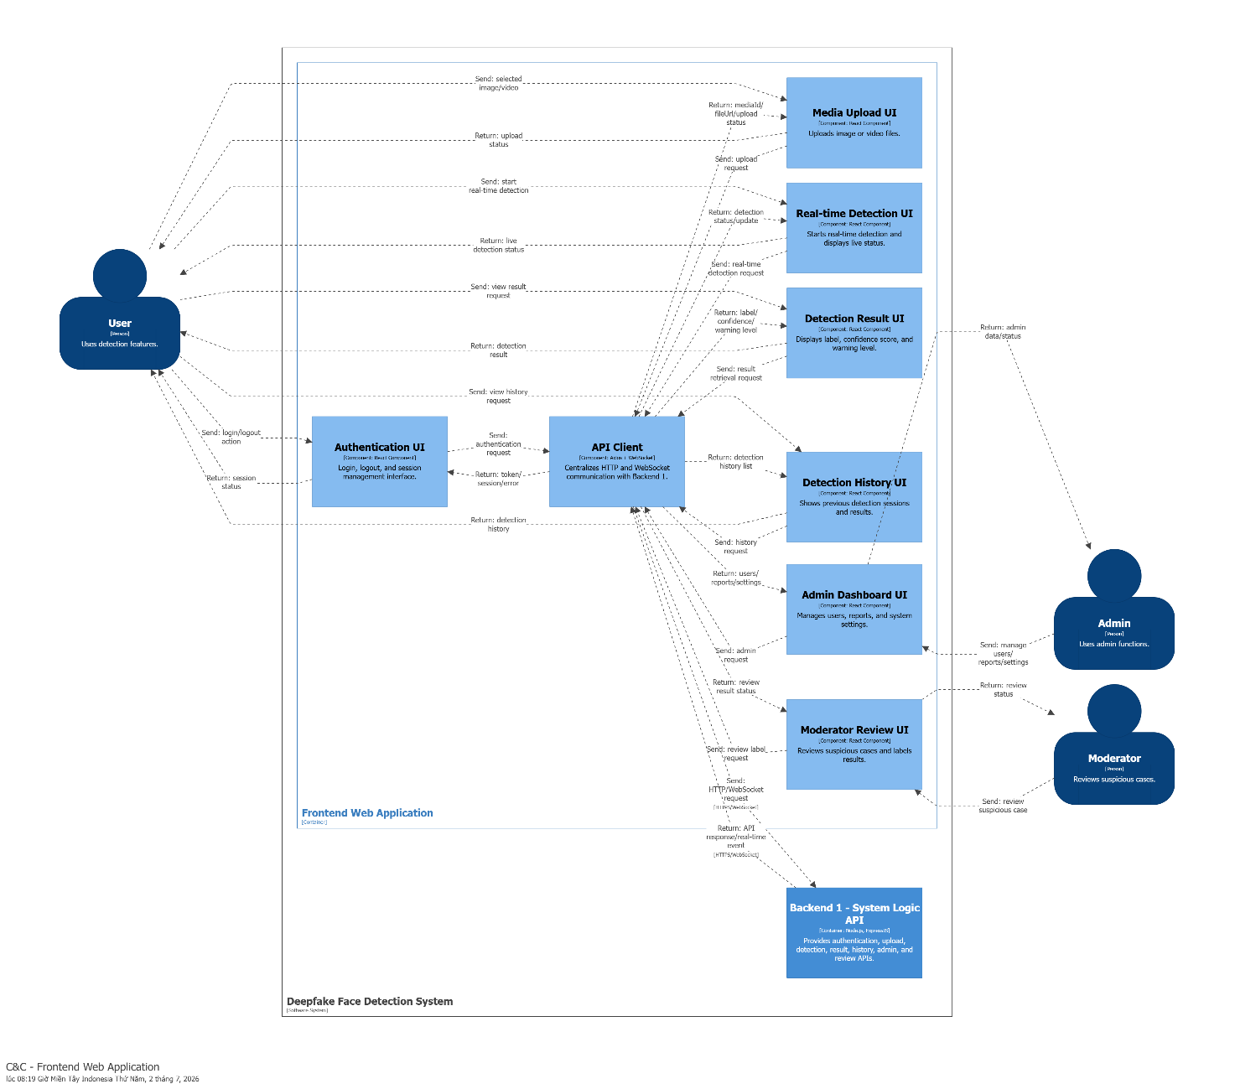
Figure 5. C&C - Frontend Web Application
Prose:
Users interact with the Deepfake Face Detection System through the Frontend Web Application. The frontend provides several user interface components that allow users to log in, manage their session, upload images or videos, start real-time detection, view detection results, and review previous detection history. Admins use the same frontend application to manage users, view reports, and configure the system, while moderators use it to review suspicious cases and label false positive or false negative results.
The Authentication UI, built as a React component, provides the login, logout, and session management interface. It allows users to authenticate before accessing the system and uses the API Client to send authentication requests to the backend.
The Media Upload UI allows users to upload image or video files for deepfake detection. After the user selects a media file, this component sends the upload request through the API Client so that the backend can store and process the uploaded media.
The Real-time Detection UI allows users to start real-time deepfake detection and view the current detection status. It communicates with the backend through the API Client, using HTTP or WebSocket communication to support real-time detection updates.
The Detection Result UI displays the final detection result to the user. It shows whether the uploaded media is classified as real, suspicious, or deepfake, together with the confidence score. This component receives result data from the backend through the API Client.
The Detection History UI shows previous detection sessions and detection results. It allows users to review their past analysis records and uses the API Client to request detection history data from Backend 1.
The Admin Dashboard UI provides administrative functions for managing users, viewing system reports, and configuring system settings. Admins interact with this component, and the component sends admin-related requests to the backend through the API Client.
The Moderator Review UI allows moderators to review flagged or suspicious cases. Moderators can label results as false positive or false negative, helping improve system review quality. This component also communicates with the backend through the API Client.
The API Client, implemented using Axios and WebSocket client logic, centralizes communication between the frontend components and Backend 1. All frontend components send their requests through the API Client, including authentication, upload, real-time detection, result retrieval, history, admin, and moderator review requests.
The Backend 1 – System Logic API, built with NodeJS and ExpressJS, receives API calls from the frontend. It handles system logic, authentication, upload processing, detection session management, result management, admin functions, and moderator review requests. The frontend does not communicate directly with the database or AI model service; instead, it sends all requests to Backend 1 through the API Client.

Backend 1 (System Logic API)
    - Quality attributes
      - Modifiability
  - Selected Design Concepts
To satisfy QA03, the architecture applies the following design concepts.
Tactic: Increase Cohesion
The main tactic for QA03 is Increase Cohesion. All warning-level calculation and mapping rules are grouped inside the Result Management area. This prevents warning logic from being scattered across the frontend, database queries, moderator review, and AI classification service.
The backend result layer becomes the single place responsible for converting model output into user-facing warning feedback.
Tactic: Encapsulate
The warning-level rules are encapsulated inside a dedicated mapping component, such as ResultMappingService or WarningLevelPolicy. This component maps detection labels and confidence scores into warning levels.
For example:
- Low confidence real result → LOW_RISK
- Suspicious result → MEDIUM_RISK
- Deepfake result with high confidence → HIGH_RISK
If new warning levels are added later, the change is made mainly inside the mapping policy.
Tactic: Abstract Common Services
The system introduces a common result response model, such as DetectionResultDTO, that contains both the original result label and the warning level. The frontend depends on this stable response model instead of recalculating warning levels by itself.
Pattern: Policy Object
The Policy Object pattern is applied by placing warning-level rules inside a dedicated policy class. Instead of hardcoding warning rules inside controllers or UI components, the system uses a WarningLevelPolicy or ResultMappingService.
This improves modifiability because business rules for warning levels can change without affecting the whole detection flow.
Pattern: Model-View Separation
The frontend separates display logic from warning-level calculation. The backend returns a result DTO, and the frontend only renders the label, confidence score, and warning level. This keeps the UI simple and prevents duplication of backend rules.

b) Pattern / Tactic Description
Item | Description
Name | Cohesive Warning-Level Mapping
Problem and Context | The system needs clearer risk feedback for detection results. Warning levels may change over time, but these changes should not affect the AI model, detection session flow, or many frontend screens. If warning rules are duplicated across backend and frontend components, adding a new warning level will be slow and error-prone.
Solution | Centralize warning-level logic inside Result Management. The ResultMappingService or WarningLevelPolicy maps detection labels and confidence scores into warning levels. The backend returns a stable DetectionResultDTO to the frontend. The frontend displays the warning level but does not calculate it.
Structure | 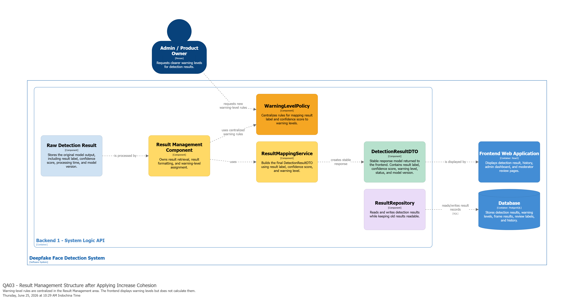
Consequences and Related Patterns | This design improves modifiability because new warning levels can be added by changing the mapping policy and UI display configuration. It also improves consistency because all screens use the same warning-level value. The trade-off is that the result mapping layer becomes a central policy point that must be tested carefully. Related patterns include Policy Object, Model-View Separation, and DTO.

      - Performance
- Selected Design Concepts
To satisfy QA05, the architecture applies the following design concepts.
Tactic: Introduce Processing Queue
The main tactic for QA05 is to introduce a Processing Queue between the Detection Session Component and the ML Service. When many image or video detection requests arrive at the same time, Backend 1 should not call Backend 2 immediately for every request. Instead, Backend 1 creates a detection session, marks it as queued, and places the heavy ML task into a queue.
This prevents the Backend API from becoming blocked by long-running AI inference tasks.
Tactic: Control Resource Demand
The system controls the number of detection jobs processed at the same time. Image detection and video detection have different processing costs, so the worker should limit concurrent jobs based on available CPU/GPU resources. This keeps Backend 2 from being overloaded by too many AI requests at once.
For example:
- Image requests can be processed more frequently.
- Video requests should be processed more carefully because frame extraction, face detection, and classification are more expensive.
- If the queue is full, the system returns a temporarily busy response instead of crashing.
Tactic: Maintain Responsiveness
The backend should return a quick response after accepting a request. Instead of forcing the user to wait until AI processing finishes, Backend 1 returns a session ID or job status. The user can then view the processing status or receive an update when the result is ready.
This keeps the frontend responsive during peak load.
Pattern: Producer-Consumer
The Producer-Consumer pattern is applied by separating request submission from request processing. The Detection Session Component acts as the producer because it creates detection jobs and pushes them into the queue. The Detection Worker acts as the consumer because it takes jobs from the queue and sends them to the AI Model Service.
This improves performance because the system can accept requests quickly and process heavy ML tasks in a controlled way.
Pattern: Asynchronous Processing
The system applies Asynchronous Processing for heavy ML detection tasks. The request is accepted first, then the detection job is processed later by a worker. The frontend does not directly wait for the full AI processing time.
This helps the system handle multiple users without hanging or becoming unresponsive.
- Pattern / Tactic Description
Item | Description
Name | Queued Detection Processing
Problem and Context | Multiple users may submit image and video detection requests at almost the same time. AI inference is expensive, especially for video because the system must extract frames, preprocess media, detect faces, classify faces, and aggregate confidence scores. If every request is processed synchronously, Backend 1 and Backend 2 may become overloaded, causing slow responses, crashes, or lost requests.
Solution | Add a Processing Queue between Backend 1 and Backend 2. Backend 1 accepts the request, creates a detection session, stores the session status as QUEUED, and pushes a DetectionJob into the queue. A Detection Worker pulls jobs from the queue based on available resources and calls Backend 2 for AI processing. When Backend 2 returns the prediction result, Backend 1 saves the result and updates the session status to COMPLETED or FAILED.
Structure | 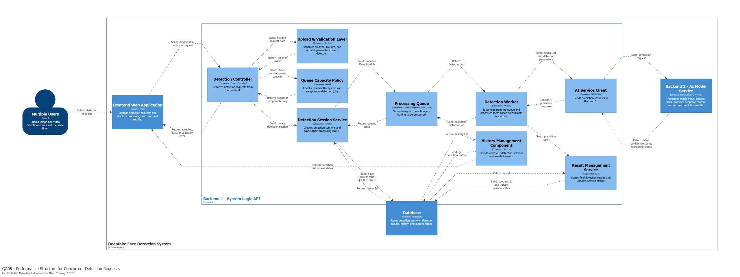
Consequences and Related Patterns | This design improves performance and system stability under peak load because heavy ML tasks are processed in a controlled way. The trade-off is that users may wait longer when the queue is full. Related patterns include Producer-Consumer, Asynchronous Processing, Rate Limiting, Backpressure, and Worker Pool.
9.2.1.3. Performance
- Selected Design Concepts
To satisfy QA06, the architecture applies the following design concepts.
  - Tactic: Authenticate Users
The system requires users to log in before uploading media or starting a real-time detection session. Authentication prevents anonymous or unauthorized users from using detection functions freely.
Backend 1 checks the user token before allowing upload, detection, history viewing, admin functions, or moderator review.
  - Tactic: Obtain Explicit User Consent
The real-time detection feature must request explicit permission before screen capture starts. The system cannot silently scan another application, browser tab, or screen content without user permission.
The Frontend Web Application must show a permission guide and only start the scanning session after the user grants browser screen-capture permission.
  - Tactic: Encrypt Communication
The system must use HTTPS in deployment. This protects uploaded media, detection requests, tokens, and result data while they are transmitted between the frontend and backend.
This is important because deepfake detection may involve sensitive face images, videos, or video-call frames.
  - Tactic: Restrict Access by Role
The system separates permissions for User, Admin, and Moderator. Normal users can upload media and view their own results. Moderators can review suspicious cases. Admins can manage users, reports, and settings.
This prevents users from accessing admin functions or moderator review data.
  - Pattern: Access Control
The Access Control pattern is applied through authentication, role checking, and permission validation in Backend 1. Every protected API request is checked before the system processes it.
  - Pattern: Consent-Based Capture
The Consent-Based Capture pattern is applied to the real-time detection feature. The system only captures selected screen content after the user grants permission through the browser-supported screen capture capability.

- Pattern / Tactic Description
Item | Description
Name | Consent-Based Secure Detection Access
Problem and Context | The system processes facial images, videos, and selected frames from real-time screen detection. These inputs may contain sensitive personal data. If the system allows unsecured transmission, unauthorized access, or silent screen scanning, it may violate user privacy and reduce trust.
Solution | Use HTTPS for communication, require authentication before detection actions, validate user roles before admin or moderator functions, and require explicit user permission before starting screen capture. Backend 1 becomes the central security checkpoint for authentication, authorization, permission validation, audit logging, and secure detection session creation.
Structure | 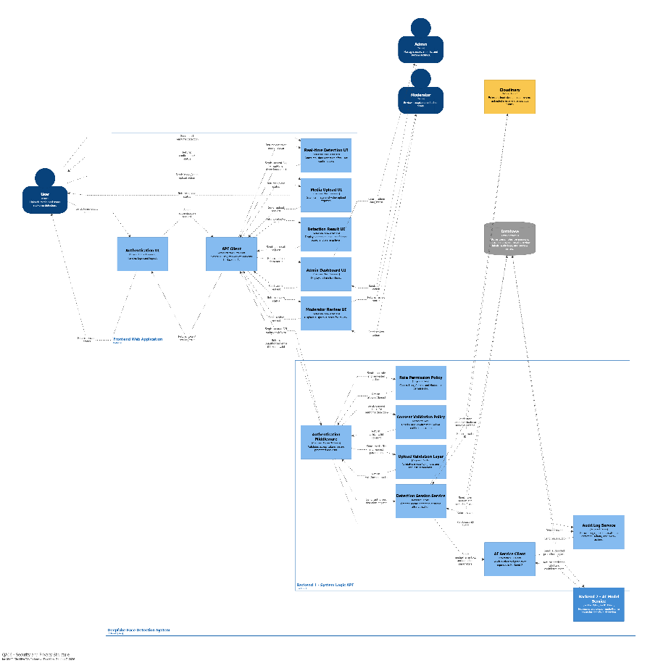
Consequences and Related Patterns | This design improves security and privacy because all detection actions are controlled and traceable. The trade-off is that users must grant permission before real-time detection can start. Related patterns include Access Control, Role-Based Access Control, Consent-Based Capture, Secure Communication, and Audit Logging.

    - Module
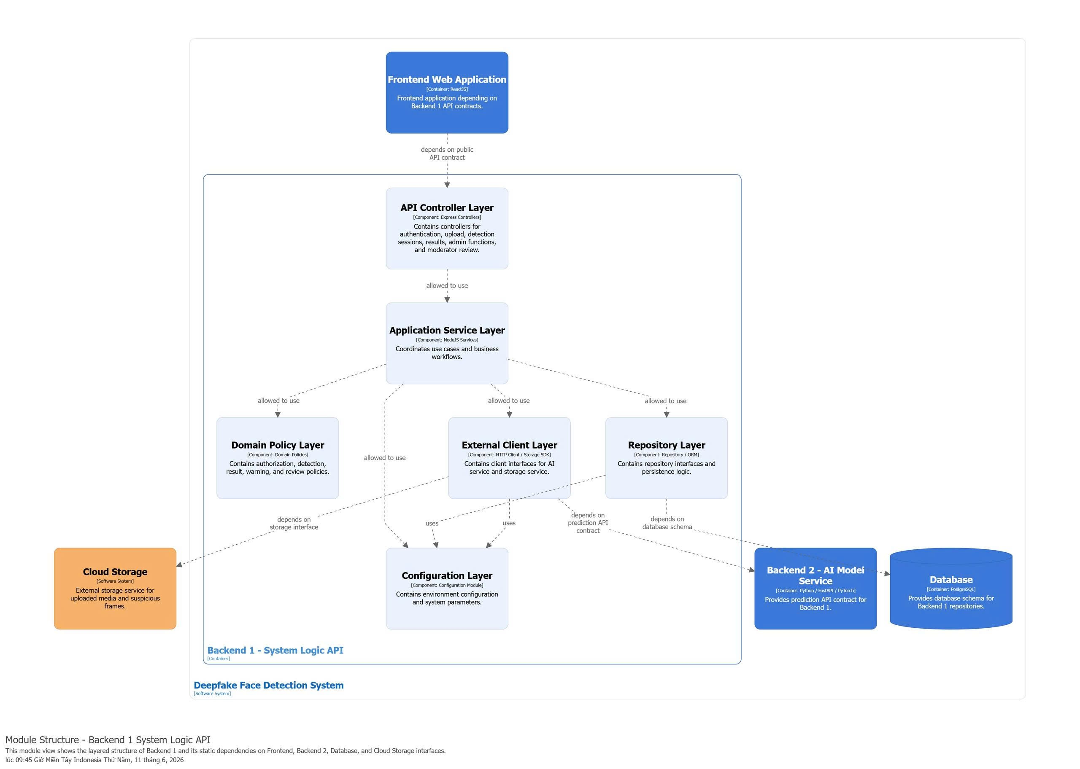
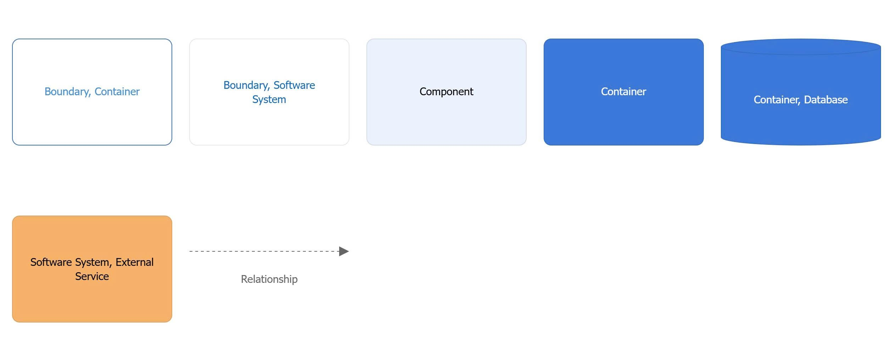
Figure 6. Module - System Logic API
Prose:
The Backend 1 – System Logic API is structured as a layered backend module that coordinates the main business workflows of the Deepfake Face Detection System. It receives requests from the Frontend Web Application through a public API contract and routes them through the API Controller Layer.
The API Controller Layer exposes backend endpoints for authentication, upload, detection sessions, results, admin functions, and moderator review. It does not directly handle business rules or persistence logic. Instead, it forwards validated requests to the Application Service Layer.
The Application Service Layer coordinates system use cases and business workflows. It connects the controller layer with the domain policy, external client, repository, and configuration layers. This layer is responsible for organizing application-level operations such as creating detection sessions, submitting media for analysis, saving detection results, retrieving history, and supporting moderator review processes.
The Domain Policy Layer contains core system policies such as authorization rules, detection result rules, warning-level logic, and review policies. Keeping these policies in a separate layer improves cohesion and makes it easier to update business rules without changing controller or infrastructure code.
The External Client Layer manages communication with external services used by Backend 1. It provides client interfaces for the AI model service and cloud storage service. Through this layer, Backend 1 sends images, videos, or extracted frames to Backend 2 for prediction and stores or retrieves uploaded media and suspicious frames from Cloud Storage.
The Repository Layer manages persistence logic and database access. It contains repository interfaces and implementation logic that allow Backend 1 to read and write system data such as users, sessions, detection results, review labels, and history records in the PostgreSQL database.
The Configuration Layer centralizes environment configuration and system parameters. It provides configuration values used by the service, repository, and external client layers, such as API endpoints, database settings, storage settings, thresholds, and runtime parameters.

Table 27. Role & Responsibilities – Component level – API Application
Role | Responsibilities
Frontend Web Application | Depends on the public API contract of Backend 1; sends authentication, upload, detection, history, admin, and moderator requests to the backend
API Controller Layer | Exposes API endpoints for authentication, upload, detection sessions, results, admin functions, and moderator review; receives requests from the frontend and delegates use cases to the Application Service Layer.
Application Service Layer | Coordinates use cases and business workflows; manages the flow between controllers, domain policies, external clients, repositories, and configuration; handles application-level logic for detection sessions, result processing, history retrieval, and moderator review.
Domain Policy Layer | Contains authorization rules, detection result policies, warning-level rules, and review policies; ensures that core business rules are separated from controllers and infrastructure logic.
External Client Layer | Provides client interfaces for external services; communicates with Backend 2 – AI Model Service through the prediction API contract; communicates with Cloud Storage through the storage interface.
Repository Layer | Contains repository interfaces and persistence logic; reads and writes users, detection sessions, detection results, review labels, history records, and system metadata through the database schema.
Configuration Layer | Stores environment configuration and system parameters; provides configuration values for service logic, external clients, repositories, API endpoints, storage settings, database settings, and runtime parameters.
Backend 2 – AI Model Service | Provides the prediction API contract used by Backend 1; receives media or extracted frames from Backend 1 and returns prediction results, confidence scores, and processing status.
Database | Provides the database schema required by the Repository Layer; stores operational data such as users, sessions, results, history, review labels, and system metadata.
Cloud Storage – Cloudinary | Provides the storage interface used by the External Client Layer; stores uploaded media and suspicious frames and returns file references for later access or review.

    - C&C
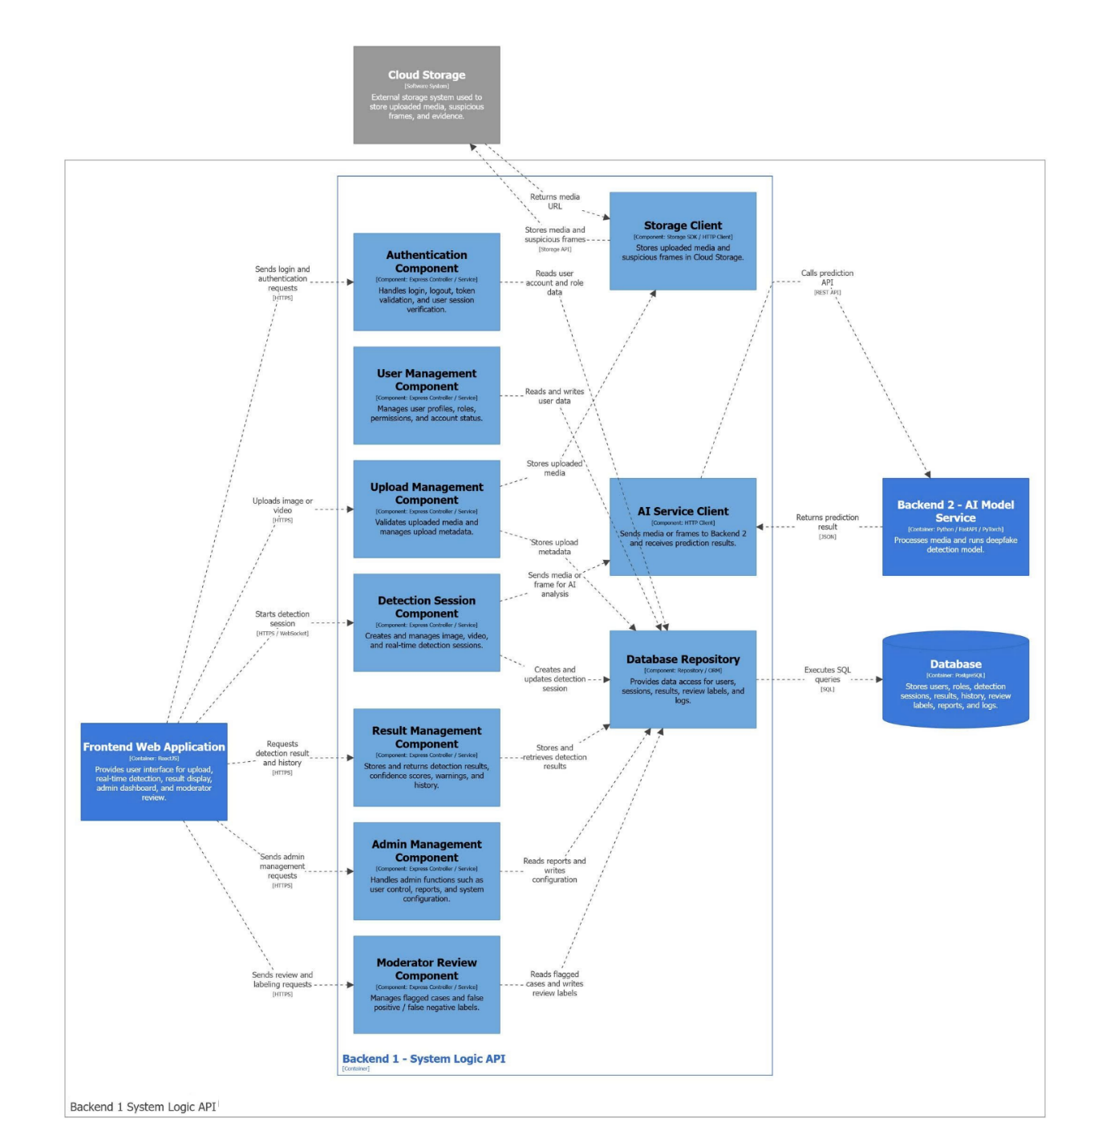
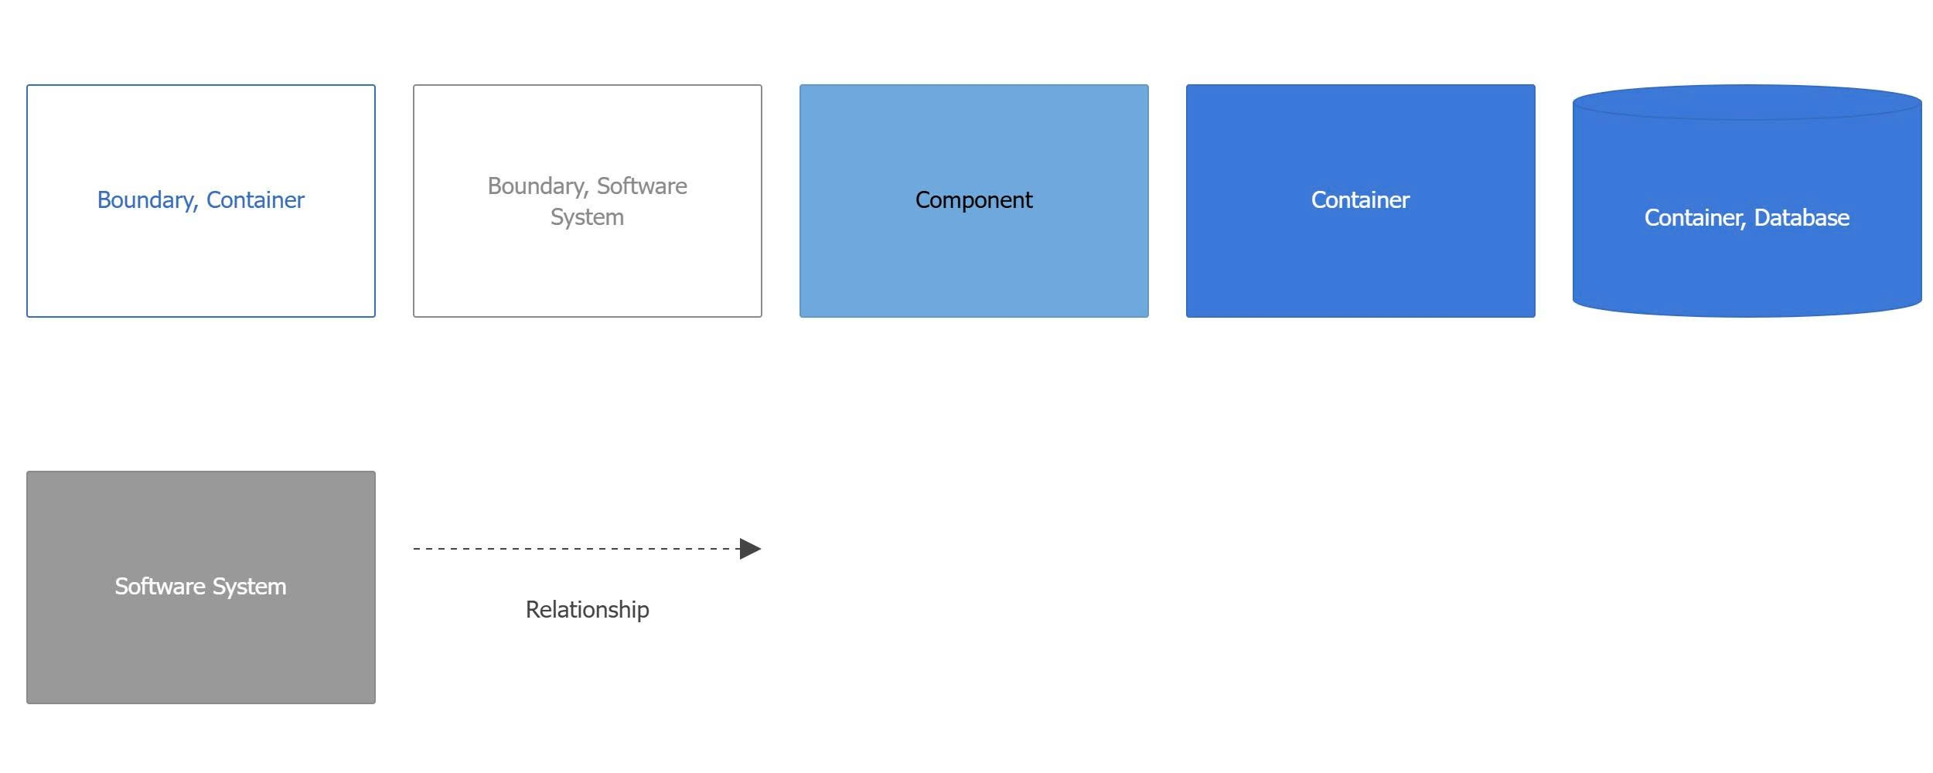
Figure 7. C&C - Backend 1 (System Logic API)
Prose:
The Frontend Web Application of the Deepfake Face Detection System is organized into several internal modules. These modules separate the user interface, routing logic, backend communication, and shared frontend state management. This structure makes the frontend easier to maintain, extend, and connect with the backend system.
The Routing Module, built with React Router, defines the page routes and navigation structure of the frontend application. It references all main UI modules, including authentication, media upload, real-time detection, detection result, detection history, admin dashboard, and moderator review pages. This module controls which page is displayed when a user, admin, or moderator navigates through the system.
The Authentication UI Module, implemented as a React component, handles the login, logout, and session interface. It allows users to authenticate before using the system. This module uses the API Client Module to send authentication requests to the backend and also uses shared state to manage login status and session information.
The Media Upload UI Module provides the image and video upload interface. Users can select media files and submit them for deepfake detection. This module uses the API Client Module to send upload requests to the backend and uses the State Management Module to update upload status and related frontend data.
The Real-time Detection UI Module provides the real-time detection interface. It allows users to start real-time deepfake detection and view the current detection process. This module communicates with the backend through the API Client Module, using HTTP or WebSocket communication, and uses shared state to display detection status updates.
The Detection Result UI Module displays the detection result after the analysis is completed. It shows information such as the detection label, confidence score, and warning level. This module receives result data through the API Client Module and uses the State Management Module to access and update result information across the frontend.
The Detection History UI Module displays previous detection sessions and results. It allows users to review their past uploaded media and detection outcomes. This module uses the API Client Module to request detection history data from the backend and uses shared state to manage the displayed history information.
The Admin Dashboard UI Module provides the interface for administrator functions. Admins can manage users, view reports, and configure system settings. This module uses the API Client Module to send admin-related requests to Backend 1 and uses the State Management Module to manage dashboard data and configuration state.
The Moderator Review UI Module provides the suspicious case review interface. Moderators can review flagged detection cases and label results such as false positive or false negative. This module uses the API Client Module to communicate with the backend and uses the State Management Module to update review status and shared frontend data.
The API Client Module, implemented using Axios and WebSocket client logic, encapsulates frontend access to backend API contracts. It acts as the communication layer between frontend modules and Backend 1. All UI modules use this module to send authentication, upload, detection, result, history, admin, and moderator review requests.
The State Management Module, implemented using React state management, manages shared frontend state. It stores and updates data such as user session information, upload status, detection status, detection results, history data, admin data, and moderator review state. This allows different UI modules to share consistent data without directly depending on each other.
The Backend 1 – System Logic API, built with NodeJS and ExpressJS, exists outside the frontend container as an external dependency. It provides backend API contracts for the frontend modules. The frontend does not directly access the database, cloud storage, or AI model service. Instead, all backend communication is handled through the API Client Module, which depends on the API contracts provided by Backend 1.

Backend 2 (AI Model Service)
    - Quality Attributes
      - Modifiability - QA1
a) Selected Design Concepts
To satisfy QA01, the architecture applies the following design concepts.

Pattern: Adapter Pattern
The Adapter Pattern is used to convert different concrete input types into a common internal format. Instead of allowing the classifier to understand every possible media source, the system introduces an InputAdapter. This adapter receives concrete input sources such as ImageInput, VideoInput, RealtimeFrameInput, or future types such as VideoUrlInput, and converts them into a stable StandardInput.
This ensures that downstream processing components do not depend on concrete input types.

Pattern: Pipes and Filters
The input processing workflow is organized as a pipeline:
Concrete Input Sources → InputAdapter → StandardInput → Frame-based Processing Pipeline → Stable Detection and Classification Core
Each stage has a clear responsibility. New input types are handled at the beginning of the pipeline, while later stages remain stable.

Tactic: Reduce Coupling – Use an Intermediary
The InputAdapter acts as an intermediary between raw input sources and the stable AI processing pipeline. This prevents the classifier from depending directly on input-specific formats.

Tactic: Reduce Coupling – Encapsulate
Input-specific information is encapsulated inside concrete input classes. For example, ImageInput, VideoInput, RealtimeFrameInput, and VideoUrlInput each store their own input-specific data. This prevents input-specific rules from being scattered across the classifier or detection pipeline.

Tactic: Restrict Dependencies
The DeepfakeClassifier is restricted from depending on raw input types. It only receives prepared face crops or preprocessed frame data after input standardization, frame extraction, preprocessing, and face detection.

Tactic: Increase Cohesion
All input-related responsibilities are grouped inside the Input Processing part of Backend 2. Upload Management and Detection Session coordinate the workflow, but media transformation remains inside the AI Model Service.
b) Pattern / Tactic Description
Item | Description
Name | Adapter-based Standard Input Pipeline
Problem and Context | The system must support new input types such as video URL or recorded call segment. Each input type has a different structure and preparation process. Without an intermediary, the classifier would need to understand every input type, causing high coupling and making future changes risky.
Solution | Introduce an input abstraction and adapter layer. Concrete input sources are converted into a common StandardInput format before entering the frame-based processing pipeline. The classifier only receives stable processed data and does not depend on raw input sources.
Structure | 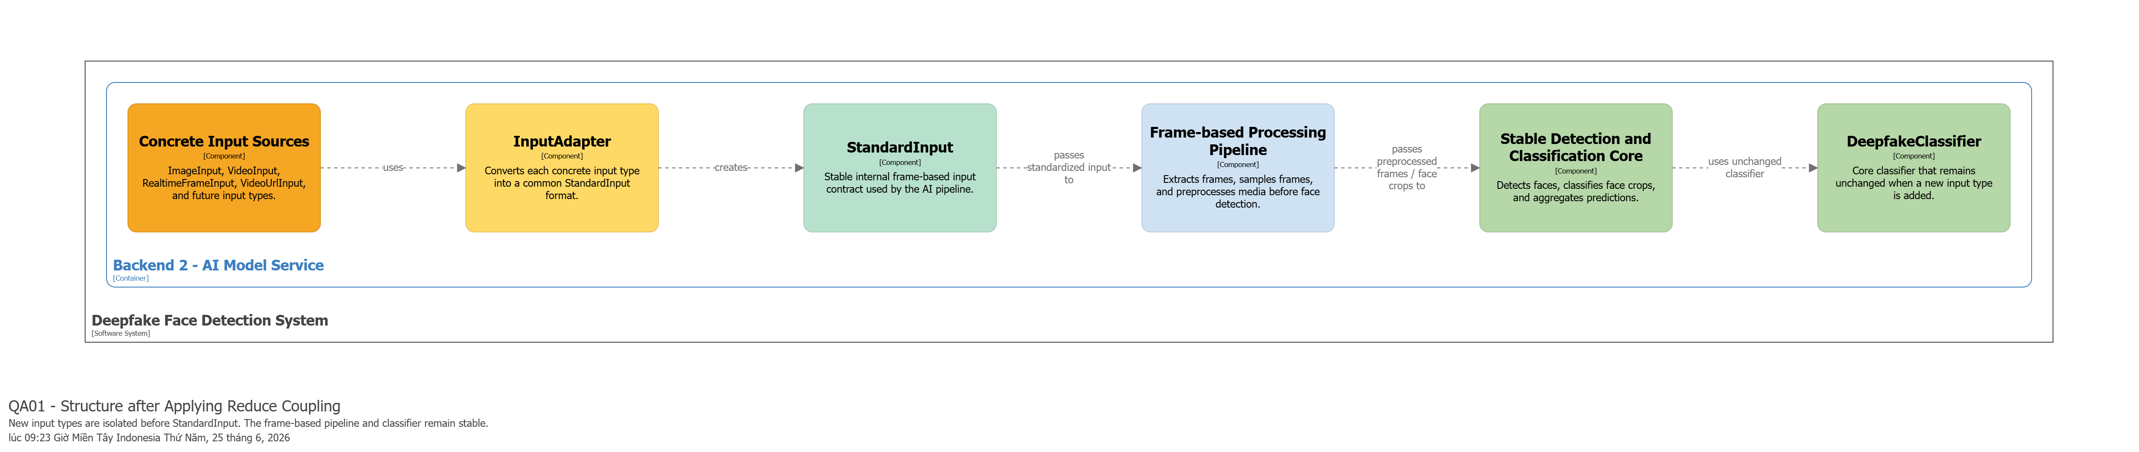
Consequences and Related Patterns | This design improves modifiability because new input types can be added with limited impact. The classifier remains unchanged, and existing image, video, and real-time detection flows remain stable. The trade-off is that the system introduces extra adapter and standardization components. Related patterns include Adapter, Pipes and Filters, and Strategy.

6.3.1.2. Modifiability - QA02
a) Selected Design Concepts
To satisfy QA02, the architecture applies the following design concepts.

Tactic: Defer Binding Time
The main tactic for QA02 is Defer Binding Time. Instead of binding the classifier directly to one hardcoded model file, the system stores model-related information in configuration and metadata. This includes model version, model path, framework type, input size, threshold, normalization method, and active model status.
The actual model is selected at runtime or service startup by the ModelLoader based on the active model version. This allows the model to be replaced without changing the main detection flow.

Pattern: Registry Pattern
The ModelRegistry acts as the central place for managing model versions. It stores and retrieves model version information, identifies the active model version, and provides model metadata to the model loading process.
This pattern helps separate model version management from classification logic.

Pattern: Strategy Pattern
The classifier can use different model implementations behind a common classification interface. For example, an Xception-based classifier or EfficientNet-based classifier can be selected as the active strategy as long as it follows the same prediction contract.
This allows the system to switch the underlying model architecture without changing the external prediction flow.

Tactic: Reduce Coupling – Use an Intermediary
The ModelLoader acts as an intermediary between the classification service and model storage. The classification service does not directly read model files or metadata. It only uses the active model prepared by the loader.

Tactic: Encapsulate
Model-specific information is encapsulated inside ModelVersion, ModelArtifact, ModelMetadata, ModelConfig, and ActiveModel. This prevents model-specific details from spreading into the API layer or user-facing detection flow.

Tactic: Restrict Dependencies
The AI API Module and Detection Session flow must not depend on a specific model file, model architecture, or framework. They depend only on the stable prediction API contract. This ensures that updating the model does not affect upload detection or real-time detection.
b) Pattern / Tactic Description
Item | Description
Name | Metadata-driven Model Loading
Problem and Context | The system must replace the deepfake detection model when the current model is not accurate or fast enough. However, the detection flow, prediction API, and user interface should remain unchanged. If model information is hardcoded in the classifier, every update requires code changes and increases regression risk.
Solution | Store model version, artifact path, framework type, input size, threshold, and model configuration in Model Storage. The ModelRegistry identifies the active model version. The ModelLoader loads the active model and validates its artifact before inference. The ClassificationService uses the loaded ActiveModel without knowing the physical file path or storage details.
Structure | 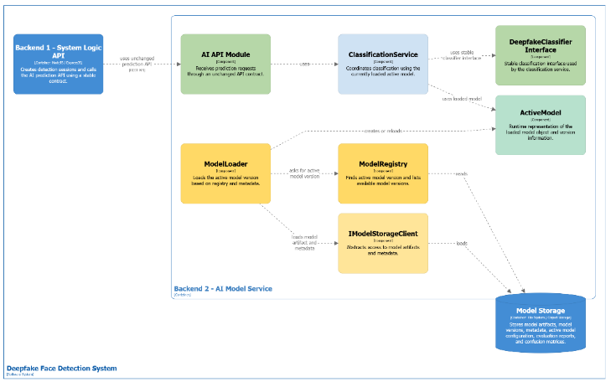
Consequences and Related Patterns | This design improves modifiability because new models can be introduced by updating metadata and activating a new version. It also supports model rollback and model comparison. The trade-off is that model metadata, validation, and version management must be maintained carefully. Related patterns include Registry, Strategy, and Dependency Inversion.
6.3.1.3 Performance
a) Selected Design Concepts
To satisfy QA04, the architecture applies the following performance patterns and tactics.
- Tactic: Manage Sampling Rate
The system does not process every frame in the uploaded video. Instead, it extracts frames from the video and selects only representative frames for analysis.
This tactic reduces the number of frames that must pass through preprocessing, face detection, and deepfake classification. It directly supports the 50-second response target.
- Tactic: Increase Resource Efficiency
The system reduces the size of input data before classification. Selected frames are resized, normalized, and then passed to face detection. After a face is detected, only the cropped face region is sent to the classifier.
This allows the classifier to process smaller face-focused inputs instead of full video frames.
- Tactic: Reduce Overhead
The active deepfake detection model is loaded once and reused during video analysis. The system should not reload the model for every sampled frame.
This reduces repeated model-loading overhead and improves inference speed.
- Tactic: Bound Execution Time
The system validates video format, file size, and duration before starting expensive AI processing. Unsupported or oversized videos are rejected early.
This prevents long-running detection sessions from exceeding the expected processing time.
- Pattern: Pipes and Filters
The video processing workflow is organized as a pipeline:
Video Input → Frame Extraction → Frame Sampling → Media Preprocessing → Face Detection → Deepfake Classification → Confidence Aggregation
Each processing stage has a focused responsibility. This structure makes the workflow easier to optimize because performance bottlenecks can be identified at a specific stage.
- Pattern: Batch Processing
Selected face crops are processed as a controlled set instead of processing the whole video frame by frame. This reduces repeated overhead and improves throughput for short video analysis.
b) Pattern / Tactic Description
Item | Description
Name | Sampling-based Video Processing Pipeline
Problem and Context | The system must return the detection result for a short uploaded video within 50 seconds. Processing every frame would create unnecessary computation, increase inference time, and may cause timeout or poor user experience.
Solution | The system validates the uploaded video, extracts frames, samples only representative frames, preprocesses selected frames, detects and crops face regions, classifies cropped faces, and aggregates frame-level predictions into one final result.
Structure | 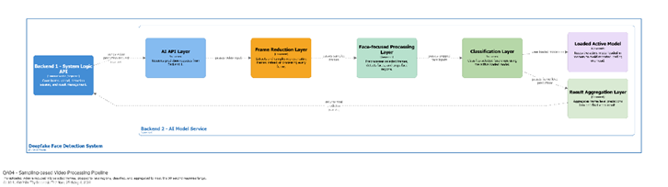
Consequences and Related Patterns | This design improves response time and reduces computation cost. It supports the 50-second response target for short videos. The trade-off is that frame sampling may miss very short deepfake segments. Related patterns include Pipes and Filters, Batch Processing, and Model Reuse.
    - Module
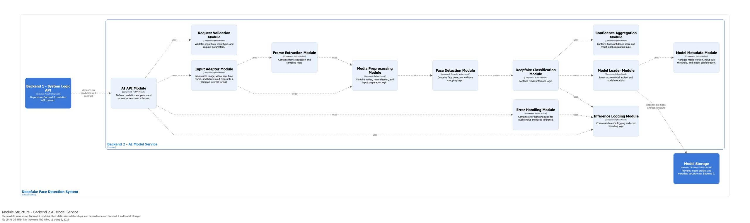

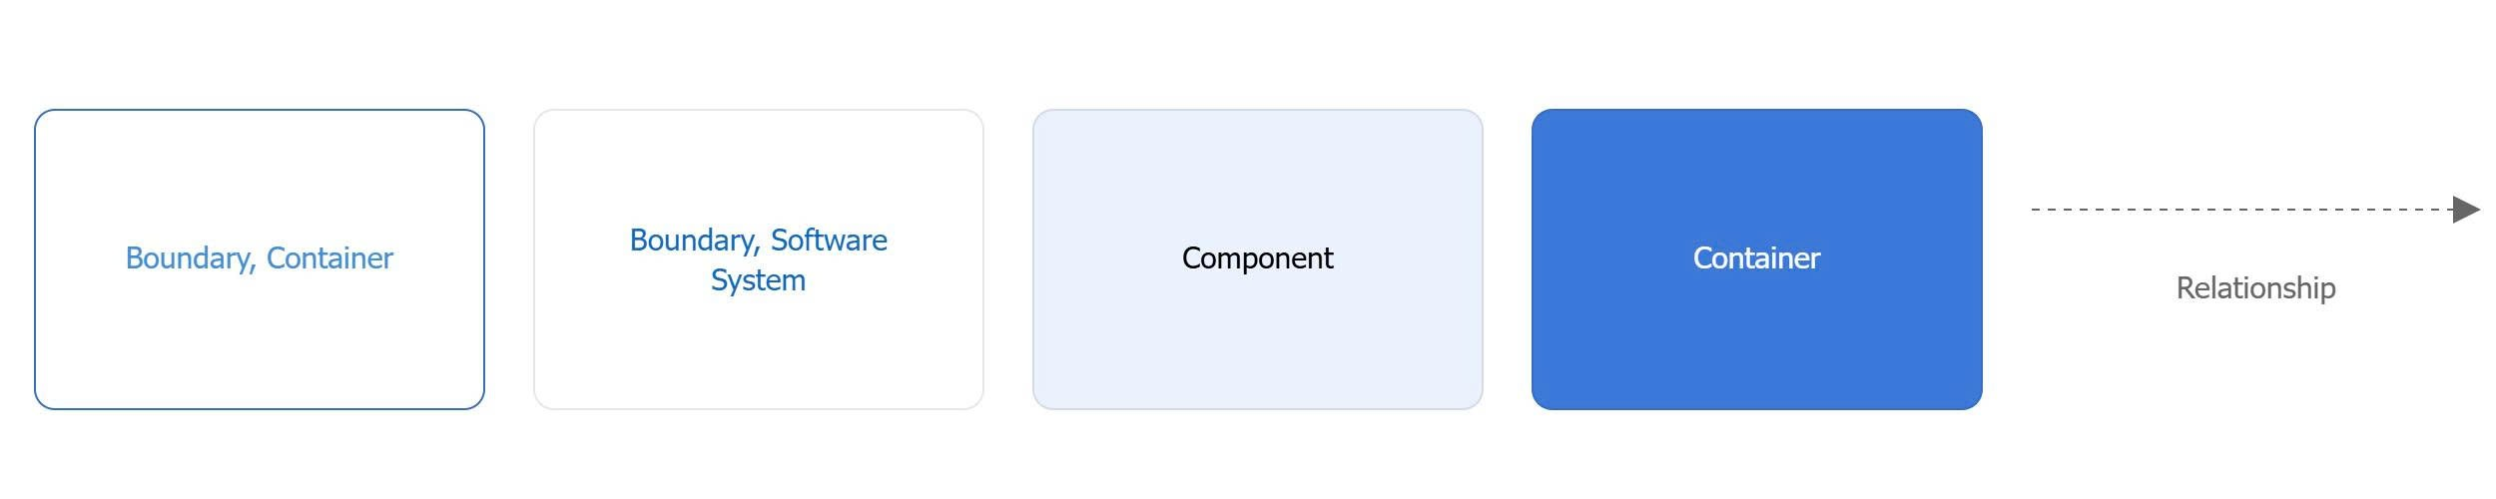
Figure 8. Module - Backend 2 (AI Model Service)

Prose:
The Backend 2 – AI Model Service is responsible for handling the AI inference workflow of the Deepfake Face Detection System. It receives prediction requests from Backend 1 – System Logic API through a defined prediction API contract and processes the submitted image, video, real-time frame, or future media input types.
The service exposes prediction endpoints through the AI API Module, which defines request and response schemas for inference operations. Incoming requests are first validated by the Request Validation Module to ensure that the input type, uploaded file, and request parameters are valid. After validation, the Input Adapter Module converts different input types into a common internal format so that the rest of the AI pipeline can process them consistently.
For video-based inputs, the Frame Extraction Module extracts and samples selected frames before sending them to the media preparation pipeline. The Media Processing Module then resizes, normalizes, and prepares the input data for face detection and model inference. The Face Detection Module detects and crops faces from the prepared media, allowing the system to focus the classification process on relevant facial regions.
The Deepfake Classification Module performs model inference using the active deepfake detection model. It uses the Model Loader Module to load the trained model artifact and related metadata from Model Storage. The Model Metadata Module manages model-related configuration such as model version, input size, classification threshold, and model configuration. After inference, the Confidence Aggregation Module calculates the final confidence score and detection label.
The Error Handling Module manages invalid inputs and failed inference cases, while the Inference Logging Module records inference logs and errors for monitoring and traceability. This structure separates API handling, validation, input adaptation, preprocessing, face detection, classification, model loading, confidence calculation, error handling, and logging into independent modules, making the AI service easier to maintain and extend.

Table 28. Role & Responsibilities – Component level – Backend2 - AI Model Service
Role | Responsibilities
Backend 1 – System Logic API | Depends on the prediction API contract of Backend 2; sends images, videos, extracted frames, or real-time frame data to the AI Model Service for deepfake prediction.
AI API Module | Defines prediction endpoints and request/response schemas; receives inference requests from Backend 1 and coordinates the AI processing workflow.
Request Validation Module | Validates input files, input types, and request parameters before the request continues through the AI pipeline.
Input Adapter Module | Normalizes image, video, real-time frame, and future input types into a common internal format for consistent processing.
Frame Extraction Module | Extracts and samples frames from video-based inputs before sending selected frames to the media processing pipeline.
Media Processing Module | Handles media preparation tasks such as resizing, normalization, and input preparation for face detection and model inference.
Face Detection Module | Detects faces from prepared media and performs face cropping so that only relevant facial regions are passed to the classifier.
Deepfake Classification Module | Performs model inference and classifies facial input as Real, Suspicious, or Deepfake based on the active detection model.
Confidence Aggregation Module | Calculates the final confidence score and determines the final result label based on inference outputs and classification rules.
Model Loader Module | Loads the active trained model artifact and model metadata required for inference.
Model Metadata Module | Manages model version, input size, threshold, and model configuration used by the AI Model Service.
Error Handling Module | Handles invalid input cases, preprocessing errors, and failed inference scenarios; prepares appropriate error responses.
Inference Logging Module | Records inference logs, prediction status, and error information for monitoring, debugging, and traceability.
Model Storage | Provides trained model artifacts and metadata structures used by the Model Loader Module and Model Metadata Module.

    - C&C - Service
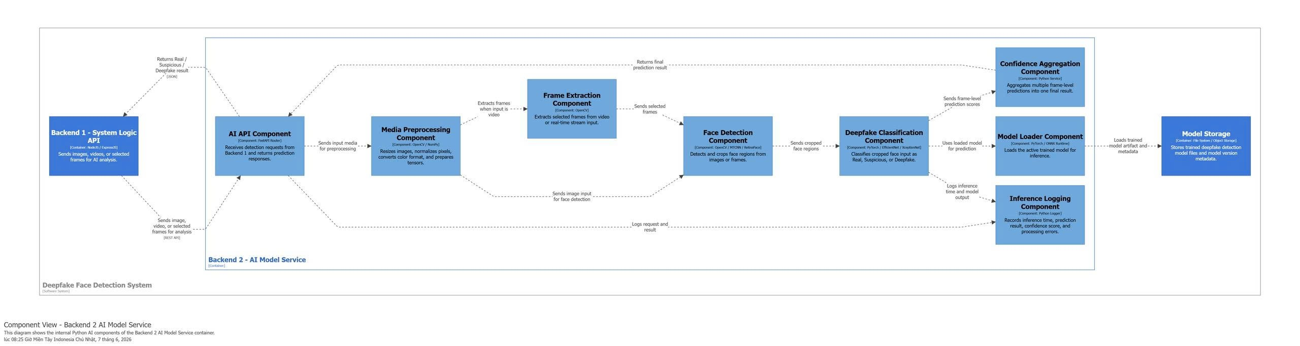
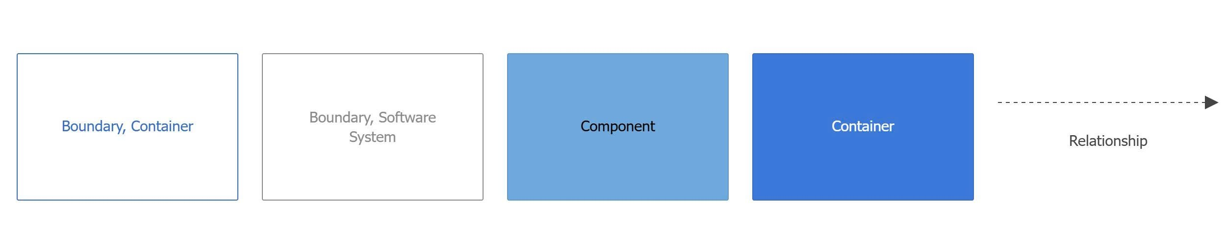
Figure 9. C&C - Backend 2 (AI Model Service)
Prose:
The Backend 2 – AI Model Service is responsible for the AI processing part of the Deepfake Face Detection System. It receives images, videos, or extracted frames from Backend 1, processes the media input, detects face regions, performs deepfake classification, aggregates confidence scores, and returns the final prediction result back to the system logic API.
The Backend 1 – System Logic API sends images, videos, or selected frames to the AI Model Service for analysis. After the AI processing is completed, it receives the final prediction result, confidence score, and processing status from Backend 2.
The AI API Component, implemented with FastAPI, acts as the external entry point of the AI Model Service. It receives REST API requests from Backend 1 and forwards the media input to the internal AI processing pipeline. After the analysis is completed, this component returns the prediction response to Backend 1.
The Media Preprocessing Component prepares the uploaded media before deepfake detection. It resizes images, normalizes pixel values, validates input format, and prepares clean input data for the next processing steps. If the input is a video, this component sends it to the Frame Extraction Component. If the input is an image or extracted frame, it can be forwarded directly to the Face Detection Component.
The Frame Extraction Component extracts selected frames from video input. Instead of processing the entire video frame by frame, it selects useful frames to reduce processing cost and improve performance. These selected frames are then sent to the Face Detection Component.
The Face Detection Component detects and crops face regions from images or video frames. This step is important because the deepfake classifier needs to analyze the face area rather than the entire image. The cropped face regions are then sent to the Deepfake Classification Component.
The Deepfake Classification Component, implemented using PyTorch, performs the main deepfake detection task. It receives cropped face regions, applies the trained AI model, and produces prediction results such as real, suspicious, or deepfake. It also calculates confidence scores for each processed image or frame.
The Model Loader Component loads the active trained deepfake detection model from Model Storage. It provides the loaded model to the Deepfake Classification Component so that inference can be performed using the correct model version.
The Model Storage stores trained model files and model version metadata. The AI Model Service depends on this storage to load the current active detection model before performing classification.
The Confidence Aggregation Component aggregates multiple prediction results from different frames or face regions. For video input, several frame-level predictions may be produced, so this component combines them into one final prediction result with an overall confidence score.
The Inference Logging Component records important inference information, including model version, confidence score, processing status, and possible processing errors. This helps the system monitor AI performance, debug problems, and review past inference activities.
Overall, Backend 2 works as a dedicated AI service. Backend 1 manages system logic and sends media input to this service, while Backend 2 focuses only on preprocessing, face detection, model inference, confidence aggregation, and returning reliable deepfake detection results.

Database 1
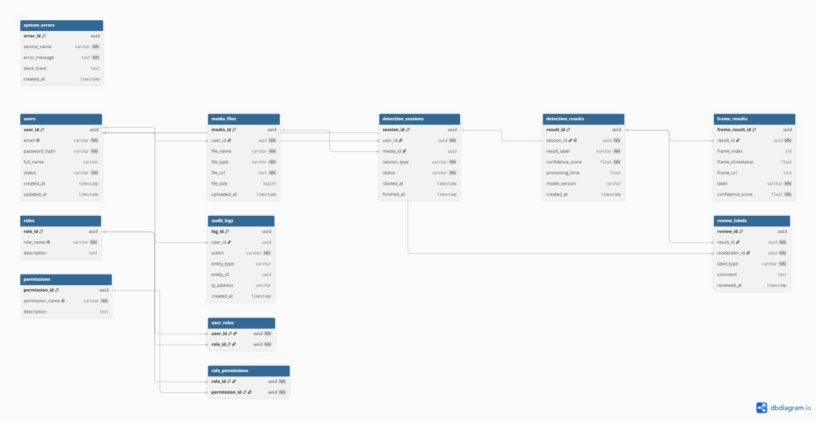
Figure 10. Component level – Database 1
Table 29. Users
Column Name | Data Type | Constraints | Description / Notes
user_id | uuid | PK, NOT NULL | Primary key of the user.
email | varchar | NOT NULL, UNIQUE | User email address used for login and account identification.
password_hash | varchar | NOT NULL | Hashed password used for authentication.
full_name | varchar | NULL | Full name of the user displayed in the system.
status | varchar | NOT NULL | Account status, such as active, inactive, or suspended.
created_at | timestamp | NULL | Time when the user account was created.
updated_at | timestamp | NULL | Time when the user account information was last updated.

Table 30. Roles
Column Name | Data Type | Constraints | Description / Notes
role_id | uuid | PK, NOT NULL | Primary key of the role.
role_name | varchar | NOT NULL, UNIQUE | Name of the role, such as User, Admin, or Moderator.
description | text | NULL | Description of the role and its purpose in the system.

Table 31. Permissions
Column Name | Data Type | Constraints | Description / Notes
permission_id | uuid | PK, NOT NULL | Primary key of the permission.
permission_name | varchar | NOT NULL, UNIQUE | Name of the permission used for access control.
description | text | NULL | Description of what the permission allows.

Table 32. User_roles
Column Name | Data Type | Constraints | Description / Notes
user_id | uuid | PK, FK, NOT NULL | References users.user_id; identifies the user assigned to a role.
role_id | uuid | PK, FK, NOT NULL | References roles.role_id; identifies the role assigned to the user.

Table 33. Role_permissions
Column Name | Data Type | Constraints | Description / Notes
role_id | uuid | PK, FK, NOT NULL | References roles.role_id; identifies the role that receives a permission.
permission_id | uuid | PK, FK, NOT NULL | References permissions.permission_id; identifies the permission assigned to the role.

Table 34. Media_files
Column Name | Data Type | Constraints | Description / Notes
media_id | uuid | PK, NOT NULL | Primary key of the uploaded media file.
user_id | uuid | FK, NOT NULL | References users.user_id; identifies the user who uploaded the media.
file_name | varchar | NOT NULL | Original or stored name of the uploaded media file.
file_type | varchar | NOT NULL | Type of media file, such as image or video.
file_url | text | NOT NULL | Storage URL or path of the uploaded media file.
file_size | bigint | NULL | Size of the uploaded file.
uploaded_at | timestamp | NULL | Time when the media file was uploaded.

Table 35. Detection_sessions
Column Name | Data Type | Constraints | Description / Notes
session_id | uuid | PK, NOT NULL | Primary key of the detection session.
user_id | uuid | FK, NOT NULL | References users.user_id; identifies the user who started the detection session.
media_id | uuid | FK, NULL | References media_files.media_id; identifies the uploaded media used in the session.
session_type | varchar | NOT NULL | Type of detection session, such as image, video, or real-time detection.
status | varchar | NOT NULL | Processing status of the session, such as pending, processing, completed, or failed.
started_at | timestamp | NULL | Time when the detection session started.
finished_at | timestamp | NULL | Time when the detection session finished.

Table 36. Detection_results
Column Name | Data Type | Constraints | Description / Notes
result_id | uuid | PK, NOT NULL | Primary key of the detection result.
session_id | uuid | FK, NOT NULL | References detection_sessions.session_id; identifies the session that produced the result.
result_label | varchar | NOT NULL | Final detection label, such as Real, Suspicious, or Deepfake.
confidence_score | float | NOT NULL | Confidence score returned by the AI model.
processing_time | float | NULL | Time taken to process the detection request.
model_version | varchar | NULL | Version of the AI model used to generate the result.
created_at | timestamp | NULL | Time when the detection result was created.

Table 37. Frame_results
Column Name | Data Type | Constraints | Description / Notes
frame_result_id | uuid | PK, NOT NULL | Primary key of the frame-level detection result.
result_id | uuid | FK, NOT NULL | References detection_results.result_id; identifies the detection result that contains this frame result.
frame_index | int | NULL | Index of the analyzed frame in the video or stream.
frame_timestamp | float | NULL | Timestamp of the frame within the video or stream.
frame_url | text | NULL | Storage URL or path of the analyzed frame.
label | varchar | NOT NULL | Detection label for the individual frame.
confidence_score | float | NOT NULL | Confidence score for the frame-level prediction.

Table 38. Review_labels
Column Name | Data Type | Constraints | Description / Notes
review_id | uuid | PK, NOT NULL | Primary key of the review label.
result_id | uuid | FK, NOT NULL | References detection_results.result_id; identifies the reviewed detection result.
moderator_id | uuid | FK, NOT NULL | References users.user_id; identifies the moderator who reviewed the result.
label_type | varchar | NOT NULL | Review label type, such as correct detection, false positive, or false negative.
comment | text | NULL | Optional moderator comment explaining the review decision.
reviewed_at | timestamp | NULL | Time when the review was submitted.

Table 39. Audit_logs
Column Name | Data Type | Constraints | Description / Notes
log_id | uuid | PK, NOT NULL | Primary key of the audit log record.
user_id | uuid | FK, NULL | References users.user_id; identifies the user who performed the action.
action | varchar | NOT NULL | Name of the action performed in the system.
entity_type | varchar | NULL | Type of entity affected by the action, such as user, media, session, or result.
entity_id | uuid | NULL | Identifier of the affected entity.
ip_address | varchar | NULL | IP address of the user or client that performed the action.
created_at | timestamp | NULL | Time when the audit log was created.

Table 40. System_errors
Column Name | Data Type | Constraints | Description / Notes
error_id | uuid | PK, NOT NULL | Primary key of the system error record.
service_name | varchar | NOT NULL | Name of the service where the error occurred.
error_message | text | NOT NULL | Error message recorded by the system.
stack_trace | text | NULL | Detailed stack trace used for debugging.
created_at | timestamp | NULL | Time when the error was recorded.

Database 2 (Model Storage)
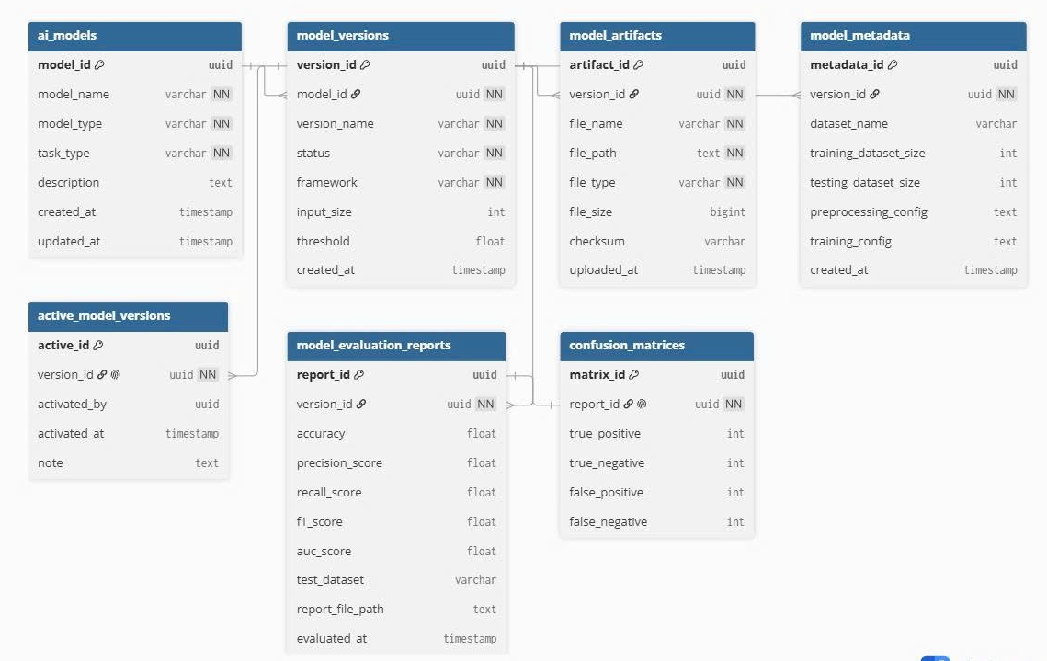
Figure 11. Component Level – Model Storage (Database 2)
Table 41. Ai_models
Column Name | Data Type | Constraints | Description / Notes
model_id | uuid | PK, NOT NULL | Primary key of the AI model.
model_name | varchar | NOT NULL | Name of the AI model.
model_type | varchar | NOT NULL | Type of the model, such as CNN, transformer-based model, or hybrid model.
task_type | varchar | NOT NULL | Type of task the model performs, such as deepfake face detection or face classification.
description | text | NULL | Description of the model, its purpose, and general usage notes.
created_at | timestamp | NULL | Time when the model record was created.
updated_at | timestamp | NULL | Time when the model record was last updated.
Table 42. Model_versions
Column Name | Data Type | Constraints | Description / Notes
version_id | uuid | PK, NOT NULL | Primary key of the model version.
model_id | uuid | FK, NOT NULL | References ai_models.model_id; identifies the AI model that owns this version.
version_name | varchar | NOT NULL | Name or label of the model version, such as v1.0 or production-v2.
status | varchar | NOT NULL | Status of the model version, such as draft, testing, active, archived, or deprecated.
framework | varchar | NOT NULL | Machine learning framework used by this model version, such as PyTorch.
input_size | int | NULL | Required input size for the model, such as image width and height configuration.
threshold | float | NULL | Classification threshold used to determine the final prediction label.
created_at | timestamp | NULL | Time when the model version was created.
Table 43. Model_artifacts
Column Name | Data Type | Constraints | Description / Notes
artifact_id | uuid | PK, NOT NULL | Primary key of the model artifact.
version_id | uuid | FK, NOT NULL | References model_versions.version_id; identifies the model version that owns this artifact.
file_name | varchar | NOT NULL | Name of the stored model artifact file.
file_path | text | NOT NULL | File system path or storage path of the model artifact.
file_type | varchar | NOT NULL | Type of artifact file, such as model weight file, configuration file, or supporting file.
file_size | bigint | NULL | Size of the artifact file.
checksum | varchar | NULL | Checksum value used to verify file integrity.
uploaded_at | timestamp | NULL | Time when the model artifact was uploaded.

Table 44. Model_metadata
Column Name | Data Type | Constraints | Description / Notes
metadata_id | uuid | PK,NOT NULL | Primary key of the model metadata record.
version_id | uuid | FK, NOT NULL | References model_versions.version_id; identifies the model version associated with this metadata.
dataset_name | varchar | NULL | Name of the dataset used for training or testing the model.
training_dataset_size | int | NULL | Number of samples used in the training dataset.
testing_dataset_size | int | NULL | Number of samples used in the testing dataset.
preprocessing_config | text | NULL | Preprocessing configuration used before model inference or training.
training_config | text | NULL | Training configuration, including important hyperparameters or training settings.
created_at | timestamp | NULL | Time when the metadata record was created.

Table 45. Active_model_versions
Column Name | Data Type | Constraints | Description / Notes
active_id | uuid | PK, NOT NULL | Primary key of the active model version record.
version_id | uuid | FK, NOT NULL | References model_versions.version_id; identifies the model version currently activated for inference.
activated_by | uuid | NULL | Identifier of the admin, user, or system process that activated the model version.
activated_at | timestamp | NULL | Time when the model version was activated.
note | text | NULL | Additional note about the activation decision or deployment context.

Table 46. Model_evaluation_reports
Column Name | Data Type | Constraints | Description / Notes
report_id | uuid | PK, NOT NULL | Primary key of the model evaluation report.
version_id | uuid | FK, NOT NULL | References model_versions.version_id; identifies the model version being evaluated.
accuracy | float | NULL | Accuracy score of the evaluated model version.
precision_score | float | NULL | Precision score of the evaluated model version.
recall_score | float | NULL | Recall score of the evaluated model version.
f1_score | float | NULL | F1 score of the evaluated model version.
auc_score | float | NULL | AUC score of the evaluated model version.
test_dataset | varchar | NULL | Name or identifier of the test dataset used for evaluation.
report_file_path | text | NULL | File path of the detailed evaluation report.
evaluated_at | timestamp | NULL | Time when the model evaluation was performed.
Table 47. Confusion_matrices
Column Name | Data Type | Constraints | Description / Notes
matrix_id | uuid | PK, NOT NULL | Primary key of the confusion matrix record.
report_id | uuid | FK, NOT NULL | References model_evaluation_reports.report_id; identifies the evaluation report associated with this matrix.
true_positive | int | NULL | Number of positive samples correctly classified as positive.
true_negative | int | NULL | Number of negative samples correctly classified as negative.
false_positive | int | NULL | Number of negative samples incorrectly classified as positive.
false_negative | int | NULL | Number of positive samples incorrectly classified as negative.

Code Diagrams

Backend 1 - Upload Management
    - Module - Class

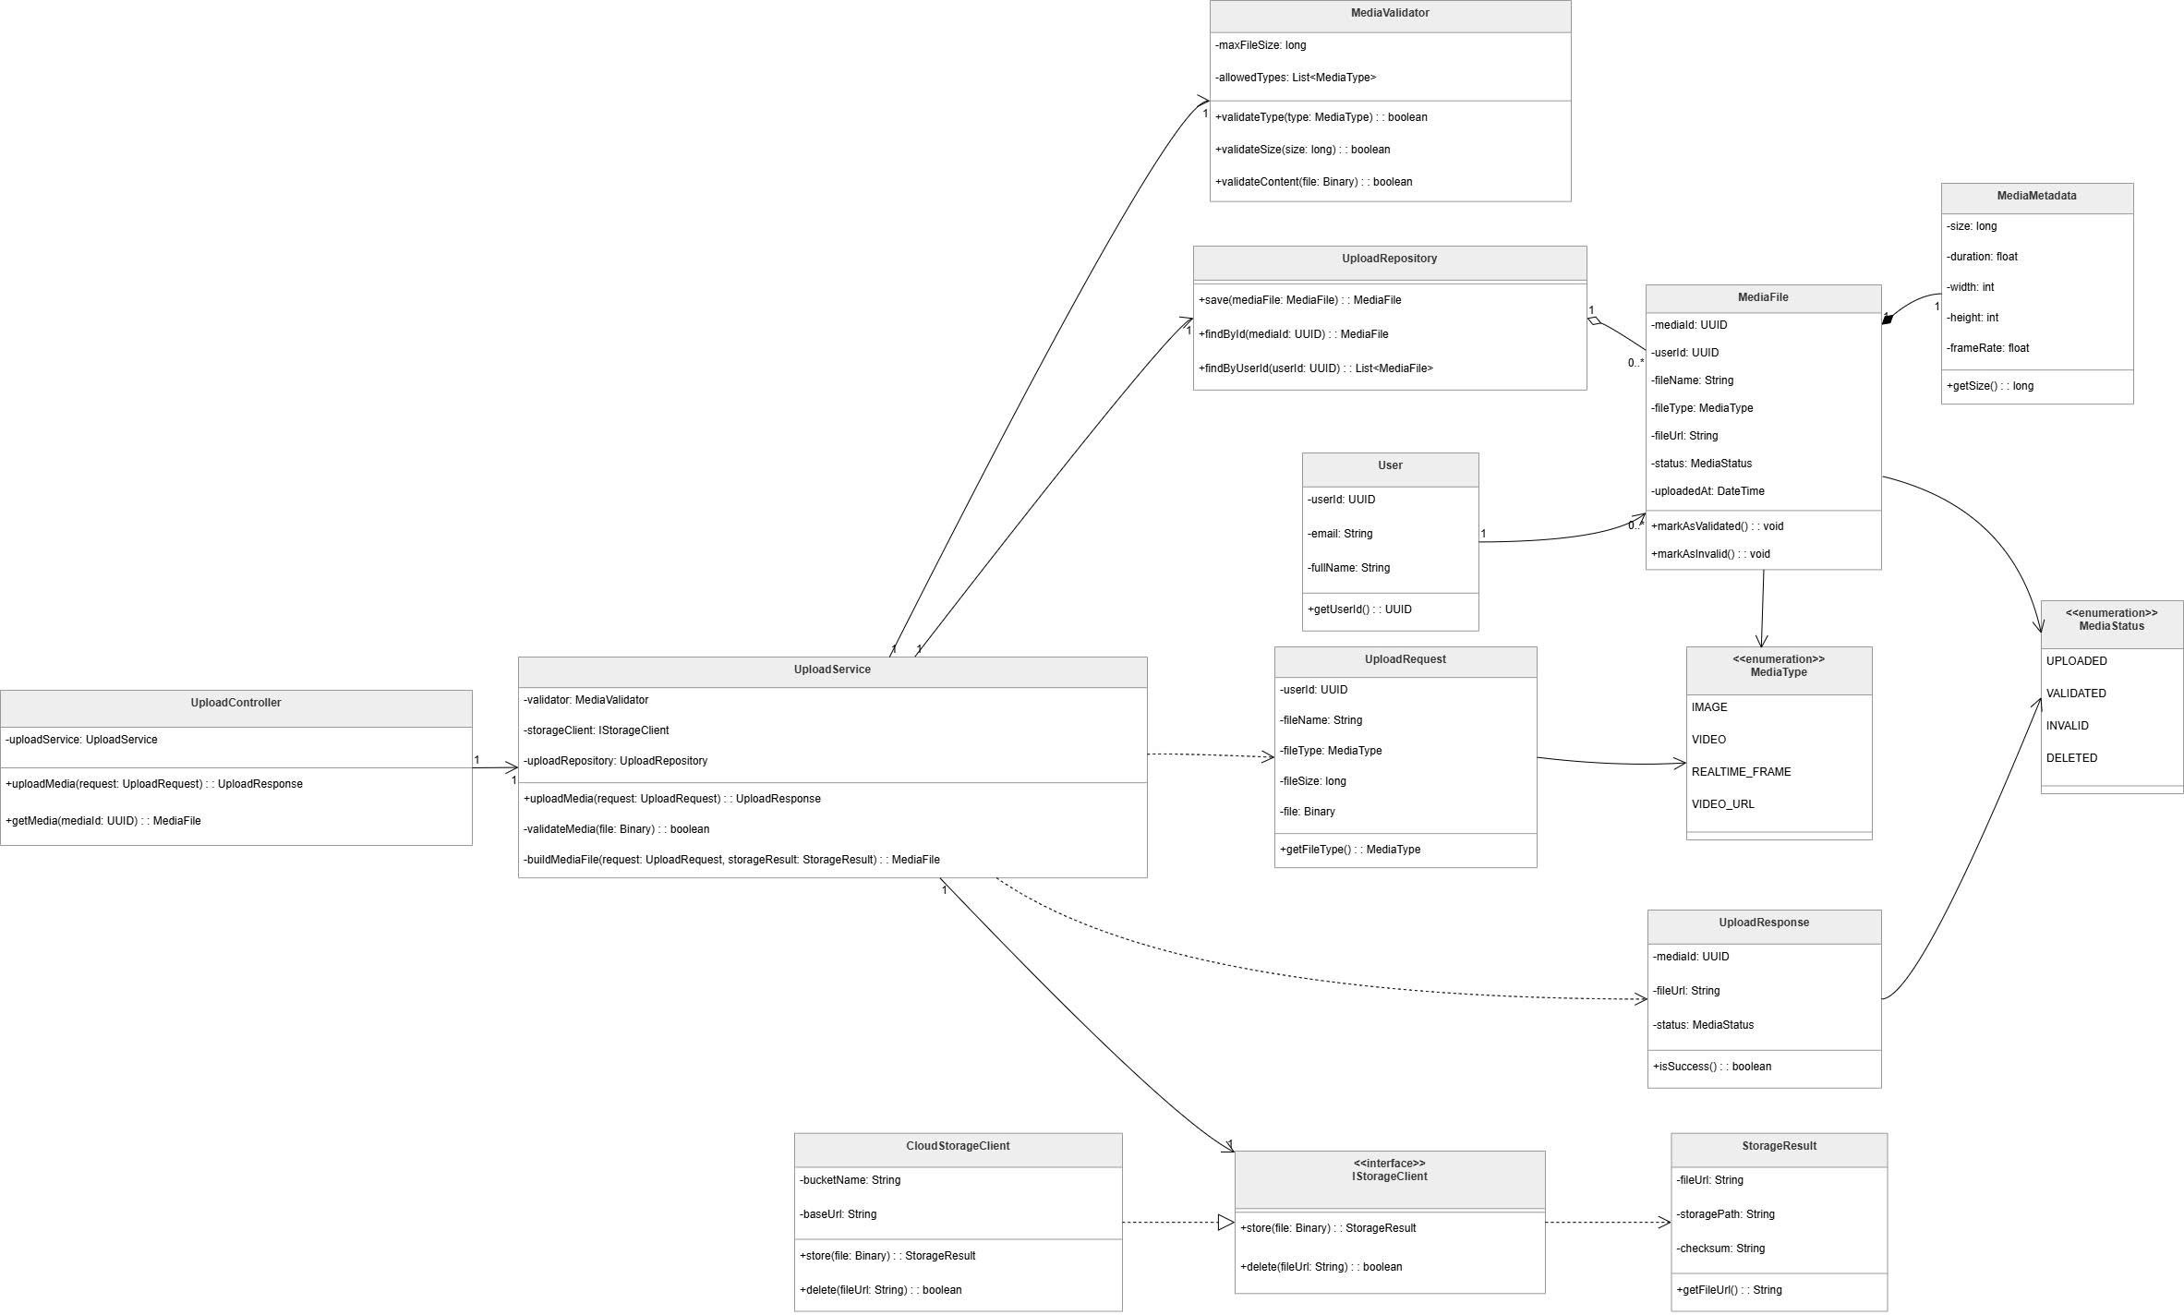
Figure 12. Backend 1 – Upload Management
Prose:
The class diagram illustrates the structure and relationships of the Upload Management part of the Deepfake Face Detection System. This part of the system is responsible for receiving media upload requests, validating uploaded files, storing media files, and returning upload results to the client. The design separates controller logic, service logic, validation logic, repository logic, storage integration, request/response models, domain entities, and enumerations to improve maintainability and reusability.
At the core of the upload workflow are the UploadController and UploadService classes. The UploadController receives upload-related requests and delegates the main processing logic to the UploadService. It provides operations such as uploading media and retrieving media information by media ID. The UploadService coordinates the upload process by using the MediaValidator, IStorageClient, and UploadRepository. It validates the uploaded file, stores the file through the storage client, builds a MediaFile object, and saves the media record through the repository.
Validation is handled by the MediaValidator class. This class defines validation rules such as maximum file size and allowed media types. It provides methods for validating file type, file size, and file content. By separating validation logic into its own class, the upload workflow remains cleaner and easier to modify when media validation rules change.
Persistence is managed by the UploadRepository class. It is responsible for saving media file records and retrieving uploaded media by media ID or user ID. This repository works with the MediaFile domain object, which represents uploaded media in the system. The MediaFile class stores key media information such as media ID, user ID, file name, media type, file URL, upload status, metadata, and upload time. It also provides behavior for marking media as validated or invalid.
Storage integration is abstracted through the IStorageClient interface. This interface defines storage operations such as storing a file and deleting a file by URL. The CloudStorageClient implements this interface and provides concrete storage behavior using cloud storage configuration such as bucket name and base URL. This design allows the system to change the storage provider without changing the upload service logic.
The diagram also includes supporting data models. The UploadRequest class represents the input data required for uploading a file, including user ID, file name, file type, and binary file content. The UploadResponse class represents the result returned after an upload operation, including media ID, file URL, upload status, and success information. The StorageResult class stores information returned by the storage operation, including file URL, storage path, and checksum.
The User class represents the user who uploads media files. The MediaMetadata class stores additional media information such as file size, duration, width, height, and frame rate. The MediaType enumeration defines supported input types, including IMAGE, VIDEO, REALTIME_FRAME, and VIDEO_URL. The MediaStatus enumeration defines possible media states, including UPLOADED, VALIDATED, INVALID, and DELETED.
Overall, this class diagram shows a modular upload management design. The controller handles external requests, the service coordinates the workflow, the validator checks media validity, the repository handles persistence, and the storage client manages file storage. This separation of responsibilities makes the upload component easier to maintain, test, and extend.

Table 48. Class/Interface & Responsibility – Upload Management
Class/Interface | Responsibility
UploadController | Handles upload-related requests from the client; delegates upload and media retrieval operations to UploadService.
UploadService | Coordinates the media upload workflow; validates media files, stores uploaded files, builds MediaFile objects, and saves media records through the repository.
MediaValidator | Validates uploaded media based on allowed media types, maximum file size, and file content rules.
UploadRepository | Manages persistence for uploaded media; saves MediaFile records and retrieves media files by media ID or user ID.
IStorageClient | Defines the storage interface for storing and deleting uploaded files.
CloudStorageClient | Implements IStorageClient; stores uploaded files in cloud storage and deletes files using their file URL.
User | Represents the user who uploads media; stores user identification and basic user information.
UploadRequest | Represents the upload request data, including user ID, file name, file type, and binary file content.
UploadResponse | Represents the upload response returned after processing; contains media ID, file URL, media status, and success information.
MediaFile | Represents an uploaded media file; stores media ID, user ID, file name, media type, file URL, status, metadata, and upload time.
MediaMetadata | Stores additional metadata of an uploaded media file, such as size, duration, width, height, and frame rate.
MediaType | Enumeration that defines supported media input types, including IMAGE, VIDEO, REALTIME_FRAME, and VIDEO_URL.
MediaStatus | Enumeration that defines media processing states, including UPLOADED, VALIDATED, INVALID, and DELETED.
StorageResult | Represents the result returned by the storage operation, including file URL, storage path, and checksum.
    - C&C - Sequence diagram
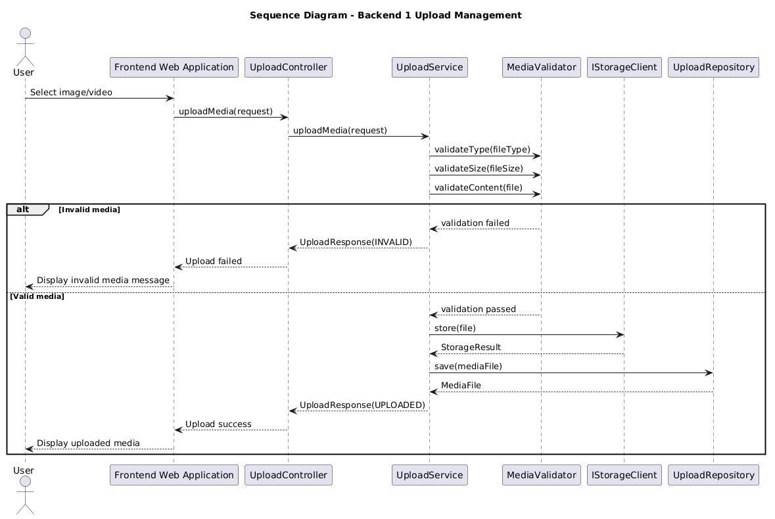
Figure 13. Sequence diagram - Backend 1 - Upload Management

Backend 1 - Detection Session
    - Module
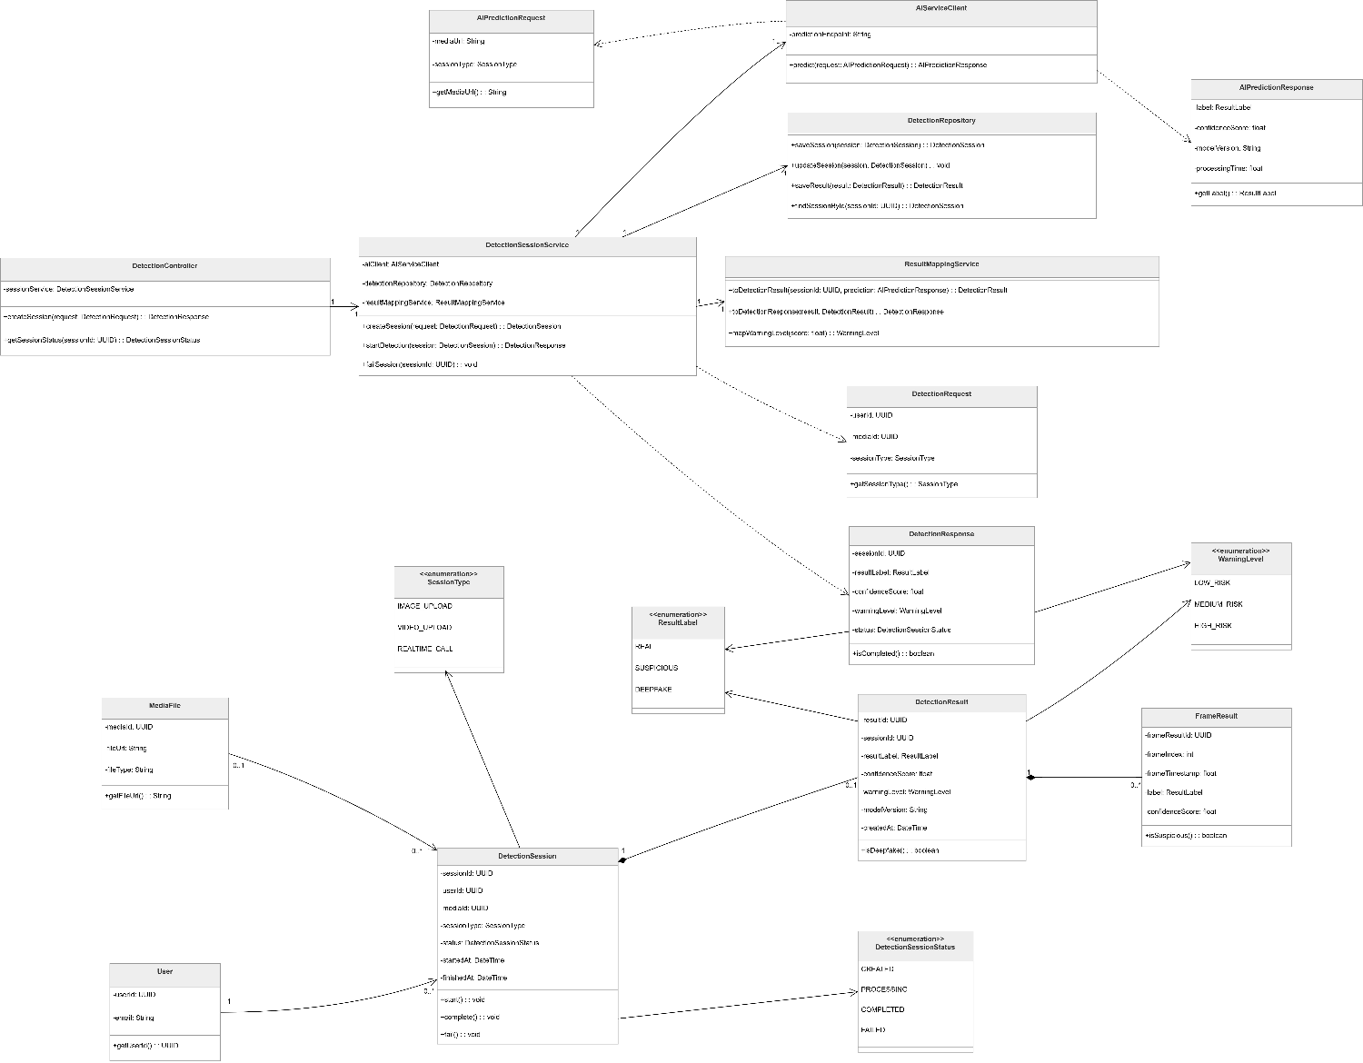
Figure 14. Backend 1 - Detection Session
Prose:
The class diagram illustrates the structure of the Detection Session component in the Deepfake Face Detection System. This component is responsible for creating detection sessions, sending prediction requests to the AI service, storing detection results, mapping AI outputs into system-level responses, and tracking the status of each detection workflow.
At the center of the design are the DetectionController and DetectionSessionService classes. The DetectionController acts as the entry point for detection-related operations. It receives detection requests from the client, creates new detection sessions, and provides session status information. Instead of handling business logic directly, the controller delegates processing to the DetectionSessionService.
The DetectionSessionService coordinates the main detection workflow. It creates detection sessions, starts the detection process, communicates with the AI service through the AIServiceClient, stores session and result data through the DetectionRepository, and converts AI responses into application-level results through the ResultMappingService. This design keeps the detection workflow centralized while still separating external communication, persistence, and response mapping responsibilities.
The AIServiceClient represents the integration point with the AI model service. It uses a prediction endpoint to send an AIPredictionRequest and receive an AIPredictionResponse. The prediction request contains information such as the media URL and session type, while the prediction response contains the predicted result label, confidence score, model version, and processing time.
Persistence is handled by the DetectionRepository. This class is responsible for saving detection sessions, updating session status, saving detection results, and retrieving sessions by session ID. By separating persistence logic from the service layer, the system can maintain a cleaner structure and reduce coupling between business logic and database operations.
The ResultMappingService converts AI prediction data into system-specific result objects. It builds a DetectionResult from the AI prediction response, creates a DetectionResponse for the client, and maps the prediction label into an appropriate WarningLevel. This class ensures that raw AI outputs are transformed into meaningful application results before being returned to users.
The diagram also includes several domain and data transfer classes. The DetectionRequest class represents the input required to start a detection session, including user ID, media ID, and session type. The DetectionResponse class represents the response returned to the client, including session ID, result label, confidence score, warning level, and session status. The DetectionSession class represents the lifecycle of a detection process and stores information such as session ID, user ID, media ID, session type, status, start time, and finish time.
Detection results are represented by the DetectionResult and FrameResult classes. The DetectionResult class stores the final result of a detection session, including result label, confidence score, warning level, model version, and creation time. The FrameResult class stores frame-level detection information, including frame index, frame timestamp, label, confidence score, and whether the frame is suspicious. This is useful for video or real-time detection workflows where multiple frames may be analyzed.
The User and MediaFile classes provide supporting information for the detection session. A detection session is associated with a user and may be associated with a media file. The MediaFile class provides the media URL and file information required by the detection process.
The diagram also defines several enumerations. ResultLabel defines the possible classification results: REAL, SUSPICIOUS, and DEEPFAKE. WarningLevel defines the risk level of the detection result: LOW_RISK, MEDIUM_RISK, and HIGH_RISK. SessionType defines the type of detection input, including IMAGE_UPLOAD, VIDEO_UPLOAD, and REALTIME_CALL. DetectionSessionStatus defines the lifecycle state of a detection session, including CREATED, PROCESSING, COMPLETED, and FAILED.
Overall, this class diagram shows a modular detection session design. The controller handles incoming requests, the service coordinates the workflow, the AI client communicates with the AI model service, the repository manages persistence, and the mapping service converts AI outputs into system-level results. This separation of responsibilities improves maintainability, testability, and extensibility.
Table 49. Class/Interface & Responsibility – Detection Session
Class/Interface | Responsibility
DetectionController | Handles detection-related requests from the client; creates detection sessions and retrieves session status by delegating operations to DetectionSessionService.
DetectionSessionService | Coordinates the detection workflow; creates sessions, starts detection, communicates with the AI service, stores results, updates session status, and returns detection responses.
AIServiceClient | Sends prediction requests to the AI model service and receives prediction responses; acts as the integration client between Backend 1 and the AI service.
DetectionRepository | Manages persistence for detection sessions and detection results; saves sessions, updates session status, saves results, and retrieves sessions by ID.
ResultMappingService | Converts AI prediction responses into DetectionResult and DetectionResponse objects; maps result labels into warning levels.
DetectionRequest | Represents the input data required to start a detection session, including user ID, media ID, and session type.
DetectionResponse | Represents the response returned to the client after detection processing; contains session ID, result label, confidence score, warning level, status, and completion information.
AIPredictionRequest | Represents the request sent to the AI service; contains media URL and session type information required for prediction.
AIPredictionResponse | Represents the response returned by the AI service; contains result label, confidence score, model version, and processing time.
DetectionSession | Represents a detection session and its lifecycle; stores session ID, user ID, media ID, session type, status, start time, and finish time.
DetectionResult | Represents the final result of a detection session; stores result label, confidence score, warning level, model version, and creation time.
FrameResult | Represents frame-level detection output; stores frame index, frame timestamp, label, confidence score, and suspicious-frame information.
MediaFile | Represents the media file used in a detection session; provides media ID, file URL, and file type information.
User | Represents the user who starts a detection session; stores user ID and email information.
ResultLabel | Enumeration that defines possible detection labels: REAL, SUSPICIOUS, and DEEPFAKE.
WarningLevel | Enumeration that defines risk levels: LOW_RISK, MEDIUM_RISK, and HIGH_RISK.
SessionType | Enumeration that defines supported detection session types: IMAGE_UPLOAD, VIDEO_UPLOAD, and REALTIME_CALL.
DetectionSessionStatus | Enumeration that defines session lifecycle states: CREATED, PROCESSING, COMPLETED, and FAILED.

    - C&C - Sequence diagram
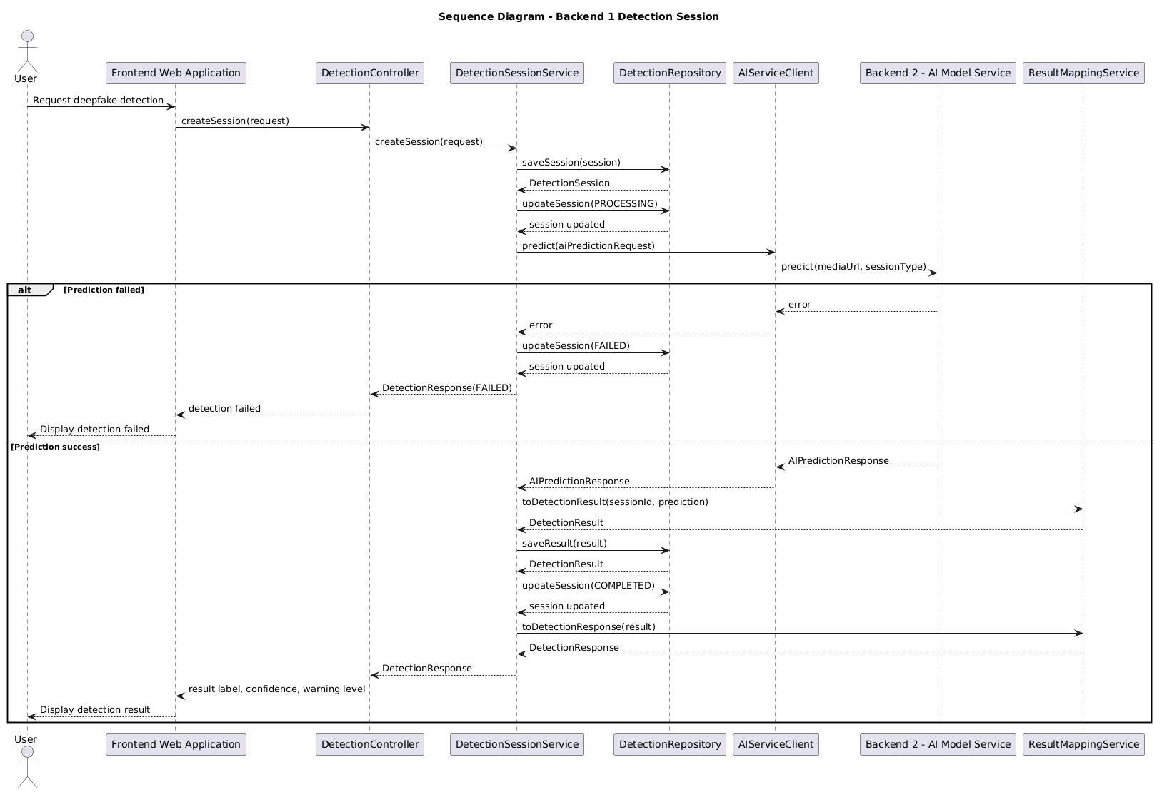
Figure 15. Sequence diagram - Backend 1 - Detection Session

Backend 1 - Result & Moderator Review
    - Module – Class
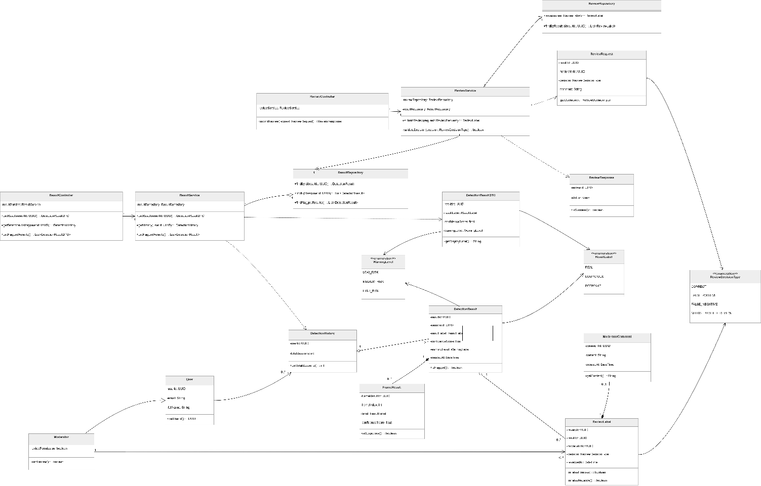
Figure 16. Backend 1 - Result & Moderator Review
Prose:
The class diagram illustrates the structure of the Result and Moderator Review component in the Deepfake Face Detection System. This component is responsible for retrieving detection results, displaying detection history, identifying flagged results, and allowing moderators to review suspicious detection cases. The design separates result retrieval, review submission, repository access, DTO objects, domain entities, and enumerations to improve maintainability and clarity.
The result retrieval workflow is handled by the ResultController and ResultService classes. The ResultController acts as the entry point for result-related requests. It allows the system to retrieve a detection result by result ID, retrieve a user's detection history, and get flagged detection results. Instead of directly accessing data, it delegates business logic to the ResultService.
The ResultService coordinates result-related operations. It uses the ResultRepository to retrieve detection results, detection history, and flagged results. This service converts repository data into result objects or DTOs that can be returned to the client. By separating the service layer from the controller and repository layers, the system keeps result retrieval logic organized and easier to modify.
Moderator review is handled by the ReviewController and ReviewService classes. The ReviewController receives review requests from moderators and delegates the review process to the ReviewService. The ReviewService validates the review decision, checks the related detection result, and stores the moderator review through the ReviewRepository. It also works with the ResultRepository when the review decision needs to be associated with an existing detection result.
The persistence layer is represented by ResultRepository and ReviewRepository. The ResultRepository retrieves detection results by result ID or user ID and provides access to flagged results that may require moderator review. The ReviewRepository saves review labels and retrieves review labels associated with a specific detection result.
The diagram also includes several domain and data transfer classes. The DetectionResultDTO class represents result data prepared for display, including result label, confidence score, and warning level. The DetectionHistory class stores summary information about a user's previous detection sessions. The DetectionResult class represents the stored detection output, including result ID, session ID, result label, confidence score, warning level, and creation time. The FrameResult class stores frame-level detection information and is associated with a detection result.
Moderator review data is represented by the ReviewRequest, ReviewResponse, ReviewLabel, and ModeratorComment classes. The ReviewRequest class contains the result ID, moderator ID, review decision, and comment submitted by a moderator. The ReviewResponse class represents the response returned after a review action. The ReviewLabel class stores the moderator's review decision, including whether the result is correct, false positive, false negative, or needs further review. The ModeratorComment class stores additional comment content written by the moderator.
The User class represents a general system user, while the Moderator class represents a specialized user with review permission. The moderator can review suspicious results and submit review decisions. This separation allows the system to distinguish normal users from users who have moderator responsibilities.
The diagram also defines several enumerations. ResultLabel defines possible detection labels, including REAL, SUSPICIOUS, and DEEPFAKE. WarningLevel defines the risk level of a detection result, including LOW_RISK, MEDIUM_RISK, and HIGH_RISK. ReviewDecisionType defines the possible moderator decisions, including CORRECT, FALSE_POSITIVE, FALSE_NEGATIVE, and NEEDS_FURTHER_REVIEW.
Overall, this class diagram shows a clear separation between result retrieval and moderator review. The result controller and service handle detection result access, while the review controller and service handle moderator decisions. Repositories manage data access, DTOs support client-facing responses, and domain classes represent stored system information. This structure improves maintainability, supports review workflows, and enables better traceability of suspicious detection results.
Table 50. Class/Interface & Responsibility – Result & Moderator Review
Class/Interface | Responsibility
ResultController | Handles result-related requests; retrieves detection results, detection history, and flagged results by delegating operations to ResultService.
ResultService | Coordinates result retrieval operations; uses ResultRepository to get detection results, user detection history, and flagged results.
ResultRepository | Manages persistence access for detection results; finds results by result ID, retrieves results by user ID, and retrieves flagged results.
ReviewController | Handles moderator review requests; receives review submissions and delegates review processing to ReviewService.
ReviewService | Coordinates the moderator review workflow; validates review decisions, checks related detection results, and saves review labels through ReviewRepository.
ReviewRepository | Manages persistence access for review data; saves ReviewLabel records and retrieves review labels by result ID.
DetectionResultDTO | Represents detection result data prepared for display; includes result label, confidence score, warning level, and display label information.
DetectionHistory | Represents a user's detection history; stores user ID and total session information.
DetectionResult | Represents the stored detection result; contains result ID, session ID, result label, confidence score, warning level, creation time, and flagged status.
FrameResult | Represents frame-level detection output; stores frame result ID, frame index, label, confidence score, and suspicious-frame information.
ReviewRequest | Represents the review data submitted by a moderator; contains result ID, moderator ID, review decision, and comment.
ReviewResponse | Represents the response returned after a review action; contains review ID, status, and success information.
ReviewLabel | Represents the moderator's final review label for a detection result; stores review ID, result ID, moderator ID, review decision, review time, and false positive or false negative information.
ModeratorComment | Represents an additional comment written by a moderator; stores comment ID, content, creation time, and comment retrieval behavior.
User | Represents a general system user; stores user ID, email, and full name information.
Moderator | Represents a specialized user with review permission; determines whether the user can review suspicious detection results.
ResultLabel | Enumeration that defines possible detection labels: REAL, SUSPICIOUS, and DEEPFAKE.
WarningLevel | Enumeration that defines warning levels: LOW_RISK, MEDIUM_RISK, and HIGH_RISK.
ReviewDecisionType | Enumeration that defines possible review decisions: CORRECT, FALSE_POSITIVE, FALSE_NEGATIVE, and NEEDS_FURTHER_REVIEW.

    - C&C - Sequence diagram
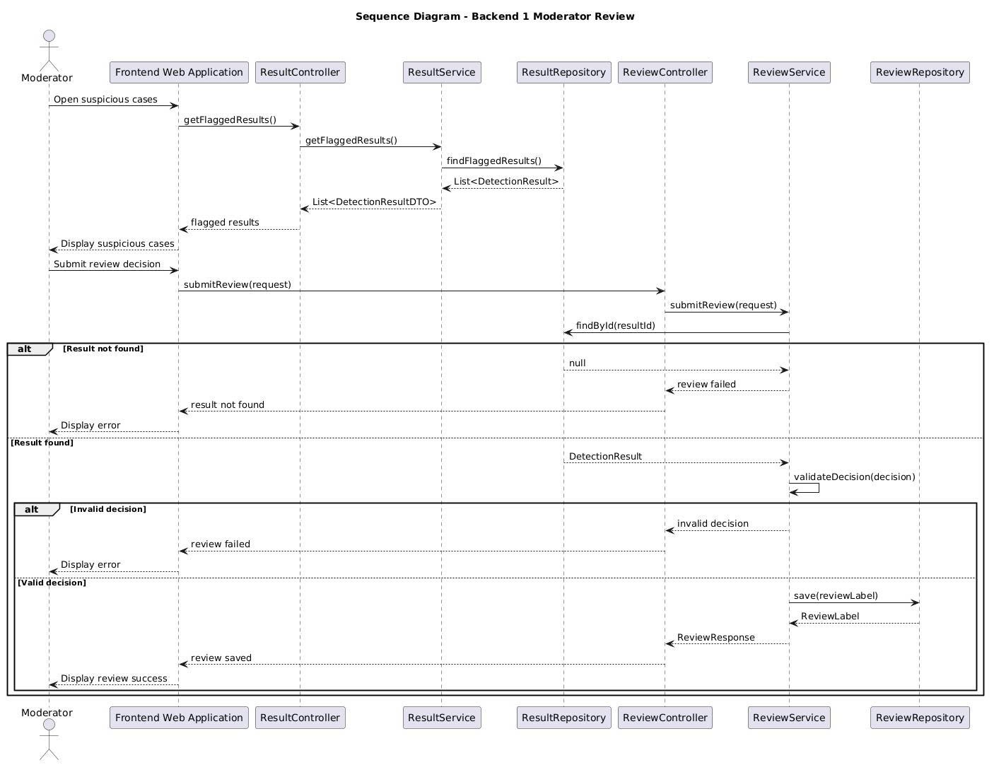
Figure 17. Sequence diagram - Backend 1 - Detection Session

Backend 2 - Input Processing
    - Module
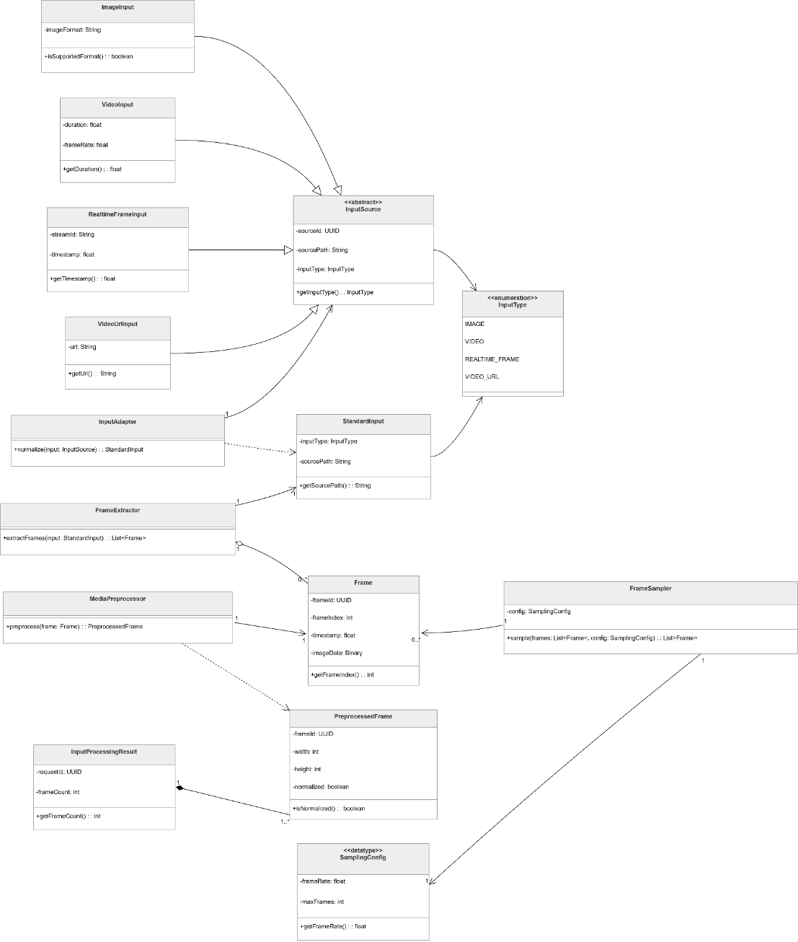
Prose:
The class diagram illustrates the structure of the Input Processing component in the Deepfake Face Detection System. This component is responsible for receiving different input types, converting them into a common internal format, extracting frames when necessary, sampling selected frames, preprocessing media data, and returning processed frames for later face detection and deepfake classification.
At the center of the design is the abstract InputSource class. This class represents a general input source that can be processed by the system. Several concrete input classes extend this abstraction, including ImageInput, VideoInput, RealtimeFrameInput, and VideoUrlInput. These classes represent different input sources supported by the system, such as uploaded images, uploaded videos, real-time frames, and video URLs. By using a common abstraction, the system can handle different input types consistently.
The InputType enumeration defines the supported categories of input. It allows the system to identify whether the input is an image, video, real-time frame, or video URL. This helps the input processing workflow decide how the input should be adapted, extracted, sampled, and preprocessed.
The InputAdapter class converts a concrete input source into a StandardInput object. The purpose of this class is to normalize different input formats into a common structure before they enter the rest of the processing pipeline. This improves maintainability because new input types can be supported by adding new input source classes and adapter logic without changing the downstream processing modules.
The StandardInput class represents the normalized input format used internally by the AI service. After the input is standardized, it can be passed to the frame extraction and preprocessing workflow. For video-based inputs, the FrameExtractor class extracts frames from the source media. These frames are represented by the Frame class, which stores frame-level information before preprocessing.
The FrameSampler class selects a subset of frames based on a SamplingConfig object. This is useful for video and real-time inputs where processing every frame may be inefficient. The sampling configuration defines how frames should be selected, allowing the system to balance detection accuracy and processing performance.
After frames are extracted and sampled, the MediaPreprocessor class prepares the frames for later AI processing. It performs preprocessing operations such as resizing, normalization, and format conversion. The result of this step is represented by the PreprocessedFrame class, which stores the processed frame data ready for face detection or model inference.
The InputProcessingResult class represents the final output of the input processing workflow. It contains the processed data and status information needed by the next stage of the AI pipeline. This result object allows the input processing component to return a consistent output regardless of whether the original input was an image, video, real-time frame, or video URL.
Overall, this class diagram shows a flexible and extensible input processing design. The use of an abstract input source, standardized input format, frame extraction, frame sampling, and preprocessing classes allows the system to support multiple media input types while keeping the downstream AI pipeline stable and consistent.
Table 51. Class/Interface & Responsibility – Input Processing
Class/Interface | Responsibility
InputSource | Abstract class that represents a general input source; provides a common structure for different input types handled by the system.
ImageInput | Represents an image input source uploaded or provided to the system for deepfake detection.
VideoInput | Represents a video input source that requires frame extraction before further processing.
RealtimeFrameInput | Represents a real-time frame input source captured from an incoming video stream.
VideoUrlInput | Represents a video input source provided through a URL that must be resolved before frame extraction.
InputType | Enumeration that defines supported input types, such as image, video, real-time frame, and video URL.
InputAdapter | Converts different concrete input sources into a standardized internal input format.
StandardInput | Represents the normalized input format used by the AI processing pipeline after adaptation.
FrameExtractor | Extracts frames from video-based input sources so they can be processed individually.
Frame | Represents a raw frame extracted from an input source before preprocessing.
FrameSampler | Selects important or representative frames from a larger frame set based on the sampling configuration.
SamplingConfig | Defines the configuration used for frame sampling, such as sampling rate or frame selection rules.
MediaPreprocessor | Prepares media frames for AI processing by applying operations such as resizing, normalization, and format conversion.
PreprocessedFrame | Represents a frame after preprocessing, ready for face detection or model inference.
InputProcessingResult | Represents the final output of the input processing workflow; contains processed frames and status information for the next AI processing stage.

    - C&C - Activity diagram
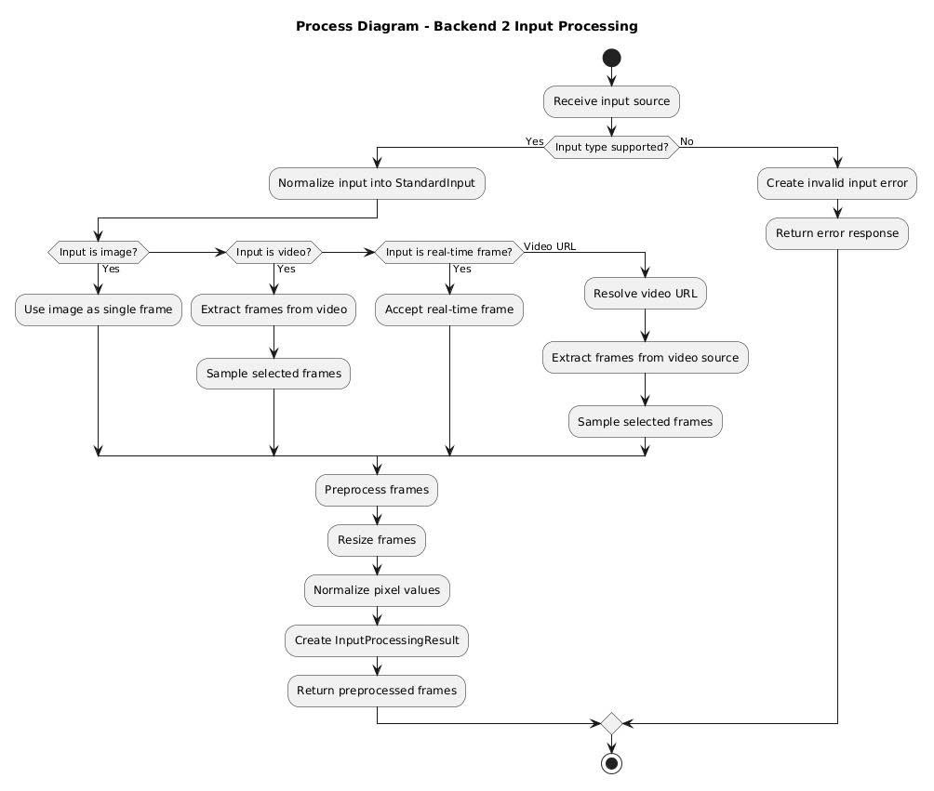
Figure 18. Activity diagram - Backend 2 - Input Processing

Backend 2 - Face Detection
    - Module – Class
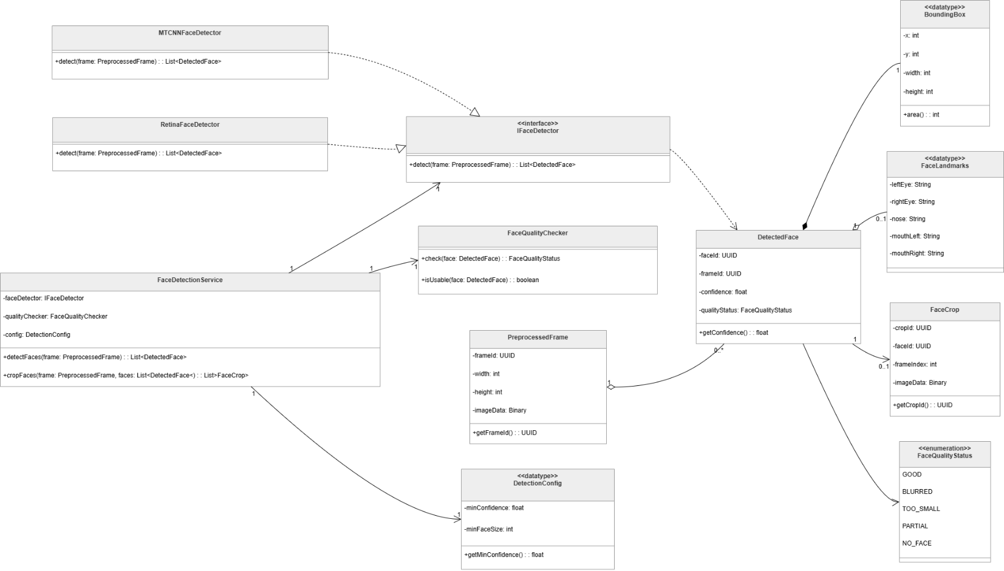
Figure 19. Backend 2 – Face Detection
Prose:
The class diagram illustrates the structure of the Face Detection component in the Deepfake Face Detection System. This component is responsible for detecting faces from preprocessed frames, evaluating face quality, extracting face regions, and preparing detected face data for the next stage of deepfake classification.
At the center of the design is the FaceDetectionService class. This service coordinates the face detection workflow by receiving a PreprocessedFrame, applying a configured face detection algorithm, checking the quality of detected faces, and returning structured face detection results. It acts as the main application-level class for this component and hides the details of the underlying face detection implementation from the rest of the AI pipeline.
The system uses the IFaceDetector interface to abstract the face detection algorithm. This interface allows different face detection implementations to be used without changing the main face detection service. The diagram includes two detector implementations: MTCNNFaceDetector and RetinaFaceDetector. Both classes represent concrete face detection strategies that can be selected or replaced depending on system requirements, accuracy, or performance.
The DetectionConfig data type stores configuration values used during face detection. These configuration values may include detector selection, confidence thresholds, minimum face size, or other detection parameters. By separating configuration into its own data type, the system can adjust detection behavior without changing the core service logic.
The PreprocessedFrame class represents an input frame that has already passed through the media preprocessing stage. It is the main input object for the face detection workflow. After a face is detected, the result is represented by the DetectedFace class. This class contains the information related to a detected face, such as its bounding box, facial landmarks, cropped face region, and quality status.
The BoundingBox data type represents the rectangular region where a face is located in the frame. The FaceLandmarks data type represents important facial key points, such as eyes, nose, and mouth positions. The FaceCrop class represents the cropped face image or region extracted from the original frame. These classes provide the structured data needed for later deepfake classification.
The FaceQualityChecker class evaluates whether a detected face is suitable for classification. It checks the quality of the detected face and returns a FaceQualityStatus value. The FaceQualityStatus enumeration defines possible quality states for detected faces. This helps the system filter out unusable or low-quality faces before they are sent to the classification model.
Overall, this class diagram shows a flexible and modular face detection design. The service layer coordinates the workflow, the detector interface allows different detection algorithms to be used, and the supporting data classes represent face location, landmarks, crops, and quality information. This structure makes the face detection component easier to maintain, test, and extend.
Table 52. Class/Interface & Responsibility – Face Detection
Class/Interface | Responsibility
FaceDetectionService | Coordinates the face detection workflow; receives preprocessed frames, applies face detection, checks face quality, and returns detected face information.
IFaceDetector | Defines the common interface for face detection algorithms; allows different detector implementations to be used interchangeably.
MTCNNFaceDetector | Implements face detection using the MTCNN-based detection approach.
RetinaFaceDetector | Implements face detection using the RetinaFace-based detection approach.
FaceQualityChecker | Evaluates the quality of detected faces and determines whether they are suitable for further classification.
PreprocessedFrame | Represents a frame that has already been processed by the media preprocessing stage and is ready for face detection.
DetectionConfig | Stores configuration values used during face detection, such as detector settings, thresholds, and detection parameters.
DetectedFace | Represents a detected face and stores related information such as bounding box, landmarks, face crop, and quality status.
BoundingBox | Represents the rectangular coordinates of a detected face within a frame.
FaceLandmarks | Represents key facial landmark points detected on a face.
FaceCrop | Represents the cropped face region extracted from the original frame.
FaceQualityStatus | Enumeration that defines the quality status of a detected face.

    - C&C - Sequence diagram
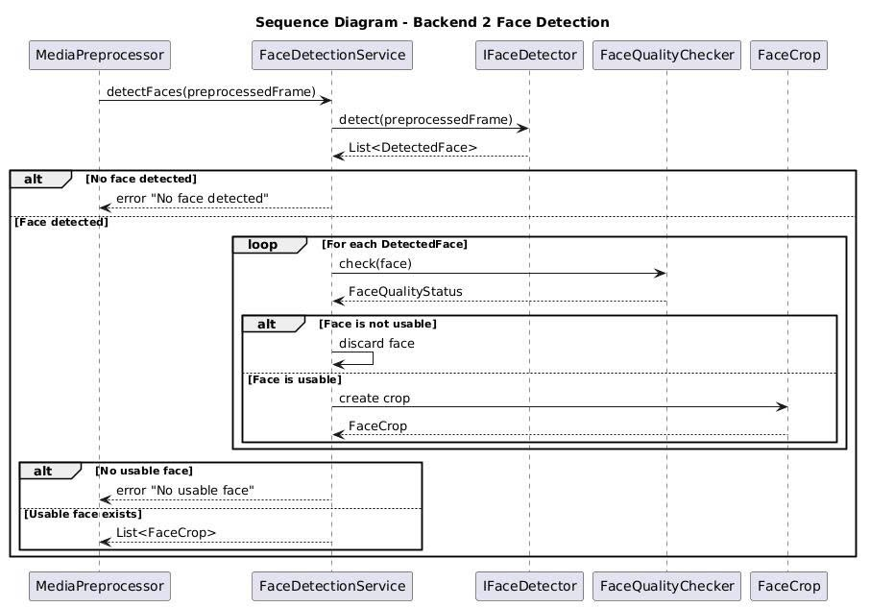
Figure 20. Sequence diagram - Backend 2 - Face Detection

Backend 2 - Deepfake Classification
    - Module – Class
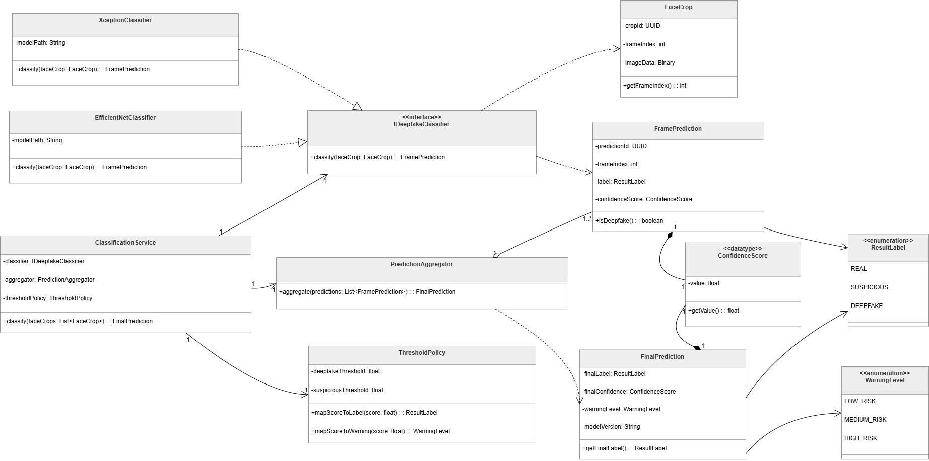
Figure 21. Backend 2 - Deepfake Classification

Prose:
The class diagram illustrates the structure of the Deepfake Classification component in the Deepfake Face Detection System. This component is responsible for classifying detected face crops, generating frame-level predictions, aggregating multiple predictions, and producing the final detection result with a label, confidence score, warning level, and model version.
At the center of the design is the ClassificationService class. This service coordinates the classification workflow by receiving a list of FaceCrop objects, sending each face crop to a deepfake classifier, collecting frame-level predictions, applying threshold rules, and generating a FinalPrediction. The service depends on three main collaborators: DeepfakeClassifier, PredictionAggregator, and ThresholdPolicy.
The DeepfakeClassifier interface defines the common classification operation used by different model implementations. It provides a classify method that receives a FaceCrop and returns a FramePrediction. This interface allows the classification service to use different deepfake detection models without changing the service logic.
The diagram includes two concrete classifier implementations: XceptionClassifier and EfficientNetClassifier. Both classifiers store a model path and implement the classification operation defined by the DeepfakeClassifier interface. This design allows the system to switch between model architectures or add new classifier implementations in the future.
The FaceCrop class represents the cropped face image extracted from a frame. It contains information such as crop ID, frame index, and binary image data. Each face crop is passed to a classifier to generate a frame-level prediction.
The FramePrediction class represents the prediction result for an individual frame or face crop. It stores the prediction ID, frame index, result label, and confidence score. It also provides behavior for checking whether the prediction is classified as deepfake.
The ConfidenceScore data type wraps the prediction confidence value. It stores a floating-point score and provides a method for retrieving the value. This keeps confidence-related data consistent between frame-level predictions and final predictions.
The PredictionAggregator class combines multiple FramePrediction objects into a single FinalPrediction. This is important for video or real-time analysis, where multiple frames may be classified separately before producing one final result.
The ThresholdPolicy class defines how raw confidence scores are mapped into result labels and warning levels. It stores thresholds for deepfake and suspicious classifications and provides mapping methods for converting a score into a ResultLabel or WarningLevel.
The FinalPrediction class represents the final output of the classification workflow. It contains the final result label, final confidence score, warning level, and model version. This object is returned after all frame-level predictions have been aggregated and interpreted.
The diagram also includes two enumerations. ResultLabel defines the possible classification labels: REAL, SUSPICIOUS, and DEEPFAKE. WarningLevel defines the possible risk levels: LOW_RISK, MEDIUM_RISK, and HIGH_RISK.
Overall, this class diagram shows a flexible and extensible classification design. The classification service coordinates the workflow, the classifier interface allows model replacement, concrete classifiers implement specific model architectures, the threshold policy controls label and warning mapping, and the aggregator produces a final result from multiple frame-level predictions.
Table 53. Class/Interface & Responsibility – Deepfake Classification
Class/Interface | Responsibility
ClassificationService | Coordinates the deepfake classification workflow; receives face crops, calls the classifier, applies aggregation, and returns the final prediction.
DeepfakeClassifier | Defines the common interface for deepfake classification models; classifies a FaceCrop and returns a FramePrediction.
XceptionClassifier | Implements DeepfakeClassifier using an Xception-based model; loads the model from a model path and classifies face crops.
EfficientNetClassifier | Implements DeepfakeClassifier using an EfficientNet-based model; loads the model from a model path and classifies face crops.
FaceCrop | Represents a cropped face image extracted from a frame; stores crop ID, frame index, and binary image data.
FramePrediction | Represents the classification result for a single face crop or frame; stores prediction ID, frame index, result label, and confidence score.
ConfidenceScore | Represents a confidence value returned by the classifier; wraps a floating-point score and provides access to the score value.
PredictionAggregator | Aggregates multiple frame-level predictions into a single final prediction.
ThresholdPolicy | Defines threshold rules for mapping confidence scores to result labels and warning levels.
FinalPrediction | Represents the final classification output; stores final label, final confidence score, warning level, and model version.
ResultLabel | Enumeration that defines possible classification labels: REAL, SUSPICIOUS, and DEEPFAKE.
WarningLevel | Enumeration that defines possible warning levels: LOW_RISK, MEDIUM_RISK, and HIGH_RISK.

    - C&C - Activity diagram
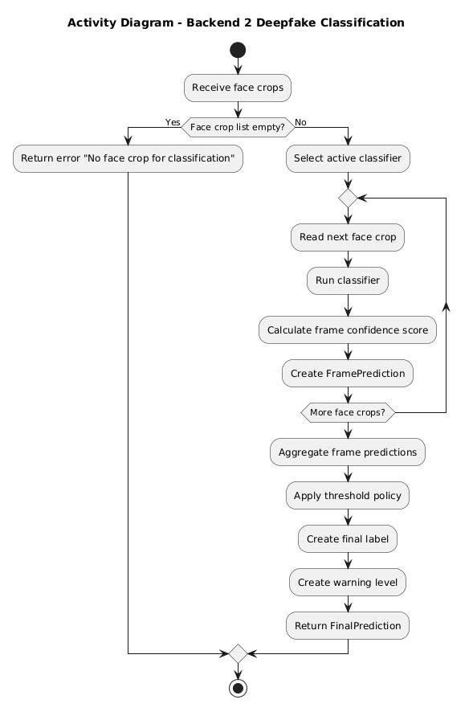
Figure 22. Activity diagram - Backend 2 - Deepfake Classification

Backend 2 - Model Management
    - Module - Class
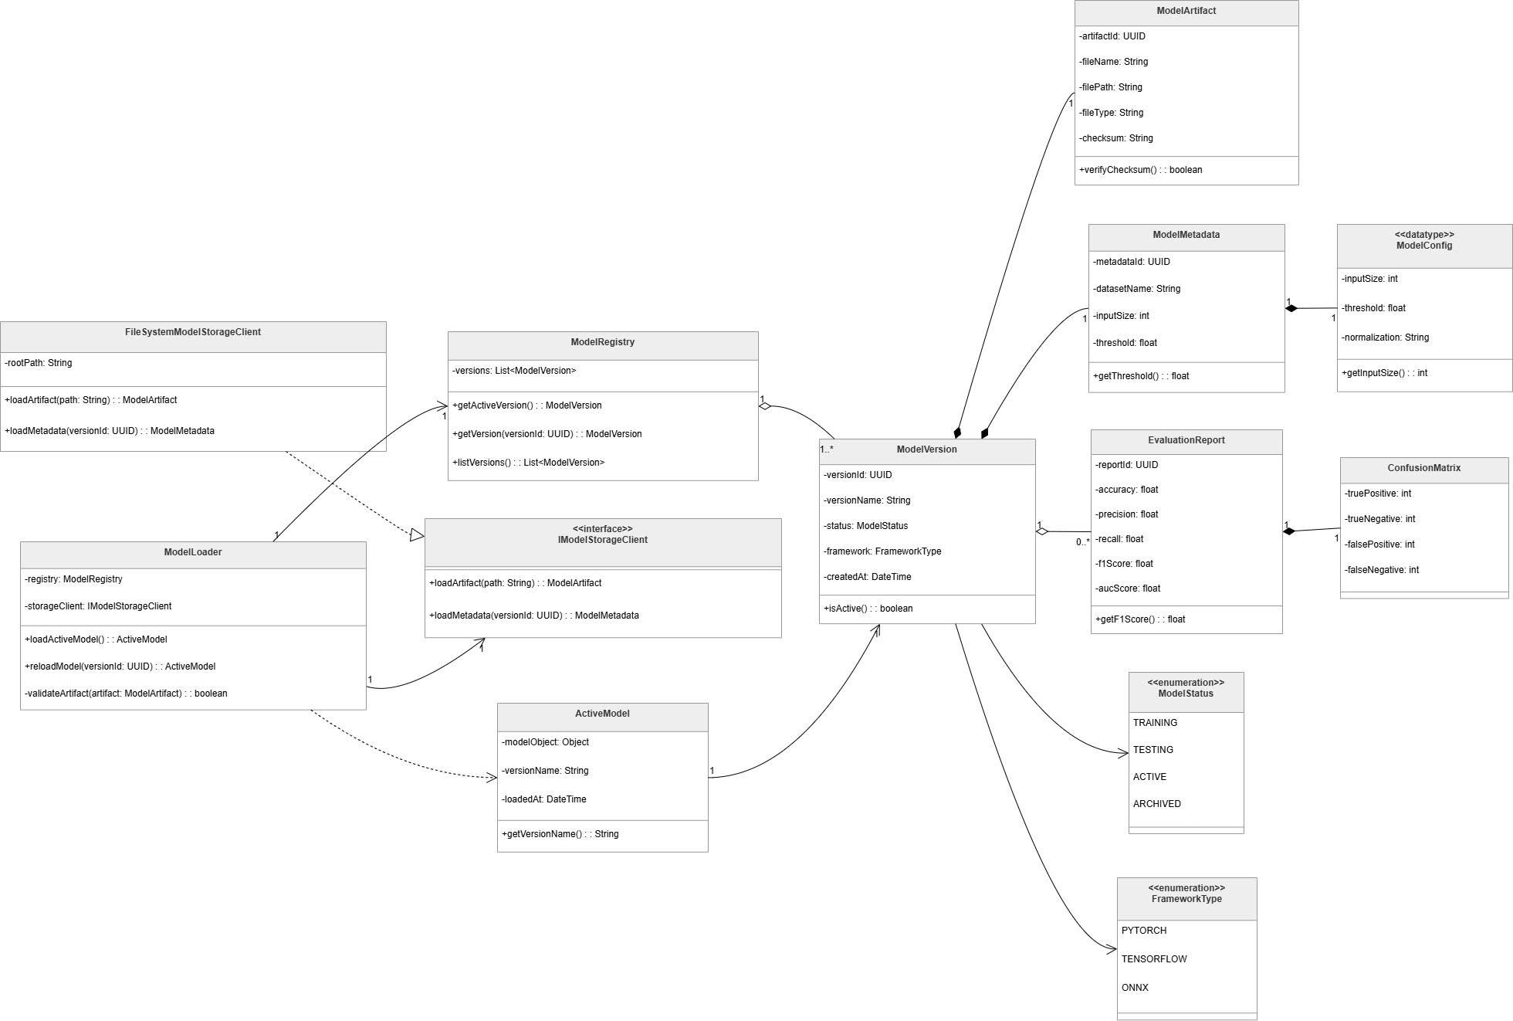
Figure 23. Backend 2 - Model Management
Prose:
The class diagram illustrates the structure of the Model Management component in the Deepfake Face Detection System. This component is responsible for managing model versions, loading the active model, retrieving model artifacts and metadata, validating model files, and providing model configuration information for inference.
At the center of the design is the ModelLoader class. This class coordinates the model loading workflow by using the ModelRegistry and the IModelStorageClient interface. The ModelLoader can load the currently active model, reload a specific model version, and validate model artifacts before they are used for inference. This allows the AI service to change or update models without modifying the main classification workflow.
The ModelRegistry class manages available model versions. It stores a list of ModelVersion objects and provides operations to retrieve the active version, get a specific model version by version ID, and list all available versions. This class acts as the source of model version information for the model loading process.
The IModelStorageClient interface abstracts the model storage mechanism. It defines operations for loading model artifacts and model metadata. The FileSystemModelStorageClient class implements this interface using a file-system-based storage approach. It loads model artifacts from a file path and loads metadata based on the model version ID. This abstraction allows the system to change the model storage implementation in the future without changing the ModelLoader logic.
The ModelVersion class represents a specific version of an AI model. It stores information such as version ID, version name, model status, framework type, and creation time. It also provides behavior for checking whether the model version is active. Each model version can be associated with model artifacts, metadata, and evaluation reports.
The ModelArtifact class represents the physical model artifact used for inference. It stores information such as artifact ID, file name, file path, file type, and checksum. It also provides behavior for verifying the checksum, which helps ensure that the model file has not been corrupted or modified incorrectly.
The ModelMetadata class stores metadata related to a model version, including dataset name, input size, and threshold. It provides access to the classification threshold used during inference. The ModelConfig data type stores configuration values such as input size, threshold, and normalization method. These configuration values allow the AI model service to prepare input data correctly before inference.
The ActiveModel class represents the model currently loaded into runtime memory. It stores the loaded model object, version name, and loading time. This class allows the system to keep track of which model version is currently available for classification.
The diagram also includes evaluation-related classes. The EvaluationReport class stores model performance metrics such as accuracy, precision, recall, F1 score, and AUC score. It is associated with the ConfusionMatrix class, which stores true positive, true negative, false positive, and false negative values. These classes support model evaluation and comparison between different model versions.
The diagram defines two important enumerations. ModelStatus represents the lifecycle state of a model version, including TRAINING, TESTING, ACTIVE, and ARCHIVED. FrameworkType defines the machine learning framework used by the model, including PYTORCH, TENSORFLOW, and ONNX.
Overall, this class diagram shows a modular model management design. The ModelLoader coordinates runtime loading, the ModelRegistry manages model versions, the storage client abstracts model storage access, and model-related data classes represent artifacts, metadata, configuration, active model information, and evaluation results. This design supports model replacement, version tracking, validation, and future extension with limited impact on the AI inference workflow.
Table 54. Class/Interface & Responsibility – Model Management
Class/Interface | Responsibility
ModelLoader | Coordinates the model loading workflow; loads the active model, reloads a specific model version, and validates model artifacts before use.
ModelRegistry | Manages available model versions; retrieves the active model version, retrieves a model version by ID, and lists all model versions.
IModelStorageClient | Defines the interface for loading model artifacts and model metadata from model storage.
FileSystemModelStorageClient | Implements IModelStorageClient using file-system-based storage; loads model artifacts and metadata from stored file paths.
ActiveModel | Represents the model currently loaded into runtime memory; stores the model object, version name, and loading time.
ModelVersion | Represents a specific version of an AI model; stores version ID, version name, status, framework type, and creation time.
ModelArtifact | Represents a stored model artifact file; stores artifact ID, file name, file path, file type, checksum, and checksum verification behavior.
ModelMetadata | Stores metadata for a model version, including dataset name, input size, threshold, and threshold access behavior.
ModelConfig | Stores model configuration values such as input size, classification threshold, and normalization method.
EvaluationReport | Stores model evaluation metrics such as accuracy, precision, recall, F1 score, and AUC score.
ConfusionMatrix | Stores confusion matrix values, including true positive, true negative, false positive, and false negative counts.
ModelStatus | Enumeration that defines model version states: TRAINING, TESTING, ACTIVE, and ARCHIVED.
FrameworkType | Enumeration that defines supported model frameworks: PYTORCH, TENSORFLOW, and ONNX.

    - C&C
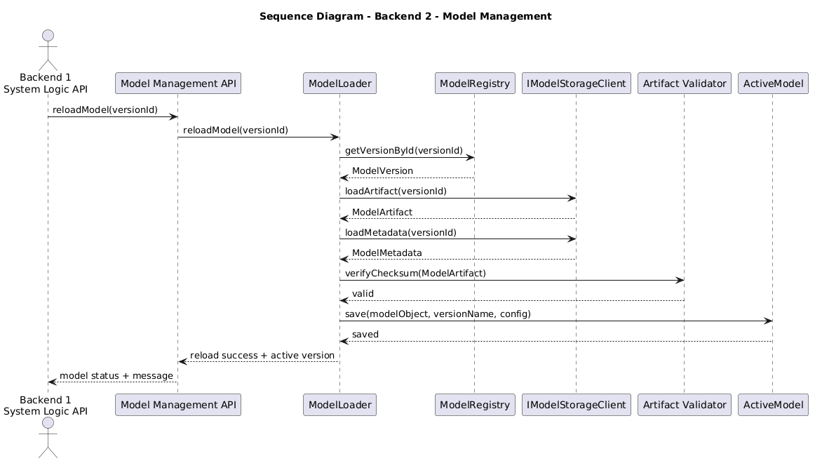
Figure 24. Sequence - Backend 2 - Model Management

Attribute-Driven Design

QA01 - Modifiability Design for Adding New Input Types without Changing the Core Classifier
    - Affected Artifacts & Allocation
Quality Attribute | Tactic / Pattern Applied | Allocation | Detailed Responsibility
Modifiability | Pattern: Adapter Pattern  Tactic: Reduce Coupling – Use an Intermediary | Container: Backend 2 – AI Model Service  Component: InputAdapter  Code: InputAdapter | Converts all concrete input types into StandardInput. When a new input type is added, the change is mainly handled inside the adapter layer.
Modifiability | Tactic: Encapsulate | Container: Backend 2 – AI Model Service  Component: Concrete Input Sources  Code: ImageInput, VideoInput, RealtimeFrameInput, VideoUrlInput | Encapsulates input-specific data and behavior inside separate input classes. This prevents input-specific logic from spreading into the classifier.
Modifiability | Tactic: Restrict Dependencies | Container: Backend 2 – AI Model Service  Component: Stable Detection and Classification Core  Code: ClassificationService, DeepfakeClassifier | Prevents the classifier from depending on raw input types. The classifier only receives prepared face crops or processed frame data.
Modifiability | Pattern: Pipes and Filters  Tactic: Increase Cohesion | Container: Backend 2 – AI Model Service  Component: Frame-based Processing Pipeline  Code: FrameExtractor, FrameSampler, MediaPreprocessor | Keeps frame extraction, sampling, and preprocessing in a cohesive pipeline. New input sources are standardized before reaching this pipeline.
Modifiability | Tactic: Abstract Common Services | Container: Backend 2 – AI Model Service  Component: StandardInput  Code: StandardInput, InputSource | Provides a stable internal contract between changing input sources and stable downstream processing components.
Modifiability | Tactic: Reduce Coupling | Container: Backend 1 – System Logic API  Component: Detection Session Component  Code: DetectionSessionService, AIPredictionRequest | Sends prediction requests using a stable API contract. Backend 1 does not need to understand the internal processing details of each input type.
Modifiability | Tactic: Encapsulate | Container: Database  Component: Media Metadata Schema  Code/Data: media_files, optional source_type metadata | Stores media metadata and optional input source information without changing the detection result schema.
    - Rationale & Discarded Alternatives
Alternative | Evaluation against Objective / Constraints | Rationale
Connect each input type directly to the classifier | Not suitable. Every new input type would require changes in the classifier or classification service. | Rejected because it increases coupling and violates the goal of keeping the classifier unchanged.
Create a separate classifier for each input type | Not suitable. It duplicates classification logic and makes model maintenance difficult. | Rejected because all input types should share the same deepfake classification logic after preprocessing.
Let Backend 1 transform all input types before calling the AI service | Partially suitable, but not ideal. Backend 1 would become responsible for media transformation logic that belongs to the AI pipeline. | Rejected because media transformation, frame extraction, and preprocessing should remain inside Backend 2 – AI Model Service.
Store every input as raw data in the database and let the classifier read from the database | Not suitable. It increases database I/O and makes the AI pipeline depend on database structure. | Rejected because the database should store metadata, sessions, and results, not act as the main data transfer mechanism for AI processing.
Convert all input types into StandardInput before processing | Suitable. It keeps downstream components independent from concrete input types. | Selected because it supports adding a new input type within 2–3 working days while keeping the classifier unchanged.
Use an adapter-based input pipeline | Suitable. It isolates input-specific changes and protects the stable classifier. | Selected because it applies Reduce Coupling, Encapsulate, Restrict Dependencies, and Increase Cohesion effectively.
    - Risks & Trade-offs
- Trade-off: Additional architectural elements are introduced.
The design adds InputSource, InputAdapter, and StandardInput. This increases the number of components, but it reduces future modification cost and protects the classifier from input-specific changes.
- Trade-off: Input processing becomes more structured but slightly more complex.
Developers must follow the input standardization pipeline instead of directly sending data to the classifier.
- Risk: Incorrect adapter logic may produce invalid standardized input.
If a new input type is converted incorrectly, downstream components may receive invalid frames or incomplete media data.
- Risk Mitigation:
Each new input type must include validation rules, adapter unit tests, and integration tests. The output of the adapter must be checked before it is passed to the frame-based processing pipeline.
- Risk: Some new input types may require additional metadata.
For example, video URL input may require source URL, duration, access status, or download state.
- Risk Mitigation:
Store input-specific metadata as optional media metadata. Avoid changing the detection result schema unless the final detection output itself changes.
- Risk: The adapter may become too large over time.
If many input types are added, InputAdapter may become complex.
- Risk Mitigation:
Split adapter logic into smaller input-specific adapter classes if the number of input types grows. For example, ImageInputAdapter, VideoInputAdapter, and VideoUrlInputAdapter can be introduced later while keeping the same StandardInput contract.

QA02 - Modifiability Design for Updating the Deepfake Detection Model without Changing the Detection Flow
    - Affected Artifacts & Allocation
Quality Attribute | Tactic / Pattern Applied | Allocation | Detailed Responsibility
Modifiability | Tactic: Defer Binding Time | Container: Backend 2 – AI Model Service  Component: ModelLoader Code: ModelLoader | Delays model selection until startup or reload time. It loads the active model based on model metadata instead of hardcoded model paths.
Modifiability | Pattern: Registry Pattern | Container: Backend 2 – AI Model Service  Component: ModelRegistry Code: ModelRegistry | Manages available model versions, retrieves the active version, and provides version information to the ModelLoader.
Modifiability | Tactic: Reduce Coupling – Use an Intermediary | Container: Backend 2 – AI Model Service  Component: IModelStorageClient  Code: IModelStorageClient, FileSystemModelStorageClient | Abstracts access to model artifacts and metadata so the ModelLoader does not depend directly on file system or object storage details.
Modifiability | Tactic: Encapsulate | Container: Model Storage Component: Model Metadata and Artifacts  Code/Data: ModelVersion, ModelArtifact, ModelMetadata, ModelConfig | Encapsulates model path, framework type, input size, threshold, checksum, and preprocessing configuration outside the classification logic.
Modifiability | Pattern: Strategy Pattern | Container: Backend 2 – AI Model Service  Component: Deepfake Classification  Code: DeepfakeClassifier, XceptionClassifier, EfficientNetClassifier | Allows different classifier implementations to be used through the same classification interface.
Modifiability | Tactic: Restrict Dependencies | Container: Backend 1 – System Logic API  Component: Detection Session Component  Code: DetectionSessionService, AIPredictionRequest | Keeps Backend 1 dependent only on the prediction API contract, not on model version, model file, or framework details.
Modifiability | Tactic: Encapsulate Runtime State | Container: Backend 2 – AI Model Service  Component: ActiveModel Code: ActiveModel | Stores the currently loaded model object, version name, and loading time so the AI service can track the model used for inference.
Modifiability | Tactic: Validate Changes | Container: Model Storage / Backend 2  Component: ModelArtifact, EvaluationReport, ConfusionMatrix  Code/Data: ModelArtifact, EvaluationReport, ConfusionMatrix | Supports checksum verification and model evaluation before or after activation to reduce the risk of loading invalid or low-quality models.
    - Rationale & Discarded Alternatives
Alternative | Evaluation against Objective / Constraints | Rationale
Hardcode the model path inside the classifier | Not suitable. Every model update requires Risks & Trade-offs ode modification and redeployment. | Rejected because it violates modifiability and increases regression risk in the classification code.
Replace the model file manually using the same file name | Partially suitable but unsafe. It may work quickly, but it loses version history and rollback ability. | Rejected because the system needs model version tracking, active model metadata, and evaluation records.
Store model version and metadata in Model Storage and load the active version through ModelLoader | Suitable. The model can be changed by updating metadata and active version configuration. | Selected because it supports Defer Binding Time and keeps the prediction flow stable.
Let Backend 1 choose the model version for every request | Not suitable. Backend 1 should not know model storage or AI model details. | Rejected because it couples business logic API with AI model management.
Load the new model dynamically during every prediction request | Not suitable. It increases inference latency and wastes resources. | Rejected because the model should be loaded once at startup or reload time, then reused during prediction.
Use a stable classifier interface with interchangeable model implementations | Suitable. It allows changing model architecture while keeping classification service stable. | Selected because it supports model replacement without changing the API contract or detection session flow.

    - Risks & Trade-offs
- Trade-off: More model management metadata is required.
The system must maintain model versions, artifact paths, thresholds, input sizes, framework types, checksums, and active model status. This adds management overhead but enables controlled model replacement.
- Trade-off: Restart or reload is required.
The QA02 scenario allows the AI service to restart with the new model. This creates short downtime, but the target is to keep downtime within 10 minutes.
- Risk: A new model may have a different input size or preprocessing requirement.
If the new model expects a different input format, incorrect preprocessing may reduce accuracy or cause inference failure.
- Risk Mitigation:
Store input_size, threshold, and preprocessing_config inside ModelMetadata or ModelConfig. The preprocessing pipeline must read these values when preparing input for inference.
- Risk: A corrupted model artifact may be loaded.
A broken model file can crash the AI service or return invalid predictions.
- Risk Mitigation:
Use ModelArtifact.verifyChecksum() before activation. The AI service should reject artifacts that fail validation.
- Risk: A new model may improve speed but reduce accuracy, or improve accuracy but increase latency.
This creates a trade-off between model performance and detection quality.
- Risk Mitigation:
Store evaluation metrics such as accuracy, precision, recall, F1 score, AUC score, and confusion matrix results before activating the model. The team should compare models before switching the active version.
- Risk: Rollback may be needed after deployment.
The new model may introduce unexpected inference errors or poor results.
- Risk Mitigation:
Keep previous model versions in Model Storage and allow the ModelRegistry to reactivate an older stable version.

QA03 - Modifiability Design for Adding New Warning Levels to Detection results
    - Affected Artifacts & Allocation
Quality Attribute | Tactic / Pattern Applied | Allocation | Detailed Responsibility
Modifiability | Tactic: Increase Cohesion | Container: Backend 1 – System Logic API  Component: Result Management Component  Code: ResultManagement, ResultService | Groups result formatting, result retrieval, and warning-level assignment inside one cohesive backend area.
Modifiability | Pattern: Policy Object Tactic: Encapsulate | Container: Backend 1 – System Logic API  Component: Warning-Level Mapping Layer  Code: WarningLevelPolicy | Centralizes rules for mapping result labels and confidence scores into warning levels. New warning levels are added mainly here.
Modifiability | Pattern: DTO Tactic: Abstract Common Services | Container: Backend 1 – System Logic API  Component: Result Mapping  Code: ResultMappingService, DetectionResultDTO | Builds a stable result response model that contains result label, confidence score, warning level, model version, and status.
Modifiability | Tactic: Restrict Dependencies | Container: Backend 2 – AI Model Service  Component: Deepfake Classification  Code: ClassificationService, DeepfakeClassifier | Prevents warning-level changes from affecting the AI classifier. The classifier only produces prediction labels and confidence scores.
Modifiability | Tactic: Increase Cohesion | Container: Frontend Web Application  Component: Detection Result UI  Code: DetectionResultUI, WarningDisplayConfig | Displays warning levels consistently using shared display configuration. The UI does not recalculate warning-level rules.
Modifiability | Tactic: Encapsulate | Container: Frontend Web Application  Component: Detection History UI and Moderator Review UI  Code: DetectionHistoryUI, ModeratorReviewUI | Uses the warning level returned by the backend and applies consistent visual representation for history and review screens.
Modifiability | Tactic: Maintain Backward Compatibility | Container: Database  Component: Detection Result Schema  Code/Data: detection_results.warning_level | Stores warning-level data while keeping old detection results readable. Old results can be mapped to a default or derived warning level when needed.
    - Rationale & Discarded Alternatives
Alternative | Evaluation against Objective / Constraints | Rationale
Hardcode warning-level logic inside every frontend screen | Not suitable. Each screen would need to be modified when warning levels change. | Rejected because it duplicates business logic and increases the number of affected components.
Let the AI classifier directly output warning levels | Not suitable. Warning levels are product-facing risk feedback, not core model classification logic. | Rejected because it couples product policy with AI inference and makes future warning-level changes harder.
Store only warning levels and remove original result labels | Not suitable. Old results and model outputs would lose semantic meaning. | Rejected because the system still needs to preserve Real, Suspicious, and Deepfake as the original detection labels.
Add warning-level rules directly inside database queries | Not suitable. This makes business policy hard to test and maintain. | Rejected because mapping rules should stay in the backend result management layer, not inside SQL logic.
Centralize warning-level mapping inside Result Management | Suitable. Only result mapping and display configuration need to change. | Selected because it supports the QA03 goal of limiting the change to no more than 3 affected components.
Use a stable result DTO with warning-level field | Suitable. The frontend can display new levels without knowing the calculation rules. | Selected because it separates backend policy from frontend display and keeps old results readable.
    - Risks & Trade-offs
- Trade-off: Result Management becomes the central policy point.
Centralizing warning-level logic improves cohesion, but it also means this component must be carefully tested whenever warning rules change.
- Trade-off: The frontend becomes dependent on warning-level names returned by the backend.
If warning-level names change, the frontend display configuration must be updated.
- Risk: Old detection results may not have a warning-level value.
If the schema is extended after previous results already exist, old records may contain no warning-level data.
- Risk Mitigation:
Old results should remain readable by deriving a default warning level from existing result labels and confidence scores. For example, old REAL results may be displayed as LOW_RISK, old SUSPICIOUS results as MEDIUM_RISK, and old DEEPFAKE results as HIGH_RISK.
- Risk: Different screens may display warning levels inconsistently.
Detection Result UI, Detection History UI, and Moderator Review UI may present warning levels differently.
- Risk Mitigation:
Use a shared WarningDisplayConfig in the frontend so that all screens use the same text, icon, color, and priority rules.
- Risk: New warning levels may confuse users.
Too many warning levels may make the result harder to understand.
- Risk Mitigation:
Warning levels should be limited to clear and actionable categories. Each level should have a short explanation in the Detection Result UI.

QA04 - Performance Design for Short Video Deepfake Detection within 50 Seconds
    - Affected Artifacts & Allocation
Quality Attribute | Tactic / Pattern Applied | Allocation | Detailed Responsibility
Performance | Tactic: Manage Sampling Rate | Container: Backend 2 – AI Model Service Component: Frame Reduction Layer Code: FrameExtractor, FrameSampler, SamplingConfig | Reduces the number of frames processed from the uploaded video. Only representative frames are selected for analysis.
Performance | Tactic: Increase Resource Efficiency | Container: Backend 2 – AI Model Service Component: Face-focused Processing Layer Code: MediaPreprocessor, FaceDetectionService, FaceCrop | Resizes frames, detects faces, and crops only face regions so the classifier processes smaller inputs instead of full frames.
Performance | Tactic: Reduce Overhead | Container: Backend 2 – AI Model Service Component: Loaded Active Model Code: ModelLoader, ActiveModel | Keeps the active model loaded in memory and avoids reloading the model for every sampled frame.
Performance | Tactic: Bound Execution Time | Container: Backend 1 – System Logic API Component: Upload & Validation Layer Code: MediaValidator, UploadService | Rejects unsupported or oversized videos early to avoid detection sessions that exceed the expected processing time.
Performance | Pattern: Pipes and Filters | Container: Backend 2 – AI Model Service Component: AI Processing Pipeline Code: FrameExtractor, FrameSampler, MediaPreprocessor, FaceDetectionService, ClassificationService, PredictionAggregator | Organizes video detection into sequential stages so each stage can be optimized independently.
Performance | Pattern: Batch Processing | Container: Backend 2 – AI Model Service Component: Classification Layer Code: ClassificationService, DeepfakeClassifier, FramePrediction | Processes selected face crops as a controlled set instead of processing the entire video frame by frame.
Performance | Tactic: Reduce Overhead | Container: Backend 1 – System Logic API Component: Result Management Layer Code: ResultService, DetectionResponse | Returns a compact final result after aggregation instead of sending unnecessary frame-level details to the frontend.

    - Rationale & Discarded Alternatives
Alternative | Evaluation against Objective / Constraints | Rationale
Process every frame in the uploaded video | Not suitable. It creates high computation cost and may exceed the 50-second response target. | Rejected because full-frame processing is too expensive for short video detection under limited resources.
Store every extracted frame in the database before AI processing | Not suitable. It adds heavy database I/O and slows down the detection workflow. | Rejected because the database should store metadata, results, and selected evidence, not every intermediate frame.
Classify full video frames without face cropping | Not suitable. The classifier would process unnecessary background data. | Rejected because deepfake detection should focus on face regions, and face cropping improves resource efficiency.
Reload the model for each sampled frame | Not suitable. It creates repeated loading overhead and increases inference time. | Rejected because the active model should be loaded once and reused.
Use frame sampling and face-focused classification | Suitable. It reduces frame count and input size while preserving the main detection workflow. | Selected because it supports the 50-second response requirement.
Aggregate frame-level predictions into one final result | Suitable. It reduces response payload size and provides a clear user-facing output. | Selected because users need a final label and confidence score rather than raw predictions for every frame.

    - Risks & Trade-offs
- Trade-off: Performance vs. Detection Completeness
Frame sampling improves performance, but it may miss short deepfake segments that appear between sampled frames.
- Risk: False negatives from skipped frames
If deepfake manipulation appears only briefly, the sampled frames may not capture it.
- Risk Mitigation:
Use a reasonable sampling configuration. For suspicious videos or short clips, the system can increase sampling density to reduce the chance of missing manipulated frames.
- Trade-off: Face cropping improves speed but depends on face detection quality
If face detection fails, the classifier may not receive the correct face region.
- Risk Mitigation:
If no face is detected in selected frames, the system should return a clear processing status instead of producing a misleading classification.
- Risk: Large video files may still cause timeout
Even with sampling, very large or long videos may exceed the expected processing time.
- Risk Mitigation:
Apply validation rules for file format, file size, and duration before starting the AI pipeline.
- Risk: Model inference may still be the bottleneck
If the active model is too slow, the system may still fail to meet the 50-second target.
- Risk Mitigation:
Keep the model loaded in memory, process only selected face crops, and compare model inference speed before activating a new model version.

QA05 - Performance Design for Handling Concurrent Detection Requests
    - Affected Artifacts & Allocation
Quality Attribute | Tactic / Pattern Applied | Allocation | Detailed Responsibility
Performance | Tactic: Introduce Processing Queue | Container: Backend 1 – System Logic API Component: Processing Queue Code: DetectionTaskQueue, DetectionJob | Stores heavy ML detection tasks instead of processing every request immediately. This prevents Backend 1 from blocking when many users submit requests at the same time.
Performance | Pattern: Producer-Consumer | Container: Backend 1 – System Logic API Component: Detection Session Service and Detection Worker Code: DetectionSessionService, DetectionWorker, DetectionJobProcessor | Detection Session Service produces jobs and places them into the queue. Detection Worker consumes jobs and sends them to Backend 2 when resources are available.
Performance | Tactic: Control Resource Demand | Container: Backend 1 – System Logic API Component: Queue Capacity Policy Code: QueueCapacityPolicy, RateLimitPolicy | Limits how many jobs can wait or run at the same time. If the queue is full, the system returns a temporarily busy message instead of crashing.
Performance | Pattern: Asynchronous Processing | Container: Backend 1 – System Logic API Component: Detection Session Component Code: DetectionController, DetectionSessionService, DetectionStatus | Returns a session ID or queued status quickly, while ML processing continues in the background. Users can later retrieve status or results.
Performance | Tactic: Bound Execution Time | Container: Backend 1 – System Logic API Component: Upload & Validation Layer Code: MediaValidator, UploadService | Rejects invalid, unsupported, or oversized files early before they enter the queue. This prevents expensive detection jobs from wasting processing resources.
Performance | Tactic: Increase Resource Efficiency | Container: Backend 2 – AI Model Service Component: AI Processing Pipeline Code: FrameSampler, MediaPreprocessor, FaceDetectionService, ClassificationService | Reduces AI workload by sampling video frames, preprocessing media, cropping face regions, and sending only useful inputs to the classifier. Backend 2 is responsible for preprocessing, face detection, classification, and confidence aggregation.
Performance | Tactic: Maintain System Responsiveness | Container: Frontend Web Application / Backend 1 Component: Detection Result UI, History Management Component Code: DetectionResultUI, DetectionHistoryUI, HistoryManagementService | Lets users see queued, processing, completed, or failed status instead of waiting on a blocked request.
Performance | Tactic: Preserve Request State | Container: Database Component: Detection Session Schema and Detection Result Schema Code/Data: detection_sessions, detection_results, system_errors | Stores session status and result data so queued or failed jobs can be tracked. This reduces the risk of losing requests during peak load.

    - Rationale & Discarded Alternatives
Alternative | Evaluation against Objective / Constraints | Rationale
Process every detection request synchronously inside Backend 1 | Not suitable. Image and video detection can take time, especially video detection because it requires frame extraction, face detection, classification, and aggregation. | Rejected because synchronous processing may block Backend 1 and make the web application unresponsive during peak load.
Send every incoming request directly to Backend 2 without queue control | Not suitable. Backend 2 has limited CPU/GPU resources and may become overloaded when many users submit requests together. | Rejected because uncontrolled AI requests can cause slow inference, service timeout, or crashes.
Allow unlimited jobs in the queue | Not suitable. A very large queue may consume memory and make users wait too long. | Rejected because queue size must be bounded to avoid queue overflow and backend instability.
Drop new requests immediately when the system is busy | Partially suitable but not user-friendly. It protects the system but may lose valid user requests. | Rejected because the system should accept requests when possible and only return temporarily busy when the queue reaches its limit.
Store every intermediate frame in the database before AI processing | Not suitable. It increases database I/O and slows down the processing pipeline. | Rejected because the database should store sessions, metadata, results, and selected evidence, not every intermediate frame.
Use a bounded processing queue with detection workers | Suitable. It allows Backend 1 to accept requests quickly and process heavy ML jobs based on available resources. | Selected because it supports QA05 by preventing crashes, hanging, and lost requests under peak load.
Use asynchronous status updates or result polling | Suitable. The frontend can show QUEUED, PROCESSING, COMPLETED, or FAILED status while the job is processed. | Selected because it improves user experience and keeps the system responsive.

    - Risks & Trade-offs
- Trade-off: Users may not receive results immediately.
Because detection jobs are queued, some users may need to wait before their request is processed.
- Risk Mitigation:
The frontend should display clear statuses such as QUEUED, PROCESSING, COMPLETED, and FAILED so users understand what is happening.
- Trade-off: The architecture becomes more complex.
Adding a processing queue and detection worker introduces more components than direct synchronous processing.
- Risk Mitigation:
Keep the queue simple for the academic demo. For example, use an in-memory queue first, and only move to Redis/BullMQ if the demo needs stronger reliability.
- Risk: Queue overflow during prolonged peak load.
If too many users submit requests for a long time, the queue may become full and memory usage may increase.
- Risk Mitigation:
Apply a queue capacity limit. When the queue is full, Backend 1 should return a temporarily busy response instead of accepting unlimited jobs.
- Risk: Backend 2 may still become overloaded.
Even with a queue, too many workers may send requests to the AI Model Service at the same time.
- Risk Mitigation:
Limit the number of active detection workers. Use fewer workers for video detection and more controlled processing for image detection.
- Risk: A detection job may get stuck in PROCESSING status.
AI inference can fail because of timeout, invalid media, memory limitation, or Backend 2 errors.
- Risk Mitigation:
Add timeout handling and update failed jobs to FAILED status. Store error information in system_errors for debugging.
- Risk: Users may repeatedly submit the same request while waiting.
This can increase queue pressure.
- Risk Mitigation: Disable repeated submit buttons while a detection session is already queued or processing.

QA06 - Security and Privacy Design for Real-time Screen Detection
    - Affected Artifacts & Allocation
Quality Attribute | Tactic / Pattern Applied | Allocation | Detailed Responsibility
Security / Privacy | Tactic: Authenticate Users | Container: Backend 1 – System Logic API Component: Authentication Middleware  Code: AuthMiddleware, TokenService | Validates user token before allowing upload, detection, result, history, admin, or review requests.
Security / Privacy | Pattern: Role-Based Access Control | Container: Backend 1 – System Logic API  Component: Role Permission Policy  Code: RolePermissionPolicy, PermissionService | Ensures that users, admins, and moderators can only access functions allowed by their role.
Security / Privacy | Tactic: Obtain Explicit User Consent | Container: Frontend Web Application / Backend 1  Component: Real-time Detection UI, Consent Validation Policy  Code: RealtimeDetectionUI, ConsentValidationPolicy | Ensures real-time screen detection only starts after the user grants browser permission. This follows the project constraint that screen scanning cannot happen silently.
Security / Privacy | Tactic: Encrypt Communication | Container: Frontend Web Application / Backend 1 Component: API Client, Backend API Code: ApiClient, HTTPS Configuration | Sends upload, detection, result, history, admin, and review requests through secure HTTPS/WebSocket communication. The project requires HTTPS to protect client-server data streams.
Security / Privacy | Tactic: Validate Input | Container: Backend 1 – System Logic API Component: Upload Validation Layer Code: MediaValidator, UploadService | Validates image/video type, MIME type, size, and duration before saving or sending media to Backend 2.
Security / Privacy | Tactic: Audit Security Events | Container: Backend 1 – System Logic API / Database Component: Audit Log Service Code/Data: AuditLogService, audit_logs | Records login, upload, detection, admin, and moderator actions for traceability.
Security / Privacy | Tactic: Restrict Sensitive Data Exposure | Container: Frontend Web Application / Backend 1 Component: Result Management, Detection Result UI Code: DetectionResultDTO, ResultService | Returns only necessary result information such as label, confidence score, warning level, status, and model version instead of exposing internal data.

    - Rationale & Discarded Alternatives
Alternative | Evaluation against Objective / Constraints | Rationale
Allow real-time screen detection without explicit permission | Not suitable. The system may scan user screen content silently and violate privacy. | Rejected because the project requires explicit user consent before initializing any scanning session.
Use HTTP during deployment | Not suitable. Uploaded media, tokens, and detection results may be exposed during transmission. | Rejected because the project requires HTTPS to encrypt data streams between client and server.
Let frontend decide user permissions only | Not suitable. Frontend-side permission checks can be bypassed. | Rejected because role and permission checks must be enforced in Backend 1.
Allow all logged-in users to access moderator/admin functions | Not suitable. Users could access suspicious cases, reports, or system settings. | Rejected because the system has separate User, Admin, and Moderator roles.
Store full sensitive media everywhere for convenience | Not suitable. It increases privacy risk and storage exposure. | Rejected because the system should store uploaded media and suspicious frames only when needed for detection, review, or audit.
Centralize authentication, role checking, consent validation, and audit logging in Backend 1 | Suitable. Backend 1 is already the central system logic API. | Selected because it keeps security logic in one controlled backend layer.
Use browser-supported screen capture with user permission | Suitable. It follows browser security rules and prevents silent scanning. | Selected because it matches the project’s screen capture and privacy constraints.

    - Risks & Trade-offs
- Trade-off: Users must grant permission before real-time detection starts.
This adds one more step before using the feature.
- Risk Mitigation:
The Real-time Detection UI should clearly explain why screen capture permission is needed and how the captured frames are used.
- Trade-off: HTTPS setup adds deployment complexity.
Local demo may be easier with HTTP, but real screen capture and secure deployment require HTTPS.
- Risk Mitigation:
Use HTTPS for deployment and clearly document local/demo limitations.
- Risk: Token or session misuse.
If tokens are not validated correctly, unauthorized users may access protected functions.
- Risk Mitigation:
Backend 1 must check authentication middleware before every protected API request.
- Risk: Role misconfiguration.
A normal user may accidentally receive moderator or admin permissions.
- Risk Mitigation:
Use role_permissions and user_roles tables consistently and test each role separately.
- Risk: Sensitive uploaded media may be exposed.
Deepfake detection uses face images, videos, or suspicious frames.
- Risk Mitigation:
Store only necessary media, restrict media URLs, and avoid exposing internal storage paths to frontend users.
- Risk: Audit logs may contain too much sensitive data.
Logs are useful for traceability but can become a privacy risk.
- Risk Mitigation:
Audit logs should store action type, user ID, timestamp, and status, but should not store full image/video content.

Allocation – Deployment View
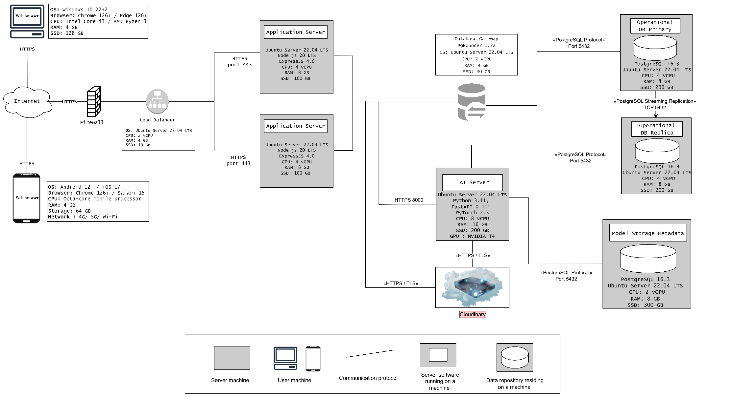

9.1. Execution Zones & Node Configurations
The deployment environment is organized into specialized virtual/physical execution nodes:
Node / Zone | Software Stack | Hardware Configuration | Primary Responsibility
Client Devices | Modern browsers (Chrome, Safari, Edge 126+) | Desktop: i3 / r3 CPU, 4GB RAM  Mobile: Octa-core, 4GB RAM | Access the web interface, upload media, and receive detection results.
Load Balancer | Ubuntu 22.04 LTS | 2 vCPU, 4 GB RAM, 40 GB SSD | Securely distribute incoming HTTPS traffic to application servers.
Application Server (x2) | Ubuntu 22.04, Node.js 20, ExpressJS 4.0 | 4 vCPU, 8 GB RAM, 100 GB SSD | Host System Logic API (handles auth, sessions, admin tools, and metadata).
AI Server | Ubuntu 22.04, Python 3.11, FastAPI 0.111, PyTorch 2.3 | 8 vCPU, 16 GB RAM, 200 GB SSD, NVIDIA T4 GPU | Execute computationally intensive frame extraction, preprocessing, and model inference.
Database Gateway | PgBouncer 1.22, Ubuntu 22.04 | 2 vCPU, 4 GB RAM, 40 GB SSD | Manage connection pooling to optimize database performance.
Operational DB (Primary) | PostgreSQL 16.3, Ubuntu 22.04 | 4 vCPU, 8 GB RAM, 200 GB SSD | Store main transactional data (users, sessions, media metadata, logs).
Operational DB (Replica) | PostgreSQL 16.3, Ubuntu 22.04 | 4 vCPU, 8 GB RAM, 200 GB SSD | Act as a standby node; receive real-time updates and support read scalability.
Model Metadata DB | PostgreSQL 16.3, Ubuntu 22.04 | 2 vCPU, 8 GB RAM, 300 GB SSD | Store model versions, configurations, and evaluation metrics.
Cloud Storage | Cloudinary API | External Managed Service | Offload and serve large binary objects (images, videos, flagged frames).
9.2. Communication Pathways
The runtime communication pathways are strictly defined as follows:
- Client $→$ Firewall / WAF $→$ Load Balancer: HTTPS (Port 443). Traffic is filtered via ModSecurity and OWASP CRS at the WAF layer.
- Load Balancer $→$ Application Servers: HTTPS (Port 443) to balance incoming application workloads.
- Application Servers $→$ AI Server: HTTPS (Port 8000) to send prediction requests and receive inference results.
- Application Servers $→$ Cloudinary: HTTPS/TLS (Port 443) to upload raw media and retrieve hosted file URLs.
- App / AI Server $→$ Database Gateway: PostgreSQL protocol to access pooled connections.
- Database Gateway $→$ PostgreSQL Nodes: PostgreSQL protocol (TCP Port 5432).
- Operational DB Primary $→$ Replica: PostgreSQL Streaming Replication (TCP Port 5432).
9.3. Quality Attribute Realization
- Security: Outer boundary protection is achieved using a dedicated Firewall and a WAF to mitigate common application threats (SQLi, XSS, and malicious file uploads). Only the Load Balancer is exposed to public traffic, leaving the rest of the server infrastructure securely within private networks. All communication paths are encrypted (HTTPS/TLS).
- Availability & Scalability:
  - Application Layer: Horizontal scaling is supported by deploying two identical Application Servers behind the Load Balancer to avoid a single point of failure.
  - Database Layer: Operational high availability is guaranteed via active-standby PostgreSQL streaming replication.
  - AI Layer: Because inference is heavy, isolating it on a dedicated GPU server ensures normal web traffic is not impacted. Scalability can be achieved by adding further AI nodes behind an internal dispatcher as request volume increases.

