
INTERNATIONAL SCHOOL

Capstone Project 1
C1SE.07

SOFTWARE ARCHITECTURE DOCUMENT

DRUGTIME

MENTORS: B.Eng. Nguyen Trong Giap
PhD. Nguyen Duc Man

FULL NAME | STUDENT ID
Nguyen Quang Bao | 29211158850
Nguyen Tan Duc | 29211156669
Nguyen Van Nguyen | 29211364802
Nguyen Ngoc Phuc | 29219051745
Dang Ngo Ngoc Viet | 29219064788

Da Nang, 09/2026

PROJECT INFORMATION

Project acronym | DrugTime
Project Title | Medication Reminder, Drug-Interaction Safety, and AI-Assisted Care Platform
Start Date | 06 Jun 2026 | End Date | 15 July 2026
Lead Institution | International School, Duy Tan University
Project Mentor | B.Eng. Nguyen Trong Giap  PhD. Nguyen Duc Man
Scrum master / Project Leader | Nguyen Ngoc Phuc  Email: phucnguyenngoc2005@gmail.com  Tel: 0943009865
Partner Organization | Kaopiz Software Da Nang
Project Web URL
Team members | Name | Email | Contact
1 | Nguyen Ngoc Phuc | phucnguyenngoc2005@gmail.com | 0943009865
2 | Nguyen Quang Bao | nguyenquangbao575@gmail.com | 0779598354
3 | Nguyen Tan Duc | nguyentanduc1445@gmail.com | 0899961445
4 | Nguyen Van Nguyen | nguyenvannguyen10@dtu.edu.vn | 0359796984
5 | Dang Ngo Ngoc Viet | vietdangg2005@gmail.com | 0904833187

TABLE OF CONTENTS

1. Introduction 7
1.1. Purpose 7
1.2. Scope and Audience 7
1.3. Documents references 8
2. Project Statement 8
2.1. Project definition 8
2.2. Business needs/ User needs 9
2.3. Project Goal 10
3. Architectural Drivers 11
3.1. Functional Requirements 11
3.2. Quality Attributes 11
3.3. Constraints 18
4. System Context Diagram 22
5. Container Diagrams 24
6. Component Diagram 27
6.1. Frontend Web Application 27
6.2. Backend 1 (System Logic API) 32
6.3. Backend 2 (AI Model Service) 45
6.4. Database 1 56
6.5. Database 2 (Model Storage) 62
7. Code Diagrams 66
7.1. Backend 1 - Upload Management 66
7.2. Backend 1 - Detection Session 70
7.3. Backend 1 - Result & Moderator Review 75
7.4. Backend 2 - Input Processing 80
7.5. Backend 2 - Face Detection 84
7.6. Backend 2 - Deepfake Classification 88
7.7. Backend 2 - Model Management 93
8. Attribute-Driven Design 96
8.1. QA01 - Modifiability Design for Adding New Input Types without Changing the Core Classifier 96
8.2. QA02 - Modifiability Design for Updating the Deepfake Detection Model without Changing the Detection Flow 99
8.3. QA03 - Modifiability Design for Adding New Warning Levels to Detection results 103
8.4. QA04 - Performance Design for Short Video Deepfake Detection within 50 Seconds 106
8.5. QA05 - Performance Design for Handling Concurrent Detection Requests 109
8.6. QA06 - Security and Privacy Design for Real-time Screen Detection 113
9. Allocation – Deployment View 117

TABLE OF FIGURES

Figure 1: System Context Diagram 22
Figure 2. Module - Container Diagram 24
Figure 3. C&C - Container diagram 26
Figure 4. Module – Frontend Web Application 28
Figure 5. C&C - Frontend Web Application 31
Figure 6. Module - System Logic API 39
Figure 7. C&C - Backend 1 (System Logic API) 43
Figure 8. Module - Backend 2 (AI Model Service) 50
Figure 9. C&C - Backend 2 (AI Model Service) 54
Figure 10. Component level – Database 1 56
Figure 11. Component Level – Model Storage (Database 2) 62
Figure 12. Backend 1 – Upload Management 67
Figure 13. Sequence diagram - Backend 1 - Upload Management 70
Figure 14. Backend 1 - Detection Session 71
Figure 15. Sequence diagram - Backend 1 - Detection Session 75
Figure 16. Backend 1 - Result & Moderator Review 76
Figure 17. Sequence diagram - Backend 1 - Detection Session 80
Figure 18. Activity diagram - Backend 2 - Input Processing 84
Figure 19. Backend 2 – Face Detection 85
Figure 20. Sequence diagram - Backend 2 - Face Detection 88
Figure 21. Backend 2 - Deepfake Classification 88
Figure 22. Activity diagram - Backend 2 - Deepfake Classification 92
Figure 23. Backend 2 - Model Management 93
Figure 24. Sequence - Backend 2 - Model Management 96
TABLE OF TABLES

Table 1 Documents references 8
Table 2. Quality Attributes – Security & Privacy 11
Table 3. Quality Attributes – Security & Privacy 12
Table 4. Quality Attributes – Usability 13
Table 5. Quality Attributes – Localization 13
Table 6. Quality Attributes – Performance 14
Table 7. Quality Attributes – Performance 14
Table 8. Business Constraints – Time Limitation 18
Table 9. Business Constraints – Resource Limitation 18
Table 10. Business Constraints – Feature Prioritization 18
Table 11. Business Constraints – Cost Minimization 18
Table 12. Business Constraints – Target Environment 19
Table 13. Business Constraints – Project Deliverables 19
Table 14. Business Constraints – Regulatory Compliance Scope 19
Table 15. Business Constraints – Accuracy and Safety Expectation 19
Table 16. Technical Constraints – Application Type 20
Table 17. Technical Constraints – Backend APIs 20
Table 18.Technical Constraints – Core Technology 20
Table 19.Technical Constraints – On-Device Blister-Pack Scanning 20
Table 20.Technical Constraints – Local Notification Delivery 20
Table 21. Technical Constraints – Background Job Processing 21
Table 22. Technical Constraints – Security Protocol 21
Table 23.Technical Constraints – Privacy and Consent Enforcement 21
Table 24. Technical Constraints – Shared Database Dependency 21
Table 25. Role & Responsibilities – Container level 25
Table 26. Role & Responsibilities – Component level – Backend1 - System Logic API 29
Table 27. Role & Responsibilities – Component level – API Application 41
Table 28. Role & Responsibilities – Component level – Backend2 - AI Model Service 52
Table 29. Users 56
Table 30. Roles 57
Table 31. Permissions 57
Table 32. User_roles 57
Table 33. Role_permissions 58
Table 34. Media_files 58
Table 35. Detection_sessions 58
Table 36. Detection_results 59
Table 37. Frame_results 59
Table 38. Review_labels 60
Table 39. Audit_logs 60
Table 40. System_errors 61
Table 41. Ai_models 62
Table 42. Model_versions 63
Table 43. Model_artifacts 63
Table 44. Model_metadata 64
Table 45. Active_model_versions 65
Table 46. Model_evaluation_reports 65
Table 47. Confusion_matrices 66
Table 48. Class/Interface & Responsibility – Upload Management 69
Table 49. Class/Interface & Responsibility – Detection Session 73
Table 50. Class/Interface & Responsibility – Result & Moderator Review 78
Table 51. Class/Interface & Responsibility – Input Processing 83
Table 52. Class/Interface & Responsibility – Face Detection 86
Table 53. Class/Interface & Responsibility – Deepfake Classification 90
Table 54. Class/Interface & Responsibility – Model Management 95

Introduction

Purpose
The purpose of this Architecture Design Document is to describe the software architecture of DrugTime, a medication reminder, drug-interaction safety, and AI-assisted care platform for Vietnamese patients. This document explains how the system is organized to support medication management, local reminder scheduling, drug-drug and drug-food interaction checking, family caregiver monitoring, and AI-based meal suggestions.
DrugTime is designed to help patients on multi-drug regimens avoid missed doses and unsafe drug or food combinations. To achieve this, the system separates the mobile application, the admin web dashboard, the backend API, the background job worker, and the shared database into independent architectural parts. This document records those parts, their responsibilities, and how they communicate with one another.
This document focuses on the architectural design needed to build and maintain the system. It describes the main actors, system boundary, containers, components, database structure, class design, and important processing flows such as medication entry, reminder scheduling, dose confirmation, interaction checking, family-alert delivery, and admin catalogue management.
The document also explains the architectural decisions that allow the system to evolve over time. Since Phase 2 features such as OCR prescription scanning, partner-pharmacy integration, Zalo reminders, and voice confirmation are planned after the MVP, the architecture is designed to support modifiability. The system should allow new reminder channels, new interaction data sources, and new Phase 2 features to be added with limited impact on existing components.

Scope and Audience
This document defines the software architecture of DrugTime for the Phase 1 (MVP) release: the mobile application (Flutter, Android and iOS), the Admin web dashboard (React + Next.js), the Backend API (Python + FastAPI), the background job worker (RQ + Redis), and the shared Supabase database. It covers the system context, container view, component decomposition, class-level design for key modules, quality-attribute design decisions, and the deployment view. Phase 2 features (OCR prescription scanning, partner-pharmacy integration, Zalo OA reminders, voice confirmation, pharmacist consultation, and the Premium tier) are referenced only where they affect the extensibility of the Phase 1 design; their detailed architecture is out of scope for this document.
The intended audience is the DrugTime development team, the project mentor, and the Capstone review panel. Developers use this document to understand module boundaries and responsibilities before implementation; the mentor and review panel use it to assess whether the proposed architecture satisfies the functional and non-functional requirements defined in the Project Proposal.

Documents references
Table 1 Documents references
No. | Reference
1 | Product Backlog Document
2 | Project Plan Document
3 | Database Design Document

Project Statement

Project definition
DrugTime is a mobile-first, AI-assisted software platform that helps patients on multi-drug regimens manage medications safely. It receives medication data through manual entry or on-device blister-pack scanning, schedules local dose reminders, checks entered medications against the Vietnamese drug catalogue for drug-drug and drug-food interactions, and generates AI-based meal suggestions.
The system includes three main types of users:
- Patient: adds medications, receives reminders, confirms doses, and looks up drug-drug and drug-food interaction warnings.
- Family member: links to a patient account, receives missed-dose alerts, and views the patient's adherence history.
- Admin: manages the medication and interaction catalogue, conducts DPIA, and processes data-deletion or consent-withdrawal requests.
The system is composed of several major architectural components. The Mobile App provides the user interface for medication entry, reminders, dose confirmation, adherence history, and interaction look-up for both Patients and Family members. The Admin Web Dashboard provides catalogue management and compliance oversight for Admins. The Backend API handles authentication, consent enforcement, medication management, interaction checking, family linking, and admin functions. The Background Job Worker handles scheduled reminders and catalogue synchronization, and triggers push notifications on a missed dose. The Database stores operational data such as patient profiles, medication schedules, adherence history, and catalogues.
For the blister-pack scan, the system does not send the packaging photo off the device. Instead, on-device text recognition reads the medication text locally and matches it against the licensed drug-name database, so no packaging image leaves the device.

Business needs/ User needs
The business need for this project comes from a documented gap in medication adherence in Vietnam. A survey of 60 respondents in Da Nang found that 75% had forgotten to take a medication in the past week, while only 5% used a dedicated medication-reminder app, and existing international apps do not reflect the Vietnamese drug formulary or interaction database.
From a business perspective, the system needs to:
- Provide a practical solution for medication reminders and Vietnamese drug-interaction checking, reflecting the local formulary and guidance.
- Support reliable adherence tracking by storing medication schedules, dose confirmations, adherence history, and timestamps.
- Allow administrators to manage the medication and interaction catalogue and synchronize it from the Vietnamese Drug Regulatory Data Source.
- Allow administrators to conduct DPIA, process data-deletion and consent-withdrawal requests, and maintain a sensitive-data access log under Vietnam's 2025 Personal Data Protection Law.
- Support future changes such as adding Phase 2 features (OCR, partner-pharmacy integration, Zalo reminders, voice confirmation) with minimal impact on the overall system.
From the user perspective, the system needs to be simple, clear, and reliable. Patients need to add a medication and receive timely reminders with a clear confirmation action. When an interaction risk exists, patients need the system to show a clear, disclaimed warning at the point they need it. Patients also need access to their adherence history so they can review past doses when necessary.
Admins need tools to manage the medication and interaction catalogue and to oversee compliance. Family members need a way to monitor a linked patient's adherence and receive missed-dose alerts without having day-to-day access to unrelated health data. These needs ensure that the system is not only a reminder and interaction-checking tool but also a manageable and privacy-conscious care platform.

Project Goal
The goal of DrugTime is to design and develop a maintainable software system that helps Vietnamese patients on multi-drug regimens take their medications correctly and avoid unsafe drug or food interactions.
The system aims to achieve the following objectives:
- Allow patients to add medications via manual entry or on-device blister-pack scanning.
- Schedule and deliver local on-device reminders for medication doses.
- Return clear drug-drug and drug-food interaction warnings, including a mandatory medical disclaimer.
- Store medication schedules, dose confirmations, adherence history, and timestamps for history and audit purposes.
- Provide family caregiver alerts for missed doses.
- Provide admin functions for catalogue management, compliance oversight, and consent/deletion request handling.
- Separate the mobile app, admin dashboard, backend API, background worker, and database into independent components to reduce coupling and improve maintainability.
- Support future extension, including OCR prescription scanning, partner-pharmacy integration, Zalo reminders, and voice confirmation.
The expected outcome of the project is a flexible and extensible medication safety platform that can evolve as reminder channels, interaction data sources, and regulatory requirements change over time.

Architectural Drivers

Functional Requirements
ID | Functional Requirement
FR-01 | The system must allow users to register, log in, and complete purpose-separated consent for data processing.
FR-02 | The system must allow users to add medication via manual input or on-device blister-pack scanning, requiring manual confirmation.
FR-03 | The system must schedule and deliver local on-device notification reminders for medication doses.
FR-04 | The system must provide drug-drug and drug-food interaction warnings with mandatory medical disclaimers.
FR-05 | The system must generate suitable AI-based meal suggestions with explanations.
FR-06 | The system must provide a high-contrast, minimal-UI Simple Mode.
FR-07 | The system must allow family caregiver accounts to be linked via QR or referral codes to send real-time missed-dose alerts and basic adherence history.
FR-08 | The system must provide admin catalog management, including CRUD operations on the medication/interaction catalog and periodic synchronization from the Vietnamese Drug Regulatory Data Source.
FR-09 | Family member extended access: multi-patient management and drug safety lookup for linked patients, scoped to explicit patient consent

Quality Attributes
Table 2. Quality Attributes – Security & Privacy
ID | QA.01
Title | Withdraw consent for a specific data-processing purpose
Quality Attribute | Security & Privacy (NFR01)
Source(s) of Stimulus | Authenticated Patient
Stimulus | The Patient withdraws consent for one processing purpose (e.g., sharing data with a Family Member, or AI-based meal suggestions) from the account settings screen.
Environment | Runtime, normal operation, device connected to the Internet.
Artifacts | Backend API (consent enforcement layer), Supabase (consent data), Mobile App (consent settings screen)
System Response | Record the consent withdrawal with a timestamp. The Backend API rejects any further data-processing operation under the withdrawn purpose. Other purposes remain unaffected. If the Patient requests data deletion, the request is queued for Admin approval.
Response Measure(s) | - 100% of requests under the withdrawn purpose are rejected after the withdrawal time (0 requests slip through).  - Consent withdrawal takes effect within ≤ 5 seconds.  - 100% of data-deletion requests appear in the Admin queue within ≤ 1 minute.  - 0 other purposes are unintentionally affected.
Table 3. Quality Attributes – Security & Privacy
ID | QA.02
Title | Block a Family Member from accessing data outside the consent scope
Quality Attribute | Security & Privacy (NFR01)
Source(s) of Stimulus | A Family Member who is unlinked, has been unlinked, or whose sharing permission has been revoked by the Patient (including attempts to tamper with the patient ID in the request).
Stimulus | Sends a request to view a Patient's adherence history, medication information, or interaction warnings without authorization.
Environment | Runtime, normal operation.
Artifacts | Backend API (authentication and authorization), Supabase (family-linking and consent data)
System Response | Validate the token, check the linking relationship and consent scope before returning any data. Reject the request (HTTP 403) and return no health data. Log the denied access attempt.
Response Measure(s) | - 100% of unauthorized requests are rejected.  - 0 health records are returned for unauthorized requests.  - Permission revocation takes effect within ≤ 5 seconds.  - The cross-patient authorization test suite (≥ 20 cases) passes 100%.
Table 4. Quality Attributes – Usability
ID | QA.03
Title | Confirm medication intake in Simple Mode
Quality Attribute | Usability (NFR02)
Source(s) of Stimulus | Elderly Patient with limited technology experience.
Stimulus | Receives a medication reminder notification and wants to confirm the dose was taken.
Environment | Runtime, Simple Mode enabled, using a mobile device (possibly in low-light conditions).
Artifacts | Mobile App – reminder and dose-confirmation screen in Simple Mode
System Response | Display a minimal interface with one large, high-contrast confirmation button and large text. After confirmation, show clear feedback that the dose has been recorded.
Response Measure(s) | - Confirmation completed in ≤ 2 taps and ≤ 10 seconds from opening the notification.  - First-time success rate ≥ 90% (tested with ≥ 5 elderly users).  - Mis-tap rate ≤ 5%.  - Primary text contrast ratio ≥ 7:1, tap target size ≥ 48 dp, primary font size ≥ 18 sp.
Table 6. Quality Attributes – Performance
ID | QA.05
Title | Process medication dose confirmation
Quality Attribute | Performance (NFR04)
Source(s) of Stimulus | Patient
Stimulus | Taps the confirm-dose-taken button (random, non-periodic request).
Environment | Normal operation, device online.
Artifacts | Mobile App, Backend API (adherence), Supabase
System Response | The Backend API processes the request synchronously, records the taken dose in the adherence history, and returns the result. The Mobile App displays confirmation feedback as soon as the result is received.
Response Measure(s) | - Time from tap to confirmation display: p95 ≤ 2 seconds.  - Successful recording rate ≥ 99%, 0 records lost.
Table 7. Quality Attributes – Performance
ID | QA.06
Title | Deliver medication reminders on time
Quality Attribute | Performance (NFR04)
Source(s) of Stimulus | Device's local notification scheduler
Stimulus | A scheduled dose time is reached (periodic event).
Environment | Normal operation; app running in background or closed; notification permission granted.
Artifacts | Mobile App – reminder module (local notification)
System Response | Display an alarm-style notification at the scheduled time, with a dose-confirmation action.
Response Measure(s) | - Deviation from the scheduled time ≤ 2 seconds.  - ≥ 99% of scheduled notifications are delivered on time in tests on both Android and iOS.
Table 8. Quality Attributes – Availability
ID | QA.07
Title | Maintain ≥ 99% uptime for core services
Quality Attribute | Availability (NFR05)
Source(s) of Stimulus | Patient and Family Member using core services at any time of day.
Stimulus | Requests to use core services throughout the operating cycle: reminder synchronization and scheduling, adherence tracking, and drug lookup.
Environment | Runtime.
Artifacts | Backend API (adherence tracking, drug lookup), Background Job Worker (scheduled reminders), Supabase
System Response | Core services continue serving user requests. The system monitors the status of each core service via periodic health checks and logs every downtime interval to compute uptime.
Response Measure(s) | - Uptime of each core service (reminders, adherence tracking, drug lookup) ≥ 99% per month  - Health checks run at intervals of ≤ 1 minute.  - 100% of downtime intervals are logged.
Table 9. Quality Attributes – Availability
ID | QA.08
Title | Reminders continue to function during network loss
Quality Attribute | Availability (NFR05)
Source(s) of Stimulus | Physical environment (Patient's device loses Internet access or cannot reach the Backend).
Stimulus | Network connectivity is lost exactly when a dose is due or when the Patient confirms a dose.
Environment | Degraded mode (offline); the medication schedule was previously synced.
Artifacts | Mobile App – local notification scheduler, local storage
System Response | The app still delivers reminders via local notification. Dose confirmations are stored locally and shown as "pending sync". Once connectivity is restored, the app automatically syncs to the Backend. Functions that require Internet access (interaction checking, meal suggestions) display a connectivity-required message.
Response Measure(s) | - 100% of scheduled reminders are still delivered while offline.  - 0 dose confirmations are lost.  - Sync completes within ≤ 30 seconds after connectivity is restored.
Table 10. Quality Attributes – Auditability
ID | QA.09
Title | Log every access to sensitive data
Quality Attribute | Auditability (NFR06)
Source(s) of Stimulus | Family Member or Admin
Stimulus | Accesses a Patient's health data (adherence history, medication list, interaction warnings).
Environment | Runtime, normal operation.
Artifacts | Backend API, Admin module (access log), Supabase (log table)
System Response | For each access, record an entry containing the actor, role, timestamp, the Patient accessed, and the data scope. Denied access attempts are also logged. Admin can view and filter the log on the Admin Web Dashboard.
Response Measure(s) | - 100% of accesses produce a log entry with all three fields (actor, timestamp, data scope) (0 unlogged accesses in the test set).  - The log entry appears within ≤ 5 seconds of the access.  - Logging does not cause operations to exceed the 2-second limit defined in NFR04.
Table 11. Quality Attributes – Extensibility
ID | QA.10
Title | Add a new disease group in Phase 2
Quality Attribute | Extensibility (NFR07)
Source(s) of Stimulus | Developer
Stimulus | A request to add a new disease group the system.
Environment | Development time.
Artifacts | Medication Module, Interaction Module, catalog data, Admin Web Dashboard
System Response | Add the catalog data and disease-group configuration (via Admin Dashboard or migration) without changing the logic of other modules. Run the regression test suite and deploy.
Response Measure(s) | - Completed within ≤ 3 person-days.  - ≤ 2 modules modified (Medication, Interaction); 0 changes to the Reminder module.  - 100% of the existing regression test suite still passes.
Table 12. Quality Attributes – Extensibility
ID | QA.11
Title | Add a Zalo OA reminder channel
Quality Attribute | Modifiability (NFR07)
Source(s) of Stimulus | Developer
Stimulus | A request to add Zalo OA as a secondary reminder channel.
Environment | Development time and deployment time.
Artifacts | Reminder Module (notification port), Backend API, Background Job Worker
System Response | Write a new Zalo OA adapter implementing the existing notification port and register it via configuration. The Reminder Module's business logic remains unchanged. Test the adapter using a mock of the Zalo OA API.
Response Measure(s) | - Completed within ≤ 5 person-days.  - Only 1 adapter and its configuration are added; ≤ 1 existing module affected (Reminder).  - 0 changes to domain logic; 100% of the existing regression test suite still passes.

Constraints

Business Constraints
Table 13. Business Constraints – Time Limitation
ID | BC-01
Title | Time Limitation
Description | The MVP (Phase 1) must be delivered within a 3-month timeline (10 Sep - 26 Dec 2026, including six two-week implementation sprints). The team must manage the schedule strictly so that consent, reminder, and interaction-checking features are delivered before secondary features.
Table 14. Business Constraints – Resource Limitation
ID | BC-02
Title | Resource Limitation
Description | The development team consists of 5 members, so the project scope must be suitable for a small team. Tasks are split across two development tracks, with at least two members owning each track to reduce single-person dependency.
Table 15. Business Constraints – Feature Prioritization
ID | BC-03
Title | Feature Prioritization
Description | Phase 1 must focus on core features first: consent, manual/blister-pack medication entry, local reminders, interaction warnings, family linking, and the Admin catalogue. Phase 2 features (OCR, partner-pharmacy integration, Zalo reminders, voice confirmation, pharmacist consultation, Premium tier) are out of scope until the MVP is validated.
Table 16. Business Constraints – Cost Minimization
ID | BC-04
Title | Cost Minimization
Description | The MVP must be built on a near-zero budget using free or free-tier services (Render, Supabase, Redis), plus the Apple Developer Program (99 USD/year) required for the iOS build. Zalo OA and the Premium tier are Phase 2 items requiring a separate funding decision before they are built.
Table 18. Business Constraints – Project Deliverables
ID | BC-06
Title | Project Deliverables
Description | The final Phase 1 submission must include working Android and iOS builds, the Admin web dashboard, and documentation (Architecture Design Document, Database Design Document) clear enough for the mentor and review panel to assess the design and for the team to hand off after graduation.
Table 19. Business Constraints – Regulatory Compliance Scope
ID | BC-07
Title | Regulatory Compliance Scope
Description | Personal-data processing must comply with Vietnam's Law on Personal Data Protection (2025) and Decree 356/2025/ND-CP. The platform does not provide medical advice or diagnosis; drug-drug and drug-food interaction warnings are automated look-ups only, each carrying a disclaimer directing the patient to a doctor or pharmacist.
Table 20. Business Constraints – Accuracy and Safety Expectation
ID | BC-08
Title | Accuracy and Safety Expectation
Description | The system does not guarantee that its interaction database or AI meal suggestions cover every clinical scenario. Results must be presented as automated, disclaimed support information, and users must be directed to consult a doctor or pharmacist rather than treat the output as medical advice.

Technical Constraints
Table 21. Technical Constraints – Application Type
ID | TC-01
Title | Application Type
Description | The system must be implemented as a Flutter mobile application (Android and iOS) for patients and family members, plus a React + Next.js Admin web dashboard for administrators.
Table 22. Technical Constraints – Backend APIs
Title | Backend APIs
Description | The Backend API (Python + FastAPI) must expose endpoints for authentication and consent, medication management, interaction checking, reminder scheduling, family linking, and admin catalogue/compliance operations. Endpoints must be secured and documented.
Table 23.Technical Constraints – Core Technology
ID | TC-03
Title | Core Technology
Description | The Backend API must be structured as a modular monolith, split into independent modules (medication, interaction, reminder, partner, admin) with a light hexagonal (ports-and-adapters) structure inside each module to separate business logic from infrastructure.
Table 24.Technical Constraints – On-Device Blister-Pack Scanning
ID | TC-04
Title | On-Device Blister-Pack Scanning
Description | The blister-pack scan must use on-device text recognition (Google ML Kit) followed by fuzzy matching against the licensed drug-name database, so that no packaging image leaves the device for Phase 1.
Table 25.Technical Constraints – Local Notification Delivery
ID | TC-05
Title | Local Notification Delivery
Description | Medication reminders must be scheduled and delivered as on-device local notifications using the mobile framework's built-in local-notification APIs; no server round-trip is required to fire a scheduled reminder.
Table 26. Technical Constraints – Background Job Processing
ID | TC-06
Title | Background Job Processing
Description | Catalogue synchronization and missed-dose detection must run as asynchronous background jobs (RQ + Redis) rather than blocking the Backend API's synchronous request path.
Table 27. Technical Constraints – Security Protocol
ID | TC-07
Title | Security Protocol
Description | The Backend API and Admin dashboard must use HTTPS in deployment, and Render must handle automatic HTTPS termination, so that data in transit between the mobile app, dashboard, and backend is encrypted.
Table 28.Technical Constraints – Privacy and Consent Enforcement
ID | TC-08
Title | Privacy and Consent Enforcement
Description | The system must obtain purpose-separated consent before any data-processing action and must not process or transmit sensitive health data for a purpose the patient has not explicitly consented to.
Table 29. Technical Constraints – Shared Database Dependency
ID | TC-09
Title | Shared Database Dependency
Description | All containers (Mobile App, Admin Dashboard, Backend API, Background Job Worker) must read and write to the shared Supabase database (PostgreSQL + Storage) as the single source of truth for patient profiles, medication schedules, adherence history, and catalogues.

System Context Diagram

Figure 1: System Context Diagram
The System Context Diagram presents DrugTime as a single software system and shows how it interacts with external actors and external services. At this level, the internal structure of the system is not shown. Instead, the diagram focuses on the system boundary, the main users of the system, and the information exchanged between the system and its surrounding environment.
The central element in the diagram is DrugTime. This system helps patients on multi-drug regimens manage medications safely: it accepts medication entry (manual input or on-device blister-pack scanning), schedules local dose reminders, checks entered medications against the Vietnamese drug catalogue for drug-drug and drug-food interactions, generates AI-based meal suggestions, and notifies family caregivers of missed doses.
The first actor is the Patient. The patient registers, completes purpose-separated consent, adds medications, receives local reminders, confirms doses, views adherence history, and looks up drug-drug and drug-food interaction warnings. The patient can also link a family member and switch to Simple Mode for a high-contrast, minimal UI.
The second actor is the Family Member. The family member links to a patient's account with the patient's consent, receives real-time missed-dose alerts, views the linked patient's adherence history, and can manage multiple linked patients.
The third actor is the Admin. The admin manages the medication and interaction catalogue, synchronizes catalogue data from the Vietnamese Drug Regulatory Data Source, conducts DPIA for new sensitive-data flows, processes data-deletion and consent-withdrawal requests, and reviews the sensitive-data access log for compliance with Vietnam's 2025 Personal Data Protection Law and Decree 356/2025/ND-CP.
The diagram also includes three external systems. An AI LLM API generates the meal suggestions and their explanations. Firebase Cloud Messaging (FCM) delivers push notifications to a family member's device when a scheduled check detects a missed dose. The Vietnamese Drug Regulatory Data Source (drugbank.vn / dichvucong.dav.gov.vn, the QD 5948/QD-BYT interaction guidance, and Duoc thu Quoc gia Viet Nam) supplies the drug and interaction data that the Admin synchronizes into the catalogue.
Overall, the System Context Diagram defines the DrugTime system boundary and shows the major interactions between the system and its environment. Patients add medications and receive reminders and interaction warnings, family members monitor adherence and receive missed-dose alerts, admins manage the catalogue and compliance obligations, and the external systems provide storage, on-device recognition, AI-generated suggestions, push notifications, and authoritative drug data.

Container Diagrams
  - Architectural Decisions
Four decisions shape the container structure. They realize the quality attributes in Section 3.2.
CD1 – Single data gatekeeper (API-only data access)
Tactic / pattern | Tactic: Limit Exposure, Authorize Actors. Pattern: Policy Enforcement Point (one entry to all data).
Reason | Purpose-separated consent, family authorization and access logging must be enforced in one place. If one code path skipped them, QA.01, QA.02 and QA.09 (NFR01, NFR06) would fail.
Description | The Mobile App and the Admin Web Dashboard call only the Backend API. Only the Backend API and the Worker hold database credentials. Supabase runs with Row Level Security enabled and no policy for the anon and authenticated roles, so a direct client call to Supabase returns nothing.
Risk and mitigation | The API is a single point of failure and a bottleneck, and one bug in the enforcement point would expose data for every module. Mitigation: one enforcement component (BD2) covered by the cross-patient test suite (≥ 20 cases), plus health monitoring (CD4).
Trade-off | Every feature needs an API endpoint, and Supabase client features (direct queries, realtime) are not used. Each request has one more network hop.

CD2 – Offline-first Mobile App
Tactic / pattern | Tactic: Graceful Degradation, Redundancy of Data, Retry. Pattern: on-device local notifications; Transactional Outbox (device side).
Reason | Reminders must fire and dose confirmations must not be lost when the network or the backend is unavailable (QA.06, QA.08, NFR05).
Description | The Mobile App schedules reminders with the OS local-notification API, keeps schedules and dose confirmations in an encrypted local store, and syncs them to the Backend API later. Features that need the Internet (interaction check, meal suggestion) show a “connection required” message.
Risk and mitigation | OS limits can drop reminders: iOS keeps at most 64 pending local notifications, and Android can restrict exact alarms or clear them after a reboot. The device copy and the server copy of a schedule can also differ. Mitigation: a rolling scheduling window, re-scheduling on app start and after reboot, on-time tests on both OS (QA.06 ≥ 99%), and refreshing the device copy at every sync.
Trade-off | Schedule logic exists on the device and on the server (the server needs it to detect missed doses). Sync and error handling make the Mobile App more complex.

CD3 – Asynchronous Background Job Worker
Tactic / pattern | Tactic: Introduce Concurrency (background processing). Pattern: Producer–Consumer through a job queue (RQ + Redis).
Reason | Missed-dose detection and catalogue synchronization are periodic or slow, so they must not block the API request path (TC-06) or push dose confirmation beyond 2 s (QA.05).
Description | The API or a periodic scheduler puts jobs into Redis. The Worker takes them, reads and writes Supabase, and sends missed-dose alerts through FCM. Redis holds only job triggers; all state stays in Supabase.
Risk and mitigation | A free Redis instance can lose queued jobs on restart, and a retried job can send a duplicate alert. Mitigation: periodic jobs re-scan the database, so a lost trigger is recovered by the next run, and jobs are idempotent (WD2). Note that Render has no free instance type for Background Workers, which conflicts with the near-zero budget (BC-04).
Trade-off | One more container to deploy and monitor. Alerts arrive after scan interval plus grace period, not instantly.

CD4 – Health monitoring and automatic restart
Tactic / pattern | Tactic: Detect Faults (ping/echo), Recover from Faults (restart).
Reason | QA.07 requires ≥ 99% uptime, checks at intervals ≤ 1 minute, and every downtime interval logged.
Description | The Backend API exposes /health, which runs a real query on Supabase and pings Redis. An external monitor calls it at intervals ≤ 1 minute and records each downtime interval. Render restarts an unhealthy instance.
Risk and mitigation | A Render Free web service spins down after 15 minutes without traffic and needs about one minute to start, which would break QA.05 (p95 ≤ 2 s) and QA.07. Free instances also have a monthly instance-hour limit. Mitigation: the monitor’s pings keep the service awake; move to a paid instance if the demo needs a guarantee.
Trade-off | Constant pings use free-tier hours and bandwidth. A container-level check cannot see a fault inside one module.

  - Module
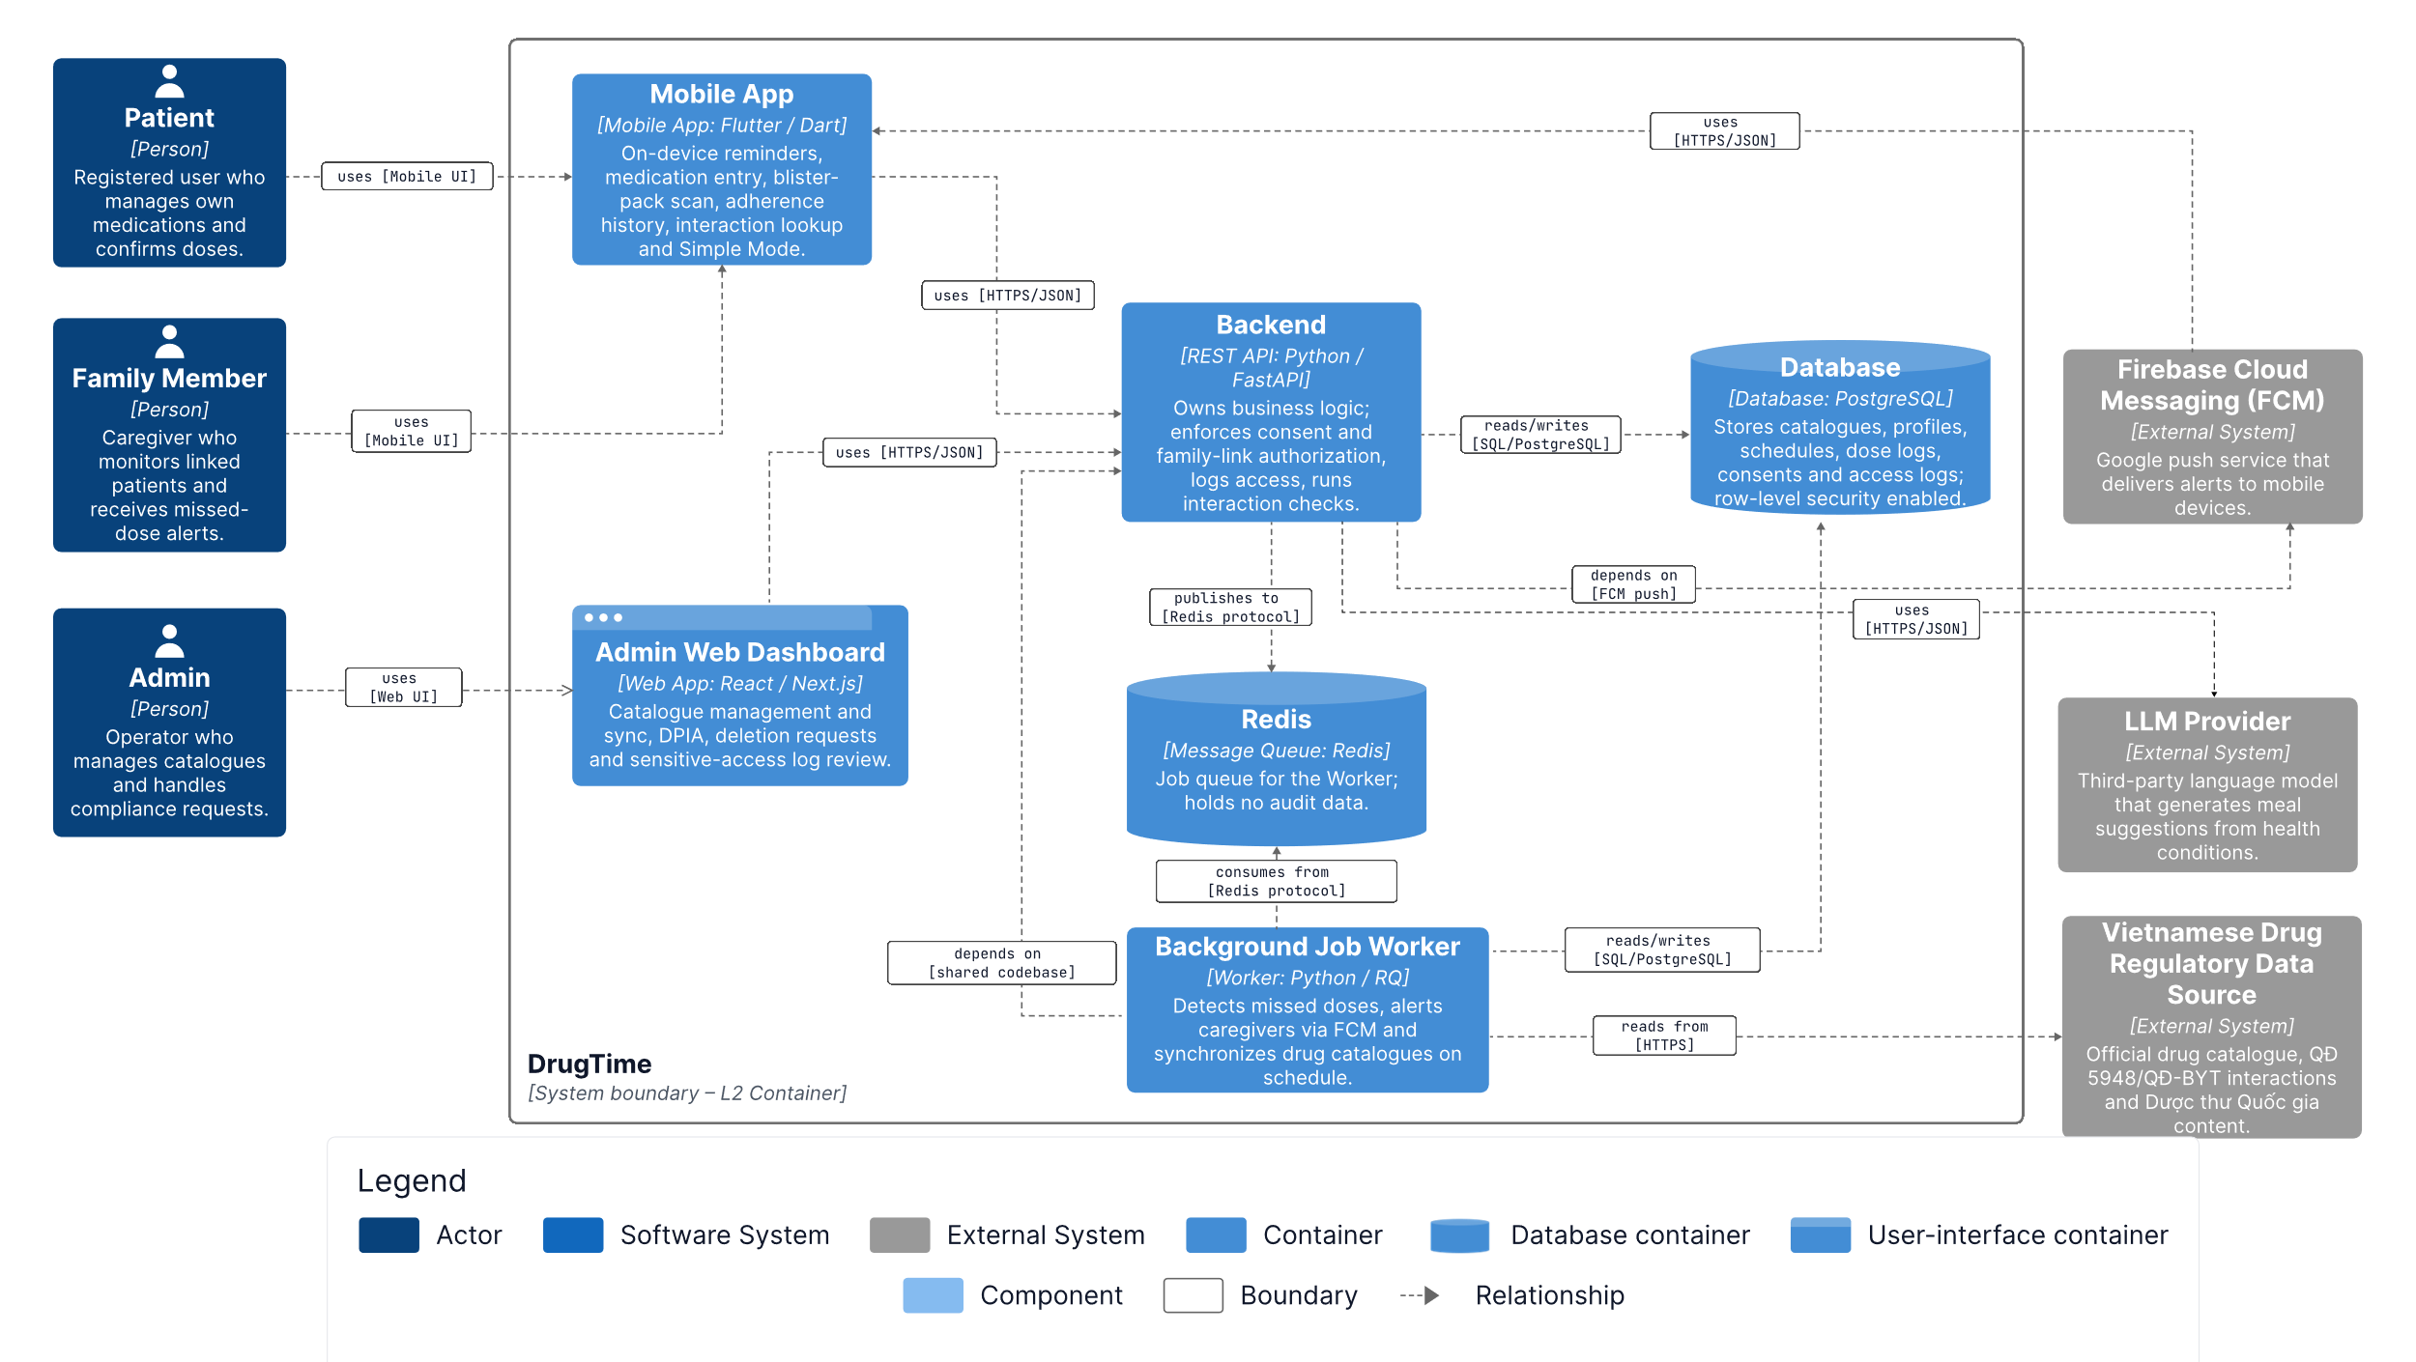
Figure 2. Module - Container Diagram
Prose:
Entity Name | Technology | Description / Responsibility
Patient | - | Manages own medications, reminders, and consents to data sharing.
Family Member | - | Monitors the treatment adherence of linked patients who have granted sharing permissions.
Admin | - | Manages the catalogue and data-protection compliance.
Mobile App | Flutter / Dart | Interface for Patient and Family Member; local reminders scheduling; queues offline dose confirmations.
Mobile Local Store | SQLite + SQLCipher | Encrypted on-device copy of medication schedules and dose-confirmation outbox.
Admin Web Dashboard | React / Next.js | Manages catalogue, deletion requests, and access logs; calls Backend API only.
Backend API | Python / FastAPI | Modular monolith following hexagonal architecture; single enforcement point for health data.
Redis Cache | Redis | TTL cache storing LLM-validated meal suggestions, keyed by de-identified input.
RabbitMQ | RabbitMQ | Durable task broker for the Background Job Worker.
Database | PostgreSQL | System of record; Row-Level Security (RLS) enabled; separates access roles api_role and worker_role.
Background Job Worker | Python / Celery + Beat | Shares codebase with Backend API; executes background tasks: missed-dose scan, catalogue sync, data erasure, and heartbeat.
LLM Provider | - | Generates meal suggestions based on de-identified context.
Supabase Auth | - | Stores credentials and issues identity tokens.
Firebase Cloud Messaging (FCM) | - | Provides push notifications to Android devices.
Vietnamese Drug Regulatory Data Source | - | Official medicine and interaction references, aggregated from 3 sources.

  - C&C
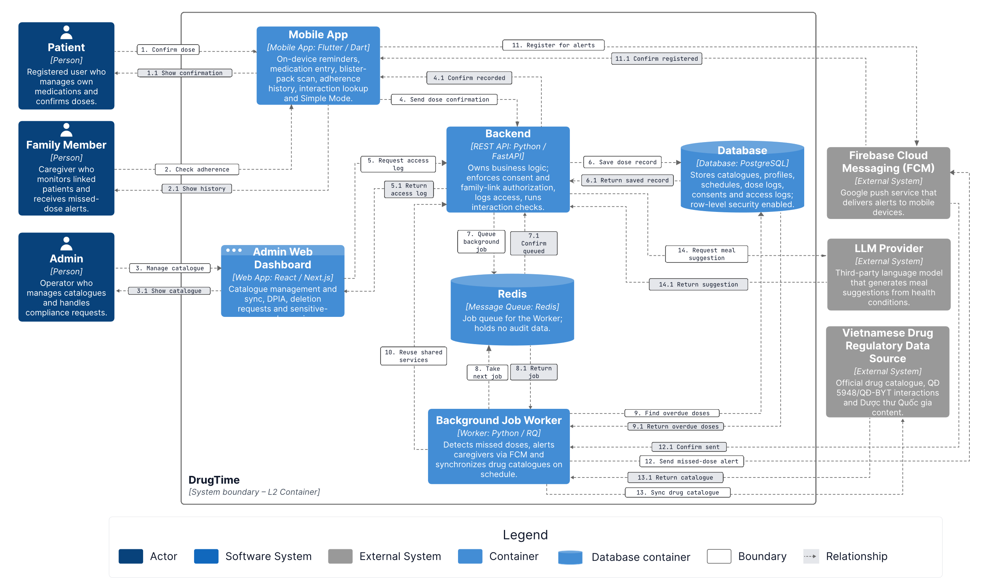
Prose:

2.1 Scenario 1 — Patient uses the mobile app (medication management, offline-first sync)
1. Patient → Mobile App: (1) Manage meds, confirm doses — Patient manages medications and confirms doses on the Mobile App; Mobile App responds (1.1) Show reminders and status.
2. Mobile App → Mobile Local Store: (3) Save schedules and outbox — Mobile App saves medication schedules and dose-confirmation outbox to local storage; Mobile Local Store responds (3.1) Return cached data.
3. Mobile App → Backend API: (4) Sync doses, use features — Mobile App syncs dose data and calls business features to Backend API; Backend API responds (4.1) Return data and results.
4. Mobile App → Firebase Cloud Messaging: (16) Register for alerts — Mobile App registers for push notifications; FCM responds by sending notifications (16.1) Deliver alert push back to the Mobile App.

2.2 Scenario 2 — Family Member monitors treatment adherence
1. Family Member → Mobile App: (2) Monitor linked patient — Family Member requests adherence status of linked patients; Mobile App responds (2.1) Show adherence and alerts.
2. This flow continues using the shared interaction (4) Sync doses, use features between the Mobile App and Backend API (described in Scenario 1) to fetch the latest adherence data and alerts.

2.3 Scenario 3 — Admin manages catalogue and deletion requests
1. Admin → Admin Web Dashboard: (5) Manage catalogue, requests — Admin manages the catalogue and related requests; Admin Web Dashboard responds (5.1) Show admin views.
2. Admin Web Dashboard → Backend API: (6) Send admin actions — Admin Web Dashboard sends admin actions to Backend API (the single calling point — calls Backend API only); Backend API responds (6.1) Return admin data.
3. Backend API → Supabase Auth: (18) Delete erased account — Backend API executes erasure requests for approved accounts on Supabase Auth; Supabase Auth responds (18.1) Confirm account deleted.

2.4 Scenario 4 — Authentication and data access via Backend API
1. Backend API → Supabase Auth: (8) Verify account sign-in — Backend API verifies the user's login session (Mobile App or Admin Web Dashboard); Supabase Auth responds (8.1) Return identity token.
2. Backend API → Database: (9) Read/write app data — Backend API reads/writes application data to the Database (PostgreSQL/Supabase); Database responds (9.1) Return query results.

2.5 Scenario 5 — Meal suggestions from LLM Provider (via cache)
1. Backend API → Redis Cache: (10) Look up meal suggestion — Backend API checks the cache for existing meal suggestions for the (de-identified) input; Redis Cache responds (10.1) Return hit or miss.
2. Backend API → LLM Provider: (11) Request meal suggestions — On a cache miss, Backend API sends a request to generate meal suggestions to the LLM Provider; LLM Provider responds (11.1) Return suggested meals.

2.6 Scenario 6 — Background task processing via Background Job Worker
1. Backend API → RabbitMQ: (12) Publish sync/erasure task — Backend API pushes a sync or data erasure task to the queue; RabbitMQ responds (12.1) Confirm task queued.
2. RabbitMQ → Background Job Worker: (13) Take next task — Background Job Worker takes the next task from the queue; RabbitMQ delivers it via (13.1) Deliver task message.
3. Background Job Worker → Database: (14) Scan doses, save results — Worker scans dose data (for missed dose detection, catalogue sync, data erasure...) and writes results to the Database; Database responds (14.1) Return rows, commit.
4. Background Job Worker → Firebase Cloud Messaging: (15) Send missed-dose alert — When a missed dose is detected, Worker sends a push alert via FCM; FCM responds (15.1) Accept push.
5. Background Job Worker → Vietnamese Drug Regulatory Data Source: (17) Fetch catalogue data — Worker fetches drug catalogue data from the Vietnamese regulatory source to sync internal catalogues; the source responds (17.1) Return medicine records.

Component Diagram

Mobile App
    - Module

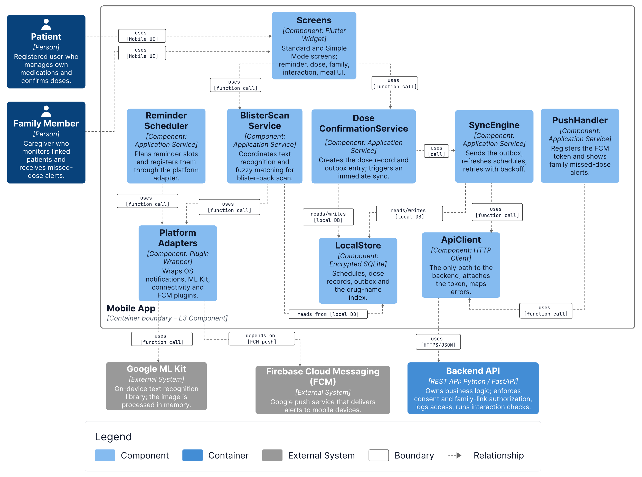Prose:

    - C&C
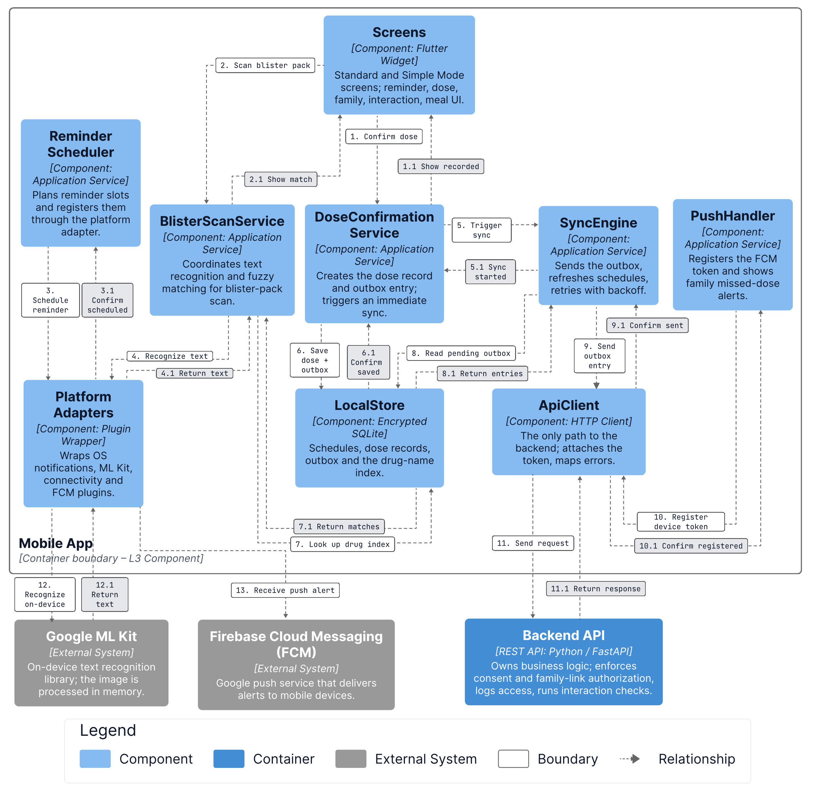

Figure 5. C&C - Frontend Web Application
Prose:

Admin Web Dashboard
    - Module

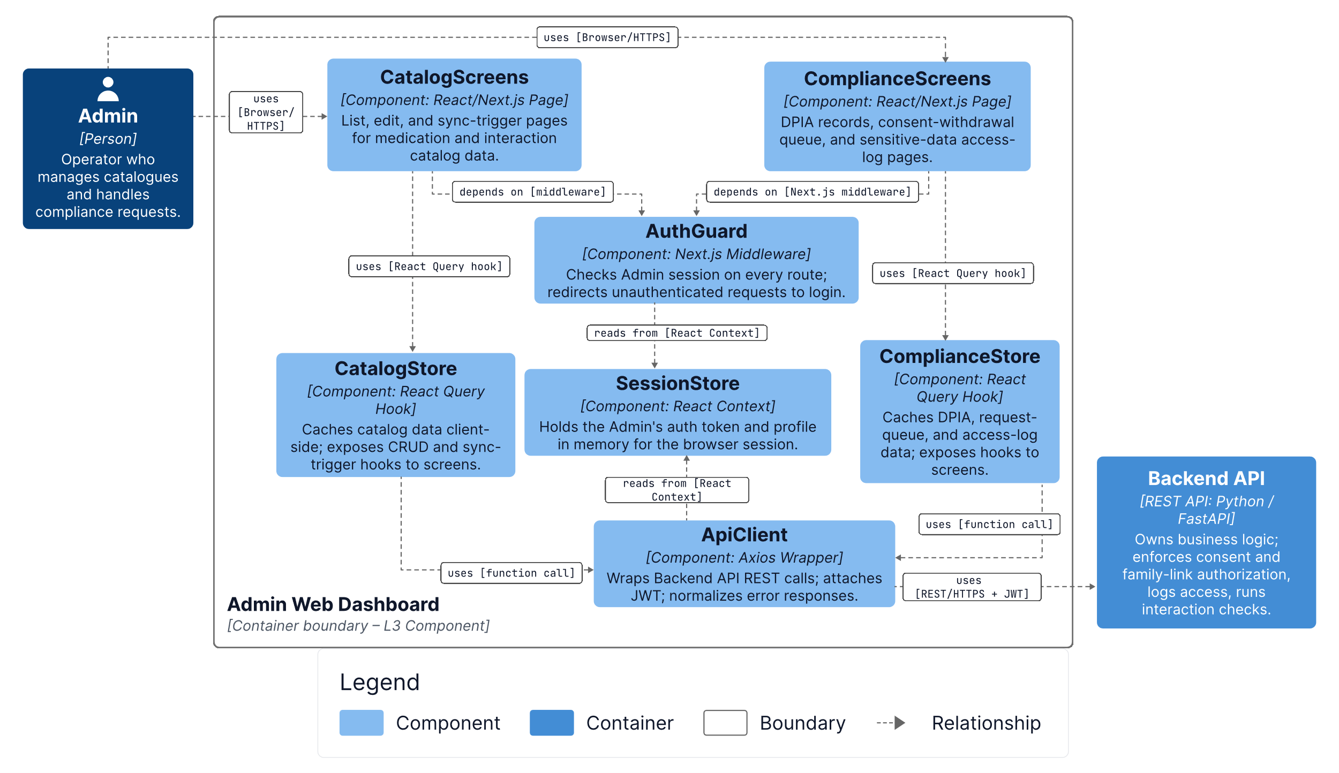
Figure 6. Module - System Logic API
Prose:

Table 32. Role & Responsibilities – Component level – API Application
Role | Responsibilities
Frontend Web Application
API Controller Layer
Application Service Layer
Domain Policy Layer
External Client Layer
Repository Layer
Configuration Layer
Backend 2 – AI Model Service
Database
Cloud Storage – Cloudinary

    - C&C
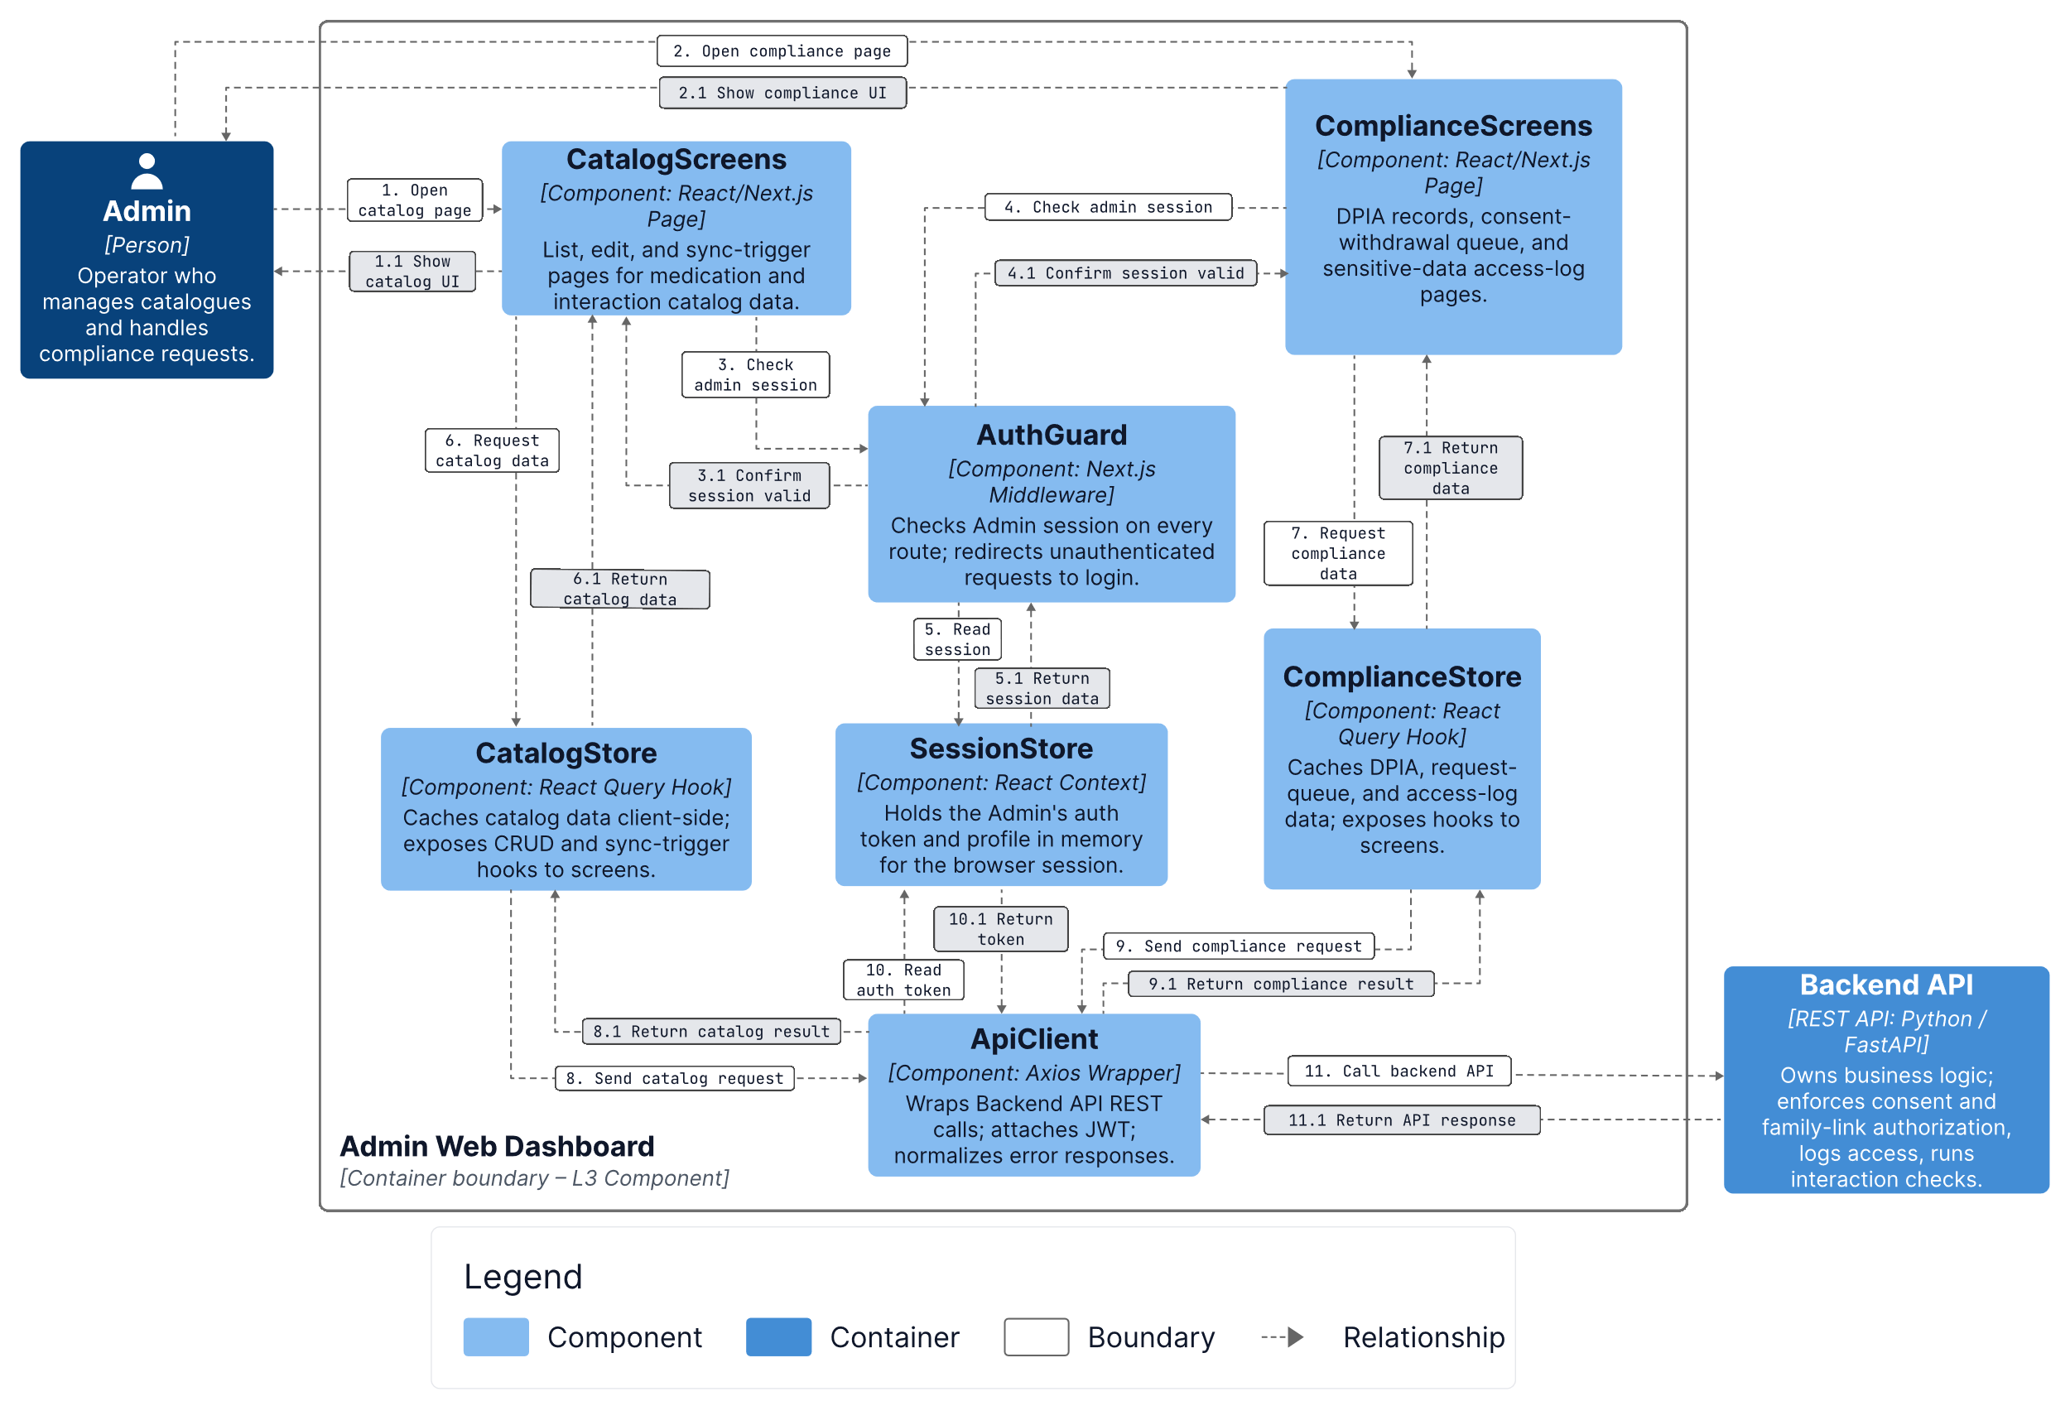

Figure 7. C&C - Backend 1 (System Logic API)
Prose:

Backend
    - Module
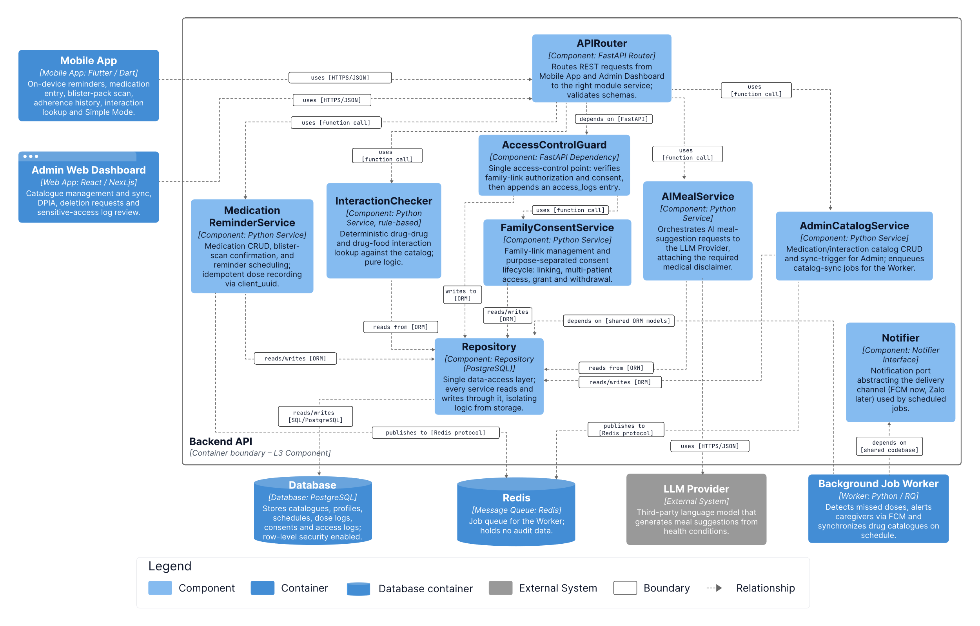

Prose:

Table 33. Role & Responsibilities – Component level – Backend2 - AI Model Service
Role | Responsibilities

    - C&C
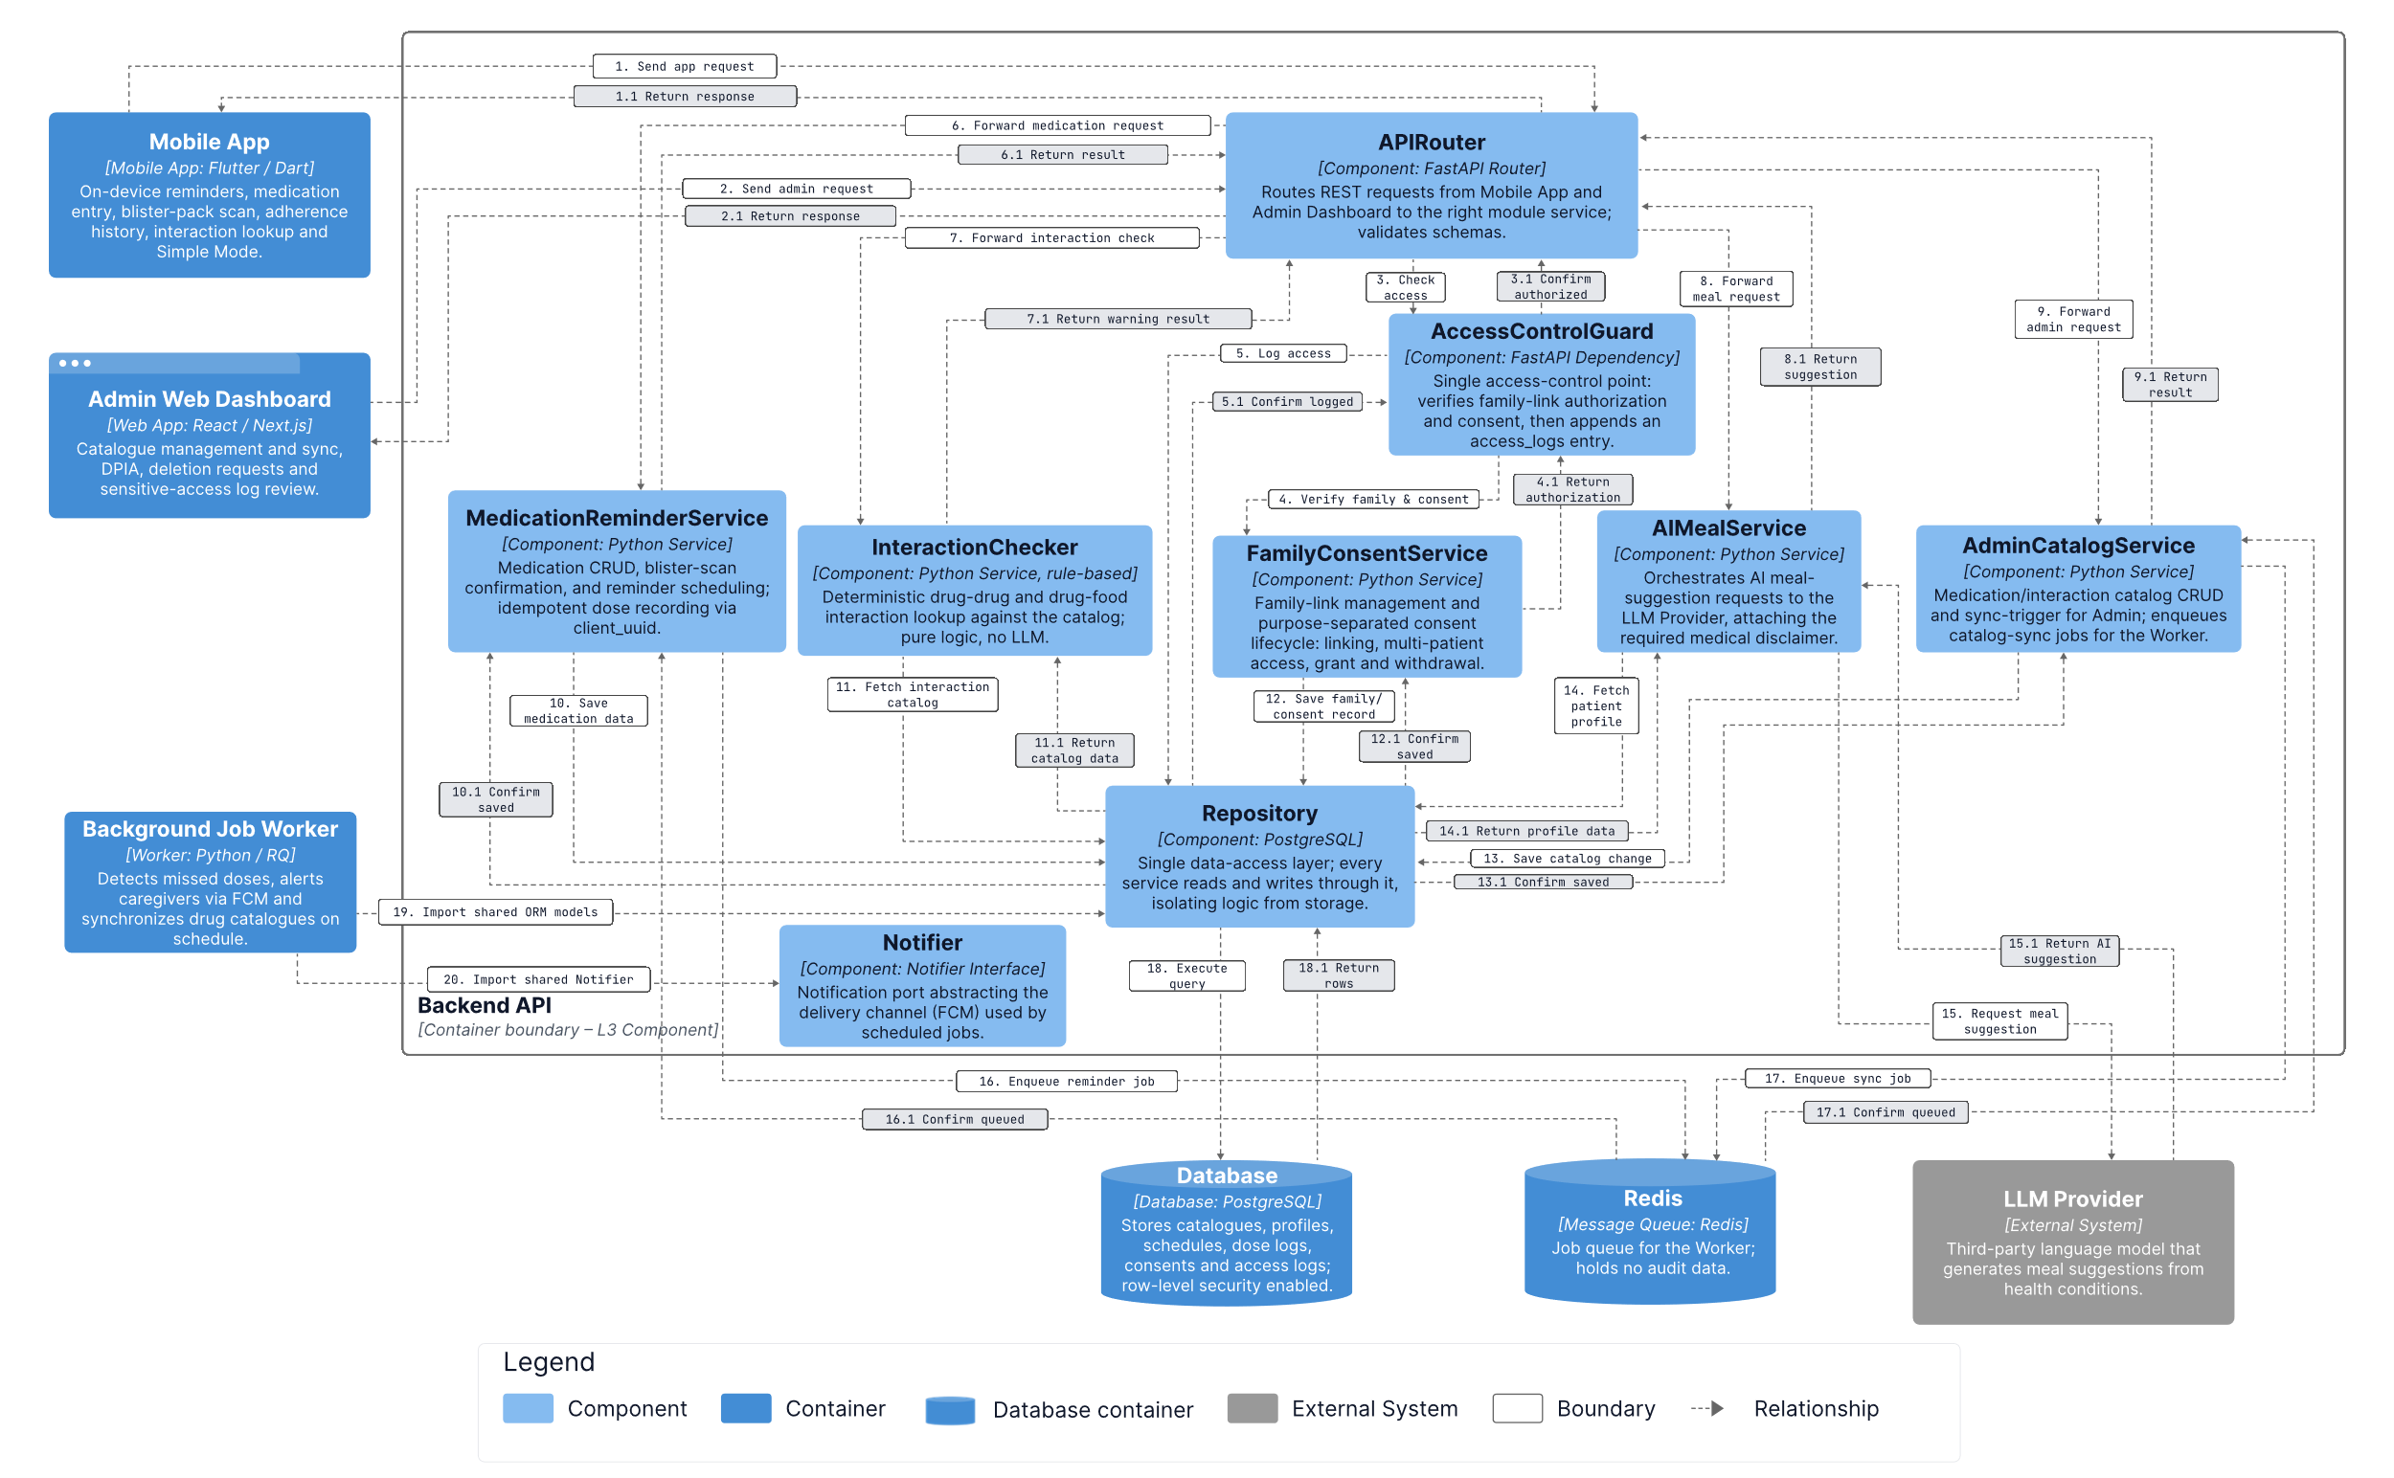
Prose:

Redis

Background Job Worker
    - Module
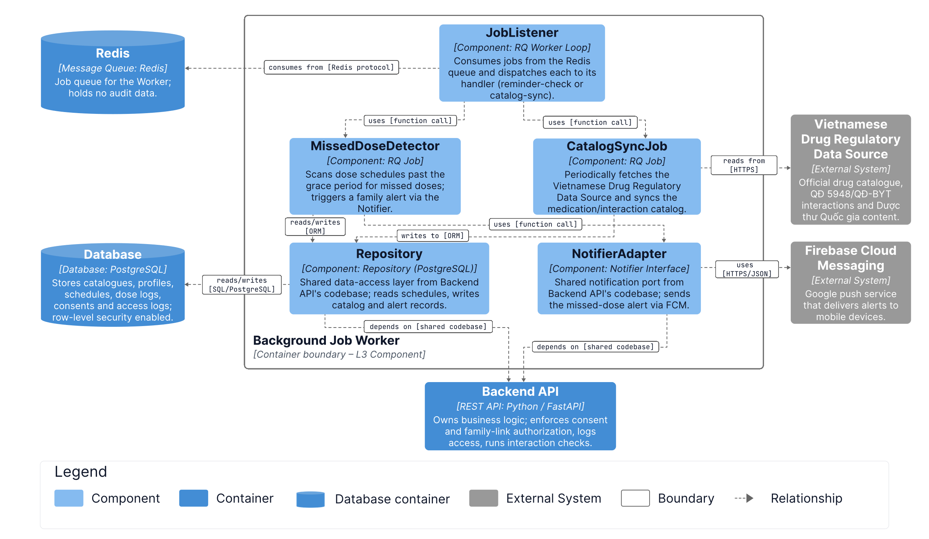
    - C&C
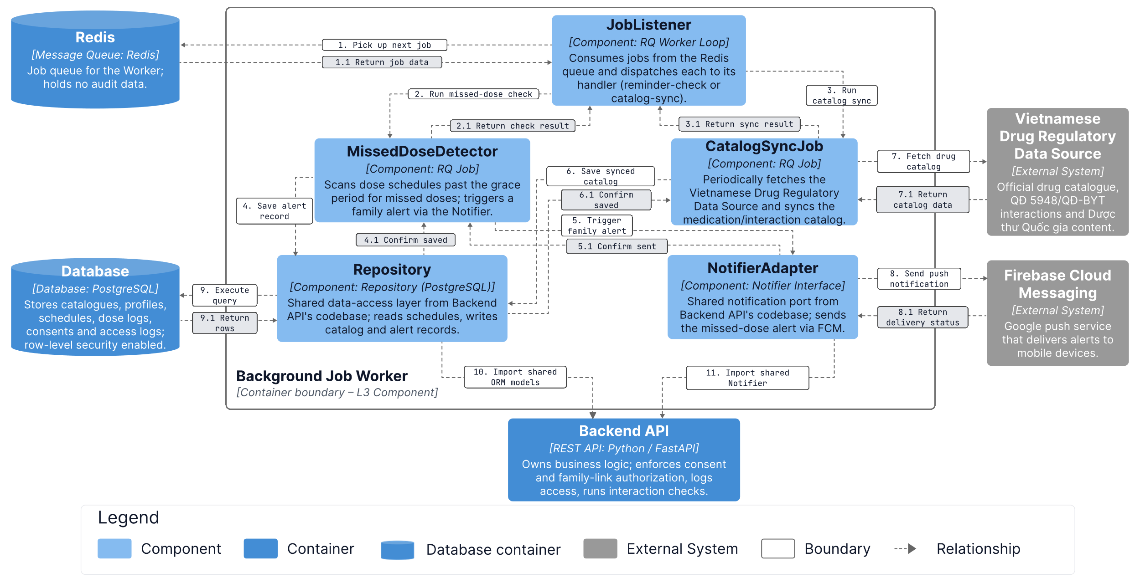

Code Diagrams

Backend 1 - Upload Management
    - Module - Class

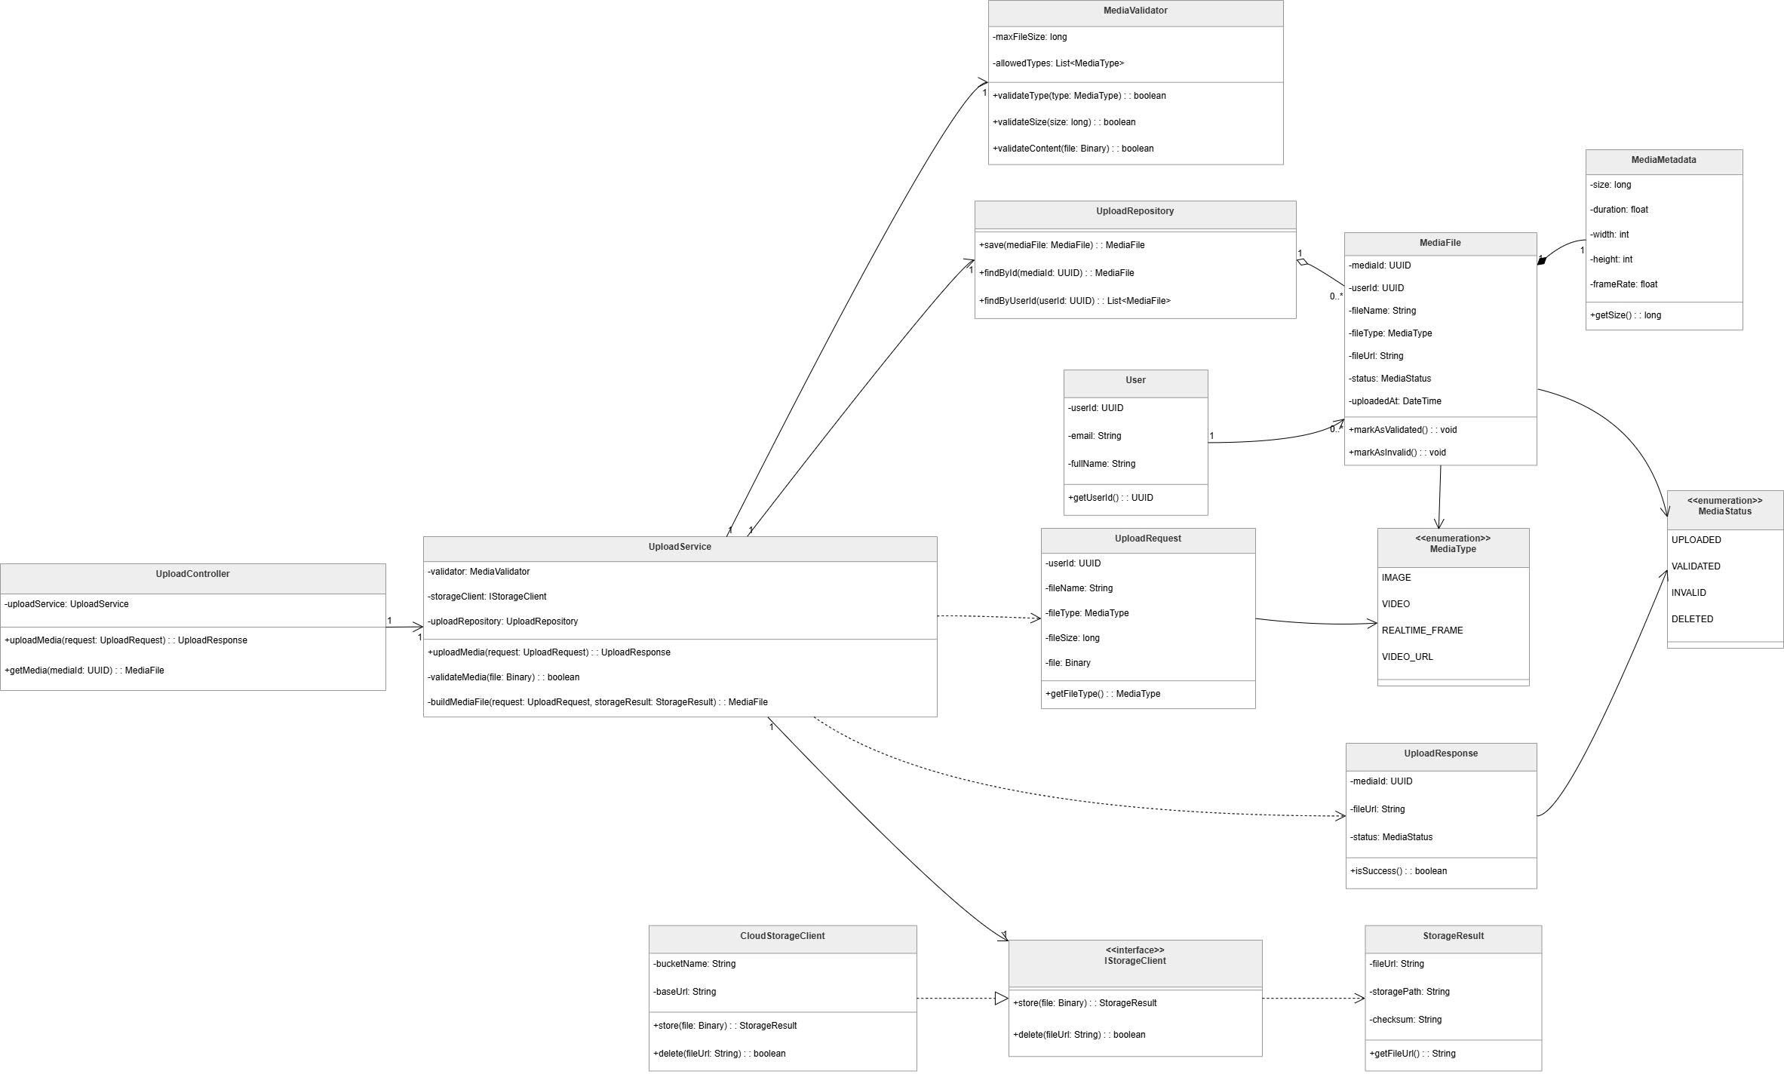
Figure 12. Backend 1 – Upload Management
Prose:
The class diagram illustrates the structure and relationships of the Upload Management part of the Deepfake Face Detection System. This part of the system is responsible for receiving media upload requests, validating uploaded files, storing media files, and returning upload results to the client. The design separates controller logic, service logic, validation logic, repository logic, storage integration, request/response models, domain entities, and enumerations to improve maintainability and reusability.
At the core of the upload workflow are the UploadController and UploadService classes. The UploadController receives upload-related requests and delegates the main processing logic to the UploadService. It provides operations such as uploading media and retrieving media information by media ID. The UploadService coordinates the upload process by using the MediaValidator, IStorageClient, and UploadRepository. It validates the uploaded file, stores the file through the storage client, builds a MediaFile object, and saves the media record through the repository.
Validation is handled by the MediaValidator class. This class defines validation rules such as maximum file size and allowed media types. It provides methods for validating file type, file size, and file content. By separating validation logic into its own class, the upload workflow remains cleaner and easier to modify when media validation rules change.
Persistence is managed by the UploadRepository class. It is responsible for saving media file records and retrieving uploaded media by media ID or user ID. This repository works with the MediaFile domain object, which represents uploaded media in the system. The MediaFile class stores key media information such as media ID, user ID, file name, media type, file URL, upload status, metadata, and upload time. It also provides behavior for marking media as validated or invalid.
Storage integration is abstracted through the IStorageClient interface. This interface defines storage operations such as storing a file and deleting a file by URL. The CloudStorageClient implements this interface and provides concrete storage behavior using cloud storage configuration such as bucket name and base URL. This design allows the system to change the storage provider without changing the upload service logic.
The diagram also includes supporting data models. The UploadRequest class represents the input data required for uploading a file, including user ID, file name, file type, and binary file content. The UploadResponse class represents the result returned after an upload operation, including media ID, file URL, upload status, and success information. The StorageResult class stores information returned by the storage operation, including file URL, storage path, and checksum.
The User class represents the user who uploads media files. The MediaMetadata class stores additional media information such as file size, duration, width, height, and frame rate. The MediaType enumeration defines supported input types, including IMAGE, VIDEO, REALTIME_FRAME, and VIDEO_URL. The MediaStatus enumeration defines possible media states, including UPLOADED, VALIDATED, INVALID, and DELETED.
Overall, this class diagram shows a modular upload management design. The controller handles external requests, the service coordinates the workflow, the validator checks media validity, the repository handles persistence, and the storage client manages file storage. This separation of responsibilities makes the upload component easier to maintain, test, and extend.

Table 53. Class/Interface & Responsibility – Upload Management
Class/Interface | Responsibility
UploadController | Handles upload-related requests from the client; delegates upload and media retrieval operations to UploadService.
UploadService | Coordinates the media upload workflow; validates media files, stores uploaded files, builds MediaFile objects, and saves media records through the repository.
MediaValidator | Validates uploaded media based on allowed media types, maximum file size, and file content rules.
UploadRepository | Manages persistence for uploaded media; saves MediaFile records and retrieves media files by media ID or user ID.
IStorageClient | Defines the storage interface for storing and deleting uploaded files.
CloudStorageClient | Implements IStorageClient; stores uploaded files in cloud storage and deletes files using their file URL.
User | Represents the user who uploads media; stores user identification and basic user information.
UploadRequest | Represents the upload request data, including user ID, file name, file type, and binary file content.
UploadResponse | Represents the upload response returned after processing; contains media ID, file URL, media status, and success information.
MediaFile | Represents an uploaded media file; stores media ID, user ID, file name, media type, file URL, status, metadata, and upload time.
MediaMetadata | Stores additional metadata of an uploaded media file, such as size, duration, width, height, and frame rate.
MediaType | Enumeration that defines supported media input types, including IMAGE, VIDEO, REALTIME_FRAME, and VIDEO_URL.
MediaStatus | Enumeration that defines media processing states, including UPLOADED, VALIDATED, INVALID, and DELETED.
StorageResult | Represents the result returned by the storage operation, including file URL, storage path, and checksum.
    - C&C - Sequence diagram
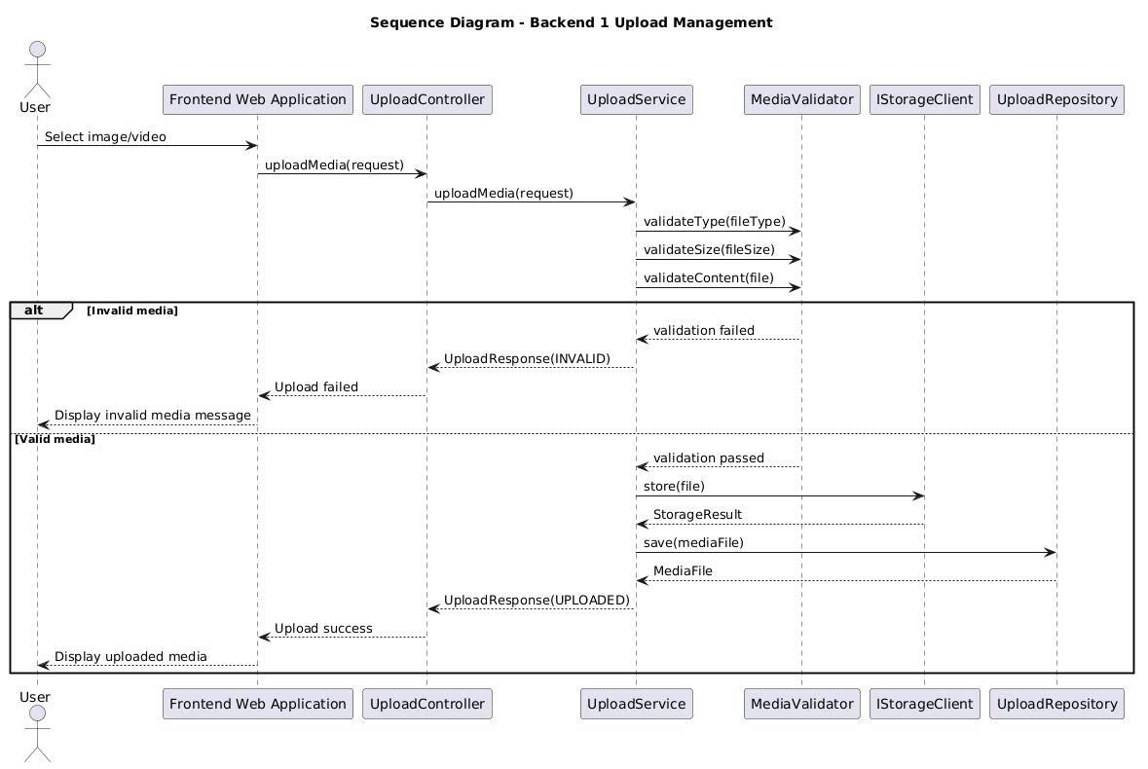
Figure 13. Sequence diagram - Backend 1 - Upload Management

Backend 1 - Detection Session
    - Module
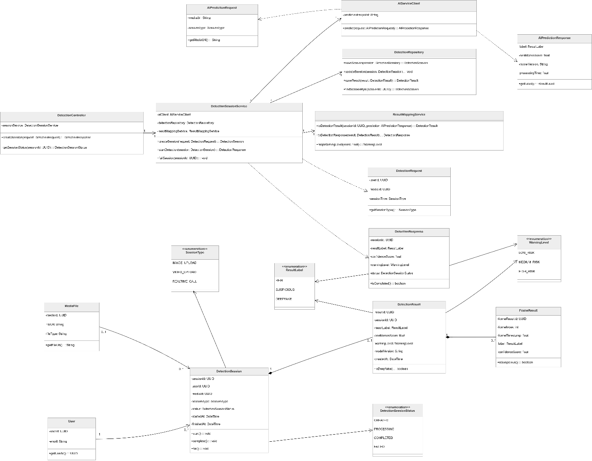
Figure 14. Backend 1 - Detection Session
Prose:
The class diagram illustrates the structure of the Detection Session component in the Deepfake Face Detection System. This component is responsible for creating detection sessions, sending prediction requests to the AI service, storing detection results, mapping AI outputs into system-level responses, and tracking the status of each detection workflow.
At the center of the design are the DetectionController and DetectionSessionService classes. The DetectionController acts as the entry point for detection-related operations. It receives detection requests from the client, creates new detection sessions, and provides session status information. Instead of handling business logic directly, the controller delegates processing to the DetectionSessionService.
The DetectionSessionService coordinates the main detection workflow. It creates detection sessions, starts the detection process, communicates with the AI service through the AIServiceClient, stores session and result data through the DetectionRepository, and converts AI responses into application-level results through the ResultMappingService. This design keeps the detection workflow centralized while still separating external communication, persistence, and response mapping responsibilities.
The AIServiceClient represents the integration point with the AI model service. It uses a prediction endpoint to send an AIPredictionRequest and receive an AIPredictionResponse. The prediction request contains information such as the media URL and session type, while the prediction response contains the predicted result label, confidence score, model version, and processing time.
Persistence is handled by the DetectionRepository. This class is responsible for saving detection sessions, updating session status, saving detection results, and retrieving sessions by session ID. By separating persistence logic from the service layer, the system can maintain a cleaner structure and reduce coupling between business logic and database operations.
The ResultMappingService converts AI prediction data into system-specific result objects. It builds a DetectionResult from the AI prediction response, creates a DetectionResponse for the client, and maps the prediction label into an appropriate WarningLevel. This class ensures that raw AI outputs are transformed into meaningful application results before being returned to users.
The diagram also includes several domain and data transfer classes. The DetectionRequest class represents the input required to start a detection session, including user ID, media ID, and session type. The DetectionResponse class represents the response returned to the client, including session ID, result label, confidence score, warning level, and session status. The DetectionSession class represents the lifecycle of a detection process and stores information such as session ID, user ID, media ID, session type, status, start time, and finish time.
Detection results are represented by the DetectionResult and FrameResult classes. The DetectionResult class stores the final result of a detection session, including result label, confidence score, warning level, model version, and creation time. The FrameResult class stores frame-level detection information, including frame index, frame timestamp, label, confidence score, and whether the frame is suspicious. This is useful for video or real-time detection workflows where multiple frames may be analyzed.
The User and MediaFile classes provide supporting information for the detection session. A detection session is associated with a user and may be associated with a media file. The MediaFile class provides the media URL and file information required by the detection process.
The diagram also defines several enumerations. ResultLabel defines the possible classification results: REAL, SUSPICIOUS, and DEEPFAKE. WarningLevel defines the risk level of the detection result: LOW_RISK, MEDIUM_RISK, and HIGH_RISK. SessionType defines the type of detection input, including IMAGE_UPLOAD, VIDEO_UPLOAD, and REALTIME_CALL. DetectionSessionStatus defines the lifecycle state of a detection session, including CREATED, PROCESSING, COMPLETED, and FAILED.
Overall, this class diagram shows a modular detection session design. The controller handles incoming requests, the service coordinates the workflow, the AI client communicates with the AI model service, the repository manages persistence, and the mapping service converts AI outputs into system-level results. This separation of responsibilities improves maintainability, testability, and extensibility.
Table 54. Class/Interface & Responsibility – Detection Session
Class/Interface | Responsibility
DetectionController | Handles detection-related requests from the client; creates detection sessions and retrieves session status by delegating operations to DetectionSessionService.
DetectionSessionService | Coordinates the detection workflow; creates sessions, starts detection, communicates with the AI service, stores results, updates session status, and returns detection responses.
AIServiceClient | Sends prediction requests to the AI model service and receives prediction responses; acts as the integration client between Backend 1 and the AI service.
DetectionRepository | Manages persistence for detection sessions and detection results; saves sessions, updates session status, saves results, and retrieves sessions by ID.
ResultMappingService | Converts AI prediction responses into DetectionResult and DetectionResponse objects; maps result labels into warning levels.
DetectionRequest | Represents the input data required to start a detection session, including user ID, media ID, and session type.
DetectionResponse | Represents the response returned to the client after detection processing; contains session ID, result label, confidence score, warning level, status, and completion information.
AIPredictionRequest | Represents the request sent to the AI service; contains media URL and session type information required for prediction.
AIPredictionResponse | Represents the response returned by the AI service; contains result label, confidence score, model version, and processing time.
DetectionSession | Represents a detection session and its lifecycle; stores session ID, user ID, media ID, session type, status, start time, and finish time.
DetectionResult | Represents the final result of a detection session; stores result label, confidence score, warning level, model version, and creation time.
FrameResult | Represents frame-level detection output; stores frame index, frame timestamp, label, confidence score, and suspicious-frame information.
MediaFile | Represents the media file used in a detection session; provides media ID, file URL, and file type information.
User | Represents the user who starts a detection session; stores user ID and email information.
ResultLabel | Enumeration that defines possible detection labels: REAL, SUSPICIOUS, and DEEPFAKE.
WarningLevel | Enumeration that defines risk levels: LOW_RISK, MEDIUM_RISK, and HIGH_RISK.
SessionType | Enumeration that defines supported detection session types: IMAGE_UPLOAD, VIDEO_UPLOAD, and REALTIME_CALL.
DetectionSessionStatus | Enumeration that defines session lifecycle states: CREATED, PROCESSING, COMPLETED, and FAILED.

    - C&C - Sequence diagram
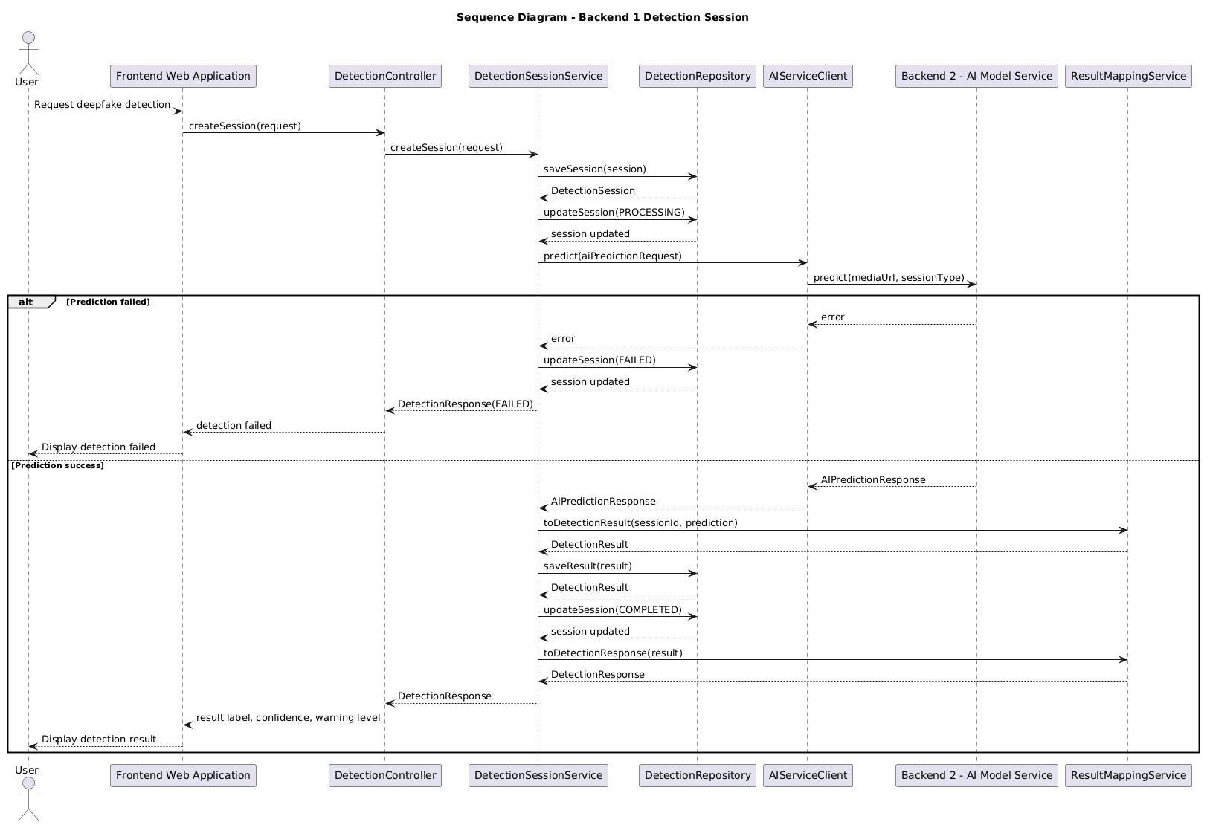
Figure 15. Sequence diagram - Backend 1 - Detection Session

Backend 1 - Result & Moderator Review
    - Module – Class
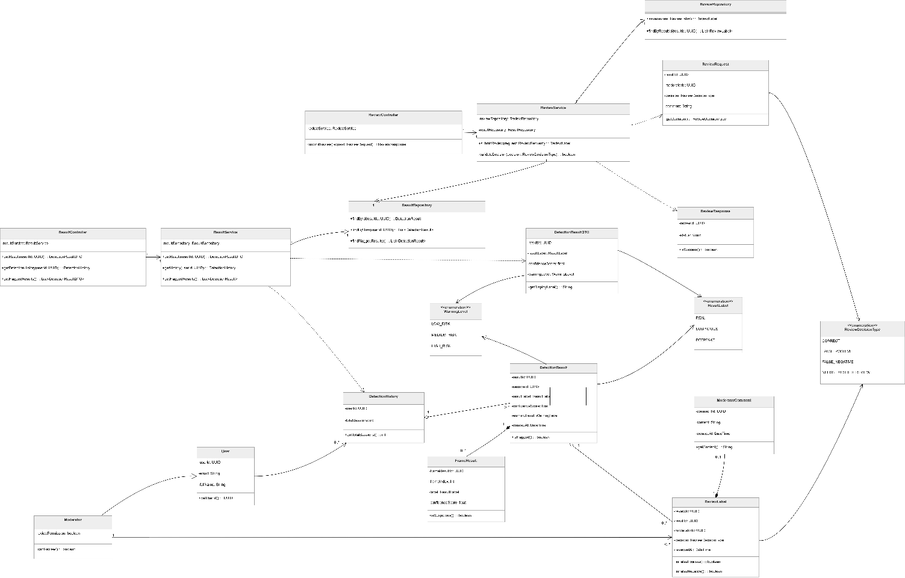
Figure 16. Backend 1 - Result & Moderator Review
Prose:
The class diagram illustrates the structure of the Result and Moderator Review component in the Deepfake Face Detection System. This component is responsible for retrieving detection results, displaying detection history, identifying flagged results, and allowing moderators to review suspicious detection cases. The design separates result retrieval, review submission, repository access, DTO objects, domain entities, and enumerations to improve maintainability and clarity.
The result retrieval workflow is handled by the ResultController and ResultService classes. The ResultController acts as the entry point for result-related requests. It allows the system to retrieve a detection result by result ID, retrieve a user's detection history, and get flagged detection results. Instead of directly accessing data, it delegates business logic to the ResultService.
The ResultService coordinates result-related operations. It uses the ResultRepository to retrieve detection results, detection history, and flagged results. This service converts repository data into result objects or DTOs that can be returned to the client. By separating the service layer from the controller and repository layers, the system keeps result retrieval logic organized and easier to modify.
Moderator review is handled by the ReviewController and ReviewService classes. The ReviewController receives review requests from moderators and delegates the review process to the ReviewService. The ReviewService validates the review decision, checks the related detection result, and stores the moderator review through the ReviewRepository. It also works with the ResultRepository when the review decision needs to be associated with an existing detection result.
The persistence layer is represented by ResultRepository and ReviewRepository. The ResultRepository retrieves detection results by result ID or user ID and provides access to flagged results that may require moderator review. The ReviewRepository saves review labels and retrieves review labels associated with a specific detection result.
The diagram also includes several domain and data transfer classes. The DetectionResultDTO class represents result data prepared for display, including result label, confidence score, and warning level. The DetectionHistory class stores summary information about a user's previous detection sessions. The DetectionResult class represents the stored detection output, including result ID, session ID, result label, confidence score, warning level, and creation time. The FrameResult class stores frame-level detection information and is associated with a detection result.
Moderator review data is represented by the ReviewRequest, ReviewResponse, ReviewLabel, and ModeratorComment classes. The ReviewRequest class contains the result ID, moderator ID, review decision, and comment submitted by a moderator. The ReviewResponse class represents the response returned after a review action. The ReviewLabel class stores the moderator's review decision, including whether the result is correct, false positive, false negative, or needs further review. The ModeratorComment class stores additional comment content written by the moderator.
The User class represents a general system user, while the Moderator class represents a specialized user with review permission. The moderator can review suspicious results and submit review decisions. This separation allows the system to distinguish normal users from users who have moderator responsibilities.
The diagram also defines several enumerations. ResultLabel defines possible detection labels, including REAL, SUSPICIOUS, and DEEPFAKE. WarningLevel defines the risk level of a detection result, including LOW_RISK, MEDIUM_RISK, and HIGH_RISK. ReviewDecisionType defines the possible moderator decisions, including CORRECT, FALSE_POSITIVE, FALSE_NEGATIVE, and NEEDS_FURTHER_REVIEW.
Overall, this class diagram shows a clear separation between result retrieval and moderator review. The result controller and service handle detection result access, while the review controller and service handle moderator decisions. Repositories manage data access, DTOs support client-facing responses, and domain classes represent stored system information. This structure improves maintainability, supports review workflows, and enables better traceability of suspicious detection results.
Table 55. Class/Interface & Responsibility – Result & Moderator Review
Class/Interface | Responsibility
ResultController | Handles result-related requests; retrieves detection results, detection history, and flagged results by delegating operations to ResultService.
ResultService | Coordinates result retrieval operations; uses ResultRepository to get detection results, user detection history, and flagged results.
ResultRepository | Manages persistence access for detection results; finds results by result ID, retrieves results by user ID, and retrieves flagged results.
ReviewController | Handles moderator review requests; receives review submissions and delegates review processing to ReviewService.
ReviewService | Coordinates the moderator review workflow; validates review decisions, checks related detection results, and saves review labels through ReviewRepository.
ReviewRepository | Manages persistence access for review data; saves ReviewLabel records and retrieves review labels by result ID.
DetectionResultDTO | Represents detection result data prepared for display; includes result label, confidence score, warning level, and display label information.
DetectionHistory | Represents a user's detection history; stores user ID and total session information.
DetectionResult | Represents the stored detection result; contains result ID, session ID, result label, confidence score, warning level, creation time, and flagged status.
FrameResult | Represents frame-level detection output; stores frame result ID, frame index, label, confidence score, and suspicious-frame information.
ReviewRequest | Represents the review data submitted by a moderator; contains result ID, moderator ID, review decision, and comment.
ReviewResponse | Represents the response returned after a review action; contains review ID, status, and success information.
ReviewLabel | Represents the moderator's final review label for a detection result; stores review ID, result ID, moderator ID, review decision, review time, and false positive or false negative information.
ModeratorComment | Represents an additional comment written by a moderator; stores comment ID, content, creation time, and comment retrieval behavior.
User | Represents a general system user; stores user ID, email, and full name information.
Moderator | Represents a specialized user with review permission; determines whether the user can review suspicious detection results.
ResultLabel | Enumeration that defines possible detection labels: REAL, SUSPICIOUS, and DEEPFAKE.
WarningLevel | Enumeration that defines warning levels: LOW_RISK, MEDIUM_RISK, and HIGH_RISK.
ReviewDecisionType | Enumeration that defines possible review decisions: CORRECT, FALSE_POSITIVE, FALSE_NEGATIVE, and NEEDS_FURTHER_REVIEW.

    - C&C - Sequence diagram
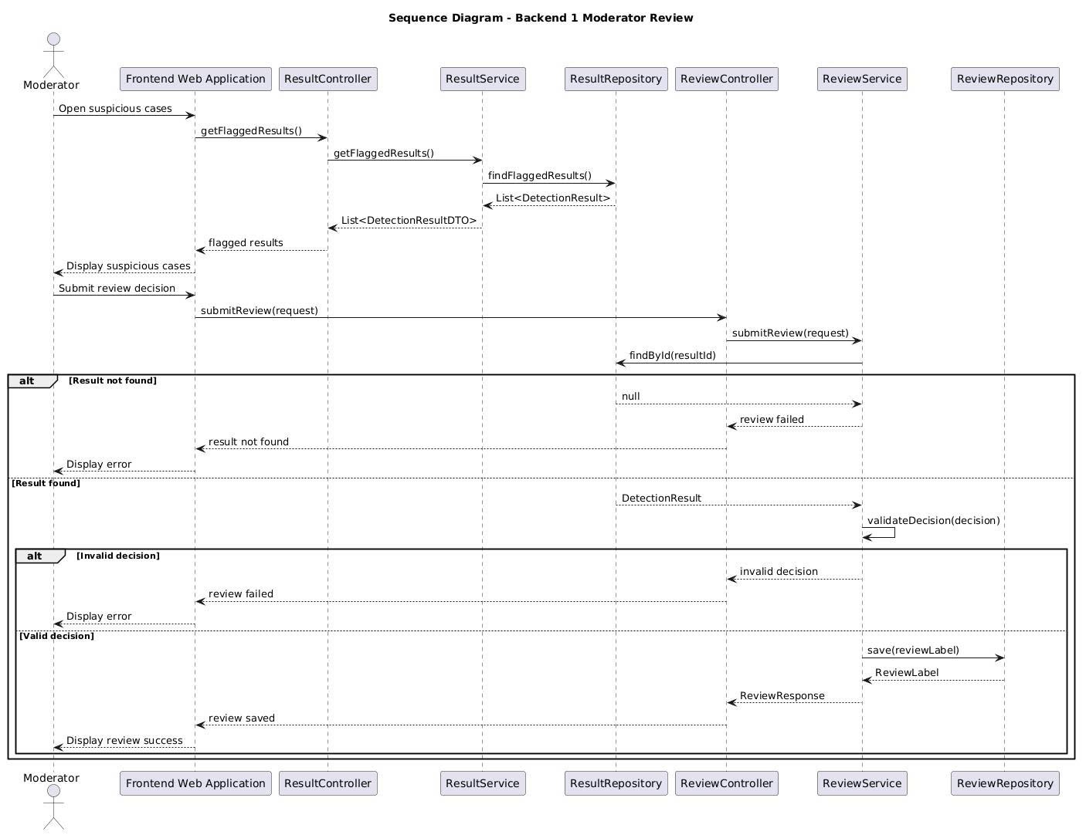
Figure 17. Sequence diagram - Backend 1 - Detection Session

Backend 2 - Input Processing
    - Module
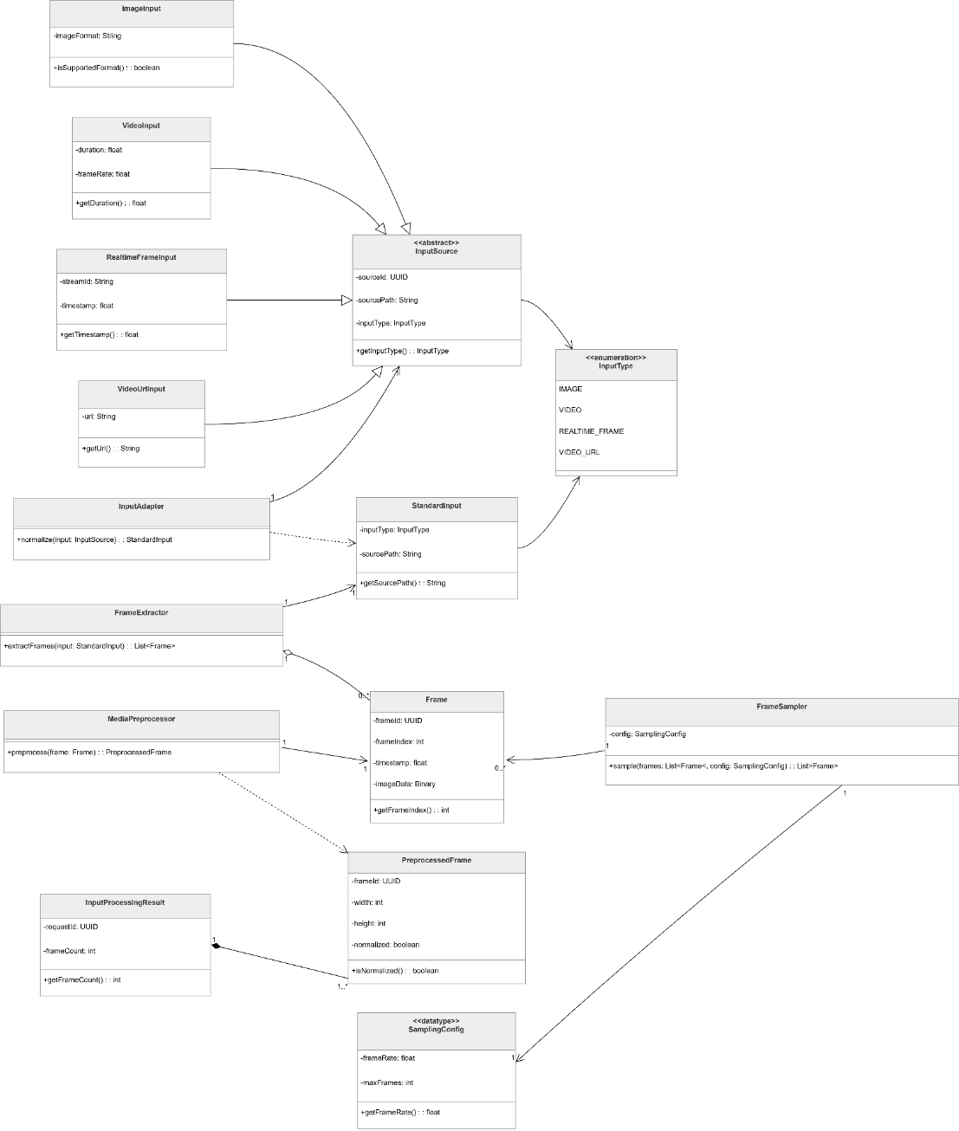
Prose:
The class diagram illustrates the structure of the Input Processing component in the Deepfake Face Detection System. This component is responsible for receiving different input types, converting them into a common internal format, extracting frames when necessary, sampling selected frames, preprocessing media data, and returning processed frames for later face detection and deepfake classification.
At the center of the design is the abstract InputSource class. This class represents a general input source that can be processed by the system. Several concrete input classes extend this abstraction, including ImageInput, VideoInput, RealtimeFrameInput, and VideoUrlInput. These classes represent different input sources supported by the system, such as uploaded images, uploaded videos, real-time frames, and video URLs. By using a common abstraction, the system can handle different input types consistently.
The InputType enumeration defines the supported categories of input. It allows the system to identify whether the input is an image, video, real-time frame, or video URL. This helps the input processing workflow decide how the input should be adapted, extracted, sampled, and preprocessed.
The InputAdapter class converts a concrete input source into a StandardInput object. The purpose of this class is to normalize different input formats into a common structure before they enter the rest of the processing pipeline. This improves maintainability because new input types can be supported by adding new input source classes and adapter logic without changing the downstream processing modules.
The StandardInput class represents the normalized input format used internally by the AI service. After the input is standardized, it can be passed to the frame extraction and preprocessing workflow. For video-based inputs, the FrameExtractor class extracts frames from the source media. These frames are represented by the Frame class, which stores frame-level information before preprocessing.
The FrameSampler class selects a subset of frames based on a SamplingConfig object. This is useful for video and real-time inputs where processing every frame may be inefficient. The sampling configuration defines how frames should be selected, allowing the system to balance detection accuracy and processing performance.
After frames are extracted and sampled, the MediaPreprocessor class prepares the frames for later AI processing. It performs preprocessing operations such as resizing, normalization, and format conversion. The result of this step is represented by the PreprocessedFrame class, which stores the processed frame data ready for face detection or model inference.
The InputProcessingResult class represents the final output of the input processing workflow. It contains the processed data and status information needed by the next stage of the AI pipeline. This result object allows the input processing component to return a consistent output regardless of whether the original input was an image, video, real-time frame, or video URL.
Overall, this class diagram shows a flexible and extensible input processing design. The use of an abstract input source, standardized input format, frame extraction, frame sampling, and preprocessing classes allows the system to support multiple media input types while keeping the downstream AI pipeline stable and consistent.
Table 56. Class/Interface & Responsibility – Input Processing
Class/Interface | Responsibility
InputSource | Abstract class that represents a general input source; provides a common structure for different input types handled by the system.
ImageInput | Represents an image input source uploaded or provided to the system for deepfake detection.
VideoInput | Represents a video input source that requires frame extraction before further processing.
RealtimeFrameInput | Represents a real-time frame input source captured from an incoming video stream.
VideoUrlInput | Represents a video input source provided through a URL that must be resolved before frame extraction.
InputType | Enumeration that defines supported input types, such as image, video, real-time frame, and video URL.
InputAdapter | Converts different concrete input sources into a standardized internal input format.
StandardInput | Represents the normalized input format used by the AI processing pipeline after adaptation.
FrameExtractor | Extracts frames from video-based input sources so they can be processed individually.
Frame | Represents a raw frame extracted from an input source before preprocessing.
FrameSampler | Selects important or representative frames from a larger frame set based on the sampling configuration.
SamplingConfig | Defines the configuration used for frame sampling, such as sampling rate or frame selection rules.
MediaPreprocessor | Prepares media frames for AI processing by applying operations such as resizing, normalization, and format conversion.
PreprocessedFrame | Represents a frame after preprocessing, ready for face detection or model inference.
InputProcessingResult | Represents the final output of the input processing workflow; contains processed frames and status information for the next AI processing stage.

    - C&C - Activity diagram
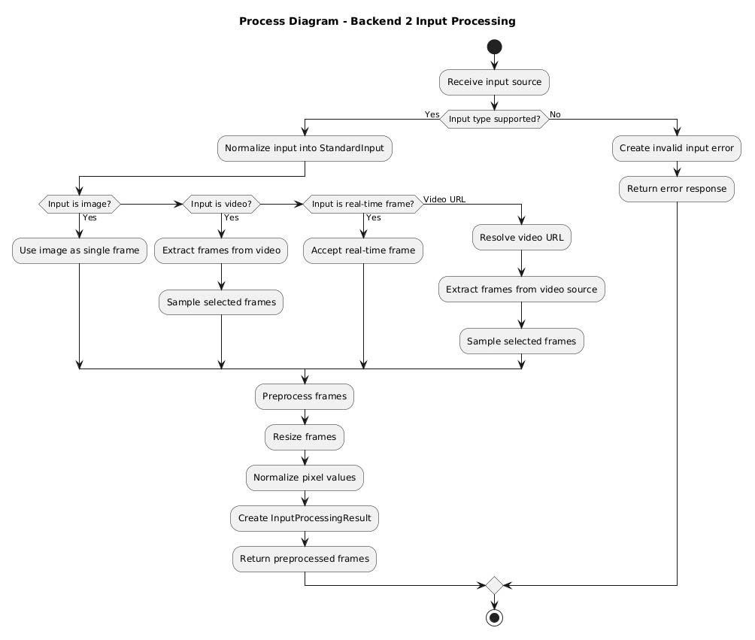
Figure 18. Activity diagram - Backend 2 - Input Processing

Backend 2 - Face Detection
    - Module – Class
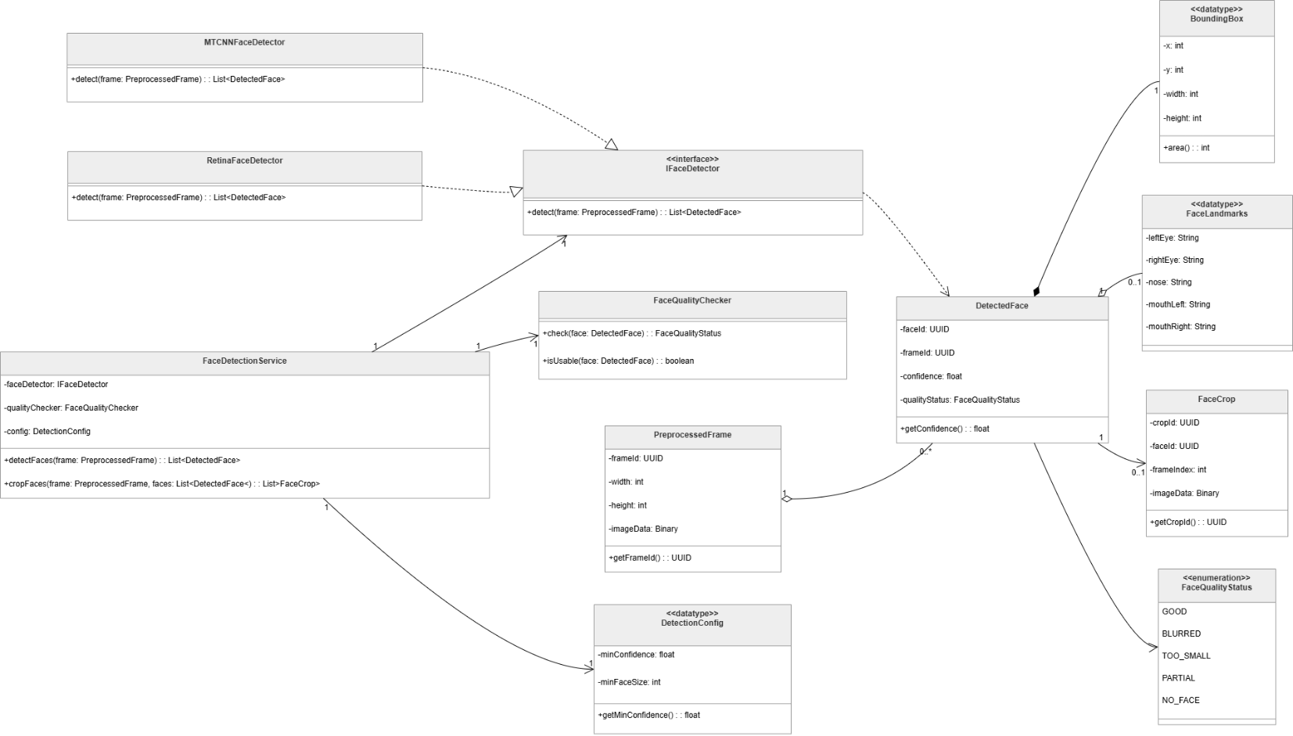
Figure 19. Backend 2 – Face Detection
Prose:
The class diagram illustrates the structure of the Face Detection component in the Deepfake Face Detection System. This component is responsible for detecting faces from preprocessed frames, evaluating face quality, extracting face regions, and preparing detected face data for the next stage of deepfake classification.
At the center of the design is the FaceDetectionService class. This service coordinates the face detection workflow by receiving a PreprocessedFrame, applying a configured face detection algorithm, checking the quality of detected faces, and returning structured face detection results. It acts as the main application-level class for this component and hides the details of the underlying face detection implementation from the rest of the AI pipeline.
The system uses the IFaceDetector interface to abstract the face detection algorithm. This interface allows different face detection implementations to be used without changing the main face detection service. The diagram includes two detector implementations: MTCNNFaceDetector and RetinaFaceDetector. Both classes represent concrete face detection strategies that can be selected or replaced depending on system requirements, accuracy, or performance.
The DetectionConfig data type stores configuration values used during face detection. These configuration values may include detector selection, confidence thresholds, minimum face size, or other detection parameters. By separating configuration into its own data type, the system can adjust detection behavior without changing the core service logic.
The PreprocessedFrame class represents an input frame that has already passed through the media preprocessing stage. It is the main input object for the face detection workflow. After a face is detected, the result is represented by the DetectedFace class. This class contains the information related to a detected face, such as its bounding box, facial landmarks, cropped face region, and quality status.
The BoundingBox data type represents the rectangular region where a face is located in the frame. The FaceLandmarks data type represents important facial key points, such as eyes, nose, and mouth positions. The FaceCrop class represents the cropped face image or region extracted from the original frame. These classes provide the structured data needed for later deepfake classification.
The FaceQualityChecker class evaluates whether a detected face is suitable for classification. It checks the quality of the detected face and returns a FaceQualityStatus value. The FaceQualityStatus enumeration defines possible quality states for detected faces. This helps the system filter out unusable or low-quality faces before they are sent to the classification model.
Overall, this class diagram shows a flexible and modular face detection design. The service layer coordinates the workflow, the detector interface allows different detection algorithms to be used, and the supporting data classes represent face location, landmarks, crops, and quality information. This structure makes the face detection component easier to maintain, test, and extend.
Table 57. Class/Interface & Responsibility – Face Detection
Class/Interface | Responsibility
FaceDetectionService | Coordinates the face detection workflow; receives preprocessed frames, applies face detection, checks face quality, and returns detected face information.
IFaceDetector | Defines the common interface for face detection algorithms; allows different detector implementations to be used interchangeably.
MTCNNFaceDetector | Implements face detection using the MTCNN-based detection approach.
RetinaFaceDetector | Implements face detection using the RetinaFace-based detection approach.
FaceQualityChecker | Evaluates the quality of detected faces and determines whether they are suitable for further classification.
PreprocessedFrame | Represents a frame that has already been processed by the media preprocessing stage and is ready for face detection.
DetectionConfig | Stores configuration values used during face detection, such as detector settings, thresholds, and detection parameters.
DetectedFace | Represents a detected face and stores related information such as bounding box, landmarks, face crop, and quality status.
BoundingBox | Represents the rectangular coordinates of a detected face within a frame.
FaceLandmarks | Represents key facial landmark points detected on a face.
FaceCrop | Represents the cropped face region extracted from the original frame.
FaceQualityStatus | Enumeration that defines the quality status of a detected face.

    - C&C - Sequence diagram
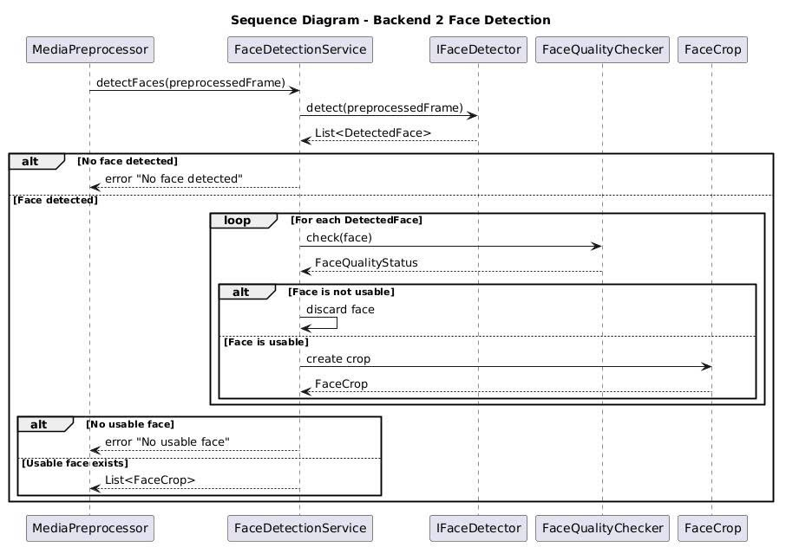
Figure 20. Sequence diagram - Backend 2 - Face Detection

Backend 2 - Deepfake Classification
    - Module – Class
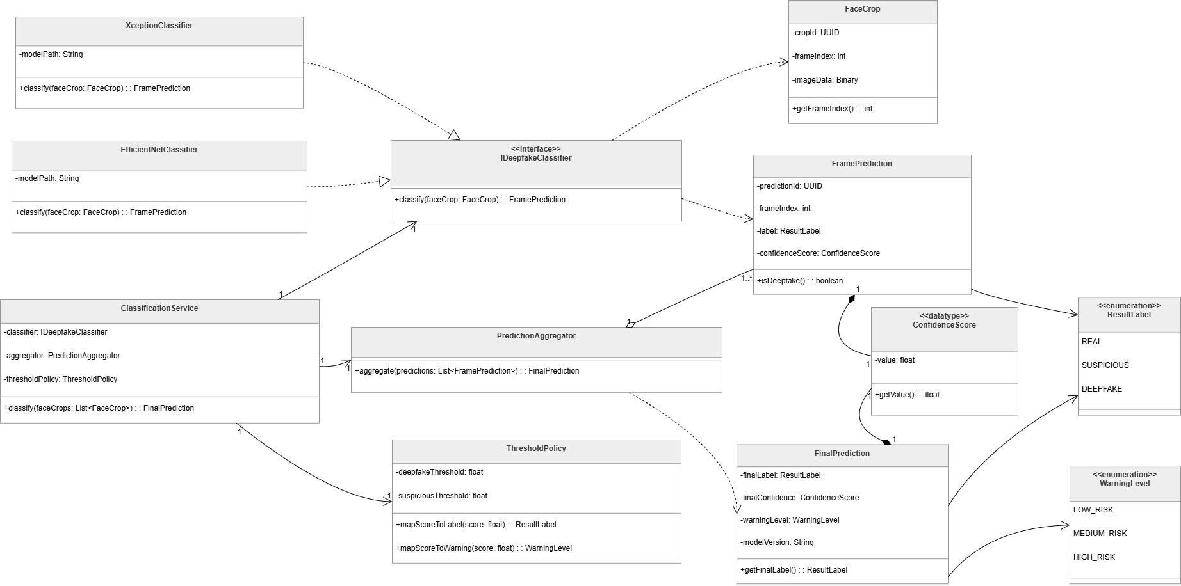
Figure 21. Backend 2 - Deepfake Classification

Prose:
The class diagram illustrates the structure of the Deepfake Classification component in the Deepfake Face Detection System. This component is responsible for classifying detected face crops, generating frame-level predictions, aggregating multiple predictions, and producing the final detection result with a label, confidence score, warning level, and model version.
At the center of the design is the ClassificationService class. This service coordinates the classification workflow by receiving a list of FaceCrop objects, sending each face crop to a deepfake classifier, collecting frame-level predictions, applying threshold rules, and generating a FinalPrediction. The service depends on three main collaborators: DeepfakeClassifier, PredictionAggregator, and ThresholdPolicy.
The DeepfakeClassifier interface defines the common classification operation used by different model implementations. It provides a classify method that receives a FaceCrop and returns a FramePrediction. This interface allows the classification service to use different deepfake detection models without changing the service logic.
The diagram includes two concrete classifier implementations: XceptionClassifier and EfficientNetClassifier. Both classifiers store a model path and implement the classification operation defined by the DeepfakeClassifier interface. This design allows the system to switch between model architectures or add new classifier implementations in the future.
The FaceCrop class represents the cropped face image extracted from a frame. It contains information such as crop ID, frame index, and binary image data. Each face crop is passed to a classifier to generate a frame-level prediction.
The FramePrediction class represents the prediction result for an individual frame or face crop. It stores the prediction ID, frame index, result label, and confidence score. It also provides behavior for checking whether the prediction is classified as deepfake.
The ConfidenceScore data type wraps the prediction confidence value. It stores a floating-point score and provides a method for retrieving the value. This keeps confidence-related data consistent between frame-level predictions and final predictions.
The PredictionAggregator class combines multiple FramePrediction objects into a single FinalPrediction. This is important for video or real-time analysis, where multiple frames may be classified separately before producing one final result.
The ThresholdPolicy class defines how raw confidence scores are mapped into result labels and warning levels. It stores thresholds for deepfake and suspicious classifications and provides mapping methods for converting a score into a ResultLabel or WarningLevel.
The FinalPrediction class represents the final output of the classification workflow. It contains the final result label, final confidence score, warning level, and model version. This object is returned after all frame-level predictions have been aggregated and interpreted.
The diagram also includes two enumerations. ResultLabel defines the possible classification labels: REAL, SUSPICIOUS, and DEEPFAKE. WarningLevel defines the possible risk levels: LOW_RISK, MEDIUM_RISK, and HIGH_RISK.
Overall, this class diagram shows a flexible and extensible classification design. The classification service coordinates the workflow, the classifier interface allows model replacement, concrete classifiers implement specific model architectures, the threshold policy controls label and warning mapping, and the aggregator produces a final result from multiple frame-level predictions.
Table 58. Class/Interface & Responsibility – Deepfake Classification
Class/Interface | Responsibility
ClassificationService | Coordinates the deepfake classification workflow; receives face crops, calls the classifier, applies aggregation, and returns the final prediction.
DeepfakeClassifier | Defines the common interface for deepfake classification models; classifies a FaceCrop and returns a FramePrediction.
XceptionClassifier | Implements DeepfakeClassifier using an Xception-based model; loads the model from a model path and classifies face crops.
EfficientNetClassifier | Implements DeepfakeClassifier using an EfficientNet-based model; loads the model from a model path and classifies face crops.
FaceCrop | Represents a cropped face image extracted from a frame; stores crop ID, frame index, and binary image data.
FramePrediction | Represents the classification result for a single face crop or frame; stores prediction ID, frame index, result label, and confidence score.
ConfidenceScore | Represents a confidence value returned by the classifier; wraps a floating-point score and provides access to the score value.
PredictionAggregator | Aggregates multiple frame-level predictions into a single final prediction.
ThresholdPolicy | Defines threshold rules for mapping confidence scores to result labels and warning levels.
FinalPrediction | Represents the final classification output; stores final label, final confidence score, warning level, and model version.
ResultLabel | Enumeration that defines possible classification labels: REAL, SUSPICIOUS, and DEEPFAKE.
WarningLevel | Enumeration that defines possible warning levels: LOW_RISK, MEDIUM_RISK, and HIGH_RISK.

    - C&C - Activity diagram
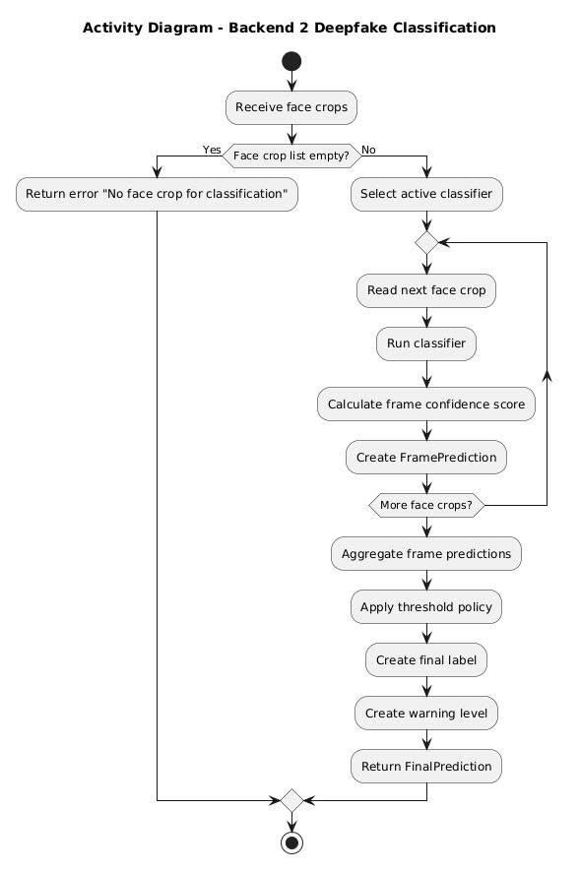
Figure 22. Activity diagram - Backend 2 - Deepfake Classification

Backend 2 - Model Management
    - Module - Class
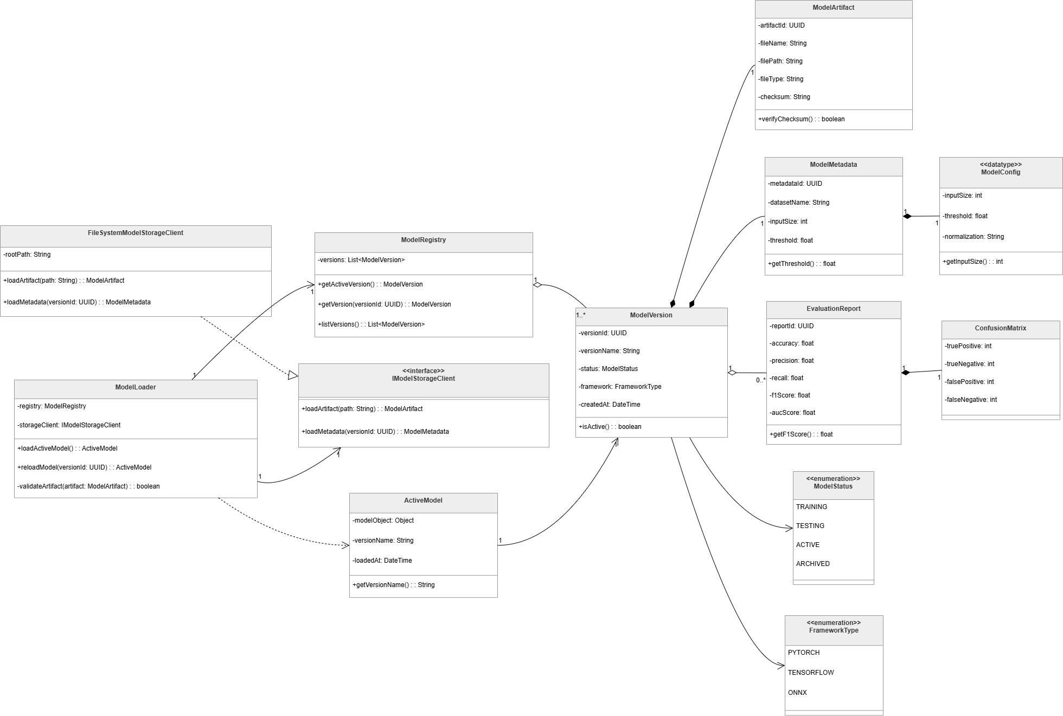
Figure 23. Backend 2 - Model Management
Prose:
The class diagram illustrates the structure of the Model Management component in the Deepfake Face Detection System. This component is responsible for managing model versions, loading the active model, retrieving model artifacts and metadata, validating model files, and providing model configuration information for inference.
At the center of the design is the ModelLoader class. This class coordinates the model loading workflow by using the ModelRegistry and the IModelStorageClient interface. The ModelLoader can load the currently active model, reload a specific model version, and validate model artifacts before they are used for inference. This allows the AI service to change or update models without modifying the main classification workflow.
The ModelRegistry class manages available model versions. It stores a list of ModelVersion objects and provides operations to retrieve the active version, get a specific model version by version ID, and list all available versions. This class acts as the source of model version information for the model loading process.
The IModelStorageClient interface abstracts the model storage mechanism. It defines operations for loading model artifacts and model metadata. The FileSystemModelStorageClient class implements this interface using a file-system-based storage approach. It loads model artifacts from a file path and loads metadata based on the model version ID. This abstraction allows the system to change the model storage implementation in the future without changing the ModelLoader logic.
The ModelVersion class represents a specific version of an AI model. It stores information such as version ID, version name, model status, framework type, and creation time. It also provides behavior for checking whether the model version is active. Each model version can be associated with model artifacts, metadata, and evaluation reports.
The ModelArtifact class represents the physical model artifact used for inference. It stores information such as artifact ID, file name, file path, file type, and checksum. It also provides behavior for verifying the checksum, which helps ensure that the model file has not been corrupted or modified incorrectly.
The ModelMetadata class stores metadata related to a model version, including dataset name, input size, and threshold. It provides access to the classification threshold used during inference. The ModelConfig data type stores configuration values such as input size, threshold, and normalization method. These configuration values allow the AI model service to prepare input data correctly before inference.
The ActiveModel class represents the model currently loaded into runtime memory. It stores the loaded model object, version name, and loading time. This class allows the system to keep track of which model version is currently available for classification.
The diagram also includes evaluation-related classes. The EvaluationReport class stores model performance metrics such as accuracy, precision, recall, F1 score, and AUC score. It is associated with the ConfusionMatrix class, which stores true positive, true negative, false positive, and false negative values. These classes support model evaluation and comparison between different model versions.
The diagram defines two important enumerations. ModelStatus represents the lifecycle state of a model version, including TRAINING, TESTING, ACTIVE, and ARCHIVED. FrameworkType defines the machine learning framework used by the model, including PYTORCH, TENSORFLOW, and ONNX.
Overall, this class diagram shows a modular model management design. The ModelLoader coordinates runtime loading, the ModelRegistry manages model versions, the storage client abstracts model storage access, and model-related data classes represent artifacts, metadata, configuration, active model information, and evaluation results. This design supports model replacement, version tracking, validation, and future extension with limited impact on the AI inference workflow.
Table 59. Class/Interface & Responsibility – Model Management
Class/Interface | Responsibility
ModelLoader | Coordinates the model loading workflow; loads the active model, reloads a specific model version, and validates model artifacts before use.
ModelRegistry | Manages available model versions; retrieves the active model version, retrieves a model version by ID, and lists all model versions.
IModelStorageClient | Defines the interface for loading model artifacts and model metadata from model storage.
FileSystemModelStorageClient | Implements IModelStorageClient using file-system-based storage; loads model artifacts and metadata from stored file paths.
ActiveModel | Represents the model currently loaded into runtime memory; stores the model object, version name, and loading time.
ModelVersion | Represents a specific version of an AI model; stores version ID, version name, status, framework type, and creation time.
ModelArtifact | Represents a stored model artifact file; stores artifact ID, file name, file path, file type, checksum, and checksum verification behavior.
ModelMetadata | Stores metadata for a model version, including dataset name, input size, threshold, and threshold access behavior.
ModelConfig | Stores model configuration values such as input size, classification threshold, and normalization method.
EvaluationReport | Stores model evaluation metrics such as accuracy, precision, recall, F1 score, and AUC score.
ConfusionMatrix | Stores confusion matrix values, including true positive, true negative, false positive, and false negative counts.
ModelStatus | Enumeration that defines model version states: TRAINING, TESTING, ACTIVE, and ARCHIVED.
FrameworkType | Enumeration that defines supported model frameworks: PYTORCH, TENSORFLOW, and ONNX.

    - C&C
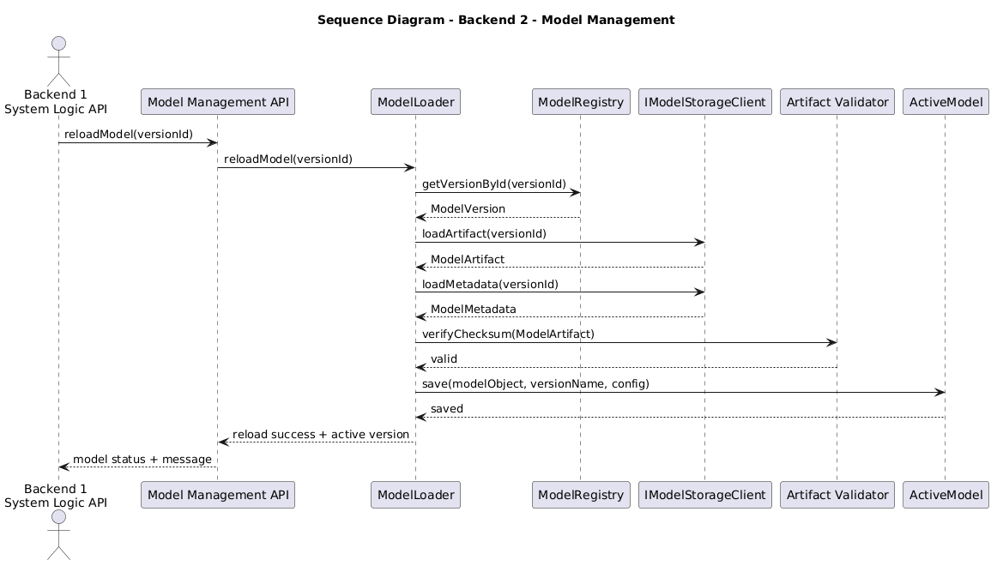
Figure 24. Sequence - Backend 2 - Model Management

Attribute-Driven Design

QA01 - Modifiability Design for Adding New Input Types without Changing the Core Classifier
    - Affected Artifacts & Allocation
Quality Attribute | Tactic / Pattern Applied | Allocation | Detailed Responsibility
Modifiability | Pattern: Adapter Pattern  Tactic: Reduce Coupling – Use an Intermediary | Container: Backend 2 – AI Model Service  Component: InputAdapter  Code: InputAdapter | Converts all concrete input types into StandardInput. When a new input type is added, the change is mainly handled inside the adapter layer.
Modifiability | Tactic: Encapsulate | Container: Backend 2 – AI Model Service  Component: Concrete Input Sources  Code: ImageInput, VideoInput, RealtimeFrameInput, VideoUrlInput | Encapsulates input-specific data and behavior inside separate input classes. This prevents input-specific logic from spreading into the classifier.
Modifiability | Tactic: Restrict Dependencies | Container: Backend 2 – AI Model Service  Component: Stable Detection and Classification Core  Code: ClassificationService, DeepfakeClassifier | Prevents the classifier from depending on raw input types. The classifier only receives prepared face crops or processed frame data.
Modifiability | Pattern: Pipes and Filters  Tactic: Increase Cohesion | Container: Backend 2 – AI Model Service  Component: Frame-based Processing Pipeline  Code: FrameExtractor, FrameSampler, MediaPreprocessor | Keeps frame extraction, sampling, and preprocessing in a cohesive pipeline. New input sources are standardized before reaching this pipeline.
Modifiability | Tactic: Abstract Common Services | Container: Backend 2 – AI Model Service  Component: StandardInput  Code: StandardInput, InputSource | Provides a stable internal contract between changing input sources and stable downstream processing components.
Modifiability | Tactic: Reduce Coupling | Container: Backend 1 – System Logic API  Component: Detection Session Component  Code: DetectionSessionService, AIPredictionRequest | Sends prediction requests using a stable API contract. Backend 1 does not need to understand the internal processing details of each input type.
Modifiability | Tactic: Encapsulate | Container: Database  Component: Media Metadata Schema  Code/Data: media_files, optional source_type metadata | Stores media metadata and optional input source information without changing the detection result schema.
    - Rationale & Discarded Alternatives
Alternative | Evaluation against Objective / Constraints | Rationale
Connect each input type directly to the classifier | Not suitable. Every new input type would require changes in the classifier or classification service. | Rejected because it increases coupling and violates the goal of keeping the classifier unchanged.
Create a separate classifier for each input type | Not suitable. It duplicates classification logic and makes model maintenance difficult. | Rejected because all input types should share the same deepfake classification logic after preprocessing.
Let Backend 1 transform all input types before calling the AI service | Partially suitable, but not ideal. Backend 1 would become responsible for media transformation logic that belongs to the AI pipeline. | Rejected because media transformation, frame extraction, and preprocessing should remain inside Backend 2 – AI Model Service.
Store every input as raw data in the database and let the classifier read from the database | Not suitable. It increases database I/O and makes the AI pipeline depend on database structure. | Rejected because the database should store metadata, sessions, and results, not act as the main data transfer mechanism for AI processing.
Convert all input types into StandardInput before processing | Suitable. It keeps downstream components independent from concrete input types. | Selected because it supports adding a new input type within 2–3 working days while keeping the classifier unchanged.
Use an adapter-based input pipeline | Suitable. It isolates input-specific changes and protects the stable classifier. | Selected because it applies Reduce Coupling, Encapsulate, Restrict Dependencies, and Increase Cohesion effectively.
    - Risks & Trade-offs
- Trade-off: Additional architectural elements are introduced.
The design adds InputSource, InputAdapter, and StandardInput. This increases the number of components, but it reduces future modification cost and protects the classifier from input-specific changes.
- Trade-off: Input processing becomes more structured but slightly more complex.
Developers must follow the input standardization pipeline instead of directly sending data to the classifier.
- Risk: Incorrect adapter logic may produce invalid standardized input.
If a new input type is converted incorrectly, downstream components may receive invalid frames or incomplete media data.
- Risk Mitigation:
Each new input type must include validation rules, adapter unit tests, and integration tests. The output of the adapter must be checked before it is passed to the frame-based processing pipeline.
- Risk: Some new input types may require additional metadata.
For example, video URL input may require source URL, duration, access status, or download state.
- Risk Mitigation:
Store input-specific metadata as optional media metadata. Avoid changing the detection result schema unless the final detection output itself changes.
- Risk: The adapter may become too large over time.
If many input types are added, InputAdapter may become complex.
- Risk Mitigation:
Split adapter logic into smaller input-specific adapter classes if the number of input types grows. For example, ImageInputAdapter, VideoInputAdapter, and VideoUrlInputAdapter can be introduced later while keeping the same StandardInput contract.

QA02 - Modifiability Design for Updating the Deepfake Detection Model without Changing the Detection Flow
    - Affected Artifacts & Allocation
Quality Attribute | Tactic / Pattern Applied | Allocation | Detailed Responsibility
Modifiability | Tactic: Defer Binding Time | Container: Backend 2 – AI Model Service  Component: ModelLoader Code: ModelLoader | Delays model selection until startup or reload time. It loads the active model based on model metadata instead of hardcoded model paths.
Modifiability | Pattern: Registry Pattern | Container: Backend 2 – AI Model Service  Component: ModelRegistry Code: ModelRegistry | Manages available model versions, retrieves the active version, and provides version information to the ModelLoader.
Modifiability | Tactic: Reduce Coupling – Use an Intermediary | Container: Backend 2 – AI Model Service  Component: IModelStorageClient  Code: IModelStorageClient, FileSystemModelStorageClient | Abstracts access to model artifacts and metadata so the ModelLoader does not depend directly on file system or object storage details.
Modifiability | Tactic: Encapsulate | Container: Model Storage Component: Model Metadata and Artifacts  Code/Data: ModelVersion, ModelArtifact, ModelMetadata, ModelConfig | Encapsulates model path, framework type, input size, threshold, checksum, and preprocessing configuration outside the classification logic.
Modifiability | Pattern: Strategy Pattern | Container: Backend 2 – AI Model Service  Component: Deepfake Classification  Code: DeepfakeClassifier, XceptionClassifier, EfficientNetClassifier | Allows different classifier implementations to be used through the same classification interface.
Modifiability | Tactic: Restrict Dependencies | Container: Backend 1 – System Logic API  Component: Detection Session Component  Code: DetectionSessionService, AIPredictionRequest | Keeps Backend 1 dependent only on the prediction API contract, not on model version, model file, or framework details.
Modifiability | Tactic: Encapsulate Runtime State | Container: Backend 2 – AI Model Service  Component: ActiveModel Code: ActiveModel | Stores the currently loaded model object, version name, and loading time so the AI service can track the model used for inference.
Modifiability | Tactic: Validate Changes | Container: Model Storage / Backend 2  Component: ModelArtifact, EvaluationReport, ConfusionMatrix  Code/Data: ModelArtifact, EvaluationReport, ConfusionMatrix | Supports checksum verification and model evaluation before or after activation to reduce the risk of loading invalid or low-quality models.
    - Rationale & Discarded Alternatives
Alternative | Evaluation against Objective / Constraints | Rationale
Hardcode the model path inside the classifier | Not suitable. Every model update requires Risks & Trade-offs ode modification and redeployment. | Rejected because it violates modifiability and increases regression risk in the classification code.
Replace the model file manually using the same file name | Partially suitable but unsafe. It may work quickly, but it loses version history and rollback ability. | Rejected because the system needs model version tracking, active model metadata, and evaluation records.
Store model version and metadata in Model Storage and load the active version through ModelLoader | Suitable. The model can be changed by updating metadata and active version configuration. | Selected because it supports Defer Binding Time and keeps the prediction flow stable.
Let Backend 1 choose the model version for every request | Not suitable. Backend 1 should not know model storage or AI model details. | Rejected because it couples business logic API with AI model management.
Load the new model dynamically during every prediction request | Not suitable. It increases inference latency and wastes resources. | Rejected because the model should be loaded once at startup or reload time, then reused during prediction.
Use a stable classifier interface with interchangeable model implementations | Suitable. It allows changing model architecture while keeping classification service stable. | Selected because it supports model replacement without changing the API contract or detection session flow.

    - Risks & Trade-offs
- Trade-off: More model management metadata is required.
The system must maintain model versions, artifact paths, thresholds, input sizes, framework types, checksums, and active model status. This adds management overhead but enables controlled model replacement.
- Trade-off: Restart or reload is required.
The QA02 scenario allows the AI service to restart with the new model. This creates short downtime, but the target is to keep downtime within 10 minutes.
- Risk: A new model may have a different input size or preprocessing requirement.
If the new model expects a different input format, incorrect preprocessing may reduce accuracy or cause inference failure.
- Risk Mitigation:
Store input_size, threshold, and preprocessing_config inside ModelMetadata or ModelConfig. The preprocessing pipeline must read these values when preparing input for inference.
- Risk: A corrupted model artifact may be loaded.
A broken model file can crash the AI service or return invalid predictions.
- Risk Mitigation:
Use ModelArtifact.verifyChecksum() before activation. The AI service should reject artifacts that fail validation.
- Risk: A new model may improve speed but reduce accuracy, or improve accuracy but increase latency.
This creates a trade-off between model performance and detection quality.
- Risk Mitigation:
Store evaluation metrics such as accuracy, precision, recall, F1 score, AUC score, and confusion matrix results before activating the model. The team should compare models before switching the active version.
- Risk: Rollback may be needed after deployment.
The new model may introduce unexpected inference errors or poor results.
- Risk Mitigation:
Keep previous model versions in Model Storage and allow the ModelRegistry to reactivate an older stable version.

QA03 - Modifiability Design for Adding New Warning Levels to Detection results
    - Affected Artifacts & Allocation
Quality Attribute | Tactic / Pattern Applied | Allocation | Detailed Responsibility
Modifiability | Tactic: Increase Cohesion | Container: Backend 1 – System Logic API  Component: Result Management Component  Code: ResultManagement, ResultService | Groups result formatting, result retrieval, and warning-level assignment inside one cohesive backend area.
Modifiability | Pattern: Policy Object Tactic: Encapsulate | Container: Backend 1 – System Logic API  Component: Warning-Level Mapping Layer  Code: WarningLevelPolicy | Centralizes rules for mapping result labels and confidence scores into warning levels. New warning levels are added mainly here.
Modifiability | Pattern: DTO Tactic: Abstract Common Services | Container: Backend 1 – System Logic API  Component: Result Mapping  Code: ResultMappingService, DetectionResultDTO | Builds a stable result response model that contains result label, confidence score, warning level, model version, and status.
Modifiability | Tactic: Restrict Dependencies | Container: Backend 2 – AI Model Service  Component: Deepfake Classification  Code: ClassificationService, DeepfakeClassifier | Prevents warning-level changes from affecting the AI classifier. The classifier only produces prediction labels and confidence scores.
Modifiability | Tactic: Increase Cohesion | Container: Frontend Web Application  Component: Detection Result UI  Code: DetectionResultUI, WarningDisplayConfig | Displays warning levels consistently using shared display configuration. The UI does not recalculate warning-level rules.
Modifiability | Tactic: Encapsulate | Container: Frontend Web Application  Component: Detection History UI and Moderator Review UI  Code: DetectionHistoryUI, ModeratorReviewUI | Uses the warning level returned by the backend and applies consistent visual representation for history and review screens.
Modifiability | Tactic: Maintain Backward Compatibility | Container: Database  Component: Detection Result Schema  Code/Data: detection_results.warning_level | Stores warning-level data while keeping old detection results readable. Old results can be mapped to a default or derived warning level when needed.
    - Rationale & Discarded Alternatives
Alternative | Evaluation against Objective / Constraints | Rationale
Hardcode warning-level logic inside every frontend screen | Not suitable. Each screen would need to be modified when warning levels change. | Rejected because it duplicates business logic and increases the number of affected components.
Let the AI classifier directly output warning levels | Not suitable. Warning levels are product-facing risk feedback, not core model classification logic. | Rejected because it couples product policy with AI inference and makes future warning-level changes harder.
Store only warning levels and remove original result labels | Not suitable. Old results and model outputs would lose semantic meaning. | Rejected because the system still needs to preserve Real, Suspicious, and Deepfake as the original detection labels.
Add warning-level rules directly inside database queries | Not suitable. This makes business policy hard to test and maintain. | Rejected because mapping rules should stay in the backend result management layer, not inside SQL logic.
Centralize warning-level mapping inside Result Management | Suitable. Only result mapping and display configuration need to change. | Selected because it supports the QA03 goal of limiting the change to no more than 3 affected components.
Use a stable result DTO with warning-level field | Suitable. The frontend can display new levels without knowing the calculation rules. | Selected because it separates backend policy from frontend display and keeps old results readable.
    - Risks & Trade-offs
- Trade-off: Result Management becomes the central policy point.
Centralizing warning-level logic improves cohesion, but it also means this component must be carefully tested whenever warning rules change.
- Trade-off: The frontend becomes dependent on warning-level names returned by the backend.
If warning-level names change, the frontend display configuration must be updated.
- Risk: Old detection results may not have a warning-level value.
If the schema is extended after previous results already exist, old records may contain no warning-level data.
- Risk Mitigation:
Old results should remain readable by deriving a default warning level from existing result labels and confidence scores. For example, old REAL results may be displayed as LOW_RISK, old SUSPICIOUS results as MEDIUM_RISK, and old DEEPFAKE results as HIGH_RISK.
- Risk: Different screens may display warning levels inconsistently.
Detection Result UI, Detection History UI, and Moderator Review UI may present warning levels differently.
- Risk Mitigation:
Use a shared WarningDisplayConfig in the frontend so that all screens use the same text, icon, color, and priority rules.
- Risk: New warning levels may confuse users.
Too many warning levels may make the result harder to understand.
- Risk Mitigation:
Warning levels should be limited to clear and actionable categories. Each level should have a short explanation in the Detection Result UI.

QA04 - Performance Design for Short Video Deepfake Detection within 50 Seconds
    - Affected Artifacts & Allocation
Quality Attribute | Tactic / Pattern Applied | Allocation | Detailed Responsibility
Performance | Tactic: Manage Sampling Rate | Container: Backend 2 – AI Model Service Component: Frame Reduction Layer Code: FrameExtractor, FrameSampler, SamplingConfig | Reduces the number of frames processed from the uploaded video. Only representative frames are selected for analysis.
Performance | Tactic: Increase Resource Efficiency | Container: Backend 2 – AI Model Service Component: Face-focused Processing Layer Code: MediaPreprocessor, FaceDetectionService, FaceCrop | Resizes frames, detects faces, and crops only face regions so the classifier processes smaller inputs instead of full frames.
Performance | Tactic: Reduce Overhead | Container: Backend 2 – AI Model Service Component: Loaded Active Model Code: ModelLoader, ActiveModel | Keeps the active model loaded in memory and avoids reloading the model for every sampled frame.
Performance | Tactic: Bound Execution Time | Container: Backend 1 – System Logic API Component: Upload & Validation Layer Code: MediaValidator, UploadService | Rejects unsupported or oversized videos early to avoid detection sessions that exceed the expected processing time.
Performance | Pattern: Pipes and Filters | Container: Backend 2 – AI Model Service Component: AI Processing Pipeline Code: FrameExtractor, FrameSampler, MediaPreprocessor, FaceDetectionService, ClassificationService, PredictionAggregator | Organizes video detection into sequential stages so each stage can be optimized independently.
Performance | Pattern: Batch Processing | Container: Backend 2 – AI Model Service Component: Classification Layer Code: ClassificationService, DeepfakeClassifier, FramePrediction | Processes selected face crops as a controlled set instead of processing the entire video frame by frame.
Performance | Tactic: Reduce Overhead | Container: Backend 1 – System Logic API Component: Result Management Layer Code: ResultService, DetectionResponse | Returns a compact final result after aggregation instead of sending unnecessary frame-level details to the frontend.

    - Rationale & Discarded Alternatives
Alternative | Evaluation against Objective / Constraints | Rationale
Process every frame in the uploaded video | Not suitable. It creates high computation cost and may exceed the 50-second response target. | Rejected because full-frame processing is too expensive for short video detection under limited resources.
Store every extracted frame in the database before AI processing | Not suitable. It adds heavy database I/O and slows down the detection workflow. | Rejected because the database should store metadata, results, and selected evidence, not every intermediate frame.
Classify full video frames without face cropping | Not suitable. The classifier would process unnecessary background data. | Rejected because deepfake detection should focus on face regions, and face cropping improves resource efficiency.
Reload the model for each sampled frame | Not suitable. It creates repeated loading overhead and increases inference time. | Rejected because the active model should be loaded once and reused.
Use frame sampling and face-focused classification | Suitable. It reduces frame count and input size while preserving the main detection workflow. | Selected because it supports the 50-second response requirement.
Aggregate frame-level predictions into one final result | Suitable. It reduces response payload size and provides a clear user-facing output. | Selected because users need a final label and confidence score rather than raw predictions for every frame.

    - Risks & Trade-offs
- Trade-off: Performance vs. Detection Completeness
Frame sampling improves performance, but it may miss short deepfake segments that appear between sampled frames.
- Risk: False negatives from skipped frames
If deepfake manipulation appears only briefly, the sampled frames may not capture it.
- Risk Mitigation:
Use a reasonable sampling configuration. For suspicious videos or short clips, the system can increase sampling density to reduce the chance of missing manipulated frames.
- Trade-off: Face cropping improves speed but depends on face detection quality
If face detection fails, the classifier may not receive the correct face region.
- Risk Mitigation:
If no face is detected in selected frames, the system should return a clear processing status instead of producing a misleading classification.
- Risk: Large video files may still cause timeout
Even with sampling, very large or long videos may exceed the expected processing time.
- Risk Mitigation:
Apply validation rules for file format, file size, and duration before starting the AI pipeline.
- Risk: Model inference may still be the bottleneck
If the active model is too slow, the system may still fail to meet the 50-second target.
- Risk Mitigation:
Keep the model loaded in memory, process only selected face crops, and compare model inference speed before activating a new model version.

QA05 - Performance Design for Handling Concurrent Detection Requests
    - Affected Artifacts & Allocation
Quality Attribute | Tactic / Pattern Applied | Allocation | Detailed Responsibility
Performance | Tactic: Introduce Processing Queue | Container: Backend 1 – System Logic API Component: Processing Queue Code: DetectionTaskQueue, DetectionJob | Stores heavy ML detection tasks instead of processing every request immediately. This prevents Backend 1 from blocking when many users submit requests at the same time.
Performance | Pattern: Producer-Consumer | Container: Backend 1 – System Logic API Component: Detection Session Service and Detection Worker Code: DetectionSessionService, DetectionWorker, DetectionJobProcessor | Detection Session Service produces jobs and places them into the queue. Detection Worker consumes jobs and sends them to Backend 2 when resources are available.
Performance | Tactic: Control Resource Demand | Container: Backend 1 – System Logic API Component: Queue Capacity Policy Code: QueueCapacityPolicy, RateLimitPolicy | Limits how many jobs can wait or run at the same time. If the queue is full, the system returns a temporarily busy message instead of crashing.
Performance | Pattern: Asynchronous Processing | Container: Backend 1 – System Logic API Component: Detection Session Component Code: DetectionController, DetectionSessionService, DetectionStatus | Returns a session ID or queued status quickly, while ML processing continues in the background. Users can later retrieve status or results.
Performance | Tactic: Bound Execution Time | Container: Backend 1 – System Logic API Component: Upload & Validation Layer Code: MediaValidator, UploadService | Rejects invalid, unsupported, or oversized files early before they enter the queue. This prevents expensive detection jobs from wasting processing resources.
Performance | Tactic: Increase Resource Efficiency | Container: Backend 2 – AI Model Service Component: AI Processing Pipeline Code: FrameSampler, MediaPreprocessor, FaceDetectionService, ClassificationService | Reduces AI workload by sampling video frames, preprocessing media, cropping face regions, and sending only useful inputs to the classifier. Backend 2 is responsible for preprocessing, face detection, classification, and confidence aggregation.
Performance | Tactic: Maintain System Responsiveness | Container: Frontend Web Application / Backend 1 Component: Detection Result UI, History Management Component Code: DetectionResultUI, DetectionHistoryUI, HistoryManagementService | Lets users see queued, processing, completed, or failed status instead of waiting on a blocked request.
Performance | Tactic: Preserve Request State | Container: Database Component: Detection Session Schema and Detection Result Schema Code/Data: detection_sessions, detection_results, system_errors | Stores session status and result data so queued or failed jobs can be tracked. This reduces the risk of losing requests during peak load.

    - Rationale & Discarded Alternatives
Alternative | Evaluation against Objective / Constraints | Rationale
Process every detection request synchronously inside Backend 1 | Not suitable. Image and video detection can take time, especially video detection because it requires frame extraction, face detection, classification, and aggregation. | Rejected because synchronous processing may block Backend 1 and make the web application unresponsive during peak load.
Send every incoming request directly to Backend 2 without queue control | Not suitable. Backend 2 has limited CPU/GPU resources and may become overloaded when many users submit requests together. | Rejected because uncontrolled AI requests can cause slow inference, service timeout, or crashes.
Allow unlimited jobs in the queue | Not suitable. A very large queue may consume memory and make users wait too long. | Rejected because queue size must be bounded to avoid queue overflow and backend instability.
Drop new requests immediately when the system is busy | Partially suitable but not user-friendly. It protects the system but may lose valid user requests. | Rejected because the system should accept requests when possible and only return temporarily busy when the queue reaches its limit.
Store every intermediate frame in the database before AI processing | Not suitable. It increases database I/O and slows down the processing pipeline. | Rejected because the database should store sessions, metadata, results, and selected evidence, not every intermediate frame.
Use a bounded processing queue with detection workers | Suitable. It allows Backend 1 to accept requests quickly and process heavy ML jobs based on available resources. | Selected because it supports QA05 by preventing crashes, hanging, and lost requests under peak load.
Use asynchronous status updates or result polling | Suitable. The frontend can show QUEUED, PROCESSING, COMPLETED, or FAILED status while the job is processed. | Selected because it improves user experience and keeps the system responsive.

    - Risks & Trade-offs
- Trade-off: Users may not receive results immediately.
Because detection jobs are queued, some users may need to wait before their request is processed.
- Risk Mitigation:
The frontend should display clear statuses such as QUEUED, PROCESSING, COMPLETED, and FAILED so users understand what is happening.
- Trade-off: The architecture becomes more complex.
Adding a processing queue and detection worker introduces more components than direct synchronous processing.
- Risk Mitigation:
Keep the queue simple for the academic demo. For example, use an in-memory queue first, and only move to Redis/BullMQ if the demo needs stronger reliability.
- Risk: Queue overflow during prolonged peak load.
If too many users submit requests for a long time, the queue may become full and memory usage may increase.
- Risk Mitigation:
Apply a queue capacity limit. When the queue is full, Backend 1 should return a temporarily busy response instead of accepting unlimited jobs.
- Risk: Backend 2 may still become overloaded.
Even with a queue, too many workers may send requests to the AI Model Service at the same time.
- Risk Mitigation:
Limit the number of active detection workers. Use fewer workers for video detection and more controlled processing for image detection.
- Risk: A detection job may get stuck in PROCESSING status.
AI inference can fail because of timeout, invalid media, memory limitation, or Backend 2 errors.
- Risk Mitigation:
Add timeout handling and update failed jobs to FAILED status. Store error information in system_errors for debugging.
- Risk: Users may repeatedly submit the same request while waiting.
This can increase queue pressure.
- Risk Mitigation: Disable repeated submit buttons while a detection session is already queued or processing.

QA06 - Security and Privacy Design for Real-time Screen Detection
    - Affected Artifacts & Allocation
Quality Attribute | Tactic / Pattern Applied | Allocation | Detailed Responsibility
Security / Privacy | Tactic: Authenticate Users | Container: Backend 1 – System Logic API Component: Authentication Middleware  Code: AuthMiddleware, TokenService | Validates user token before allowing upload, detection, result, history, admin, or review requests.
Security / Privacy | Pattern: Role-Based Access Control | Container: Backend 1 – System Logic API  Component: Role Permission Policy  Code: RolePermissionPolicy, PermissionService | Ensures that users, admins, and moderators can only access functions allowed by their role.
Security / Privacy | Tactic: Obtain Explicit User Consent | Container: Frontend Web Application / Backend 1  Component: Real-time Detection UI, Consent Validation Policy  Code: RealtimeDetectionUI, ConsentValidationPolicy | Ensures real-time screen detection only starts after the user grants browser permission. This follows the project constraint that screen scanning cannot happen silently.
Security / Privacy | Tactic: Encrypt Communication | Container: Frontend Web Application / Backend 1 Component: API Client, Backend API Code: ApiClient, HTTPS Configuration | Sends upload, detection, result, history, admin, and review requests through secure HTTPS/WebSocket communication. The project requires HTTPS to protect client-server data streams.
Security / Privacy | Tactic: Validate Input | Container: Backend 1 – System Logic API Component: Upload Validation Layer Code: MediaValidator, UploadService | Validates image/video type, MIME type, size, and duration before saving or sending media to Backend 2.
Security / Privacy | Tactic: Audit Security Events | Container: Backend 1 – System Logic API / Database Component: Audit Log Service Code/Data: AuditLogService, audit_logs | Records login, upload, detection, admin, and moderator actions for traceability.
Security / Privacy | Tactic: Restrict Sensitive Data Exposure | Container: Frontend Web Application / Backend 1 Component: Result Management, Detection Result UI Code: DetectionResultDTO, ResultService | Returns only necessary result information such as label, confidence score, warning level, status, and model version instead of exposing internal data.

    - Rationale & Discarded Alternatives
Alternative | Evaluation against Objective / Constraints | Rationale
Allow real-time screen detection without explicit permission | Not suitable. The system may scan user screen content silently and violate privacy. | Rejected because the project requires explicit user consent before initializing any scanning session.
Use HTTP during deployment | Not suitable. Uploaded media, tokens, and detection results may be exposed during transmission. | Rejected because the project requires HTTPS to encrypt data streams between client and server.
Let frontend decide user permissions only | Not suitable. Frontend-side permission checks can be bypassed. | Rejected because role and permission checks must be enforced in Backend 1.
Allow all logged-in users to access moderator/admin functions | Not suitable. Users could access suspicious cases, reports, or system settings. | Rejected because the system has separate User, Admin, and Moderator roles.
Store full sensitive media everywhere for convenience | Not suitable. It increases privacy risk and storage exposure. | Rejected because the system should store uploaded media and suspicious frames only when needed for detection, review, or audit.
Centralize authentication, role checking, consent validation, and audit logging in Backend 1 | Suitable. Backend 1 is already the central system logic API. | Selected because it keeps security logic in one controlled backend layer.
Use browser-supported screen capture with user permission | Suitable. It follows browser security rules and prevents silent scanning. | Selected because it matches the project’s screen capture and privacy constraints.

    - Risks & Trade-offs
- Trade-off: Users must grant permission before real-time detection starts.
This adds one more step before using the feature.
- Risk Mitigation:
The Real-time Detection UI should clearly explain why screen capture permission is needed and how the captured frames are used.
- Trade-off: HTTPS setup adds deployment complexity.
Local demo may be easier with HTTP, but real screen capture and secure deployment require HTTPS.
- Risk Mitigation:
Use HTTPS for deployment and clearly document local/demo limitations.
- Risk: Token or session misuse.
If tokens are not validated correctly, unauthorized users may access protected functions.
- Risk Mitigation:
Backend 1 must check authentication middleware before every protected API request.
- Risk: Role misconfiguration.
A normal user may accidentally receive moderator or admin permissions.
- Risk Mitigation:
Use role_permissions and user_roles tables consistently and test each role separately.
- Risk: Sensitive uploaded media may be exposed.
Deepfake detection uses face images, videos, or suspicious frames.
- Risk Mitigation:
Store only necessary media, restrict media URLs, and avoid exposing internal storage paths to frontend users.
- Risk: Audit logs may contain too much sensitive data.
Logs are useful for traceability but can become a privacy risk.
- Risk Mitigation:
Audit logs should store action type, user ID, timestamp, and status, but should not store full image/video content.

Allocation – Deployment View
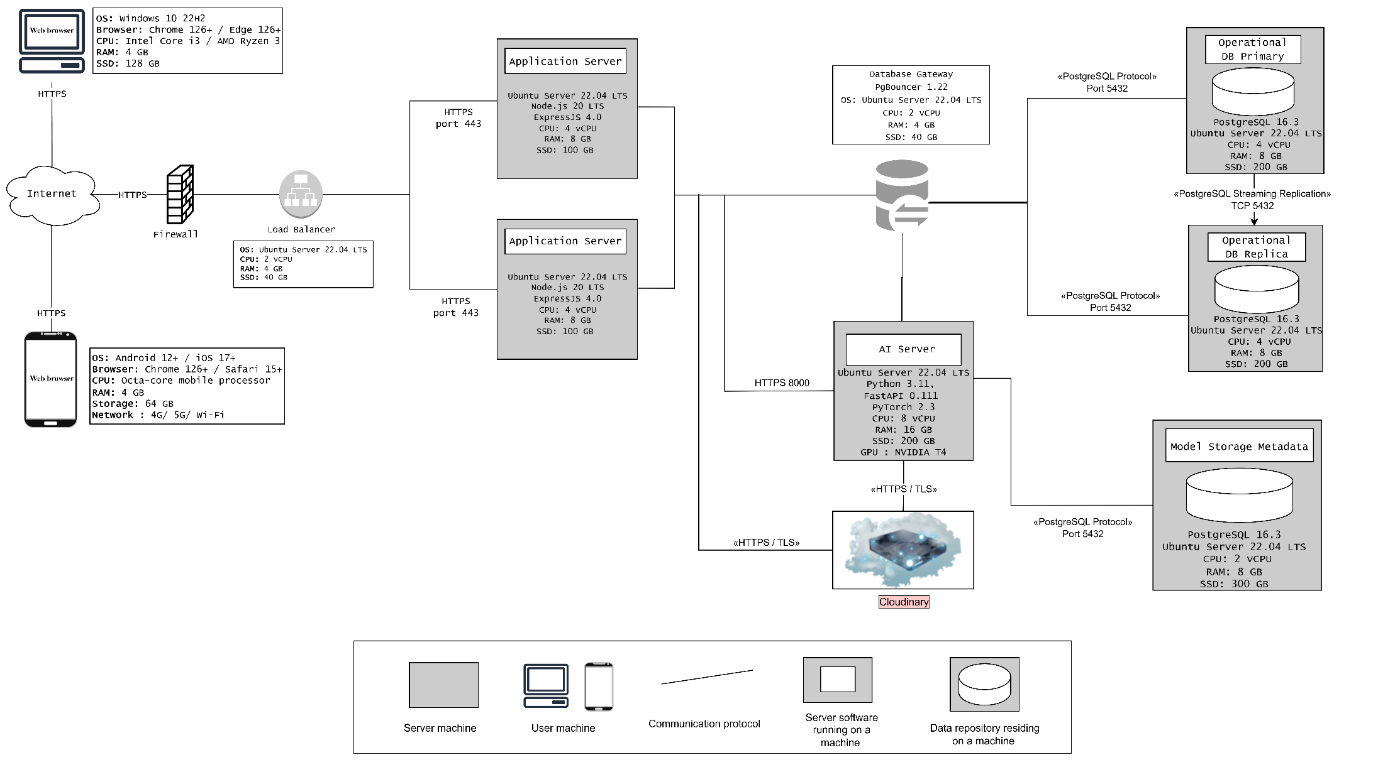

9.1. Execution Zones & Node Configurations
The deployment environment is organized into specialized virtual/physical execution nodes:
Node / Zone | Software Stack | Hardware Configuration | Primary Responsibility
Client Devices | Modern browsers (Chrome, Safari, Edge 126+) | Desktop: i3 / r3 CPU, 4GB RAM  Mobile: Octa-core, 4GB RAM | Access the web interface, upload media, and receive detection results.
Load Balancer | Ubuntu 22.04 LTS | 2 vCPU, 4 GB RAM, 40 GB SSD | Securely distribute incoming HTTPS traffic to application servers.
Application Server (x2) | Ubuntu 22.04, Node.js 20, ExpressJS 4.0 | 4 vCPU, 8 GB RAM, 100 GB SSD | Host System Logic API (handles auth, sessions, admin tools, and metadata).
AI Server | Ubuntu 22.04, Python 3.11, FastAPI 0.111, PyTorch 2.3 | 8 vCPU, 16 GB RAM, 200 GB SSD, NVIDIA T4 GPU | Execute computationally intensive frame extraction, preprocessing, and model inference.
Database Gateway | PgBouncer 1.22, Ubuntu 22.04 | 2 vCPU, 4 GB RAM, 40 GB SSD | Manage connection pooling to optimize database performance.
Operational DB (Primary) | PostgreSQL 16.3, Ubuntu 22.04 | 4 vCPU, 8 GB RAM, 200 GB SSD | Store main transactional data (users, sessions, media metadata, logs).
Operational DB (Replica) | PostgreSQL 16.3, Ubuntu 22.04 | 4 vCPU, 8 GB RAM, 200 GB SSD | Act as a standby node; receive real-time updates and support read scalability.
Model Metadata DB | PostgreSQL 16.3, Ubuntu 22.04 | 2 vCPU, 8 GB RAM, 300 GB SSD | Store model versions, configurations, and evaluation metrics.
Cloud Storage | Cloudinary API | External Managed Service | Offload and serve large binary objects (images, videos, flagged frames).
9.2. Communication Pathways
The runtime communication pathways are strictly defined as follows:
- Client $→$ Firewall / WAF $→$ Load Balancer: HTTPS (Port 443). Traffic is filtered via ModSecurity and OWASP CRS at the WAF layer.
- Load Balancer $→$ Application Servers: HTTPS (Port 443) to balance incoming application workloads.
- Application Servers $→$ AI Server: HTTPS (Port 8000) to send prediction requests and receive inference results.
- Application Servers $→$ Cloudinary: HTTPS/TLS (Port 443) to upload raw media and retrieve hosted file URLs.
- App / AI Server $→$ Database Gateway: PostgreSQL protocol to access pooled connections.
- Database Gateway $→$ PostgreSQL Nodes: PostgreSQL protocol (TCP Port 5432).
- Operational DB Primary $→$ Replica: PostgreSQL Streaming Replication (TCP Port 5432).
9.3. Quality Attribute Realization
- Security: Outer boundary protection is achieved using a dedicated Firewall and a WAF to mitigate common application threats (SQLi, XSS, and malicious file uploads). Only the Load Balancer is exposed to public traffic, leaving the rest of the server infrastructure securely within private networks. All communication paths are encrypted (HTTPS/TLS).
- Availability & Scalability:
  - Application Layer: Horizontal scaling is supported by deploying two identical Application Servers behind the Load Balancer to avoid a single point of failure.
  - Database Layer: Operational high availability is guaranteed via active-standby PostgreSQL streaming replication.
  - AI Layer: Because inference is heavy, isolating it on a dedicated GPU server ensures normal web traffic is not impacted. Scalability can be achieved by adding further AI nodes behind an internal dispatcher as request volume increases.

