SOFTWARE REQUIREMENT SPECIFICATION
DOCUMENT

DRUG TIME
Version: Version 1.0
ABSTRACT
This document is intended to be the SRS for developing DrugTime

Project Title | DrugTime
Project Mentor | B.Eng.Nguyen Trong Giap
Contact Information
Start Date | 10/09/2026 | End Date

Table of Contents
Revision History 4
1. Introduction 5
1.1. Purpose 5
1.2. Intended Audience and Reading Suggestions 5
1.3. References 5
2. Project Overview 6
2.1. Project Description 6
2.2. Business Need 6
2.3. Project Analyst 6
2.3.1. Business Function Diagram 6
2.3.2. System Context Diagram 6
2.3.3. Data Flow Diagram 6
2.4. Software Requirement Specification 6
2.4.1. High level Fucntional Requirement (FR) 6
2.4.2. Stakeholders 6
2.4.3. Usecase 7
2.4.3.1. <<project name>> Use Case Diagram Overview 7
2.4.4. List of use cases 7
2.4.5. List of business rule 8
2.4.6. Use Case Specification 9
UC 01: Create a New Place 9
UC 02: Edit a Place’s Information 11
2.4.7. Software Quality Attributes 13
2.4.7.1. Usability 13
2.4.7.2. Reliability 14
2.4.7.3. Security 14
2.4.7.4. Maintainability 15
2.4.7.5. Portability 15
2.4.7.6. Performance 15
2.5. Software Design Description 16
2.5.1. Sequence Diagrams 16
2.5.1.1. Cập nhật thông tin nhân viên 16
2.5.1.2. Quan hệ Gia đình 17
2.5.2. Activity Diagrams 18
2.5.2.1. Cập nhật thông tin nhân viên 18
2.5.3. State Diagram 18
2.5.4. Class Diagram 19
2.5.5. Allocation Diagram 19
Appendix A: Glossary 19

Table 1. Team Members
No. | Full name | Role | Email
1 | Nguyen Ngoc Phuc | Team Leader/ Scrum Master
2 | Nguyen Quang Bao | Team Member
3 | Nguyen Van Nguyen | Team Member
4 | Dang Ngo Ngoc Viet | Team Member
5 | Nguyen Tan Duc | Team Member

Table 2. Revision History
Date | Change Iterm | Description | by | Version
10/09/2026 | Draft |  | All Team Member | 1.0

Introduction

Purpose
This Software Requirements Specification (SRS) defines the functional and non-functional requirements of DrugTime, a medication-management mobile application designed to help patients take medications on time, maintain accurate medication records, and be alerted to potential drug-drug and drug-food interaction risks, while allowing linked family members to monitor adherence remotely.
This document serves as the primary reference for the development team, the course mentor, and any pharmacy or pharmacist collaborators throughout the design, development, and evaluation of DrugTime under the PHM396D course ("Tranh tài giải pháp"). Section 1.2 identifies each intended reader group and the sections most relevant to them.
The specific objectives of DrugTime are to:
- Improve medication adherence through timely, multi-channel medication reminders.
- Reduce errors when patients enter and manage their medication information.
- Provide reliable medication information based on authoritative Vietnamese pharmaceutical sources.
- Support identification of potential drug-drug and drug-food interaction risks.
- Allow family members to monitor medication adherence remotely.
- Connect patients with partner pharmacists when questions exceed the scope of automated information retrieval.
- Provide a platform for cooperation between patients, pharmacies, and pharmacists while protecting users' personal information.
DrugTime is a medication-management and information-support system. It does not replace physicians or pharmacists in clinical decision-making, prescribing, or determining treatment plans — all medication and interaction information is provided for reference only, sourced from Dược thư Quốc gia Việt Nam 2022 and related authoritative references (see 1.3 References).

Intended Audience and Reading Suggestions

Intended Audience | Reading Suggestions
Patients | Account registration and purpose-separated consent, medication entry (manual input, blister-pack scan with mandatory confirmation), medication scheduling and local reminders, dose confirmation and adherence history, drug-drug/drug-food interaction warnings, AI meal-suggestion assistant, family-linking and consent management, and Simple Mode UI.
Family Members | Account linking to a patient, real-time missed-dose alerts, adherence history of linked patients, drug safety lookup for linked patients, and the AI assistant for linked-patient queries.
Admin | Medication and interaction catalog management, catalog synchronization from external sources, DPIA and PDPL 2025 / Decree 356 compliance oversight, data-deletion and consent-withdrawal processing, and the sensitive-data access log.
Project Mentor | The complete SRS, with particular attention to Business Need, Functional Requirements (FR01–FR10), Non-Functional Requirements, and Use Case Specifications, for evaluation against the Capstone Project 1 (C1SE.07) deliverable schedule.
Development Team | The complete SRS, with particular attention to functional and non-functional requirements, business rules, use case specifications, actors, system architecture, and technical/legal constraints.

References

No | References | Document Information
1 |  | Slide: Requirements Engineering
2 |  | SRS Template
3 | Dược thư Quốc gia Việt Nam 2022 | Source for medication information and food-related warnings associated with medications.
4 | Cục Quản lý Dược | Source for information related to medications authorized for circulation in Vietnam.
5 | Nghị định 356/2025/NĐ-CP | Reference for the official drug-drug interaction information used by the system.

Project Overview

Project Description
DrugTime is a medication management system that assists patients in organizing and monitoring their medication usage.
The system provides a centralized environment in which patients can create their medication profiles, register medications, configure medication schedules, receive reminders, confirm medication intake, and review medication-related information.
DrugTime also supports collaboration between patients and other parties involved in medication management. Patients can link their accounts with family members so that family members can monitor adherence and receive notifications when a medication dose is missed. Partner pharmacies can provide standardized medication QR/barcodes, while partner pharmacists can respond to questions that require professional assistance.
The system provides several major capabilities:
- Patient medication management
  - Create and manage medication profiles.
  - Add medications using QR/barcodes.
  - Add medications using OCR from medication packaging.
  - Confirm medication information before adding it to the medication list.
  - Configure medication schedules.
- Medication reminder and adherence management
  - Send medication reminders.
  - Allow patients to confirm, skip, or postpone a medication dose.
  - Support confirmation through button actions or voice commands.
  - Record medication adherence history.
  - Notify linked family members when a dose is not confirmed.
- Medication information and safety support
  - Provide medication information from authoritative sources.
  - Display potential drug-drug interaction warnings.
  - Display relevant drug-food warnings.
  - Provide source references for medication-related information.
- Family collaboration
  - Link patient and family-member accounts.
  - Monitor medication adherence.
  - Receive missed-dose notifications.
  - Review adherence reports.
- Pharmacy and pharmacist collaboration
  - Allow partner pharmacies to provide standardized medication codes.
  - Allow pharmacies to publish promotional information.
  - Allow patients to submit questions to partner pharmacists.
  - Provide pharmacists with a dedicated question-management queue.
- Administration
  - Manage medication data.
  - Manage interaction information.
  - Approve partner pharmacies and pharmacists.
  - Monitor system data and partner activities.
  - Manage data synchronization from external pharmaceutical information sources.
In summary, DrugTime aims to provide an integrated medication-management environment connecting patients, family members, pharmacies, pharmacists, and system administrators.

Business Problems
A preliminary survey of 60 respondents in Da Nang indicated that 75% had forgotten to take medication at least once during the previous week, while only 5% reported using a dedicated medication-reminder application. The survey also indicated that many respondents managed multiple medications and lacked a unified mechanism for medication scheduling, interaction checking, and family-based adherence monitoring.

Business Need
DrugTime is needed to improve the accuracy, adherence, safety, and accessibility of medication management for patients in Vietnam, particularly patients who take multiple medications and may require support from family members or healthcare professionals.
The current medication-management process can depend heavily on patients or caregivers remembering medication schedules, manually recording medication information, and independently searching for medication-related information. This fragmented process can increase the risk of missed doses, inaccurate medication records, and difficulty identifying relevant medication-related warnings.
DrugTime addresses these needs by providing a centralized medication-management platform that:
- Enables patients to store and manage medication information and schedules in one system;
- Provides timely medication reminders and adherence tracking;
- Reduces medication-entry errors through QR/barcode identification and OCR-assisted recognition, with user confirmation before information is stored;
- Provides medication information and relevant drug-drug and drug-food interaction information from defined and authoritative sources;
- Enables family members or caregivers to monitor medication adherence and receive notifications when a patient does not confirm a required dose;
- Provides a channel for patients to consult pharmacists when questions require professional assistance beyond automated information retrieval;
- Enables partner pharmacies to participate through medication identification, promotional activities, and pharmacy-related services;
- Enables administrators to manage medication information, interaction data, users, partners, and system operations.
Overall, DrugTime aims to transform medication management from a largely individual and memory-dependent process into a centralized, trackable, source-based, and collaborative process, while maintaining a clear boundary between medication information support and professional medical decision-making.

Project Analyst

Business Function Diagram
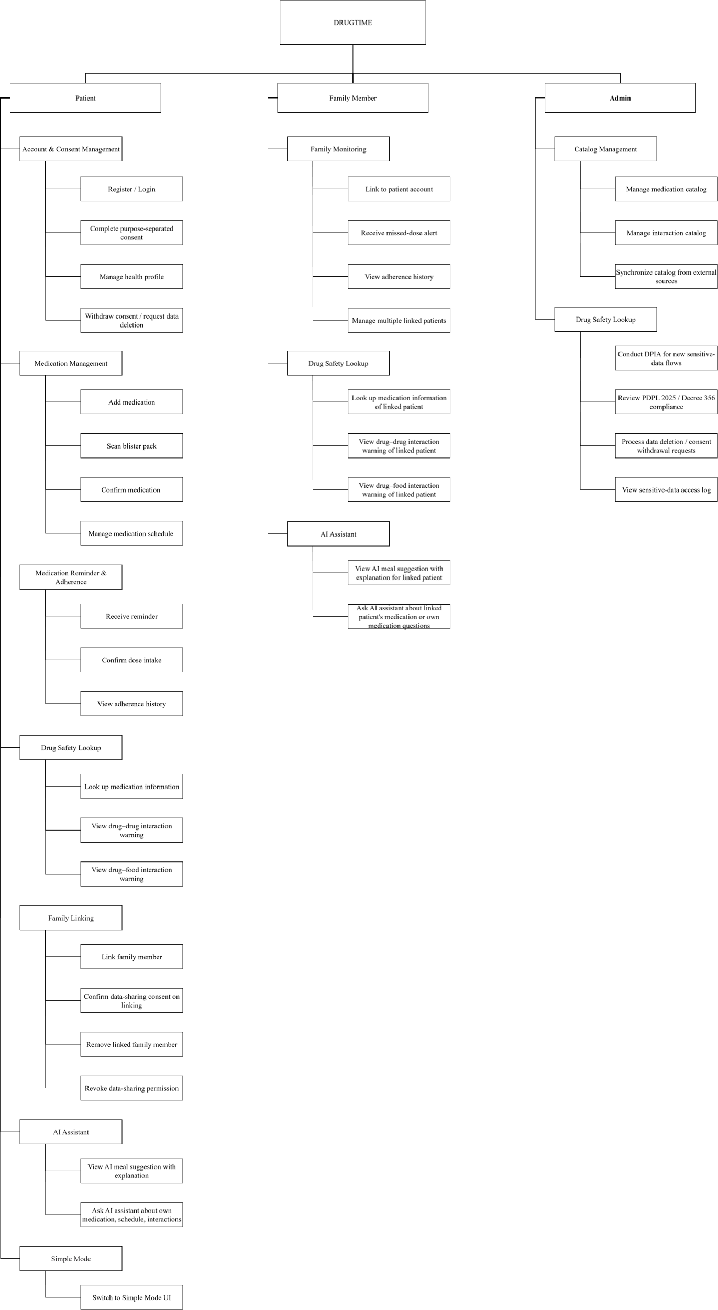

System Context Diagram

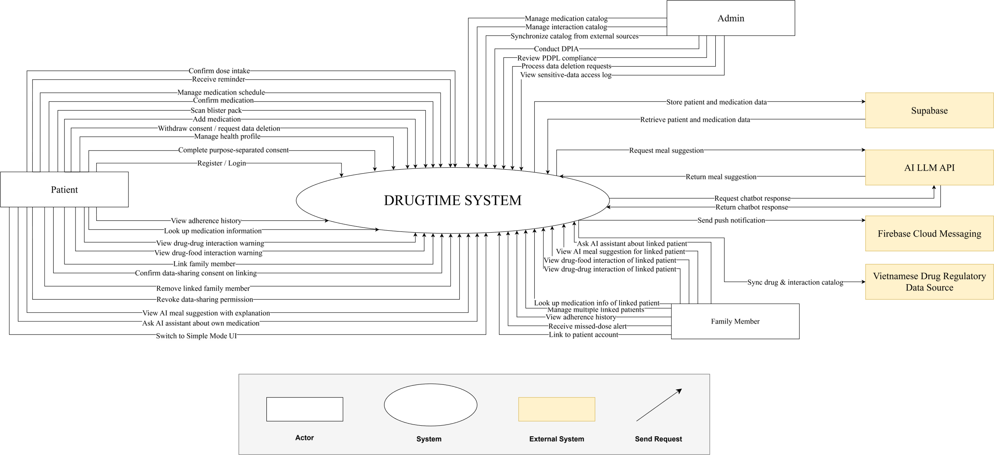

Data Flow Diagram

Software Requirement Specification

High level Fucntional Requirement (FR)
FR1.1 | Title | Create new place
FR1.1 | Stakeholder | Users who use jukebox for playing music
FR1.1 | Description | If user is new one, the system will allow him/her establish an account and specify amount the money that he/she allocate from their credit card into Jukebox account. Otherwise, user can check Jukebox balance.
FR1.2 | Title | Edit a Place’s Information
FR1.2 | Stakeholder | Users who use jukebox for playing music
FR1.2 | Description | The system shall display list of songs grouped into music genres and will allow user select music genres and songs to play. Once the first song is selected the song will start playing while allowing user to make further choices. The system shall also record such selected and played song into database. User can deselect his/her songs from the current playlist and amount of deselecting shall refund. User can create account on one Jukebox and play music on another in distributed system.

Stakeholders

Stakeholder | Description
Users | People who use jukeboxes to play music
System administrators | People who administer and configure the jukebox system
Engineer | Person who deploy the Jukebox System

Usecase

List of use cases

Use case ID | Use case name | Functional Req.
UC.01 | Create new place | FR1.1
UC.02 | Edit a Place’s Information | FR1.2
UC.03 | Login | FR1.3

<<project name>> Use Case Diagram Overview
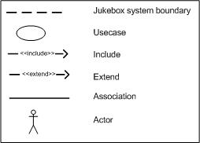

List of business rule

Code | Business rules | Use case
BR-01 | DrugTime Phase 1 supports three system roles: Patient, Family Member, and Admin. Partner Pharmacy Staff and Partner Pharmacist are supported in Phase 2. | UC.01,
BR-02 | Consent for each applicable data-processing purpose must be collected separately. A single bundled consent must not represent consent for multiple independent purposes. | UC.02
BR-03 | Consent granted for one data-processing purpose must not be treated as consent for another processing purpose. | UC. 02
BR-04 | A Patient can withdraw applicable consent through Account Settings. Withdrawal applies to the corresponding processing purpose. | UC.02
BR-05 | A Patient can submit a request for deletion of applicable personal and/or health data through Account Settings.
BR-06 | DrugTime collects only personal or health data that is necessary for an explicitly stated and approved processing purpose.
BR-07 | Linking a Family Member account to a Patient account does not automatically grant access to the Patient's health or adherence data. The Patient must explicitly authorize the applicable data-sharing scope.
BR-08 | A Family Member may access a linked Patient's data only within the data-sharing scope explicitly authorized by that Patient.
BR-09 | A Patient can revoke a Family Member's previously granted data-sharing permission. After revocation, the Family Member must no longer be authorized to access the revoked scope.
BR-10 | Medication information obtained through blister-pack scanning must be manually reviewed and confirmed by the user before it can be saved.
BR-11 | When automated blister-pack recognition or catalogue matching fails, DrugTime must provide a manual medication-entry fallback using the available medication catalogue.
BR-12 | An unmatched medication scan result must be recorded for Admin review and subsequent catalogue-management activities.
BR-13 | A medication dose is considered confirmed only when the Patient performs the supported explicit dose-confirmation action.
BR-14 | DrugTime maintains an adherence history for medication doses that are confirmed or classified as missed. The history is available to the Patient and authorized Family Members.
BR-15 | When a scheduled dose is classified as missed according to the defined missed-dose condition, DrugTime generates a missed-dose alert for eligible linked Family Members.
BR-16 | DrugTime must not present interaction or AI results as medical diagnosis, treatment decisions, or formal clinical advice.
BR-17 | Every drug-drug or drug-food interaction warning must display a medical disclaimer directing the user to consult a doctor or pharmacist.
BR-18 | Medication and interaction information must be based on the approved Vietnamese pharmaceutical reference sources defined by the project, including DAV, QĐ 5948/QĐ-BYT and “Dược thư Quốc gia Việt Nam 2022.”
BR-19 | AI-generated meal suggestions are informational recommendations associated with the Patient's active medications and must not be presented as medical or dietary prescriptions.
BR-20 | AI-generated meal suggestions must display an appropriate medical disclaimer and direct the user to consult a doctor or pharmacist when dietary changes relate to a medical condition.
BR-21 | Patient and Family Member accounts may be linked using the supported QR-code or referral-code mechanism.
BR-22 | A Family Member may perform drug-safety look-ups for a linked Patient only when the Patient has granted the corresponding data-sharing permission.
BR-23 | A Family Member may use AI-assisted functions involving a linked Patient only within the data-sharing scope explicitly authorized by that Patient.
BR-24 | A Family Member may manage multiple linked Patient accounts, subject to the authorization granted by each individual Patient.
BR-25 | Personal data and health data processed by DrugTime must comply with the applicable Vietnamese personal-data protection requirements, including the 2025 Personal Data Protection Law and Decree 356/2025/NĐ-CP.
BR-26 | An applicable DPIA must be completed before a new sensitive-data processing flow is used in production. The corresponding compliance operation is managed by Admin.
BR-27 | An applicable cross-border data-transfer assessment must be completed before a sensitive-data flow involving an overseas service is activated in production.
BR-28 | Every access to a Patient's sensitive health data by a Family Member or Admin must generate an auditable record containing actor identity, access timestamp, and accessed data scope.
BR-29 | DrugTime's medication and interaction catalogues must use the approved Vietnamese regulatory/reference sources defined by the project.
BR-30 | Medication and interaction catalogues must be synchronized periodically from approved Vietnamese regulatory/reference sources as part of Admin catalogue management.
BR-31 | Partner Pharmacy Staff must be approved by Admin based on a valid pharmacy business licence before receiving access to partner-pharmacy functions.
BR-32 | Partner Pharmacists must be verified by Admin based on a valid pharmacy practising certificate before receiving access to the pharmacist consultation queue.

Use Case Specification

UC 001: Register User Account
- Use Case Diagram

- Use Case Specìication

Use case ID | UC.01
Use case name | Register User Account
Create by | Viet Dang |  | Last updated by |  | Viet Dang
Date created | September 16, 2026 |  | Date last updated |  | September 16, 2026
Actor | Patient, Family Member
Description | This use case allows a Patient or Family Member to register and activate a new DrugTime account using an Email address, Phone Number, or a supported third-party OAuth provider. During registration, the user selects an account type and must complete the Purpose-Separated Consent process before the account can be activated.
Goal | To create a DrugTime account for the selected user type and complete the required purpose-separated consent process.
Trigger | The user opens the DrugTime application for the first time and selects “Register Account” from the welcome screen.
Pre-condition | 1. The user can access the DrugTime mobile application.  2. An Internet connection is available, as required by the project assumptions.  3. The user has not completed the registration process yet.
Post-condition | 1. A DrugTime account is successfully registered for the selected user type.  2. Purpose-separated consent decisions have been recorded for the applicable data-processing purposes.  3. The user can proceed to the corresponding onboarding flow.  4. The account is available for subsequent DrugTime features according to the user's account type and granted consent.
Main Success Scenario: | Step | Actor Action |  | System Response
Main Success Scenario: | 1 | User chooses to register a new DrugTime account. |  | System displays the available account types for registration.
Main Success Scenario: | 2 | User selects Patient or Family Member. |  | System identifies the selected account type and displays the corresponding registration interface.
Main Success Scenario: | 3 | User provides the information required by the selected registration interface. |  | System validates the submitted registration information.
Main Success Scenario: | 4 | User submits the registration information. |  | System processes the registration request and creates the account for the selected account type.
Main Success Scenario: | 5 |  |  | System displays the purpose-separated consent interface.
Main Success Scenario: | 6 | User reviews the applicable data-processing purposes and provides the required consent decisions. |  | System records the consent decision separately for each applicable data-processing purpose.
Main Success Scenario: | 7 |  |  | System completes the registration process and makes the corresponding onboarding flow available.
Main Success Scenario: | 8 |  |  | System displays the onboarding flow corresponding to the selected account type.
Alternative Scenario | Alternative Flow 1: User Changes Account Type Before Submission
Alternative Scenario | Step | Actor Action |  | System Response
Alternative Scenario | 1 | User chooses to change the selected account type. |  | System displays the available account types.
Alternative Scenario | 2 | User selects another account type. |  | System displays the registration interface corresponding to the newly selected account type.
Alternative Scenario | 3 | User provides the information required for the newly selected account type. |  | System validates the registration information.
Alternative Scenario | Alternative Flow 2: User Reviews and Adjusts Consent Decisions Before Completion
Alternative Scenario | 1 | User reviews the applicable data-processing purposes. |  | System displays each applicable purpose separately.
Alternative Scenario | 2 | User changes one or more consent decisions. |  | System updates the displayed consent selections.
Alternative Scenario | 3 | User confirms the updated decisions. |  | System records the updated consent decisions separately for each applicable purpose.
Alternative Scenario | Alternative 3: User Returns to Registration Information Before Completion
Alternative Scenario | 1 | User chooses to return to the registration information. |  | System returns to the applicable registration interface.
Alternative Scenario | 2 | User reviews or modifies the registration information. |  | System validates the updated information.
Alternative Scenario | 3 | User submits the updated registration information. |  | System continues processing the registration.
Exceptions | Exception 1: Invalid Registration Information
Exceptions | Step | Actor Action |  | System Response
Exceptions | 1 | User submits invalid or incomplete registration information. |  | System rejects the registration request.
Exceptions | 2 |  |  | System identifies the information that needs to be corrected.
Exceptions | 3 | User corrects the information. |  | System validates the updated information.
Exceptions | Exception 2: Registration Processing Failure
Exceptions | Step | Actor Action |  | System Response
Exceptions | 1 | User submits the registration information. |  | System encounters an error while processing the registration request.
Exceptions | 2 |  |  | System informs the user that registration cannot be completed at that time.
Exceptions | 3 | User chooses to retry. |  | System allows the registration process to be attempted again.
Exceptions | Exception 3: Internet Connection Unavailable
Exceptions | Step | Actor Action |  | System Response
Exceptions | 1 | User attempts to perform a registration operation without an Internet connection. |  | System cannot complete the registration request.
Exceptions | 2 |  |  | System informs the user that an Internet connection is required to continue.
Exceptions | 3 | User restores the Internet connection. |  | System allows the registration process to be retried.
Exceptions | 2 | User reviews the applicable consent options. |  | System allows the user to review or modify the available consent decisions.
Priority | High
Business rule | BR-01, BR-02, BR-06
Description: | This use case describes how a new user registers a DrugTime account as either a Patient or Family Member, provides the required registration information, and completes the applicable purpose-separated consent process before proceeding to the corresponding onboarding flow.

- Prototype

UC 02: Authenticate User
- Use Case Diagram

- Use Case Specìication

Use case ID | UC.02
Use case name | Authenticate User
Create by | Viet Dang |  | Last updated by |  | Viet Dang
Date created | September 16, 2026 |  | Date last updated |  | September 16, 2026
Actor | Patient, Family Member, Admin
Description | This use case describes how a registered DrugTime user authenticates to the system and gains access according to the user's account type and applicable authorization.
Goal | To authenticate a registered DrugTime user and provide access to the functions authorized for the user's account type.
Trigger | The user chooses to log in to DrugTime.
Pre-condition | 1. The user has a registered DrugTime account.  2. The user can access the DrugTime application or Admin interface.  3. Network connectivity is available as required by the project assumptions.
Post-condition | 1. The user is successfully authenticated.  2. The system establishes an authenticated session for the user.  3. The system provides access according to the user's account type and applicable authorization.  4. The user can proceed to the corresponding DrugTime functions.
Main Success Scenario: | Step | Actor Action |  | System Response
Main Success Scenario: | 1 | User chooses Log In. |  | System displays the authentication interface.
Main Success Scenario: | 2 | User provides the required authentication information. |  | System validates the submitted authentication information.
Main Success Scenario: | 3 | User submits the authentication request. |  | System verifies the user's identity against the registered account.
Main Success Scenario: | 4 |  |  | System verifies that the authenticated account is eligible to access DrugTime.
Main Success Scenario: | 5 |  |  | System establishes an authenticated session for the user.
Main Success Scenario: | 6 |  |  | System identifies the user's account type and applicable authorization.
Main Success Scenario: | 7 |  |  | System provides the interface and functions available to the authenticated user according to the user's account type and authorization.
Alternative Scenario | Alternative Flow 1: User Revises Authentication Information
Alternative Scenario | Step | Actor Action |  | System Response
Alternative Scenario | 1 | User chooses to revise the authentication information. |  | System returns the user to the authentication information input step.
Alternative Scenario | 2 | User modifies or re-enters the required authentication information. |  | System accepts the updated information.
Alternative Scenario | 3 | User submits the authentication request. |  | System continues the authentication process.
Alternative Scenario | Alternative Flow 2: Returns to the Previous Authentication Step User
Alternative Scenario | Step | Actor Action |  | System Response
Alternative Scenario | 1 | User chooses to return to the previous authentication step. |  | System returns the user to the previous step without establishing an authenticated session.
Alternative Scenario | 2 | User chooses to continue authentication. |  | System displays the authentication interface.
Alternative Scenario | 3 | User provides the required authentication information. |  | System accepts the provided information.
Alternative Scenario | 4 |  |  | System continues the authentication process.
Exceptions | Exception 1: Invalid Registration Information
Exceptions | Step | Actor Action |  | System Response
Exceptions | 1 | User submits invalid or incomplete registration information. |  | System cannot verify the provided authentication information.
Exceptions | 2 |  |  | System rejects the authentication request and informs the user that authentication was unsuccessful.
Exceptions | 3 | User provides corrected authentication information. |  | System allows the user to retry authentication.
Exceptions | Exception 2: Account Not Eligible for Authentication
Exceptions | Step | Actor Action |  | System Response
Exceptions | 1 | User submits authentication information. |  | System determines that the associated account is not eligible for authentication.
Exceptions | 2 |  |  | System does not establish an authenticated session and informs the user that authentication cannot be completed.
Exceptions | Exception 3: Authentication Service Unavailable
Exceptions | Step | Actor Action |  | System Response
Exceptions | 1 | User submits an authentication request. |  | System cannot complete authentication because the required authentication service is unavailable.
Exceptions | 2 |  |  | System informs the user that authentication cannot currently be completed.
Exceptions | 3 | User retries after the service becomes available. |  | System allows the authentication process to continue.
Exceptions | Exception 4: Authentication Service Unavailable
Exceptions | Step | Actor Action |  | System Response
Exceptions | 1 | User attempts to authenticate. |  | System cannot complete the authentication request because the required network connection is unavailable.
Exceptions | 2 |  |  | System informs the user that network connectivity is required to continue authentication.
Exceptions | 3 | User retries after network connectivity is restored. |  | System allows the authentication process to continue.
Priority | High
Business rule | BR-01

- Prototype
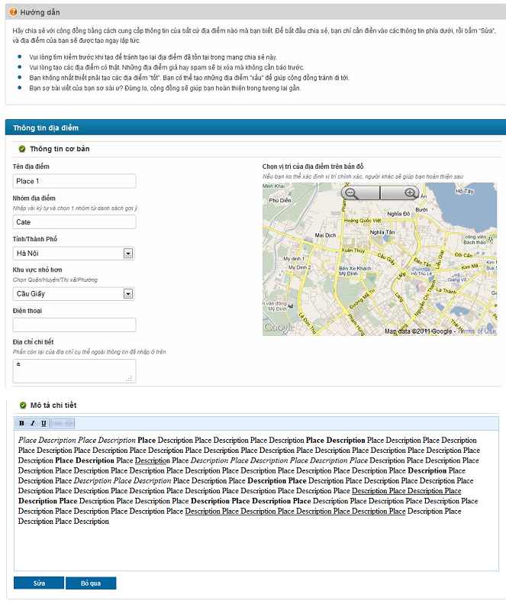UC 03: Manage Purpose-Separated Consent
- Use Case Diagram

- Use Case Specification

Use case ID | UC.03
Use case name | Manage Purpose-Separated Consent
Create by | Viet Dang |  | Last updated by |  | Viet Dang
Date created | September 16, 2026 |  | Date last updated |  | September 16, 2026
Actor | Patient
Description | This use case describes how a Patient reviews and manages consent decisions for individual data-processing purposes, withdraws applicable consent through Account Settings, and submits a request for deletion of applicable personal and/or health data.
Goal | To allow the Patient to manage consent separately for each applicable data-processing purpose and exercise the supported consent withdrawal and data-deletion request rights.
Trigger | The Patient chooses to review or manage consent through the applicable DrugTime consent interface or Account Settings.
Pre-condition | 1. The Patient has a DrugTime account.  2. The Patient is authenticated.  3. The Patient can access the applicable consent or Account Settings interface.
Post-condition | 1. The Patient's consent decision for each affected processing purpose is recorded separately.  2. A withdrawn consent applies only to its corresponding processing purpose.  3. If the Patient submits a data-deletion request, the request is recorded for subsequent processing.  4. Subsequent processing of personal or health data remains subject to the applicable consent and data-protection requirements.
Main Success Scenario: | Step | Actor Action |  | System Response
Main Success Scenario: | 1 | Patient opens the consent management interface or Account Settings. |  | System displays the Patient's applicable data-processing purposes and current consent decisions.
Main Success Scenario: | 2 | Patient reviews the applicable data-processing purposes and their corresponding consent decisions. |  | System presents each applicable purpose separately so that each consent decision can be managed independently.
Main Success Scenario: | 3 | Patient selects a data-processing purpose to manage. |  | System displays the current consent status and the available consent action for the selected purpose.
Main Success Scenario: | 4 | Patient provides the desired consent decision for the selected purpose. |  | System records the decision for that specific purpose independently from other purposes.
Main Success Scenario: | 5 |  |  | System preserves the separate consent decision for each affected purpose.
Main Success Scenario: | 6 | Patient completes the consent-management action. |  | System confirms the updated consent state and applies the decision to the corresponding processing purpose.
Main Success Scenario: | 7 |  |  | System makes subsequent processing subject to the applicable consent decisions and personal-data protection requirements.
Alternative Scenario | Alternative Flow 1: Patient Revises a Consent Decision Before Completion
Alternative Scenario | Step | Actor Action |  | System Response
Alternative Scenario | 1 | Patient changes the consent decision for a selected processing purpose. |  | System updates the pending decision for that purpose.
Alternative Scenario | 2 | Patient decides to revise the decision before completing the action. |  | System allows the Patient to return to the applicable consent decision.
Alternative Scenario | 3 | Patient changes the consent decision again. |  | System updates the decision for the selected purpose without changing
Alternative Scenario | 4 | Patient completes the consent-management action. |  | System records the final decision for the selected purpose separately.
Alternative Scenario | Alternative Flow 2: Patient Withdraws Consent for a Specific Processing Purpose
Alternative Scenario | Step | Actor Action |  | System Response
Alternative Scenario | 1 | Patient selects a previously granted processing purpose. |  | System displays the current consent status for that purpose.
Alternative Scenario | 2 | Patient chooses to withdraw consent for the selected purpose. |  | System updates the consent decision for that purpose to indicate withdrawal.
Alternative Scenario | 3 | Patient completes the withdrawal action. |  | System does not treat the withdrawn consent as consent for other processing purposes.
Alternative Scenario | 4 |  |  | System continues the authentication process.
Alternative Scenario | Alternative Flow 3: Patient Submits a Data-Deletion Request
Alternative Scenario | Step | Actor Action |  | System Response
Alternative Scenario | 1 | Patient accesses the applicable data-management option in Account Settings. |  | System provides the supported option for submitting a data-deletion request.
Alternative Scenario | 2 | Patient chooses to request deletion of applicable personal and/or health data. |  | System displays the applicable deletion-request information and allows the Patient to submit the request.
Alternative Scenario | 3 | Patient submits the deletion request. |  | System records the deletion request for subsequent processing.
Alternative Scenario | 4 |  |  | System confirms that the deletion request has been submitted.
Exceptions | Exception 1: Consent Decision Cannot Be Recorded
Exceptions | Step | Actor Action |  | System Response
Exceptions | 1 | Patient submits a consent decision. |  | System cannot record the consent decision.
Exceptions | 2 |  |  | System displays the applicable deletion-request information and allows the Patient to submit the request.
Exceptions | 3 | Patient retries the action. |  | System attempts to process the consent decision again.
Exceptions | Exception 2: Data-Deletion Request Cannot Be Submitted
Exceptions | Step | Actor Action |  | System Response
Exceptions | 1 | Patient submits a data-deletion request. |  | System cannot record the request.
Exceptions | 2 |  |  | System informs the Patient that the deletion request could not be submitted.
Exceptions | 3 | Patient retries the request. |  | System attempts to submit the request again.
Exceptions | Exception 3: Internet Connection Unavailable
Exceptions | Step | Actor Action |  | System Response
Exceptions | 1 | Patient attempts to submit a consent change or deletion request. |  | System cannot complete the operation because the required connection is unavailable.
Exceptions | 2 |  |  | System informs the Patient that the operation cannot currently be completed.
Exceptions | 3 | Patient retries after connectivity is restored. |  | System allows the operation to continue.
Priority | High
Business rule | BR-02, BR-03, BR-04, BR-05, BR-06, BR-25

- Prototype

UC 04: Check Drug Safety / Drug Interaction
- Use Case Diagram
- Use Case Specification
Use case ID | UC.04
Use case name | Check Drug Safety / Drug Interaction
Create by | Viet Dang |  | Last updated by |  | Viet Dang
Date created | September 16, 2026 |  | Date last updated |  | September 16, 2026
Actor | Patient, Family Member
Description | This use case describes how a Patient or an authorized Family Member checks medication safety information, including drug-drug and drug-food interactions, using the approved Vietnamese pharmaceutical reference sources.
Goal | To provide the user with relevant drug safety and interaction information for the selected medication(s) while clearly presenting the information as safety information rather than medical diagnosis, treatment decisions, or formal clinical advice.
Trigger | The user chooses to perform a drug safety or interaction lookup.
Pre-condition | 1. The user is authenticated.  2. The user has access to the Drug Safety / Drug Interaction function.  3. If the actor is a Family Member checking information involving a linked Patient, the corresponding data-sharing permission has been explicitly granted by that Patient.  4. The approved medication and interaction reference information is available to the system.
Post-condition | 1. The requested drug safety information is displayed to the user.  2. Applicable drug-drug or drug-food interaction warnings are displayed with the required medical disclaimer.  3. The information is presented as informational safety information and not as medical diagnosis, treatment decisions, or formal clinical advice.  4. For a Family Member, the displayed information remains within the Patient's explicitly authorized data-sharing scope.
Main Success Scenario: | Step | Actor Action |  | System Response
Main Success Scenario: | 1 | User chooses Drug Safety / Drug Interaction. |  | System displays the available drug-safety lookup interface.
Main Success Scenario: | 2 | User selects or provides the medication information to be checked. |  | System accepts the selected medication information and prepares the safety lookup.
Main Success Scenario: | 3 | User submits the safety lookup request. |  | System checks the requested medication information against the approved Vietnamese pharmaceutical reference information.
Main Success Scenario: | 4 | Patient provides the desired consent decision for the selected purpose. |  | System evaluates the available drug-safety information for the requested medication(s), including applicable drug-drug or drug-food interaction information.
Main Success Scenario: | 5 |  |  | System displays the relevant safety information and applicable interaction results.
Main Success Scenario: | 6 |  |  | If an interaction warning applies, System displays the warning together with the required medical disclaimer.
Main Success Scenario: | 7 |  |  | System presents the information as informational safety information and does not present it as medical diagnosis, treatment decisions, or formal clinical advice.
Main Success Scenario: | 8 |  |  | System keeps the relevant safety information available for the user to review.
Alternative Scenario | Alternative Flow 1: User Adds Another Medication to the Safety Check
Alternative Scenario | Step | Actor Action |  | System Response
Alternative Scenario | 1 | User chooses to add another medication to the current safety lookup. |  | System allows the user to provide an additional medication.
Alternative Scenario | 2 | User selects or provides the additional medication information. |  | System adds the medication to the current lookup context.
Alternative Scenario | 3 | User submits the updated safety lookup. |  | System evaluates the updated set of medication information against the approved pharmaceutical reference information.
Alternative Scenario | 4 |  |  | System displays the updated drug safety and interaction results, including any applicable drug-drug interaction warnings and required medical disclaimer.
Alternative Scenario | Alternative Flow 2: Family Member Performs a Safety Lookup for an Authorized Linked Patient
Alternative Scenario | Step | Actor Action |  | System Response
Alternative Scenario | 1 | Family Member selects an authorized linked Patient. |  | System identifies the selected Patient and the applicable authorized data-sharing scope.
Alternative Scenario | 2 | Family Member selects or provides the medication information to be checked. |  | System accepts the requested safety lookup within the authorized scope.
Alternative Scenario | 3 | Family Member submits the lookup request. |  | System performs the safety lookup using the approved pharmaceutical reference information.
Alternative Scenario | 4 |  |  | System displays the applicable drug safety and interaction information within the authorized scope.
Alternative Scenario | 5 |  |  | If an interaction warning applies, System displays the warning with the required medical disclaimer.
Exceptions | Exception 1: Invalid or Unrecognized Medication Information
Exceptions | Step | Actor Action |  | System Response
Exceptions | 1 | User submits the medication information. |  | System cannot identify the medication sufficiently for the requested lookup.
Exceptions | 2 |  |  | System informs the user that the safety lookup cannot be completed with the provided medication information.
Exceptions | 3 | User provides corrected or additional medication information. |  | System allows the user to retry the safety lookup.
Exceptions | Exception 2: Family Member Does Not Have the Required Data-Sharing Permission
Exceptions | Step | Actor Action |  | System Response
Exceptions | 1 | Family Member selects a linked Patient and requests a safety lookup. |  | System determines that the corresponding data-sharing permission has not been granted.
Exceptions | 2 |  |  | System does not provide the restricted Patient-related safety information.
Exceptions | 3 |  |  | System informs the Family Member that the requested information is not available within the current authorization scope.
Exceptions | Exception 3: Required Drug Reference Information Unavailable
Exceptions | Step | Actor Action |  | System Response
Exceptions | 1 | User submits a safety lookup request. |  | System cannot obtain the required approved reference information.
Exceptions | 2 |  |  | System does not present an unsupported interaction result as a confirmed safety result.
Exceptions | 3 | Patient retries after connectivity is restored. |  | System informs the user that the requested safety lookup cannot currently be completed.
Exceptions | Exception 4: Internet Connection Unavailable
Exceptions | Step | Actor Action |  | System Response
Exceptions | 1 | User submits a safety lookup request. |  | System cannot complete the required lookup because the network connection is unavailable.
Exceptions | 2 |  |  | System informs the user that the safety lookup cannot currently be completed.
Exceptions | 3 | User retries after connectivity is restored. |  | System allows the lookup to continue.
Priority | High
Business rule | BR-16, BR-17, BR-18, BR-22, BR-29

- Prototype

UC 05: Manage Medication
- Use Case Diagram
- Use Case Specification
Use case ID | UC.04
Use case name | Check Drug Safety / Drug Interaction
Create by | Viet Dang |  | Last updated by |  | Viet Dang
Date created | September 16, 2026 |  | Date last updated |  | September 16, 2026
Actor | Patient, Family Member
Description | This use case describes how a Patient or an authorized Family Member checks medication safety information, including drug-drug and drug-food interactions, using the approved Vietnamese pharmaceutical reference sources.
Goal | To provide the user with relevant drug safety and interaction information for the selected medication(s) while clearly presenting the information as safety information rather than medical diagnosis, treatment decisions, or formal clinical advice.
Trigger | The user chooses to perform a drug safety or interaction lookup.
Pre-condition | 1. The user is authenticated.  2. The user has access to the Drug Safety / Drug Interaction function.  3. If the actor is a Family Member checking information involving a linked Patient, the corresponding data-sharing permission has been explicitly granted by that Patient.  4. The approved medication and interaction reference information is available to the system.
Post-condition | 1. The requested drug safety information is displayed to the user.  2. Applicable drug-drug or drug-food interaction warnings are displayed with the required medical disclaimer.  3. The information is presented as informational safety information and not as medical diagnosis, treatment decisions, or formal clinical advice.  4. For a Family Member, the displayed information remains within the Patient's explicitly authorized data-sharing scope.
Main Success Scenario: | Step | Actor Action |  | System Response
Main Success Scenario: | 1 | User chooses Drug Safety / Drug Interaction. |  | System displays the available drug-safety lookup interface.
Main Success Scenario: | 2 | User selects or provides the medication information to be checked. |  | System accepts the selected medication information and prepares the safety lookup.
Main Success Scenario: | 3 | User submits the safety lookup request. |  | System checks the requested medication information against the approved Vietnamese pharmaceutical reference information.
Main Success Scenario: | 4 | Patient provides the desired consent decision for the selected purpose. |  | System evaluates the available drug-safety information for the requested medication(s), including applicable drug-drug or drug-food interaction information.
Main Success Scenario: | 5 |  |  | System displays the relevant safety information and applicable interaction results.
Main Success Scenario: | 6 |  |  | If an interaction warning applies, System displays the warning together with the required medical disclaimer.
Main Success Scenario: | 7 |  |  | System presents the information as informational safety information and does not present it as medical diagnosis, treatment decisions, or formal clinical advice.
Main Success Scenario: | 8 |  |  | System keeps the relevant safety information available for the user to review.
Alternative Scenario | Alternative Flow 1: User Adds Another Medication to the Safety Check
Alternative Scenario | Step | Actor Action |  | System Response
Alternative Scenario | 1 | User chooses to add another medication to the current safety lookup. |  | System allows the user to provide an additional medication.
Alternative Scenario | 2 | User selects or provides the additional medication information. |  | System adds the medication to the current lookup context.
Alternative Scenario | 3 | User submits the updated safety lookup. |  | System evaluates the updated set of medication information against the approved pharmaceutical reference information.
Alternative Scenario | 4 |  |  | System displays the updated drug safety and interaction results, including any applicable drug-drug interaction warnings and required medical disclaimer.
Alternative Scenario | Alternative Flow 2: Family Member Performs a Safety Lookup for an Authorized Linked Patient
Alternative Scenario | Step | Actor Action |  | System Response
Alternative Scenario | 1 | Family Member selects an authorized linked Patient. |  | System identifies the selected Patient and the applicable authorized data-sharing scope.
Alternative Scenario | 2 | Family Member selects or provides the medication information to be checked. |  | System accepts the requested safety lookup within the authorized scope.
Alternative Scenario | 3 | Family Member submits the lookup request. |  | System performs the safety lookup using the approved pharmaceutical reference information.
Alternative Scenario | 4 |  |  | System displays the applicable drug safety and interaction information within the authorized scope.
Alternative Scenario | 5 |  |  | If an interaction warning applies, System displays the warning with the required medical disclaimer.
Exceptions | Exception 1: Invalid or Unrecognized Medication Information
Exceptions | Step | Actor Action |  | System Response
Exceptions | 1 | User submits the medication information. |  | System cannot identify the medication sufficiently for the requested lookup.
Exceptions | 2 |  |  | System informs the user that the safety lookup cannot be completed with the provided medication information.
Exceptions | 3 | User provides corrected or additional medication information. |  | System allows the user to retry the safety lookup.
Exceptions | Exception 2: Family Member Does Not Have the Required Data-Sharing Permission
Exceptions | Step | Actor Action |  | System Response
Exceptions | 1 | Family Member selects a linked Patient and requests a safety lookup. |  | System determines that the corresponding data-sharing permission has not been granted.
Exceptions | 2 |  |  | System does not provide the restricted Patient-related safety information.
Exceptions | 3 |  |  | System informs the Family Member that the requested information is not available within the current authorization scope.
Exceptions | Exception 3: Required Drug Reference Information Unavailable
Exceptions | Step | Actor Action |  | System Response
Exceptions | 1 | User submits a safety lookup request. |  | System cannot obtain the required approved reference information.
Exceptions | 2 |  |  | System does not present an unsupported interaction result as a confirmed safety result.
Exceptions | 3 | Patient retries after connectivity is restored. |  | System informs the user that the requested safety lookup cannot currently be completed.
Exceptions | Exception 4: Internet Connection Unavailable
Exceptions | Step | Actor Action |  | System Response
Exceptions | 1 | User submits a safety lookup request. |  | System cannot complete the required lookup because the network connection is unavailable.
Exceptions | 2 |  |  | System informs the user that the safety lookup cannot currently be completed.
Exceptions | 3 | User retries after connectivity is restored. |  | System allows the lookup to continue.
Priority | High
Business rule | BR-16, BR-17, BR-18, BR-22, BR-29

- Prototype

Software Quality Attributes

Usability
GUI
- All the text, image text and help documents should be in Vietnamese.
- The interface should be elegant, simple and out‐standing.
- All images must also provide alt attribute.
Usability for end‐users
- Searching tool should be easy to use.
- The website must provide a help page to support novice users.
- Users can use main functionality of the system without logging in to the system.
- The system should remember information (but not confidential) that users have to
provide regularly. For example: name, address…
Usability for admin and staff
- Website admin and shop’s staff should need no more than one day of training to be
productive with the system.
- Detailed help must be available for the admin and staff, both in web pages and separate
documentations.
Installation
- The system must be easy to deploy. Customer can deploy successfully and learn to
configure, maintain the system within one day of training.
- The documentation for installation must be included. It describes detailed steps for
installing or deploying the system. The customer can follow the steps without direct help from
the developing team.

Reliability
- Initial data must be collected carefully and correctly
- The database must be backed up regularly and can be recovered if necessary
- Have a good spam filter
- Rating system must be reliable
- Not conflict with other software
- Rate of fault occurrence (ROFO): a number of 0.005 is acceptable. It means that it is
acceptable to have 5 failures happen in each 1000 operational time units (e.g. 5 failures per
1000 hours of operation).
- Mean Time Between Failures (MTBF): 1 month
- Mean Time To Repair (MTTR): immediately when admin finds out problem or website is attacked by someone. Average 1 day.
- Accuracy: precision of floating number should be rounded to 0.01. All currency units must be displayed (e.g. $, VND…)
- Maximum Bugs or Defect Rate: 5 bugs / KLOC.
- Bugs or Defect Rate
o Minor bugs: bugs related to GUI
o Significant bugs: bugs related to minor business logic
o Critical bugs: function can’t execute correctly, completely loss of data,
disconnect to the server

Security
- Privacy: the system should provide protection method for protecting user information from
outside or from other users. All the information of users must not be available for anyone or
software that is not part of the system. User password is also invisible for the system
administrator.
- The system must provide methods to prevent common security attacks. E.g. SQL injection,
Ddos,…
- Transformation of confidential information must be encrypted.
- The system must provide secure methods for users to recovery their password, including
the interference of system’s admin.
- Secure information of customers should not be stored on customer’s machine.
- Utilize certain cryptographic techniques for database
- Provide options for users to choose whether to share private information
- Restrict communications between some areas of the program
- Check data integrity for critical variables
- Must use secure connection (SSL) for transferring sensitive data

Maintainability
Coding standards and naming conventions
- Output of the project must include coding standards and naming conventions
documentations. Implementation code must be easy to maintain.
- All code must be clearly commented, including class, method documentations.
- If some components are reused, the documentations of those components must also be
included.
Design
- The design of the system must be loosely coupled that chances on some module will not
affect others.
Logging
- All the errors should be logged, supporting for bug fixing and maintenance.
- All strange or sensitive situations should also be logged.
Email
- The system must provide an email address to receive customer feedback or send emails.

Portability
Website can be used by any people with a browser and an Internet connection..

Performance
Load time
- Every page should be completely displayed within: average 1.5 second and maximum 5
seconds.
- Searching should return and display the result within 2 seconds.
- Comments and rating and the like should affect immediately, without reloading the web
page.
- Frequently accessed data must be cached
- Reference data must be cached
Mailing system
- Mail server should send emails within 1 minute after associated events happen.
Capacity
- The system should serve correctly and reasonably with at least 1000 online users at a
moment.
- The system can store at least 100000 places and 10000 users without affecting the loading
speed.
- If the system is busy, it has to inform users about that.
Compatibility
- The system should provide elegant responses for nowadays common screen resolutions:
1024*768, 1280*800.
- The output must be compatible with all common browsers: Mozilla Firefox, Internet
Explorer, Google Chrome, Apple Safari, and Opera.

Software Design Description

Sequence Diagrams

Cập nhật thông tin nhân viên
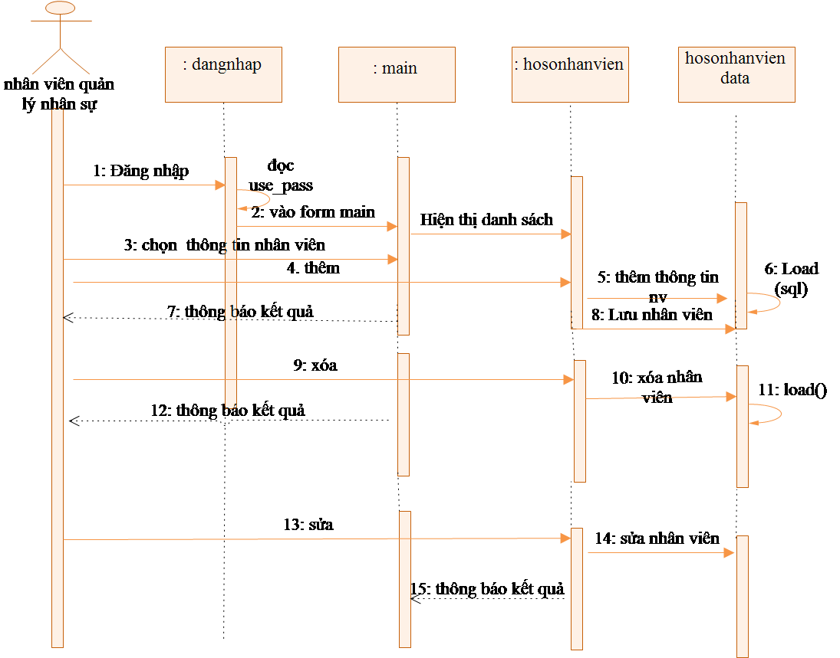

Quan hệ Gia đình
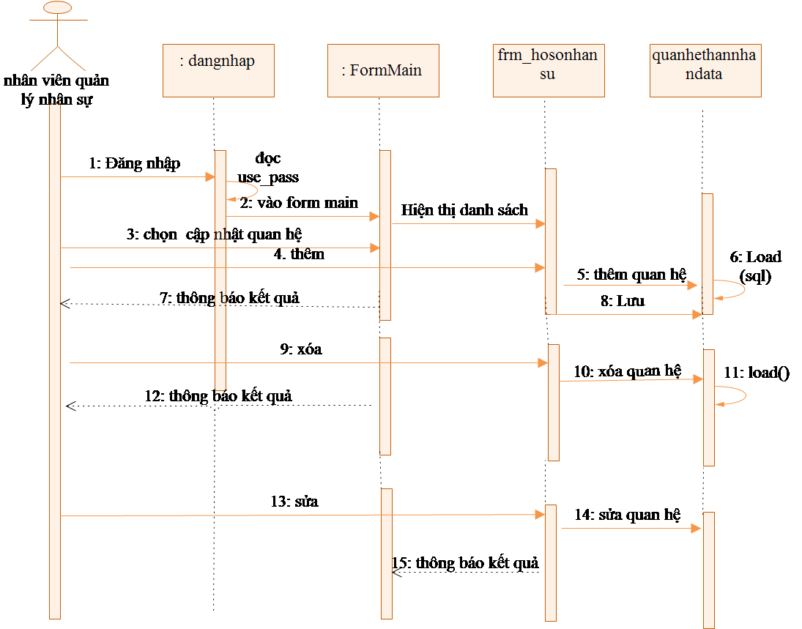

Activity Diagrams

Cập nhật thông tin nhân viên
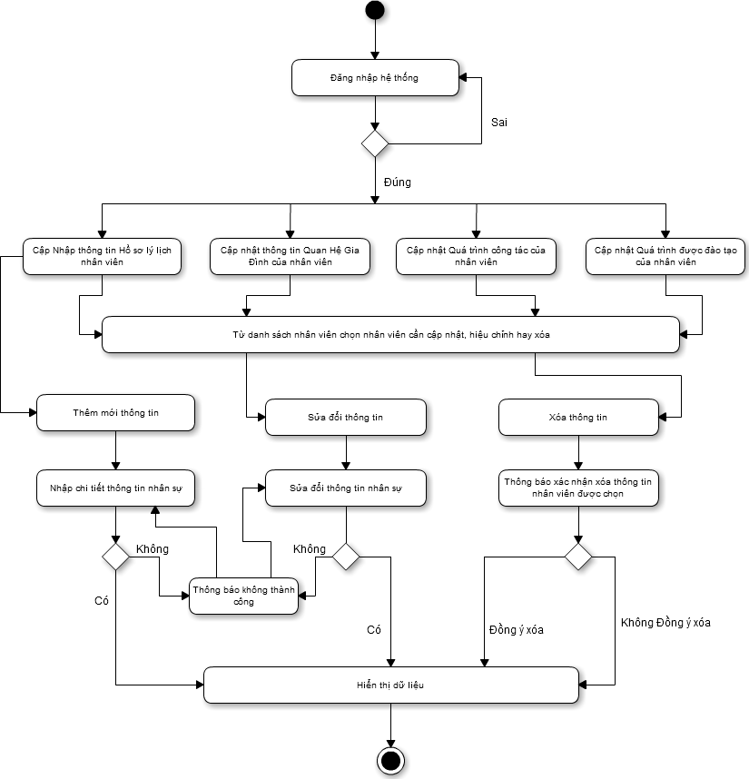

State Diagram

Class Diagram
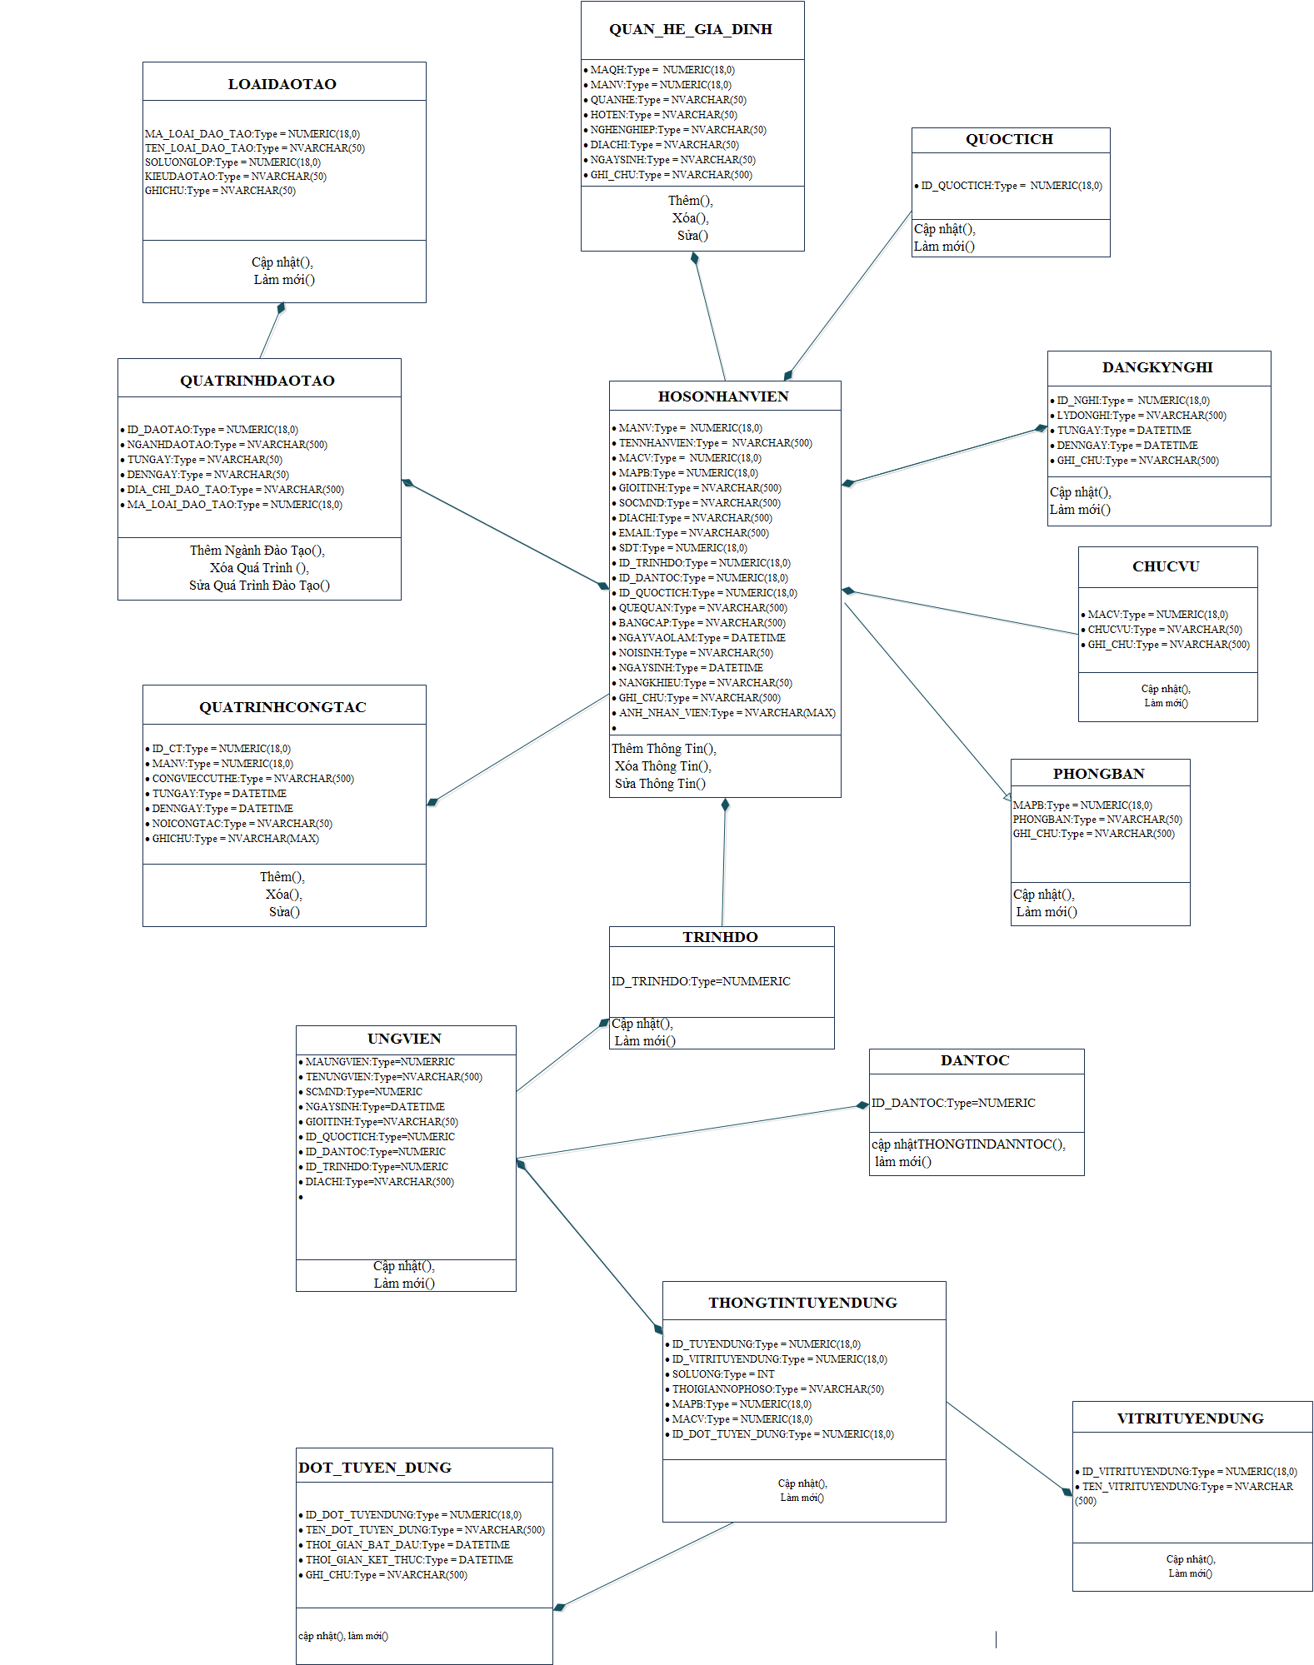

Allocation Diagram

Appendix A: Glossary

BC | Business Constraint
TC | Technical Constraint
FR | Functional Requirement
QA | Quality Attribute
UC | Use case
BR | Business rule

