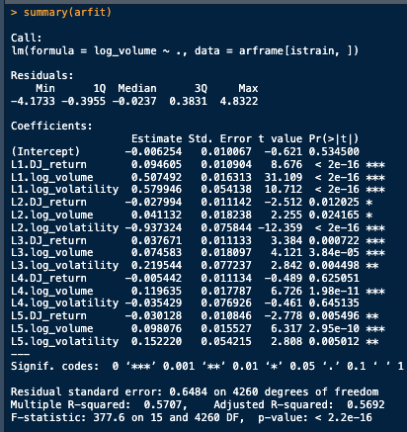
Problem 9:
I started by using the book’s torch code to create and fit a lag-5 AR model to the NYSE data. Using the book’s definition to find the R^2, I achieved a value of R^2 = .413223. This means that 41% of the variance of the output variable log_volume can be described using a linear combination of the input variables, that is an intercept variable and 5 sets of 3 lagged variables, the previous Dow Jones return, log volume, and log volatility. Many of these independent variables had a very low p-value and contributed significantly to the variance of the output, but not all of them. Since we used an AR model, it is not relevant to pull out previous lags for the variables that do not contribute as much to the overall R^2.
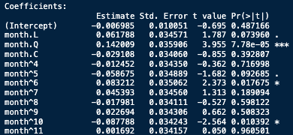
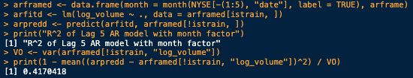
After this I reframed the data to use the month number as a factor in the model. I chose to use the month name since the numeric value of the month doesn’t have much semantic meaning; month 1 is close to month 2, but that doesn’t mean that February is “double” January, whatever that means in terms of a month. After this change, I got an R^2 of .4170418. While this was a very slight increase in R^2, by adding 12 extra factors our complexity has gone up. Interpretability remains about the same, but I don’t think the extra tiny increase in R^2 is worth the added complexity. It improves performance, but only by a negligible amount. Several of the months had a very high p-value, which also tells us that the month factor does not contribute that much to the overall success results.
Problem 10:
Now we fit a linear AR model to the data. After setting up the model and flattening the sequences to provide and input for the RNN model, our R^2 drops to 0.3992342. The test R^2 was lower than the linear AR fit in the lab. By flattening the short sequences, we lose some of the data associated with each day, because now instead of a 3*5 matrix (5 lagged days * 3 metrics / day), we have a 1 * 15 vector input. This splits up the corresponding lagged value to position 1,4,7, etc., 2,5,8, etc, and so on. We lose some information as to on which day that metric occurred, but by doing so we make our model have a much simpler input.
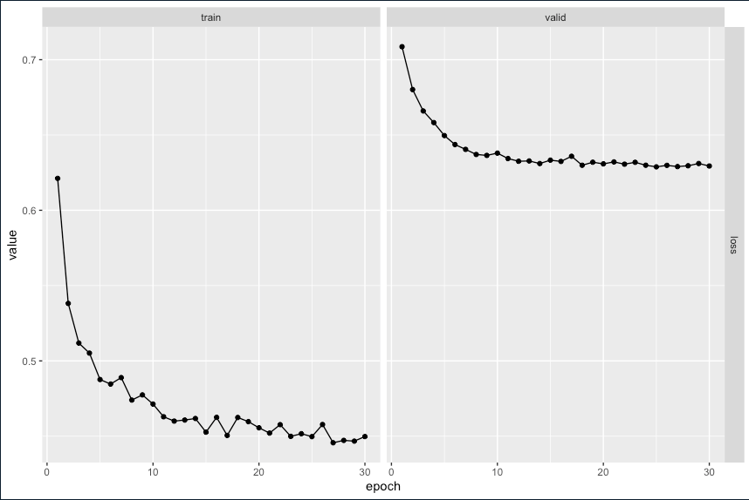
Problem 11:
I now fit a flattened non-linear AR model. This increases our R^2 up to .4228921. By making our model non-linear, we have much more flexibility in our training since our hidden layers are affected by non-linear activation functions. In the previous example, a linear AR can only create linear combinations of the inputs, which is what our linear regression models can do well. At best, we can match the performance of the linear regression models. By adding non-linearity, we can capture more complex relationships that linear activation functions cannot model, which can (and does) give us a better R^2. It’s still not amazingly better, but is certainly a percentage point of improvement compared to a .05 increase by adding the month factor.
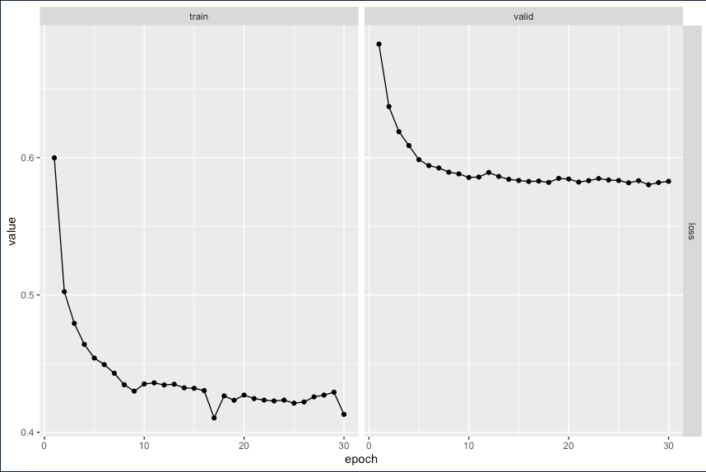
Problem 12:
Continuing this one step further, we try the flattened non-linear AR model with the day of week factor. This model is able to capture the most complex and unique relationships from our independent variables -> dependent variable log_volume output. Intuitively this model should perform the best, and in practice it certainly does. Our R^2 now jumps to .4679491, which is better than the other models we’ve tried. Our loss is lower than the model without the day_of_week factor, which is good as well.

