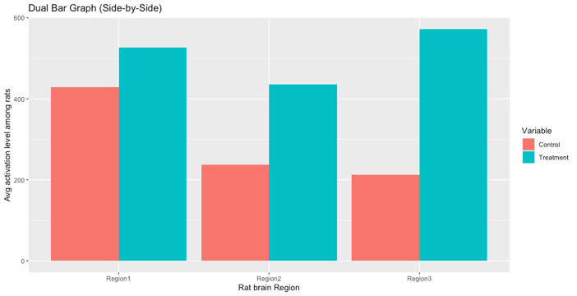
Problem 3:
c)
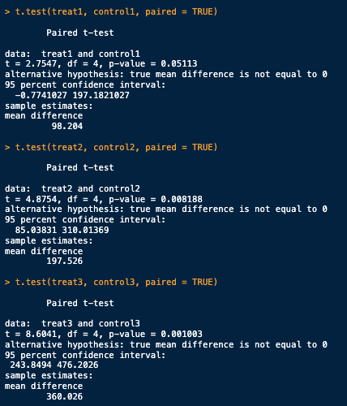
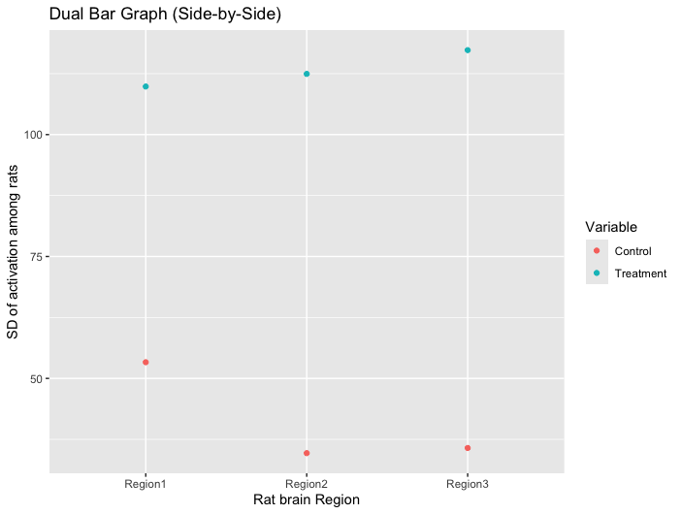
After framing the data appropriately and separating out our groups, I plotted dual bar graphs showing mean and variance. Visually (control is salmon, treatment is blue split by brain region), the mean of the activation level of the treatment was higher than the control groups, especially in the third brain region. Numerically, the means for the treatment groups were 98.204, 197.526, and 360.026 units higher than our controls, for an average of 218.585 units higher than the control groups. The standard deviations however, were much higher. The sd were 56.543, 77.774, and 81.593 higher, for an average of 71.970 standard deviation points higher than the control. This is to say that the results performed better in their mean, but with more variability in results than the control group. After performing separate paired T-tests for each brain region (results shown in image), brain regions 2 and 3 had p-values that were below a significance cutoff of .01 (99% confidence) and can be counted as statistically significantly different means. Brain region 1 has a p-value of .05113, which is just outside the p-value cutoff of .5 for a 95% confidence level, so we reject this null hypothesis, we cannot conclude that the treatment is statistically effective in brain region 1, but we can say with 99% confidence that it is significant in regions 2 and 3.

Problem 7:

- Dependent variable: MathACH
  - UOA: Student
  - LVL 1: Sex – Fixed
  - LVL 1: Minority – Fixed
  - LVL 1: SES – Fixed
  - LVL 2: School – Random
  - LVL 2: MEANSES – Random (it’s fixed per school)
- After grouping by sex, our results were as follows:
Sex group effect on MathAch | Male | Female
Mean | 13.64 | 11.95
SD | 7.01 | 6.65
  - After performing a Wilcoxon signed-rank test (to compare the means and standard deviations of the two groups) and finding a p-value of 1.10^-26, we reject the null hypothesis that the means of the two sex groups are not different. There is sufficient evidence to reject the null in favor of the alt. hypothesis, that our means of the two population groups differ.
  - Repeating this for grouping by minority, we get:
Minority group effect on MathAch | No | Yes
Mean | 13.88 | 9.75
SD | 6.66 | 6.55
  - Using another Wilcoxon test, our p-value is 1.17^-112, which is certainly significant enough to reject our null hypothesis in favor of the alternative, that the means are different between the two groups.
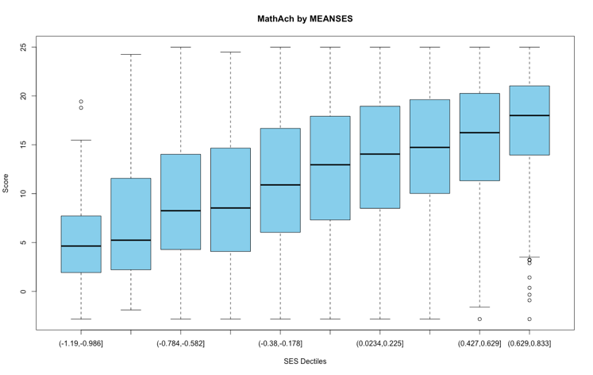
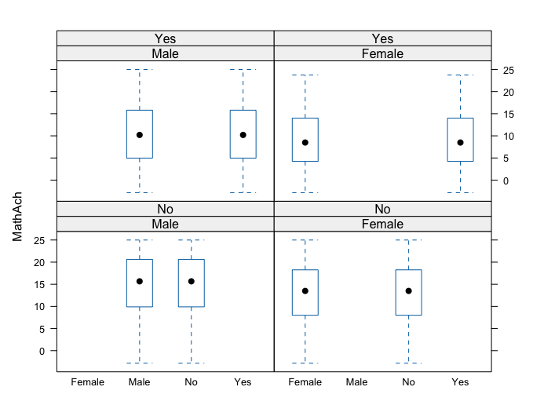
- I grouped the MEANSES values into 10 different groups (dectiles) and made a box and whisker plot to show the mean and sd to visually compare them. It is very evident that as the MEANSES increases, the MathAch score also increases. After performing an analysis of variance test to the dectile’d data, we get an F statistic of 107.4 and a corresponding p-value of less than 1^-26, telling us that at least one of the means is statistically different than the others, so grouping by MEANSES (at least on a 10-rank scale) is certainly a good idea as it plays an important factor in the difference in overall MathAch score.
- I split the data by sex and minority, and did both a B&W visual plot an a two-way aov test. The B&W showed significant differences in the means when crossing the Sex and Minority factors. The two-way aov test did not support this however, both sex and minority had p-values that were negligible close to 0, but the crossed data had a p-value of .339, which we would not use to show that this coefficient is significant with any reasonable confidence. There is not enough evidence to show that the interaction between sex and minority should be considered for the MathAch output.
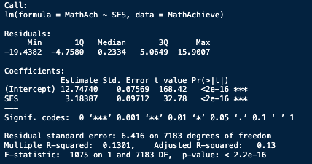
- Yes, according to a simple linear fit, both the intercept and SES terms have p-values of essentially 0, meaning they both are significant in predicting the output of MathAch.
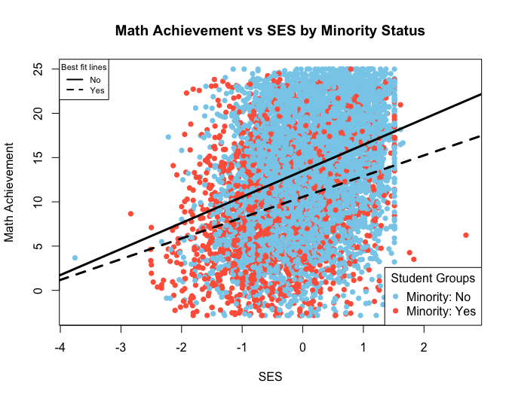
- After grouping the data by Minority status, the line of best fit contains such coefficients:
 | No | Yes
Int. | 13.499 | 10.558
SES Slope | 2.942 | 2.344
  - There certainly is a clear distinction in the difference of the effect of SES on MathAch when grouped by Minority status.

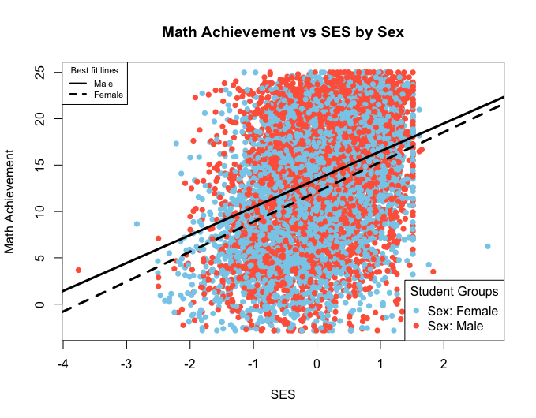
- I repeated this for SES grouped by sex. The results are:
 | Male | Female
Int | 13.475 | 12.108
SES slope | 3.011 | 3.225
  - Visually, grouping by sex does not correspond to as big of a difference on effect of the MathAch score, especially as SES gets higher.
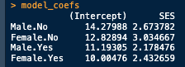
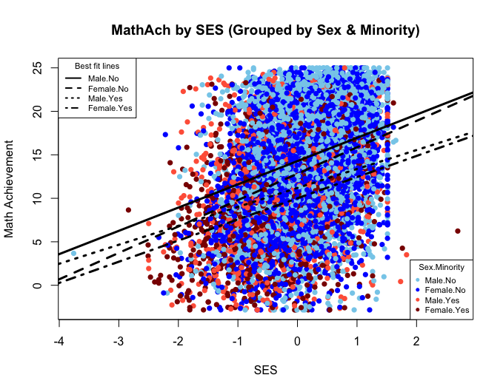
- Finally, I group by crossing Sex & Minority. For the lower SES values, there is less distinction between the crossed groups of Sex & Minority, however especially as SES scores increase, students who are not minorities (classified in the “no” category) perform better than those who are. In this case, Males perform slightly better than females, but there is not as big of a difference across sex than there is across minority. Specific coefficients are as follows:
- Given our explorations, SES values affect MathAch scores significantly, and we should group by Minority status (as a fixed factor). In this case, we have not done as much exploration on the effects of school or MEANSES (we did a little in part c), but the MEANSES data certainly plays a crucial role in our MathAch scores. I would set up my LMM predicting MathACH using SES, Sex, and Minority as our fixed factors, and MEANSES as a random factor (different per school). With a model this simple, we can always train more and then prune unnecessary coefficients later. We should use all our given data

