Project 1
a)
First I loaded the rat_pup data set to my R, and then set to work reproducing the tables and figures from chapter 3. Here is my table of weight statistics by splitting between treatment groups and sex: 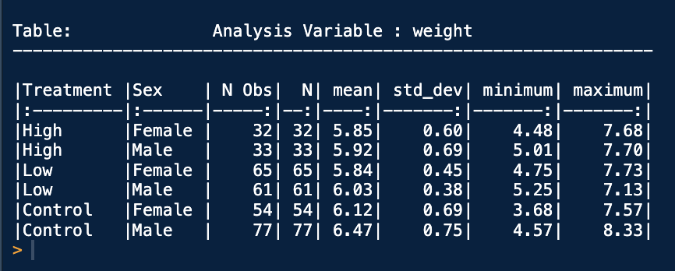
I couldn’t find a graphic that grouped the treatments visually, so I opted for the table route, but all the information is still there. I’m not sure why they have an “N Obs” column and an “N” column, they seem to both imply the same thing, but I added it for consistency.
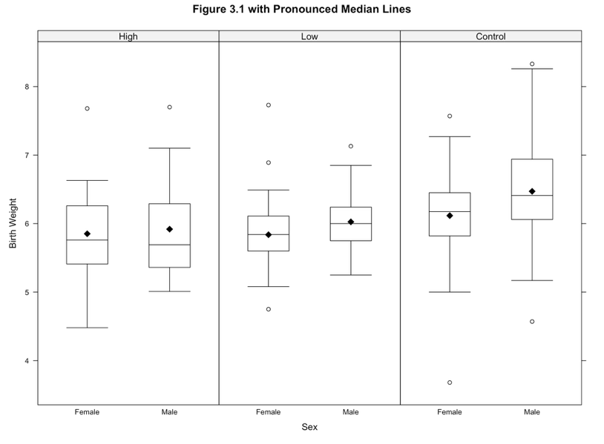
For figure 3.1, I had to do the same thing, but use a bwplot this time. Afterwards, I also added the mean as a diamond using a panel on top of the pre-existing bwplot. I reordered the treatment and sex factors to match the book, and got this. Visually, there is certainly a difference between the control and high / low groups, but as we’ll come to find out later in model3.3, there is not enough evidence to show that high and low are statistically different, and we group the random factors together.

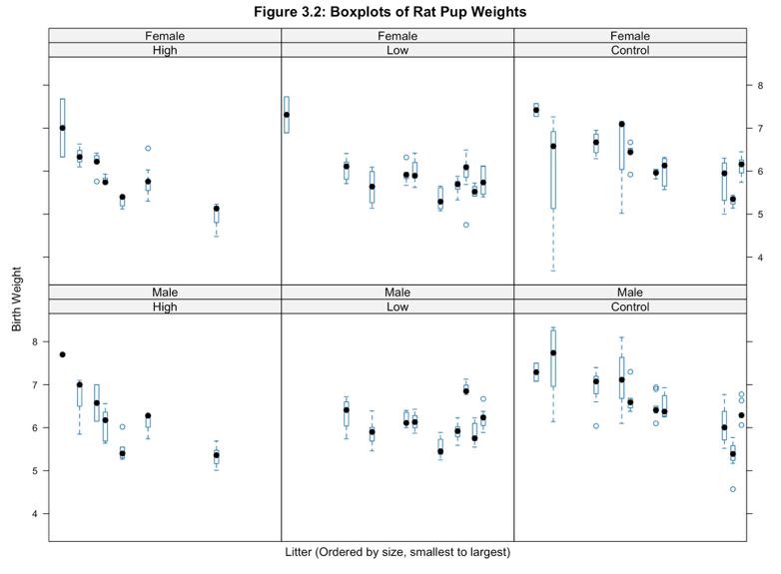
Figure 3.2 is another set of bwplots split by treatment and sex, but this time ordered by size of the rat litter. To do this, I ordered the data appropriately to match the book, and then drew weight ~ litter | treatment * sex to get the crossing.
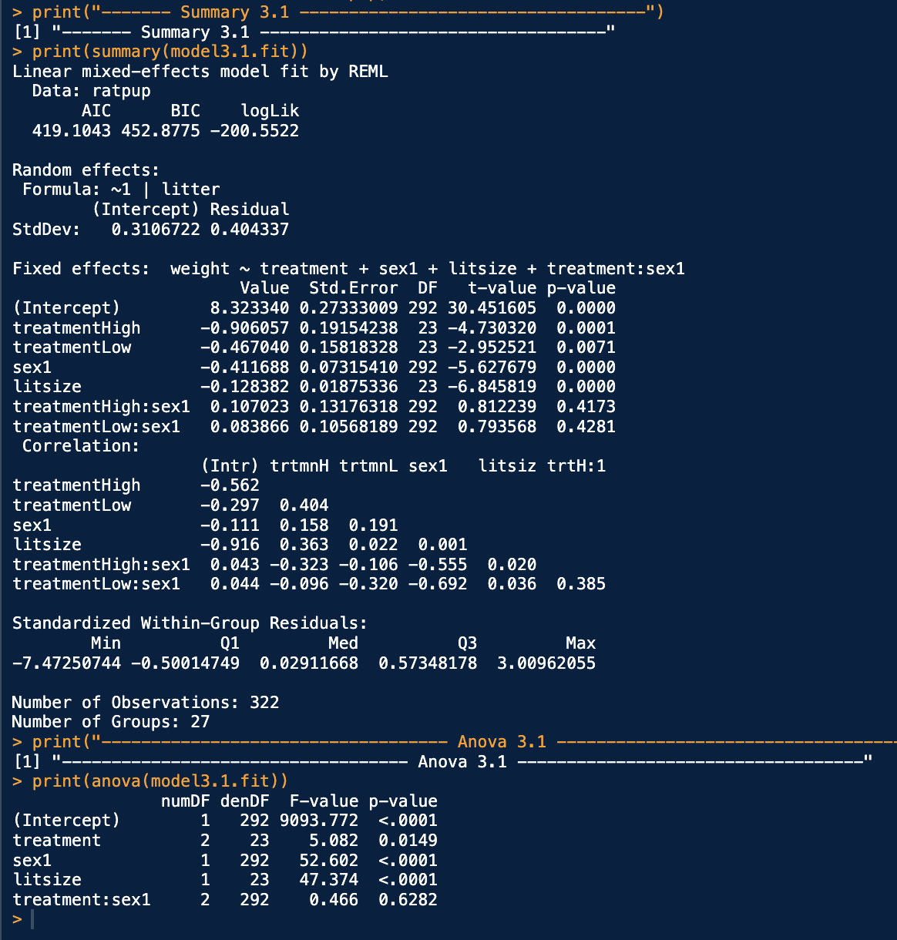
This matches the book’s production of this graph. As it mentions, weights decrease as a function of litter size, a trend we can see from these box plots.
b)
We start off with Hypothesis 3.1: that the random effects associated with litter-specific intercepts can be omitted from model 3.1. After creating model 3.1, we get this summary and Anova test. Our p-values are low for everything except the crossing of treatHi:sex1 and treatLow:sex1, given that both treat and sex are presupposed in the model (from the Anova test). Likely, we will remove this factor by the summary insignificance and the Anova test. However, we need to do a likelihood ratio test to confirm this against another model. After creating model 3.1a with no residual error variance among treatment groups, we get this anova summary: 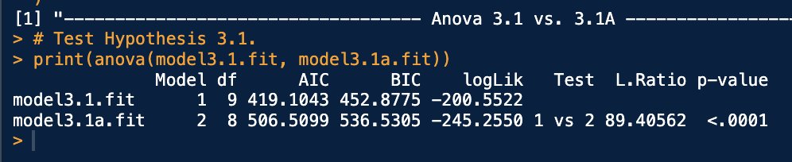
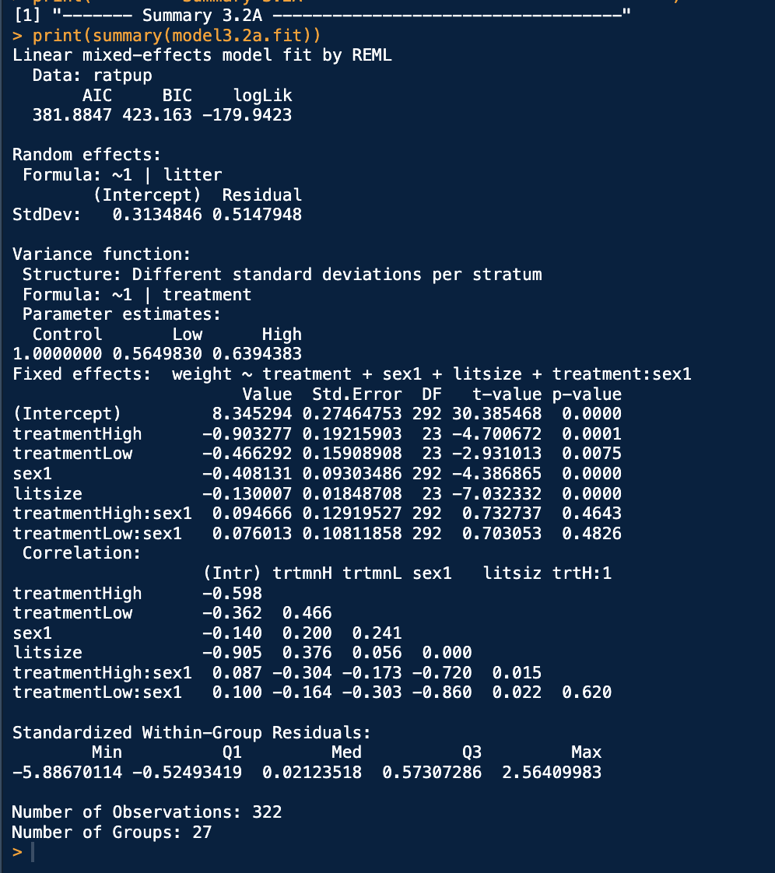
Since our p-value is less than any strong significance level, we reject the null hypothesis that our residual error variances are all equal to 0. We should definitely keep different residual error variances among treatment groups, meaning treatment variance should be considered a random factor (at least using a random intercept).

Hypothesis 3.2: The variance of the residual errors is the same (homogeneous) for the three treatment groups (high, low, and control).
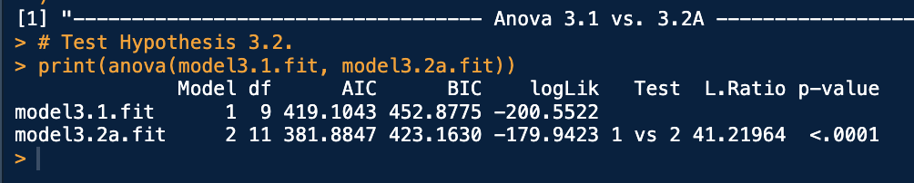
Model 3.2 helps us determine if each variance is different from each other. Our summary from 3.2 is this. Our parameter estimates for the variance function differ between control, Low, and High, which gives us insight to say we should consider doing an Anova test against our previously chosen model 3.1. A p-value of less than .0001 tells us that the variance in residual errors is certainly non-zero.
Hypothesis 3.3: The residual error variances for the high and low treatment groups are equal
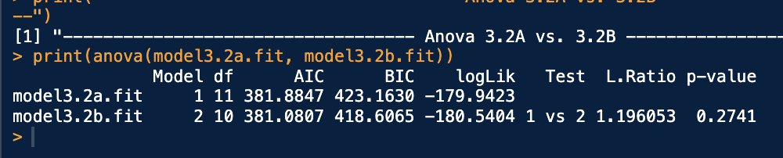
To test this, we create another model 3.2b, which groups the high and low treatment groups together. After fitting Model 3.2b and running an anova test compared to 3.2, our p-value is .2741. Since 3.2b is a nested model of 3.2a and 3.2b is simpler, we can select model 3.2b to continue with because we can combine the high and low treatment groups together, making it easier to explain and having less parameters, while still performing just as well as Model 3.2a.
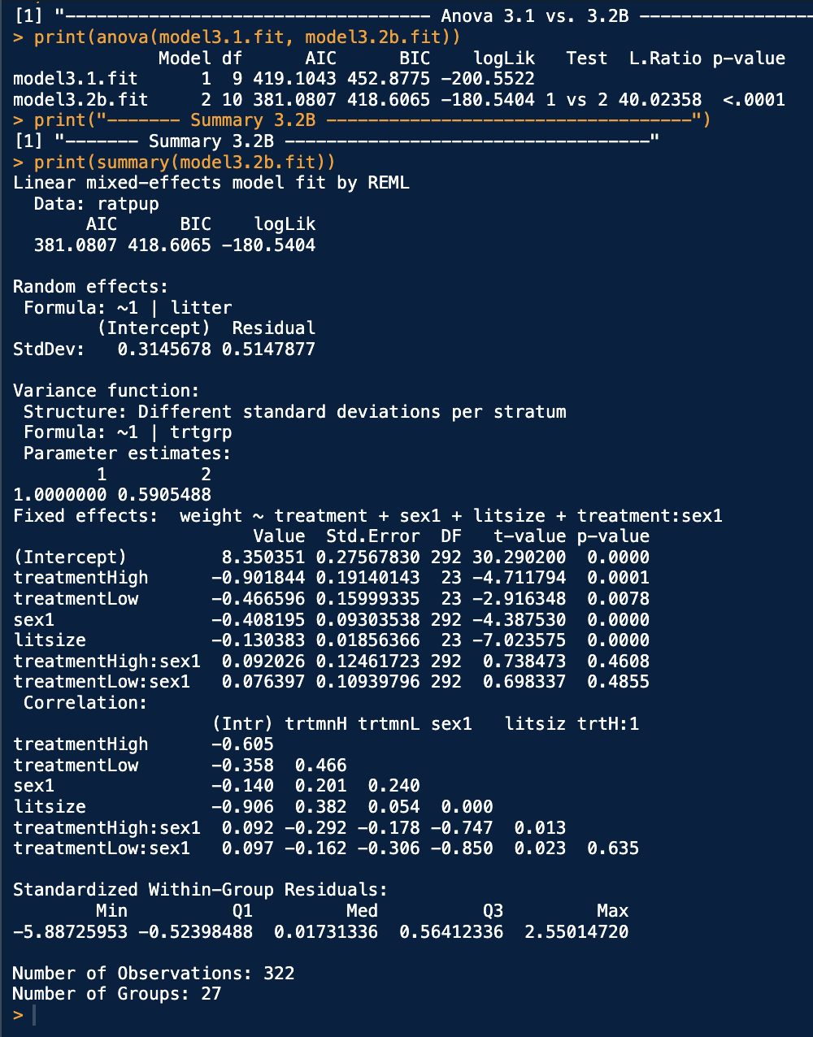
Hypothesis 3.4: The residual error variance for the combined high/low treatment group is equal to the residual error variance for the control group.
Hypothesis test 3.4 tells us whether we need to do all this splitting apart by treatment, or if we can group all the residual error variances together. Looking at the anova test, model 3.2b compared to model 3.1 has a p-value of <.0001, meaning it is better to fit the model with a difference in residual error variances compared to our equal variance model 3.1. Seeing the summary, we can conclude that there is a difference in the trtgrp parameters as far as a random intercept is concerned.
Hypothesis 3.5: The fixed effects associated with the treatment by sex interaction are equal to zero in Model 3.2B.
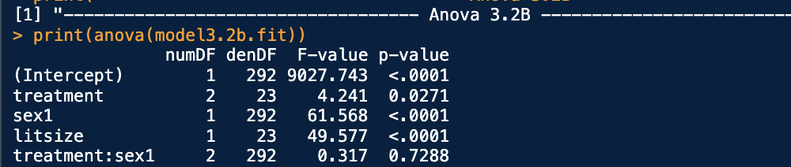
To test hypothesis 3.5, we perform a simple F-test to see if the fixed effect of the crossing treatment & sex group is needed. Given our preceding add-1 effects from the anova test, we have a p-value of .7288 for adding treatment:sex, which is not significant enough to keep in our model. Moving forward, we will remove the interaction term for simplicity since it is not significant to include.
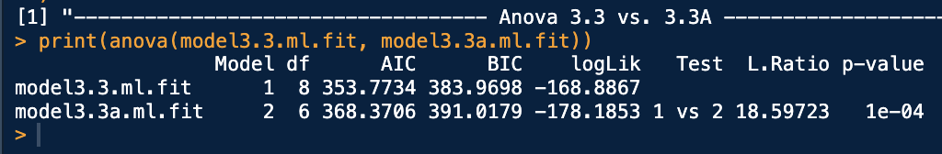
Finally,
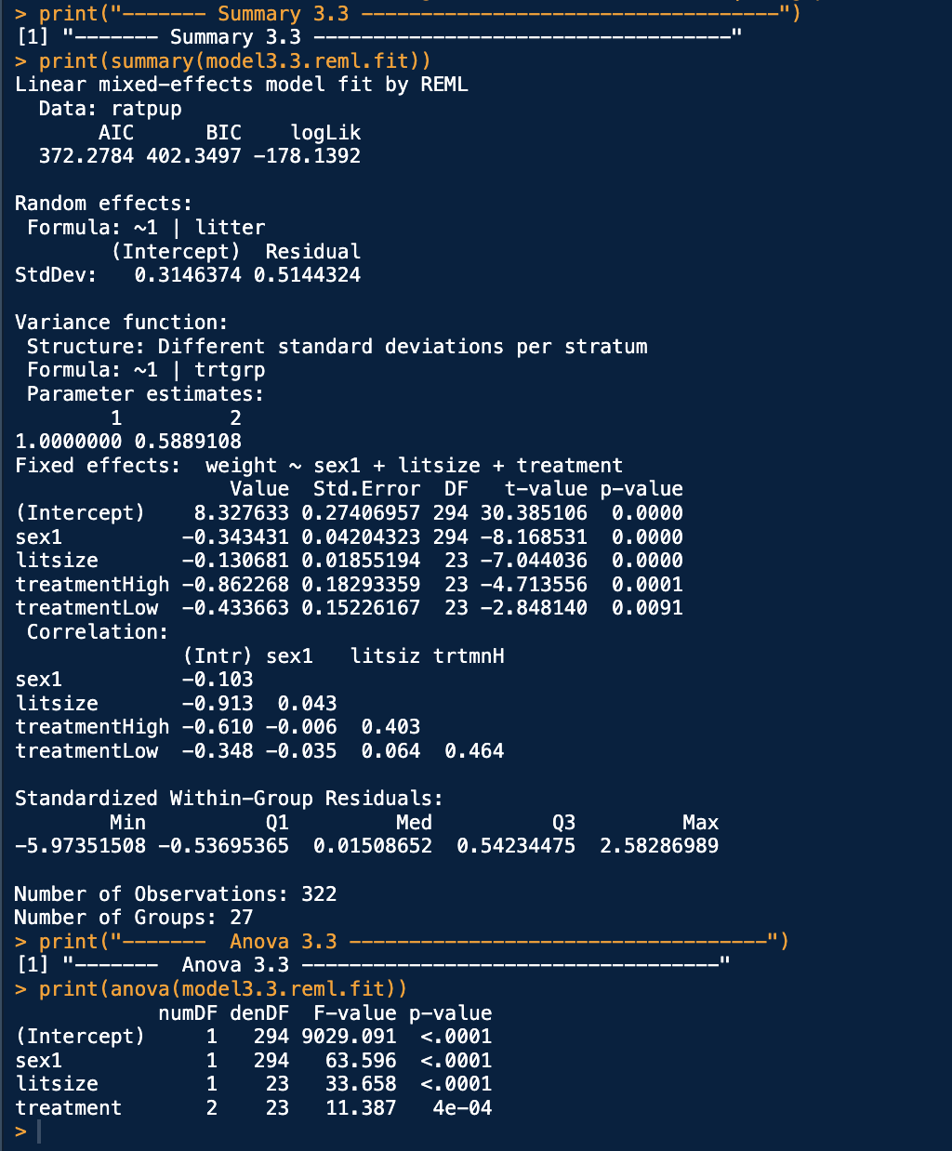
Hypothesis 3.6: The fixed effects associated with treatment are equal to zero in Model 3.3 (Primary research hypothesis, weight is affected by treatment group). We define model 3.3a to include the treatment as a fixed factor, which with a p-value of 1e-04, has a statistically significant effect on our model fit. We should keep the treatment group as a fixed factor in its effects on the output weight.
We output the final summary of model 3.3. our treatment group is included as a fixed factor along with sex and litsize, while the trtgrp is included as a random intercept factor. Each term included in the model significantly contributes to the model’s fitting of weight based on the anova table on the bottom. This model is not considered for selection, only for research purposes
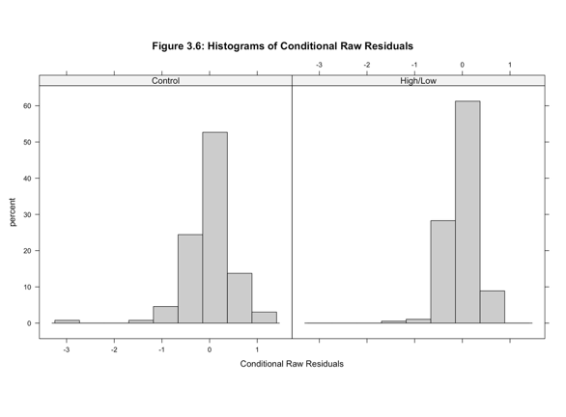
c)
From AIC, model 3.3a is the best model with the lowest AIC of 368.3706.
BIC also leads to the same conclusion, with a value of 391.0179.
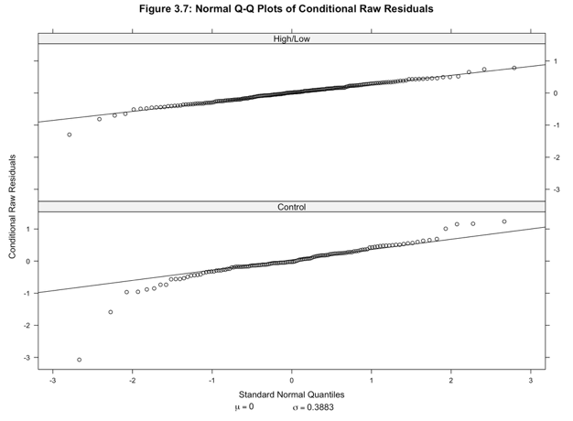
Our fit is superior with model 3.3a, even though we chose 3.3 for the result since 3.3a was fit for research purposes.
d)
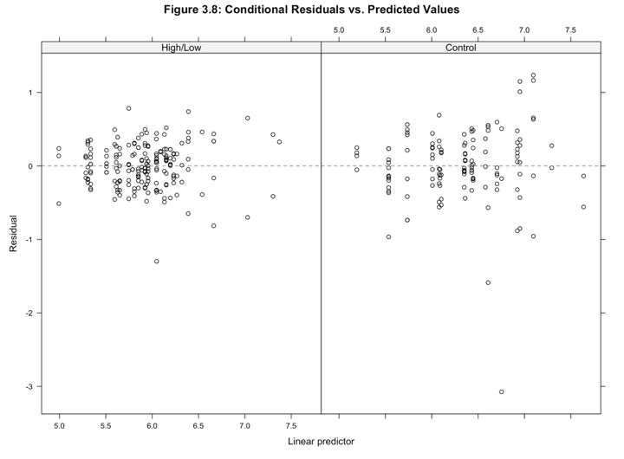
Here is figure 3.6, histograms for the conditional raw residuals of our fitted model. Both sets of residuals look approximately normal with slightly skewed tails on the left side.
Figure 3.7: The Q-Q plot of standard normal quantiles. Our line of best fit is overall good, save for a few outliers at the tails (especially the left tail)

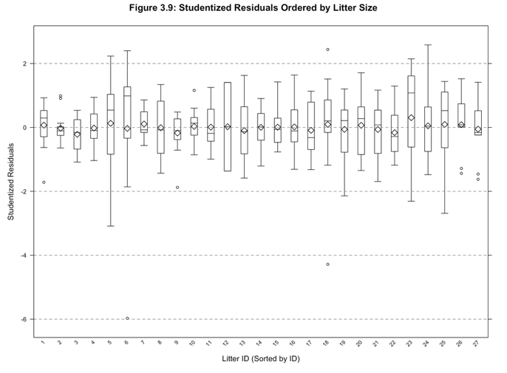
Figure 3.8: Scatterplot of residuals to the predicted values. There is strong evidence here of nonconstant variance for the hi/low pooled group, however there was an outlier in the control group, pup_id = 66. It was poorly fitted, but did not have a significant effect on the output estimates.
Figure 3.9: The studentized residuals are approximately homogeneous across litters

