R Problem 13:
I first started by copying the online code for the torch lab version of the book’s Chapter 10 lab. I keep trying to use Keras, but it is giving me so many issues that I just went to torch, which is much more extensive but works better.
After copying the code, I commented it to explain what each step of the process was doing using the book’s explanation. This helped me break down what was happening. Finally, I started my data exploration.
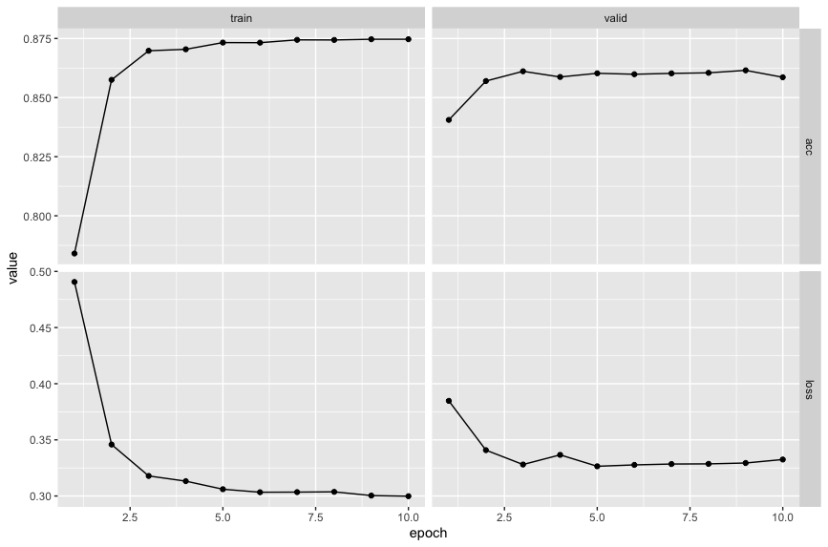
I first started by using a max_feature size of 1,000. This only uses 1,000 of the most common words from the imdb_dataset. I didn’t expect this to work very well, since upon a quick google search, there are roughly 100 words that are either articles, conjunctions, or prepositions in the English language, all words that don’t really tell us much about the sentiment of a movie review (except for maybe positive / negative words like “not”). This accounts for over 1/10 of the words in our dictionary. Looking at the results, after 10 epochs of training, the training accuracy stabilized around .875, whereas the validation accuracy stabilized around .857. Overall, these are not terrible results, but we could certainly increase these results by training for longer or enabling more words to be used for the classification task (which we do next). Valid Acc: 0.85796

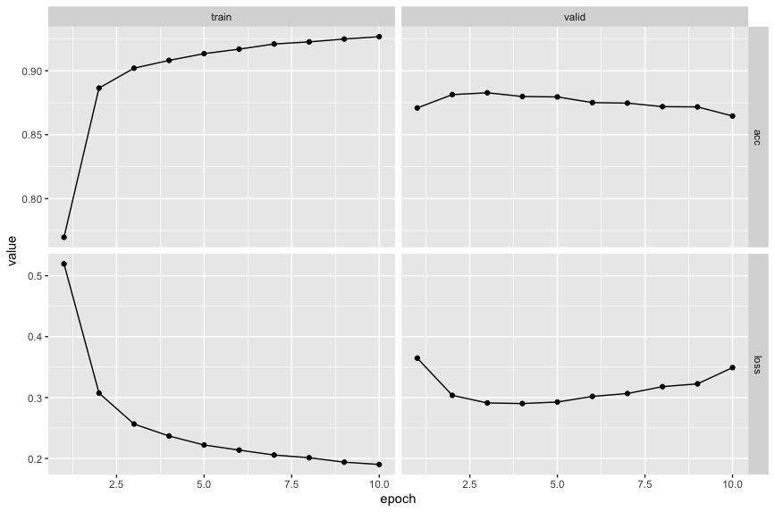
I then extended our dictionary out to 3,000 words. As shown in the upper left graph, our training accuracy continued to increase (and could even probably increase more with more epochs, since it is still sloped upwards), and our validation accuracy started off better than the 1,000 word dictionary, but got worse as time went on, dropping down to about the same level the 1,000 word dictionary had. Valid Acc: 0.8646
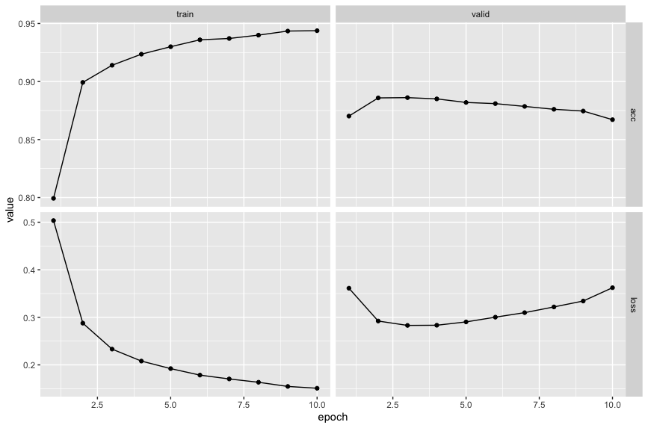
I repeated this process with 5,000 feature words. Overall, roughly similar results to the 3,000 word dictionary were achieved. It performed slightly worse, and certainly had a higher validation loss, which is not a good thing as we continue to increase our number of features we’re training on. To make use of this extended number of features, we should certainly increase our number of epochs to give the model a chance to catch more of the nuance of the English language. Valid Acc: 0.8671
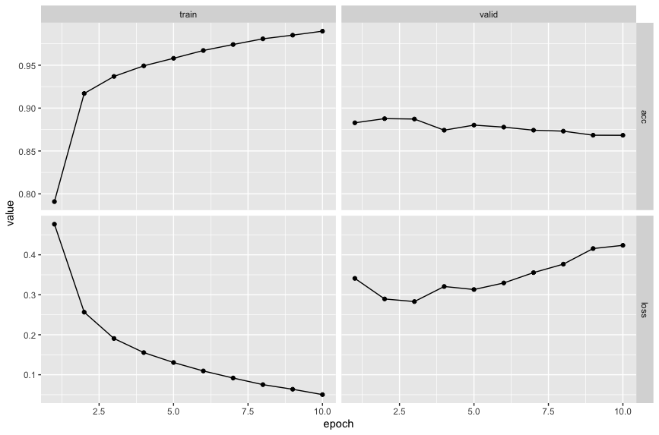
The 10,000 word dictionary performed the best according to the training data, but on validation data it performed about equally to the 3,000 and 5,000 word dictionaries. At this point with only 10 epochs and a large vocabulary, I am incredibly worried about the training data getting overfit and not being able to train on enough different scenarios to make full use of the different ways that 10,000 words in the English language are used. Valid Acc: 0.8683
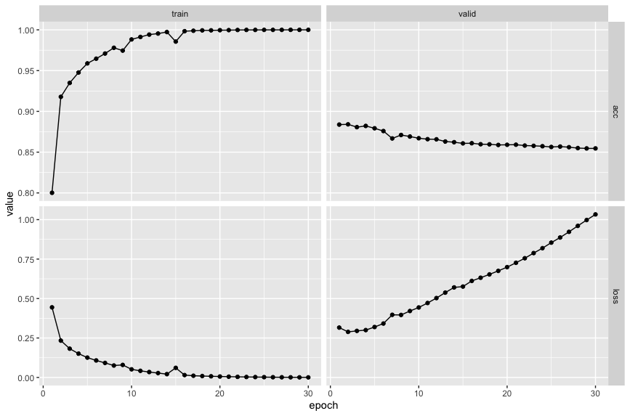
As a test, I tried increasing the number of epochs to 30. While this was “helpful” in a sense to take care of the training accuracy plateauing, it made the validation accuracy and loss much worse. Our model is probably not complex enough to make good use of the vast dictionary of words we have at our disposal using 10,000 words. We should probably consider using a more complex model (more layers, add regularization / dropout to increase randomness and non-linearity) to capture and train on more of the extensiveness of the English language.

Overall, our highest accuracy was with that of 10,000 words in our feature dictionary, but our simplest model was the 1,000 word dictionary. The accuracy difference is so negligble that it would certainly be better to choose the 1,000 word dictionary strictly on the basis of its simplicity in terms of number of features. My intuition in this case was wrong, but I still think with a more complex model, this would allow us to capture more nuance using more words in our dictionary. Further testing is needed to see if this is the case.

