Problem 7:
This problem asks us to fit a neural network to the Default data set, a dataset including data on whether each row is a student, their balance, and income will default on a loan or not. We are then told to compare this model’s performance to a linear logistic regression model to determine which is better.

I began by setting the seed to 42 and splitting up my data into a test and training set, setting aside 1/3 of the data for testing. There are only 10,000 rows, so 6,667 training and 3,333 rows for testing will be fine. I then scaled the X data using R’s scale function.

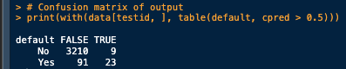
I then created the linear logistic regression model to get a baseline. I used my training data with a type.measure set to ‘class’ to set the internal validation loss to an entropy-based loss since we are doing classification (whether the student will default on their loan). I used the binomial family to signify that I wanted a logistic regression model. I ran the testing data through the prediction function and outputted my confusion matrix. The results gave me a total misclassification error of 100/3333, which results in an overall accuracy of 96.9997%
After this, I used the problem’s description and the book’s lab to create a neural network. My first layer was the input layer connected to a 10 node dense layer, all set to use the ReLU activation function due to its nonlinearity and its simplicity to compute. After this, I added a dropout layer with a rate of .4, the book’s suggestion and a relatively standard dropout chance. I then combined this layer to an output layer, using the sigmoid activation function to specify that I wanted a percentage change of the student not defaulting on their loan (since 1 signifies a NO, a .95 means that the student is 95% likely to not default on their loan). I compiled this model using binary cross-entropy loss for the final loss (since cross-entropy is used in classification problems as this one), set the recommended optimizer for classification problems, and graphed the accuracy metric. Finally, it was time to train.

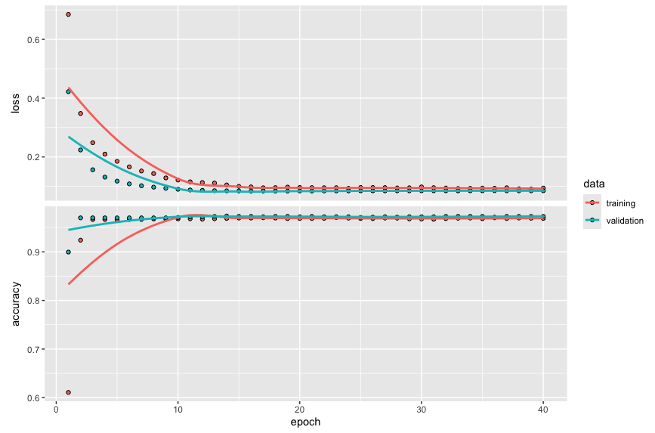
I trained for 40 epochs with a batch size of 32 cases. I took 20% of these 6,667 rows and set them aside for validation data (a total of 1,334 rows). After training, here was the result of my model:
This model tells us that our loss converged to around .1 just after 10 epochs, and our training and validation accuracy converged to around .97 at the same time. I do not necessarily need to train the model for 40 epochs, since we reached convergence after 15 epochs or so. Another choice would be to shorten training time to 20 epochs.

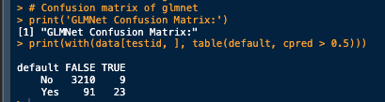
Finally, I compared my two confusion matrices:
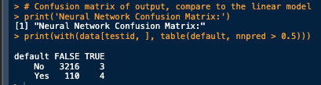

In comparing the accuracies of the two models, there is no significant difference between the GLMNet model (on the left) and the neural network on the right. In fact, the neural network performed slightly worse, with an accuracy of 96.6%. The difference of .3% is negligible compared to a scale of 3333 test examples.

Conclusions:
To compare models, there are 4 main categories to consider:
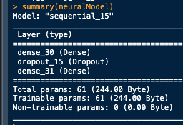
- Accuracy: The GLMNet performed marginally better than the neural network. This is certainly not enough to conclude that the neural network was better or worse
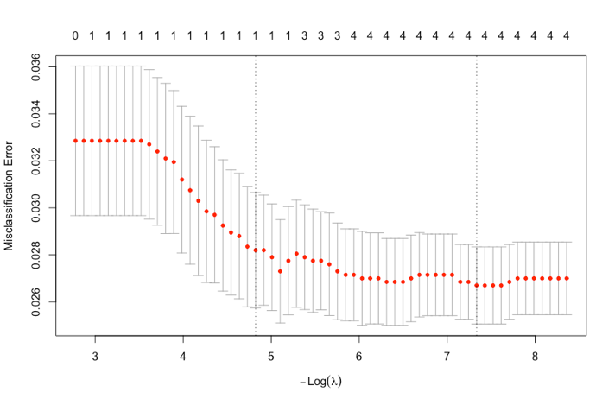
- Complexity: The GLMNet is significantly less complex than the Neural network. The neural net has 61 trainable parameters, whereas the GLMnet uses only 4 parameters, an intercept, the student field, balance, and income. The second graph below shows the result of using the top number of parameters in the GLMNet. The dotted line on the right shows that the Misclassification error is lowest when 4 parameters are used, these being the ones listed above.
- Training time: The GLMNet took .018 seconds to fit the data (internally in the system), while the neural network took .683 seconds. This is almost 38 times as long! For a model that performs slightly worse, this is certainly not a good statistic
- Explainability: The GLMNet is much easier to explain what each coefficient means compared to the neural network. The first 50 weights of the neural network work to create 10 different linear combinations of the input variables, then run it through the ReLU activation function. The last 11 take the result of these linear combinations -> ReLU and create another linear combination, only to run this through the sigmoid function. You cannot easily tell by looking at a weight number how it contributes to the overall output, whereas the GLMNet coefficients tell us how much a particular factor of the input data is going to contribute to the overall likelihood that a student will not default on their loan. For example, the coefficient for the balance is 1.982705 (gotten by using the coef() function on the cvfit glmnet fitted model. This means that the higher the student balance is on a card after making a monthly payment, the more likely they are to default on their credit card loan. After scaling, each point increase on the balance variable contributes to an overall 198% overall chance they will default on their loan.
The GLMNet is certainly a better choice of models here, due to its simplicity to explain, 38x faster training time, 15x less complexity, and negligible accuracty increase. We should use the GLMNet model to fit the Default data.

