
Project 1 – HW8
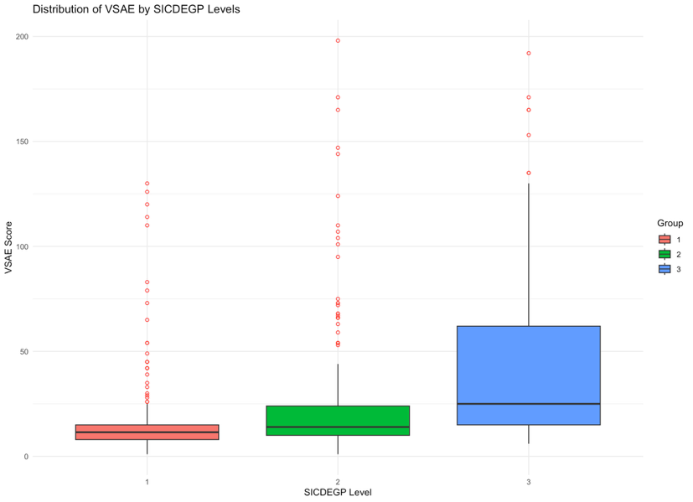
a) I used the book’s code and grouped the data by sicdegp level, and printed a table of the vsae standard deviations. Remembering that 0 means group 3, we can see that group 3 has a significantly higher standard deviation than 1 and 2, being ordered from 1 – 2 – 0 in order of increasing variance. My boxplots are as follows, which certainly confirm this data from the table. One comment I can make is that in the first two groups, there are certainly many outliers (indicated by the red dots). The means also increase across levels, but the most significant difference is the width of the boxes representing standard deviation.
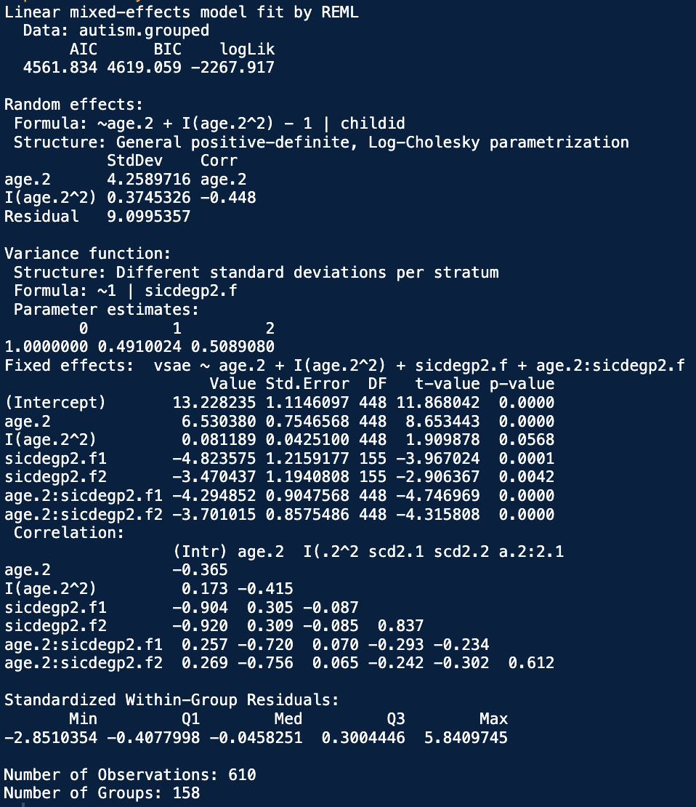
b) After refitting the model with the updated residual structure, we get this R summary. Based on the variance function summary, we can very clearly see this trend reflected in the variance adjustments by group. The variance from group 3 (lvl 0) to group 1 gets cut in half! Same with group 3 to group 2, although cut by a little less than a half (but not by much compared to group 1). Intuitively this certainly tells us that this updated structure will be better, and an anova LRT between the two models confirms this with a p-value of less than .0001 under a null distribution assumption of Chi^2 with df = 2. AIC and BIC also significantly support this decision, even though we make our model more complex, the fit is so much better that this difference is also reflected in the BIC measurement.

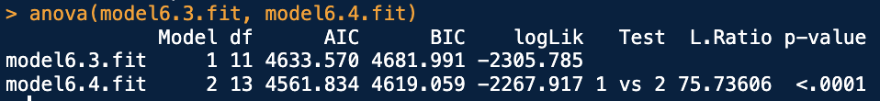
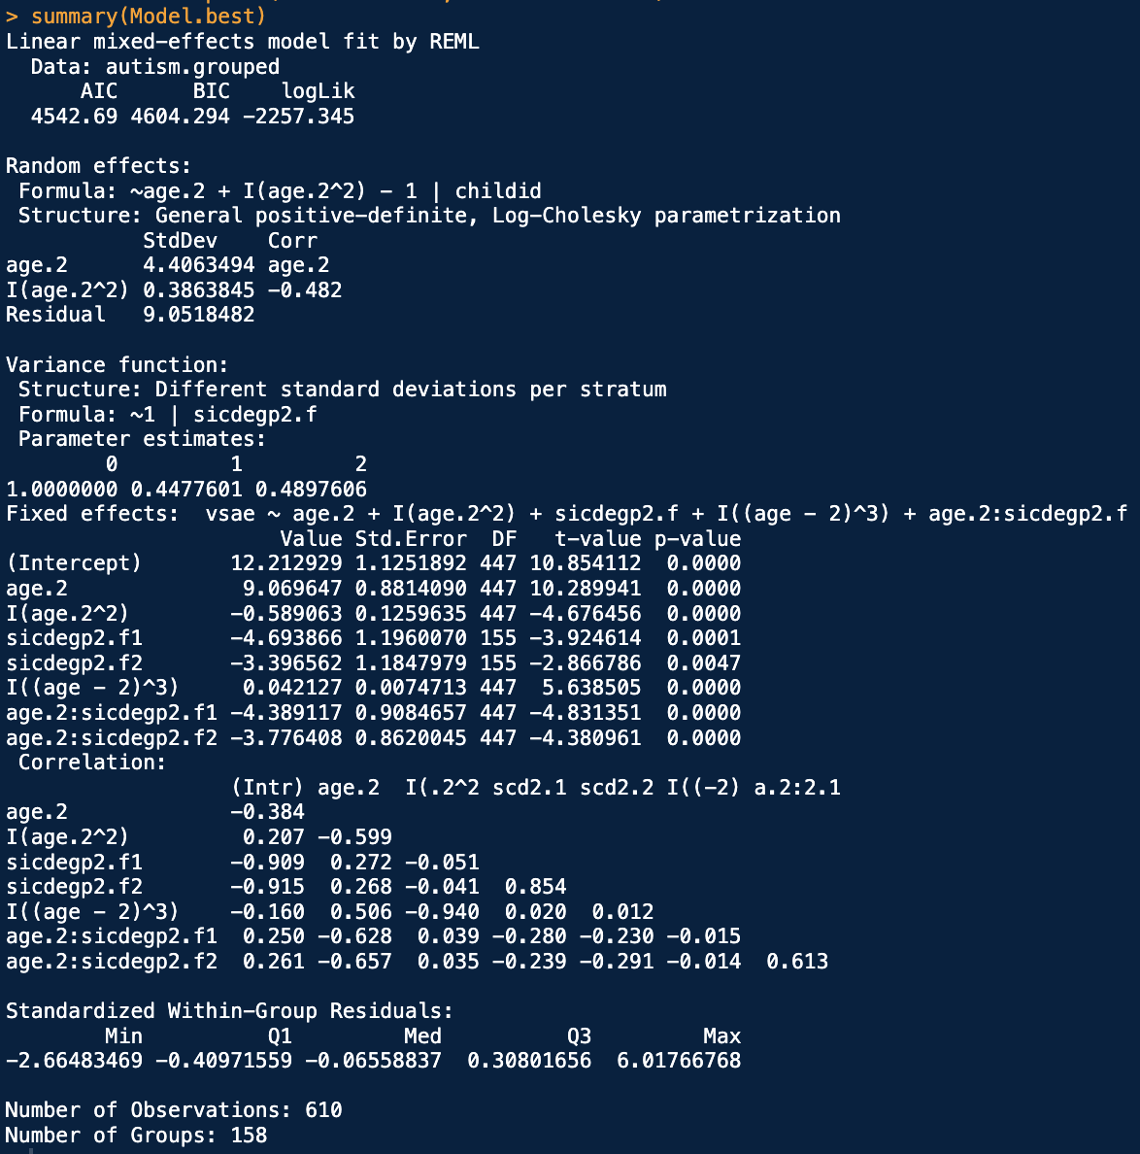
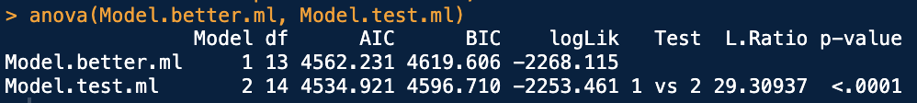
c) I denoted this second model as Model.better and then updated it and named a new model Model.test, updating both models to now fit using ML since we are going to try adding a cubic fixed effect term. Based on an anova LRT following a Chi^2 with df = 1, a p-value of <.0001 tells us that the inclusion of this cubic term significantly improves our model fit. AIC and BIC both support this coice as well, again making the model more complex improves the fit so much that the BIC criterion still decreases even taking into consideration the added penalty for the extra term. Model.test with the cubic term is certainly the best way to go.
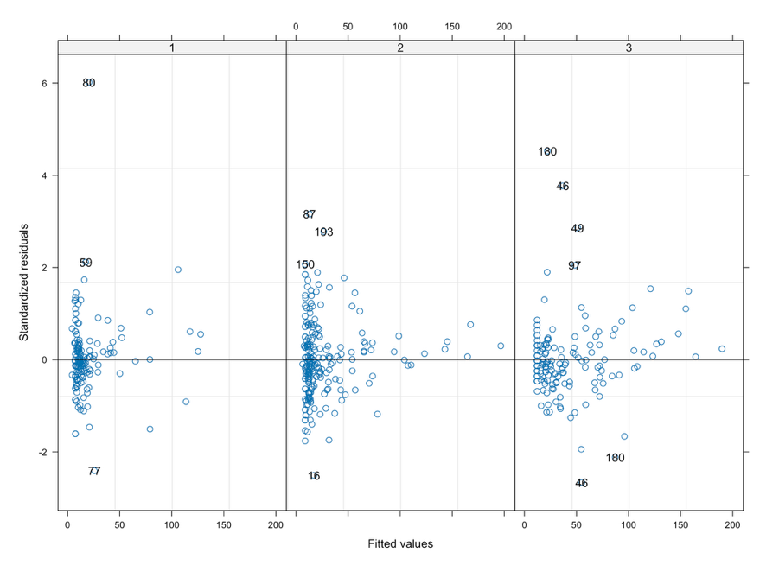
d) Given parts b and c, we certainly have a better model than the one in the book. After refitting using REML, here is the output summary. We can see that with this new added term, the difference in variance among the Sicdegp groups is even more distinct, reducing by 44% and 49% compared to 49% and 50% respectively among groups 1 and 2. All our fixed effect terms are highly significant in their contributions to the mean value, and our random effect variances and correlations do not change by a significant margin, telling us this fit is straight up better.
Table 6.8 shows the fitted values compared to standardized residuals. Similar to the book, we can see that the variance decreases as fitted values increase, however now the group 1 and group 2’s variances are slightly more spread out than the book’s graphic. This is due to them allowing to have their own fitted variance, which is smaller than that of group 3, but independent, so the residuals scale better not to overcompensate for the extreme spread in group 3.
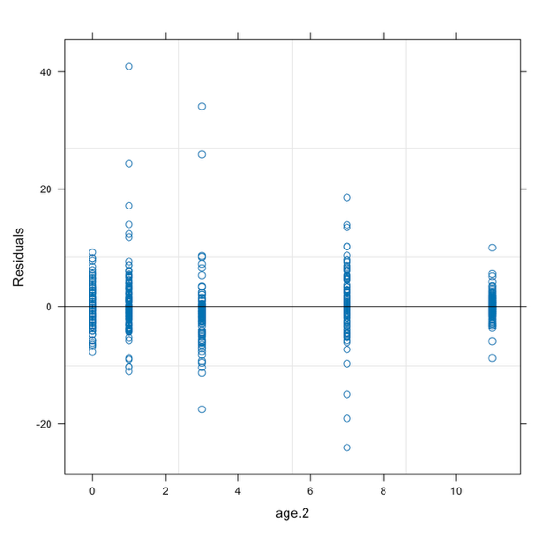
The residuals as grouped by age did not change significantly compared to the book’s plot. While the added cubic term helped the mean, the presence of outliers still remains about the same, telling us that the cubic term helped to more closely fit the data closer to the mean of the VSAE score, but didn’t affect the outlying data much.

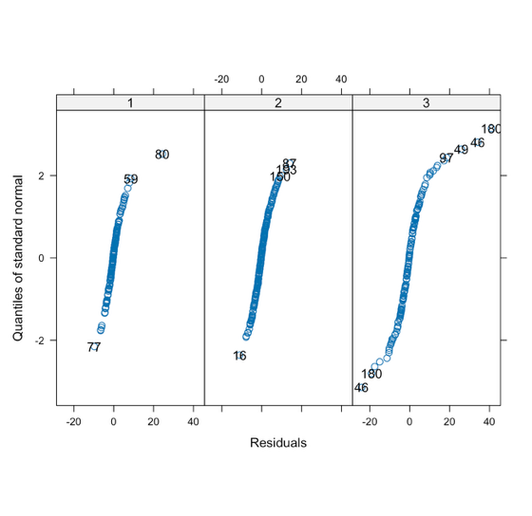
It’s hard to get a sense of the spread in the Q-Q plots in the book since the graphics are very smushed, so I tried to replicate the image as close as I could. Overall the fit seems about the same. Most noticeably, there are now a few more listed outliers in the groups 1 and 2 categories (since their variance changed so we can now recalculate outliers), most noticeably 80 became more of an outlier than it originally was in the book’s graph. More exploration is needed on this point. There are a few more outliers at the tails of group 2, but there are actually less outliers in group 3. Overall as group 3 gets further from the mean, the outliers still tail off much more.
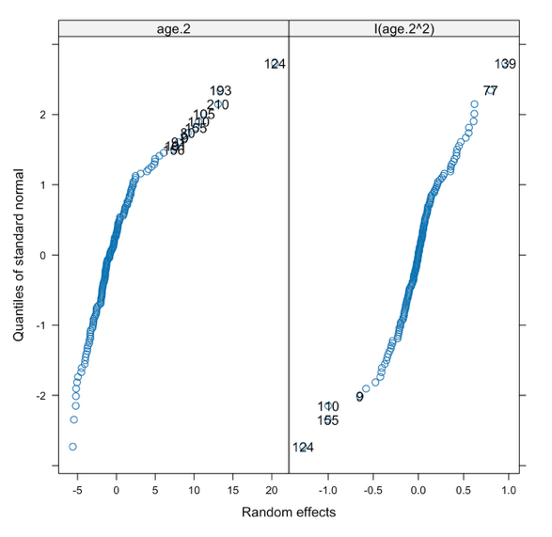
The inclusion of the cubic fixed effect had little effect on the EBLUPs for the random effects, however further consideration might lead us to test whether a random variance term for the cubic term would be significant. Overall the cubic term had a much more drastic effect on the higher side of the age.2 random factor, and messed with both tails of the age.2^2 factor. Compared to the book, the EBLUPs for age.2 seem a bit worse to be considered normal, but the squared term’s normality assumption improved slightly. Further testing would certainly be needed, especially for the assumption of normality of the newly fitted EBLUPs for the age.2 term

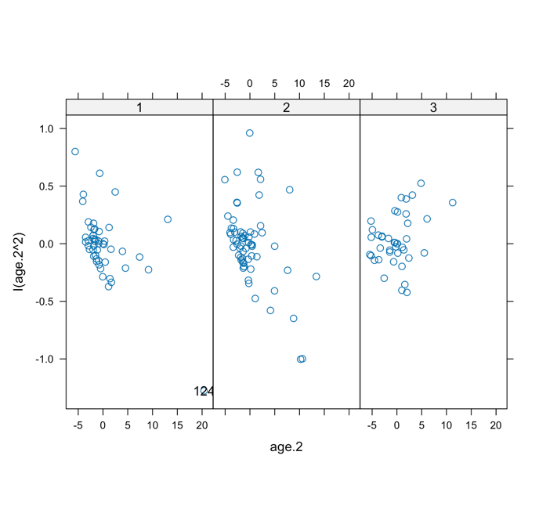
The pairs plot didn’t change all that much, the most change was in the group 3 category. Groups 1 and 2 didn’t change, but the spread of group 3 was reduced significantly. This is because the inclusion of the cubic term is able to capture more data than the quadratic term on the mean, leaving the quadratic EBLUPs to more accurately reflect the effect of the quadratic term on the mean. The random quadratic term appears to be fit a little better than without the cubic fixed effect term.

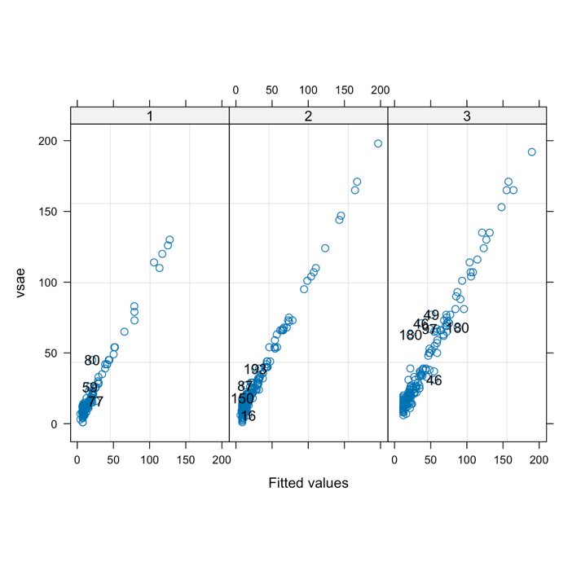
Finally, the Agreement of observed VSAE scores with conditional predicted scores by SICDEGP level. These graphs did not change at all, meaning our overall conditional predictions didn’t really get better or worse. This makes sense since we didn’t mess with the random structure. Hypothetically we would expect there to be slightly less outliers, but it seems to not help as much (conditionally on the child) to make a difference in this graph, however it significantly helped our unconditional predictions (adding a new child, for example).

