Question 8a iv.

I extracted the coefficients more efficiently this time, and then plugged them into the linear model with an x input of 98 to get an estimated y-hat of 24.47

Question 9

a) To make a scatterplot with all of the variables, you need to use the pairs() function to get all of the quantitative variables against each other

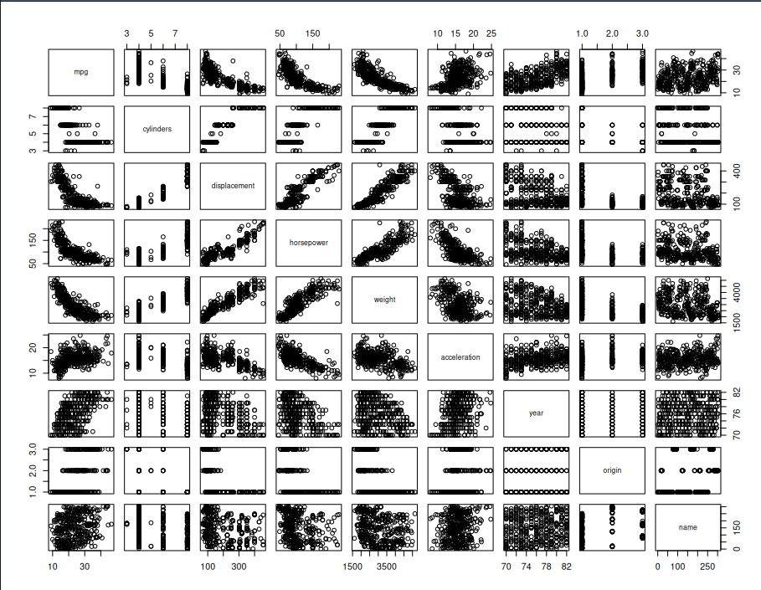

b) Correlation Matrix: cor(Auto) after removing name column

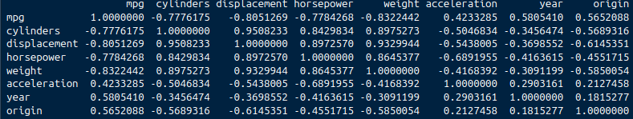

c)

Results of multiple linear regression model:

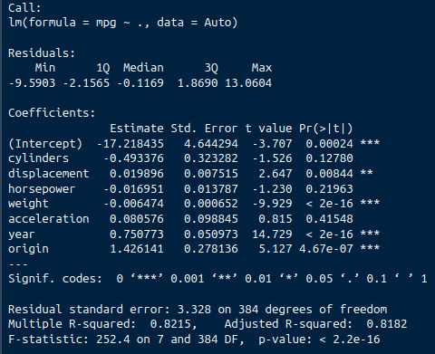i) There are relations between most of the parameters and the mpg response., shown by the number of predictors that have significant p-values (with the 3 asterisks \*\*\*)

ii) Cylinders, Horsepower, and Acceleration all do not have very low p-values, so they are not statistically significant to the mpg response variable

iii) The coefficient for year suggests that for every increase by 1 year, the mpg increases by .75, as shown by the “Estimate” column