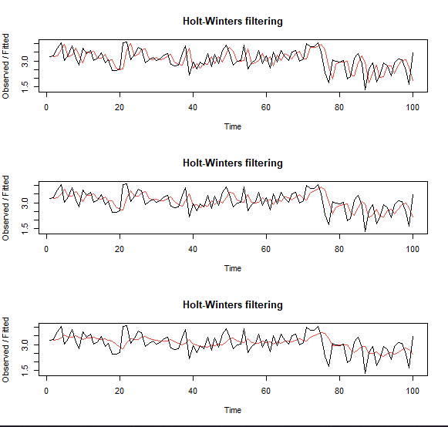Question 3.30

I performed a HoltWinters function on all 3 lambdas, with Alpha = .75, .5, .25. After plotting these against their original time series, it is easy to include that as lambda increases (and alpha decreases) that the functions get more smooth

Question 3.32

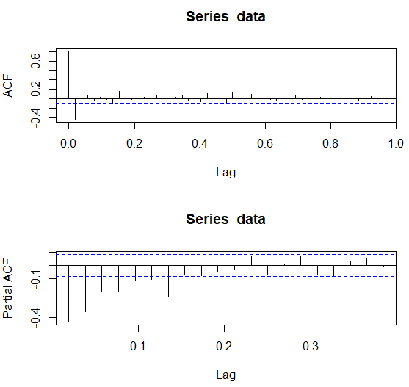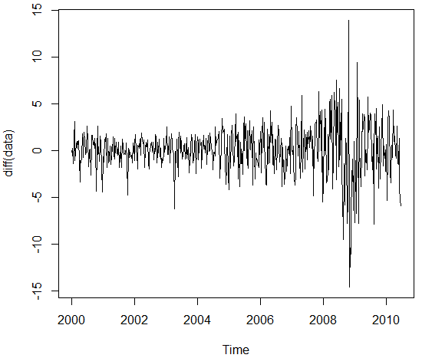First I plotted the data. This looks maybe non-statationary, as it does have a general increasing trend over time. Then I plotted it’s difference. This looks much better. Then I did the ACF and PACF of the diff data. The ACF seems to cut off after 2, but the PACF tails off. This suggests something of the sort ARIMA(?,1,2). I then fit an ARIMA(0,1,2) model and checked the acf and pacf residuals. Overall not bad!

I tried Auto.arima, which then gave me a Arima(1,0,1) of the differenced data, so I was pretty close! I checked the residuals of my model, which seem to overall be decent.

Question 3.39

I copied the book’s code from Example 3.47 and changed the coefficients appropriately. Here is the ACF Graph below. Looks about the same as the book’s! High seasonality trend here, which makes sense due to the model’s defintion.