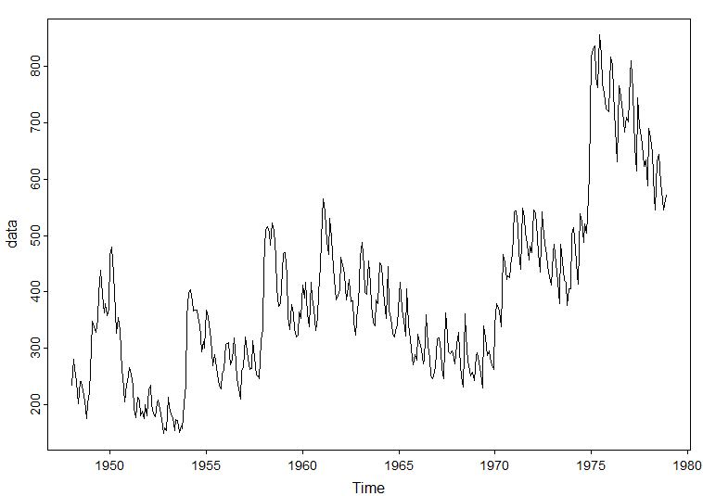Question 3.41

I first plot data and diff(data). The diff(data) looks to exhibit more stationary trends.

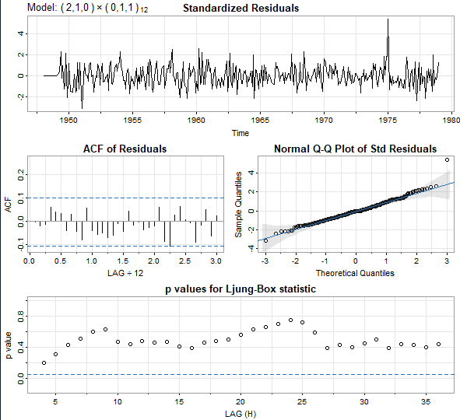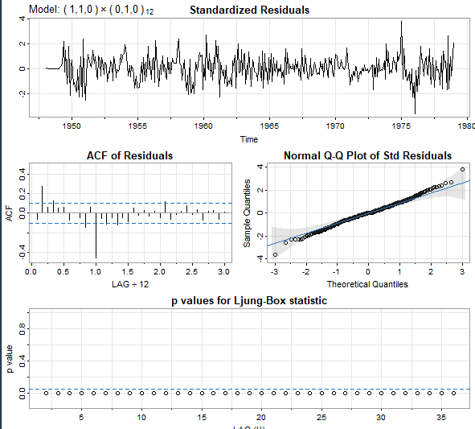I then plot the ACF and PACF using the acf2 function. There is a clear seasonality trend every 12 months or 1 year. The diff suggests an ARIMA d of 1 and s of 12 to caputre this seasonal trend. The ACF seems to tail off, and PACF looks to maybe cut off after 1 large lag, or 2. I first tried an ARIMA(1,1,0) x (0,1,0)_12 as an initial guess. Here are the results: The QQ plot looks decent, but the p values for the box test do not give me much hope. I decided to bump up the AR value to capture this significant lag in PACF. This new ARIMA(2,1,0) x (0,1,1)_12 worked much much better. For fun I ran an auto arima function too. It gave me a model. Forecast looks decent too!

Question 5.4

After plotting the data, yea the graph definitely looks explosive. I ran the 3 tests from the supplemental reading, all with the alternative hypothesis = “explosive”. Each of them gave a p-value of .01, meaning we reject the null in facor of the alternative, being that according to each of these 3 tests the series is explosive.

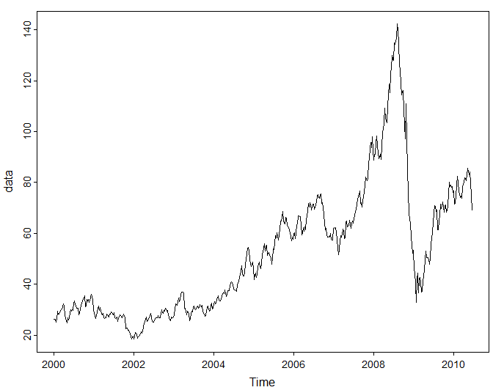Question 5.6

First I plotted the data and the diff(log(data)) . The log data looks like much more of an appropriate fit for a GARCH model. I tried a bunch of different SARIMA models to see what the general trends looked like. The ACF and PACF of the diff(log(data)) were both not very helpful, as many of the lag coefficients were non-significant. I settled on this model:

It’s not perfect, the Q-Q plot looks decent until about the +- 2 std dev from 0. Many of the p-values for the box test are close to the line for a significant p-value, but the first few start out pretty great. I ran a GARCH model as such, following the book’s code and some online suggestions for basic GARCH models. The results are shown below in black. Many of the p values are very low, which indicate a model that fits well. Overall it’s not the best model in the world, but it seems to perform pretty well.