Question 8:

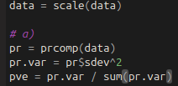
a) Before doing anything, I scaled the data using the scale function. I followed the book’s code to produce the percent of variance explained for the scaled data.

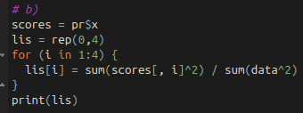
b) According to Equation 12.10, our PVE can be expressed by using the component scores (which is the phi * x term) squared, divided by the sum of all the data squared. I did this, and received the same PVE as the book.

Question 10

a) I wrote a long for loop to create some clusters of data. They are very separated, which should bode well for PCA and K-means clustering when we get there on Wednesday.

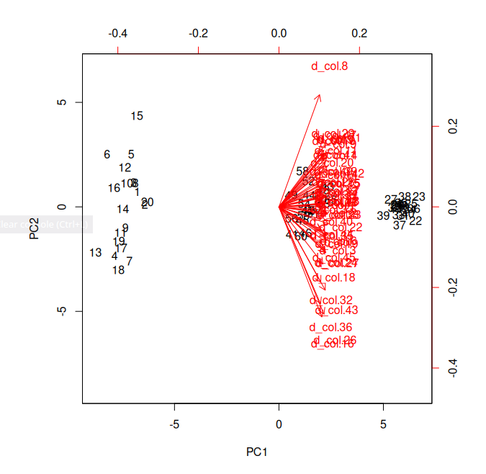
b) I could not get the plot to color the different clusters, however here is the plot, with the 3 clear distinct clusters. You can’t see the center cluster super well since the directions are covering it, but the data points are there.

