Question 1.21

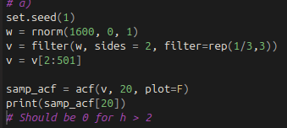
a) I did this using code from Example 1.8. According to Example 1.19, since I used the same moving average filter of 3 observations, the p(h) should be 0 for any lags greater than 2. My p_hat(h) was -.081 for lag = 20. This isn’t unexpected per se since the p_hat(h) is calculated from actual sample data, so it wasn’t that far off

b) I repeated part a for n=50. The results for lag 20 actually got closer to 0, which is a little surprising. Typically I’d expect with a larger n the results to be more “normal” or close to the theoretical values, but this was not the case. I got a p_hat(h) of .037, which is actually closer in absolute value to 0 than the result with n=500

Question 2.1

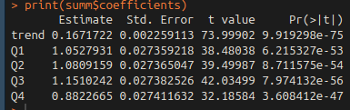
a & b) I copied the book’s code, and printed the output. The resulting trend is an increase of .167 per year

c) They decrease from Q3→Q4, by a percentage of 23.3%, as shown by the summary output here

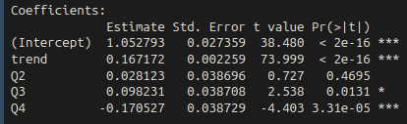
d) Including an intercept term removes quarter 1 from the model, and it also makes everything significantly less significant (lol)

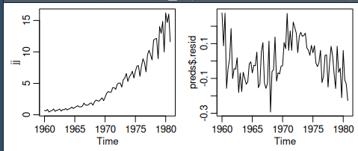
e) I couldn’t get the graph exactly, but I was able to plot the residuals. The residuals showed no apparent pattern, so we can assume that the model is a decent fit

Question 2.3

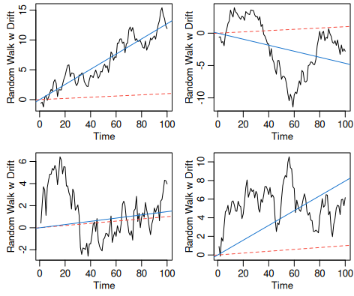
a) I copied the book’s code from the problem, and plotted the results. The first graph seems to model the fit very well (in terms of the fitted line), but the rest of them do not model the series well
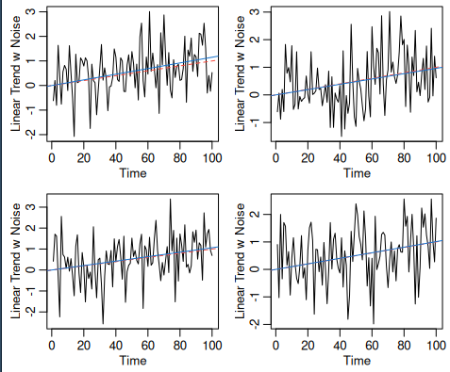
b) Same, but instead I made a linear trend. The fitted and mean lines fit the data much better, and it’s sometimes almost impossible to distinguish between the two.

