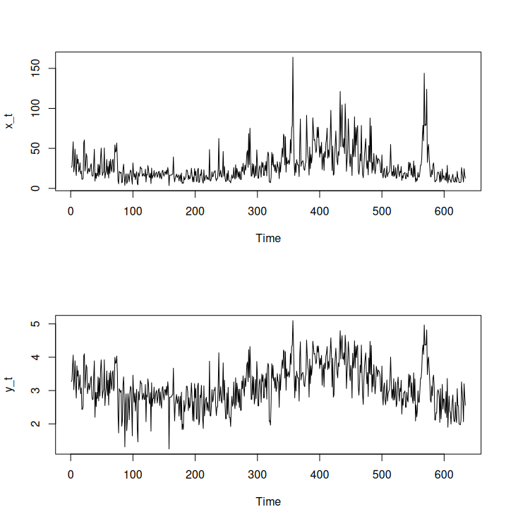
Question 2.8

a) The variance in the first half of the data is 133.4574, while the variance in the second half is 594.4904. This is around 4 times as much variance, and surely would not be constant to say that the data is not heteroscedastic. By log transforming the data, the variance is significantly decreased as time increases, both visually and numerically (Top: Xt, Bottom: Yt = log(Xt))

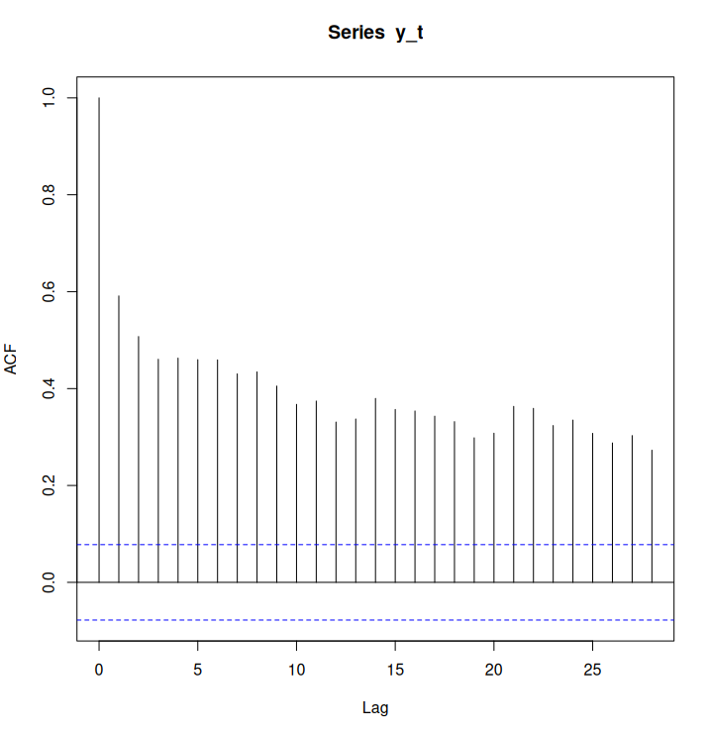
c) Below the graph from a is the sample ACF of Yt. The lagged correlation does decrease, and seems to maybe have a slightl cyclical pattern, but overall the acf decreases as lag increases. We do not hit anywhere close to 0 in these lagged calculations.

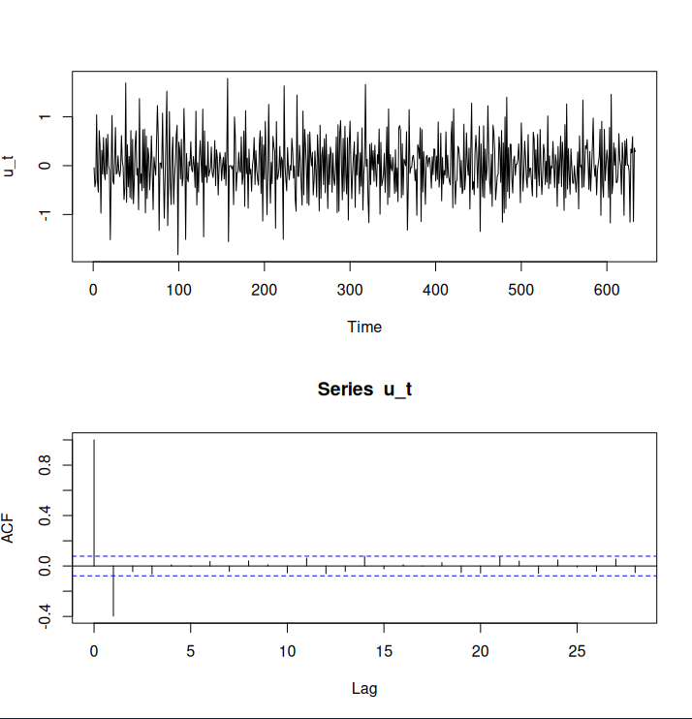
d) This differenced data seems much much more stable, and this is exhibited by its ACF plot. This looks like it would be stationary

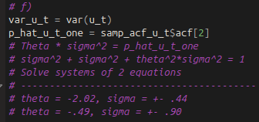
f) By setting up a system of equations and solving, I got a few potential answers for theta and sigma

Question 2.9
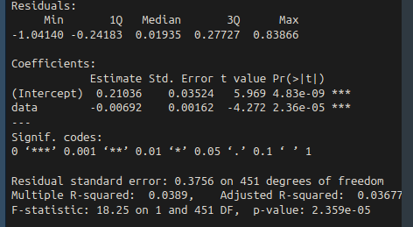
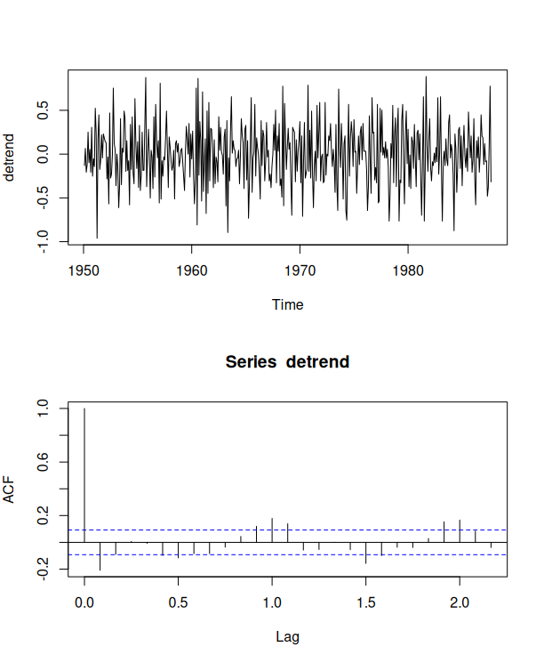
a) I set up the data such that starting from 1950 t = 0, and incremented t by 1/12. I then assigned each t to it’s value from the soi dataset, so I could do a standard lm regression on soi using t. Here is the result, highly significant with both an intercept and the soi data

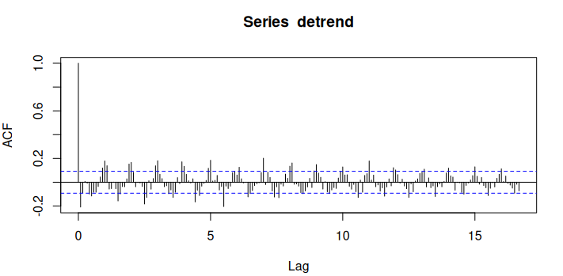
b) Here is the detrended data and the acf. There seems to be a cyclical trend around each lag integer, meaning every 12 months. Other than that, the acf doesn’t really suggest any other cycles except one full rotation every year

