Question 10

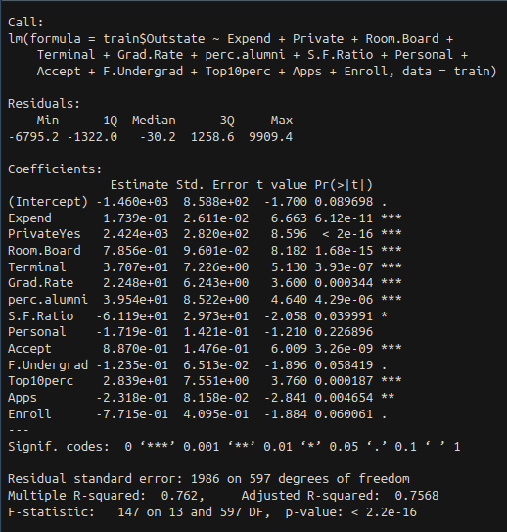
a) I split my data into a training and test set at a 4/5 ratio train. I first created an empty linear model, and a full linear model, and then used the step function to perform forward stepwise selection. 14 of the 18 original predictors were used in the Step model.

b) I took each of the predictors and created a model using natural splines with 3 degrees of freedom for each. I then plotted the result

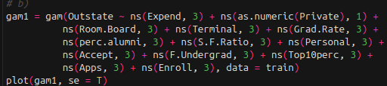

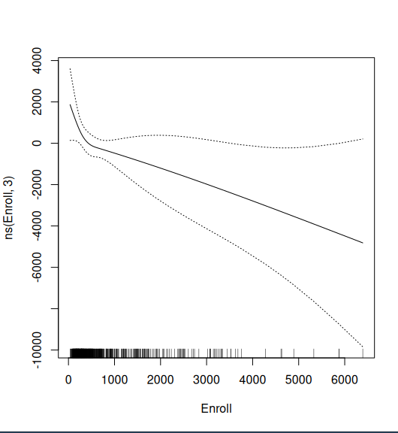

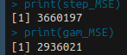
c) I found the test MSE for both the step model and the GAM model. The gam model produced a better result than the stepwise model

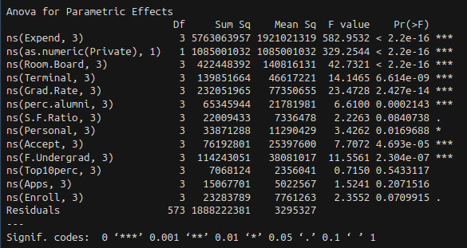
d) There is evidence that a lot of the variables have a non-linear relationship with the response

